AN INTELLIGENT FITNESS MONITORING APPLICATION USING PREDICTIVE ANALYTICS

A Capstone Project
Presented to the Faculty of the
College of Computer Studies
Global Reciprocal Colleges
Caloocan City

In Partial Fulfillment
of the Requirements for the Degree
Bachelor of Science in Information Technology

Prepared by:

Calma, Kasandra
Hoquiton, John Paul

Mrs. Ann Camile M. Maupay
Adviser

November, 2026
i

APPROVAL SHEET
This research entitled “An Intelligent Fitness Monitoring Application Using Predictive Analytics” prepared and submitted by CALMA, KASANDRA A. and HOQUITON, JOHN PAUL L. in partial fulfillment of the requirements for the Subject CAPS1: Capstone Study has been examined for ORAL EXAMINATION.

ANN CAMILE M. MAUPAY, MIT
Research Adviser

PANEL OF EXAMINERS
Approved by the Committee for Oral Defense on date with a grade of ________________.

NAME OF PANELIST
Chair

NAME OF PANELIST NAME OF PANELIST
Member Member

Accepted in partial fulfillment for the Subject CAPS2: Capstone Study

NAME
Program Head/Dean
ii

ACKNOWLEDGMENT
Part of the project ends as everything must eventually be completed. This project required time, effort, patience, and commitment, and despite the challenges we encountered along the way, we are grateful that we were able to finish it. Throughout this journey, we received support, guidance, and encouragement from many people who helped us reach this accomplishment. With sincere gratitude, we would like to thank:

First and foremost, we praise the Lord Jesus Christ for giving us the strength, wisdom, perseverance, and guidance to complete this project. Through His love, grace, and blessings, we were able to overcome the difficulties we encountered and continue moving forward even during challenging times. We are truly grateful for His presence and guidance throughout this journey.

To Mr. Eduardo S. Rodrigo, our CAPSTONE 1 professor, and Mrs. Ann Camile M. Maupay, our CAPSTONE 2 professor, for their guidance, patience, and valuable advice throughout the development of our project. Their recommendations and feedback helped us improve our system and ensure that the project was properly developed and documented.

To the owner of Triple J Fitness Center, for allowing us to conduct our study and develop the Intelligent Fitness Monitoring Application Using Predictive Analytics for the fitness center. We are sincerely grateful for the time, cooperation, and information provided, which helped us understand the needs of the organization and develop a system aligned with its requirements.

To the five IT expert respondents for taking the time to evaluate our system and provide valuable feedback. Their knowledge and insights helped us assess the functionality, performance, reliability, usability, compatibility, and maintainability of our proposed system.
iii
To our Technical Adviser, Mr. Romark Cacho, for his technical guidance, suggestions, and support throughout the development of our project. His knowledge and advice helped us address technical challenges and improve the system.

To our parents and families, for their unconditional love, understanding, encouragement, and support throughout this journey. Their continuous motivation gave us the strength to keep going, especially during stressful and difficult moments.

To our friends and classmates, for their encouragement, assistance, and support throughout the completion of this project. Their presence and willingness to help made the journey lighter and more meaningful.

Finally, we would like to express our deepest gratitude to everyone who contributed, whether directly or indirectly, to the completion of this project. Every piece of advice, words of encouragement, and form of support was greatly appreciated. This accomplishment would not have been possible without the people who stood by us throughout this journey. To everyone who became part of this journey, thank you sincerely.

iv

DEDICATION
The proponents wholeheartedly dedicate this study to Almighty God, who has given us wisdom, strength, patience, and determination throughout the entire process of completing this project. His guidance has helped us overcome every challenge and difficulty we encountered along the way.

This study is also dedicated to our beloved families, whose unconditional love, understanding, and continuous support have served as our motivation to persevere. We are deeply grateful for their moral, emotional, spiritual, and financial support, especially during the times when we felt discouraged and exhausted.

We would also like to express our sincere appreciation to our friends, classmates, professors, and peers who shared their knowledge, encouragement and words of motivation helped us remain committed to completing this study.

Lastly, we dedicate this project to everyone who believed in our capabilities and supported us throughout this journey. This accomplishment would not have been possible without the people who continuously encouraged and inspired us to pursue our goals and bring this project to completion.

v
CERTIFICATE OF ORIGINALITY
This is to certify that this research paper, entitled “An Intelligent Fitness Monitoring Application Using Predictive Analytics,” prepared and submitted by Calma, Kasandra A. and Hoquiton, John Paul L., in partial fulfillment of the requirements for the subject CAPSTONE 1 and 2: Capstone Project and Research, is the product of the researchers’ collective ideas, derived from the data gathered, with the guidance of the professionals who helped construct this research.

It does not contain any material previously published or written by another person, nor any material copied or reproduced from other sources without proper acknowledgment. Any contribution made to the research by others is explicitly acknowledged in this paper.

I further certify that the signatures appearing herein are genuine and that the work and ideas presented in this study are the original work of the researchers, developed under the supervision of their adviser, Mrs. Ann Camile M. Maupay.
Signed this __ of __ in the year of our Lord, 2026

Calma, Kasandra A.

Hoquiton, John Paul L.

vi
CERTIFICATE OF GRAMMARIAN
This is to certify that the research paper entitled “An Intelligent Fitness Monitoring Application Using Predictive Analytics,” prepared and submitted by Kasandra A. Calma and John Paul L. Hoquiton, in partial fulfillment of the requirements for the subject CAPSTONE 1 and 2: Capstone Project and Research, has been carefully reviewed and edited for grammar, spelling, punctuation, sentence structure, word usage, and overall language consistency.

The undersigned certifies that the necessary grammatical corrections and revisions have been made to ensure the clarity, coherence, and proper presentation of the research paper. The review and editing were conducted without altering the original ideas, findings, and intended meaning of the researchers
.
This certification is issued as evidence that the research paper has undergone proper grammatical review and proofreading in accordance with academic writing standards.
Given this _____ day of __________, 2026.

___________________
Grammarian

vii
ABSTRACT

Title: An Intelligent Fitness Monitoring Application Using Predictive Analytics
Researcher: Calma, Kasandra A.
Hoquiton, John Paul L.
Degree: Bachelor of Science in Information Technology
Institution: Global Reciprocal College
Year: 2026
Adviser: Mrs. Ann Camile M. Maupay
Keywords: Fitness Progress Monitoring, Predictive Analytics, Body Composition, Weight Prediction, Body Fat Prediction, Workout Monitoring, Meal Tracking, Gym Management, ISO/IEC 25010

This study aimed to develop an Intelligent Fitness Progress Monitoring Application Using Predictive Analytics for Global Reciprocal Colleges to improve the monitoring and management of fitness progress among gym members, trainers, and administrators. The study addressed challenges in manually tracking workouts, body measurements, meal intake, attendance, memberships, and fitness progress.

The study utilized the Rapid Application Development (RAD) model. The system was developed using Flutter and Dart for the member and trainer mobile applications, React with Vite for the administrator website, and Supabase with PostgreSQL for backend and database management. Supabase Realtime was used for real-time communication and chat. The system was evaluated by five (5) IT experts and 120 respondents consisting of administrators, trainers, and members.
viii
The system provides member, trainer, and administrative management features, including workout logging, BMI and progress monitoring, meal and food intake tracking, membership and attendance management, workout planning, feedback, notifications, reports, and real-time chat. Its predictive analytics feature uses historical weight and body fat data to estimate future fitness progress and support data-informed fitness planning.

The system was evaluated using the ISO/IEC 25010 software quality model and obtained an overall weighted mean of [INSERT WEIGHTED MEAN], interpreted as [INSERT INTERPRETATION]. The findings indicate that the developed application provides an organized approach to fitness monitoring and gym management while supporting users and trainers in tracking body composition and fitness progress.

ix
TABLE OF CONTENTS
TITLE PAGE i
APPROVAL SHEET ii
ACKNOWLEDGEMENT iii
DEDICATION v
CERTIFICATE OF ORIGINALITY vi
CERTIFICATE OF GRAMMARIAN vii
ABSTRACT viii
TABLE OF CONTENTS x
LIST OF TABLES xiii
LIST OF FIGURES xv
CHAPTER I - INTRODUCTION
1.1 Project Context 1
1.2 Objectives of the Study 2
General Objective
Specific Objective
1.3 Scope and Limitations of the S 3
Scope
Limitations
1.5 Definition of Terms
CHAPTER II – REVIEW OF RELATED LITERATURE AND STUDIES
2.1 Review of Related Literature 11
Foreign Literature 11
x
Local Literature
2.2 Review of Related Studies 12
Foreign Studies 12
Local Studies 16
2.3 Synthesis of the Reviewed Related Literature and Studies 20
CHAPTER III – METHODOLOGY OF THE STUDY
3.1 Research Method and Design 32
3.2 Conceptual Framework 42
3.3 Hardware and Software Requirements 41
3.4 Context Diagram 44
Existing 44
Proposed 47
3.5 Data Flow Diagram 55
Existing 57
Proposed 58
3.5 Activity Diagram 55
3.7 Entity Relationship Diagram 55
3.8 Use Case 55
3.9 Data Dictionary 55
3.10 Roles and Responsibilities 55
CHAPTER IV – RESULTS AND DISCUSSIONS
4.1 DEVELOPMENT AND TESTING
Unit and Integration Testing 57
xi
User Acceptance Testing
4.2 Evaluation Results 5
Data Interpretation 57
CHAPTER V – SUMMARY, CONCLUSIONS AND RECOMMENDATIONS
5.1 Summary of Findings 57
5.2 Conclusions 57
5.3 Recommendations 57
REFERENCES 57
APPENDICES 57
Permit to Conduct the Study 57
Letter for Interview 57
Evaluation Instrument 57
User Manual 57

xii

LIST OF TABLES
Table 1 Hardware Requirements 57
Table 2 Software Requirements 57
Table 3 Enrollments 57
Table 4 Profiles 57
Table 5 Memberships 57
Table 6 Trainer Assignments 57
Table 7 Attendance 57
Table 8 Check Ins 57
Table 9 Addresses 57
Table 10 Workout Logs 57
Table 11 Goals 57
Table 12 Member Goal Plans 57
Table 13 Plan Day Completions 57
Table 14 Trainer Feedback 57
Table 15 Meal Records 57
Table 16 Meal Logs 57
Table 17 Nutrition Foods 57
Table 18 MET Exercises 57
Table 19 Chat Rooms 57
Table 20 Chat Messages 5
Table 21 Notifications 57
Table 22 Predictions 57
xiii
Table 23 Admin Logs 57
Table 24 ISO 25010 Guideline 57
Table 25 Likert Scale 57
Table 26 Unit and Integration Testing for Web Application 57
Table 27 Unit and Integration for Member Mobile Application 57
Table 28 Unit and Integration for Trainer Mobile Application 57
Table 29 Software Evaluation of Functional Sustainability Criterion by IT Expert 57
Table 30 Software Evaluation of Functional Sustainability Criterion 57
Table 31 Software Evaluation of Performance Efficiency Criterion 57
Table 32 Software Evaluation of Compatibility Criterion 57
Table 33 Software Evaluation of Reliability Criterion 57
Table 34 Software Evaluation of Usability Criterion 57
Table 35 Software Evaluation of Maintainability Criterion 57
Table 36 Software Evaluation of Portability Criterion 57
Table 37 Software Evaluation Summary – End Users 57

xiv

list of figures
Figure 1 Research Method and Design 57
Figure 2 Input Process Output (IPO) 57
Figure 3 Context Diagram of Existing System 57
Figure 4 Context Diagram of Proposed System 57
Figure 5 Data Flow of Existing System 57
Figure 6 Data flow Diagram of Process 1 (Existing) 57
Figure 7 Data Flow Diagram of Process 2 (Existing) 57
Figure 8 Data Flow Diagram of Process 3 (Existing) 57
Figure 9 Data Flow Diagram of Proposed System 57
Figure 10 Data Flow Diagram of Process 1 (Proposed) 57
Figure 11 Data Flow Diagram of Process 2 (Proposed) 57
Figure 12 Data Flow Diagram of Process 3 (Proposed) 57
Figure 13 Data Flow Diagram of Process 4 (Proposed) 57
Figure 14 Data Flow Diagram of Process 5 (Proposed) 57
Figure 15 Activity Diagram (Member Login and Registration) 57
Figure 16 Activity Diagram (Workout Logging with Exercise Tracking) 57
Figure 17 Activity Diagram (QR Code Check-In and Check-Out) 57
Figure 18 Activity Diagram (Meal Logging and AI Food Analyst) 57
Figure 19 Activity Diagram (Dashboard View) 57
Figure 20 Activity Diagram (Trainer Feedback and Member Rating) 57
Figure 21 Activity (Goal Setting and Plan Creation) 57
Figure 22 ERD (Accounts, Membership and Attendance) 57
xv
Figure 23 ERD (Fitness Tracking, Goals and Trainer Feedback) 57
Figure 24 ERD (Nutrition, Meal Logging and Reference Data) 57
Figure 25 ERD (Communication, Notifications and Administration) 57
Figure 26 Use Case of the Member Module 57
Figure 27 Use case of the Proposed System 57
Figure 28 Use Case of the Admin Module 57
Figure 29 Gantt Chart (Work Plan) 57

xvi

CHAPTER I

THE PROBLEM AND ITS BACKGROUND
This chapter presents the context of our project, the objective of this study, the scope and limitation of the study, significances of the study and definition of key terms.

1.1 PROJECT CONTEXT
The growing awareness of physical fitness among Filipinos has driven a significant increase in gym memberships and structured exercise participation nationwide. As individuals pursue specific goals such as weight loss, muscle gain, and improved endurance, the demand for reliable and intelligent fitness management tools has become increasingly pronounced. Despite this growth, many gyms in the Philippines continue to operate without systematic digital tools for managing member records, tracking fitness progress, or facilitating structured trainer-member communication. This gap is particularly evident at Triple J Fitness Center, located in Valenzuela City, where current operations rely on manual and informal methods that limit service quality and member engagement.
Triple J Fitness Center serves a growing membership base in Valenzuela City, offering gym equipment and trainer-assisted workout programs for members with varying fitness goals. A preliminary consultation with the management and staff of the center revealed several persistent operational challenges: member workout logs are maintained informally, progress monitoring is inconsistent, trainer-member communication occurs without a structured system, and membership records are managed through non-digital means. These limitations have affected the center's ability to deliver consistent, data-driven fitness guidance and to retain members over the long term.
In response to these identified needs, this study proposes the development of a web-based Intelligent Fitness Progress Monitoring Application using Predictive Analytics, deployed specifically for Triple J Fitness Center. The system will serve three primary user roles: Admin, Member, and Trainer. Members will access the platform via QR code to log workouts, update fitness records, and transmit progress data to their assigned trainers. Each workout log entry is computed using standardized Metabolic Equivalent of Task (MET) values, allowing the system to estimate calories burned per exercise based on exercise type, member body weight, and session duration. Trainers will review member logs, assess progress, and provide personalized feedback. The admin will manage user accounts, memberships, reports, and system records. By integrating predictive analytics and a food logging feature that allows members to manually select food items and automatically computes their corresponding nutritional values (calories, protein, carbohydrates, and fats) based on the DOST Food and Nutrition Research Institute's Philippine Food Composition Table (PhilFCT), the proposed system aims to transform Triple J Fitness Center's operations into a structured, data-driven, and technology-enabled fitness environment.

1.2 OBJECTIVES OF THE STUDY
GENERAL OBJECTIVE
The general objective of this study is to design, develop, and deploy a web-based Intelligent Fitness Progress Monitoring Application using Predictive Analytics for Triple J Fitness Center in Valenzuela City by the end of Academic Year 2025-2026, integrating digital management tools for Admins, structured progress tracking for Members, and a data-driven feedback platform for Trainers.

SPECIFIC OBJECTIVE
- To develop an administrative module that enables the Admin to manage user accounts, membership records, trainer and member profiles, and generate system reports through a centralized web-based interface.
- To implement a QR code-based member access system that enables at least 90% of enrolled members to log workout sessions, record body measurements, and update fitness activity records within one month of deployment.
- To develop a workout logging module that computes estimated calories burned per exercise using standardized MET values, body weight, and session duration.
- To develop a trainer-facing module that provides trainers real-time access to member logs, progress summaries, and tools for delivering personalized feedback and workout recommendations.
- To implement a predictive analytics engine that analyzes historical member data to generate progress forecasts with a minimum accuracy threshold of 80%.
- To develop a food logging module that allows members to manually select consumed food items and automatically computes their calorie, protein, carbohydrate, and fat content using nutritional data from the DOST-FNRI's PhilFCT.

1.3 SCOPE AND LIMITATIONS OF THE STUDY
SCOPE
This study focuses on the development of the Intelligent Fitness Progress Monitoring Application, a web-based system built using Flutter (Dart) and Supabase, designed specifically for deployment at Triple J Fitness Center in Valenzuela City.
- The system allows multiple users to access the system through three roles: Admin, Member, and Trainer.
  - The Admin manages the full scope of system operations, including user account creation and management, membership records, trainer and member data, and the generation of activity and performance reports.
  - The Member accesses the web application by scanning a QR code through which they can log workout sessions, update body measurements, record fitness activity, and transmit progress data directly to their assigned trainer.
  - The Trainer uses the platform to review member logs, monitor progress trends, and provide personalized feedback and workout recommendations.
- The system computes estimated calories burned for each logged exercise.
  - Each logged exercise is matched against a stored MET value dataset, which the system uses together with the member's body weight and session duration to calculate the estimate.
- The system incorporates predictive analytics feature and a food logging feature.
  - A Predictive Analytics Engine analyzes historical member data, including workout frequency, attendance records, and body measurement trends, to generate forecasts of future fitness outcomes and identify members at risk of stagnating or disengaging.
  - A Food Logging Module allows members to manually select food items consumed, retrieving the corresponding calorie, protein, carbohydrate, and fat content from the DOST-FNRI PhilFCT database, so members can monitor their nutritional intake in relation to their weight loss, muscle gain, or maintenance objectives.
- The system is hosted on Supabase's cloud infrastructure, ensuring real-time data synchronization across all user sessions.

LIMITATIONS
The study will not include medical diagnoses, clinical dietary prescriptions, or professional healthcare treatment recommendations; all nutritional information provided by the system is informational and supplementary in nature only. The system will also not support integration with wearable fitness devices such as smartwatches or biometric trackers, as all data entry is performed manually by members through the web interface, and will not include real-time video-based workout coaching or live streaming functionality.

The other limitation of the study is that the accuracy of the food logging feature is bounded by the coverage of the PhilFCT database, as food items do not present in the database fall outside the scope of automated nutritional computation and would need to be logged without corresponding nutritional values. Also, the study is limited to the design, development, and initial evaluation of the system based on the functional requirements established in consultation with Triple J Fitness Center; full organizational adoption and long-term impact assessment are beyond the scope of this study.

The workout video feature does not track or detect the member’s actual movements to confirm whether they are performing the workout properly. For example, if a member records a bench press exercise, the system cannot guarantee that the camera will detect or verify that the member is actually performing the exercise. A member may also record a video without actually working out. Therefore, the workout video feature is intended only for the trainer to view and strictly for monitoring purposes.

1.4 SIGNIFICANCE OF THE STUDY
This part of the study explained the importance of the development of the system to the following individuals:

TRIPLE J FITNESS CENTER
The primary benefactor of this study is Triple J Fitness Center. The study on implementing an Intelligent Fitness Progress Monitoring Application would primarily benefit the center's operational efficiency, member management, and its ability to offer trainers data-driven tools for delivering personalized fitness guidance, positioning it to offer a more competitive and professional service experience.

MEMBERS OF THE TRIPLE J FITNESS CENTER
The next benefactor of this study are the members of Triple J Fitness Center. The system will give them access to an organized, data-driven platform where they can track their workout routines with accurate, MET-based calorie estimates, monitor body measurements, log meals with accurate nutritional data backed by an authoritative national nutrition database, and stay informed through predictive progress insights, supporting greater accountability, consistency, and engagement in their individual fitness journeys.
TRAINERS
The other benefactor of this study are the trainers of Triple J Fitness Center. The system will provide them a centralized platform with real-time visibility into member progress, removing reliance on informal communication and enabling a more professional and evidence-based approach to client management through structured delivery of personalized recommendations and feedback.

PROPONENTS
This will serve them as the first step towards success in the field of expertise. This will also help them apply the knowledge they have gained throughout the project, contributing to the growing body of knowledge on client-based fitness information systems, AI integration in health applications, and the application of predictive analytics within the Philippine fitness industry.

FUTURE PROPONENTS
The proposed study will serve as a reference for other or future proponents exploring similar domains, particularly future capstone and research projects on client-based fitness information systems or AI integration in health applications. It may also serve as a model for similar client-engaged research, demonstrating the practical value of integrating emerging technologies such as web-based systems, predictive analytics, and AI into student-developed capstone projects.

1.5 DEFINITION OF TERMS
Upon the implementation, the following terms that are not familiar to the users and future researchers will be the following, it has been defined clearly and conceptually for better understanding.

Admin – refers to the designated system administrator of Triple J Fitness Center, responsible for managing user accounts, membership records, trainer and member data, and system-generated reports within the proposed application.

Artificial Intelligence (AI) – refers to the application of computational methods that enable the system to analyze patterns in fitness data generate automated, context-aware outputs such as food recommendations and predictive progress forecasts.

Body Measurements – quantitative physical metrics recorded by members through the system, including body weight, height, and circumferential measurements, used to monitor physical changes over time.

Flutter (Dart) – an open-source, cross-platform application development framework used to build the web-based frontend interface of the proposed system

Food Logging in Module – a feature of the proposed system that allows members to manually select food items consumed and retrieves their corresponding nutritional values from the PhilFCT database to support monitoring of dietary intake in relation to member’s declared fitness goals

Metabolic Equivalent of Task Value (MET) – A standardized numerical value representing the energy cost of a specific physical activity relative to resting metabolism, stored in the system's exercise dataset and used, together with member body weight and session duration, to estimate calories burned per workout log entry.

Member – an enrolled member of Triple J Fitness Center who accesses the web application through a QR code to log workout sessions, update fitness activity records, and receive predictive progress insights.
Philippine Food Composition Table (PhilFCT) – the official Philippine food composition database maintained by the Department of Science and Technology Food and Nutrition Research Institute (DOST-FNRI), used by the proposed system as the reference source for the calorie, protein, carbohydrate, and fat content of logged food items.

Predictive Analytics – the use of historical fitness data, statistical methods, and machine learning algorithms to forecast future member outcomes, including projected changes in body measurements, attendance trends, and goal attainment trajectories.

QR Code Access – a quick-response code assigned to each member of Triple J Fitness Center, used as the primary method for accessing the web-based fitness management application.

Supabase – An open-source, cloud-based backend-as-a-service platform built on PostgreSQL, used to host and manage the system's database, authentication, and real-time data synchronization.

Trainer – A fitness trainer employed at Triple J Fitness Center who uses the proposed system to review member workout logs, monitor progress trends, and provide structured, data- informed feedback and workout recommendations

Workout Log – A member-generated digital record of a completed exercise session, including exercise type, sets, repetitions, duration, intensity, and MET-based estimated calories burned, stored within the system for progress monitoring and predictive analytics processing.

CHAPTER II

REVIEW OF RELATED LITERATURE AND STUDIES
This chapter shows the related literature and related studies that are significant to the proposed project. It contains facts from books, thesis, journal, article, and electronic resources and further expands the idea of the study to develop a successful project.
2.1 REVIEW OF RELATED LITERATURE
FOREIGN LITERATURE
According to Laudon and Laudon (2020). Information systems improve organizational efficiency by enabling structured data processing, storage, and automation. They also said that applying these principles to fitness management supports the development of digital platforms that replace informal, paper-based practices with organized, centralized data management.

According to Russell and Norvig (2021). Artificial intelligence is the capacity of computational systems to perform tasks that require human-like reasoning, including learning from data, recognizing patterns, and generating context-aware outputs. They also added that the integration of AI into fitness platforms enables personalized guidance, automated recommendations, and system behavior that adapts to individual user data.

According to Shatte et al. (2020). Predictive analytics techniques, including machine learning and statistical modeling, can effectively forecast future health outcomes from historical data. In the context of fitness systems, they said predictive analytics supports progress forecasting, trend detection in body composition changes, and proactive identification of members at risk of disengagement.

According to Wang et al. (2020). Mobile and web health applications significantly improve user engagement and promote more consistent health monitoring behaviors compared to manual tracking methods. Their findings affirm the practical value of web-based platforms for delivering accessible, real-time fitness management tools to gym members.

According to Patel et al. (2022). Digital health technologies have substantially improved individuals' ability to monitor physical activity and sustain health behavior change. They also said that the effectiveness of digital platforms in bridging the gap between passive health awareness and active, consistent fitness engagement underscores the relevance of such systems for gym members.

According to Johnson et al. (2021). Individuals frequently abandon manual fitness tracking due to the time and effort involved in maintaining consistent records. They also added that this behavioral pattern reinforces the need for automated, low-friction digital systems that reduce user burden while ensuring accurate and continuous monitoring.

According to Ainsworth et al. (2011). Standardized MET (Metabolic Equivalent of Task) values provide a validated basis for estimating energy expenditure from exercise type, duration, and body weight. They also said that this compendium is widely adopted in fitness and health-monitoring systems as the reference standard for calorie-burn estimation.

According to Hutchesson et al. (2015). Self-monitoring of dietary intake through structured food logging significantly improves individuals' awareness of their nutritional habits and supports better adherence to weight management and health goals. They also said that food logging systems referencing standardized food composition databases provide users with more accurate and consistent nutritional feedback than unstructured, self-estimated tracking.
LOCAL LITERATURE
According to the Commission on Higher Education (2023). Digital transformation across sectors in the Philippines should be advocated, emphasizing the development of accessible, user-centered information systems that address local operational challenges. This institutional direction affirms the relevance of developing a client-based digital fitness solution as a contribution to the broader digital transformation of the Philippine fitness industry.

According to Gonzales et al. (2023). Sustained engagement with digital health tools implemented in the Philippines depends heavily on user-centered design and alignment with local user needs. Their findings underscore the importance of designing a system's interface and features in direct consultation with its end users to ensure that the system remains accessible and contextually relevant.

According to Migriño and Batangan (2021). Machine learning predictive models can be practically applied to local Philippine health datasets, confirming that predictive analytics can generate actionable forecasts from data collected within the Philippine context. This finding validates the technical viability of incorporating a predictive analytics engine into a fitness management system developed for a local fitness center.

2.2 REVIEW OF RELATED STUDIES
FOREIGN STUDIES
According to the study by Wang et al. (2020). They developed a mobile health application for tracking physical activities and found that the system significantly improved user consistency in maintaining fitness routines. However, the system lacked predictive forecasting capabilities and did not include trainer-facing features or structured feedback mechanisms, limiting its utility as a comprehensive fitness management platform.

The study of Yang et al. (2021) developed a behavior-based fitness application that improved user motivation through personalized feedback. The study confirmed the effectiveness of goal-oriented digital interventions but noted the absence of AI-driven analytical features and trainer interaction components.

The study of Shatte et al. (2020) established that predictive analytics models are capable of generating meaningful health outcome forecasts from historical datasets. While the study focused on general healthcare contexts, the methodological framework it presents is directly applicable to fitness progress forecasting.

LOCAL STUDIES

Cruz (2022) developed a web-based fitness monitoring system that improved data organization and reduced reliance on paper records. However, the system served only individual users and did not include trainer-member communication features, administrative management tools, predictive analytics, or structured nutritional tracking, limiting its applicability to a client-based, multi-role fitness center environment.

Reyes (2021) developed a mobile-based health tracking application that improved accessibility for fitness enthusiasts. While the platform facilitated basic activity logging, it lacked trainer interaction capabilities, role-based access, and intelligent analytical features necessary for managing a fitness center's diverse user base and operational requirements.

Santos (2020) developed a fitness tracking system that generated basic progress reports, demonstrating the value of digital data management in fitness contexts. The system did not incorporate multi-user role management, predictive analytics, or AI-based features.

2.3 SYNTHESIS OF THE REVIEWED RELATED LITERATURE AND STUDIES
The proponents believe that all references and studies mentioned in this study are similar to the current study. The proponents also believe that the same methods and techniques used in the studies mentioned in the study can be applied to the current study. Additionally, the proponents believe that the results of the current study can be compared to the results of the references and studies mentioned in the study to provide a more comprehensive understanding of the topic.
The related literature, both foreign and local, all stated that the integration of information systems, artificial intelligence, and predictive analytics is essential to improving data management, decision support, and user engagement in health and fitness contexts (Laudon and Laudon, 2020; Russell and Norvig, 2021; Shatte et al., 2020). The references used also stated that manual and basic digital tracking systems are insufficient for sustaining consistent fitness monitoring (Johnson et al., 2021; Wang et al., 2020; Patel et al., 2022), and that structured food logging referencing standardized nutritional databases improves users' awareness of and adherence to their dietary goals (Hutchesson et al., 2015). Ainsworth et al. (2011) provides the specific technical grounding for standardized MET-based calorie estimation used in the proposed system's workout logging feature.

The related studies, both foreign and local, give examples of systems that are similar to the proposed project of the proponents. In the study of Wang et al. (2020), a mobile health application improved user consistency but lacked predictive forecasting and trainer-facing features. Locally, Cruz (2022), Reyes (2021), and Santos (2020) demonstrate increasing interest in digital fitness monitoring solutions among Filipino developers; however, all three systems remain limited to single-user interfaces without multi-role management, trainer communication, or intelligent analytics capabilities. All these studies provide an insight into the benefits and importance of the development of fitness management systems with predictive analytics and structured data monitoring, and the proposed project of the proponents can be developed based on the ideas presented in these studies.

The proponents can use the same technology used in these studies and develop their own system that is tailored to the specific needs of Triple J Fitness Center. In addition, the proponents can also use the findings of the studies to identify the best practices for developing their own system.

CHAPTER III

METHODOLOGY AND RESEARCH DESIGN
This chapter discusses the research design of the proposed system. It also contains, the methodology used, processes, information, diagrams that represent the proposed system.

3.1 RESEARCH METHOD AND DESIGN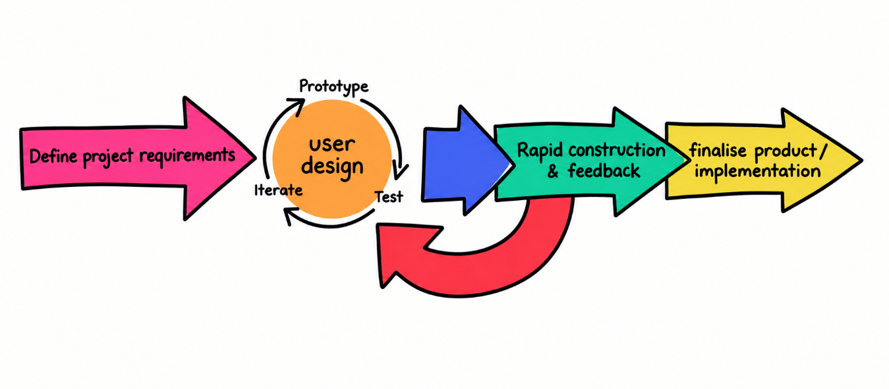
Figure 1: Research Method and Design (Rapid Application Development)
Figure 1 shows the method used in this study is the Rapid Application Development (RAD) Methodology. The RAD methodology is a software development approach that emphasizes iterative development and rapid prototyping over strict planning, allowing for continuous user involvement and progressive refinement throughout the process. The RAD methodology, as applied in this study, comprises four sequential yet iterative phases: Requirements Planning, User Design, Rapid Construction, and Cutover, with each phase producing specific outputs and using designated diagrams to document and communicate the system's structure and behavior.

The proponents began with the requirements planning phase, where the primary goal was to identify and document the operational challenges at Triple J Fitness Center and to establish the functional and non-functional requirements of the proposed system. The researchers conducted structured interviews with the center's management, trainers, and members, conducted direct observations of existing tracking and administrative practices, and reviewed available fitness records and membership documentation. This phase directly addressed the problems identified by the study and served as the foundation for the system's three-role design involving Admin, Member, and Trainer.

3.2 CONCEPTUAL FRAMEWORK
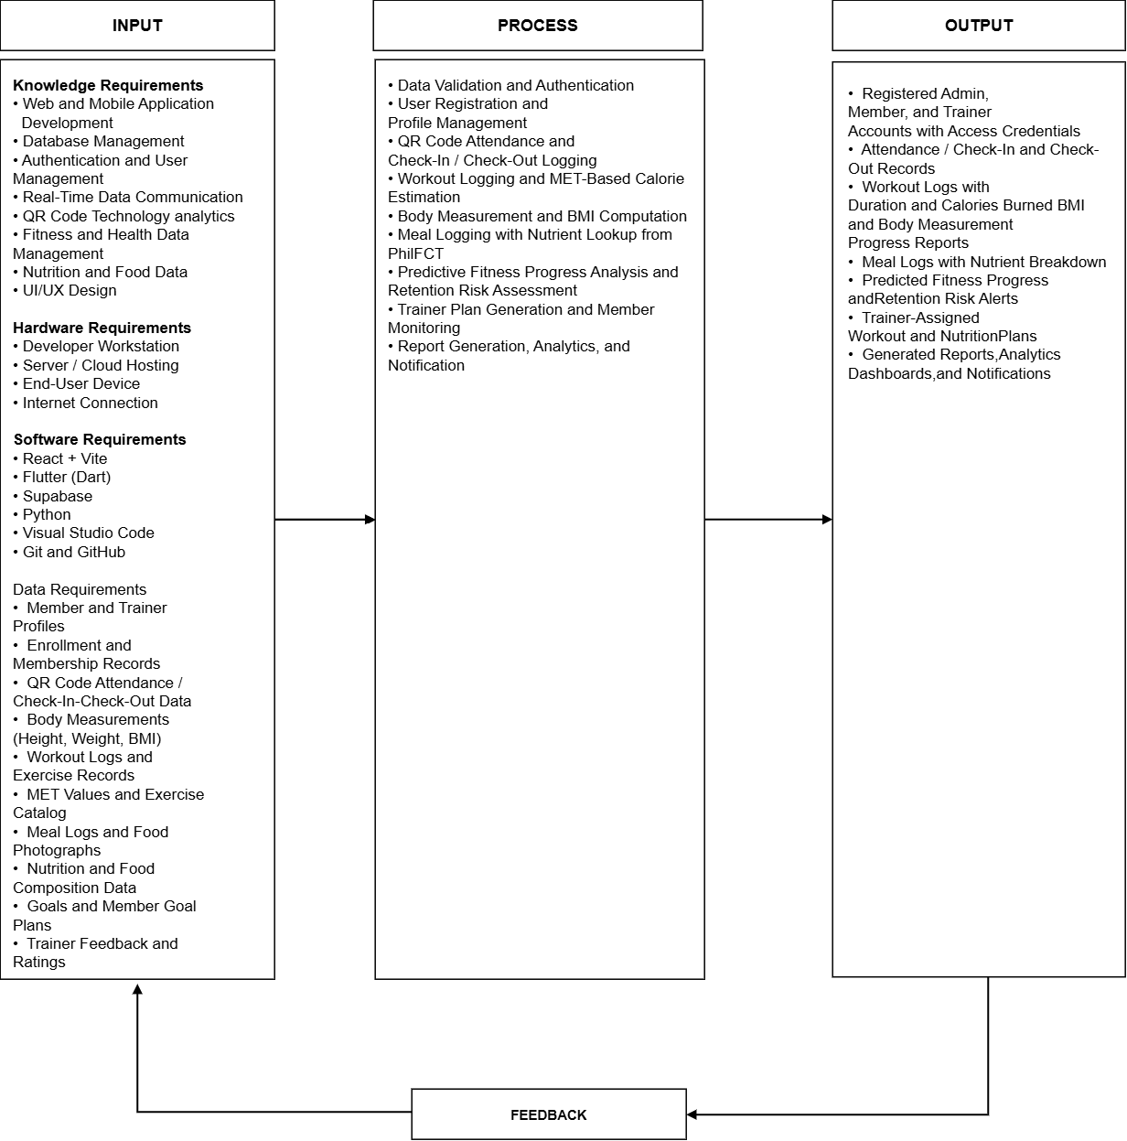

Figure 2: Conceptual Framework of the Proposed System
Figure 2 presents the conceptual framework of the proposed Intelligent Fitness Progress Monitoring Application Using Predictive Analytics following the Input-Process-Output (IPO) model.
The Input phase consists of the user credentials and profiles, gym enrollment and membership plans, QR code check-in and check-out timestamps, workout logs with exercise type and duration, body measurements including body weight and height, meal details with food name and meal type, optional meal photographs, portion size in grams, fitness goal preferences, trainer-assigned workout and nutrition plans, trainer feedback and ratings, in-app chat messages, system notifications, and the DOST-FNRI PhilFCT food composition reference database.

The Process phase encompasses user authentication and role-based authorization, enrollment and membership management, QR-based attendance tracking, workout logging with MET-based calorie burn estimation, body measurement recording and BMI computation, meal logging with PhilFCT nutrient lookup by portion weight, predictive fitness progress analysis using date-weighted ordinary least squares linear regression, member retention risk assessment based on attendance velocity, member goal setting, trainer 7-day food and exercise plan creation, plan completion monitoring, trainer feedback and rating handling, real-time messaging, notification dispatch, and administrative analytics and audit logging.

The Output phase delivers role-based dashboards for member, trainer, and admin, QR attendance verification records, computed calorie burn summaries, BMI status records, meal logs with complete nutrient breakdowns, 30-day weight progress forecasts with statistical confidence, retention risk indicators, member goal records, customized 7-day trainer plans, plan completion progress indicators, trainer feedback records, delivered notifications, and administrative summary reports.

3.3 HARDWARE AND SOFTWARE REQUIREMENTS
Table 1: Hardware Requirements
Component | Minimum Requirements | Recommended Requirements
Processor (CPU) | Intel Core i5 or AMD Ryzen 5 | Intel Core i7 or AMD Ryzen 7
RAM | 8 GB | 16 GB
Storage (Primary) | 256 GB SSD | 512 GB SSD
Backup Storage | 500 GB External HDD or Cloud Storage | 1TB External Storage or Automated Cloud Backup
Display | 19” LED Monitor | 24” IPS Monitor
Internet Connection | 10 Mbps Stable Connection | 50+ Mbps Fiber Connection
Camera | Functional built-in or external camera | 1080p HD Camera
Mobile Device | Android 7.0, quad-core 1.4  GHz, 2 GB RAM, 200MB, 5.0" 720×1280 display | Android 10+, octa-core 1.8 GHz+, 4GB RAM, 500MB, 6.0" 1080×2340 display, HD camera
Wired Networking | Ethernet LAN (RJ45) & Router

Table 1 shows the hardware requirements needed to support the development and operation of the Intelligent Fitness Progress Monitoring Application. The minimum requirements provide the necessary specifications for basic development, testing, and system access, while the recommended requirements provide better performance and smoother operation. Components such as the processor and RAM support application development, data processing, and predictive analytics tasks, while SSD storage provides faster system loading and data access. Backup storage helps protect important project and system data, while a stable internet connection ensures reliable access to the cloud-based application and real-time synchronization. Wired and wireless networking allow the mobile application to communicate with the cloud database and the AI service during attendance logging and food image submission. A server or cloud hosting instance is required to run the database and the AI service that performs food recognition and predictive analysis. The camera is necessary for QR code scanning and for capturing food photos used by the AI food recommendation feature. End-user smartphones or tablets allow Members and Trainers to access the mobile application, while the Admin accesses the web-based dashboard through a computer with a display monitor. Overall, these hardware requirements provide the necessary resources for the reliable development, deployment, and use of the proposed system.

Table 2: Software Requirements
Software | Purpose
React + Vite | Used to develop the web-based Admin interface and provide a fast development environment for the administrative dashboard
Tailwind CSS and Radix UI | Used to build the responsive user interface and reusable components of the Admin dashboard
Recharts | Used to generate the charts and analytics visualizations displayed in the Admin dashboard
Node.js and Express | Used as the runtime environment for the Admin application and as the server that handles notification and broadcast requests
Flutter (Dart) | Used to develop the Member and Trainer applications and provide a responsive cross-platform user interface
Mobile scanner, Camera, and Image picker | Used to implement QR code scanning for attendance and to capture food photographs for AI-based recognition
Riverpod and go_router | Used for state management and navigation within the Member and Trainer applications
Supabase | Used as the backend platform for database management, authentication, data storage, and real-time data synchronization
Python | Used for data processing, predictive analytics, machine learning, and AI-related system functions
Google Gemini API (google-generativeai) | Used as the AI engine for image-based food recognition and for generating food and goal recommendations
Visual Studio Code | Used by the proponents for writing, editing, debugging, and managing the application's source code
Operating System | Windows 10 or 11 (64-bit) for development; Android 8.0 or iOS 12 and higher for end-user mobile devices
scikit-learn | Used to train and run the machine learning models for predictive fitness progress analysis and retention risk assessment
Git and GitHub | Used for version control, source code management, collaboration, and tracking changes throughout the development process

Table 2 shows the software requirements needed for the development and operation of the proposed Intelligent Fitness Progress Monitoring Application. React + Vite is used to develop the web-based Admin interface, supported by Tailwind CSS and Radix UI for its user interface components and Recharts for its charts and analytics visualizations, while Node.js and Express serve as the runtime and backend server for the Admin application. Flutter (Dart) is used to develop the Member and Trainer applications, with Riverpod and go_router providing state management and navigation, and Mobile scanner, camera, and Image picker enabling QR code scanning and the capture of food photographs. Supabase serves as the backend platform for database management, authentication, data storage, row-level security, and real-time data synchronization. Python is used for data processing, machine learning, and AI-related functions of the system, scikit-learn is used to train and run the machine learning models for predictive fitness progress analysis and retention risk assessment, while the Google Gemini API is used for image-based food recognition and for generating food and goal recommendations. Visual Studio Code is used for writing, editing, debugging, and managing the source code, while Git and GitHub support version control, collaboration, and tracking of changes throughout the development process. Overall, these software requirements provide the necessary tools and technologies for developing, managing, and operating the proposed system.
3.4 CONTEXT DIAGRAM
EXISTING

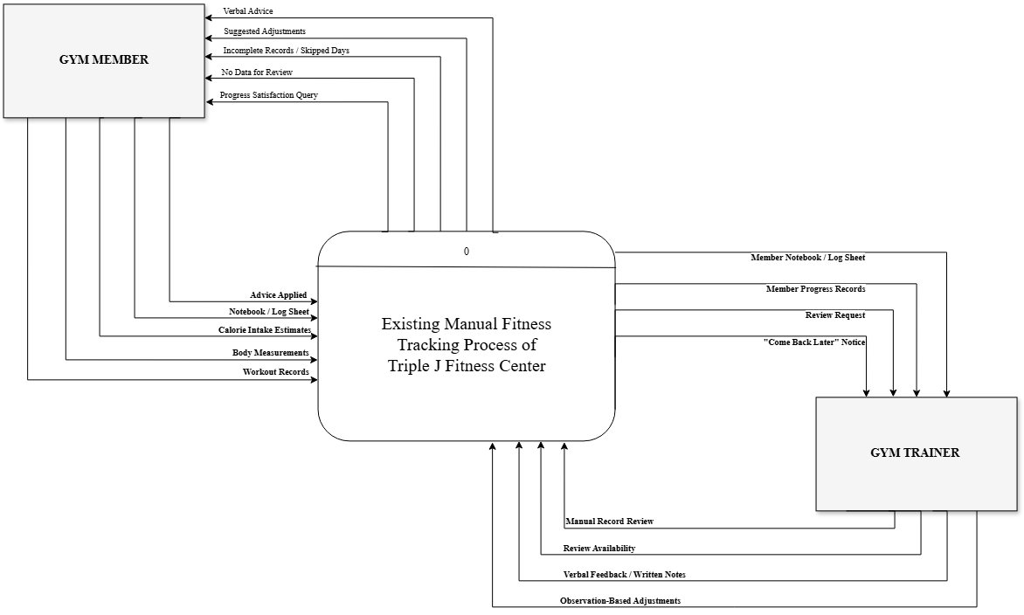

Figure 3: Context Diagram of Existing System

Figure 3 presents the context diagram of the existing system, which shows the manual fitness tracking process currently being practiced at Triple J Fitness Center. The entire manual process is represented by a single process, labeled 0, and it exchanges data with two external entities: the Gym Member and the Gym Trainer or Staff. Unlike the proposed system, the existing process does not involve any automated database, software application, or third-party service, since all records are kept manually in notebooks, spreadsheets, and log sheets.

The Gym Member provides the system with workout records containing the exercise name, sets, and repetitions, as well as body weight and body measurements obtained manually using a weighing scale and tape measure. The member also attempts to calculate calorie intake using online tools or estimates, maintains a notebook or log sheet, and later reports whether the verbal advice given was actually applied. In return, the existing system gives the member verbal advice from the trainer, informal suggested adjustments based on the trainer's observation, a notice that the records are incomplete or that days were skipped, a notice that no data is available for review, and a question regarding whether the member is satisfied with the progress achieved. Because the process depends entirely on manual recording and personal observation, the member is unable to verify whether the progress being made is accurate, which often results in the member abandoning tracking altogether.

The Gym Trainer or Staff provides the system with a manual review of the member's records, an indication of whether the trainer has time to perform the review, verbal feedback or written notes, and adjustments based on personal observation rather than measured data. In return, the existing system provides the trainer with the member's notebook or log sheet, the member's progress records which are frequently incomplete, the request for review, and a notice that the member should come back later when the trainer is unavailable.

Overall, the context diagram of the existing system shows that the current practice relies entirely on manual records and informal communication between the member and the trainer. There is no formal monitoring, no automated computation, and no data-driven basis for the advice provided, which are the limitations that the proposed system intends to address.

PROPOSED
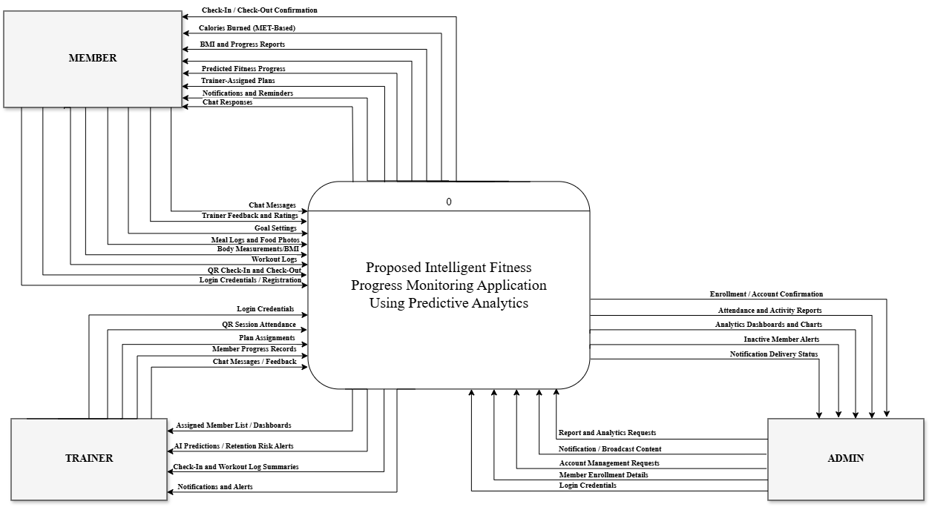
Figure 4: Context Diagram of Proposed System

Figure 4 illustrates the context diagram of the proposed Intelligent Fitness Progress Monitoring Application Using Predictive Analytics. The diagram establishes the system boundary and depicts the information flow between the system and its three external entities: the Member, the Trainer, and the Admin.

The Member provides login credentials, profile details, QR check-in and check-out requests, workout log details with optional proof videos, body measurements, meal log entries, optional meal photographs, portion weights, fitness goal selections, trainer ratings, and chat messages. In response, the system provides attendance confirmations, MET-based calories burned, BMI tracking reports, nutrient breakdowns for logged meals, predicted fitness progress trajectories, trainer-assigned plans, daily plan completion status, trainer feedback, notifications, and chat responses.

The Trainer supplies login credentials, profile updates, member body measurements recorded during evaluations, 7-day food and exercise plan assignments, written feedback, and chat messages. In return, the system supplies the assigned member list, member workout and nutrition logs, attendance recency summaries, predictive progress forecasts, member retention risk alerts, plan completion tracking reports, notifications, and chat messages.

The Admin inputs credentials, member and trainer account creations, membership configurations, trainer-to-member assignments, and PhilFCT food catalog maintenance updates. The system provides system-wide attendance records, enrollment summaries, inactive member lists, predictive analytics summaries, and administrative audit logs.

3.5 DATA FLOW DIAGRAM
EXISTING
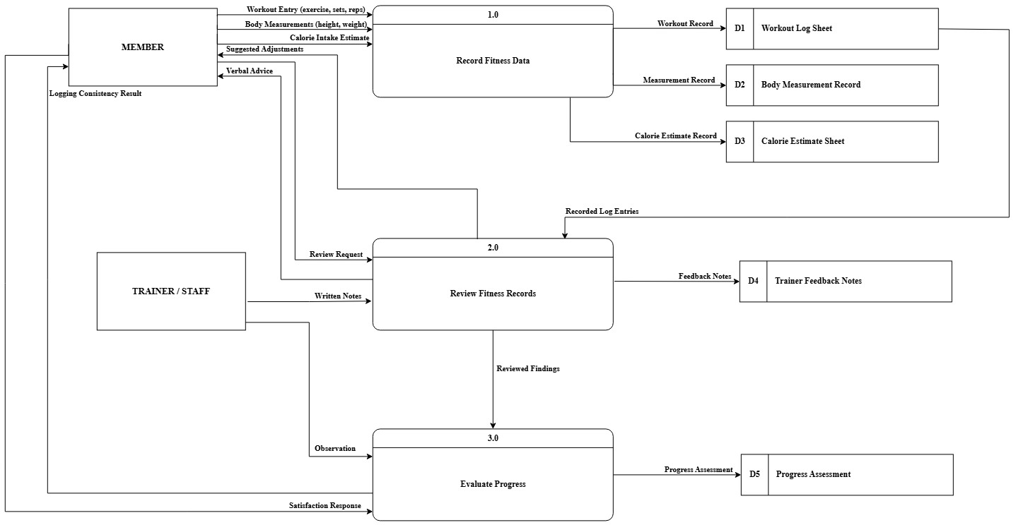
Figure 5: Data Flow Diagram of Existing System

Figure 5 presents the data flow diagram of the existing system of Triple J Fitness Center. The existing system is composed of three processes, namely 1.0 Record Fitness Data, 2.0 Review Fitness Records, and 3.0 Evaluate Progress, and it exchanges data with two external entities: the Member and the Gym Trainer or Staff. All data in the existing system are stored manually in the Workout Log Sheet, the Body Measurement Record, the Calorie Estimate Sheet, the Trainer Feedback Notes, and the Progress Assessment.

In the first process, the Member supplies the system with a workout entry containing the exercise name, the number of sets, and the number of repetitions, together with body measurements obtained manually using a weighing scale and tape measure, and a calorie intake estimate taken from online tools or personal estimation. The system records these into the Workout Log Sheet, the Body Measurement Record, and the Calorie Estimate Sheet.

In the second process, the recorded log entries are retrieved and submitted to the trainer together with the review request of the member. The Gym Trainer or Staff provides written notes, and the system produces feedback notes and returns verbal advice and suggested adjustments to the member.

In the third process, the reviewed findings are evaluated against the member's weekly logging consistency and satisfaction response. The system produces a progress assessment and returns the logging consistency result to the member. Because the entire process depends on manual recording and personal observation, the resulting assessment has no data-driven basis, which is the limitation that the proposed system addresses.

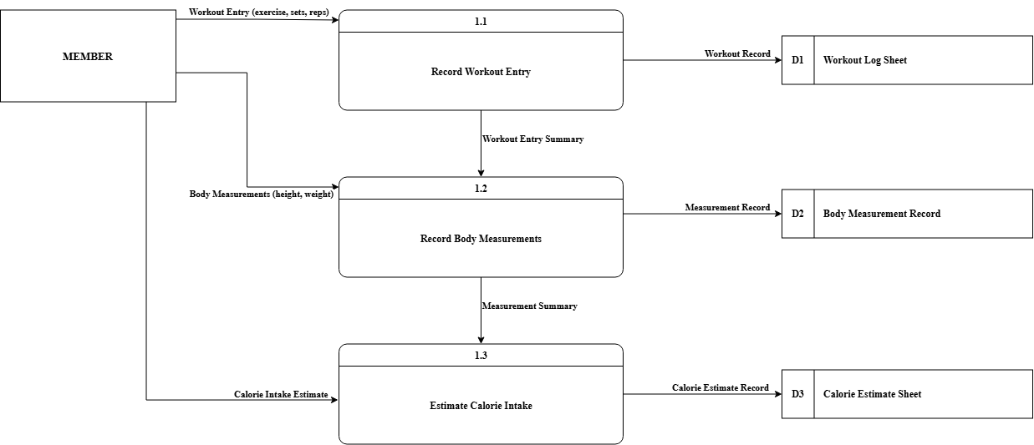
Figure 6: Data Flow Diagram of Process 1 (Existing)

Figure 6 represents the data flow diagram of process 1 of the existing system of Triple J Fitness Center. This diagram decomposes the Record Fitness Data process into three sub-processes: 1.1 Record Workout Entry, 1.2 Record Body Measurements, and 1.3 Estimate Calorie Intake.

In sub-process 1.1, the Member provides a workout entry containing the exercise name, the number of sets, and the number of repetitions, which is written into the Workout Log Sheet. The resulting workout entry summary is passed to sub-process 1.2, where the Member records body measurements such as weight and height taken manually with a weighing scale and tape measure. These are written into the Body Measurement Record and the resulting measurement summary is passed to sub-process 1.3.

In sub-process 1.3, the Member attempts to calculate calorie intake using online tools or personal estimation, and the resulting value is written into the Calorie Estimate Sheet. Because all three sub-processes are performed by hand, the records they produce are prone to missing days and inaccurate values, which frequently leaves no data available for review by the trainer.

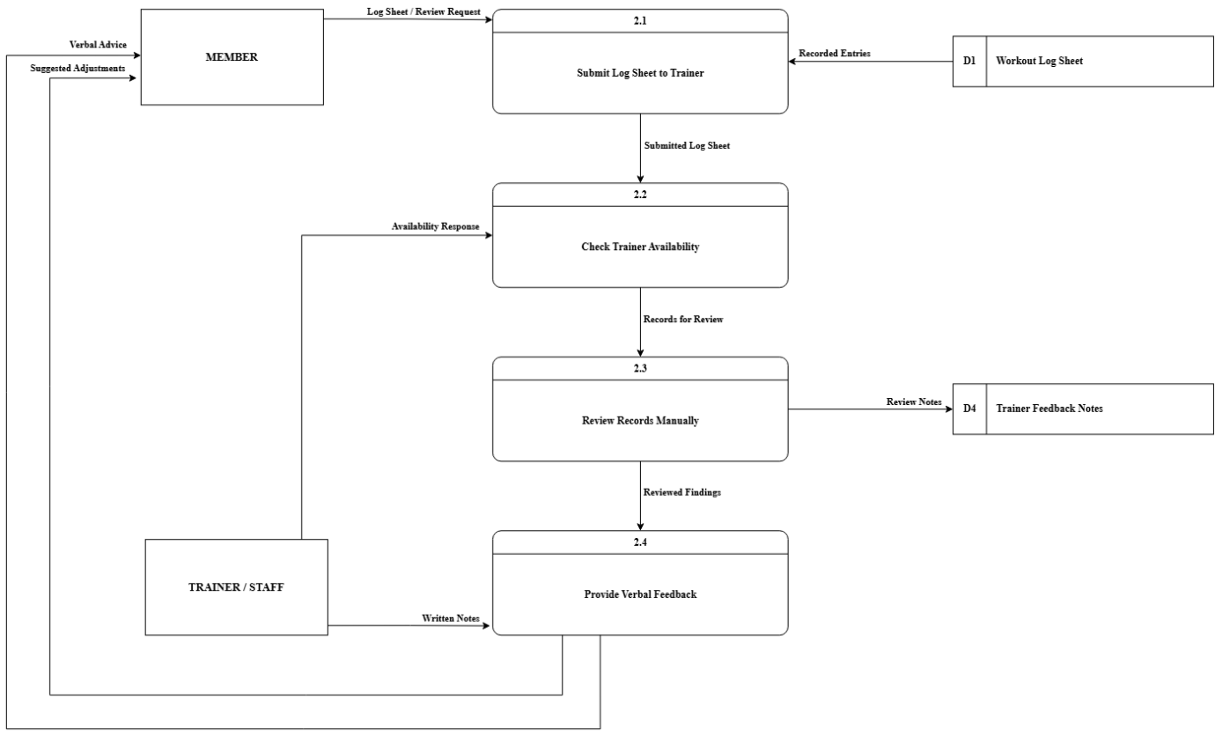
Figure 7: Data Flow Diagram of Process 2 (Existing)

Figure 7 represents the data flow diagram of process 2 of the existing system of Triple J Fitness Center. This diagram decomposes the Review Fitness Records process into four sub-processes: 2.1 Submit Log Sheet to Trainer, 2.2 Check Trainer Availability, 2.3 Review Records Manually, and 2.4 Provide Verbal Feedback.

In sub-process 2.1, the Member submits the log sheet together with a review request, while the recorded entries are retrieved from the Workout Log Sheet. The submitted log sheet is passed to sub-process 2.2, where the system determines whether the Gym Trainer or Staff has time to perform the review, based on the availability response of the trainer. If the trainer is unavailable, the member waits or comes back later.

Once the trainer is available, the records for review are passed to sub-process 2.3, where the Gym Trainer or Staff reviews the records manually and the resulting review notes are written into the Trainer Feedback Notes. The reviewed findings are then passed to sub-process 2.4, where the trainer's written notes are converted into verbal advice and suggested adjustments, which are returned to the Member.

Because the review depends entirely on the trainer's availability and personal judgement, the advice produced is not data-driven, and the member cannot verify whether the progress being made is accurate.

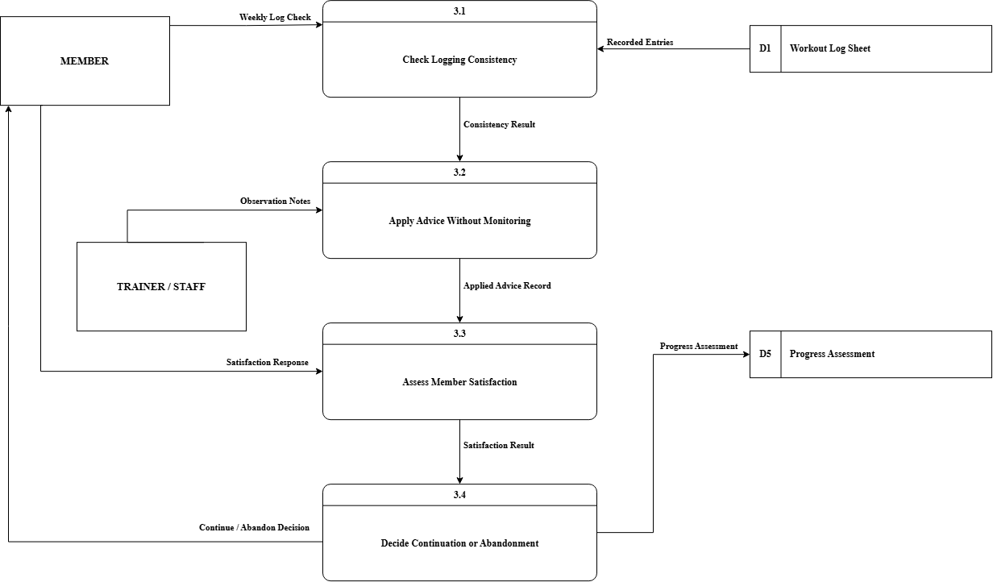
Figure 8: Data Flow Diagram of Process 3 (Existing)

Figure 8 represents the data flow diagram of process 3 of the existing system of Triple J Fitness Center. This diagram decomposes the Evaluate Progress process into four sub-processes: 3.1 Check Logging Consistency, 3.2 Apply Advice Without Monitoring, 3.3 Assess Member Satisfaction, and 3.4 Decide Continuation or Abandonment.

In sub-process 3.1, the Member's weekly log check is compared against the recorded entrie retrieved from the Workout Log Sheet, producing a consistency result. This result is passed to sub-process 3.2, where the Member applies the advice previously received from the trainer without any formal monitoring, supported only by the observation notes of the Gym Trainer or Staff. The applied advice record is passed to sub-process 3.3.

In sub-process 3.3, the Member provides a satisfaction response, which is evaluated against the applied advice record to produce a satisfaction result. This result is passed to sub-process 3.4, where the decision to continue or abandon tracking is made and the progress assessment is written into the Progress Assessment.

Because the evaluation has no measurable baseline, the decision is based on the member's feeling rather than on recorded data. When the member is not satisfied, the outcome of the existing process is that the member abandons tracking altogether.

PROPOSED
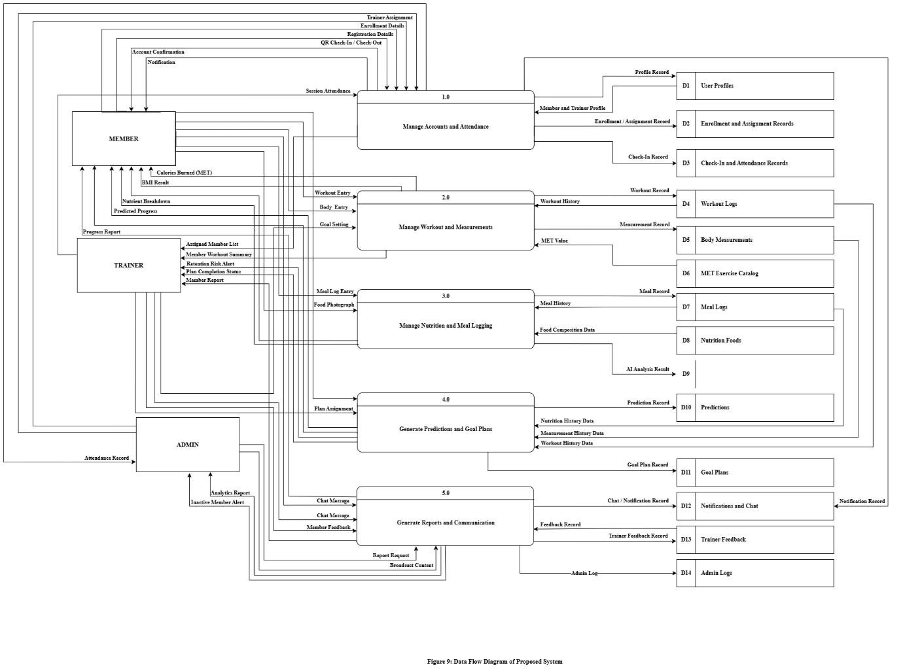
Figure 9: Data Flow Diagram of Proposed System

Figure 9 presents the overall data flow diagram (Level 0) of the proposed Intelligent Fitness Progress Monitoring Application Using Predictive Analytics. The proposed system is structured into five core processes: 1.0 Manage Accounts and Attendance, 2.0 Manage Workout and Measurements, 3.0 Manage Nutrition and Meal Logging, 4.0 Generate Predictions and Goal Plans, and 5.0 Generate Reports and Communication. The system interacts with three external entities: the Member, the Trainer, and the Admin.

In process 1.0, the Admin manages account enrollments and trainer assignments, while the Member performs account registration and QR code check-in and check-out. The process maintains data in D1 User Profiles, D2 Enrollment and Assignment Records, and D3 Check-In and Attendance Records.

In process 2.0, the Member logs workout activities and body measurements, while the Trainer records evaluation measurements. The process updates D4 Workout Logs and D5 Body Measurements, providing MET-based energy expenditure and BMI reports back to the users.

In process 3.0, the Member submits meal entries, portion weights, and optional meal photographs. Nutrient breakdowns are computed by querying D8 Nutrition Foods (PhilFCT catalog) and stored in D7 Meal Logs.

In process 4.0, historical workout data from D4, measurement records from D5, and meal logs from D7 are processed to compute trend analytics. Progress forecasts are stored in D10 Predictions and returned to the Member, while attendance velocity data produce retention risk alerts for the Trainer. Members set their goals, and Trainers create 7-day customized plans, all stored and monitored in D11 Goal Plans.

In process 5.0, communication channels between Members and Trainers are managed through D12 Chat and Feedback Records, while administrative operational reports and audit logs are recorded in D13 Admin and Audit Logs.

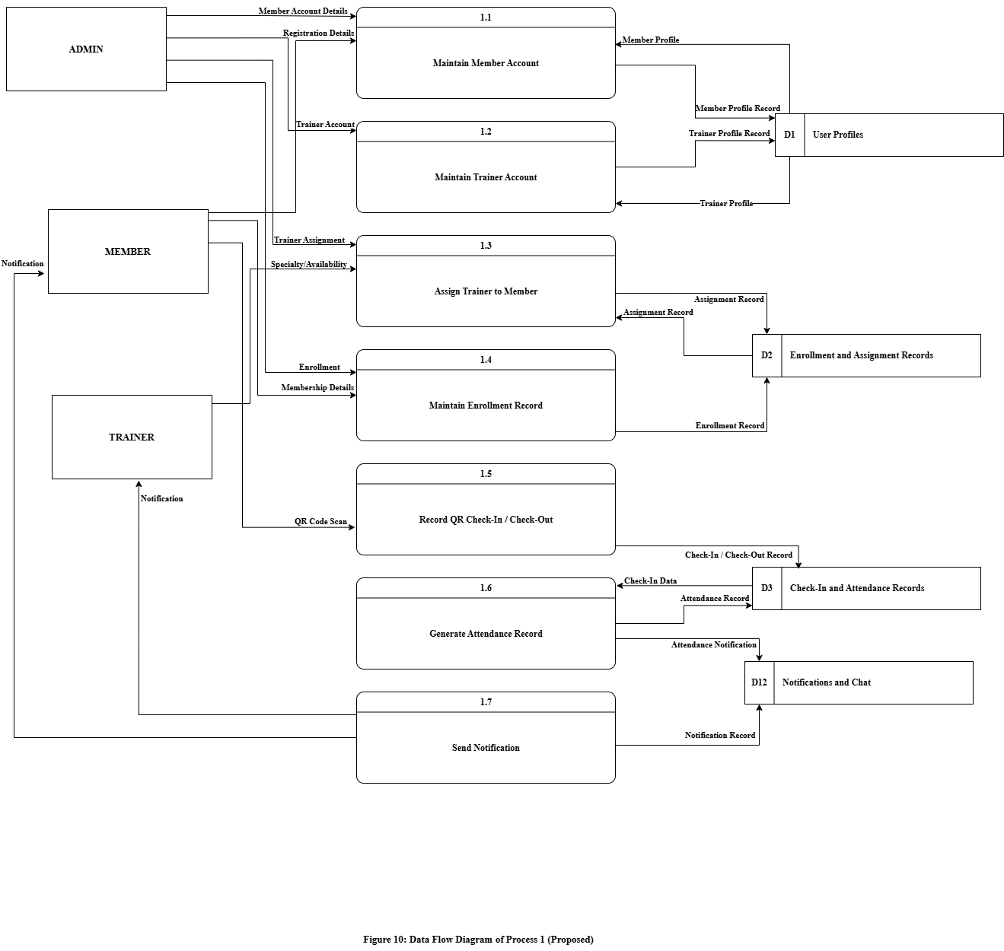
Figure 10: Data Flow Diagram of Process 1 (Proposed)

Figure 10 represents the data flow diagram of process 1 of the proposed system. This diagram decomposes the Manage Accounts and Attendance process into seven sub-processes:1.1 Maintain Member Account, 1.2 Maintain Trainer Account, 1.3 Assign Trainer to Member,1.4 Maintain Enrollment Record, 1.5 Record QR Check-In / Check-Out, 1.6 Generate Attendance Record, and 1.7 Send Notification.

In sub-process 1.1, the Admin provides the member account details while the Member provides the registration details. The process writes the member profile record into the User Profiles and returns the member profile for verification. In sub-process 1.2, the Admin provides the trainer account details, which are written into the User Profiles.

In sub-process 1.3, the Admin provides the trainer assignment while the Trainer provides the specialty and availability. The assignment record is written into the Enrollment and Assignment Records. In sub-process 1.4, the Admin provides the enrollment details and the Member provides the membership details, which are written into the same data store.

In sub-process 1.5, the Member provides the QR code scan, which is written into the Check-In and Attendance Records as a check-in and check-out record. In sub-process 1.6, the check-in data are retrieved and the attendance record is generated and stored, together with the attendance notification. In sub-process 1.7, the notification record is written into the Notifications and Chat and returned to the Member and the Trainer.

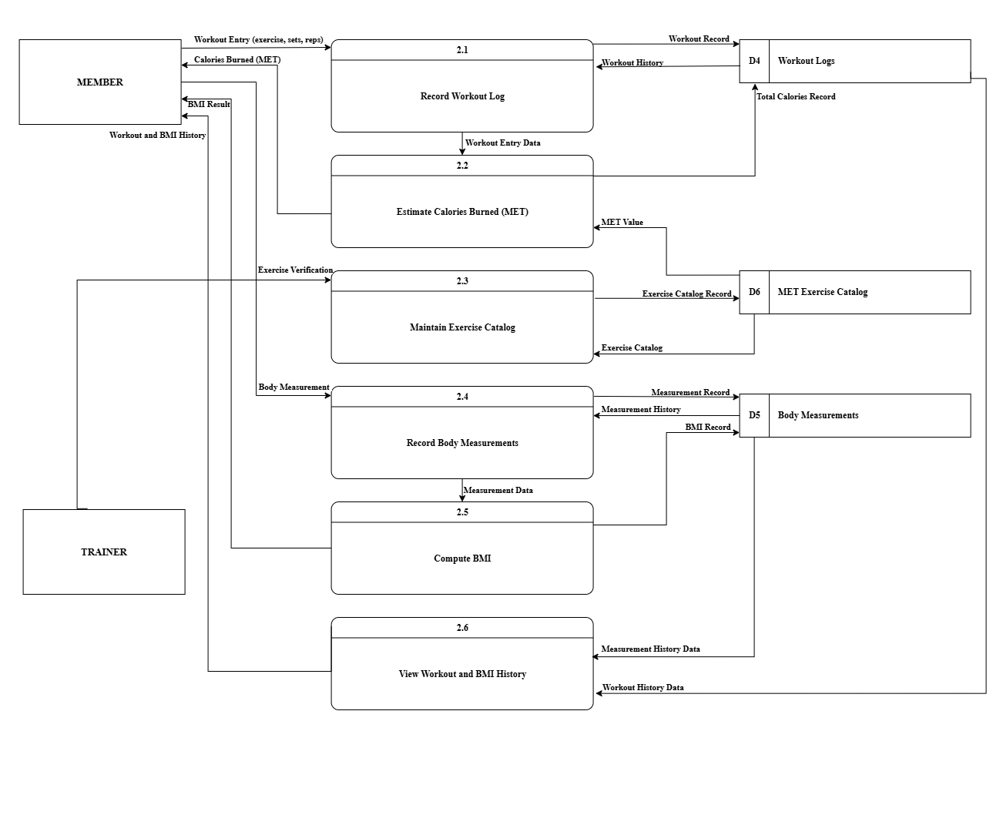
Figure 11: Data Flow Diagram of Process 2 (Proposed)
Figure 11 represents the data flow diagram of process 2 of the proposed system. This diagram decomposes the Manage Workout and Measurements process into six sub-processes: 2.1 Record Workout Log, 2.2 Estimate Calories Burned (MET), 2.3 Maintain Exercise Catalog, 2.4 Record Body Measurements, 2.5 Compute BMI, and 2.6 View Workout and BMI History.

In sub-process 2.1, the Member provides a workout entry containing the exercise name, the number of sets, the number of repetitions, and the duration, which is written into the Workout Logs. The workout entry data are passed to sub-process 2.2, where the MET value is retrieved from the MET Exercise Catalog to compute the calories burned. The computed value is returned to the Member and stored in the Workout Logs as the total calories record.

In sub-process 2.3, the Trainer provides the exercise verification and the exercise catalog record is maintained in the MET Exercise Catalog. In sub-process 2.4, the Member provides the body measurement entry, which is written into the Body Measurements together with the measured date.

The measurement data are passed to sub-process 2.5, where the BMI is computed from the recorded height and weight, returned to the Member, and stored in the Body Measurements. In sub-process 2.6, the workout history data and the measurement history data are retrieved and returned to the Member as the workout and BMI history.

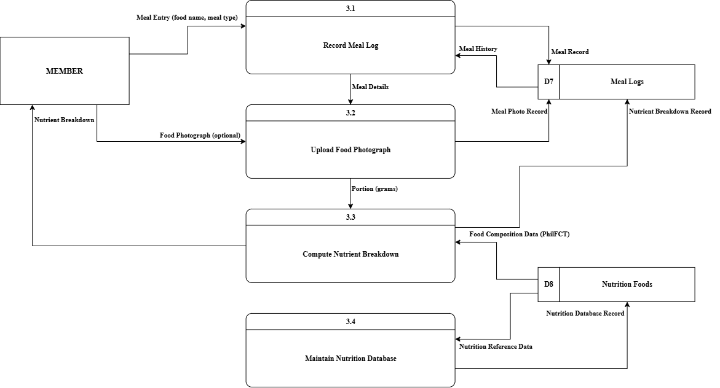
Figure 12: Data Flow Diagram of Process 3 (Proposed)
Figure 12 illustrates the detailed data flow diagram of Process 3.0 (Manage Nutrition and Meal Logging) of the proposed system. This process is decomposed into four operational sub-processes: 3.1 Record Meal Log, 3.2 Upload Food Photograph, 3.3 Compute Nutrient Breakdown, and 3.4 Maintain Nutrition Database.
In sub-process 3.1, the Member inputs initial meal information including the food name and meal type (breakfast, lunch, dinner, or snack), which initializes the record in D7 Meal Logs and retrieves recent meal history for user review.

In sub-process 3.2, the Member may optionally capture or upload a meal photograph. The image is stored as a visual meal photo record in D7 Meal Logs to serve as a verification and historical tracking reference, after which the meal and portion details proceed to nutrient computation.

In sub-process 3.3, the system queries the food item against D8 Nutrition Foods, which houses the DOST-FNRI Philippine Food Composition Tables (PhilFCT). By scaling the reference per-100 gram nutritional values by the portion weight entered by the member, the sub-process calculates total calories, protein, carbohydrates, and fats. The resulting nutrient breakdown record is committed to D7 Meal Logs and displayed directly to the Member.

In sub-process 3.4, authorized nutritional data updates are processed to maintain the integrity of D8 Nutrition Foods, ensuring that portion scaling and nutritional values remain consistent and verified.

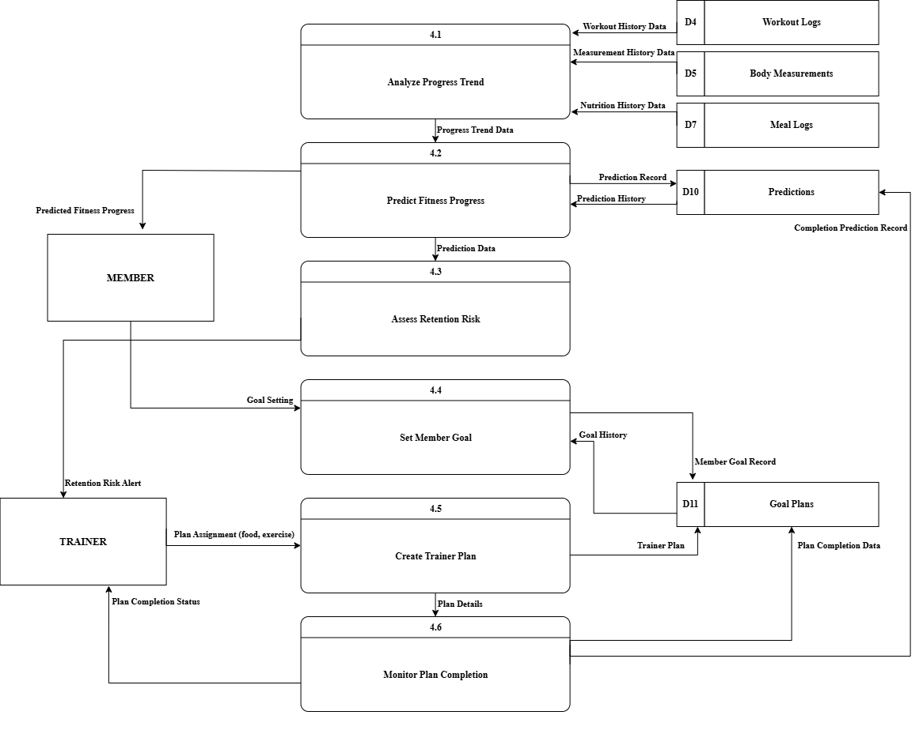
Figure 13: Data Flow Diagram of Process 4 (Proposed)
Figure 13 illustrates the detailed data flow diagram of Process 4.0 (Generate Predictions and Goal Plans) of the proposed system. This process is decomposed into six sub-processes: 4.1 Analyze Progress Trend, 4.2 Predict Fitness Progress, 4.3 Assess Retention Risk, 4.4 Set Member Goal, 4.5 Create Trainer Plan, and 4.6 Monitor Plan Completion.

In sub-process 4.1, workout history from D4 Workout Logs, weigh-in history from D5 Body Measurements, and nutritional consistency data from D7 Meal Logs are aggregated to calculate baseline progress velocities.

In sub-process 4.2, the progress trend data are fed into a date-weighted Ordinary Least Squares (OLS) regression algorithm to generate a 30-day predicted fitness progress trajectory (projected weight in kilograms). The forecast is stored in D10 Predictions and presented to the Member on their application dashboard.

In sub-process 4.3, member attendance patterns across rolling 4-week periods are evaluated to compute an attendance velocity and recency score. When a member exhibits prolonged absence or significant visit frequency decline, a retention risk alert is delivered to the assigned Trainer.

In sub-process 4.4, the Member establishes or updates their target fitness goal in light of their predicted progress trajectory. The goal specification is recorded in D11 Goal Plans.

In sub-process 4.5, the Trainer reviews the member's goal and historical logs to formulate a customized 7-day food and exercise plan, which is stored in D11 Goal Plans.

In sub-process 4.6, daily member activity logs are matched against the active trainer plan to determine completion percentages. Plan completion indicators are returned to the Trainer, with milestones recorded in D11 Goal Plans and D10 Predictions.
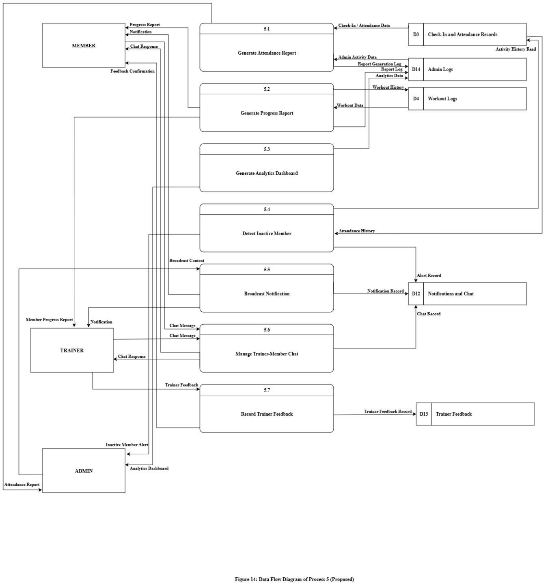
Figure 14: Data Flow Diagram of Process 5 (Proposed)
Figure 14 represents the data flow diagram of process 5 of the proposed system. This diagram decomposes the Generate Reports and Communication process into seven sub-processes: 5.1 Generate Attendance Report, 5.2 Generate Progress Report, 5.3 Generate Analytics Dashboard, 5.4 Detect Inactive Member, 5.5 Broadcast Notification, 5.6 Manage Trainer-Member Chat, and 5.7 Record Trainer Feedback.

In sub-process 5.1, the check-in and attendance data are retrieved from the Check-In and Attendance Records together with the admin activity data from the Admin Logs, and the attendance report is returned to the Admin while the report generation log is written into the Admin Logs.

In sub-process 5.2, the workout data are retrieved from the Workout Logs to generate the progress report, which is returned to the Member and to the Trainer as the member progress report, while the report log is written into the Admin Logs. In sub-process 5.3, the analytics data log is written into the Admin Logs and the analytics dashboard is returned to the Admin.

In sub-process 5.4, the attendance history is retrieved from the Check-In and Attendance Records to identify members who have stopped attending. The inactive member alert is returned to the Admin and the alert record is written into the Notifications and Chat.

In sub-process 5.5, the Admin provides the broadcast content, which is written into the Notifications and Chat and returned to the Member and the Trainer as a notification. In sub-process 5.6, the chat messages of the Member and the Trainer are exchanged, the chat record is written into the Notifications and Chat, and the chat responses are returned to both parties.

In sub-process 5.7, the Trainer provides the trainer feedback content and the Member provides the trainer rating. The trainer feedback record is written into the Trainer Feedback and the feedback confirmation is returned to the Member.

3.6 ACTIVITY DIAGRAM
An activity diagrams are graphical representations of workflows of stepwise activities and actions with support for choice, iteration and concurrency. Activity diagrams may be regarded as a form of flowchart.
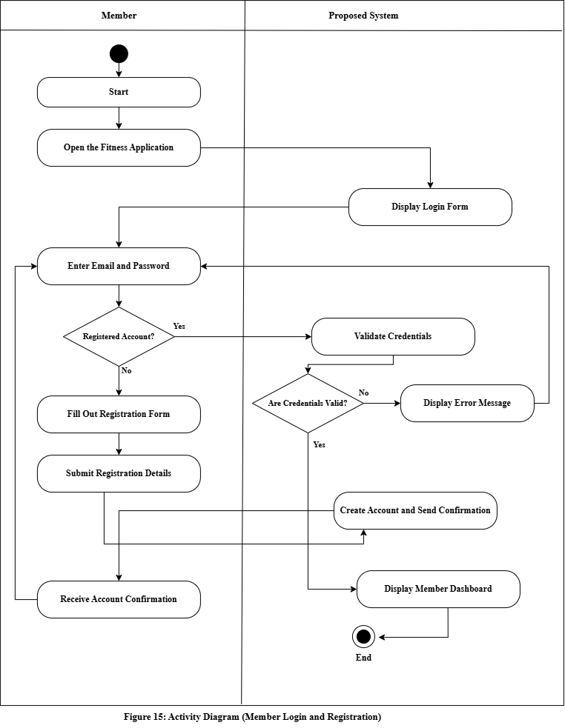
Figure 15: Activity Diagram (Member Login and Registration)
Figure 15 shows the activity diagram of the member login and registration process of the proposed system of Triple J Fitness Center. The process begins when the Member opens the fitness application and enters an email address and a password. The system first determines whether the Member has an existing registered account.
If the Member is not yet registered, the registration form is presented, where the Member fills out the required personal and membership details. The registration details are submitted, the account is created and stored in the User Profiles, and the Member receives an account confirmation before returning to the login step.
If the Member is already registered, the system validates the entered credentials against the stored account records. When the credentials are valid, the system displays the member dashboard and the process ends. When the credentials are invalid, an error message is displayed and the Member is returned to the login step to re-enter the email and password. This automated validation replaces the manual checking of member records in the existing system.

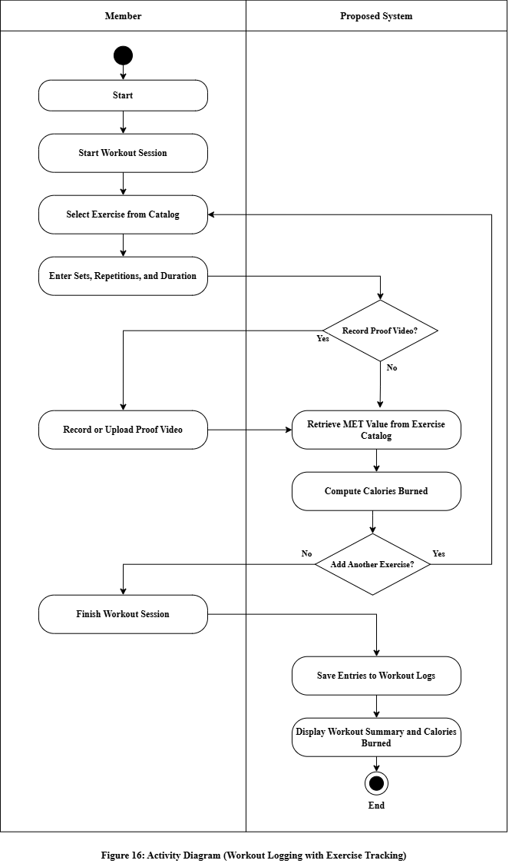
Figure 16: Activity Diagram (Workout Logging with Exercise Tracking)
Figure 16 shows the activity diagram of the workout logging process of the proposed system of Triple J Fitness Center. The process begins when the Member starts a workout session and selects an exercise from the exercise catalog. For each selected exercise, the Member enters the number of sets, the number of repetitions, and the duration of the exercise.

After the exercise details are entered, the system determines whether the Member will record a proof video. If a proof video is recorded, the Member captures or uploads the video before proceeding otherwise, the process continues directly. The system then retrieves the MET value of the selected exercise from the MET Exercise Catalog and computes the calories burned based on the exercise duration and the recorded body weight of the member.

The system then determines whether the Member will add another exercise. If yes, the process returns to the exercise selection step; if no, the Member finishes the session. All recorded entries are saved into the Workout Logs, and the system displays the workout summary together with the total calories burned, which ends the process.

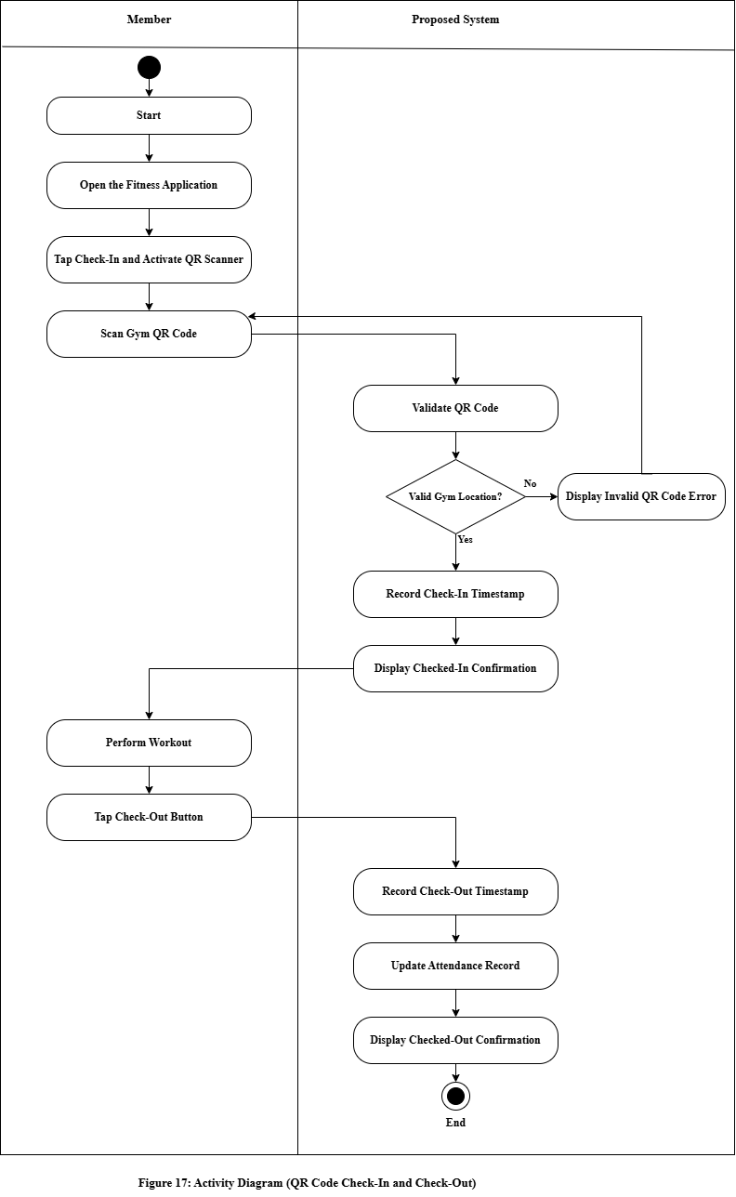
Figure 17: Activity Diagram (QR Code Check-In and Check-Out)
Figure 17 shows the activity diagram of the QR code check-in and check-out process of the proposed system of Triple J Fitness Center. The process begins when the Member opens the application and taps the check-in button, which activates the QR scanner. The Member scans the QR code posted at the gym, and the system validates whether the scanned code corresponds to a recognized gym location.

If the QR code is invalid, an error message is displayed and the Member is returned to the scanning step. If the QR code is valid, the system records the check-in timestamp into the Check-In and Attendance Records, displays a checked-in confirmation, and the Member performs the workout.

After the workout, the Member taps the check-out button. The system records the check-out timestamp, updates the attendance record, and displays a checked-out confirmation, which ends the process. This automated attendance flow replaces the manual log sheets used in the existing system.
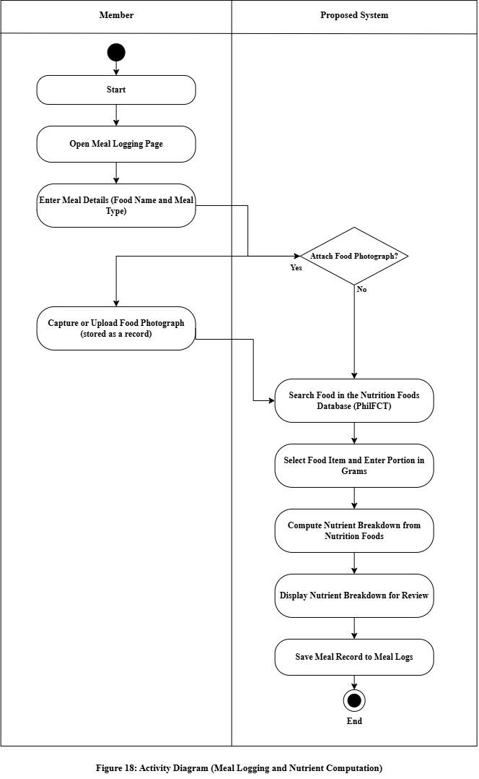
Figure 18: Activity Diagram (Meal Logging and Nutrient Computation)
Figure 18 shows the activity diagram of the meal logging and nutrient computation process of the proposed system for Triple J Fitness Center. The workflow illustrates the interaction between the Member and the Proposed System through a guided multi-step wizard.

The activity begins when the Member navigates to the meal logging screen and inputs the meal details, including the meal name and meal type. The flow reaches a decision point where the Member chooses whether to attach a food photograph.

f the Member elects to attach a photograph, the camera or image gallery is invoked to capture or upload the image, which the system stores as a historical meal photo record. If the Member chooses not to attach a photograph, the photo upload step is bypassed.

In the subsequent step, the Member searches the Nutrition Foods reference database (PhilFCT) for the corresponding food item, selects the matching reference record, and enters the estimated or measured portion size in grams.

The system retrieves the food composition values for the selected item, scales the per-100 gram nutritional profile by the portion entered, and computes the complete nutrient breakdown including calories, protein, carbohydrates, and fats. The computed breakdown is displayed to the Member for review and confirmation. Upon confirmation, the completed meal entry is saved into the Meal Logs, successfully ending the process.

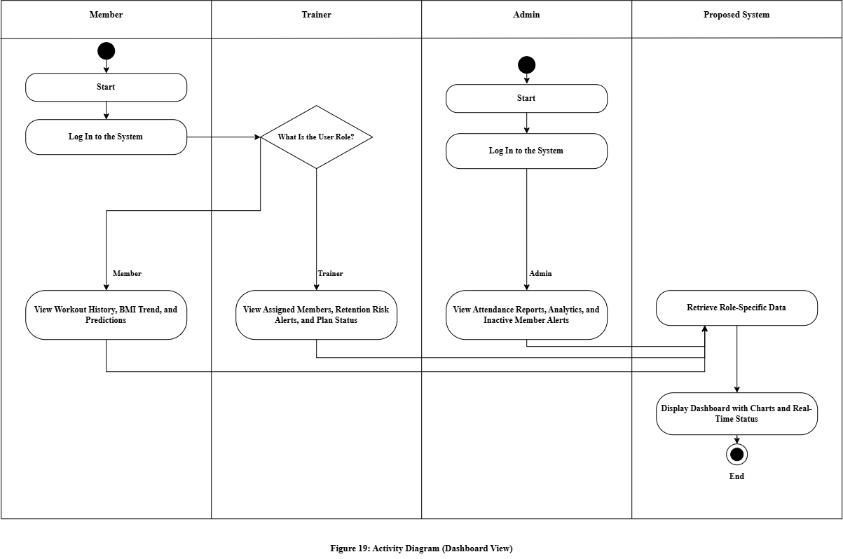
Figure 19: Activity Diagram (Dashboard View)
Figure 19 shows the activity diagram of the dashboard view process of the proposed system of Triple J Fitness Center. The process begins when the user logs in to the system, and the system determines the role of the logged-in user.

When the user is a Member, the dashboard presents the workout history, the BMI trend, and the predicted fitness progress. When the user is a Trainer, the dashboard presents the assigned members, the retention risk alerts, and the plan completion status. When the user is an Admin, the dashboard presents the attendance reports, the analytics summary, and the inactive member alerts.

After the role-specific selections are made, the system retrieves the corresponding data from the Workout Logs, the Body Measurements, the Predictions, the Goal Plans, the Check-In and Attendance Records, and the Admin Logs, and displays the dashboard containing the charts and the real-time status, which ends the process.

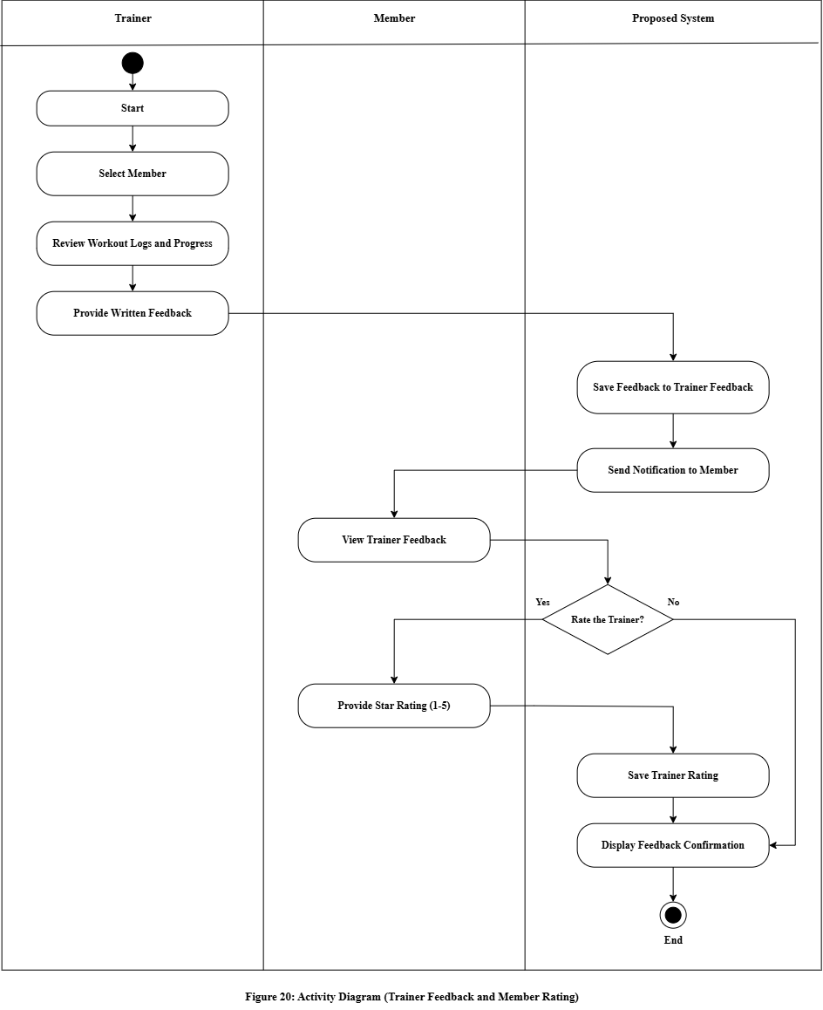
Figure 20: Activity Diagram (Trainer Feedback and Member Rating)

Figure 20 shows the activity diagram of the trainer feedback and member rating process of the proposed system of Triple J Fitness Center. The process begins when the Trainer selects a member and reviews the workout logs and progress of that member. The Trainer provides written feedback, which the system saves into the Trainer Feedback, and the system sends a notification to the Member.

The Member views the feedback and chooses whether to rate the trainer. If the Member provides a star rating from one to five, the system saves the rating; otherwise the process proceeds directly. The system then displays the feedback confirmation to the Member, which ends the process. This closed-loop feedback mechanism replaces the informal verbal advice of the existing system with recorded and rated feedback.

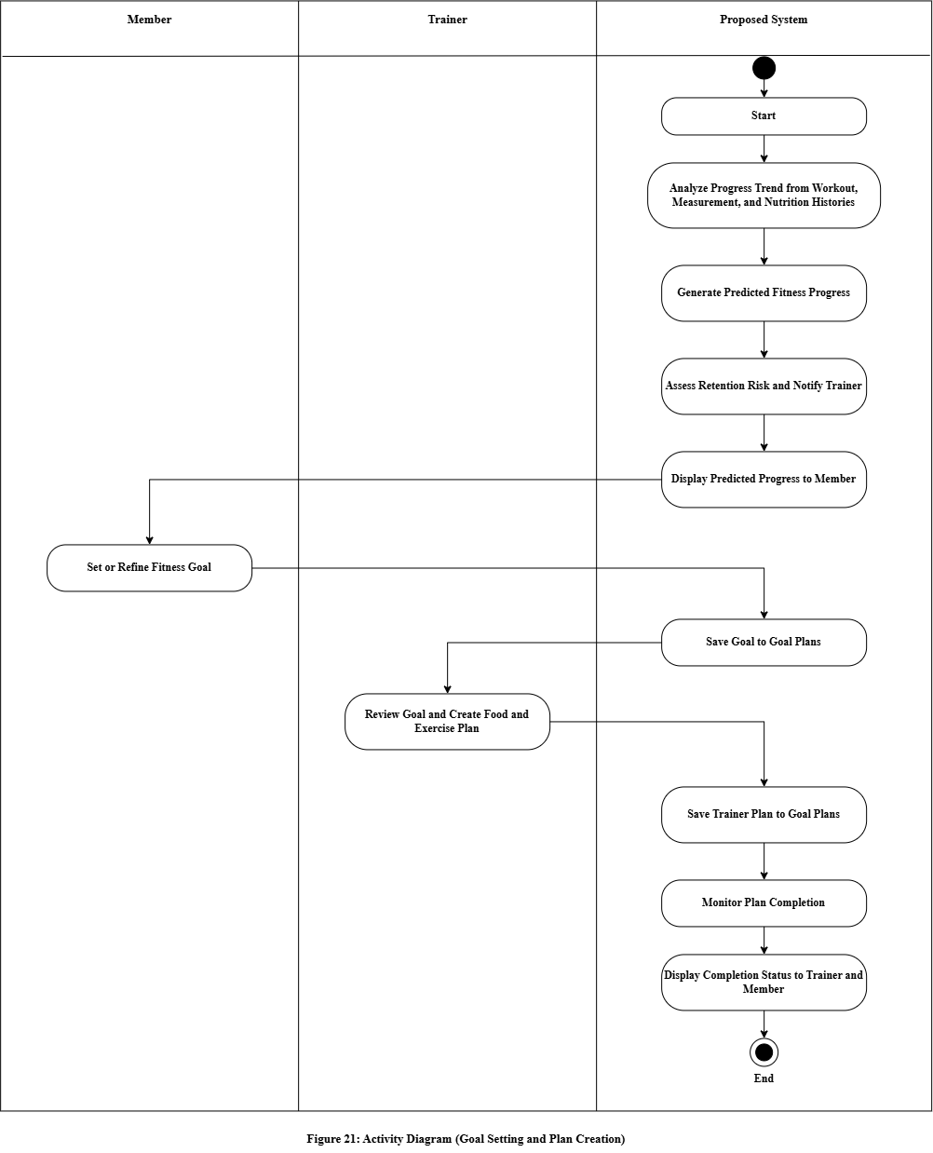

Figure 21: Activity Diagram (Goal Setting and Plan Creation)
Figure 21 illustrates the activity diagram of the goal setting and plan creation process of the proposed system, represented across three swimlanes: Member, Trainer, and Proposed System.

The process initiates when the system extracts the member's historical activity data, including workout logs, body measurements, and nutrition entries. The system computes progress trajectories and generates a 30-day predicted fitness progress forecast using linear regression. Concurrently, the system calculates member attendance recency to assess retention risk, notifying the assigned Trainer if an intervention is warranted.

The generated progress forecast is presented to the Member on their dashboard. Based on their current trajectory and personal milestones, the Member sets or refines their target fitness goal. The system saves the target into the Goal Plans data store.

The assigned Trainer reviews the member's target goal along with their physical assessment records and formulates a structured 7-day food and exercise regimen. The system registers the completed plan in Goal Plans.

As the member executes their daily routine, the system monitors plan completion by cross-referencing logged workouts and meals against the plan targets. The real-time completion status is updated and displayed to both the Trainer and the Member, terminating the activity workflow.

3.7 ENTITY RELATIONSHIP DIAGRAM
An entity–relationship model (ER model) is a data model for describing the data or information aspects of a business domain or its process requirements, in an abstract way that lends itself to ultimately being implemented in a database such as a relational database. The main components of ER models are entities and the relationships that can exist among them, and databases.
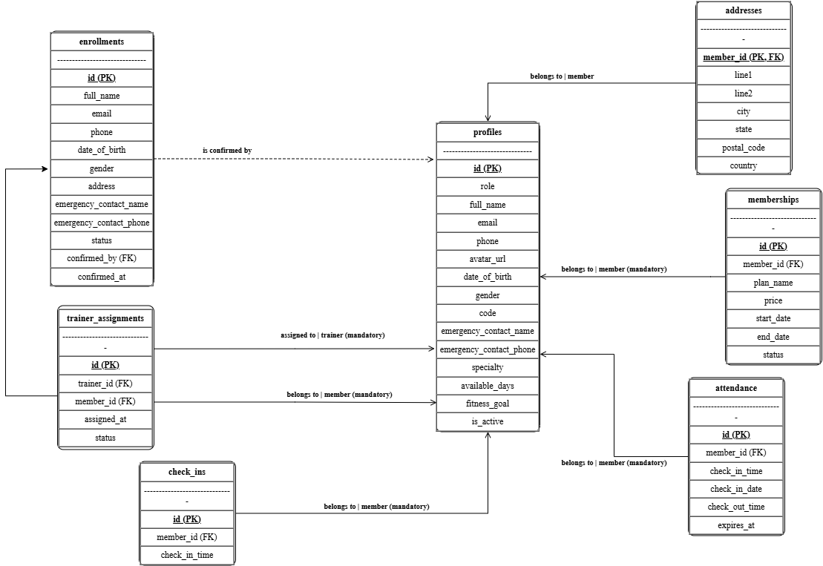
Figure 22: Entity Relationship Diagram (Accounts, Membership and Attendance)

Figure 22 presents the accounts, membership and attendance part of the entity relationship diagram of the proposed system. The profiles entity is the central entity because it stores the account records of the Admin, the Trainer, and the Member. The enrollments entity stores the pending registration details and refers to profiles through the confirmed by foreign key, which is optional because an enrollment is confirmed only after the Admin approves it. The memberships entity stores the plan name, the price, and the validity period of each membership. The trainer assignments entity links each member to an assigned trainer through both the trainer and the member foreign keys, while the attendance and check in entities store the QR code check-in and check-out records, and the addresses entity stores the home address of each member.

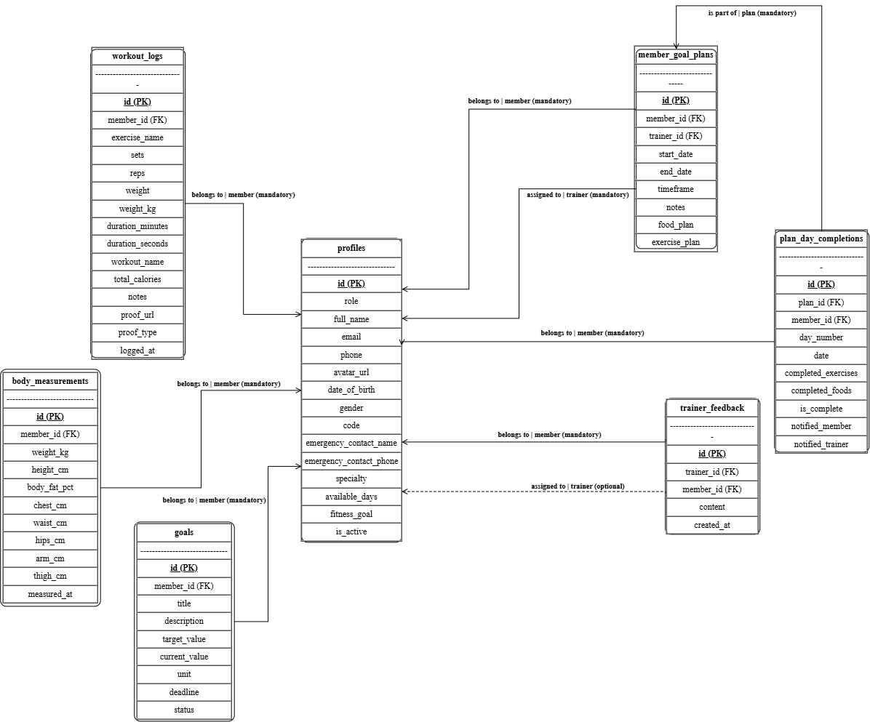
Figure 23: Entity Relationship Diagram (Fitness Tracking, Goals and Trainer Feedback)

Figure 23 presents the fitness tracking, goals, and trainer feedback part of the entity relationship diagram. The workout_logs entity stores each exercise entry together with the sets, the repetitions, the weight, the duration, the proof video, and the computed calories; the body_measurements entity stores the weight, the height, and the body circumference readings; and the goals entity stores the fitness goals set by the member. The member_goal_plans entity stores the seven-day food plan and exercise plan assigned by the trainer, and the plan_day_completions entity records the per-day completion state of each plan, referring both to member_goal_plans through the plan_id foreign key and to profiles through the member_id foreign key. The trainer_feedback entity stores the written feedback of the trainer for each member; its trainer_id foreign key is optional because feedback is written only by trainer accounts.

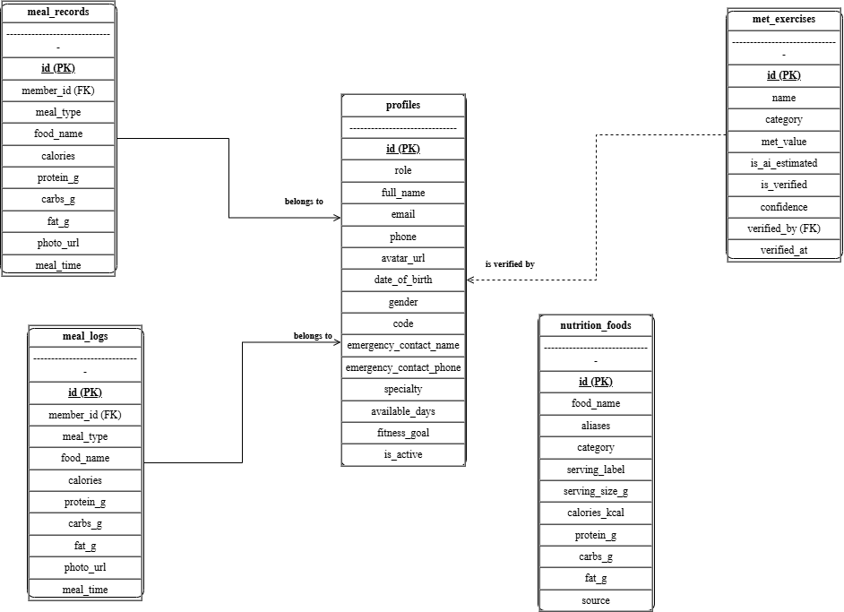
Figure 24: Entity Relationship Diagram (Nutrition, Meal Logging and Reference Data)

Figure 24 presents the nutrition, meal logging, and reference data part of the entity relationship diagram. The meal_records and meal_logs entities store the logged meals and their nutrient values; the food_recommendations entity stores the generated food suggestions; and the food_identification_logs entity stores the AI photo recognition candidates and the member's selected correction. The met_exercises reference entity stores the exercise catalog together with the MET value of each exercise and the optional verifier through the verified_by foreign key. The nutrition_foods reference entity stores the verified Filipino dish composition data taken from the DOST-FNRI reference; it has no foreign key to profiles and is therefore shown as a standalone table in the figure.

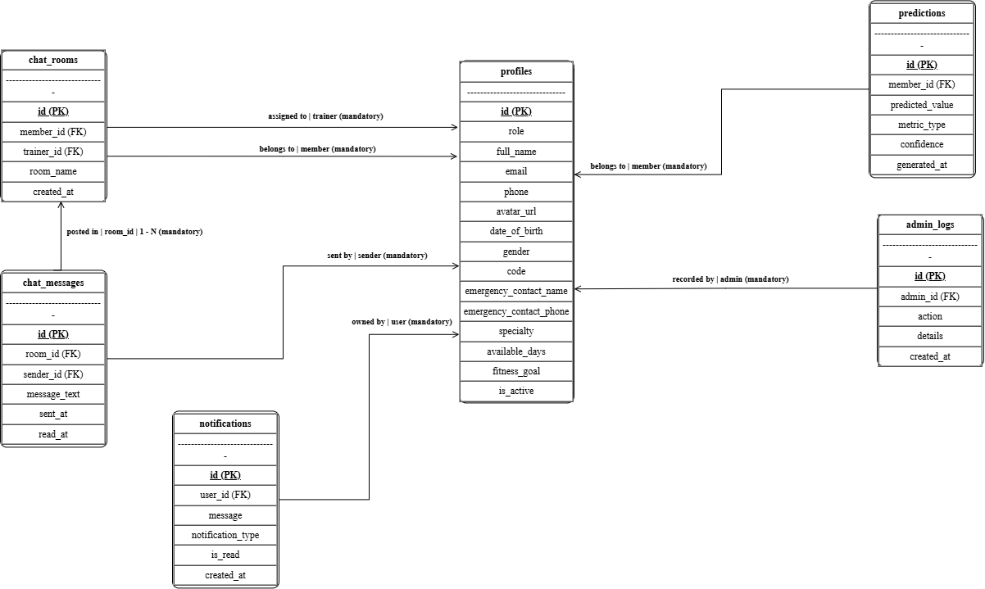

Figure 25: Entity Relationship Diagram (Communication, Notifications and Administration)

Figure 25 presents the communication, notifications, and administration part of the entity relationship diagram. The chat_rooms entity stores each trainer-member conversation room through the member_id and trainer_id foreign keys, while chat_messages stores the messages of each room through room_id and sender_id. The notifications entity stores system alerts, the predictions entity stores generated fitness progress predictions, and the admin_logs entity stores administrator activity through admin_id.

Across Figures 22 to 25, the profiles entity is repeated as the central entity because it stores the account records of the Admin, Trainer, and Member. The three optional relationships are enrollments to profiles through confirmed_by, trainer_feedback to profiles through trainer_id, and met_exercises to profiles through verified_by, while the other relationships are mandatory one-to-many relationships shown with crow's foot notation.

3.8 USE CASE DIAGRAM
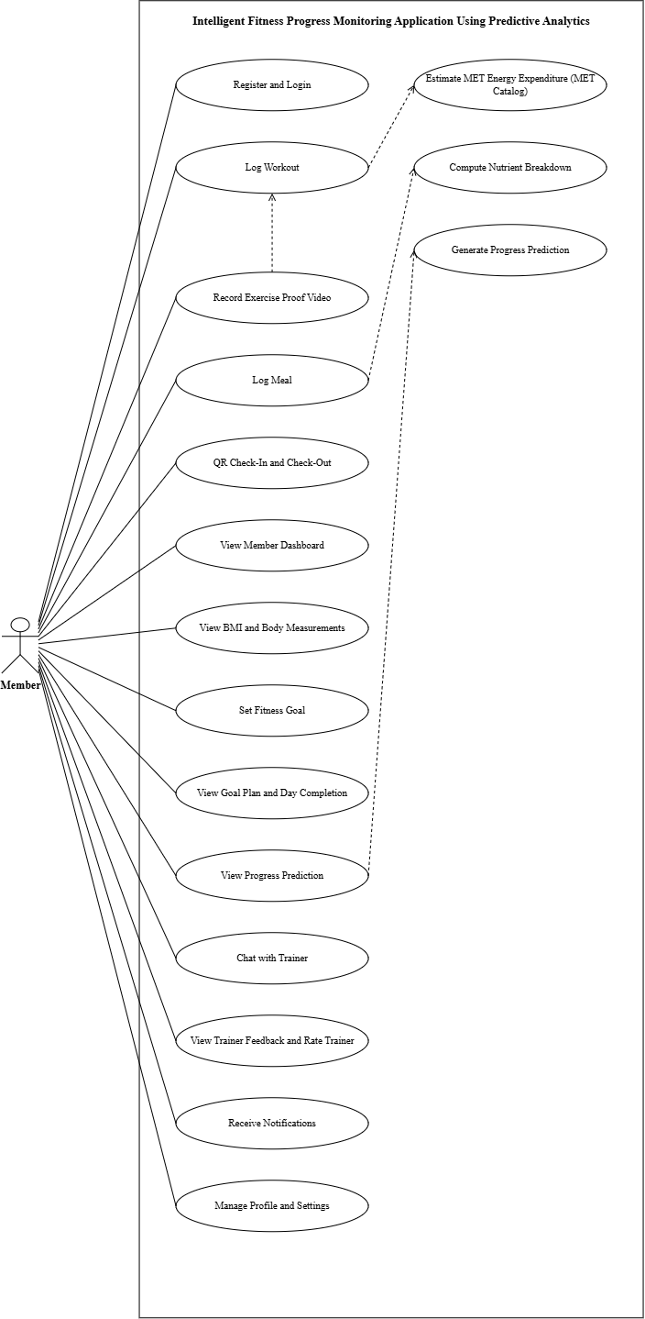
Figure 26: Use Case of the Member Module
Figure 26 depicts the use case diagram of the Member Module in the proposed system of Triple J Fitness Center, illustrating the functional scope accessible to registered gym members.

The Member actor can perform fourteen primary use cases: Register and Login, Log Workout, Record Exercise Proof Video, Log Meal, QR Check-In and Check-Out, View Member Dashboard, View BMI and Body Measurements, Set Fitness Goal, View Goal Plan and Day Completion, View Progress Prediction, Chat with Trainer, View Trainer Feedback and Rate Trainer, Receive Notifications, and Manage Profile and Settings.

The diagram includes three include dependency relationships and one extend relationship that specify backend computations. The Log Meal use case includes Compute Nutrient Breakdown, which queries the PhilFCT reference table and scales nutrient values by portion weight. The Log Workout use case includes Estimate MET Energy Expenditure, which computes calories expended based on MET intensity and body weight. The View Progress Prediction use case includes Generate Progress Prediction, which executes the 30-day weight trajectory regression model. The Record Exercise Proof Video use case extends Log Workout as an optional verification attachment.
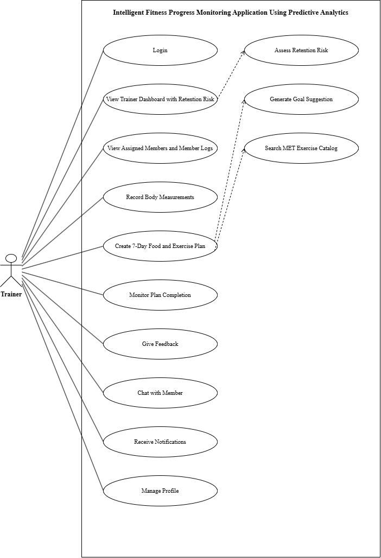
Figure 27: Use Case of the Trainer Module

Figure 27 illustrates the use case diagram of the Trainer Module in the proposed system of Triple J Fitness Center, depicting the capabilities provided to fitness instructors and trainers.

The Trainer actor interacts with ten primary use cases: Login, View Trainer Dashboard with Retention Risk, View Assigned Members and Member Logs, Record Body Measurements, Create 7-Day Food and Exercise Plan, Monitor Plan Completion, Give Feedback, Chat with Member, Receive Notifications, and Manage Profile.

Two dependency relationships detail system-assisted operations. The View Trainer Dashboard with Retention Risk use case includes Assess Retention Risk, wherein the system evaluates rolling 4-week check-in velocities and highlights members with declining attendance. The Create 7-Day Food and Exercise Plan use case includes Search MET Exercise Catalog, enabling trainers to select verified activities with calibrated energy expenditure rates when constructing workout routines.

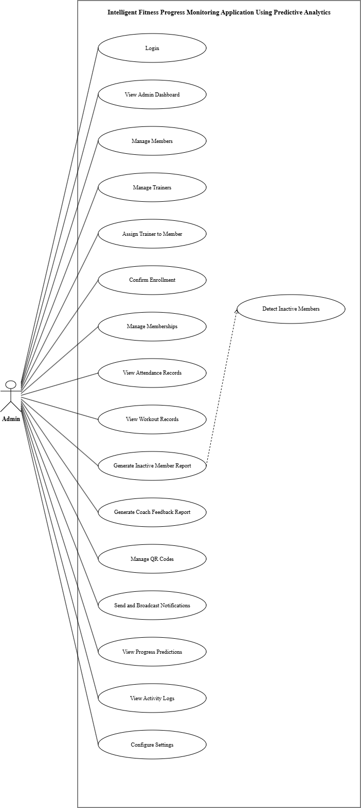
Figure 28: Use Case of the Admin Module
Figure 28 represents the access rights of the Admin of the proposed system. The Admin can log in to the administrative dashboard, manage the member records and the trainer records, assign a trainer to a member, confirm the pending enrollments, manage the membership records, view the attendance records and the workout records, generate the inactive member report and the coach feedback report, manage the QR codes used for the check-in, send and broadcast notifications, view the generated progress predictions, view the activity logs, and configure the system settings. The Generate Inactive Member Report use case includes Detect Inactive Members, and the View Progress Predictions use case includes Generate Progress Prediction, so the Admin always works with the computed result of the predictive analytics service instead of preparing the reports manually.

3.9 DATA DICTIONARY
These tables present the tables used in the system and defines what data should be stored in each table.
Table 3: Enrollments
Field Name | Description | Field Type | Field Size | Type of Key
id | Primary key uniquely identifying each row in the Enrollments table. | uuid | -- | PK
full_name | Full name of the enrolling prospect or member. | text | --
email | Email address used for communication and account identification. | text | --
phone | Phone number for SMS or voice contact. | text | --
date_of_birth | Date of birth used for age-appropriate program recommendations. | date | --
gender | Text indicating the enrollee's gender. | text | --
address | Text field capturing the enrollee's home address. | text | --
emergency_contact_name | Name of the designated emergency contact person. | text | --
emergency_contact_phone | Phone number of the designated emergency contact. | text | --
emergency_contact_relation | Text describing the relationship to the emergency contact. | text | --
status | Text indicating the enrollment's current processing status. | text | --
confirmed_at | Timestamp when the enrollment was confirmed. | time  stamp | --
confirmed_by | Foreign key referencing the profile of the user who confirmed the enrollment in the Enrollments table. | uuid | -- | FK
created_at | Timestamp recording when the record was created in the Enrollments table. | time  stamp | --
state_updated_at | Timestamp with time zone stored in the Enrollments table. | time  stamp | --
The Enrollments table captures prospect and member registration details, including contact information, demographics, and membership confirmation tracking.

Table 4: Profiles
Field Name | Description | Field Type | Field Size | Type of Key
id | Primary key uniquely identifying each row in the Profiles table. | uuid | -- | PK
role | Enumeration value (admin, trainer, or member) defining the profile's access role. | user_role | --
full_name | Text field stored in the Profiles table. | text | --
email | Text field stored in the Profiles table. | text | --
phone | Text field stored in the Profiles table. | text | --
avatar_url | URL pointing to the profile's avatar image. | text | --
date_of_birth | Date value stored in the Profiles table. | date | --
gender | Text field stored in the Profiles table. | text | --
created_at | Timestamp recording when the record was created in the Profiles table. | time  stamp | --
updated_at | Timestamp recording the last update to the record in the Profiles table. | time  stamp | --
fitness_goal | Text describing the member's overall fitness goal or focus area. | text | --
code | Text identifier or referral code associated with the profile. | text | --
emergency_contact_name | Text field stored in the Profiles table. | text | --
emergency_contact_phone | Text field stored in the Profiles table. | text | --
specialty | Text describing the trainer's area of specialization. | text | --
available_days | Text listing the days the trainer is available for sessions. | text | --
is_active | Boolean flag indicating whether the profile is currently active. | boolean | --
The Profiles table stores authenticated user accounts for members, trainers, and administrators, recording role assignment, profile attributes, and account status.

Table 5: Memberships
Field Name | Description | Field Type | Field Size | Type of Key
id | Primary key uniquely identifying each row in the Memberships table. | uuid | -- | PK
member_id | Foreign key referencing the member's profile. | uuid | -- | FK
plan_name | Text name of the membership plan purchased. | text | --
price | Decimal price of the membership plan. | decimal | 10,2
start_date | Date the membership period began. | date | --
end_date | Date the membership period ends. | date | --
status | Enumeration value (active, expired, or cancelled) indicating membership state. | membership_status | --
created_at | Timestamp recording when the record was created in the Memberships table. | time stamp | --
updated_at | Timestamp recording the last update to the record in the Memberships table. | time stamp | --
The Memberships table tracks each member's active or historical membership plans, including pricing, billing period, and current membership status.

Table 6: Trainer Assignments
Field Name | Description | Field Type | Field Size | Type of Key
id | Primary key uniquely identifying each row in the Trainer Assignments table. | uuid | -- | PK
trainer_id | Foreign key referencing the assigned trainer's profile. | uuid | -- | FK
member_id | Foreign key referencing the assigned member's profile. | uuid | -- | FK
assigned_at | Timestamp when the trainer-member assignment was created. | time stamp | --
status | Enumeration value (active or ended) indicating assignment state. | assignment_status | --
The Trainer Assignments table records the association between a trainer and a member, including the assignment date and current assignment status.

Table 7: Attendance
Field Name | Description | Field Type | Field Size | Type of Key
id | Primary key uniquely identifying each row in the Attendance table. | uuid | -- | PK
member_id | Foreign key referencing the member's profile in the Attendance table. | uuid | -- | FK
check_in_time | Timestamp when the member checked in for the session. | time stamp | --
check_in_date | Date of the attended session. | date | --
check_out_time | Timestamp when the member checked out of the session. | time stamp | --
expires_at | Timestamp after which the attendance record is considered stale. | time stamp | --
The Attendance table logs each member's gym visit sessions by recording check-in and check-out times, the visit date, and session expiry.

Table 8: Check-Ins
Field Name | Description | Field Type | Field Size | Type of Key
id | Primary key uniquely identifying each row in the Check-Ins table. | uuid | -- | PK
member_id | Foreign key referencing the member's profile in the Check-Ins table. | uuid | -- | FK
check_in_time | Timestamp recording when the member entered the gym. | time  stamp | --
The Check-Ins table records the timestamp of each member's gym entry event for quick presence tracking.

Table 9: Addresses
Field Name | Description | Field Type | Field Size | Type of Key
member_id | Primary key and foreign key referencing the member's profile; each member has one address row. | uuid | -- | PK
line1 | First line of the street address. | text | --
line2 | Optional second line of the street address. | text | --
city | City name of the address. | text | --
state | State or province of the address. | text | --
postal_code | Postal or ZIP code of the address. | text | --
country | Country of the address. | text | --
created_at | Timestamp recording when the record was created in the Addresses table. | time stamp | --
updated_at | Timestamp recording the last update to the record in the Addresses table. | times stamp | --
The Addresses table stores the physical mailing address associated with each member, keyed directly to the member's profile.

Table 10: Workout Logs
Field Name | Description | Field Type | Field Size | Type of Key
id | Primary key uniquely identifying each row in the Workout Logs table. | uuid | -- | PK
member_id | Foreign key referencing the member who performed the exercise. | uuid | -- | FK
exercise_name | Text name of the exercise performed. | text | --
sets | Integer value stored in the Workout Logs table. | int | --
reps | Integer count of repetitions performed. | int | --
weight | Decimal weight value in the legacy field (superseded by weight_kg). | decimal | 10,2
duration_minutes | Decimal duration in minutes in the legacy field (superseded by duration_seconds). | int | --
notes | Text notes about the exercise set. | text | --
logged_at | Timestamp when the workout log entry was recorded. | time stamp | --
proof_url | Text field stored in the Workout Logs table. | text | --
proof_type | Text field stored in the Workout Logs table. | text | --
weight_kg | Decimal weight in kilograms used for the set. | decimal | 10,2
duration_seconds | Decimal duration in seconds for the exercise set. | int | --
workout_name | Text field stored in the Workout Logs table. | text | --
total_calories | Integer value stored in the Workout Logs table. | integer | --
The Workout Logs table records individual exercise sessions performed by a member, capturing exercise type, sets, repetitions, and load in both metric and legacy fields.

Table 11: Goals
Field Name | Description | Field Type | Field Size | Type of Key
id | Primary key uniquely identifying each row in the Goals table. | uuid | -- | PK
member_id | Foreign key referencing the member who owns the goal. | uuid | -- | FK
title | Short text title of the fitness goal. | text | --
description | Text describing the goal in detail. | text | --
target_value | Decimal target value the member aims to reach. | decimal | 10,2
current_value | Decimal current progress value toward the target. | decimal | 10,2
unit | Text unit of measure for the target and current values. | text | --
deadline | Date by which the goal is targeted to be achieved. | date | --
status | Text indicating the goal's current state (for example, active or achieved). | text | --
created_at | Timestamp recording when the record was created in the Goals table. | time stamp | --
updated_at | Timestamp recording the last update to the record in the Goals table. | time stamp | --
The Goals table defines a member's fitness objectives with a target value, current progress, unit of measure, deadline, and status.

Table 12: Member Goal Plans
Field Name | Description | Field Type | Field Size | Type of Key
id | Primary key uniquely identifying each row in the Member Goal Plans table. | uuid | -- | PK
member_id | Foreign key referencing the member assigned to the plan. | uuid | -- | FK
trainer_id | Foreign key referencing the trainer who created the plan. | uuid | -- | FK
start_date | Date the goal plan period begins. | date | --
end_date | Date the goal plan period ends. | date | --
timeframe | Text describing the plan's timeframe category. | text | --
notes | Text notes from the trainer about the plan. | text | --
food_plan | JSON object containing the prescribed food plan. | jsonb | --
exercise_plan | JSON object containing the prescribed exercise plan. | jsonb | --
created_at | Timestamp recording when the record was created in the Member Goal Plans table. | time stamp | --
updated_at | Timestamp recording the last update to the record in the Member Goal Plans table. | time stamp | --
The Member Goal Plans table links a member and trainer to a structured plan window, storing timeframe, notes, and JSON-formatted food and exercise plans.

Table 13: Plan Day Completions
Field Name | Description | Field Type | Field Size | Type of Key
id | Primary key uniquely identifying each row in the Plan Day Completions table. | uuid | -- | PK
plan_id | Foreign key referencing the member goal plan being completed. | uuid | -- | FK
member_id | Foreign key referencing the member completing the day. | uuid | -- | FK
day_number | Integer day number within the goal plan. | int | --
date | Date the completion entry corresponds to. | date | --
completed_exercises | JSON object listing the exercises completed that day. | json | --
completed_foods | JSON object listing the foods completed that day. | json | --
is_complete | Boolean indicating whether the day's plan was fully completed. | boolean | --
notified_member | Boolean indicating whether the member was notified. | boolean | --
notified_trainer | Boolean indicating whether the trainer was notified. | boolean | --
created_at | Timestamp recording when the record was created in the Plan Day Completions table. | time stamp | --
updated_at | Timestamp recording the last update to the record in the Plan Day Completions table. | time stamp | --
The Plan Day Completions table records a member's daily progress against a goal plan, including completed exercises, completed foods, and notification state.

Table 14: Trainer Feedback
Field Name | Description | Field Type | Field Size | Type of Key
id | Primary key uniquely identifying each row in the Trainer Feedback table. | uuid | -- | PK
trainer_id | Foreign key referencing the trainer who authored the feedback. | uuid | -- | FK
member_id | Foreign key referencing the member receiving the feedback. | uuid | -- | FK
content | Text body of the trainer's feedback to the member. | text | --
created_at | Timestamp recording when the record was created in the Trainer Feedback table. | time stamp | --
The Trainer Feedback table stores written feedback entries submitted by a trainer to a member.

Table 15: Meal Records
Field Name | Description | Field Type | Field Size | Type of Key
id | Primary key uniquely identifying each row in the Meal Records table. | uuid | -- | PK
member_id | Foreign key referencing the member who logged the meal. | uuid | -- | FK
meal_type | Text categorizing the meal (for example, breakfast or lunch). | text | --
food_items | Text listing the food items in the meal. | text | --
calories | Integer total calorie count for the meal. | int | --
protein_g | Decimal protein amount in grams. | decimal | 6,2
carbs_g | Decimal carbohydrate amount in grams. | decimal | 6,2
fat_g | Decimal fat amount in grams. | decimal | 6,2
recorded_at | Timestamp when the meal record was logged. | time stamp | --
The Meal Records table logs a member's self-reported meals with aggregated macronutrient totals and calorie count.

Table 16: Meal Logs
Field Name | Description | Field Type | Field Size | Type of Key
id | Primary key uniquely identifying each row in the Meal Logs table. | uuid | -- | PK
member_id | Foreign key referencing the member who logged the meal. | uuid | -- | FK
meal_type | Text categorizing the meal (for example, breakfast or lunch). | text | --
food_name | Text name of the recognized food item. | text | --
calories | Integer calorie count for the food item. | int | --
protein_g | Decimal protein amount in grams. | decimal | 6,2
carbs_g | Decimal carbohydrate amount in grams. | decimal | 6,2
fat_g | Decimal fat amount in grams. | decimal | 6,2
photo_url | URL of the photo used to recognize the meal. | text | --
meal_time | Timestamp when the meal was consumed. | time stamp | --
The Meal Logs table logs an individual recognized meal entry with food name, macronutrients, optional photo, and meal timestamp.

Table 17: Nutrition Foods
Field Name | Description | Field Type | Field Size | Type of Key
id | Primary key uniquely identifying each row in the Nutrition Foods table. | uuid | -- | PK
food_name | Text name of the food in the reference catalog. | text | --
aliases | Array of text synonyms or alternate names for the food. | text | --
category | Text category classifying the food (for example, protein or grain). | text | --
serving_label | Text label describing the standard serving (for example, 1 cup). | text | --
serving_size_g | Numeric serving size in grams. | numeric | --
calories_kcal | Numeric calorie count per serving in kilocalories. | numeric | --
protein_g | Numeric protein amount per serving in grams. | numeric | --
carbs_g | Numeric carbohydrate amount per serving in grams. | numeric | --
fat_g | Numeric fat amount per serving in grams. | numeric | --
source | Text citing the data source for the nutritional values. | text | --
created_at | Timestamp recording when the record was created in the Nutrition Foods table. | time stamp | --
The Nutrition Foods table is a reference catalog of foods with serving size, caloric and macronutrient values, category, aliases, and sourcing metadata.

Table 18: MET Exercises
Field Name | Description | Field Type | Field Size | Type of Key
id | Primary key uniquely identifying each row in the MET Exercises table. | uuid | -- | PK
name | Text name of the exercise in the reference catalog. | text | --
category | Text category classifying the exercise. | text | --
met_value | Numeric metabolic equivalent value for the exercise. | numeric | --
is_ai_estimated | Boolean indicating whether the MET value was AI-estimated. | boolean | --
is_verified | Boolean indicating whether the MET value has been verified. | boolean | --
confidence | Numeric confidence score for the MET value. | numeric | --
created_at | Timestamp recording when the record was created in the MET Exercises table. | time  stamp | --
verified_by | Foreign key referencing the profile that verified the exercise value. | uuid | -- | FK
verified_at | Timestamp when the exercise value was verified. | time stamp | --
The MET Exercises table is a reference catalog of exercises with their metabolic equivalent (MET) value, verification state, confidence, and verifier.

Table 19: Chat Rooms
Field Name | Description | Field Type | Field Size | Type of Key
id | Primary key uniquely identifying each row in the Chat Rooms table. | uuid | -- | PK
participant_one | Primary key component and foreign key referencing the first participant's profile. | uuid | -- | FK
participant_two | Primary key component and foreign key referencing the second participant's profile. | uuid | -- | FK
created_at | Timestamp recording when the record was created in the Chat Rooms table. | time stamp | --
The Chat Rooms table represents a one-to-one conversation between two profiles, identified by the two participants and creation timestamp.

Table 20: Chat Messages
Field Name | Description | Field Type | Field Size | Type of Key
id | Primary key uniquely identifying each row in the Chat Messages table. | uuid | -- | PK
room_id | Foreign key referencing the chat room containing the message. | uuid | -- | FK
sender_id | Foreign key referencing the profile that sent the message. | uuid | -- | FK
content | Text body of the chat message. | text | --
created_at | Timestamp recording when the record was created in the Chat Messages table. | time stamp | --
The Chat Messages table stores individual messages within a chat room, including sender, content, and creation timestamp.

Table 21: Notifications
Field Name | Description | Field Type | Field Size | Type of Key
id | Primary key uniquely identifying each row in the Notifications table. | uuid | -- | PK
user_id | Foreign key referencing the profile receiving the notification. | uuid | -- | FK
title | Short text title of the notification. | text | --
body | Text body content of the notification. | text | --
read | Boolean indicating whether the notification has been read. | boolean | --
created_at | Timestamp recording when the record was created in the Notifications table. | time stamp | --
The Notifications table stores push or in-app notifications delivered to a user, including title, body, read state, and creation timestamp.

Table 22: Predictions
Field Name | Description | Field Type | Field Size | Type of Key
id | Primary key uniquely identifying each row in the Predictions table. | uuid | -- | PK
member_id | Foreign key referencing the member the prediction concerns. | uuid | -- | FK
metric_name | Text name of the predicted fitness metric. | text | --
predicted_value | Decimal value predicted by the analytics model. | decimal | 10,2
predicted_date | Date the prediction is made for. | date | --
confidence | Decimal confidence score of the prediction, between 0 and 1. | decimal | 4,3
created_at | Timestamp recording when the record was created in the Predictions table. | time stamp | --
The Predictions table stores predictive analytics outputs for a member, including the metric, predicted value, prediction date, and model confidence.

Table 23: Admin Logs
Field Name | Description | Field Type | Field Size | Type of Key
id | Primary key uniquely identifying each row in the Admin Logs table. | uuid | -- | PK
admin_id | Foreign key referencing the administrator who performed the action. | uuid | -- | FK
action | Text describing the administrative action taken. | text | --
target_type | Text categorizing the type of target entity. | text | --
target_id | UUID identifier of the target entity. | uuid | --
details | JSON object containing structured details about the action. | json | --
created_at | Timestamp recording when the record was created in the Admin Logs table. | time stamp | --
The Admin Logs table records administrative actions performed in the system, including the acting admin, action type, target, and structured details.

3.10 GANTT CHART
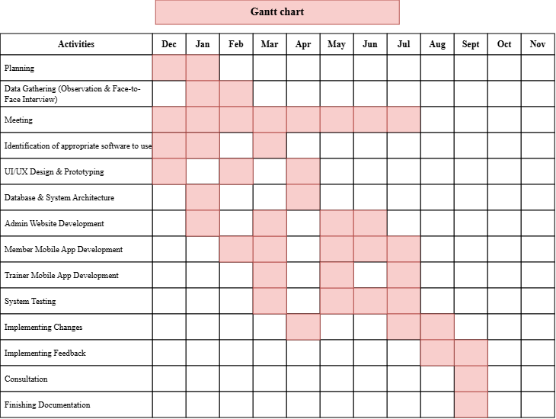
Figure 29: Gantt Chart (Work Plan)
Figure 29 presents the Gantt chart of the work plan for the development of the proposed Intelligent Fitness Progress Monitoring Application of Triple J Fitness Center. The chart covers a twelve-month development period running from December to November, and it lists in its activities column the fourteen major activities undertaken by the proponents. Each shaded cell marks the month or months during which an activity was carried out, so the chart shows the sequence and the overlapping of the work rather than only its start and end dates.

The project began with Planning in December to January, followed by Data Gathering in January to February, where the proponents conducted direct observation of the existing manual tracking and administrative practices of the center and face-to-face interviews with the management, the trainers, and the members to establish the functional and non-functional requirements of the proposed system. Group meetings were held from December to June to sustain the coordination of the proponents throughout the requirements and design stages. The appropriate software to use was identified in March, after which the design activities were undertaken: the UI/UX Design and Prototyping of the application and the Database and System Architecture of the proposed system.

Development was then carried out in three concurrent workstreams corresponding to the three roles of the system. The Admin Website Development covered the administrative modules such as enrollment confirmation, member management, and reporting; the Member Mobile App Development covered workout logging, QR check-in and check-out, meal logging with AI food analysis, and progress monitoring; and the Trainer Mobile App Development covered the trainer dashboard, assigned member monitoring, and feedback and rating. These workstreams ran alongside one another so that the shared database and the interfaces of the three platforms remained consistent.

System Testing followed the completion of each workstream, together with the Implementing Changes activity for the defects and adjustments identified during testing. The Implementing Feedback activity then covered the revisions requested by the users and the panel during beta testing, and Consultation was conducted to review the progress of the study with the adviser and the panel. The work plan concludes with Finishing Documentation, in which the proponents completed the manuscript, the figures, the data dictionary, and the other supporting documents of the study.

3.11 ROLES AND RESPONSIBILITTIES
Member | Designation | Core Responsibilities
John Paul L. Hoquiton | Project Manager  Full - Stack  Documentation | Manages the overall development of the system; coordinates tasks and monitors project progress; develops and integrates both front-end and back-end components; manages system functions and database integration; and assists in preparing and organizing project documentation.
  Kasandra A. Calma | Documentation (main)  Quality Assurance  System Tester  Asistant  Front - End | Prepares and organizes the project documentation; assists in designing the user interface and user experience; supports front-end development; conducts system testing and quality assurance; identifies and reports system issues; and assists in ensuring that the system meets the required specifications.

3.12 EVALUATION PROCEDURE
The quality model serves as a framework for evaluating the proposed software system. It provides criteria for measuring the quality, effectiveness, and overall performance of the system based on the requirements of its intended users and stakeholders. The evaluation helps determine whether the system performs its intended functions and provides a satisfactory experience to its users.

The proposed Intelligent Fitness Monitoring Application Using Predictive Analytics will be evaluated using a questionnaire adapted from the ISO/IEC 25010 Software Quality Model. The evaluation will determine the level of acceptability of the system in terms of functional suitability, performance efficiency, usability, reliability, security, maintainability, and portability. The respondents will include selected users and stakeholders of Triple J Fitness Center, who will be given an opportunity to use and assess the system based on their experience.

The evaluation will focus on the identified software quality characteristics to determine whether the system meets its intended requirements. A four-point Likert scale will be used to measure the responses of the evaluators, ranging from Strongly Disagree (1) to Strongly Agree (4). The responses collected will then be summarized and analyzed to determine the overall level of acceptability of the proposed system.

Table 24 ISO 25010 Guideline
Evaluation Criteria | Description
Functional Sustainability | Measures whether the system provides the required functions for managing members, trainers, fitness records, goals, workout logs, and fitness progress predictions
Performance Efficiency | Measures how well the system performs its functions in terms of response time, processing speed, and use of system resources.
Compatibility | Measures the system's ability to operate properly with the required devices, browsers, software, and other system components without affecting its functions.
Reliability
  Measures the system's ability to perform consistently and correctly while minimizing errors, failures, and interruptions during use.
Usability | Measures how easy the system is to understand, learn, navigate, and use for administrators, trainers, and members.
Maintainability | Measures how easily the system can be maintained, corrected, updated, and modified when changes or errors occur.
Portability
  refers to the ability of the system to operate or be transferred to different environments or platforms. It measures how easily the system can be adapted to other devices, operating systems, or platforms with minimal changes.

The proposed system will be evaluated based on selected software quality criteria to determine its overall quality, effectiveness, and acceptability. The evaluation will focus on Functional Suitability, Performance Efficiency, Compatibility, Reliability, Usability, Maintainability, and Evaluation Design to assess whether the system meets the needs and requirements of its intended users.
RESPONDENTS OF THE STUDY
The respondents of the study will consist of five (5) IT Experts with relevant knowledge and experience in information technology and software development. They will evaluate the proposed Intelligent Fitness Monitoring Application Using Predictive Analytics based on the technical aspects of the ISO/IEC 25010 Software Quality Model. The evaluation will focus on Functional Suitability, Performance Efficiency, Compatibility, Reliability, Usability, and Maintainability to determine the overall quality, functionality, and performance of the proposed system.

EVALUATION INSTRUMENT
To gather the necessary data, the researchers will utilize a structured Evaluation Rating Scale delivered via Google Forms. The instrument is adapted from the ISO/IEC 25010 quality standards, with questions translated into a user-friendly format for both technical and non-technical respondents.

RATING SCALE
The survey will utilize a 5-point Likert Scale to measure the level of agreement for each criterion:
Table 25 Likert Scale
Scale | Range | Interpretation
5 | 4.21 – 5.00 | Highly Acceptable
4 | 3.41 – 4.20 | Acceptable
3 | 2.61 – 3.40 | Neutral
2 | 1..81 – 2.60 | Unacceptable
1 | 1.00 – 1.80 | Totally Unacceptable

Table 25 presents the Likert scale used in interpreting the survey responses. The scale defines the ranges and corresponding interpretations, from “Unacceptable” to “Acceptable. This served as the basis for evaluating user feedback across all criteria, ensuring consistency in the analysis of the system’s performance.

DATA ANALYSIS METHOD
The data collected will be analyzed using the Weighted Means Method. This Method will be used to evaluate responses of the respondents gathered from the questionnaires. This will determine the overall level of systems acceptability.

The formula for the weighted means is:

Where:
- f = frequency of response
- x = Weighted Mean
- ∑(f ∙ x)= Sum of the products of the frequency and the weight
- WM – Weighted Mean

This method allows for a more accurate interpretation of data by considering the significance of each response.

3.13 ETHICAL STANDARDS AND CONSIDERATION
This study upholds ethical research practices to protect the rights, privacy, safety, and interests of the members, trainers, administrators, and other individuals involved in the development of the Intelligent Fitness Monitoring Application Using Predictive Analytics for Triple J Fitness Center.

Before collecting information and conducting system testing, the researchers will secure proper permission and informed consent from the concerned participants. The purpose of the study, the type of information to be collected, and their participation in system testing will be clearly explained, and participation will be voluntary.

Personal information collected for the system, such as member names, ages, fitness goals, body measurements, workout records, food and exercise plans, trainer feedback, and fitness progress data, will be treated with confidentiality. The researchers will follow the Data Privacy Act of 2012 (Republic Act No. 10173), which requires personal information to be processed fairly and lawfully and protected through appropriate safeguards.

Access to member and trainer information will be limited according to their assigned roles in the system. The information and fitness predictions generated by the application will only be used for the purposes of the study and system operations and will not be disclosed to unauthorized individuals or used for unrelated purposes.

The researchers will also ensure that the data, system results, testing results, and documentation are presented accurately and honestly without fabrication, falsification, or misrepresentation. Proper acknowledgment will be given to the sources, references, datasets, and related studies used in the development of the system to maintain academic integrity and avoid plagiarism.

CHAPTER IV
THE PROBLEM AND ITS BACKGROUND
This chapter presents the results and discussion of the developed Intelligent Fitness Monitoring Application Using Predictive Analytics for Triple J Fitness Center. The chapter presents the testing conducted to verify the functionality, performance, reliability, and usability of the system. The findings are discussed based on the specific objectives established for the development of the proposed system.

4.1 DEVELOPMENT AND TESING
UNIT AND INTEGRATION TESTING
Table 26 Unit and Integration Testing for Web Application
Test Case ID | Component Module | Test Condition | Expected Behavior | Actual Result | Status
TC001 | Authentication | Admin enters valid login credentials. | The system allows the admin to log in and access the dashboard. | The system successfully logged in the admin and displayed the dashboard. | Passed
TC002 | Member Management | Admin adds, edits, or views member information. | The system saves and displays the member information correctly. | The system successfully saved and displayed the member information. | Passed
TC003 | Trainer Management | Admin adds, edits, or views trainer information. | The system saves and displays the trainer information correctly. | The system successfully saved and displayed the trainer information. | Passed
TC004 | Membership Management | Admin adds or updates membership information. | The system saves and displays the correct membership details and status. | The system successfully saved and displayed the membership information. | Passed
TC005 | QR and Attendance | Admin scans a member QR code for attendance. | The system identifies the member and records the attendance. | The system successfully identified the member and recorded the attendance. | Passed
TC006 | Fitness Goals | Admin or trainer views or updates a member's fitness goals. | The system saves and displays the member's fitness goals correctly. | The system successfully saved and displayed the fitness goals. | Passed
TC007 | BMI | User enters the member's height and weight. | The system calculates and displays the member's BMI correctly. | The system successfully calculated and displayed the BMI. | Passed
TC008 | Workout Logs | Member workout information is recorded. | The system saves and displays the workout records correctly. | The system successfully saved and displayed the workout records. | Passed
TC009 | Food and Exercise Plan | Trainer creates a seven-day food and exercise plan. | The system saves the plan and displays it to the assigned member. | The system successfully saved and displayed the plan. | Passed
TC010 | Trainer Feedback | Trainer provides feedback for a member. | The system saves and displays the feedback to the intended member. | The system successfully saved and displayed the trainer feedback. | Passed
TC011 | Predictive Analytics | System processes available member fitness data. | The system generates the corresponding prediction or recommendation. | The system generates the corresponding prediction or recommendation. | Passed
TC012 | Notifications | System sends a notification to a user. | The system displays the notification to the intended user. | The system successfully displayed the notification. | Passed
TC013 | Dashboard and Reports | Admin accesses dashboard analytics or reports. | The system displays the appropriate statistics, records, and reports. | The system successfully displayed the dashboard analytics and reports. | Passed
Legend: Passed – The test case met the expected behavior and no significant errors or issues were encountered during testing.

Table 27 Unit and Integration for Member Mobile Application
Test Case ID | Component Module | Test Condition | Expected Behavior | Actual Result | Status
TC001 | User Login | User enters valid account credentials. | The application allows the user to log in and displays the Home screen. | The application successfully logged in the user and displayed the Home screen. | Passed
TC002 | User Profile | User views and updates profile information. | The application displays and saves the updated profile information correctly. | The application successfully displayed and saved the profile information. | Passed
TC003 | Home Dashboard | User opens the Home screen. | The application displays workout activity, active days, check-ins, AI progress forecast, and fitness progress information. | The application successfully displayed the user's fitness information and progress. | Passed
TC004 | Workout | User records a workout activity. | The application saves the workout activity and updates the workout information. | The application successfully saved and updated the workout activity. | Passed
TC005 | In & Out | User scans the QR code for gym check-in or check-out. | The application processes the QR scan and records the user's attendance. | The application successfully processed the QR scan and recorded the attendance. | Passed
TC006 | Food | User views or records food information. | The application displays and saves the selected food and nutrition information correctly. | The application successfully displayed and saved the food information. | Passed
TC007 | Chat | User sends a message to the trainer. | The application sends and displays the message in the chat. | The application successfully sent and displayed the message. | Passed
TC008 | BMI | User views their BMI information. | The application calculates and displays the user's BMI and category correctly. | The application successfully calculated and displayed the BMI and category. | Passed
TC009 | Fitness Goals | User views or updates fitness goals. | The application displays and saves the user's fitness goals correctly. | The application successfully displayed and saved the fitness goals. | Passed
TC010 | Trainer Feedback | User views feedback provided by the trainer. | The application displays the trainer's feedback correctly. | The application successfully displayed the trainer's feedback. | Passed
TC011 | AI Progress Forecast | Application processes the user's fitness data. | The application generates and displays the user's fitness progress forecast. | The application successfully processed the fitness data and displayed the progress forecast. | Passed
TC012 | Check-in History | User views monthly check-in information. | The application displays the user's check-in records and monthly progress correctly. | The application successfully displayed the check-in information. | Passed
TC013 | BMI Progress | User views BMI progress over time. | The application displays the user's BMI records and growth over time correctly. | The application successfully displayed the BMI progress over time. | Passed
TC014 | Notifications | User opens the notification feature. | The application displays available notifications to the user. | The application successfully displayed the notifications. | Passed
TC015 | Settings | User accesses the Settings screen and selects an available feature. | The application displays the selected settings feature and performs the requested action correctly. | The application successfully displayed the settings and performed the selected action. | Passed
Legend: Passed – The test case met the expected behavior and no significant errors were encountered

Table 28 Unit and Integration for Trainer Mobile Application
Test Case ID | Component Module | Test Condition | Expected Behavior | Actual Result | Status
TC001 | Trainer Login | Trainer enters valid account credentials. | The application allows the trainer to log in and displays the Trainer Dashboard. | The application successfully logged in the trainer and displayed the Trainer Dashboard. | Passed
TC002 | Trainer Dashboard | Trainer opens the Dashboard. | The application displays the number of members, chat status, membership information, workout activity, and at-risk members. | The application successfully displayed the trainer dashboard information. | Passed
TC003 | Member Management | Trainer opens the Dashboard. | The application displays the trainer's assigned members and their relevant information. | The application successfully displayed the assigned members and their information. | Passed
TC004 | Workout Monitoring | Trainer views the weekly workout activity of members. | The application displays the members' workout activity for the selected period. | The application successfully displayed the weekly workout activity. | Passed
TC005 | At-Risk Members | Trainer views the At-Risk Members section. | The application displays members identified as being at risk based on available fitness and attendance data. | The application successfully displayed the at-risk member information. | Passed
TC006 | In & Out | Trainer scans or uses the QR feature for member check-in and check-out. | The application processes the QR transaction and records the member's attendance. | The application successfully processed the transaction and recorded the attendance. | Passed
TC007 | Chat | Trainer sends a message to a member. | The application sends and displays the message in the chat conversation. | The application successfully sent and displayed the message. | Passed
TC008 | Create Plan | Trainer creates a food and exercise plan for a member. | The application saves the plan and makes it available to the assigned member. | The application successfully saved and assigned the plan to the member. | Passed
TC009 | Record | Trainer records information related to a member's fitness progress. | The application saves and displays the recorded information correctly. | The application successfully saved and displayed the recorded information. | Passed
TC010 | Trainer Feedback | Trainer provides feedback to a member. | The application saves the feedback and makes it available to the member. | The application successfully saved and displayed the trainer feedback. | Passed
TC011 | Trainer Profile | Trainer views the Profile section. | The application displays the trainer's account information and available profile features. | The application successfully displayed the trainer's profile information. | Passed
TC012 | Notifications | Trainer receives a notification. | The application displays the notification to the trainer. | The application successfully displayed the notification. | Passed
TC013 | Membership Monitoring | Trainer views membership information shown on the Dashboard. | The application displays the relevant membership status and expiration information. | The application successfully displayed the membership information. | Passed
TC014 | Trainer Navigation | Trainer navigates between Dashboard, Members, In & Out, Chat, and Profile. | The application loads each selected section correctly without errors. | The application successfully loaded the selected sections. | Passed
Legend: Passed – The test case met the expected behavior and no significant errors were encountered.

USER ACCEPTANCE TESTING
EVALUATED BY IT EXPERTTS
Following the ISO/IEC 25010 Software Quality Model, an evaluation was carried out on the Intelligent Fitness Monitoring Application Using Predictive Analytics for Triple J Fitness Center. The study involved five (5) IT expert respondents, selected based on their background in software development and systems administration. The evaluation focused on Functional Suitability, Performance Efficiency, Compatibility, Reliability, Usability, Maintainability and Portability. Each criterion was measured using a 5-point Likert scale, providing insights into the system’s functionality, performance, reliability, and ease of use.

Table 29 Software Evaluation of Functional Suitability Criterion by IT Expert
Criterion | Overall Rating | Interpretation
Functional Suitability | 4.60 | Highly Acceptable
Performance Efficiency | 4.80 | Highly Acceptable
Compatibility | 5.00 | Highly Acceptable
Reliability | 4.30 | Highly Acceptable
Usability | 4.80 | Highly Acceptable
Maintainability | 4.67 | Highly Acceptable
Portability | 4.90 | Highly Acceptable
Overall System Rating 4.72 |  | Highly Acceptable
Table 29 presents the ISO/IEC 25010 software evaluation results of the Intelligent Fitness Monitoring Application using Predictive Analytics as rated by five IT experts. The system obtained an Overall System Rating of 4.72, interpreted as Highly Acceptable. Compatibility received the highest rating at 5.00, followed by Portability at 4.90, while Performance Efficiency and Usability both obtained 4.80. Maintainability and Functional Suitability received 4.67 and 4.60, respectively, while Reliability obtained the lowest rating at 4.30. Despite being the lowest, all criteria were interpreted as Highly Acceptable, indicating that the IT experts found the system satisfactory across the evaluated software quality characteristics.

Evaluation By End Users
The end-user evaluation involved 120 respondents comprising Admin, Members, and Trainers of Triple J Fitness Center. The evaluation procedure followed the ISO/IEC 25010 software quality framework to assess the system’s functionality, performance, compatibility, reliability, usability, maintainability, and portability.

Table 30 Software Evaluation of Functional Suitability Criterion
Criterion | Sub- Criterion | Rating | Interpretation
 | Admin: The web dashboard provides complete member, trainer, membership, attendance, and monitoring management functions needed for my administrative tasks. | 4.87 | Highly Acceptable
FUNCTIONAL SUSTAINABILITY | Member: The mobile app provides all necessary functions for tracking workouts, monitoring progress, recording meals, managing goals, and communicating with my trainer. | 4.73 | Highly Acceptable
 | Trainer: The mobile app provides all necessary functions for viewing assigned members, monitoring their progress, reviewing workouts, providing feedback, and communicating with members. | 4.87 | Highly Acceptable
 | OVERALL RATING | 4.82 | Highly Acceptable
Table 30 presents the evaluation of the system against the Functional Suitability criterion, which measures whether the system provides the functions required by its intended users. The criterion obtained an overall rating of 4.82, interpreted as Highly Acceptable. The Admin and Trainer roles both obtained a rating of 4.87, while the Member role obtained 4.73. The results indicate that the system provides the necessary functions for all three user roles. The Admin website supports member, trainer, membership, attendance, workout, and reporting management, while the mobile applications provide members with workout, meal, progress, and goal tracking functions and trainers with member monitoring, workout review, feedback, and communication functions.
Table 31 Software Evaluation of Performance Efficiency Criterion
Criterion | Sub- Criterion | Rating | Interpretation
 | Admin: The web dashboard responds efficiently when managing members, trainers, memberships, attendance, and generating reports. | 4.80 | Highly Acceptable
PERFORMANCE EFFICIENCY | Member: The mobile app performs efficiently when recording workouts, tracking progress, logging meals, and accessing fitness recommendations. | 4.80 | Highly Acceptable
 | Trainer: The mobile app performs efficiently when viewing assigned members, monitoring progress, reviewing workouts, and providing feedback. | 4.90 | Highly Acceptable
 | OVERALL RATING | 4.83 | Highly Acceptable
Table 31 presents the evaluation of the system in terms of Performance Efficiency, which measures how effectively the system performs its functions while using appropriate response time and resources. The criterion obtained an overall rating of 4.83, interpreted as Highly Acceptable. The Admin and Member roles both obtained 4.80, while the Trainer role obtained 4.90. These results indicate that the system performs its primary functions efficiently across the three user interfaces. The web dashboard allows administrators to access and manage records efficiently, while the mobile applications provide members and trainers with responsive access to workout, progress, member, and other fitness-related information.

Table 32 Software Evaluation of Compatibility Criterion
Criterion | Sub- Criterion | Rating | Interpretation
 | Admin: The web dashboard works effectively with the system’s database and provides seamless access to member, trainer, membership, attendance, and monitoring information. | 4.90 | Highly Acceptable
COMPATIBILITY | Member: The mobile app works effectively with the system’s database and allows seamless access to workout, progress, meal, goal, and trainer communication features. | 4.93 | Highly Acceptable
 | Trainer: The mobile app works effectively with the system’s database and allows seamless access to assigned members, workout records, progress information, feedback, and communication features. | 4.83 | Highly Acceptable
 | OVERALL RATING | 4.89 | Highly Acceptable
Table 32 presents the evaluation of the system against the Compatibility criterion, which measures the system’s ability to work effectively with its components and functions, obtaining an overall rating of 4.89, interpreted as Highly Acceptable, with the Admin rating 4.90, Member rating 4.93, and Trainer rating 4.83, demonstrating that the Admin web dashboard and Member and Trainer mobile applications work effectively with the shared backend system to support member records, workout and progress data, and communication according to each user’s role.

Table 33 Software Evaluation of Reliability Criterion
Criterion | Sub- Criterion | Rating | Interpretation
 | Admin: The web dashboard consistently performs administrative tasks and securely maintains accurate member, trainer, membership, and attendance information. | 4.93 | Highly Acceptable
RELIABILITY | Member: The mobile app consistently records and displays workout, progress, meal, and goal information accurately and reliably. | 4.83 | Highly Acceptable
 | Trainer: The mobile app consistently provides accurate member information, workout records, progress updates, feedback, and communication features. | 4.97 | Highly Acceptable
 | OVERALL RATING | 4.91 | Highly Acceptable
Table 33 presents the evaluation of the system in terms of Reliability, which measures the system's ability to perform its required functions consistently and dependably. The criterion obtained an overall rating of 4.91, interpreted as Highly Acceptable. The Admin role obtained 4.93, the Member role obtained 4.83, and the Trainer role obtained 4.97. The results indicate that the system consistently supports the required activities of each user role. The Admin dashboard provides dependable access to administrative records, while the Member and Trainer applications support the recording, retrieval, and monitoring of fitness-related information.

Table 34 Software Evaluation of Usability Criterion
Criterion | Sub- Criterion | Rating | Interpretation
 | Admin: The web dashboard is easy to understand and navigate, allowing me to efficiently manage members, trainers, memberships, attendance, and reports. | 4.97 | Highly Acceptable
USABILITY | Member: The mobile app is easy to understand and navigate, allowing me to easily record workouts, track progress, log meals, manage goals, and communicate with my trainer. | 4.90 | Highly Acceptable
 | Trainer: The mobile app is easy to understand and navigate, allowing me to easily view assigned members, monitor progress, review workouts, provide feedback, and communicate with members. | 4.87 | Highly Acceptable
 | OVERALL RATING | 4.91 | Highly Acceptable
Table 34 presents the evaluation of the system according to the Usability criterion, which measures how easily users can understand, navigate, and use the system to accomplish their tasks. The criterion obtained an overall rating of 4.91, interpreted as Highly Acceptable. The Admin role received 4.97, the Member role received 4.90, and the Trainer role received 4.87. The results indicate that the interfaces are understandable and accessible to their intended users. The Admin dashboard organizes administrative functions, while the Member and Trainer applications provide structured access to their respective fitness monitoring and management functions.

Table 35 Software Evaluation of Maintainability Criterion
Criterion | Sub- Criterion | Rating | Interpretation
 | Admin: The web dashboard is easy to maintain and update, allowing system administrators to manage member, trainer, membership, attendance, and system information efficiently. | 4.97 | Highly Acceptable
MAINTAINABILITY | Member: The mobile app can be easily maintained and updated to ensure that workout, progress, meal, goal, and communication features continue to function properly. | 4.97 | Highly Acceptable
 | Trainer: The mobile app can be easily maintained and updated to ensure that member monitoring, workout review, progress tracking, feedback, and communication features remain functional. | 4.87 | Highly Acceptable
 | OVERALL RATING | 4.94 | Highly Acceptable
Table 35 presents the evaluation of the system in terms of Maintainability, which measures how effectively the system can be maintained, modified, and updated. The criterion obtained an overall rating of 4.94, interpreted as Highly Acceptable. The Admin and Member roles both obtained 4.97, while the Trainer role obtained 4.87. The results indicate that the system is organized into manageable components that support future maintenance and improvements. The separation of administrative, member, and trainer functions allows individual modules and features to be maintained without unnecessarily affecting unrelated functions.
Table 36 Software Evaluation of Portability Criterion
Criterion | Sub- Criterion | Rating | Interpretation
 | Admin: The web dashboard can be accessed through different modern web browsers and devices, allowing administrators to manage the system conveniently. | 4.97 | Highly Acceptable
PORTABILITY | Member: The mobile app can be installed and used on compatible mobile devices, allowing members to access their fitness information anytime and anywhere. | 4.97 | Highly Acceptable
 | Trainer: The mobile app can be installed and used on compatible mobile devices, allowing trainers to monitor members and manage their tasks wherever they are. | 4.87 | Highly Acceptable
 | OVERALL RATING | 4.94 | Highly Acceptable
Table 36 presents the evaluation of the system against the Portability criterion, which measures the system's ability to operate effectively in its intended environments. The criterion obtained an overall rating of 4.94, interpreted as Highly Acceptable. The Admin and Member roles both obtained 4.97, while the Trainer role obtained 4.87. The results indicate that the system can be accessed through its intended platforms. The Admin interface is provided through a web-based dashboard, while the Member and Trainer applications are designed for supported mobile devices, allowing users to access their respective functions within their intended environments.

Table 37 Software Evaluation Summary – End Users
Criterion | Overall Rating | Interpretation
Functional Sustainability | 4.82 | Highly Acceptable
Performance Efficiency | 4.83 | Highly Acceptable
Compatibility | 4.89 | Highly Acceptable
Reliability | 4.91 | Highly Acceptable
Usability | 4.91 | Highly Acceptable
Maintainability | 4.94 | Highly Acceptable
Portability | 4.94 | Highly Acceptable
Overall Rating 4.89 |  | Highly Acceptable
Table 37 presents the summary of the end-user software evaluation results for the Intelligent Fitness Monitoring Application using Predictive Analytics. The system obtained an Overall System Rating of 4.89, interpreted as Highly Acceptable. All seven ISO/IEC 25010 software quality criteria were rated within the Highly Acceptable range. Maintainability and Portability received the highest ratings at 4.94, indicating that the end users found the system easy to maintain and adaptable for its intended environment. Reliability and Usability both obtained 4.91, reflecting users’ positive assessment of the system’s consistency and ease of use. Compatibility received a rating of 4.89, while Performance Efficiency obtained 4.83. Functional Suitability received the lowest rating at 4.82, although it still fell within the Highly Acceptable range. Overall, the results indicate that the Admin, Members, and Trainers found the system highly acceptable across all evaluated software quality criteria and that the application effectively supports their respective activities and requirements.

4.2 EVALUATION RESULT
DATA INTERPRETATION
Responses to each sub-criterion were recorded on a 5-point Likert scale, where denotes Highly Acceptable, 4 Acceptable, 3 Neutral, 2 Unacceptable, and 1 Totally Unacceptable. The rating shown for each sub-criterion is the arithmetic mean of the responses to that statement. The Overall Rating for each criterion is the mean of its sub-criterion ratings, and the Overall System Rating is the mean of the six criterion ratings. Means were computed to two decimal places and interpreted against the following ranges:
Scale | Range | Interpretation
5 | 4.21 – 5.00 | Highly Acceptable
4 | 3.41 – 4.20 | Acceptable
3 | 2.61 – 3.40 | Neutral
2 | 1..81 – 2.60 | Unacceptable
1 | 1.00 – 1.80 | Totally Unacceptable
The sub-criteria under Functional Suitability, Performance Efficiency, Compatibility, Usability, Maintainability, and Portability are presented separately for each user role, namely Admin, Member, and Trainer. The Overall Rating for each criterion is computed by giving equal weight to the three roles rather than weighting the results according to the number of respondents. This approach allows the evaluation to represent the perspectives of all three intended user groups equally. The computed Overall Ratings for the seven criteria are 4.82 for Functional Suitability, 4.83 for Performance Efficiency, 4.89 for Compatibility, 4.91 for Reliability, 4.91 for Usability, 4.94 for Maintainability, and 4.94 for Portability, all of which fall within the Highly Acceptable range. The resulting Overall System Rating of 4.89 indicates that the system is Highly Acceptable across the evaluated quality characteristics. The results reflect the combined assessment of the Admin web dashboard and the Member and Trainer mobile applications, covering the system's functionality, performance, compatibility, reliability, usability, maintainability, and portability.

CHAPTER V
SUMMARY, CONCLUSIONS AND RECOMMENDATIONS

5.1 SUMMARY OF FINDINGS

5.2 CONCLUSIONS

5.3 RECOMMENDATIONS

APPENDIX A
Permit To Conduct the Study


APPENDIX B
Letter for Interview

APPENDIX C
Evaluation Instrument

EVALUATION INSTRUMENT FOR THE INTELLIGENT FITNESS MONITORING APPLICATION USING PREDICTIVE ANALYTICS

Name: ________________________________________Date: ___________________ Educational Attainment: _________________________________________________
Instruction: Please evaluate the system using the given scale and place a checkmark (√) in the appropriate column corresponding to your response.

Numerical Rating Equivalent
5 Highly Acceptable
4 Acceptable
3 Neutral
2 Unacceptable
1 Totally Unacceptable
INDICATORS |  | RATING
INDICATORS | 5 | 4 | 3 | 2 | 1
A. Functionality
1. Suitability. The system performs the task required.
2. Accurateness. The result is as expected.
3. Interoperability. The system interacts with another system.
4. Security. The system prevents unauthorized access.
B. Reliability
1. Maturity. Most of the faults in the system have been eliminated over time.
2. Fault Tolerance. The system handles errors.
C. Usability
1. Understandability. The system is easy to use.
2. Learnability. The system is easily learned.
3. Operability. The system is used without much effort.
4. Attractiveness. Graphical User Interface is attractive and looks good.
D. Efficiency
1. Time behavior. The system provides an appropriate response while performing its function.
2. Resource Utilization. The system utilizes resources efficiently.
F. Maintainability
1. Changeability. The system can be easily modified.
2. Stability. The system continues to function if changes are made.
3. Testability. The system can be tested easily.
E. Portability
1. Adaptability. The system can be moved to other environments.
2. Installability. The system can be installed easily.

APPENDIX D
User Manual
ADMIN

TO BE FOLLOWED

CURRICULUM VITAE 


