AN INTELLIGENT FITNESS PROGRESS MONITORING APPLICATION USING PREDICTIVE ANALYTICS

A Capstone Project
Presented to the Faculty of the
College of Computer Studies
Global Reciprocal Colleges
Caloocan City

In Partial Fulfillment
of the Requirements for the Degree
Bachelor of Science in Information Technology

Prepared by:.

Calma, Kasandra
Hoquiton, John Paul

Mr. Eduardo S. Rodrigo
Adviser

November, 2026

APPROVAL SHEET
This research entitled “An Intelligent Fitness Monitoring Application Using Predictive Analytics” prepared and submitted by CALMA, KASANDRA A. and HOQUITON, JOHN PAUL L. in partial fulfillment of the requirements for the Subject CAPS1: Capstone Study has been examined for ORAL EXAMINATION.

ANN CAMILE M. MAUPAY, MIT
Research Adviser

PANEL OF EXAMINERS
Approved by the Committee for Oral Defense on date with a grade of ________________.

NAME OF PANELIST
Chair

NAME OF PANELIST NAME OF PANELIST
Member Member

Accepted in partial fulfillment for the Subject CAPS2: Capstone Study

NAME
Program Head/Dean

ACKNOWLEDGMENT
First and foremost, the proponents would like to express their sincere gratitude to everyone that provided them with the necessary resources and support to complete their capstone project. The proponents would also like to thank the following people for their helpful advice and feedback throughout the process on creating this capstone project:

The GRC’s Department of General Services, for allowing the proponents to conduct the study in their company.
Ms. Ann Camile M. Maupay, Research and Technical Adviser, for her support, encouragement, thoughtful advice and recommendations throughout the study.
Mr. Domingo Tanael, CCS Program Head, for providing feedbacks,
recommendations and his time for consultation throughout the study.
To the Members of the Panel, for the constructive comments and suggestions in improving the study.
Finally, the proponents are greatly grateful to all of the friends, classmates, and relatives for their unwavering support and encouragement throughout this journey.

DEDICATION
The proponents wholeheartedly dedicate this study to Almighty God, who has given us wisdom, strength, patience, and determination throughout the entire process of completing this project. His guidance has helped us overcome every challenge and difficulty we encountered along the way.
This study is also dedicated to our beloved families, whose unconditional love, understanding, and continuous support have served as our motivation to persevere. We are deeply grateful for their moral, emotional, spiritual, and financial support, especially during the times when we felt discouraged and exhausted.
We would also like to express our sincere appreciation to our friends, classmates, professors, and peers who shared their knowledge, encouragement and words of motivation helped us remain committed to completing this study.
Lastly, we dedicate this project to everyone who believed in our capabilities and supported us throughout this journey. This accomplishment would not have been possible without the people who continuously encouraged and inspired us to pursue our goals and bring this project to completion.

ABSTRACT

TABLE OF CONTENTS
TITLE PAGE ii
APPROVAL SHEET ii
ACKNOWLEDGEMENT iii
DEDICATION iv
ABSTRACT v
TABLE OF CONTENTS vi
LIST OF TABLES ix
LIST OF FIGURES x
CHAPTER I -
1.1 PROJECT CONTEXT 1
1.2 OBJECTIVE OF T HE STUDY 2
GENERAL OBJECTIVE
SPECIFIC OBJECTIVE
1.3 SCOPE AND LIMITATIONS OF THE STUDY 3
SCOPE
LIMITATIONS
1.5 DEFINITIONS OF TERMS
CHAPTER II -
2.1 REVIEW OF RELATED LITERATURE 11
FOREIGN LITERATURE 11
LOCAL LITERATURE
2.2 REVIEW OF RELATED STUDIES 12
FOREIGN STUDIES 12
LOCAL STUDIES 16
2.3 SYNTHESIS OF THE REVIEWED RELATED LITERATURE AND STUDIES 20
CHAPTER III -
3.1 RESEARCH METHOD AND DESIGN 32
3.2 CONCEPTUAL FRAMEWORK 42
3.3 HARDWARE AND SOFTWARE REQUIREMENTS 41
3.4 CONTEXT DIAGRAM 44
EXISTING 44
PROPOSED 47
3.5 DATA FLOW DIAGRAM 55
EXISTING 57
PROPOSED 58
3.5 ACTIVITY DIAGRAM 55
3.7 ENTITY RELATIONSHIP DIAGRAM 55
3.8 USE CASE 55
3.9 DATA DICTIONARY 55
3.10 ROLES AND RESPONSIBILITIES 55

LIST OF TABLES
Table Title Page
1
2
3
4
5
6
7
8
9
10
11
12
13
14

list of figures
Figure Title Page
1
2
3
4
5
6
7
8
9
10
11
12
13
14

CHAPTER I

THE PROBLEM AND ITS BACKGROUND
This chapter presents the context of our project, the objective of this study, the scope and limitation of the study, significances of the study and definition of key terms.

1.1 PROJECT CONTEXT
The growing awareness of physical fitness among Filipinos has driven a significant increase in gym memberships and structured exercise participation nationwide. As individuals pursue specific goals such as weight loss, muscle gain, and improved endurance, the demand for reliable and intelligent fitness management tools has become increasingly pronounced. Despite this growth, many gyms in the Philippines continue to operate without systematic digital tools for managing member records, tracking fitness progress, or facilitating structured trainer-member communication. This gap is particularly evident at Triple J Fitness Center, located in Valenzuela City, where current operations rely on manual and informal methods that limit service quality and member engagement.
Triple J Fitness Center serves a growing membership base in Valenzuela City, offering gym equipment and trainer-assisted workout programs for members with varying fitness goals. A preliminary consultation with the management and staff of the center revealed several persistent operational challenges: member workout logs are maintained informally, progress monitoring is inconsistent, trainer-member communication occurs without a structured system, and membership records are managed through non-digital means. These limitations have affected the center's ability to deliver consistent, data-driven fitness guidance and to retain members over the long term.
In response to these identified needs, this study proposes the development of a web-based Intelligent Fitness Progress Monitoring Application using Predictive Analytics, deployed specifically for Triple J Fitness Center. The system will serve three primary user roles: Admin, Member, and Trainer. Members will access the platform via QR code to log workouts, update fitness records, and transmit progress data to their assigned trainers. Each workout log entry is computed using standardized Metabolic Equivalent of Task (MET) values, allowing the system to estimate calories burned per exercise based on exercise type, member body weight, and session duration. Trainers will review member logs, assess progress, and provide personalized feedback. The admin will manage user accounts, memberships, reports, and system records. By integrating predictive analytics and an AI-powered food recommendation feature which identifies food items from member-submitted photos and retrieves their corresponding nutritional values (calories, protein, carbohydrates, and fats) from the DOST Food and Nutrition Research Institute's Philippine Food Composition Table (PhilFCT), the proposed system aims to transform Triple J Fitness Center's operations into a structured, data-driven, and technology-enabled fitness environment.

1.2 OBJECTIVES OF THE STUDY
GENERAL OBJECTIVE
The general objective of this study is to design, develop, and deploy a web-based Intelligent Fitness Progress Monitoring Application using Predictive Analytics for Triple J Fitness Center in Valenzuela City by the end of Academic Year 2025-2026, integrating digital management tools for Admins, structured progress tracking for Members, and a data-driven feedback platform for Trainers.

SPECIFIC OBJECTIVE
- To develop an administrative module that enables the Admin to manage user accounts, membership records, trainer and member profiles, and generate system reports through a centralized web-based interface.
- To implement a QR code-based member access system that enables at least 90% of enrolled members to log workout sessions, record body measurements, and update fitness activity records within one month of deployment.
- To develop a workout logging module that computes estimated calories burned per exercise using standardized MET values, body weight, and session duration.
- To develop a trainer-facing module that provides trainers real-time access to member logs, progress summaries, and tools for delivering personalized feedback and workout recommendations.
- To implement a predictive analytics engine that analyzes historical member data to generate progress forecasts with a minimum accuracy threshold of 80%.
- To integrate an AI-powered food recommendation module that identifies food items from member-submitted photos and generates personalized meal suggestions using nutritional data from the DOST-FNRI's PhilFCT.

1.3 SCOPE AND LIMITATIONS OF THE STUDY
SCOPE
This study focuses on the development of the Intelligent Fitness Progress Monitoring Application, a web-based system built using Flutter (Dart) and Supabase, designed specifically for deployment at Triple J Fitness Center in Valenzuela City.
- The system allows multiple users to access the system through three roles: Admin, Member, and Trainer.
  - The Admin manages the full scope of system operations, including user account creation and management, membership records, trainer and member data, and the generation of activity and performance reports.
  - The Member accesses the web application by scanning a QR code unique to their account, through which they can log workout sessions, update body measurements, record fitness activity, and transmit progress data directly to their assigned trainer.
  - The Trainer uses the platform to review member logs, monitor progress trends, and provide personalized feedback and workout recommendations.
- The system computes estimated calories burned for each logged exercise.
  - Each logged exercise is matched against a stored MET value dataset, which the system uses together with the member's body weight and session duration to calculate the estimate.
- The system incorporates two AI-driven features.
  - A Predictive Analytics Engine analyzes historical member data, including workout frequency, attendance records, and body measurement trends, to generate forecasts of future fitness outcomes and identify members at risk of stagnating or disengaging.
  - An AI Food Recommendation Module allows members to submit a photo of their meal, which the system analyzes to identify the food item and retrieve its corresponding calorie, protein, carbohydrate, and fat content from the DOST-FNRI PhilFCT database, then uses this data to generate personalized meal suggestions aligned with the member's weight loss, muscle gain, or maintenance objectives.
- The system is hosted on Supabase's cloud infrastructure, ensuring real-time data synchronization across all user sessions.

LIMITATIONS
The study will not include medical diagnoses, clinical dietary prescriptions, or professional healthcare treatment recommendations; all AI-generated suggestions are informational and supplementary in nature only. The system will also not support integration with wearable fitness devices such as smartwatches or biometric trackers, as all data entry is performed manually by members through the web interface, and will not include real-time video-based workout coaching or live streaming functionality.
The other limitations of the study are that the accuracy of the AI food recommendation feature is bounded by the coverage of the PhilFCT database and the food-image identification model, as food items do not present in the database or not visually identifiable from a submitted photo fall outside the scope of automated recognition. Also, the study is limited to the design, development, and initial evaluation of the system based on the functional requirements established in consultation with Triple J Fitness Center; full organizational adoption and long-term impact assessment are beyond the scope of this study.

1.4 SIGNIFICANCE OF THE STUDY
This part of the study explained the importance of the development of the system to the following individuals:

TRIPLE J FITNESS CENTER
The primary benefactor of this study is Triple J Fitness Center. The study on implementing an Intelligent Fitness Progress Monitoring Application would primarily benefit the center's operational efficiency, member management, and its ability to offer trainers data-driven tools for delivering personalized fitness guidance, positioning it to offer a more competitive and professional service experience.

MEMBERS OF THE TRIPLE J FITNESS CENTER
The next benefactor of this study are the members of Triple J Fitness Center. The system will give them access to an organized, data-driven platform where they can track their workout routines with accurate, MET-based calorie estimates, monitor body measurements, receive AI-generated food recommendations backed by an authoritative national nutrition database, and stay informed through predictive progress insights, supporting greater accountability, consistency, and engagement in their individual fitness journeys.

TRAINERS
The other benefactor of this study are the trainers of Triple J Fitness Center. The system will provide them a centralized platform with real-time visibility into member progress, removing reliance on informal communication and enabling a more professional and evidence-based approach to client management through structured delivery of personalized recommendations and feedback.
PROPONENTS
This will serve them as the first step towards success in the field of expertise. This will also help them apply the knowledge they have gained throughout the project, contributing to the growing body of knowledge on client-based fitness information systems, AI integration in health applications, and the application of predictive analytics within the Philippine fitness industry.

FUTURE PROPONENTS
The proposed study will serve as a reference for other or future proponents exploring similar domains, particularly future capstone and research projects on client-based fitness information systems or AI integration in health applications. It may also serve as a model for similar client-engaged research, demonstrating the practical value of integrating emerging technologies such as web-based systems, predictive analytics, and AI into student-developed capstone projects.

1.5 DEFINITION OF TERMS
Upon the implementation, the following terms that are not familiar to the users and future researchers will be the following, it has been defined clearly and conceptually for better understanding.

Admin – refers to the designated system administrator of Triple J Fitness Center, responsible for managing user accounts, membership records, trainer and member data, and system-generated reports within the proposed application.

Artificial Intelligence (AI) – refers to the application of computational methods that enable the system to analyze patterns in fitness data generate automated, context-aware outputs such as food recommendations and predictive progress forecasts.

Body Measurements – quantitative physical metrics recorded by members through the system, including body weight, height, body mass index, and circumferential measurements, used to monitor physical changes over time.

Flutter (Dart) – an open-source, cross-platform application development framework used to build the web-based frontend interface of the proposed system

Food Recommendation Module – an AI-powered feature of the proposed system that identifies food items from member-submitted photos, retrieves their corresponding nutritional values from the PhilFCT database, and generates personalized meals and dietary suggestions for members based on their declared fitness goals, including weight loss, muscle gain, or maintenance
Metabolic Equivalent of Task Value (MET) – A standardized numerical value representing the energy cost of a specific physical activity relative to resting metabolism, stored in the system's exercise dataset and used, together with member body weight and session duration, to estimate calories burned per workout log entry.

Member – an enrolled member of Triple J Fitness Center who accesses the web application through a QR code to log workout sessions, update fitness activity records, and receive AI-generated food recommendations and predictive progress insights.

Philippine Food Composition Table (PhilFCT) – the official Philippine food composition database maintained by the Department of Science and Technology Food and Nutrition Research Institute (DOST-FNRI), used by the proposed system as the reference source for the calorie, protein, carbohydrate, and fat content of identified food items.

Predictive Analytics – the use of historical fitness data, statistical methods, and machine learning algorithms to forecast future member outcomes, including projected changes in body measurements, attendance trends, and goal attainment trajectories.

QR Code Access – a quick-response code assigned to each member of Triple J Fitness Center, used as the primary method for accessing the web-based fitness management application.

Supabase – an open-source, cloud-based backend-as-a-service platform built on PostgreSQL, used to host and manage the system's database, authentication, and real-time data synchronization.

Trainer – A fitness trainer employed at Triple J Fitness Center who uses the proposed system to review member workout logs, monitor progress trends, and provide structured, data- informed feedback and workout recommendations

Workout Log – A member-generated digital record of a completed exercise session, including exercise type, sets, repetitions, duration, intensity, and MET-based estimated calories burned, stored within the system for progress monitoring and predictive analytics processing

CHAPTER II

REVIEW OF RELATED LITERATURE AND STUDIES
This chapter shows the related literature and related studies that are significant to the proposed project. It contains facts from books, thesis, journal, article, and electronic resources and further expands the idea of the study to develop a successful project.
2.1 REVIEW OF RELATED LITERATURE
FOREIGN LITERATURE
According to Laudon and Laudon (2020). Information systems improve organizational efficiency by enabling structured data processing, storage, and automation. They also said that applying these principles to fitness management supports the development of digital platforms that replace informal, paper-based practices with organized, centralized data management.

According to Russell and Norvig (2021). Artificial intelligence is the capacity of computational systems to perform tasks that require human-like reasoning, including learning from data, recognizing patterns, and generating context-aware outputs. They also added that the integration of AI into fitness platforms enables personalized guidance, automated recommendations, and system behavior that adapts to individual user data.

According to Shatte et al. (2020). Predictive analytics techniques, including machine learning and statistical modeling, can effectively forecast future health outcomes from historical data. In the context of fitness systems, they said predictive analytics supports progress forecasting, trend detection in body composition changes, and proactive identification of members at risk of disengagement.

According to Wang et al. (2020). Mobile and web health applications significantly improve user engagement and promote more consistent health monitoring behaviors compared to manual tracking methods. Their findings affirm the practical value of web-based platforms for delivering accessible, real-time fitness management tools to gym members.

According to Patel et al. (2022). Digital health technologies have substantially improved individuals' ability to monitor physical activity and sustain health behavior change. They also said that the effectiveness of digital platforms in bridging the gap between passive health awareness and active, consistent fitness engagement underscores the relevance of such systems for gym members.

According to Johnson et al. (2021). Individuals frequently abandon manual fitness tracking due to the time and effort involved in maintaining consistent records. They also added that this behavioral pattern reinforces the need for automated, low-friction digital systems that reduce user burden while ensuring accurate and continuous monitoring.

According to Tewari and Gupta (2020). AI-driven nutritional recommendation systems that generate personalized dietary guidance from user profile data significantly improve adherence to nutritional goals. Their findings support the integration of AI food recommendation features in fitness systems, particularly for members whose goals include weight management or muscle development.

According to Ainsworth et al. (2011). Standardized MET (Metabolic Equivalent of Task) values provide a validated basis for estimating energy expenditure from exercise type, duration, and body weight. They also said that this compendium is widely adopted in fitness and health-monitoring systems as the reference standard for calorie-burn estimation.

According to Kawano and Yanai (2014). Image-based food recognition systems, when paired with structured food composition databases, can automatically identify food items from photographs and retrieve corresponding nutritional information with high accuracy. Their findings support the technical feasibility of combining AI-based food image recognition with an established food composition reference to automate nutritional analysis for individual users.
LOCAL LITERATURE
According to the Commission on Higher Education (2023). Digital transformation across sectors in the Philippines should be advocated, emphasizing the development of accessible, user-centered information systems that address local operational challenges. This institutional direction affirms the relevance of developing a client-based digital fitness solution as a contribution to the broader digital transformation of the Philippine fitness industry.

According to Gonzales et al. (2023). Sustained engagement with digital health tools implemented in the Philippines depends heavily on user-centered design and alignment with local user needs. Their findings underscore the importance of designing a system's interface and features in direct consultation with its end users to ensure that the system remains accessible and contextually relevant.

According to Migriño and Batangan (2021). Machine learning predictive models can be practically applied to local Philippine health datasets, confirming that predictive analytics can generate actionable forecasts from data collected within the Philippine context. This finding validates the technical viability of incorporating a predictive analytics engine into a fitness management system developed for a local fitness center.

2.2 REVIEW OF RELATED STUDIES
FOREIGN STUDIES
According to the study by Wang et al. (2020). They developed a mobile health application for tracking physical activities and found that the system significantly improved user consistency in maintaining fitness routines. However, the system lacked predictive forecasting capabilities and did not include trainer-facing features or structured feedback mechanisms, limiting its utility as a comprehensive fitness management platform.

The study of Yang et al. (2021) developed a behavior-based fitness application that improved user motivation through personalized feedback. The study confirmed the effectiveness of goal-oriented digital interventions but noted the absence of AI-driven analytical features and trainer interaction components.

The study of Shatte et al. (2020) established that predictive analytics models are capable of generating meaningful health outcome forecasts from historical datasets. While the study focused on general healthcare contexts, the methodological framework it presents is directly applicable to fitness progress forecasting.
LOCAL STUDIES

Cruz (2022) developed a web-based fitness monitoring system that improved data organization and reduced reliance on paper records. However, the system served only individual users and did not include trainer-member communication features, administrative management tools, predictive analytics, or AI-generated dietary guidance, limiting its applicability to a client-based, multi-role fitness center environment.

Reyes (2021) developed a mobile-based health tracking application that improved accessibility for fitness enthusiasts. While the platform facilitated basic activity logging, it lacked trainer interaction capabilities, role-based access, and intelligent analytical features necessary for managing a fitness center's diverse user base and operational requirements.

Santos (2020) developed a fitness tracking system that generated basic progress reports, demonstrating the value of digital data management in fitness contexts. The system did not incorporate multi-user role management, predictive analytics, or AI-based features.

2.3 SYNTHESIS OF THE REVIEWED RELATED LITERATURE AND STUDIES
The proponents believe that all references and studies mentioned in this study are similar to the current study. The proponents also believe that the same methods and techniques used in the studies mentioned in the study can be applied to the current study. Additionally, the proponents believe that the results of the current study can be compared to the results of the references and studies mentioned in the study to provide a more comprehensive understanding of the topic.

The related literature, both foreign and local, all stated that the integration of information systems, artificial intelligence, and predictive analytics is essential to improving data management, decision support, and user engagement in health and fitness contexts (Laudon and Laudon, 2020; Russell and Norvig, 2021; Shatte et al., 2020). The references used also stated that manual and basic digital tracking systems are insufficient for sustaining consistent fitness monitoring (Johnson et al., 2021; Wang et al., 2020; Patel et al., 2022), and that AI-driven food recommendation features support members with specific dietary goals (Tewari and Gupta, 2020). Ainsworth et al. (2011) and Kawano and Yanai (2014) provide the specific technical grounding for standardized MET-based calorie estimation and image-based food recognition matched against an established food composition database.

The related studies, both foreign and local, give examples of systems that are similar to the proposed project of the proponents. In the study of Wang et al. (2020), a mobile health application improved user consistency but lacked predictive forecasting and trainer-facing features. Locally, Cruz (2022), Reyes (2021), and Santos (2020) demonstrate increasing interest in digital fitness monitoring solutions among Filipino developers; however, all three systems remain limited to single-user interfaces without multi-role management, trainer communication, or intelligent analytics capabilities. All these studies provide an insight into the benefits and importance of the development of fitness management systems with AI and predictive analytics, and the proposed project of the proponents can be developed based on the ideas presented in these studies.

The proponents can use the same technology used in these studies and develop their own system that is tailored to the specific needs of Triple J Fitness Center. In addition, the proponents can also use the findings of the studies to identify the best practices for developing their own system.

CHAPTER III

METHODOLOGY AND RESEARCH DESIGN
This chapter discusses the research design of the proposed system. It also contains, the methodology used, processes, information, diagrams that represent the proposed system.

3.1 RESEARCH METHOD AND DESIG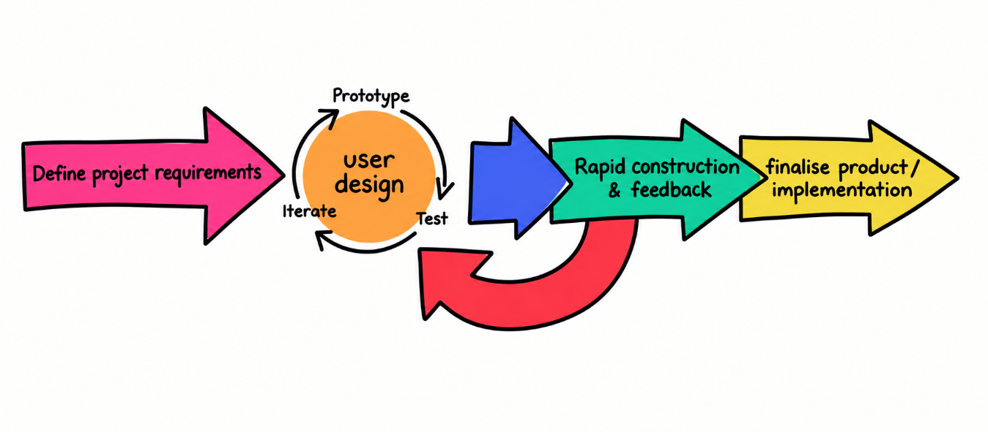
Figure 1: Rapid Application Development (RAD) Methodology
Figure 1 shows the method used in this study is the Rapid Application Development (RAD) Methodology. The RAD methodology is a software development approach that emphasizes iterative development and rapid prototyping over strict planning, allowing for continuous user involvement and progressive refinement throughout the process. The RAD methodology, as applied in this study, comprises four sequential yet iterative phases: Requirements Planning, User Design, Rapid Construction, and Cutover, with each phase producing specific outputs and using designated diagrams to document and communicate the system's structure and behavior.

The proponents began with the requirements planning phase, where the primary goal was to identify and document the operational challenges at Triple J Fitness Center and to establish the functional and non-functional requirements of the proposed system. The researchers conducted structured interviews with the center's management, trainers, and members, conducted direct observations of existing tracking and administrative practices, and reviewed available fitness records and membership documentation. This phase directly addressed the problems identified by the study and served as the foundation for the system's three-role design involving Admin, Member, and Trainer.

3.2 CONCEPTUAL FRAMEWORK
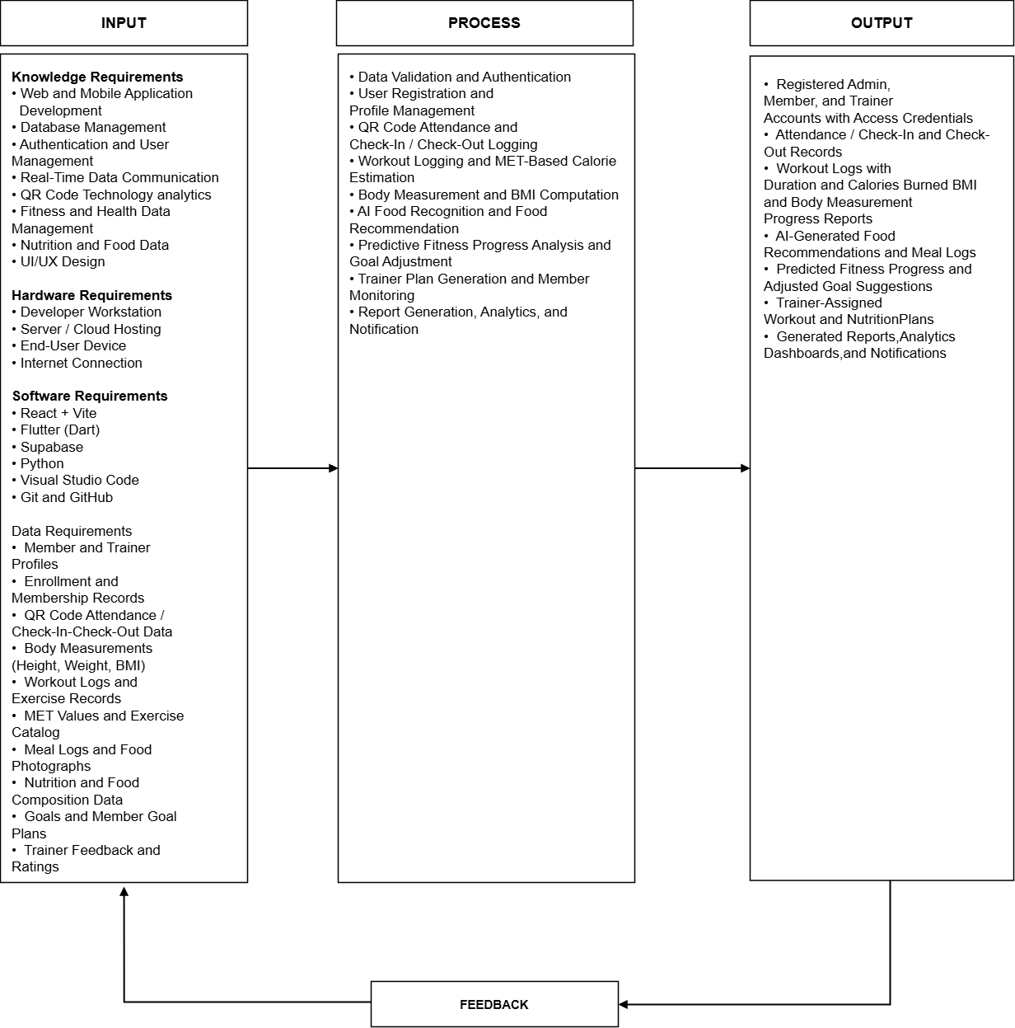

Figure 2: Input Process Output (IPO)

The Intelligent Fitness Progress Monitoring Application Using Predictive Analytics follows the Input-Process-Output (IPO) model. For the Input, the project integrates the Knowledge Requirements, which include web and mobile application development, database management, authentication and user management, real-time data communication, QR code technology analytics, fitness and health data management, nutrition and food data, and UI/UX design. It also includes the necessary Hardware Requirements, such as the developer workstation, server or cloud hosting, end-user devices, and internet connection. The Software Requirements include React with Vite, Flutter using Dart, Supabase, Python, Visual Studio Code, and Git and GitHub, which provide the necessary tools and technologies for developing and managing the system. In addition, the Data Requirements consist of the actual information that the system collects and processes, including member and trainer profiles, enrollment and membership records, QR code attendance and check-in and check-out data, body measurements such as height, weight, and BMI, workout logs and exercise records, MET values and the exercise catalog, meal logs and food photographs, nutrition and food composition data, member goals and goal plans, and trainer feedback and ratings.

The Process covers the operational functions performed by the system. It begins with data validation and authentication, which verifies user identities and enforces role-based access for Admin, Member, and Trainer accounts. This is followed by user registration and profile management, QR code attendance and check-in and check-out logging, and workout logging with MET-based calorie estimation. The system also performs body measurement and BMI computation, AI-powered food recognition and food recommendation using the nutrition and food composition database, and predictive fitness progress analysis with goal adjustment based on recorded trends. Trainer plan generation with member monitoring, together with report generation, analytics, and notification, complete the process. These processes are carried out iteratively following the Rapid Application Development (RAD) methodology presented in Figure 1, allowing continuous refinement based on user feedback and system performance.

The Output phase produces the Intelligent Fitness Progress Monitoring Application Using Predictive Analytics, which provides a structured platform for managing fitness-related information and monitoring member progress. The system generates registered Admin, Member, and Trainer accounts with access credentials; attendance and check-in and check-out records; workout logs with duration and calories burned; BMI and body measurement progress reports; AI-generated food recommendations and meal logs; predicted fitness progress with adjusted goal suggestions; trainer-assigned workout and nutrition plans; and generated reports, analytics dashboards, and notifications. These outputs are intended to support more organized fitness management, data-driven progress monitoring, and improved communication between members and trainers.

The Feedback component provides a continuous mechanism for improving the system. As shown in Figure 2, feedback is drawn from the Output stage and returned to the Input and Process stages, so that user evaluation of the developed system can be used to identify areas for improvement and guide necessary adjustments to the requirements, design, development, and testing processes. This allows the system to be refined based on actual user needs and system performance.

3.3 Hardware and Software Requirements
Component | Minimum Requirements | Recommended Requirements
Processor (CPU) | Intel Core i5 or AMD Ryzen 5 | Intel Core i7 or AMD Ryzen 7
RAM | 8 GB | 16 GB
Storage (Primary) | 256 GB SSD | 512 GB SSD
Backup Storage | 500 GB External HDD or Cloud Storage | 1TB External Storage or Automated Cloud Backup
Display | 19” LED Monitor | 24” IPS Monitor
Internet Connection | 10 Mbps Stable Connection | 50+ Mbps Fiber Connection
Camera | Functional built-in or external camera | 1080p HD Camera
Mobile Device | Android 7.0, quad-core 1.4  GHz, 2 GB RAM, 200MB, 5.0" 720×1280 display | Android 10+, octa-core 1.8 GHz+, 4GB RAM, 500MB, 6.0" 1080×2340 display, HD camera
Wired Networking | Ethernet LAN (RJ45) & Router
Table 1: Hardware Requirements

Table 1 shows the hardware requirements needed to support the development and operation of the Intelligent Fitness Progress Monitoring Application. The minimum requirements provide the necessary specifications for basic development, testing, and system access, while the recommended requirements provide better performance and smoother operation. Components such as the processor and RAM support application development, data processing, and predictive analytics tasks, while SSD storage provides faster system loading and data access. Backup storage helps protect important project and system data, while a stable internet connection ensures reliable access to the cloud-based application and real-time synchronization. Wired and wireless networking allow the mobile application to communicate with the cloud database and the AI service during attendance logging and food image submission. A server or cloud hosting instance is required to run the database and the AI service that performs food recognition and predictive analysis. The camera is necessary for QR code scanning and for capturing food photos used by the AI food recommendation feature. End-user smartphones or tablets allow Members and Trainers to access the mobile application, while the Admin accesses the web-based dashboard through a computer with a display monitor. Overall, these hardware requirements provide the necessary resources for the reliable development, deployment, and use of the proposed system.

Table 2: Software Requirements
Software | Purpose
React + Vite | Used to develop the web-based Admin interface and provide a fast development environment for the administrative dashboard
Tailwind CSS and Radix UI | Used to build the responsive user interface and reusable components of the Admin dashboard
Recharts | Used to generate the charts and analytics visualizations displayed in the Admin dashboard
Node.js and Express | Used as the runtime environment for the Admin application and as the server that handles notification and broadcast requests
Flutter (Dart) | Used to develop the Member and Trainer applications and provide a responsive cross-platform user interface
Mobile scanner, Camera, and Image picker | Used to implement QR code scanning for attendance and to capture food photographs for AI-based recognition
Riverpod and go_router | Used for state management and navigation within the Member and Trainer applications
Supabase | Used as the backend platform for database management, authentication, data storage, and real-time data synchronization
Python | Used for data processing, predictive analytics, machine learning, and AI-related system functions
Google Gemini API (google-generativeai) | Used as the AI engine for image-based food recognition and for generating food and goal recommendations
Visual Studio Code | Used by the proponents for writing, editing, debugging, and managing the application's source code
Operating System | Windows 10 or 11 (64-bit) for development; Android 8.0 or iOS 12 and higher for end-user mobile devices
scikit-learn | Used to train and run the machine learning models for predictive fitness progress analysis and retention risk assessment
Git and GitHub | Used for version control, source code management, collaboration, and tracking changes throughout the development process

Table 2 shows the software requirements needed for the development and operation of the proposed Intelligent Fitness Progress Monitoring Application. React + Vite is used to develop the web-based Admin interface, supported by Tailwind CSS and Radix UI for its user interface components and Recharts for its charts and analytics visualizations, while Node.js and Express serve as the runtime and backend server for the Admin application. Flutter (Dart) is used to develop the Member and Trainer applications, with Riverpod and go_router providing state management and navigation, and Mobile scanner, camera, and Image picker enabling QR code scanning and the capture of food photographs. Supabase serves as the backend platform for database management, authentication, data storage, row-level security, and real-time data synchronization. Python is used for data processing, machine learning, and AI-related functions of the system, scikit-learn is used to train and run the machine learning models for predictive fitness progress analysis and retention risk assessment, while the Google Gemini API is used for image-based food recognition and for generating food and goal recommendations. Visual Studio Code is used for writing, editing, debugging, and managing the source code, while Git and GitHub support version control, collaboration, and tracking of changes throughout the development process. Overall, these software requirements provide the necessary tools and technologies for developing, managing, and operating the proposed system.

3.4 CONTEXT DIAGRAM
EXISTING

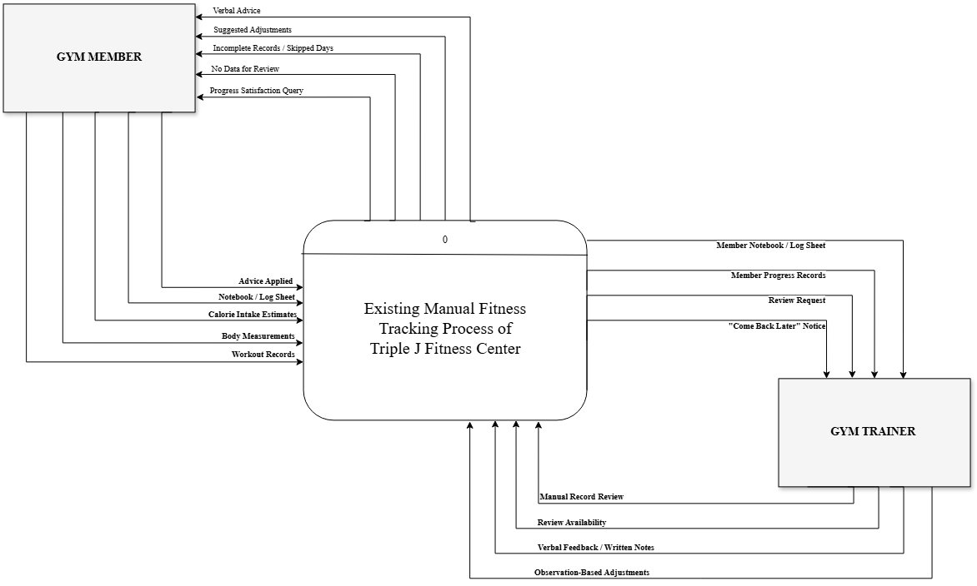

Figure 3: Context Diagram of Existing System

Figure 3 presents the context diagram of the existing system, which shows the manual fitness tracking process currently being practiced at Triple J Fitness Center. The entire manual process is represented by a single process, labeled 0, and it exchanges data with two external entities: the Gym Member and the Gym Trainer or Staff. Unlike the proposed system, the existing process does not involve any automated database, software application, or third-party service, since all records are kept manually in notebooks, spreadsheets, and log sheets.

The Gym Member provides the system with workout records containing the exercise name, sets, and repetitions, as well as body weight and body measurements obtained manually using a weighing scale and tape measure. The member also attempts to calculate calorie intake using online tools or estimates, maintains a notebook or log sheet, and later reports whether the verbal advice given was actually applied. In return, the existing system gives the member verbal advice from the trainer, informal suggested adjustments based on the trainer's observation, a notice that the records are incomplete or that days were skipped, a notice that no data is available for review, and a question regarding whether the member is satisfied with the progress achieved. Because the process depends entirely on manual recording and personal observation, the member is unable to verify whether the progress being made is accurate, which often results in the member abandoning tracking altogether.

The Gym Trainer or Staff provides the system with a manual review of the member's records, an indication of whether the trainer has time to perform the review, verbal feedback or written notes, and adjustments based on personal observation rather than measured data. In return, the existing system provides the trainer with the member's notebook or log sheet, the member's progress records which are frequently incomplete, the request for review, and a notice that the member should come back later when the trainer is unavailable.

Overall, the context diagram of the existing system shows that the current practice relies entirely on manual records and informal communication between the member and the trainer. There is no formal monitoring, no automated computation, and no data-driven basis for the advice provided, which are the limitations that the proposed system intends to address.

PROPOSED
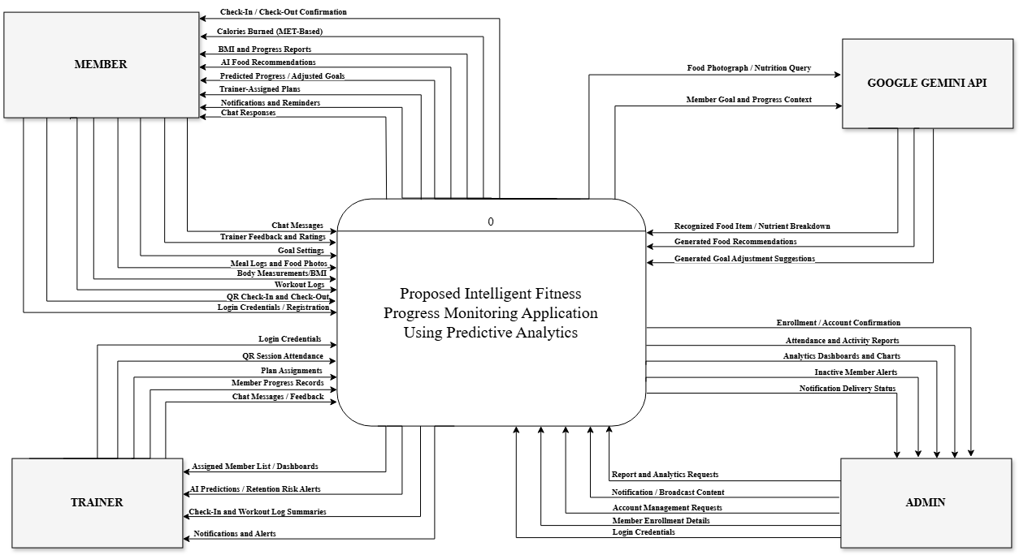
Figure 4: Context Diagram of Proposed System

Figure 4 presents the context diagram of the proposed Intelligent Fitness Progress Monitoring Application Using Predictive Analytics. The entire proposed system is represented by a single process, labeled 0, and it exchanges data with four external entities: the Member, the Trainer, the Admin, and the Google Gemini API.

The Member provides the system with login credentials and registration details, QR code check-in and check-out data, workout logs containing the exercise performed, sets, repetitions, and duration, body measurements such as height and weight, meal logs together with food photographs, goal settings, trainer feedback and ratings, and chat messages addressed to the assigned trainer. In return, the system provides the member with check-in and check-out confirmations, the computed calories burned using MET-based estimation, BMI and progress reports presented through charts, AI-generated food recommendations, predicted fitness progress with adjusted goal suggestions, trainer-assigned workout and nutrition plans, notifications and reminders, and chat responses from the trainer.
The Trainer provides the system with login credentials, QR code session attendance, workout and nutrition plan assignments for assigned members, member progress records, and chat messages and feedback. In return, the system provides the trainer with the list of assigned members and their progress dashboards, AI-generated progress predictions and retention risk alerts, summaries of member check-ins and workout logs, chat messages from members, and notifications and alerts.

The Admin provides the system with login credentials, member enrollment details, account management requests such as creating accounts, assigning trainers, and deleting users, notification and broadcast content, and report and analytics requests. In return, the system provides the admin with enrollment and account confirmations, attendance and activity reports, analytics dashboards and charts, inactive member alerts, and the delivery status of notifications.

The Google Gemini API, acting as an external third-party service, receives food photographs and nutrition queries from the system and returns the recognized food item with its nutrient breakdown and generated food recommendations. It likewise receives the member's goal and progress context and returns generated goal adjustment suggestions. The system's predictive analytics component, which uses scikit-learn, and the Supabase platform, which serves as the system's database and authentication backend, are considered part of the system rather than external entities.

Overall, the context diagram of the proposed system shows that the manual recording and informal communication observed in the existing system are replaced by an automated platform that captures data through QR codes and mobile inputs, processes them through predefined and AI-based computations, stores them in a centralized cloud database, and returns accurate, data-driven outputs to the member, the trainer, and the admin.

3.5 DATA FLOW DIAGRAM
EXISTING
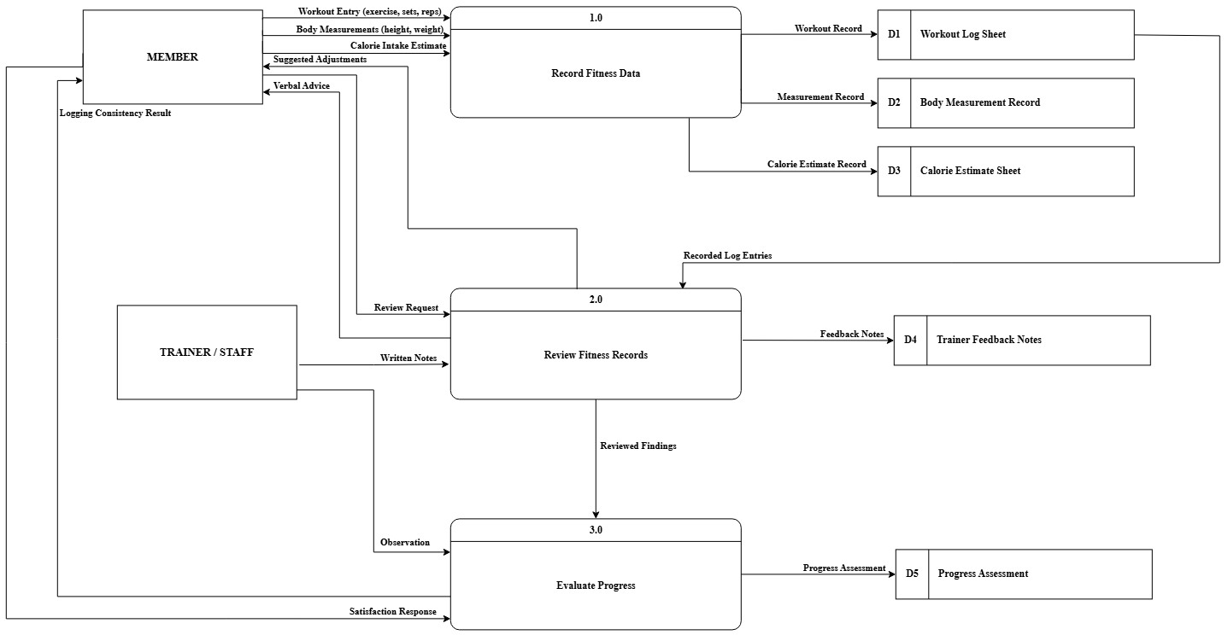
Figure 5: Data Flow Diagram of Existing System

Figure 5 presents the data flow diagram of the existing system of Triple J Fitness Center. The existing system is composed of three processes, namely 1.0 Record Fitness Data, 2.0 Review Fitness Records, and 3.0 Evaluate Progress, and it exchanges data with two external entities: the Member and the Gym Trainer or Staff. All data in the existing system are stored manually in the Workout Log Sheet, the Body Measurement Record, the Calorie Estimate Sheet, the Trainer Feedback Notes, and the Progress Assessment.

In the first process, the Member supplies the system with a workout entry containing the exercise name, the number of sets, and the number of repetitions, together with body measurements obtained manually using a weighing scale and tape measure, and a calorie intake estimate taken from online tools or personal estimation. The system records these into the Workout Log Sheet, the Body Measurement Record, and the Calorie Estimate Sheet.

In the second process, the recorded log entries are retrieved and submitted to the trainer together with the review request of the member. The Gym Trainer or Staff provides written notes, and the system produces feedback notes and returns verbal advice and suggested adjustments to the member.

In the third process, the reviewed findings are evaluated against the member's weekly logging consistency and satisfaction response. The system produces a progress assessment and returns the logging consistency result to the member. Because the entire process depends on manual recording and personal observation, the resulting assessment has no data-driven basis, which is the limitation that the proposed system addresses.

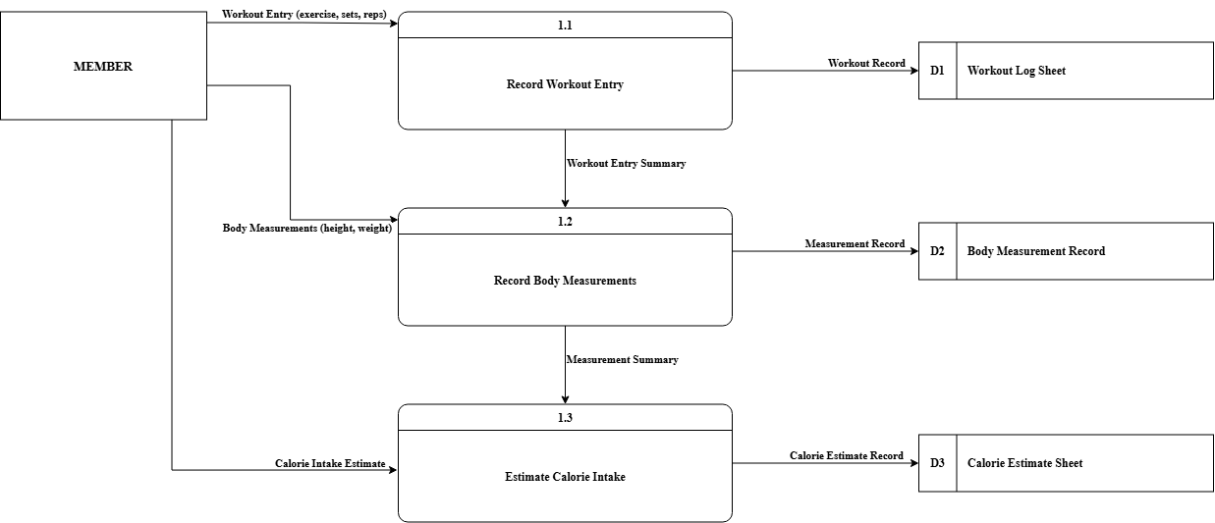
Figure 6: Data Flow Diagram of Process 1 (Existing)

Figure 6 represents the data flow diagram of process 1 of the existing system of Triple J Fitness Center. This diagram decomposes the Record Fitness Data process into three sub-processes: 1.1 Record Workout Entry, 1.2 Record Body Measurements, and 1.3 Estimate Calorie Intake.

In sub-process 1.1, the Member provides a workout entry containing the exercise name, the number of sets, and the number of repetitions, which is written into the Workout Log Sheet. The resulting workout entry summary is passed to sub-process 1.2, where the Member records body measurements such as weight and height taken manually with a weighing scale and tape measure. These are written into the Body Measurement Record and the resulting measurement summary is passed to sub-process 1.3.

In sub-process 1.3, the Member attempts to calculate calorie intake using online tools or personal estimation, and the resulting value is written into the Calorie Estimate Sheet. Because all three sub-processes are performed by hand, the records they produce are prone to missing days and inaccurate values, which frequently leaves no data available for review by the trainer.

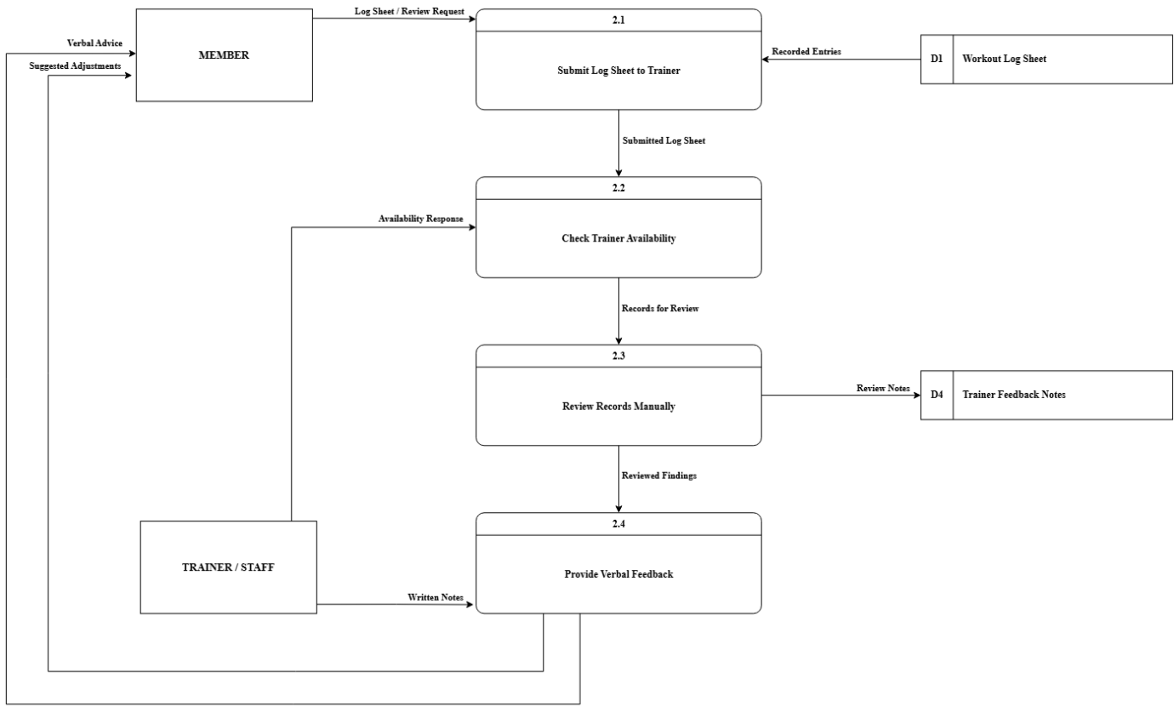
Figure 7: Data Flow Diagram of Process 2 (Existing)

Figure 7 represents the data flow diagram of process 2 of the existing system of Triple J Fitness Center. This diagram decomposes the Review Fitness Records process into four sub-processes: 2.1 Submit Log Sheet to Trainer, 2.2 Check Trainer Availability, 2.3 Review Records Manually, and 2.4 Provide Verbal Feedback.

In sub-process 2.1, the Member submits the log sheet together with a review request, while the recorded entries are retrieved from the Workout Log Sheet. The submitted log sheet is passed to sub-process 2.2, where the system determines whether the Gym Trainer or Staff has time to perform the review, based on the availability response of the trainer. If the trainer is unavailable, the member waits or comes back later.

Once the trainer is available, the records for review are passed to sub-process 2.3, where the Gym Trainer or Staff reviews the records manually and the resulting review notes are written into the Trainer Feedback Notes. The reviewed findings are then passed to sub-process 2.4, where the trainer's written notes are converted into verbal advice and suggested adjustments, which are returned to the Member.

Because the review depends entirely on the trainer's availability and personal judgement, the advice produced is not data-driven, and the member cannot verify whether the progress being made is accurate.

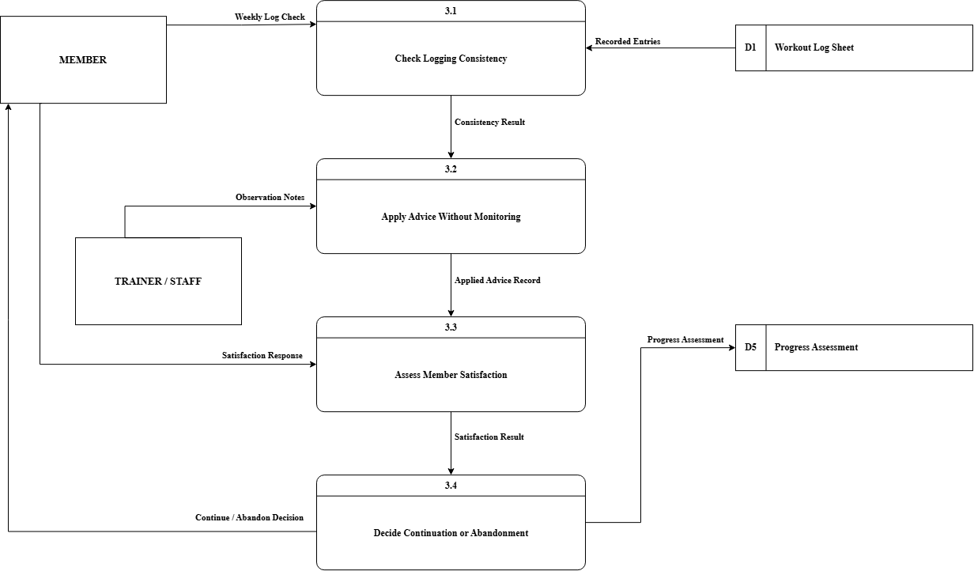
Figure 8: Data Flow Diagram of Process 3 (Existing)
Figure 8 represents the data flow diagram of process 3 of the existing system of Triple J Fitness Center. This diagram decomposes the Evaluate Progress process into four sub-processes: 3.1 Check Logging Consistency, 3.2 Apply Advice Without Monitoring, 3.3 Assess Member Satisfaction, and 3.4 Decide Continuation or Abandonment.

In sub-process 3.1, the Member's weekly log check is compared against the recorded entrie retrieved from the Workout Log Sheet, producing a consistency result. This result is passed to sub-process 3.2, where the Member applies the advice previously received from the trainer without any formal monitoring, supported only by the observation notes of the Gym Trainer or Staff. The applied advice record is passed to sub-process 3.3.

In sub-process 3.3, the Member provides a satisfaction response, which is evaluated against the applied advice record to produce a satisfaction result. This result is passed to sub-process 3.4, where the decision to continue or abandon tracking is made and the progress assessment is written into the Progress Assessment.

Because the evaluation has no measurable baseline, the decision is based on the member's feeling rather than on recorded data. When the member is not satisfied, the outcome of the existing process is that the member abandons tracking altogether.

PROPOSED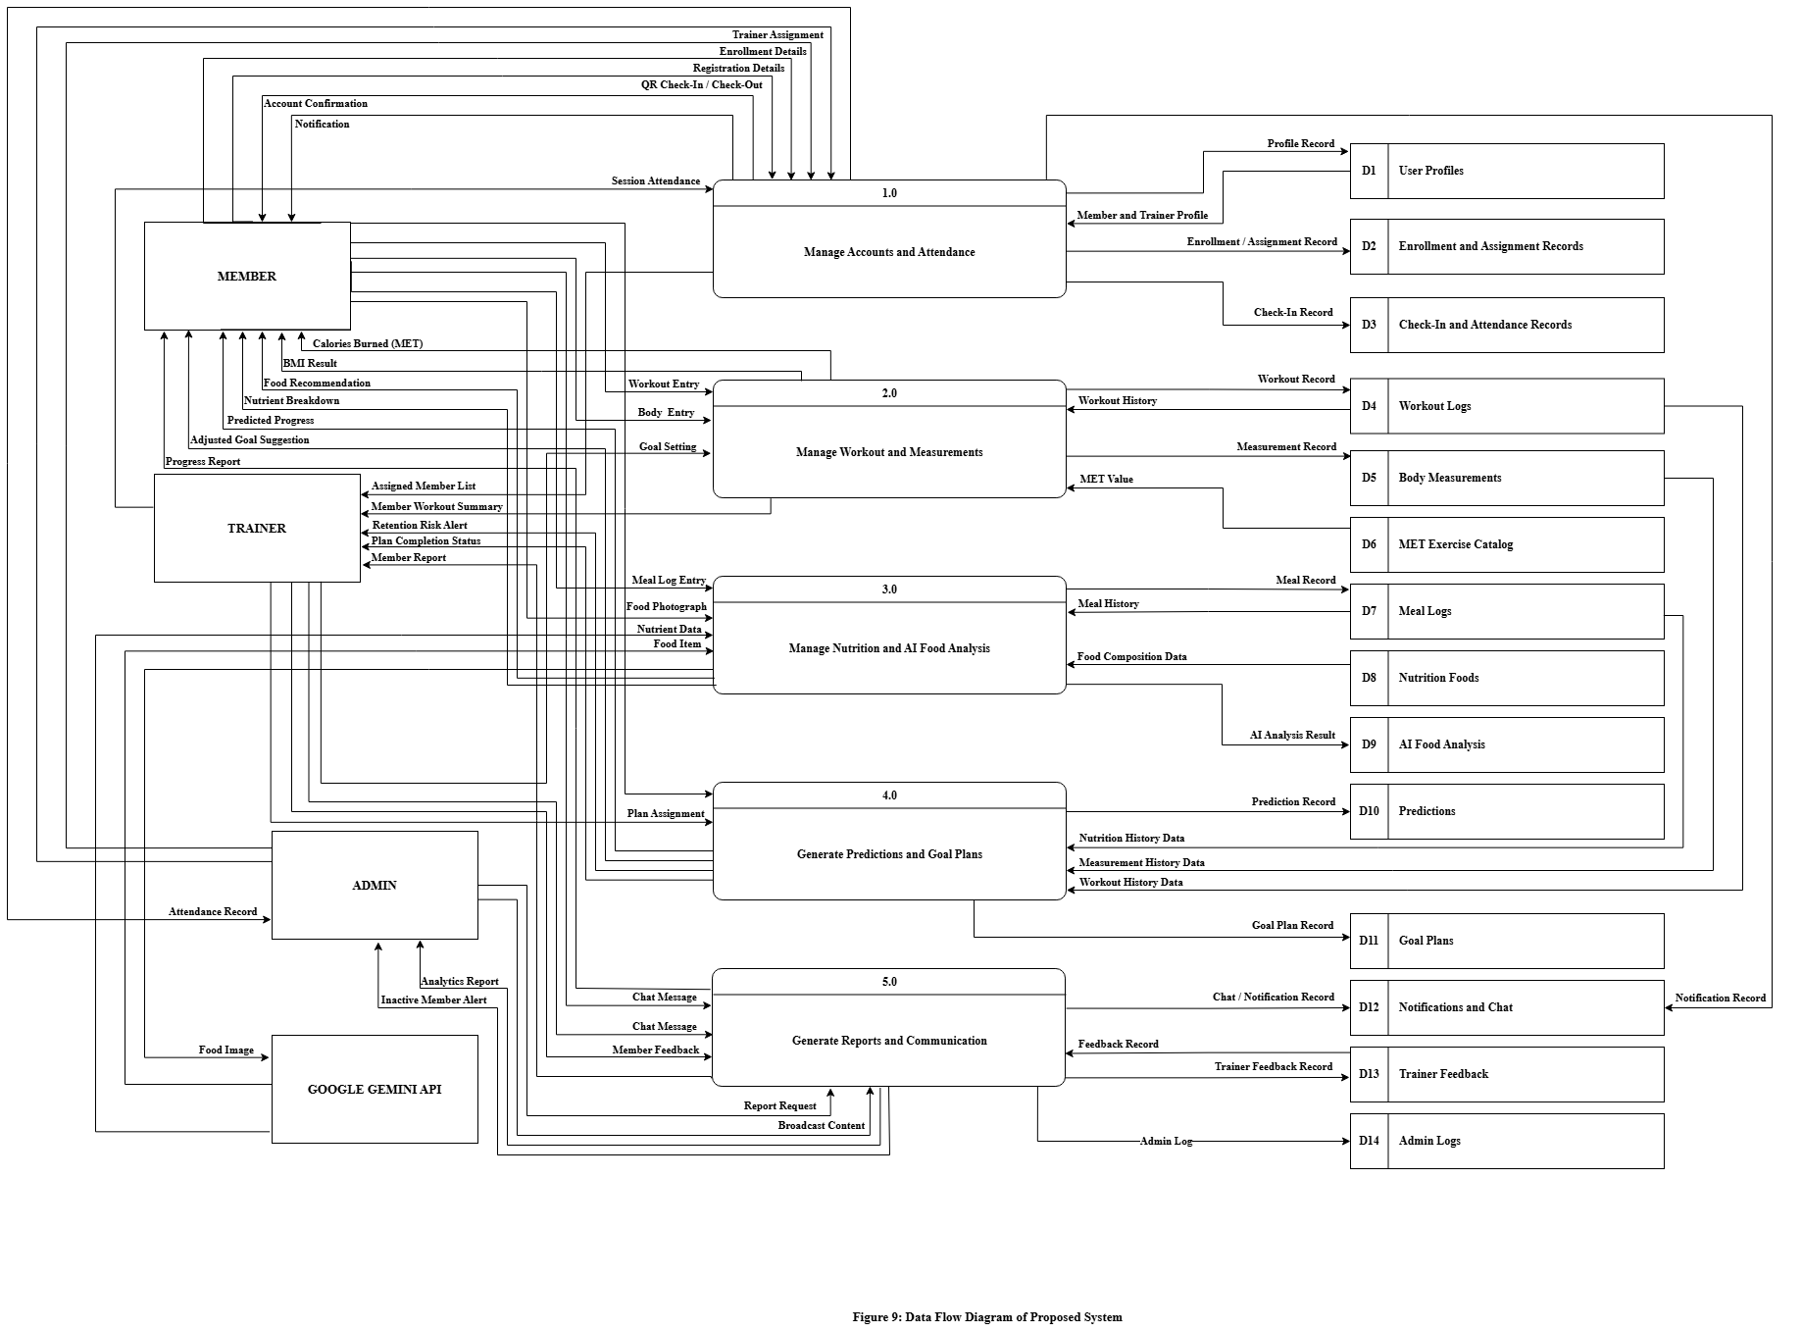

Figure 9: Data Flow Diagram of Proposed System

Figure 9 presents the data flow diagram of the proposed Intelligent Fitness Progress Monitoring Application Using Predictive Analytics. The proposed system is composed of five processes, namely 1.0 Manage Accounts and Attendance, 2.0 Manage Workout and Measurements, 3.0 Manage Nutrition and AI Food Analysis, 4.0 Generate Predictions and Goal Plans, and 5.0 Generate Reports and Communication. The system exchanges data with four external entities: the Member, the Trainer, the Admin, and the Google Gemini API.

In process 1.0, the Admin provides enrollment details and trainer assignment requests, while the Member provides registration details and QR code check-in and check-out data. The process stores the profile records in the User Profiles, the enrollment and assignment records in the Enrollment and Assignment Records, the check-in record in the Check-In and Attendance Records, and returns the account confirmation, attendance record, assigned member list, and notification to the users.

In process 2.0, the Member provides a workout entry and a body measurement entry. The process retrieves the MET value from the MET Exercise Catalog, computes the calories burned, and stores the workout record in the Workout Logs and the measurement record in the Body Measurements, while returning the calories burned and the BMI result to the member and the member workout summary to the trainer.

In process 3.0, the Member provides a meal log entry and a food photograph. The food image
and nutrition query are sent to the Google Gemini API, which returns the recognized food item and the nutrient breakdown data. The process stores the meal record in the Meal Logs and the analysis result in the AI Food Analysis, and returns the food recommendation and the nutrient breakdown to the member.

In process 4.0, the workout, measurement, and nutrition histories are analysed to produce the prediction record and the goal plan record. The process returns the predicted fitness progress and the adjusted goal suggestion to the member, and the retention risk alert and the plan completion status to the trainer.

In process 5.0, the chat messages and trainer ratings of the member, the feedback of the trainer, and the report request and broadcast content of the admin are processed to produce the progress report, the member report, the analytics report, and the inactive member alert.

Overall, the data flow diagram of the proposed system shows that the manual recording and informal communication of the existing system are replaced by an automated platform that captures data through QR codes and mobile inputs, processes it through predefined and AI-based computations, stores it in a centralized cloud database, and returns accurate, data-driven outputs to the member, the trainer, and the admin.

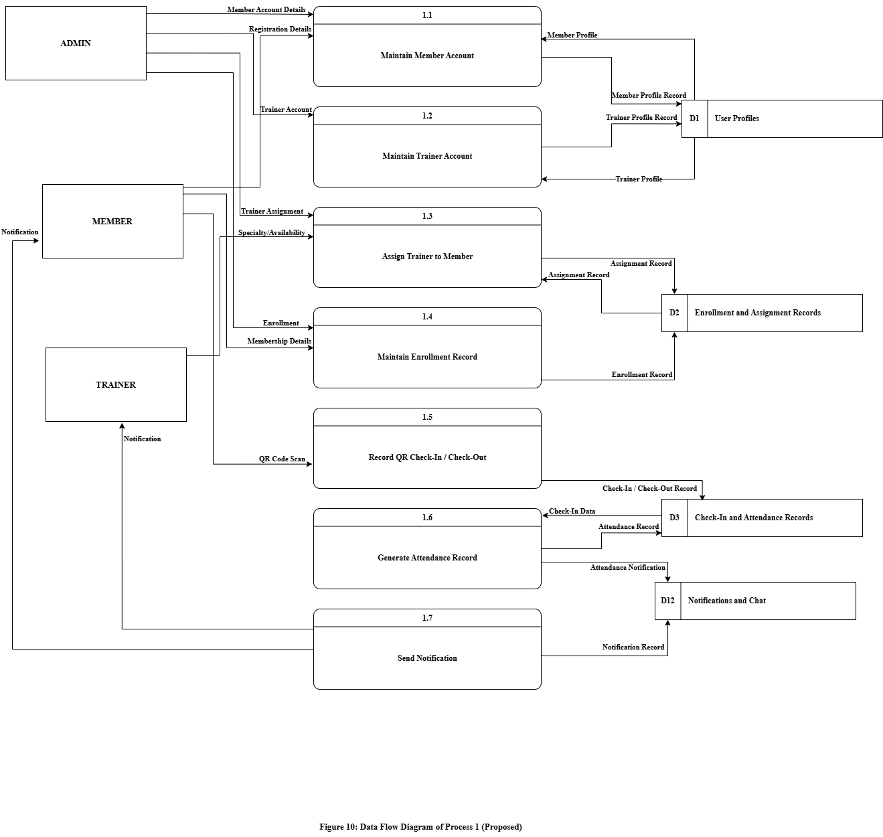
Figure 10: Data Flow Diagram of Process 1 (Proposed)

Figure 10 represents the data flow diagram of process 1 of the proposed system. This diagram decomposes the Manage Accounts and Attendance process into seven sub-processes:1.1 Maintain Member Account, 1.2 Maintain Trainer Account, 1.3 Assign Trainer to Member,1.4 Maintain Enrollment Record, 1.5 Record QR Check-In / Check-Out, 1.6 Generate Attendance Record, and 1.7 Send Notification.

In sub-process 1.1, the Admin provides the member account details while the Member provides the registration details. The process writes the member profile record into the User Profiles and returns the member profile for verification. In sub-process 1.2, the Admin provides the trainer account details, which are written into the User Profiles.

In sub-process 1.3, the Admin provides the trainer assignment while the Trainer provides the specialty and availability. The assignment record is written into the Enrollment and Assignment Records. In sub-process 1.4, the Admin provides the enrollment details and the Member provides the membership details, which are written into the same data store.

In sub-process 1.5, the Member provides the QR code scan, which is written into the Check-In and Attendance Records as a check-in and check-out record. In sub-process 1.6, the check-in data are retrieved and the attendance record is generated and stored, together with the attendance notification. In sub-process 1.7, the notification record is written into the Notifications and Chat and returned to the Member and the Trainer.

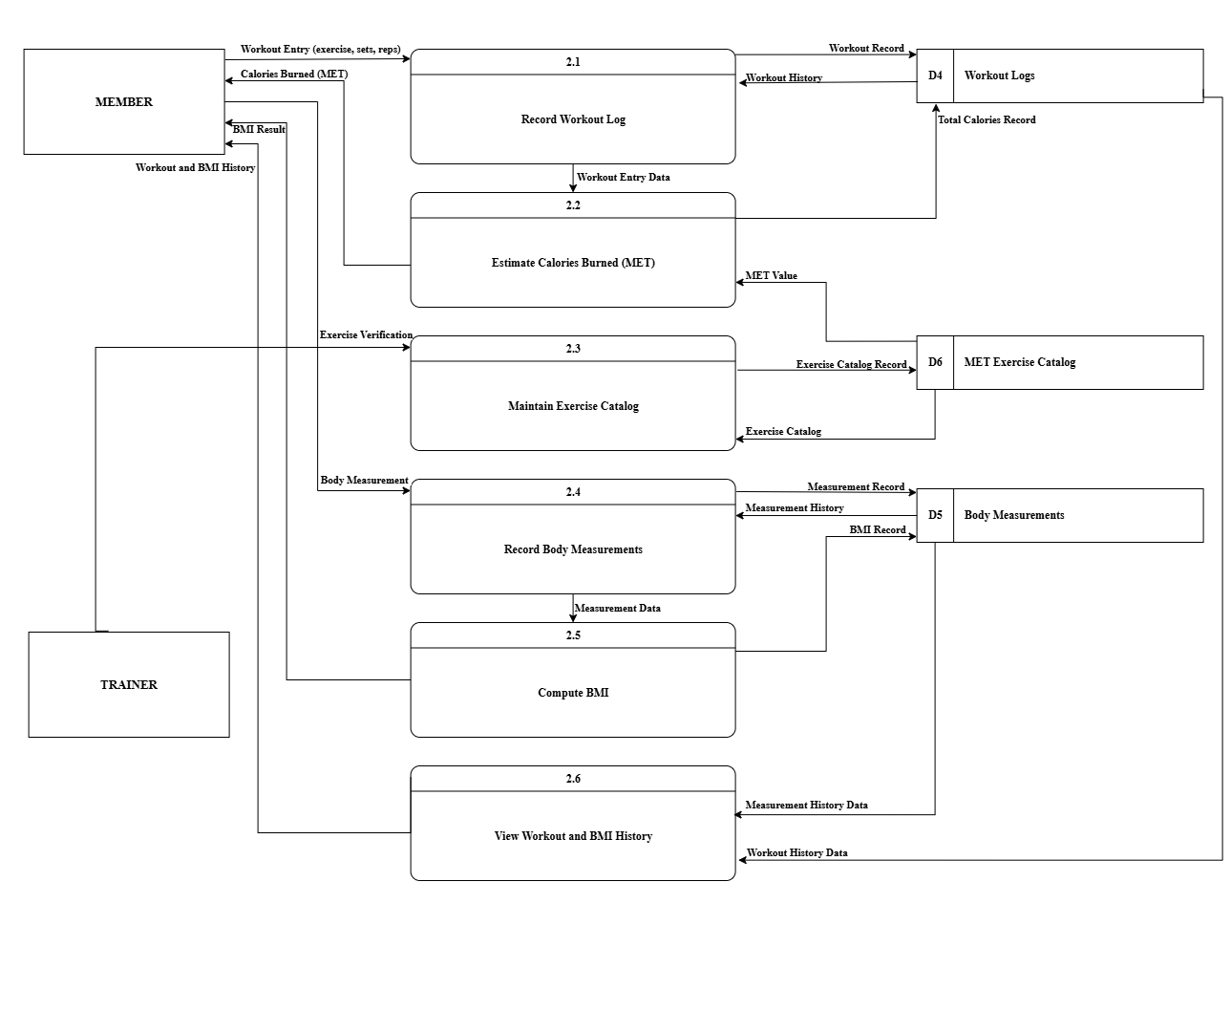
Figure 11: Data Flow Diagram of Process 2 (Proposed)
Figure 11 represents the data flow diagram of process 2 of the proposed system. This diagram decomposes the Manage Workout and Measurements process into six sub-processes: 2.1 Record Workout Log, 2.2 Estimate Calories Burned (MET), 2.3 Maintain Exercise Catalog,
2.4 Record Body Measurements, 2.5 Compute BMI, and 2.6 View Workout and BMI History.

In sub-process 2.1, the Member provides a workout entry containing the exercise name, the number of sets, the number of repetitions, and the duration, which is written into the Workout Logs. The workout entry data are passed to sub-process 2.2, where the MET value is retrieved from the MET Exercise Catalog to compute the calories burned. The computed value is returned to the Member and stored in the Workout Logs as the total calories record.

In sub-process 2.3, the Trainer provides the exercise verification and the exercise catalog record is maintained in the MET Exercise Catalog. In sub-process 2.4, the Member provides the body measurement entry, which is written into the Body Measurements together with the measured date.

The measurement data are passed to sub-process 2.5, where the BMI is computed from the recorded height and weight, returned to the Member, and stored in the Body Measurements. In sub-process 2.6, the workout history data and the measurement history data are retrieved and returned to the Member as the workout and BMI history.

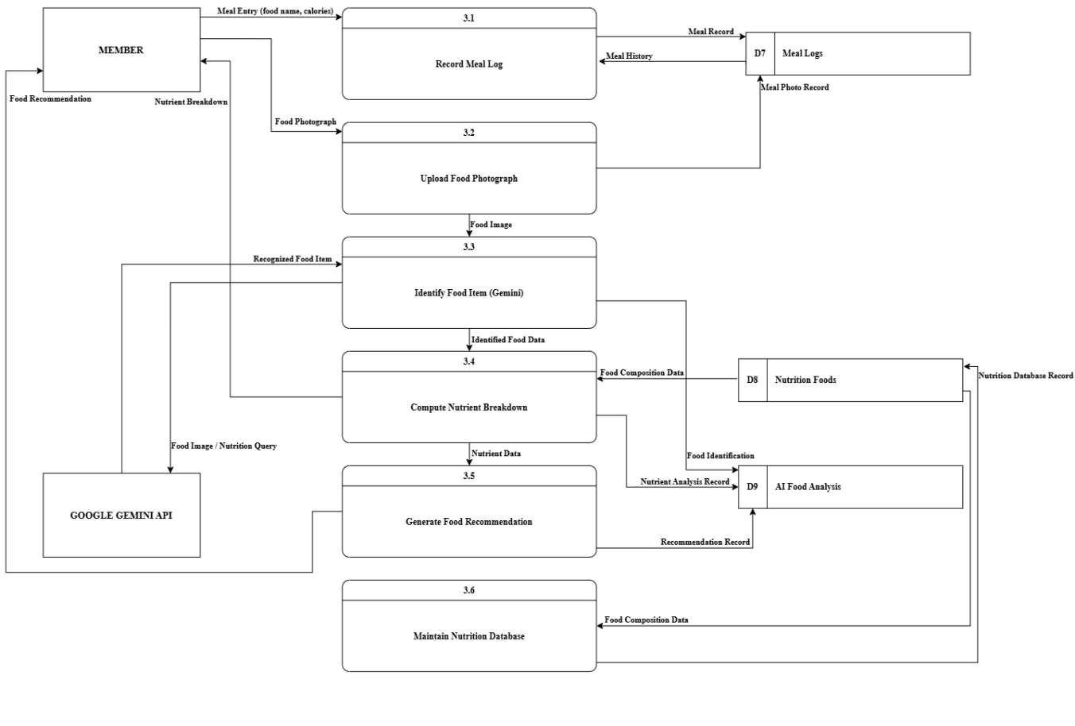
Figure 12: Data Flow Diagram of Process 3 (Proposed)
Figure 12 represents the data flow diagram of process 3 of the proposed system. This diagram decomposes the Manage Nutrition and AI Food Analysis process into six sub-processes: 3.1 Record Meal Log, 3.2 Upload Food Photograph, 3.3 Identify Food Item (Gemini), 3.4 Compute Nutrient Breakdown, 3.5 Generate Food Recommendation, and 3.6 Maintain Nutrition Database.

In sub-process 3.1, the Member provides a meal entry containing the food name, the meal type, and the calories, which is written into the Meal Logs. In sub-process 3.2, the Member provides the food photograph, which is stored as the meal photo record, and the food image is passed to sub-process 3.3.

In sub-process 3.3, the food image and the nutrition query are sent to the Google Gemini API, which returns the recognized food item. The result is written into the AI Food Analysis and the identified food data are passed to sub-process 3.4.

In sub-process 3.4, the food composition data are retrieved from the Nutrition Foods to compute the nutrient breakdown, which is returned to the Member and written into the AI Food Analysis. In sub-process 3.5, the nutrient data are used to generate the food recommendation, which is returned to the Member and stored in the AI Food Analysis.

In sub-process 3.6, the food composition data retrieved from the Nutrition Foods are used to maintain the nutrition database record, ensuring that the food reference data used by the AI analysis remain accurate.

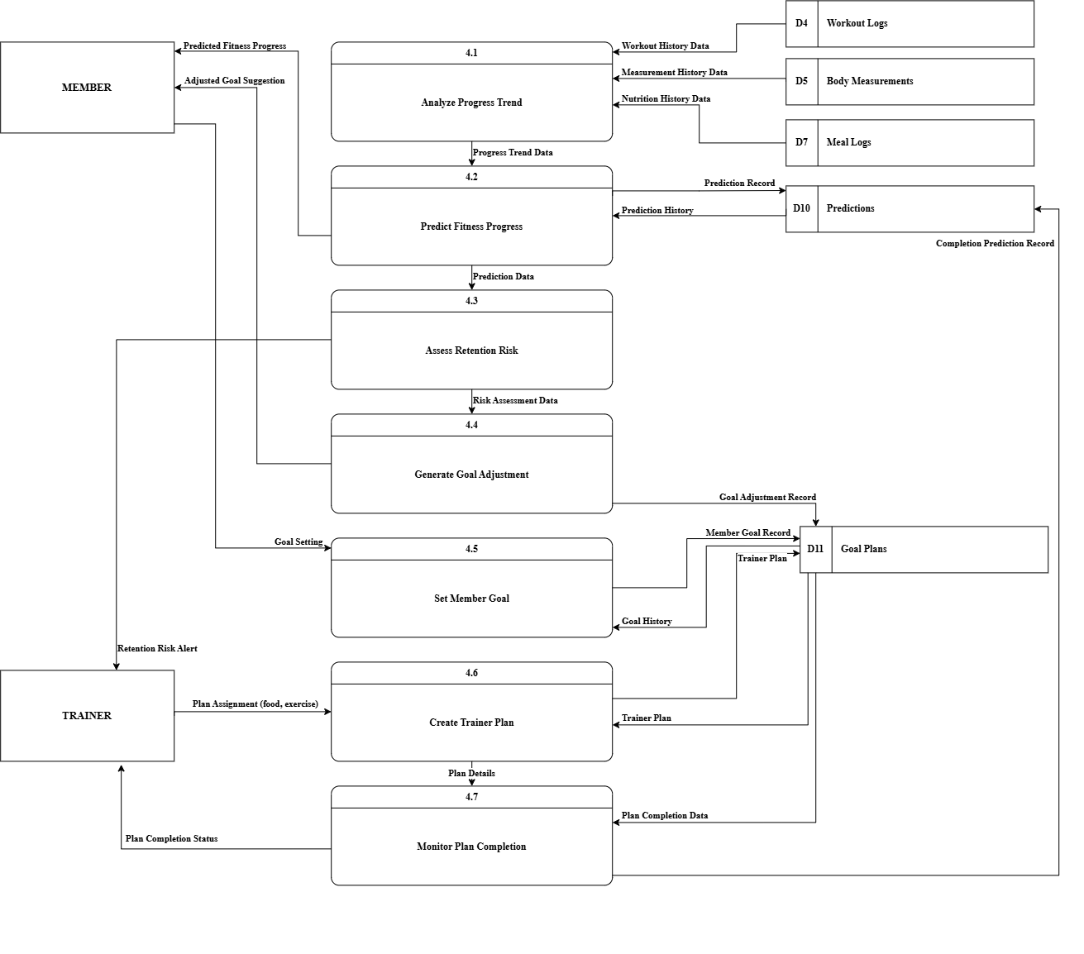
Figure 13: Data Flow Diagram of Process 4 (Proposed)
Figure 13 represents the data flow diagram of process 4 of the proposed system. This diagram decomposes the Generate Predictions and Goal Plans process into seven sub-processes: 4.1 Analyze Progress Trend, 4.2 Predict Fitness Progress, 4.3 Assess Retention Risk, 4.4 Generate Goal Adjustment, 4.5 Set Member Goal, 4.6 Create Trainer Plan, and 4.7 Monitor Plan Completion.

In sub-process 4.1, the workout history data, the measurement history data, and the nutrition history data are retrieved from the Workout Logs, the Body Measurements, and the Meal Logs, and the progress trend data are produced. These data are passed to sub-process4.2, where the predicted fitness progress is generated and the prediction record is written into the Predictions, while the prediction history is retrieved for comparison.

The prediction data are passed to sub-process 4.3, where the retention risk is assessed and the retention risk alert is returned to the Trainer. The risk assessment data are passed to sub-process 4.4, where the adjusted goal suggestion is generated, returned to the Member, and written into the Goal Plans.

In sub-process 4.5, the Member provides the goal setting and the member goal record is written into the Goal Plans, while the goal history is retrieved. In sub-process 4.6, the Trainer provides the plan assignment containing the food plan and the exercise plan, and the trainer plan record is written into the Goal Plans.

In sub-process 4.7, the plan completion data are retrieved from the Goal Plans and the plan completion status is returned to the Trainer, while the completion prediction record is written into the Predictions.
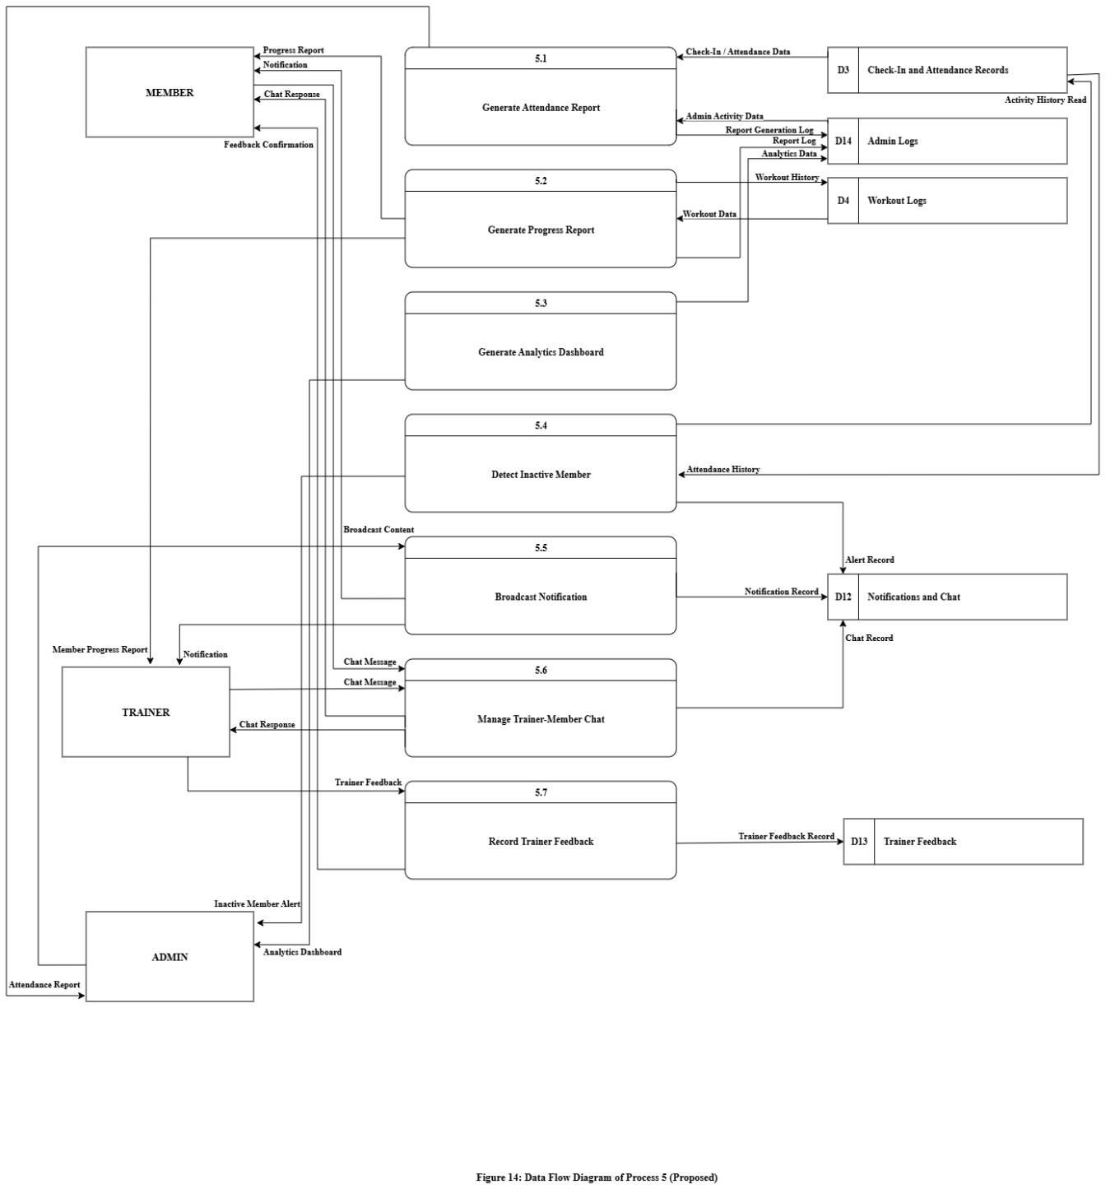
Figure 14: Data Flow Diagram of Process 5 (Proposed)
Figure 14 represents the data flow diagram of process 5 of the proposed system. This diagram decomposes the Generate Reports and Communication process into seven sub-processes: 5.1 Generate Attendance Report, 5.2 Generate Progress Report, 5.3 Generate Analytics Dashboard, 5.4 Detect Inactive Member, 5.5 Broadcast Notification, 5.6 Manage Trainer-Member Chat, and 5.7 Record Trainer Feedback.

In sub-process 5.1, the check-in and attendance data are retrieved from the Check-In and Attendance Records together with the admin activity data from the Admin Logs, and the attendance report is returned to the Admin while the report generation log is written into the Admin Logs.

In sub-process 5.2, the workout data are retrieved from the Workout Logs to generate the progress report, which is returned to the Member and to the Trainer as the member progress
report, while the report log is written into the Admin Logs. In sub-process 5.3, the analytics data log is written into the Admin Logs and the analytics dashboard is returned to the Admin.

In sub-process 5.4, the attendance history is retrieved from the Check-In and Attendance Records to identify members who have stopped attending. The inactive member alert is returned to the Admin and the alert record is written into the Notifications and Chat.

In sub-process 5.5, the Admin provides the broadcast content, which is written into the Notifications and Chat and returned to the Member and the Trainer as a notification. In sub-process 5.6, the chat messages of the Member and the Trainer are exchanged, the chat record is written into the Notifications and Chat, and the chat responses are returned to both parties.

In sub-process 5.7, the Trainer provides the trainer feedback content and the Member provides the trainer rating. The trainer feedback record is written into the Trainer Feedback and the feedback confirmation is returned to the Member.

3.6 ACTIVITY DIAGRAM
An activity diagrams are graphical representations of workflows of stepwise activities and actions with support for choice, iteration and concurrency. Activity diagrams may be regarded as a form of flowchart.

