**administrator**

-add office,end user"barangay" it can be processing or viewer-add user inside the office and barangay

-receive and accept or decline

-foward document

-request documents

-report can be print

-view tracking history

- can change password

**department**

- request doc

- view end-user info or document,

- accept, decline, receive

- forward doc.

- see tracking history

- can change password

**end-user**

- request

- view documents

- can change password

**proccessing**

- can request,forward document

- accept, decline, receive

- see tracking history

viewer

- can request

- tracking history

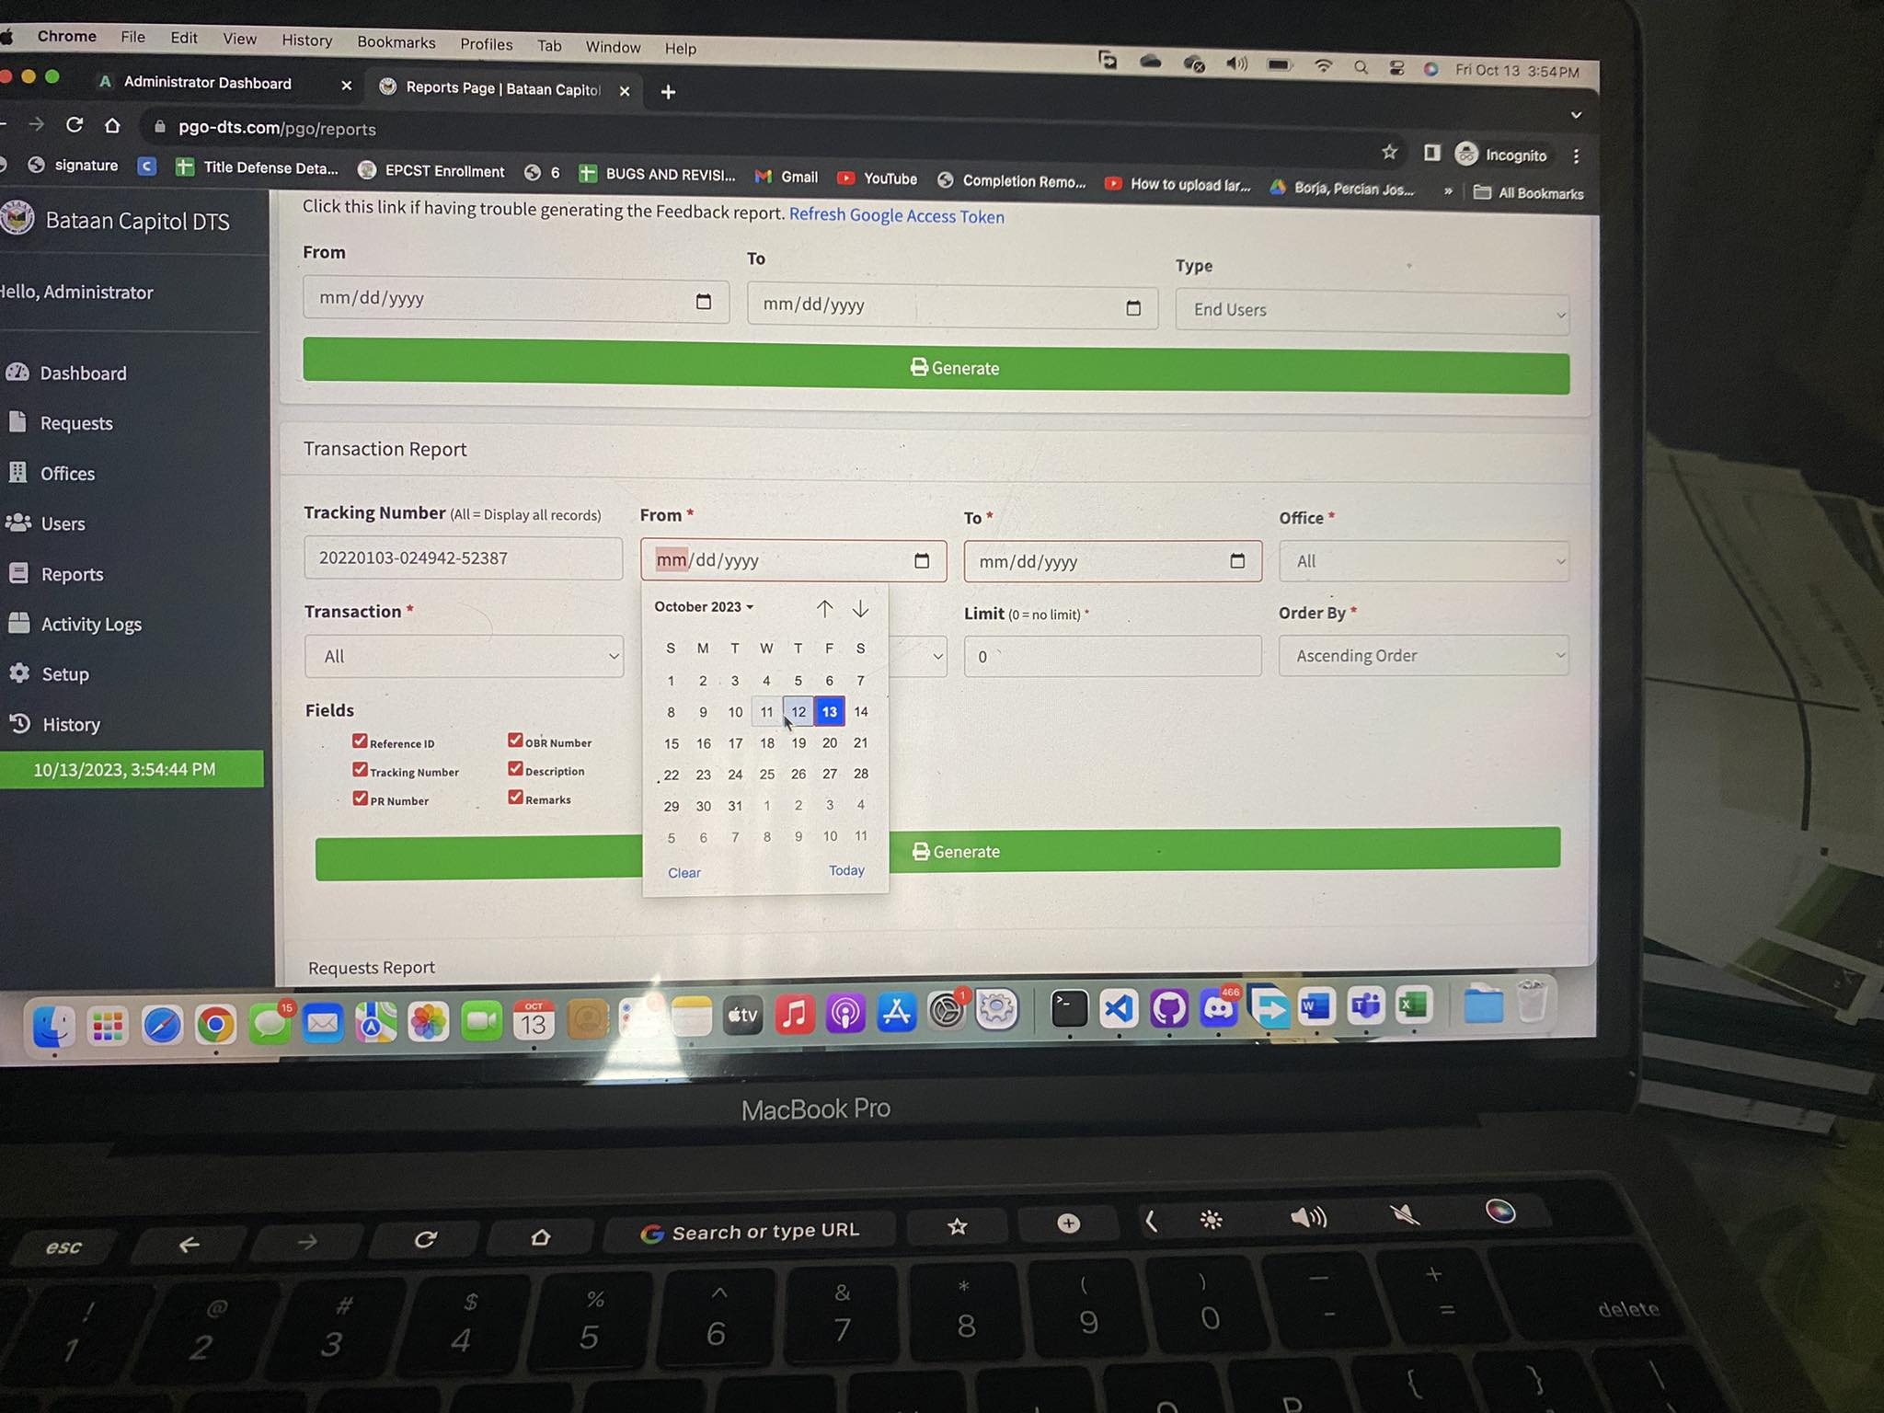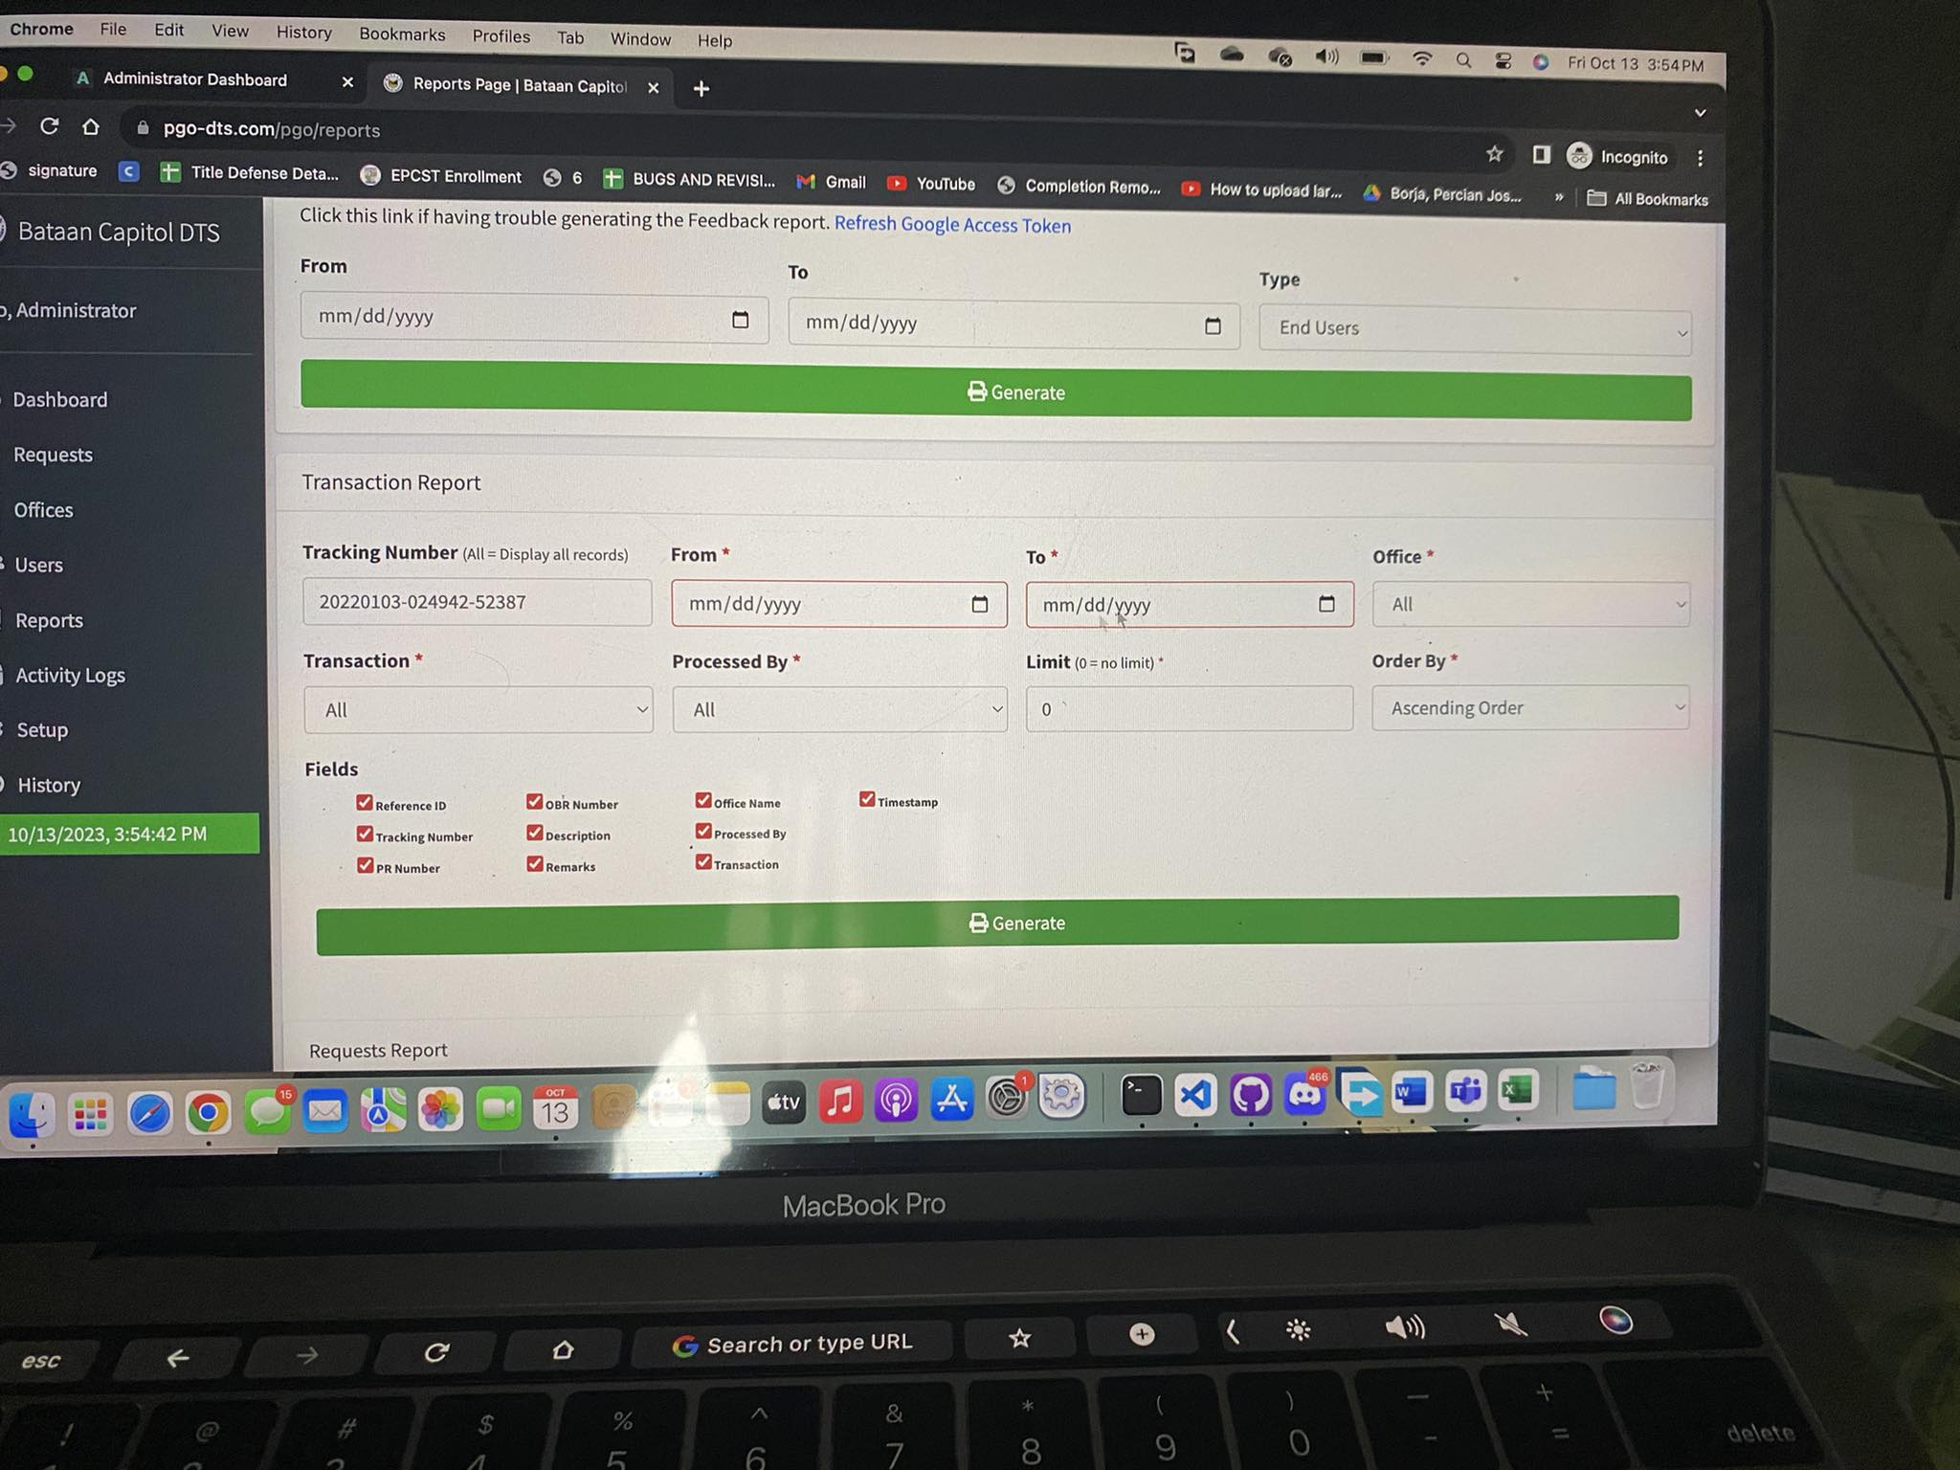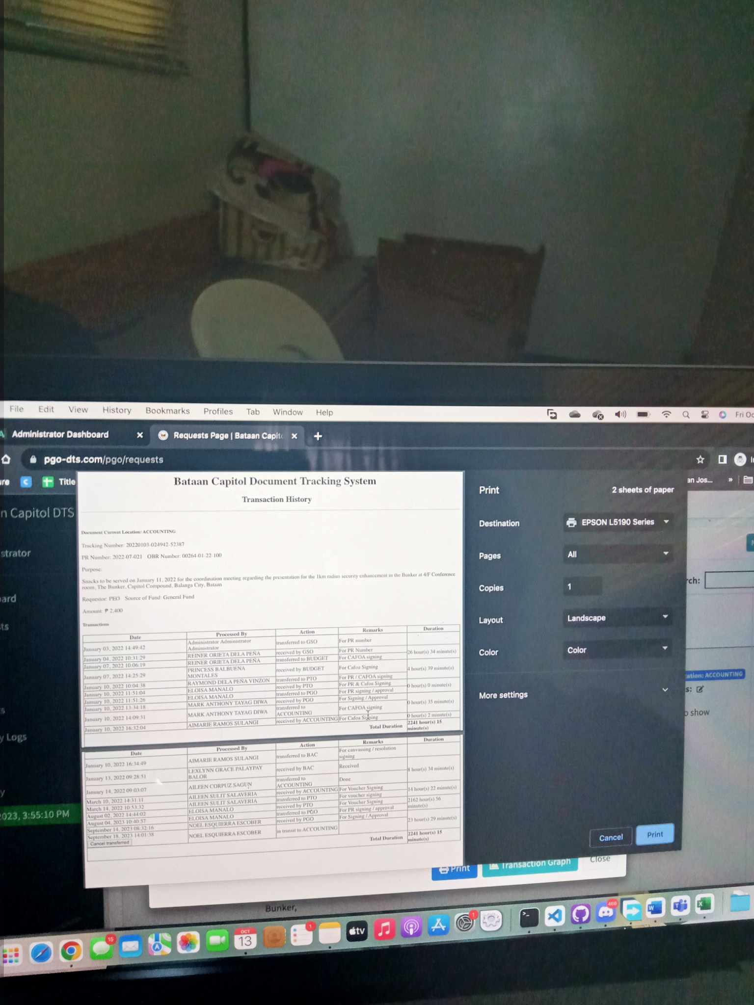

Photo of the report

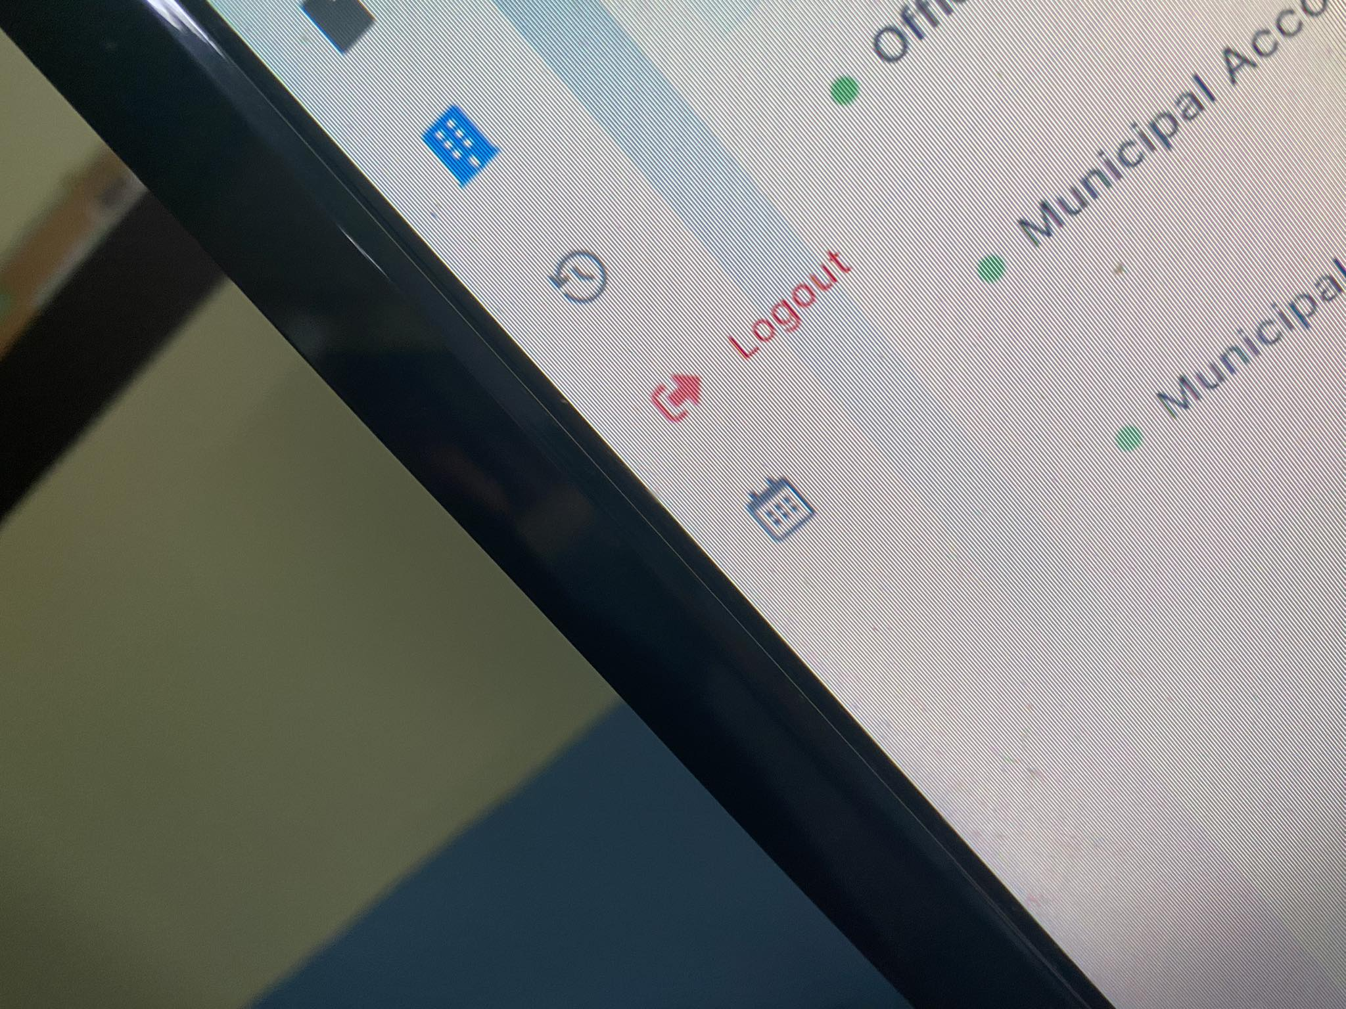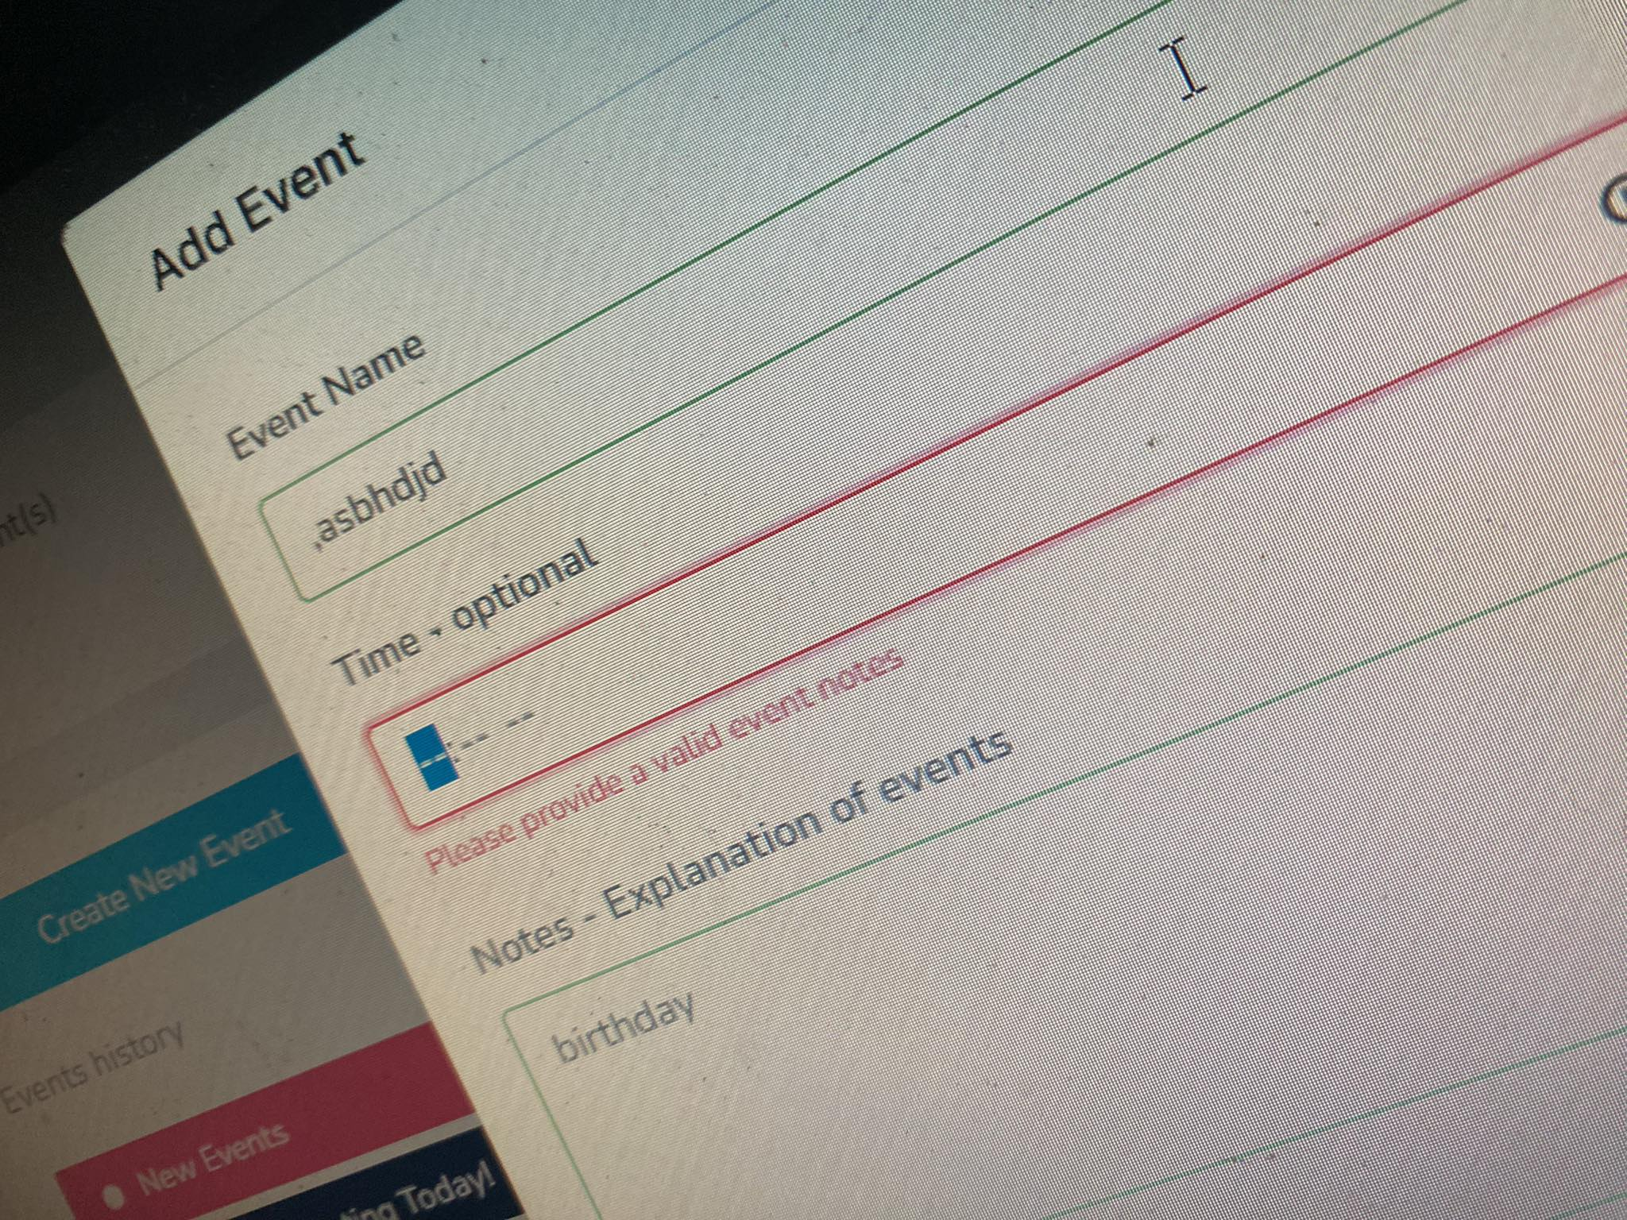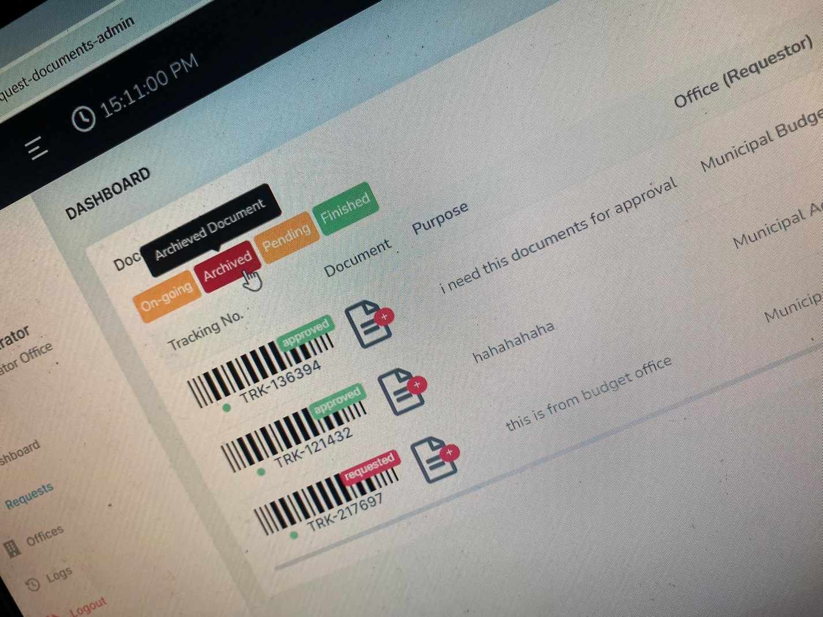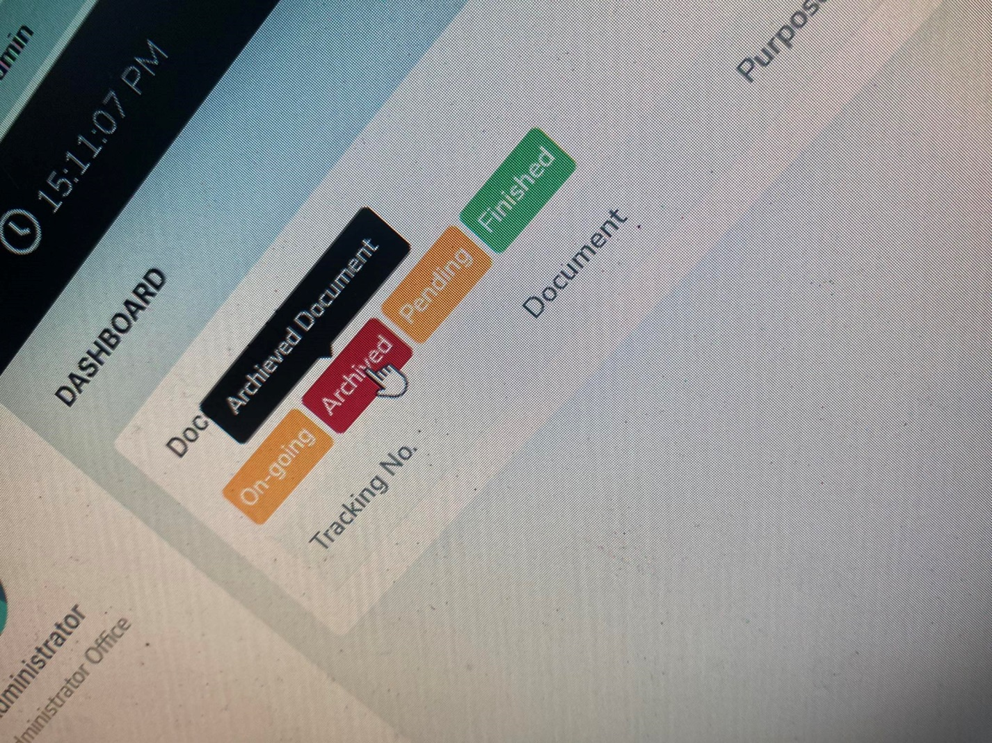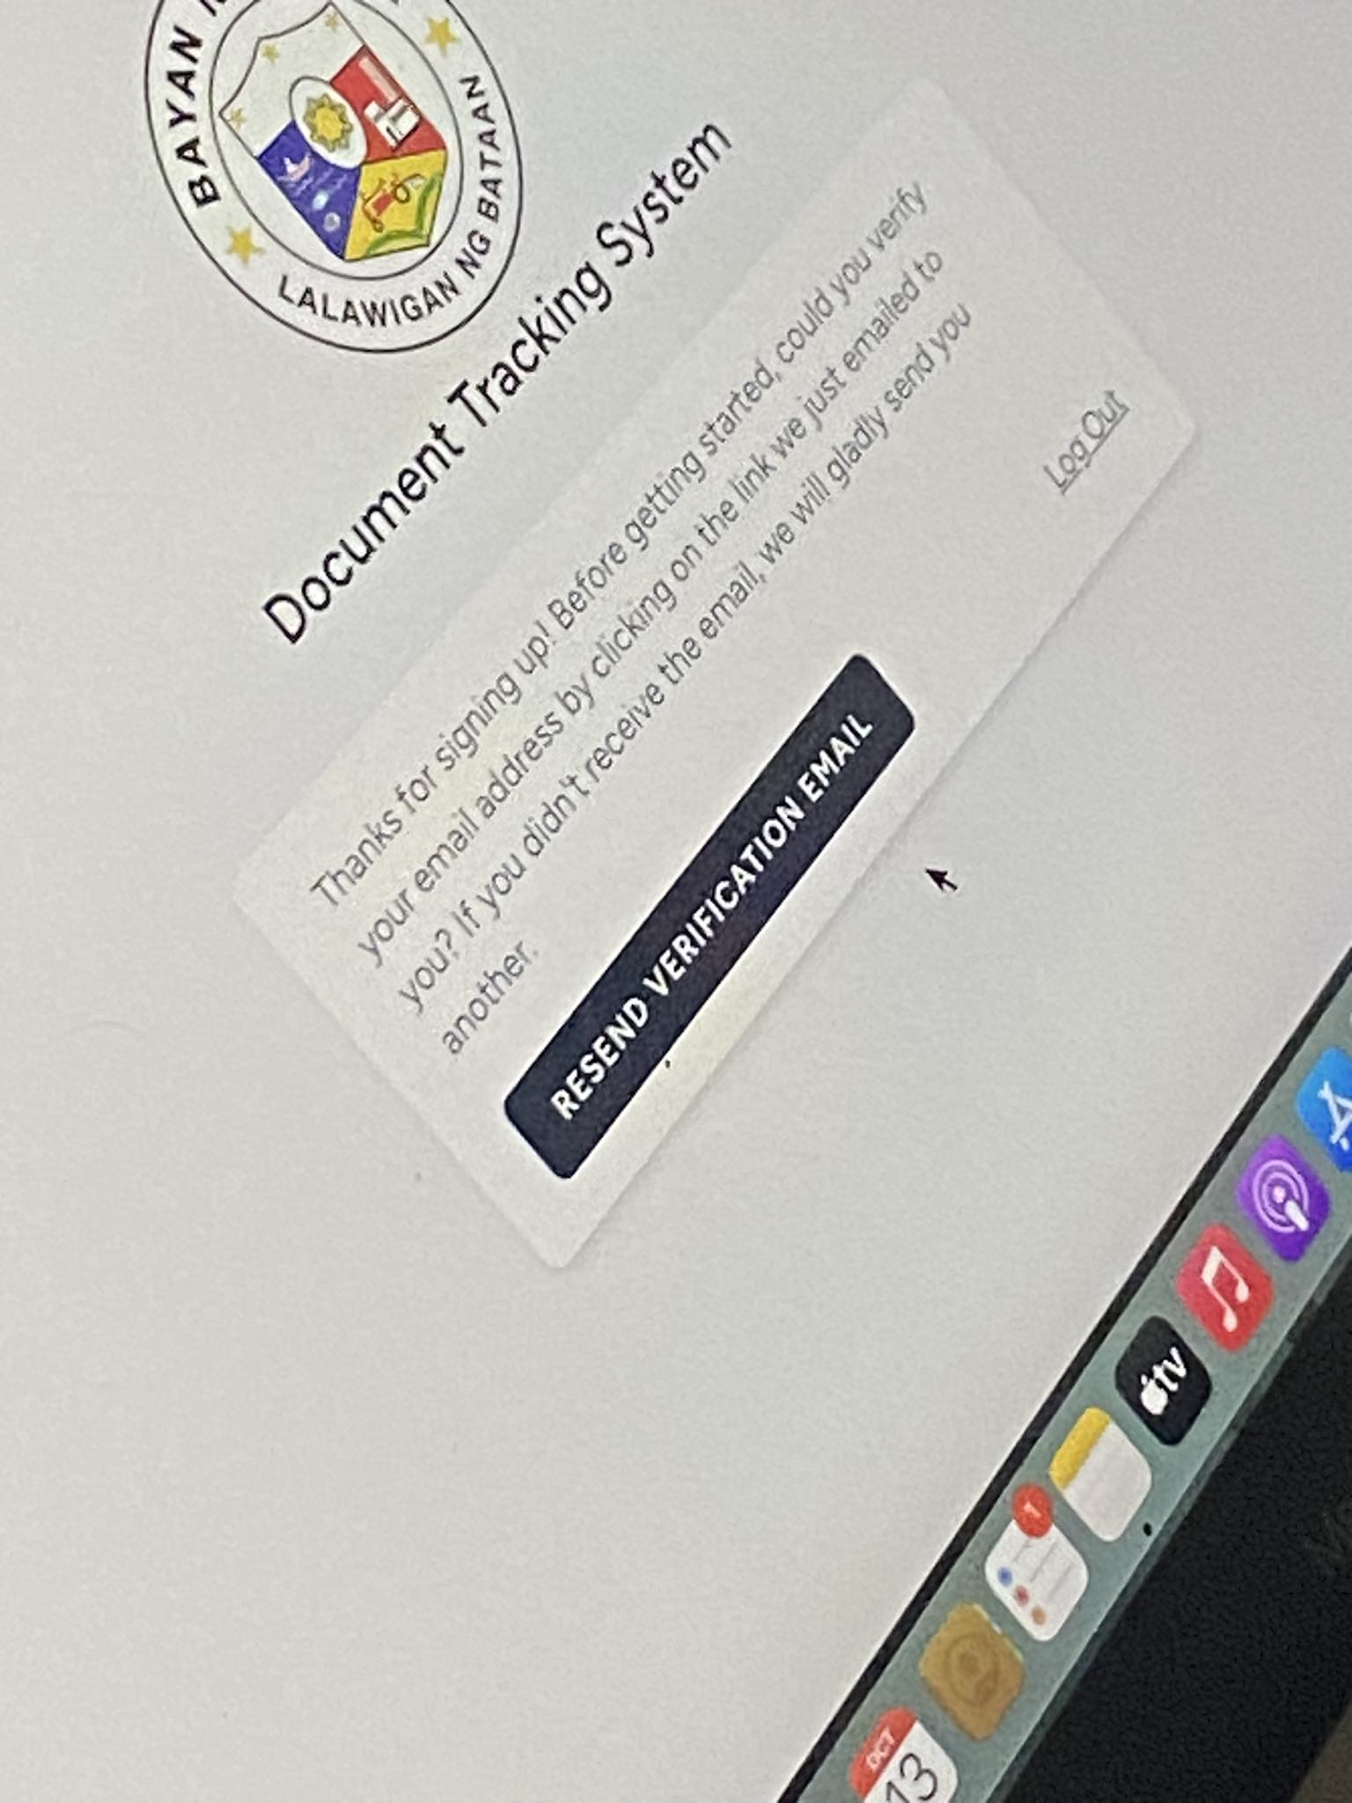

Nag error sya kuya kasi need pa din sya lagyan kahit optional lang

Ung logout na word kuya di sya nawawala

Need ayusin ug button kasi di sya working kuya

Need palitan ng SEND VERIFIATION EMAIL lang kuya