SYSTEM INTEGRATION DOCUMENTATION
Student Information Management System and Student Attendance System Using REST API

Submitted by: John Paul Sibay
Submitted to: Emmanuel Saligue
Date: May 2026
Course / Subject: API Integration / System Integration

Table of Contents
1. System Overview
1.1 Architecture Diagram
1.2 Technology Stack
2. School Portal — PHP Web Application (S1)
2.1 System Purpose
2.2 Main Integrated Features
2.3 Important PHP Files
3. Student Attendance System — C# WinForms Application (S2)
3.1 System Purpose
3.2 Integrated Forms
3.3 Role-Based Access Control
4. Node.js REST API Documentation (S3)
4.1 Server Configuration
4.2 REST API Endpoints
4.3 Standard API Response Format
4.4 Key API Endpoint Details
5. Database Design Overview
5.1 Key Database Relationships
6. Installation and Setup Guide
6.1 Prerequisites
6.2 Step-by-Step Setup
7. Cross-System Data Flow
7.1 Login Flow
7.2 Student, Lecturer, and Parent Flow
7.3 Course, Event, and Attendance Flow
8. Testing and Validation
9. Error Handling and Data Consistency
10. Security Considerations
11. Benefits of the Integration
12. Conclusion

Documentation Focus
This documentation focuses on the primary integration modules of the project, specifically Login/User Authentication, Students, Lecturers, Parents, Courses, Events, and Attendance. The purpose of the document is to demonstrate how two independent systems can share centralized academic records through a REST API architecture while remaining decoupled from each other.
The documentation emphasises the core integration design rather than legacy school modules that are outside the main scope of the integration project.
1. System Overview

This project establishes a professional system integration architecture connecting two independently developed academic systems through a centralized REST API and shared database environment.
The first system, referred to as S1, is a PHP-based School Portal hosted through XAMPP and accessed using a web browser. The second system, referred to as S2, is a C# Windows Forms Student Attendance System designed for attendance and academic management operations. Both systems communicate exclusively with S3, a centralized Node.js REST API connected to a shared MySQL database named student_api_db.
The primary objective of the integration is to allow both systems to share official academic records without directly communicating with each other. Instead of using direct database sharing between applications, all operations are routed through S3 using HTTP requests and JSON responses. S3 serves as the sole integration layer and authoritative source of truth for all shared records.
This architecture improves interoperability, maintainability, scalability, and centralized data consistency. Any changes performed in one system are immediately reflected in the other because both systems rely on the same centralized API and database.
1.1 Architecture Diagram
The following diagram illustrates the high-level integration architecture.
┌────────────────────────────────────────────────────┐
│ S1: PHP School Portal (XAMPP) │
│ Administrator / Employee Portal │
└───────────────────────┬────────────────────────────┘
│
HTTP JSON Requests
│
▼
┌────────────────────────────────────────────────────┐
│ S3: Node.js REST API │
│ localhost:3000 │
│ Express.js ──────► MySQL │
│ student_api_db │
└───────────────────────▲────────────────────────────┘
│
HTTP JSON Requests
│
┌───────────────────────┴────────────────────────────┐
│ S2: Student Attendance System (WinForms) │
│ Attendance and Academic Management │
└────────────────────────────────────────────────────┘
Note: S1 and S2 do not directly communicate with each other. All shared records are accessed exclusively through S3 using REST API communication and JSON responses.
1.2 Technology Stack
System | Technology | Role in Integration
S1 — School Portal | PHP / XAMPP / Apache | Web-based academic portal
S2 — Student Attendance System | C# WinForms / .NET Framework | Attendance and academic desktop system
S3 — REST API | Node.js / Express.js | Centralized API and integration middleware
Shared Database | MySQL student_api_db | Central source of truth
Communication Protocol | REST API / HTTP | JSON-based communication
Development Tools | XAMPP, Visual Studio 2022, npm, Postman, phpMyAdmin | Development and testing tools

2. School Portal — PHP Web Application (S1)

2.1 System Purpose
The School Portal (S1) is a PHP-based web application hosted through XAMPP and accessed through a browser. It serves as the administrator and employee portal for managing academic information and viewing centralised attendance records.
Rather than maintaining isolated records, S1 retrieves and manages integrated data through S3 REST API endpoints. This preserves the existing PHP structure while enabling centralised integration with S2 through the shared database.
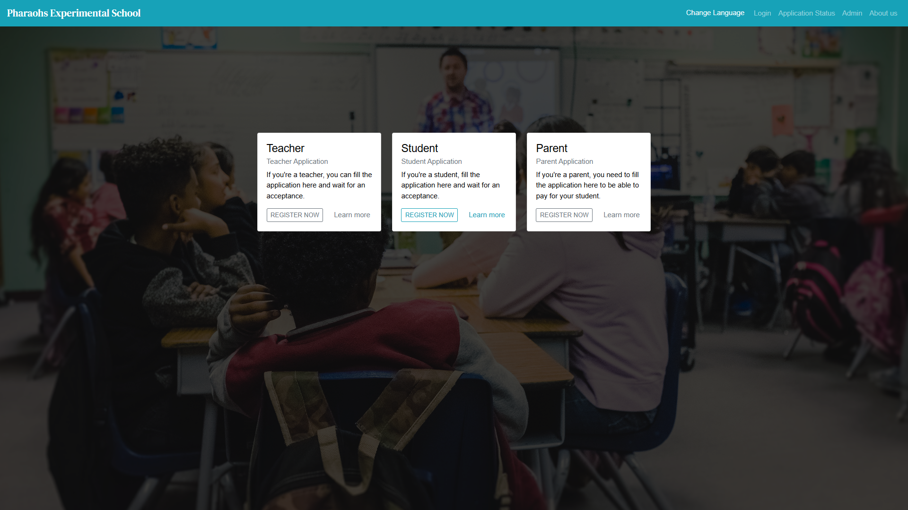
Figure 2.1 — S1 Login Page
2.2 Main Integrated Features
Administrator / Employee Role
- API-based login authentication using /api/login.
- Student management through /api/students.
- Lecturer management through /api/lecturers.
- Parent management through /api/parents.
- Course viewing through /api/courses.
- Event viewing through /api/events.
- Attendance viewing through /api/attendance.
- Centralised academic record retrieval from S3.
Lecturer Role
- View attendance records related to assigned courses.
- Access lecturer-related academic records.
- Retrieve filtered attendance records through lecturer endpoints.
Student Role
- View personal attendance history.
- Retrieve records using linked student_id.
- Access attendance records through API-based filtering.
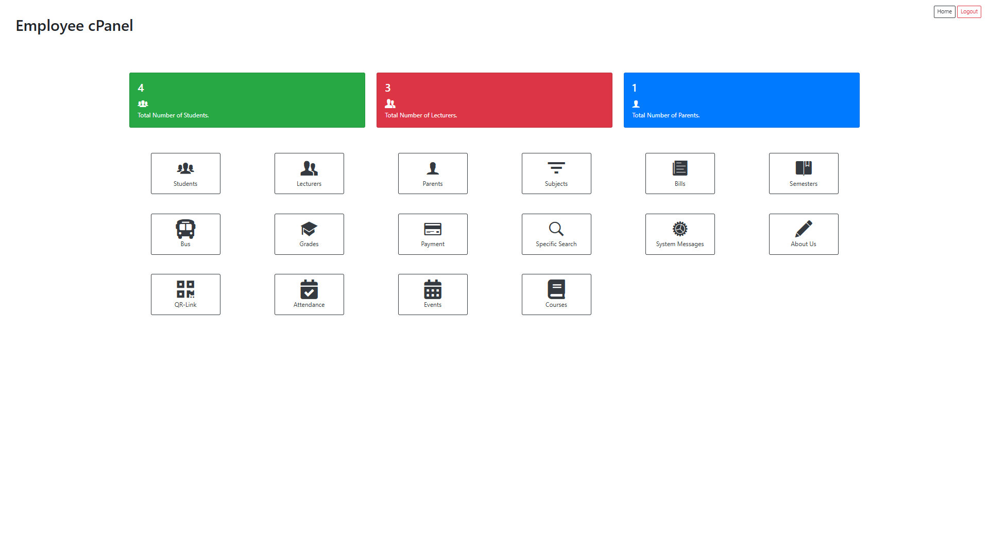
Figure 2.2 — Employee Dashboard
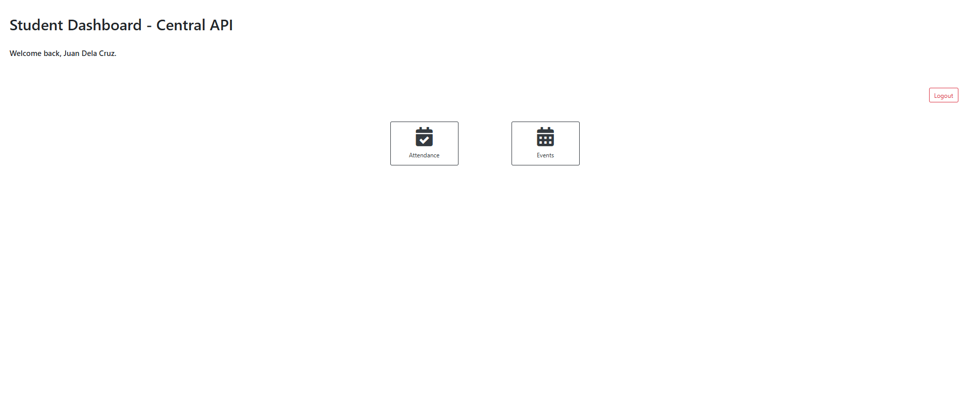
Figure 2.3 — Student Management Page
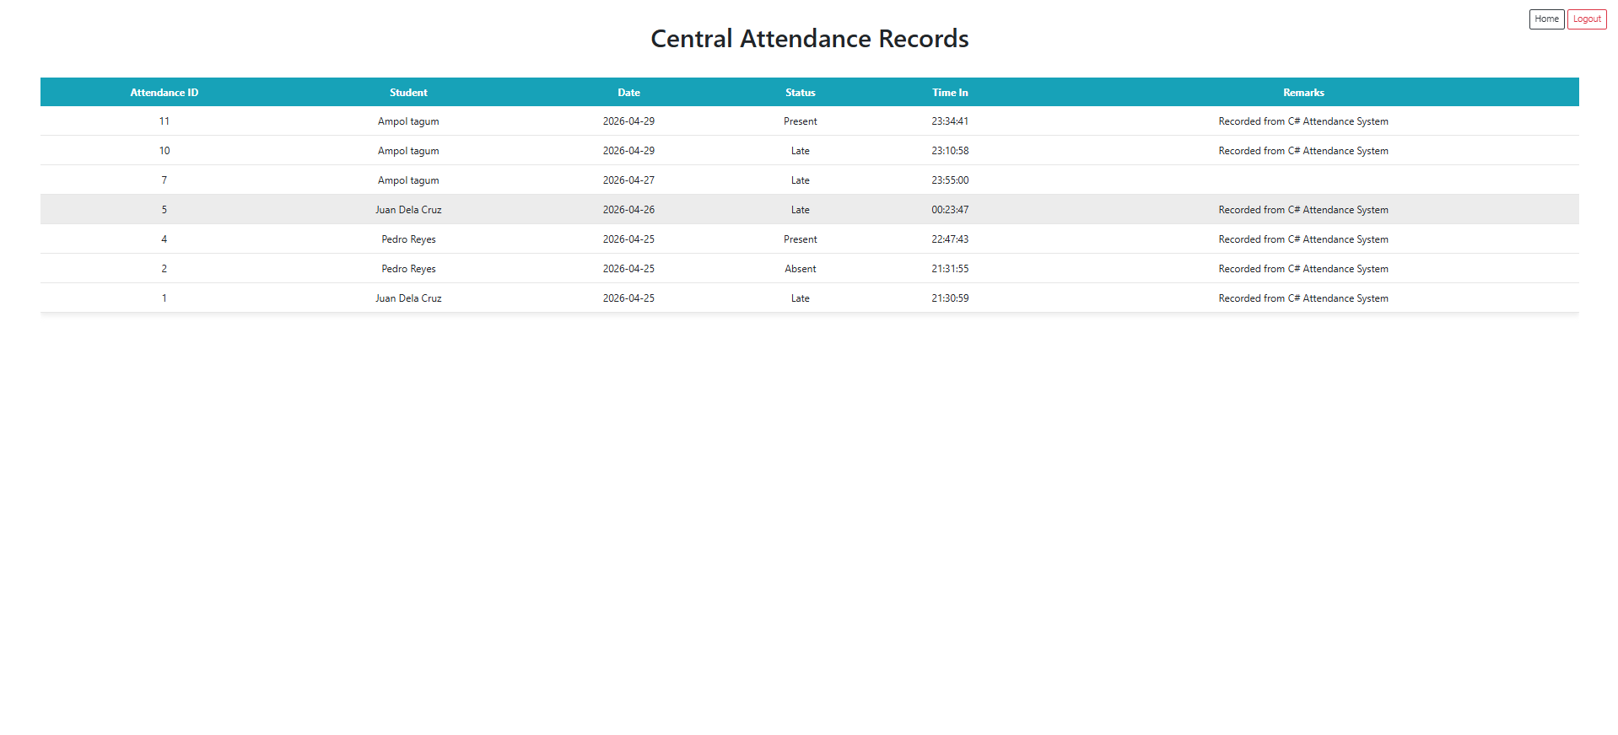
Figure 2.4 — Attendance Records View


Figure 2.5 — Student Attendance View
2.3 Important PHP Files
File Path | Description
login.php | Handles API-based login authentication
employeeLogin.php | Redirects API administrator login to the Employee cPanel
modules/userModel.php | Sends login credentials to S3 /api/login
modules/Employee/Controller/employeeController.php | Main S1 admin controller for API-connected Students, Lecturers, Parents, Courses, Events, and Attendance
modules/Employee/View/employeeView.php | Displays API data and admin forms for central records
modules/Employee/Model/employeeModel.php | Supports existing legacy Employee cPanel behaviour
modules/Student/Controller/studentController.php | Handles student portal access to API-based attendance records
modules/Student/View/studentView.php | Displays student attendance records retrieved from S3

3. Student Attendance System — C# WinForms Application (S2)

3.1 System Purpose
The Student Attendance System (S2) is a C# WinForms desktop application responsible for attendance-related operations and academic management functions.
S2 communicates exclusively with S3 using HTTP requests. It does not directly access the database. All integrated records are stored and retrieved through S3 and the centralised student_api_db database.
The system demonstrates the main integration flow of the project by creating attendance records that become immediately accessible in S1.
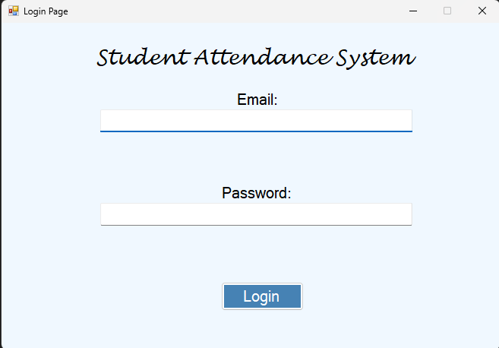
Figure 3.1 — S2 Login Page
3.2 Integrated Forms
Form File | API Endpoints Used | Purpose
LoginPage.cs | POST /api/login | Authenticates users through the central API
UserPage.cs | GET, POST, PUT, DELETE /api/users | Manages central user accounts
LecturerPage.cs | GET /api/lecturers, GET /api/attendance/lecturer/:teacher_id | Displays lecturer data and lecturer-filtered attendance
Course / MataKuliah Page | GET, POST, PUT, DELETE /api/courses, GET /api/lecturers | Manages courses and assigns lecturers
EventPage.cs | GET, POST, PUT, DELETE /api/events, GET /api/courses | Manages events connected to courses
AttendancePage.cs | GET, POST, PUT, DELETE /api/attendance, GET /api/students, GET /api/events | Manages attendance records
StudentPage.cs | GET /api/attendance/student/:student_id | Displays attendance records for logged-in students

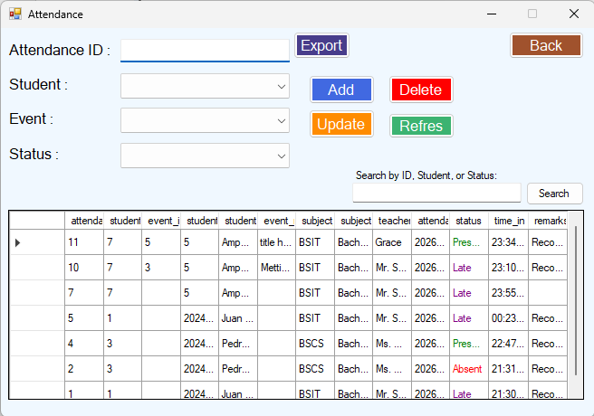
Figure 3.2 — AttendancePage.cs
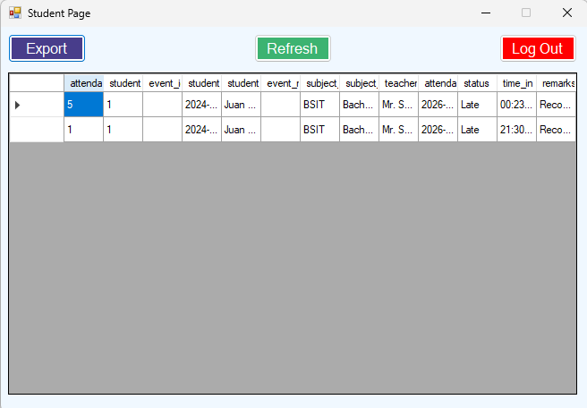
Figure 3.3 — Student Attendance DataGridView
3.3 Role-Based Access Control
The system implements role-based access control using centralised API authentication.
- Administrator — manages integrated records and attendance operations.
- Lecturer — accesses lecturer-specific attendance records.
- Student — views personal attendance records filtered by student_id.
4. Node.js REST API Documentation (S3)

4.1 Server Configuration
Property | Value
Runtime | Node.js
Framework | Express.js
Host | localhost
Port | 3000
Database | MySQL — student_api_db
Entry File | server.js

4.2 REST API Endpoints
Module | Endpoint | Method
Login | /api/login | POST
Users | /api/users | GET, POST, PUT, DELETE
Students | /api/students | GET, POST
Students | /api/students/:id | GET, PUT, DELETE
Lecturers | /api/lecturers | GET, POST
Lecturers | /api/lecturers/:id | GET, PUT, DELETE
Parents | /api/parents | GET, POST
Parents | /api/parents/:id | GET, PUT, DELETE
Courses | /api/courses | GET, POST, PUT, DELETE
Events | /api/events | GET, POST, PUT, DELETE
Attendance | /api/attendance | GET, POST, PUT, DELETE
Student Attendance | /api/attendance/student/:student_id | GET
Lecturer Attendance | /api/attendance/lecturer/:teacher_id | GET

4.3 Standard API Response Format
Successful Response:
{
"status": "success",
"data": []
}
Error Response:
{
"status": "error",
"message": "Description of the error"
}
4.4 Key API Endpoint Details
Endpoint | Description
POST /api/login | Authenticates users and returns role/session data
GET /api/students | Retrieves centralised student records
POST /api/attendance | Creates attendance records
GET /api/attendance/student/:student_id | Retrieves student attendance
GET /api/attendance/lecturer/:teacher_id | Retrieves lecturer attendance records
GET /api/events | Retrieves event records
GET /api/courses | Retrieves official course records

5. Database Design Overview

The centralised database student_api_db stores all integrated academic records and serves as the authoritative source of truth for S1 and S2.
Table | Purpose
users | Stores user accounts and linked identifiers
students | Stores centralised student information
teachers | Stores lecturer records
parents | Stores parent records
courses | Stores official course records
events | Stores attendance-related events
attendance | Stores attendance records

5.1 Key Database Relationships
Relationship | Description
users.student_id → students.student_id | Links student login accounts to student records
users.teacher_id → teachers.teacher_id | Links lecturer login accounts to lecturer records
parents.student_id → students.student_id | Links parent records to student records
courses.teacher_id → teachers.teacher_id | Assigns lecturers to courses
events.course_id → courses.course_id | Links events to courses
attendance.student_id → students.student_id | Links attendance records to students

6. Installation and Setup Guide

6.1 Prerequisites
Software | Purpose
XAMPP | Hosts S1 PHP School Portal
Node.js | Runs S3 REST API
npm | Installs API dependencies
Visual Studio 2022 | Runs S2 WinForms system
MySQL | Hosts integrated database
Postman | API testing

6.2 Step-by-Step Setup
Step 1 — Start XAMPP Services
- Open XAMPP Control Panel.
- Start Apache and MySQL.

Step 2 — Import Database
- Open phpMyAdmin.
- Create student_api_db.
- Import the SQL database file.

Step 3 — Start S3 REST API
- Open terminal in API project folder.
- Run: npm install
- Run: node server.js

Step 4 — Open S1
- Place PHP project inside htdocs.
- Open browser.
- Navigate to localhost project URL.

Step 5 — Run S2
- Open project in Visual Studio 2022.
- Build solution.
- Run application.

Step 6 — Verify API Connectivity
- Open http://localhost:3000/api/students
- Verify valid JSON response.

7. Cross-System Data Flow

7.1 Login Flow
Users authenticate through either S1 or S2 using /api/login. S3 validates credentials using student_api_db and returns session information.
7.2 Student, Lecturer, and Parent Flow
S1 manages Students, Lecturers, and Parents through S3. Changes are stored centrally and immediately accessible to S2.
7.3 Course, Event, and Attendance Flow
S2 manages attendance-related operations through S3. S1 retrieves and displays the same centralised records.
8. Testing and Validation

Test Area | Validation Method
API Connectivity | Verified through browser and Postman
Login Authentication | Tested valid and invalid credentials
Student Records | Verified centralised synchronisation
Lecturer Records | Verified centralised synchronisation
Parent Records | Verified student-parent relationship through S3
Course and Event Records | Verified S2 management and S1 viewing
Attendance Records | Verified cross-system consistency
Data Consistency | Confirmed centralised records from student_api_db

9. Error Handling and Data Consistency

The systems use structured JSON error responses to handle failures gracefully.
Error Scenario | Handling
Invalid login | Returns authentication error
Missing required fields | Returns validation error
Record not found | Returns record-not-found response
API offline | Displays connection failure message
Foreign key conflict | Prevents invalid delete/update when records are still related

Foreign key relationships help maintain data consistency across the centralised database. For example, a lecturer assigned to a course should be reassigned before the lecturer record is deleted.
10. Security Considerations

The architecture centralises all database operations through S3 to minimise direct database exposure.
Recommended future improvements include:
- JWT authentication
- Password hashing using bcrypt
- HTTPS implementation
- Environment variable configuration
- Role-based API authorisation
11. Benefits of the Integration

- Centralised source of truth through student_api_db.
- Independent operation of S1 and S2.
- Improved interoperability between PHP and C# systems.
- Real-time data synchronisation.
- Easier maintenance through centralised API logic.
- Better scalability for future integrations.
- Reduced duplicate academic records.
12. Conclusion

This project successfully demonstrates a professional system integration architecture connecting the PHP School Portal (S1) and the C# Student Attendance System (S2) through a centralised Node.js REST API (S3).
S3 serves as the centralised integration layer and controls all access to the MySQL student_api_db database. By focusing on the integration of Login, Students, Lecturers, Parents, Courses, Events, and Attendance, the project clearly demonstrates how independent systems can share official academic records without direct system-to-system communication.
The final architecture improves interoperability, maintainability, scalability, and centralised data consistency while establishing a strong foundation for future API-based academic systems.

