|  |
| --- |
| Data Communications 2013 |
| Testing Document |
| Comm Audio |

|  |
| --- |
| Jesse Wright, Luke Tao  April 1 2013 |

|  |  |  |
| --- | --- | --- |
| Test | Expected Result | Result |
| Connecting to Sever for File Transfer | Server will accept connection and create a socket to deal with client request. | Refer to figure 1 |
| Multicast Playing Library | See the name of the current song being sent to the multicast group. | Refer to figure 2 |
| Client Getting a list of songs on the server. | Client should print a list of songs that the server sends over. | Refer to figure 3 |
| File Transfer Actually complete. | We should be able to see the new audio file on the client and play it in any media player. | Refer to figure 4 |
|  |  |  |

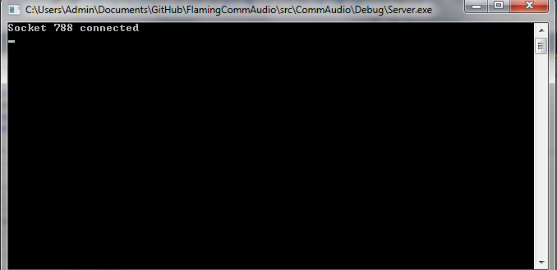

Figure 1.

After a client connects to the server we are notified that we someone has connected and present the socket number. Something similar to this happens when the client disconnects as well.

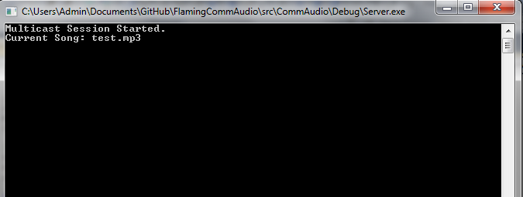

Figure 2.

When the multicast server starts we are prompted with a message saying the server has started. The current song will be displayed whenever the song changes.

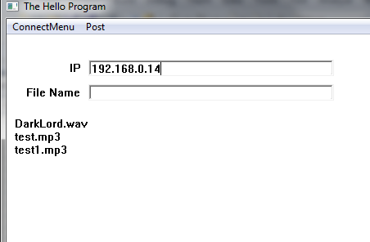

Figure 3.

Once the client connects to the server, the server responds with a list of files that the client can choose from to download.

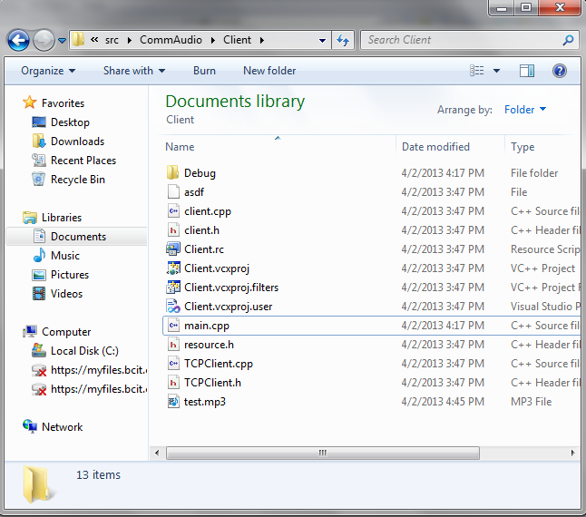

Figure 4.

Once the client has finished receiving data from the server we can check the current directory and see that the "Test.mp3" has been transferred.