|  |
| --- |
|  |
| Sonim-SafetyLine Mobile Application |
| Design Document |
|  |
| **John Payment**  **Aaron Lee**  **Steve Lo**  **Luke Tao** |
| **4/25/2013** |

Table of Contents

Use Case Scenario 3

Controls 4

Red Side Button 4

‘2’ Button (Yellow) 4

‘3’ Button (Green) 4

Check-in Component 5

Sign-out Component 6

Configurator Component 7

## Use Case Scenario

|  |  |
| --- | --- |
| **Use Case Name** | Create new reservation order |
| **Use Case Scenario** | User works alone |
| **Brief Description Of Use Case** | When user works alone, user presses sign in button. User checks in every set interval by pressing the check in button. When the user is done his work shift, he presses the sign out button. |
| **Actors** | Worker |
| **Related Use Cases** | Customer reserves vehicle over phone, customer reserves vehicle in-person |
| **Stakeholders** | Tsunami Ltd: to provide access to the SafetyLine service  Sonim: to provide access to the phone functions |
| **Preconditions** | Worker and Sonim phone must be present.  SafetyLine servers must be running. |
| **Postconditions** | Worker logged in to SafetyLine server (checked in and out). |
| ***Activities Flow*** | ***Actor Action***   1. Worker inputs login credentials 2. Worker presses sign in button 3. Worker presses check in button at predetermined intervals 4. Worker presses sign out button |
| **Exception Conditions** | 3.1 If worker does not check in before interval, SafetyLine will send notifications to emergency contacts |

## Controls

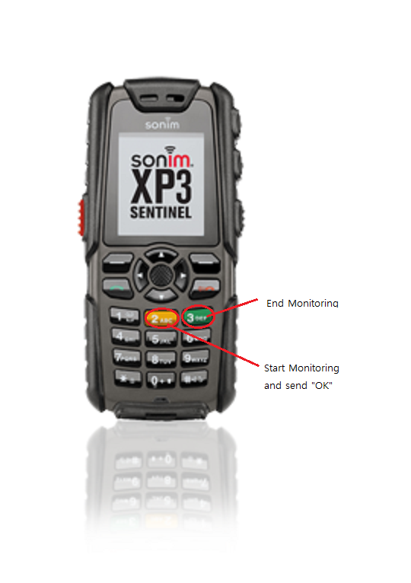

### Red Side Button

When the red button is pressed, it should display “Emergency Response Centre called” on the phone if the message was successfully sent to SafetyLine.

### ‘2’ Button (Yellow)

When the yellow button is pressed, it should display “Check-in complete” on the phone  if the message was successfully sent to SafetyLine.

### ‘3’ Button (Green)

When the green button is held down, it should display “Signed off” on the phone if the message was successfully sent to SafetyLine.

## Check-in Component

The user holds down the ‘2’ key to launch this application. The application will read the configuration settings stored on the phone to build a XML formatted message to send to the SafetyLine servers. If successful, a notification will appear notifying the user that the transmission was successful. As soon as the application exits, the “sign-on” switch is toggled to remind the worker to check in at fixed intervals and messages will be relayed to the SafetyLine servers.



## Sign-out Component

When the user holds presses the ‘3’ key, the application will send out a XML-formatted message to the SafetyLine server that the worker is signing out. If the transmission is successful, a message will pop-up informing the user that the sign-out was successful. Also, the “sign-on” switch will be toggled.



## Configurator Component

This separate application is used to change parameters of the button applications. It will be used, primarily, to set the SafetyLine server login credentials. All settings will be saved to an internal file that will be read by the other applications to ensure persistence.

