|  |
| --- |
| COMP 4908 |
| Sonim SafetyLine Phone Project |
| Installation Guide |
|  |
| **By Luke Tao** |
|  |

|  |
| --- |
|  |

Table of Contents

Getting Started 3

Installing Java ME to NetBeans 7.3 5

# Getting Started

The steps below provides a link to download and install requirements in order to run the Sonim Phone applications.

1. Download the Java SE Development Kit 7u21 from <http://www.oracle.com/technetwork/java/javase/downloads/jdk7-downloads-1880260.html>

Accept License Agreement and download the JDK, specifying a desired OS (highlighted is the Windows 64-bit version). Install the JDK.

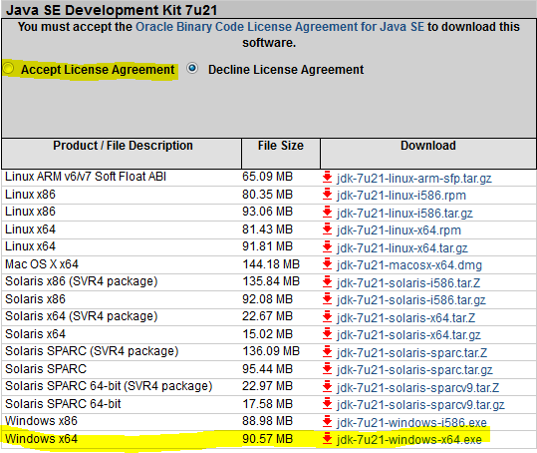

1. Download and install NetBeans 7.3 from <https://netbeans.org/downloads/>

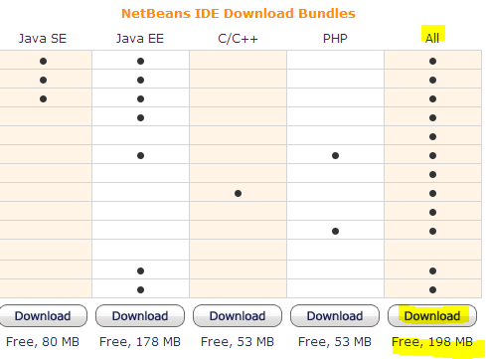

1. Download and install Java ME SDK 3.2 from <http://www.oracle.com/technetwork/java/javame/javamobile/download/sdk/index.html>

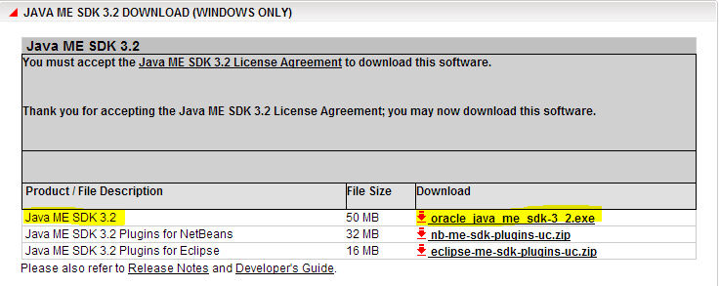

# Installing Java ME to NetBeans 7.3

Now that you installed the JDK, Netbeans, and Java ME, it's now time to integrate the Java ME to Netbeans so that we can run the apps for our mobile emulator.

1.