Contents

Summary 2

Test Cases 2

Change Language from English to French 2

Expected Result 2

Actual Result 2

Verification 2

Change Language from French to English 2

Expected Result 2

Actual Result 2

Verification 3

Login Using Valid Credentials 3

Expected Result 3

Actual Result 3

Verification 3

Login Using Invalid Credentials 3

Expected Result 3

Actual Result 3

Verification 4

Review Saved Login Information While Logged In 4

Expected Result 4

Actual Result 4

Verification 4

Turn off the Service 4

Expected Result 4

Actual Result 4

Verification 4

Check-in with Stored Credentials 4

Expected Result 4

Actual Result 4

Verification 4

Send Formatted Data to Safety Line Server 5

Expected Result 5

Actual Result 5

Verification 5

Conclusion 5

# Summary

# Test Cases

## Change Language from English to French

### Expected Result

Success

### Actual Result

Available Language on the configurator is now changed to French. All the text, display messages, and error messages are written in English.

### Verification

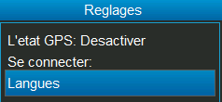

## Change Language from French to English

### Expected Result

Success

### Actual Result

Available Language on the configurator is now changed to English. All the text, display messages, and error messages are written in French.

### Verification

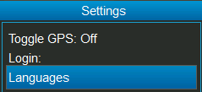

## Login Using Valid Credentials

### Expected Result

Success & The content should be written in a file & Success message

### Actual Result

Login succeeded, all the buttons and features are now functional.

### Verification

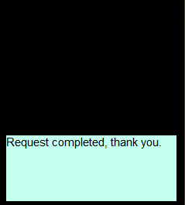

## Login Using Invalid Credentials

### Expected Result

Failure & Error Message

### Actual Result

Error message is displayed to hint invalid credentials entered, failed to login

### Verification

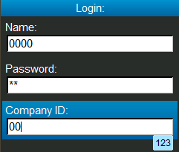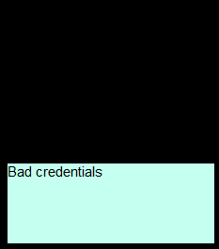

## Review Saved Login Information While Logged In

### Expected Result

Success & displays username

### Actual Result

### Verification

## Turn off the Service

### Expected Result

Displays confirmation & Success

### Actual Result

### Verification

## Check-in with Stored Credentials

### Expected Result

Success

### Actual Result

Success

### Verification

## Send Formatted Data to Safety Line Server

### Expected Result

### Actual Result

### Verification

# Conclusion