|  |
| --- |
|  |
| User Manual |
| **Tsunami Solutions Ltd. SafetyLine Sonim Rugged Phone Application** |
| **John Payment**  **Aaron Lee** |
| **Steve Lo**  **Luke Tao** |
| **5/15/2013** |

|  |
| --- |
|  |

Contents

Introduction 3

Background 3

Features 3

Walkthrough 3

Configurator 4

Button2 5

Button3 6

# Introduction

## Background

The SafetyLine service offered by Tsunami Solutions is a package that helps monitors the status of people who work alone in Canada. The purpose of this project is to make an application coded in Java ME for the Sonim phone to make this process more user friendly. This will allow Tsunami Solutions to offer a better solution for rugged phone users and tap into an additional market area.

Please not that all demonstrations in our case are running from the Java ME emulator.

## Features

* Login to the SafetyLine server is done with the Configurator application
* User can change the application settings with the Configurator application
* After successfully logged in, the user can "check-in" with a single press on the Button 2
* GPS information is sent to the server when "check-in"
* User can "Sign off" with only a single press on the Button 3, and all the monitoring from the server will be stopped

# Walkthrough

Run our applications using NetBeans by pressing the Run (green arrow) button on the top.

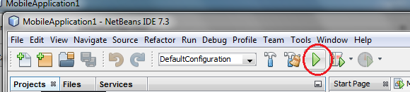

## Configurator

The Configurator allows user to login to the SafetyLine server

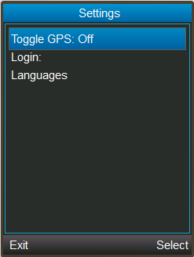

One you start the Configurator:

* Toggle GPS - toggle the GPS feature, send the information to the server or not
* Login - login to the server with your Username, password, and Company ID

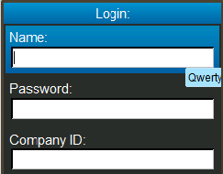



Error is displayed when invalid credentials are used

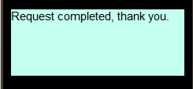

Login succeeded

* Languages - change the display language to English or French
* Exit - exit the application

## Button2

Button2 is the "check-in" button. The application connects and sends the "check-in" message as soon as it runs.

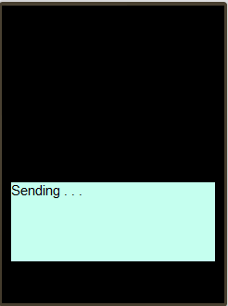

Sending check-in information...

A message will be display when "check-in" succeeded, and the next check-in time will be shown to remind the user.

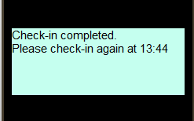

## Button3

Button3 is the "sign-off" button. The application connects and sends the "sign-off" message as soon as it runs.



Sending check-in information...

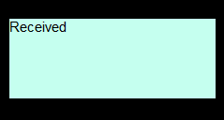

"Sign-off" information is sent and received by the server