## Controls



* The Red Button
  + When the red button is pressed, it should display “Emergency Response Centre called” on the phone if the message was successfully sent to SafetyLine.
* ‘2’ Button (Yellow)
  + When the yellow button is pressed, it should display “Check-in complete” on the phone  if the message was successfully sent to SafetyLine.
* ‘3’ Button (Green)
  + When the green button is held down, it should display “Signed off” on the phone if the message was successfully sent to SafetyLine.
* ‘5’ Button
  + When the ‘5’ button is held down, the “Man-down” function will be toggled on or off with a message being displayed to notify the user.

## Check-in Component

The user holds down the ‘2’ key to launch this application. The application will read the configuration settings stored on the phone to build a XML formatted message to send to the SafetyLine servers. If successful, a notification will appear notifying the user that the transmission was successful. As soon as the application exits, the “sign-on” switch is toggled to remind the worker to check in at fixed intervals and messages will be relayed to the SafetyLine servers.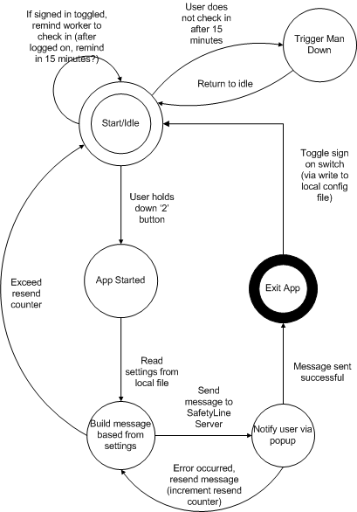

## Sign-out Component

When the user holds presses the ‘3’ key, the application will send out a XML-formatted message to the SafetyLine server that the worker is signing out. If the transmission is successful, a message will pop-up informing the user that the sign-out was successful. Also, the “sign-on” switch will be toggled.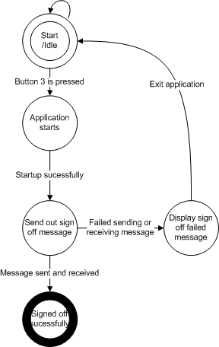

## Configurator Component

This Java application is used to change the parameters of the phone with a configuration file. This configuration will take effect when the Sonim-SafetyLine applications are restarted.