9-Hour Hands-on Java Training: Library Management System
Target audience: Second-year UG Computer Science students
Role: Java Trainer
Duration: 9 hours
Training approach: Learn the concept → demonstrate a small program → implement a feature in the Library Management System → test the feature.
The best way to conduct this training is to develop one complete, console-based Java project throughout the nine hours. Students will learn Java fundamentals while building a practical application rather than studying each topic independently.

Training objectives
By the end of the training, students should be able to:
  - Understand Java program structure, variables, data types, operators, control statements, methods, classes and objects.
  - Apply encapsulation, constructors, collections and exception handling in a real application.
  - Use Lambda expressions to filter, search and sort library records.
  - Use the Java Date and Time API to record borrowing dates, calculate due dates and identify overdue books.
  - Understand the Java Platform Module System (JPMS) and create a modular Java application.
  - Develop, execute and test a Library Management System using a step-by-step implementation approach.

Nine-hour training schedule
The schedule below assumes nine instructional hours, excluding any separate lunch break.

1 hr

Hour 1
Session 1 — Java fundamentals and project setup
JDK, JRE, JVM, compilation and execution
main() method, variables, data types and operators
if , switch , loops and console input
Create the project and display the library menu

Deliverable: Running menu-driven Java application.
1 hr

Hour 2
Session 2 — Classes, objects and encapsulation
Define Book and Borrower classes
Fields, constructors, getters and setters Access modifiers and object creation

Display book and borrower details

Deliverable: Book and borrower data models.
1 hr  Hour 3 | Session 3 — Collections, methods and exception handling  ArrayList , List and Map Add, view and search books Store borrowers and transactions  Validate input and handle invalid operations  Deliverable: Book catalogue and borrower registry.
1 hr  Hour 4 | Session 4 — Borrowing, returning and business rules  Issue a book to a borrower  Prevent issuing an unavailable book Return a book and update availability Create and track transaction records  Deliverable: Working circulation workflow.
1 hr  Hour 5 | Session 5 — Java Date and Time API  LocalDate , Period and ChronoUnit Borrow date, due date and return date Date arithmetic and overdue calculation Display overdue transactions  Deliverable: Date-aware borrowing and overdue reports.
1 hr  Hour 6 | Session 6 — Lambda expressions  Functional interfaces and Predicate  Lambda syntax: (parameters) -> expression  Filter books by title, author or availability Sort books using Comparator and lambdas  Deliverable: Search, filter and sort features.
1 hr  Hour 7 | Session 7 — Java Modules (JPMS)  Why modules are useful  module-info.java

exports and requires
Separate model, service and application modules

Deliverable: Modularized library application.
1 hr Session 8 — Integration and complete application testing
Integrate all modules and features
^{Hour} ⁸ Test valid and invalid inputs
Verify issue, return and overdue workflows Correct compilation and runtime errors
Deliverable: Integrated, tested application.

1 hr Session 9 — Student hands-on challenge and evaluation
Add one new feature independently
^{Hour} ⁹ Run test cases and demonstrate the application Explain lambdas, dates and modules
Review code quality and possible enhancements

Deliverable: Demonstrated project and individual assessment.

Project requirements and feature list
Project title: University Library Management System

The university wants a simple application to manage its books, borrowers and borrowing transactions. For a nine-hour training session, use a console application with in-memory collections. This keeps the focus on Java rather than database configuration or UI development.

Module Features students implement

Book management Add, view, search and sort books

Borrower management Register and view borrowers

Issue management Issue available books and calculate due dates
Return management Record returns and update availability Transaction management View loan history and current loans Overdue report Identify books past their due date

Java enhancements Lambda expressions, Date API and JPMS modules

Business rules
- Every book has a unique ID, title, author and availability status.
- Every borrower has a unique ID, name and email.
- Only available books can be issued.
- A loan is assigned a borrowing date and a due date 14 days later.
- A returned book becomes available again.
- A loan is overdue when it has not been returned and the current date is after its due date.
- Searching should be case-insensitive, and books can be sorted by title.
- Invalid book IDs, borrower IDs and duplicate registrations must be handled appropriately.

Project architecture
Use Java 17 or later so the students can use the module system and modern Java features.
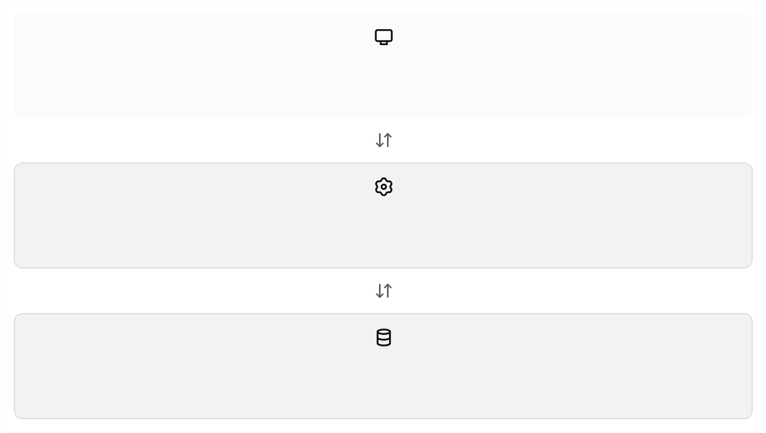
library.app
Main menu and console input
library.core
LibraryService, collections, lambda expressions and Date API
library.model
Book, Borrower and Loan classes

This three-module structure demonstrates JPMS clearly. The project uses collections for temporary storage; data will be lost when the application exits. Persistent storage can be a later extension.

Complete Java project source code
Create the following folder structure:



Plain text

LibraryManagementSystem/
└── src/


├── library.model/
│ ├── module-info.java
│ └── com/university/library/model/
│ ├── Book.java
│ ├── Borrower.java
│ └── Loan.java
├── library.core/
│ ├── module-info.java
│ └── com/university/library/service/
│ └── LibraryService.java
└── library.app/
├── module-info.java
└── com/university/library/app/
└── Main.java

Module 1: File:
library.model
src/library.model/module-info.java


Java

module library.model {
exports com.university.library.model;
}

This exports the model package so other modules can use its public classes.

File:
Book.java



Java

package com.university.library.model;

public class Book { private final int id;
private final String title; private final String author; private boolean available = true;

public Book(int id, String title, String author) { this.id = id;
this.title = title; this.author = author;
}

public int getId() {


return id;
}

public String getTitle() { return title;

File:
Borrower.java



Java

package com.university.library.model;

public class Borrower { private final int id; private final String name; private final String email;

public Borrower(int id, String name, String email) { this.id = id;
this.name = name; this.email = email;
}

public int getId() { return id;
}

public String getName() { return name;
}

File:
Loan.java



Java

package com.university.library.model;

import java.time.LocalDate;
import java.time.temporal.ChronoUnit;

public class Loan { private final int id;
private final Book book; private final Borrower borrower;
private final LocalDate borrowDate; private final LocalDate dueDate; private LocalDate returnDate;



public Loan(int id, Book book, Borrower borrower, LocalDate borrowDate, LocalDate dueDate) {
this.id = id; this.book = book;
this.borrower = borrower; this.borrowDate = borrowDate;
this.dueDate = dueDate;

Module 2: File:
library.core
src/library.core/module-info.java


Java

module library.core { requires library.model;

exports com.university.library.service;
}

File:
LibraryService.java

This class demonstrates
ArrayList
,
,
, lambda expressions,

and .
HashMap
LocalDate
Predicate
Comparator



Java

package com.university.library.service;

import com.university.library.model.Book; import com.university.library.model.Borrower; import com.university.library.model.Loan;

import java.time.LocalDate; import java.util.ArrayList; import java.util.Comparator; import java.util.HashMap; import java.util.List; import java.util.Map; import java.util.Optional;
import java.util.function.Predicate; import java.util.stream.Collectors;

public class LibraryService {
private final Map<Integer, Book> books = new HashMap<>();

private final Map<Integer, Borrower> borrowers = new HashMap<>(); private final List<Loan> loans = new ArrayList<>();

Module 3: File:
library.app
src/library.app/module-info.java


Java

module library.app { requires library.model; requires library.core;
}

File:
Main.java



Java

package com.university.library.app;

import com.university.library.model.Book; import com.university.library.model.Borrower; import com.university.library.model.Loan;
import com.university.library.service.LibraryService;

import java.util.List; import java.util.Scanner;

public class Main {
private static final Scanner scanner = new Scanner(System.in); private static final LibraryService library = new LibraryService();

public static void main(String[] args) { boolean running = true;

while (running) { printMenu();

Compile and run the modular project
Open a terminal in the installed.
LibraryManagementSystem

directory. Ensure that JDK 17 or later is

Check the Java installation:



Bash

java -version javac -version

Compile all three modules:

Bash

javac -d out --module-source-path src \
-m library.model,library.core,library.app

Run the application:

Bash

java --module-path out \
-m library.app/com.university.library.app.Main

These commands work in a shell that supports multiline commands with backslashes, such as Linux, macOS or Git Bash on Windows. In Windows Command Prompt, enter each command on one line.

Sample test session

Expected application output

Plain text

===== UNIVERSITY LIBRARY =====
- Add Book
- List Books
- Search Books
- Register Borrower
- List Borrowers
- Issue Book
- Return Book
- View Loan History
- View Overdue Loans
0. Exit



Enter choice: 6
Book ID: 101
Borrower ID: 1
Book issued successfully. Borrow date: 2026-10-12
Due date: 2026-10-26

The dates shown are illustrative for the current date. Actual output depends on the system date.

Try issuing book 101 a second time. The application should reject the request because the book is already issued. Return book 101 , then list the books again to verify that its availability has changed.

Detailed trainer delivery plan
Use the following practical sequence so students progressively build the application.

Hour 1 — Fundamentals
Explain: JDK, JVM, source code, bytecode, main() , variables, operators, conditions and loops.
Demonstrate: A small menu using Scanner and switch .
Student activity: Print the library menu and repeatedly accept choices until Exit is selected.
Check understanding: Ask students to explain why a loop is needed in a menu-driven program.

Hour 2 — Object-oriented Java
Explain: Classes, objects, fields, constructors, methods, access modifiers and encapsulation.
Demonstrate: Create a Book object and print its details.
Student activity: Create Book and Borrower classes, then instantiate three books.
Check understanding: Ask why fields should be private and why constructors are useful.

Hour 3 — Collections and validation Explain: Lists, maps, generics and exceptions.
Demonstrate: Store books using a Map<Integer, Book> and prevent duplicate IDs.
Student activity: Implement adding, listing and searching books.
Check understanding: Ask why a map is useful when each book has a unique ID.

Hour 4 — Transactions

Explain: Relationships between objects and validation of business rules.
Demonstrate: Issue a book, mark it unavailable and create a loan.
Student activity: Implement issuing, returning and loan-history display.
Check understanding: Test issuing an unavailable book and returning a book without an active loan.


Hour 5 — Date API
Explain: Immutable dates, plusDays() , isAfter() and ChronoUnit.DAYS.between() .
Demonstrate:
Java

LocalDate borrowDate = LocalDate.now(); LocalDate dueDate = borrowDate.plusDays(14);

System.out.println("Borrowed: " + borrowDate); System.out.println("Due: " + dueDate);
Student activity: Add due dates and overdue calculations to the loan workflow.
Check understanding: Ask students to calculate the due date for a book borrowed on a specified date.
Hour 6 — Lambda expressions
Explain: Functional interfaces, lambda syntax, method references, streams, filter() and
sorted() .
Demonstrate:

Java

books.stream()
.filter(book -> book.isAvailable())
.sorted(Comparator.comparing(Book::getTitle))
.forEach(System.out::println);

Student activity: Implement title/author search, available-book filtering and alphabetical sorting.

Map<Integer, Book>
Check understanding: Ask students to explain what the lambda expression passed to
filter() does.
Hour 7 — Java modules
Explain: Modules, packages, exported APIs and dependencies.
Demonstrate: Create three module-info.java files and compile the application.
Student activity: Separate the models, services and console application into modules.
Check understanding: Ask what happens if library.core does not declare requires library.model .
Hour 8 — Integration and testing
Explain: Integration testing, invalid input and regression testing.
Student activity: Run all menu operations and correct errors.
Trainer checklist: Verify duplicate IDs, invalid references, unavailable books, valid returns and overdue calculations.
Hour 9 — Assessment
Students complete an independent extension, demonstrate their code and explain the concepts used.
Suggested challenge: Add a report that counts how many books are available and how many are issued, using streams and lambda expressions.

Java concepts mapped to the project

Topic Where students apply it
Loan

Variables and data types Book IDs, titles, availability

Conditions and loops Menu and business-rule validation

Classes and objects Book , Borrower ,

Encapsulation Private fields and public methods

Collections and generics List<Book> ,

Exception handling Invalid IDs, duplicates and unavailable books

Lambda expressions Search, filter, sort and overdue reports

Java Date API Borrowing, due and return dates
exports

Java modules module-info.java , requires ,

One important teaching point: Lambda expressions were introduced in Java 8, the Date and Time API was also introduced in Java 8, and the Java Platform Module System was introduced in Java 9. They are newer Java features relative to the original Java versions, but they are standard features in modern Java.

9. Student assessment rubric
Assessment criterion | Marks
Java fundamentals and object-oriented design | 20
Book and borrower management | 15
Issue and return transactions | 20
Date API and overdue calculations | 15
Lambda expressions and sorting/filtering | 15
Java modules and compilation | 10
Demonstration and code explanation | 5
Total  10. Suggested student assignments | 100
- Add a feature to search borrowers by name.
- Sort the book list by author.
- Display only available books.
- Add a report of books currently issued to each borrower.
- Display the number of days remaining until a book's due date.
- Modify the overdue report to sort transactions by the number of overdue days.
- Add a maximum borrowing limit of three active books per borrower.
- Add a fine calculation of ₹5 per overdue day, as a university-defined business rule.

Trainer recommendation: Distribute the project skeleton before training, but ask students to implement one feature at a time. Use Hours 1–4 to build the core application, Hours 5–7 to introduce the requested modern Java features, Hour 8 for integration, and Hour 9 for independent implementation and assessment. This makes the nine-hour session practical and achievable for second-year UG students.

