John Robertson

CS330-ZB1

Assignment 05 Report

**Purpose**

The purpose of this assignment was to do some basic operations in assembly code.

**Source Code**

.text

a: .quad 2

b: .quad 4

movq $a, %rcx

movq $b, %rdx

.global main

main:

muldivadd:

movq %rcx, %rsi

push %rdx

imulq %rsp, %rsi

push %rsi

movq %rdx, %rsi

movq %rcx, %rax

xorl %edx, %edx

idivq %rsi

pop %rax

addq %rsi, %rax

pop %rbx

ret

addsubsub:

movq %rcx, %rsi

movq %rcx, %rbx

push %rdx

addq %rsp, %rsi

subq %rsp, %rbx

subq %rsi, %rbx

movq %rbx, %rax

pop %rbx

ret

**Testing**

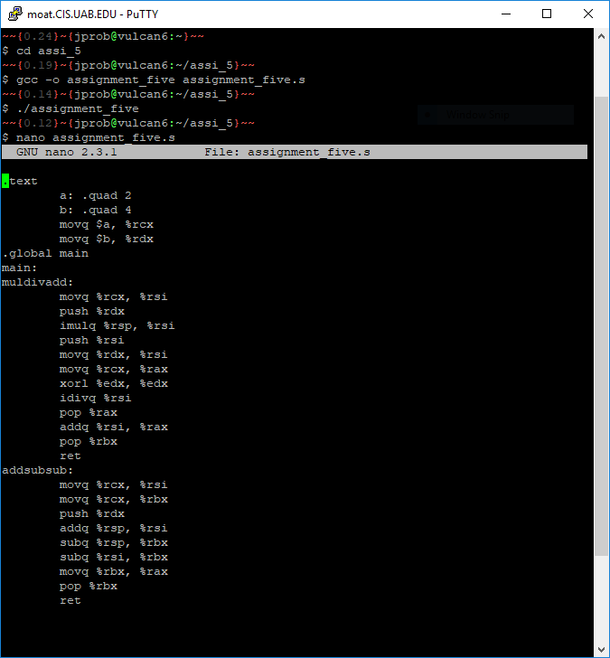

It compiles and runs without errors. Nano is to show that it’s the same file as the above source code and that I didn’t change anything so that it could compile.

**Summary**

This assignment taught me how to write a basic assembly program, figure which registers to use, and how to combine basic operations to do larger operations in assembly. Although my code compiled and ran without errors, I could not figure out how to make it work using the provided print function, so I do not know if the answers provided were the right answers. I learned how to go properly use registers, however: my earlier version of this code had me using very many registers because I didn’t think that I could just reassign things. I learned that idiv only has one argument and how to use %rsp for useful purposes. When trying to add the ability to print, I couldn’t figure out how not to get a segfault after adding calls to printr after both of the functions. It looked like it was supposed to work, but it couldn’t.