John Robertson

CS330-ZB

Assignment 07 Report

**Purpose**

The purpose of this assignment was to implement one algorithm that is somewhat more complex than what had to implement in the last assignment.

**Source Code**

See attached .s file.

**Testing**

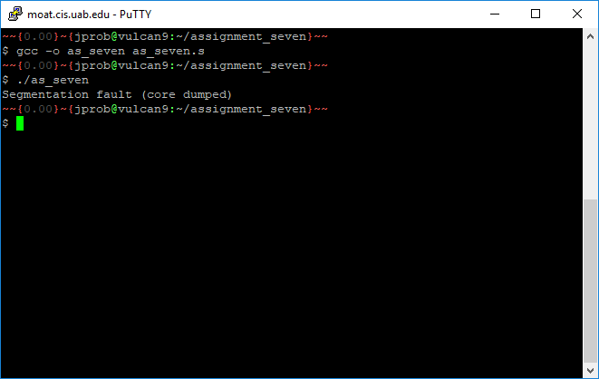

**Summary**

In this assignment, I attempted to implement a selection sort algorithm, which is important to be able to implement because this algorithm is very memory efficient, which is important for assembly. From this assignment, I learned how to interact with arrays, and I also learned that you cannot use cmp on memory references, while you can on cmov. Printing now looks simpler and easier to wrap my head around that last assignment. I now know how to use memory references, whereas I couldn’t last week from never practicing with Dr. Unan’s examples. I figured that my segfault was caused by using %r8, but my attempted fix avoiding that register by moving the value of %rdi into the stack did not fix anything. I noticed that I misspelled global, but that didn’t change anything either. Apparently, that’s not a keyword.