John Robertson

CS330-ZB

Assignment 06 Report

**Purpose**

The purpose of this assignment was to implement three simple algorithms, namely checking for a prime number, finding the *i*-th number in the Fibonacci sequence, and to calculate factorials.

**Source Code**

See the three attached files.

**Testing**

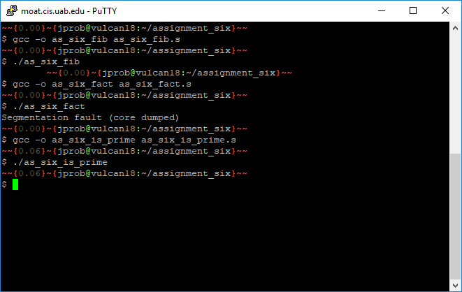

**Summary**

In this assignment, I implemented three basic algorithms in asm. From this assignment, I learned how to use jump conditions and the printr function from the functions.s file. I was unable to complete this project.

I have not examined as_six_is_prime as closely as the other two, but repeated examination and my intuition tell me that I at least have a basic understanding of how factorial and Fibonacci ought to work, and that my problems must be in my implementation. Perhaps, I thought, it was a mistake to use %rax for the right-hand multiplier, and I should have used some other register, but doing a quick nano in Vulcan only gave me the same error. I tried changing the location of the decrement, but this didn’t change the result. For Fibonacci, I made sure to pop what I pushed onto the stack. I changed the “i” of my loop, %rcx, from 0 to 1 and put the increment at the beginning, but this still didn’t yield a right answer. The prime number program was the worst, because it only ever printed numbers (and in the final case shown above, nothing). At least I made sure not to use %rdx, seeing that I would have to clear it in order to divide. Google taught me during this assignment that %rdx stores the remainder of a signed division.