**John Robertson, jprob**

**Part 1**

I request you to provide the screenshots for each and every client switch which indicates the commands you have given:

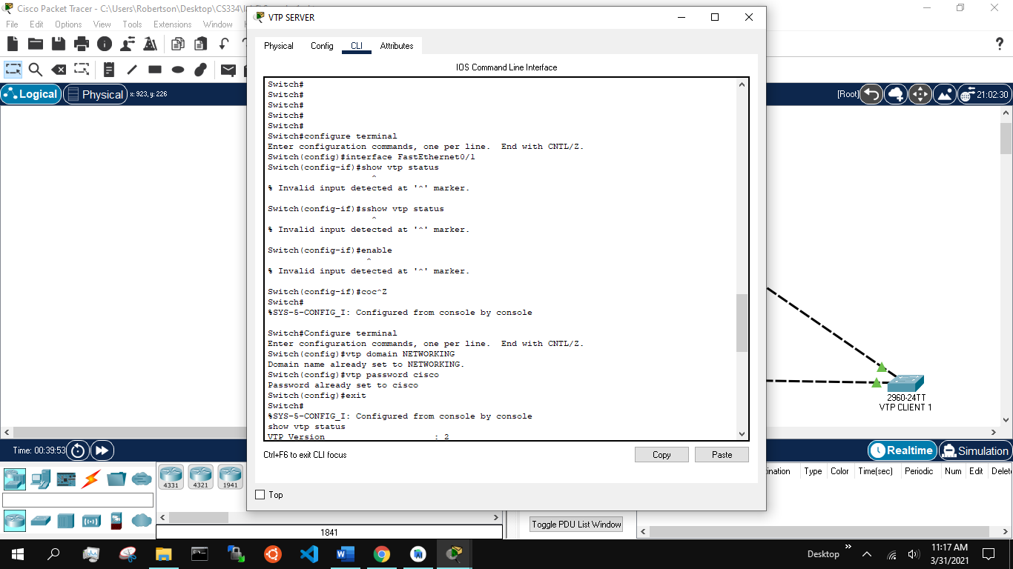

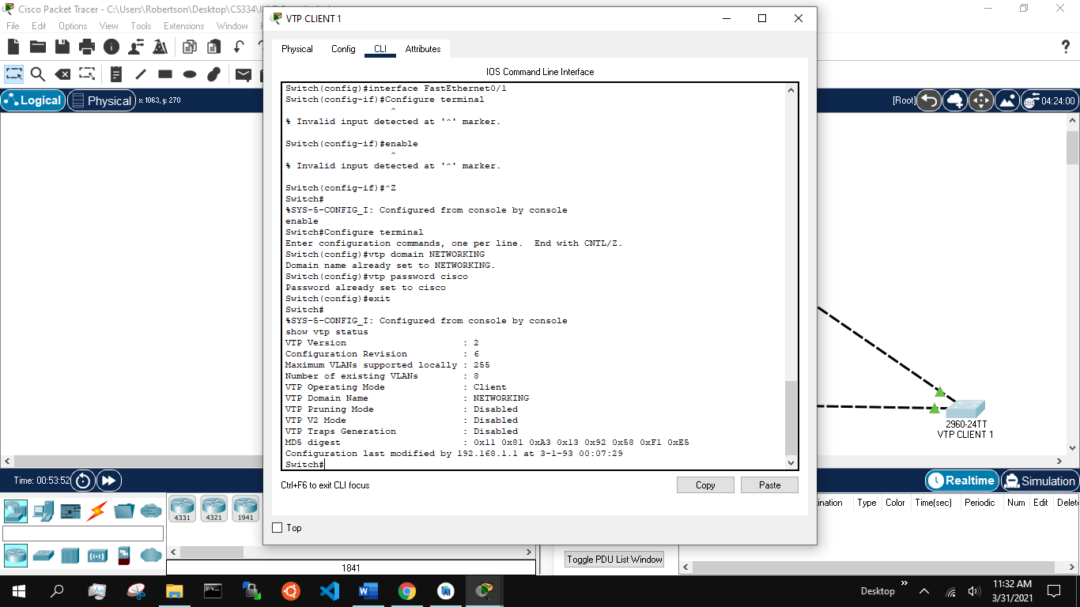

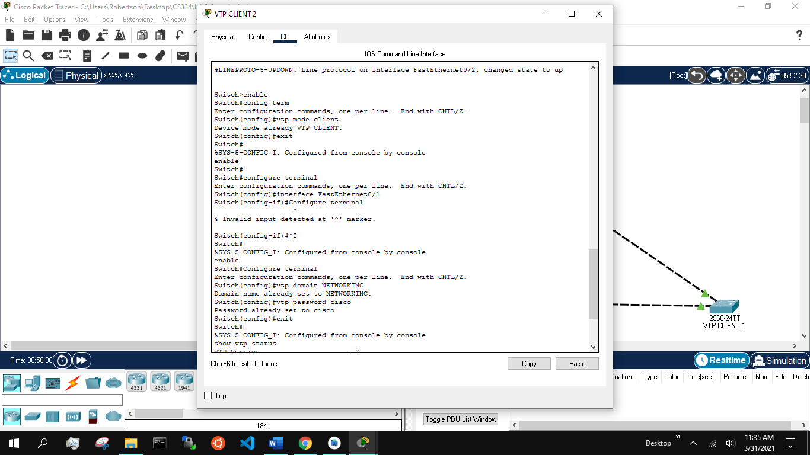

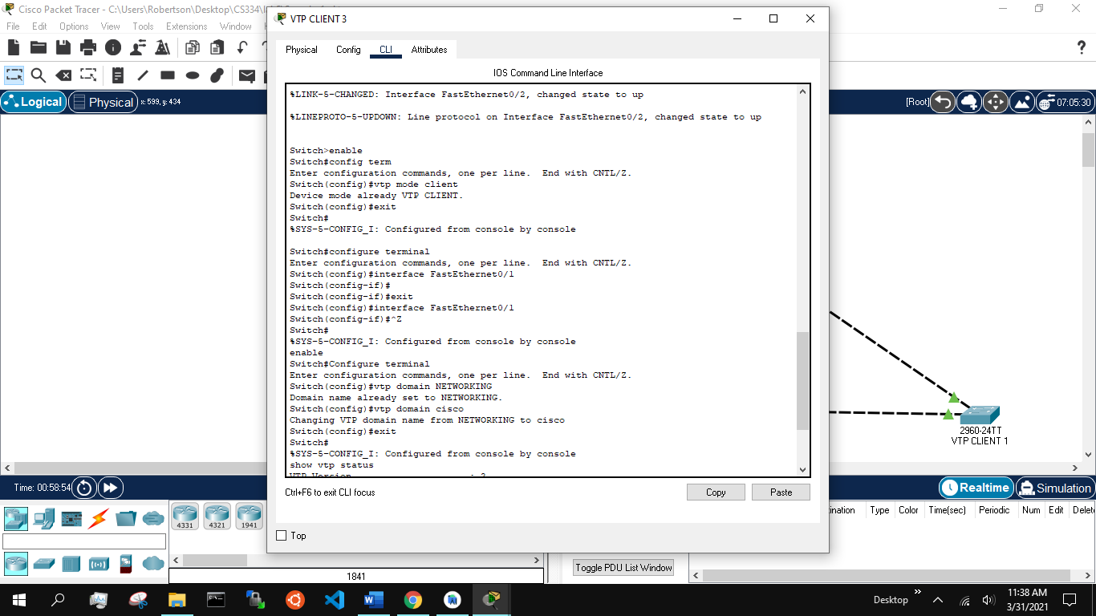

Later, I want you to provide screenshot of the server switch where you provide commands and add 2 vlans.

Lastly, I want the screenshot which indicates that the vlans which are added in the server are reflected in client switches.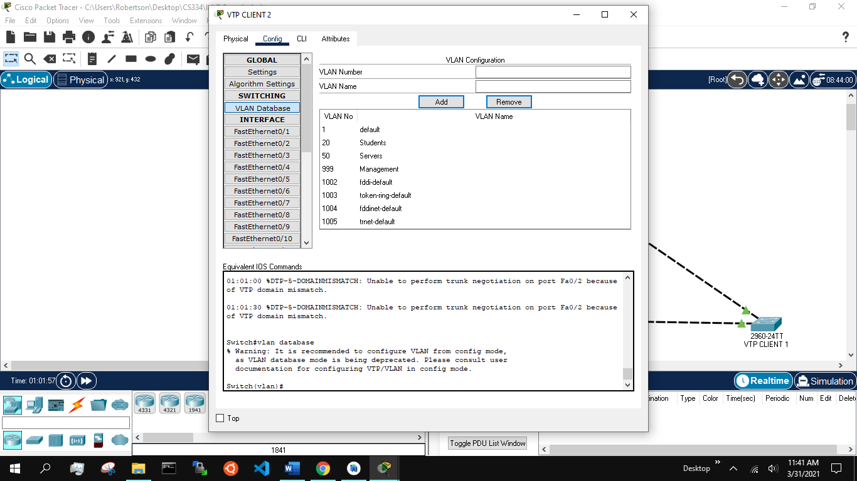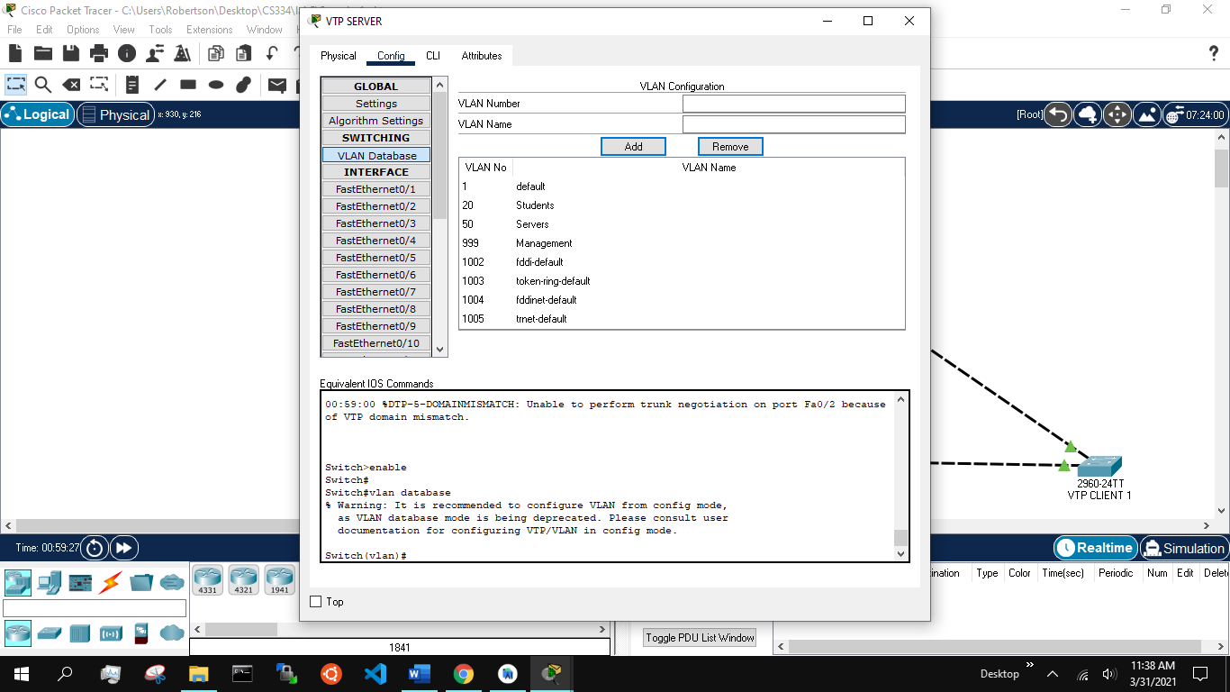

**Part 2**

A screenshot of your environment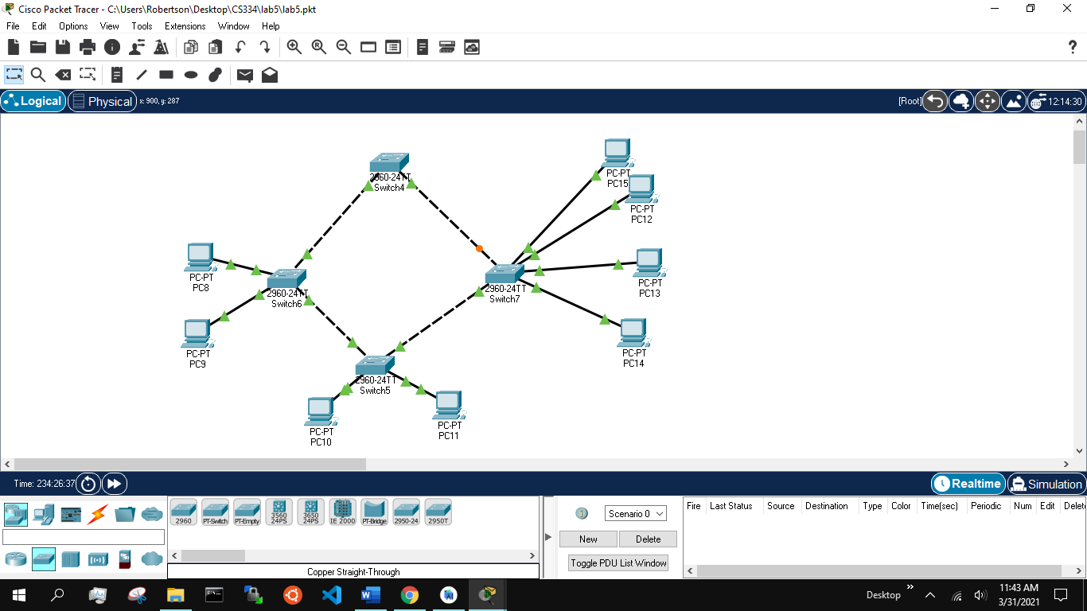:

Screenshot indicating that the connection between all the switches is TRUNK:

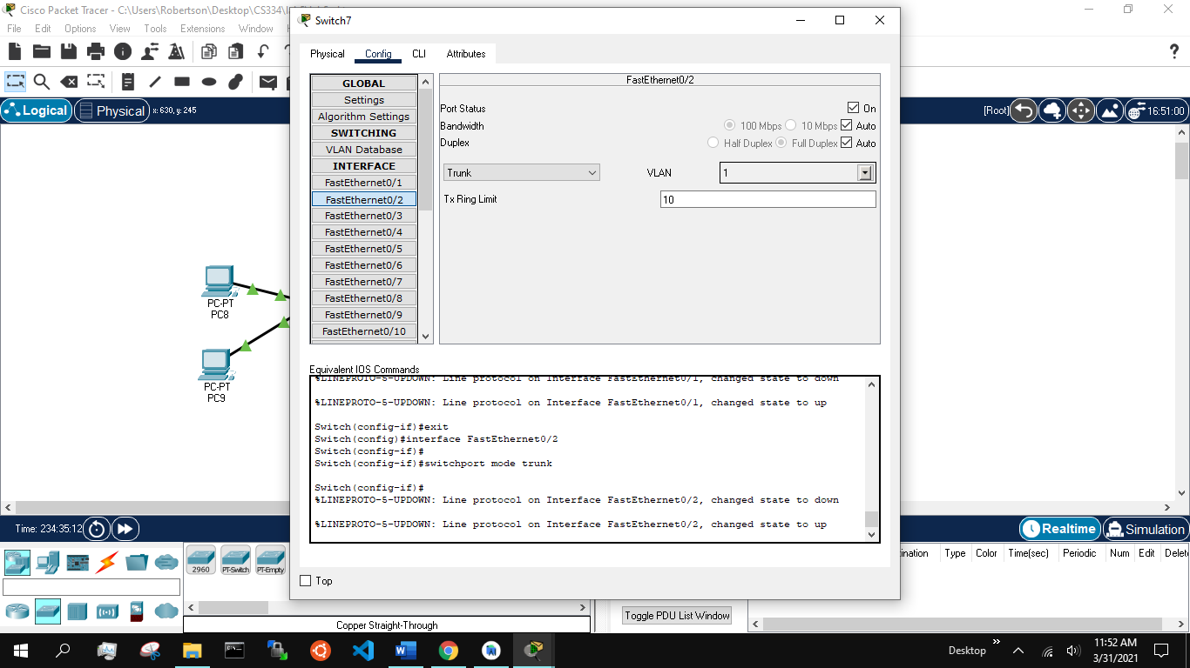

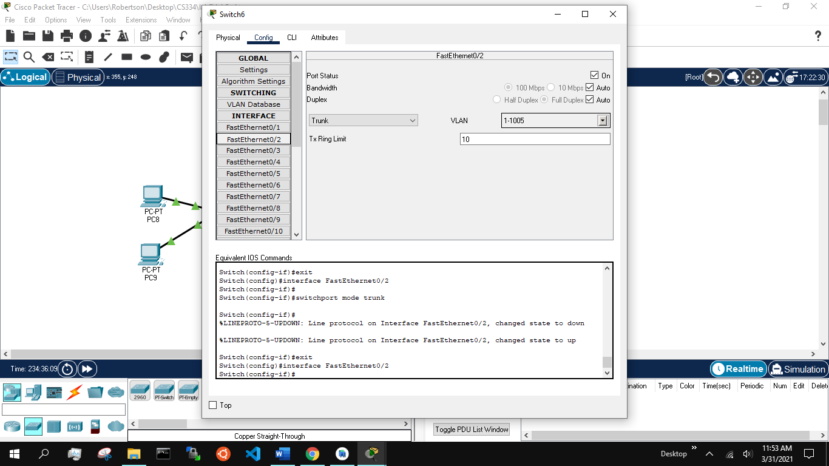

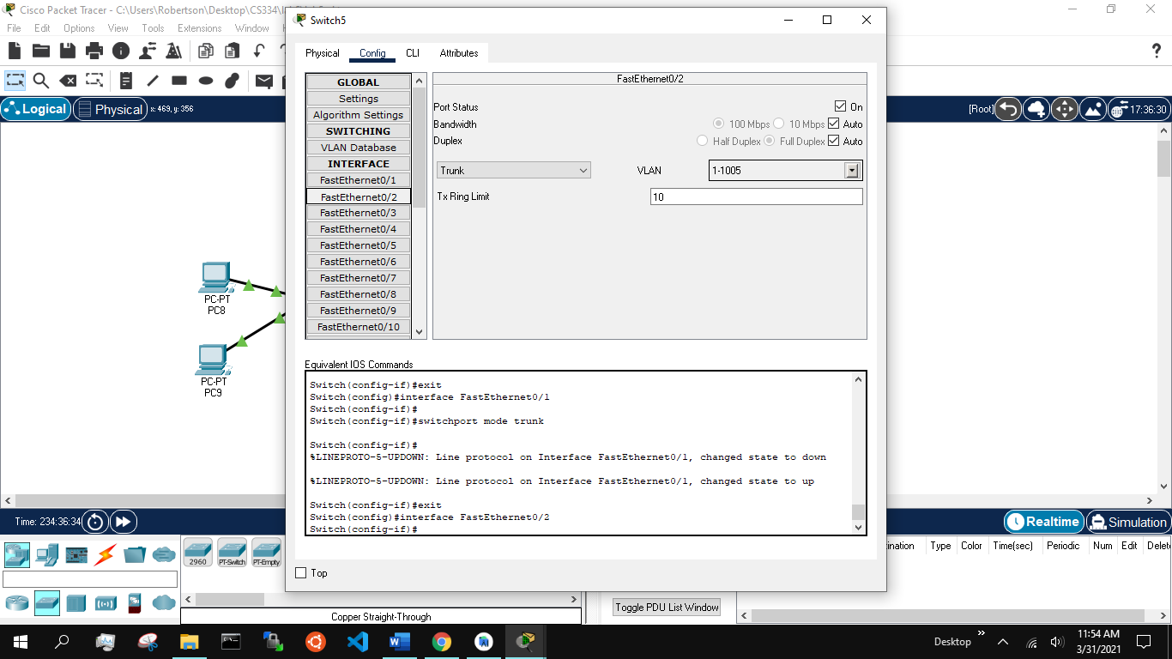

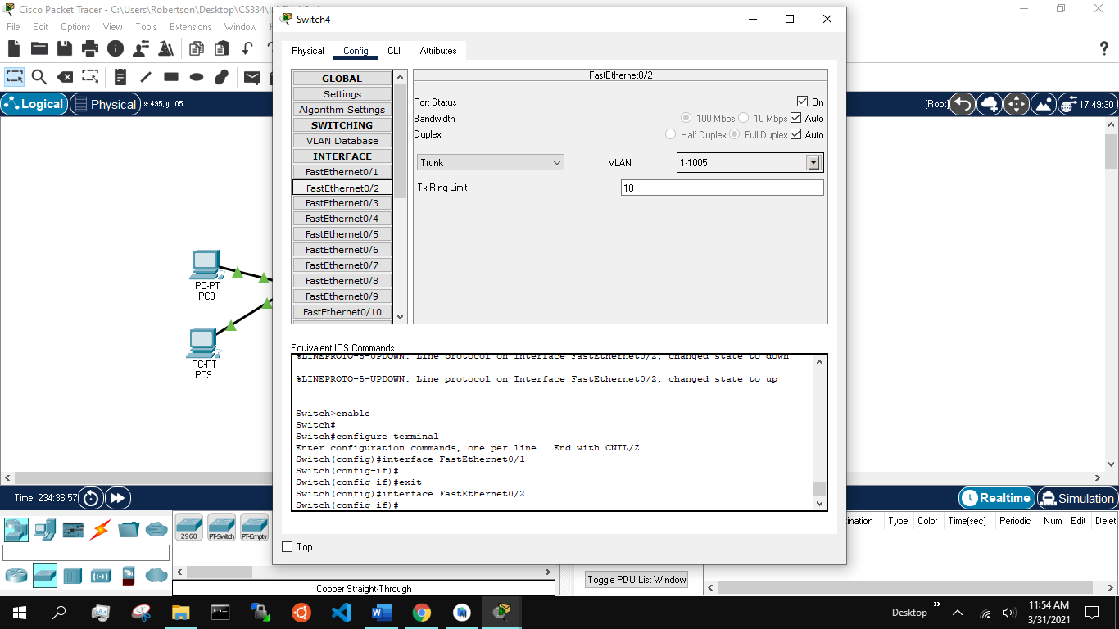

Screenshots indicating that the PDU is success when it is sent from Research to Research in different rooms(switches):

**At this stage, I configured the IPs of each PC, giving 192.168.3.x to management, 192.168.2.x to professors, and 192.168.1.x to researchers.**

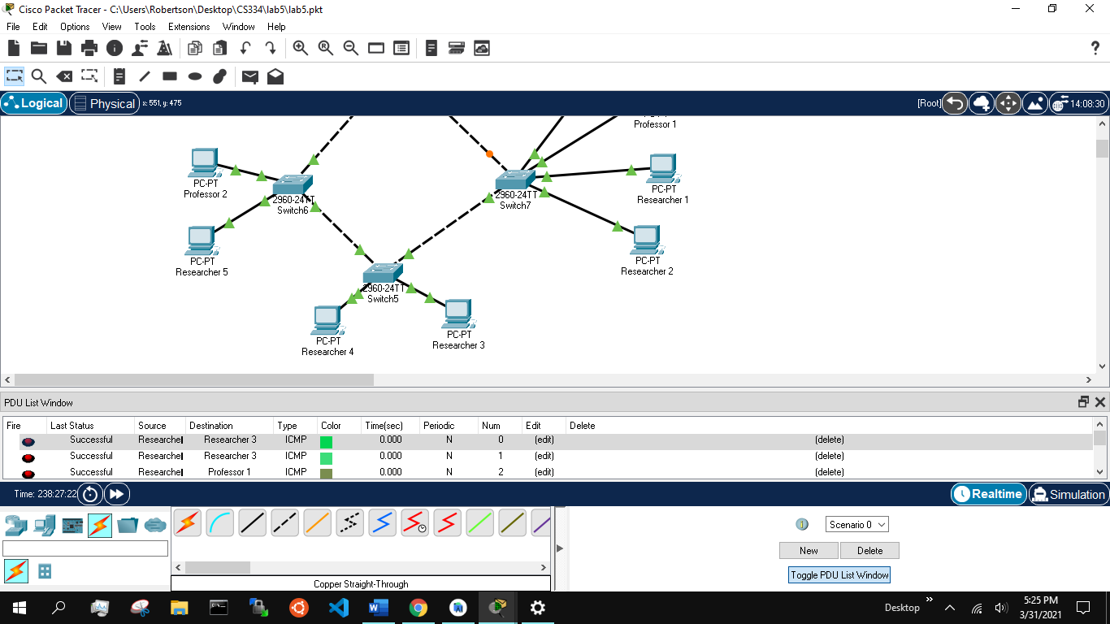

Screenshots indicating that the PDU is fail when a Researcher tries to contact Lab Professor in the same room:

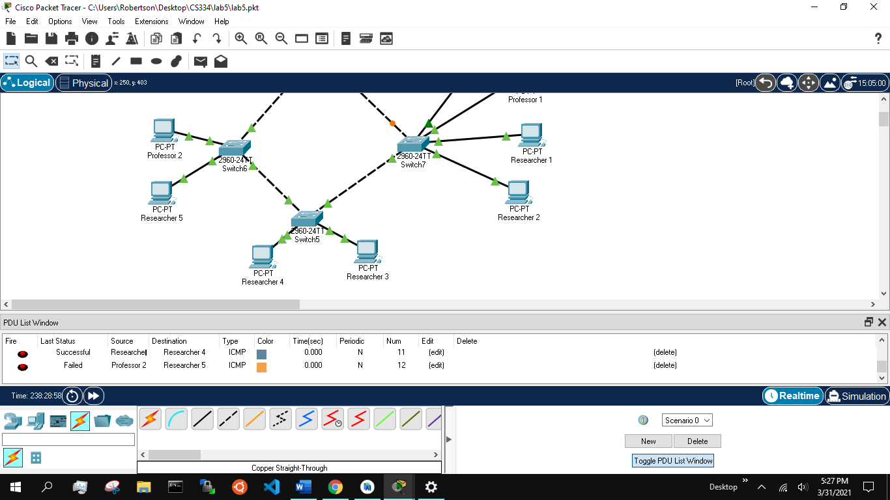

Screenshot indicating that the researcher fails sending a PDU to lab director:

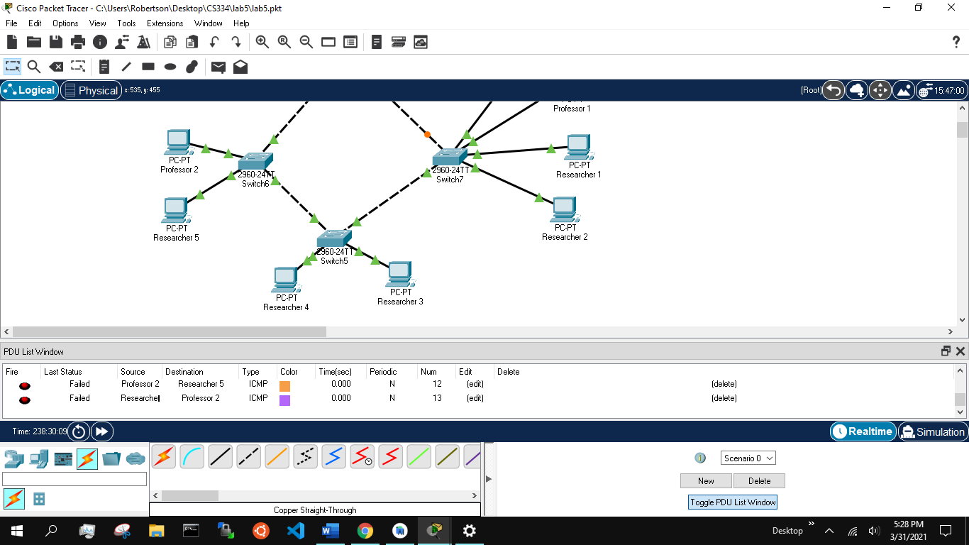

Screenshot indicating that the PDU is failed when we send it from any other system to the management:

