**Part 1**

1. **5**
2. **3**
3. **8**
4. **30**

|  |  |
| --- | --- |
| NET 0 | 192.168.10. **0 0 0 0 0 0 0 0** |
| **NET 1** | 192.168.10. **0 0 1 0 0 0 0 0** |
| **NET 2** | 192.168.10. **0 1 0 0 0 0 0 0** |
| **NET 3** | 192.168.10. **0 1 1 0 0 0 0 0** |
| **NET 4** | 192.168.10. **1** **0 0 0 0 0 0 0** |

* 1. Binary: 11111111.11111111.11111111.**11100000**
  2. Decimal: 255.255.255.**224**

|  |  |  |  |  |
| --- | --- | --- | --- | --- |
| Subnet Number | Subnet Address | First Usable Host Address | Last Usable Host Address | Broadcast Address |
| 0 | **192.168.10.0** | **192.168.0.1** | **192.168.0.30** | **192.168.0.31** |
| 1 | **192.168.10.32** | **192.168.0.33** | **192.168.0.62** | **192.168.0.63** |
| 2 | **192.168.10.64** | **192.168.10.65** | **192.168.10.94** | **192.168.10.95** |
| 3 | **192.168.10.96** | **192.168.10.97** | **192.168.10.126** | **192.168.10.127** |
| 4 | **192.168.10.128** | **192.168.10.129** | **192.168.10.158** | **192.168.10.159** |

**Part 2**

1. 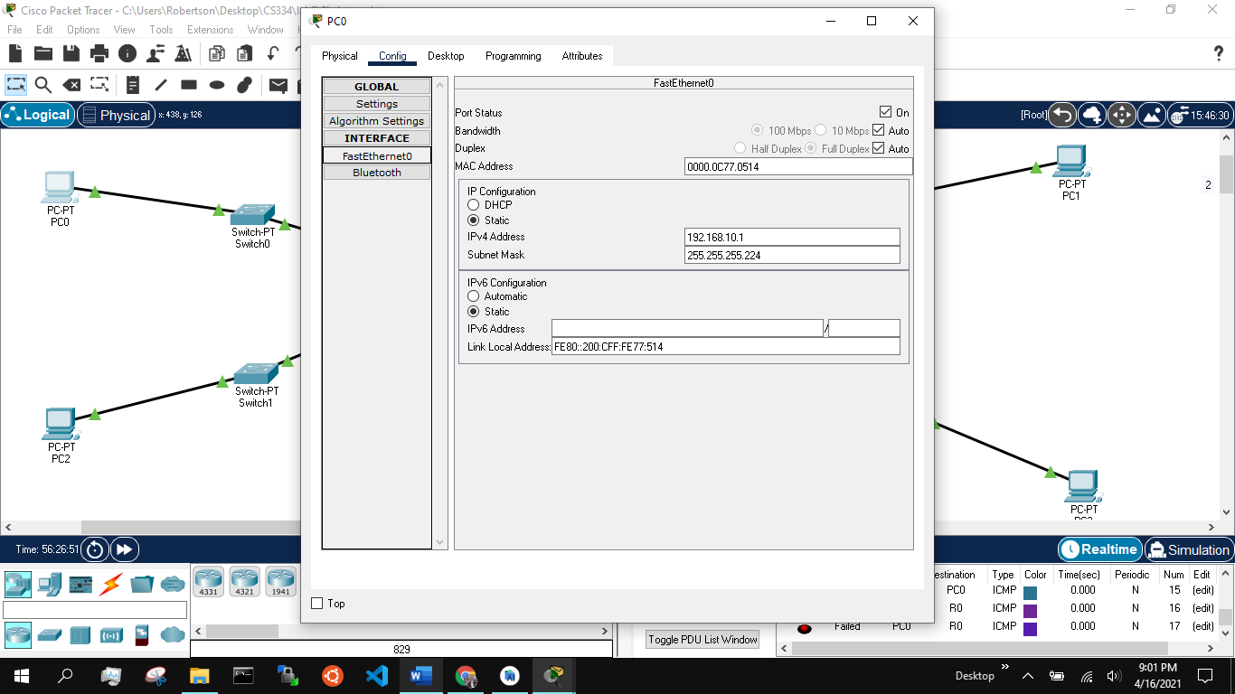
2. 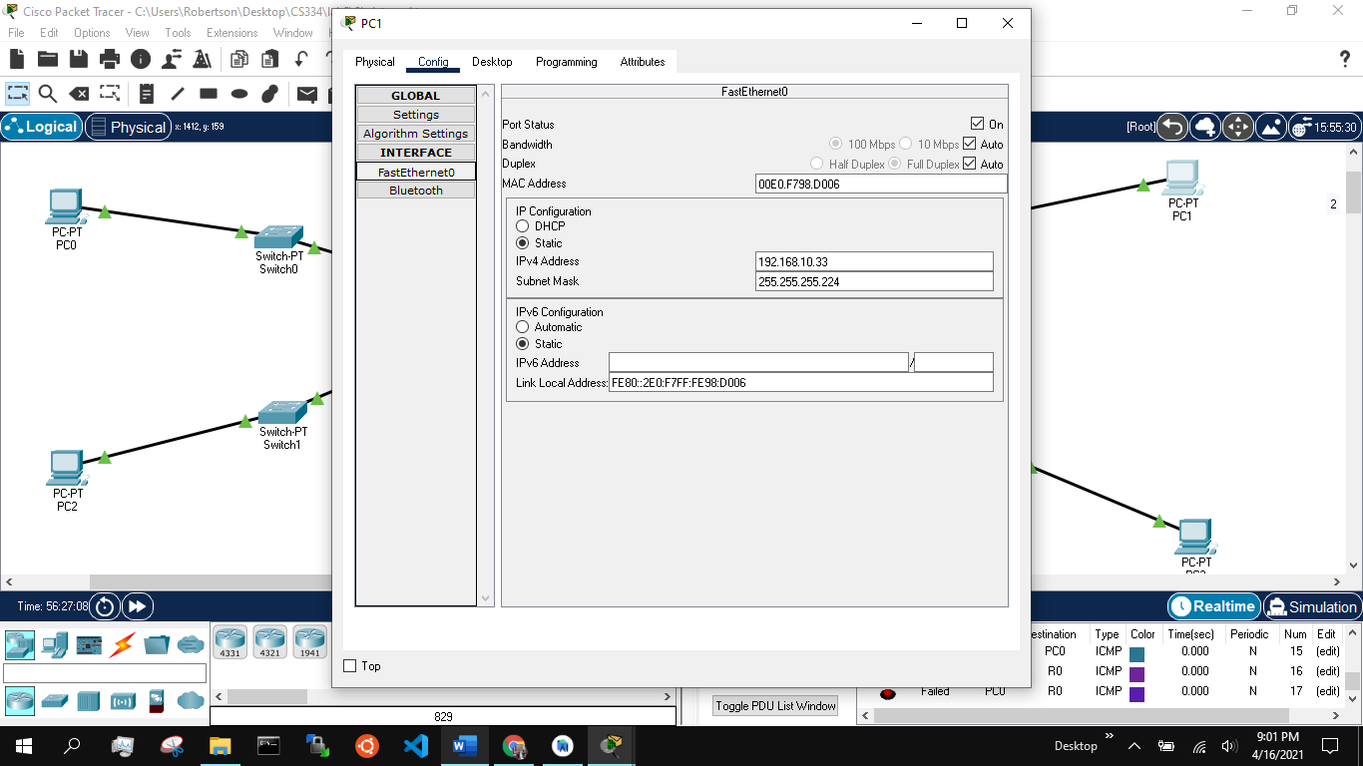

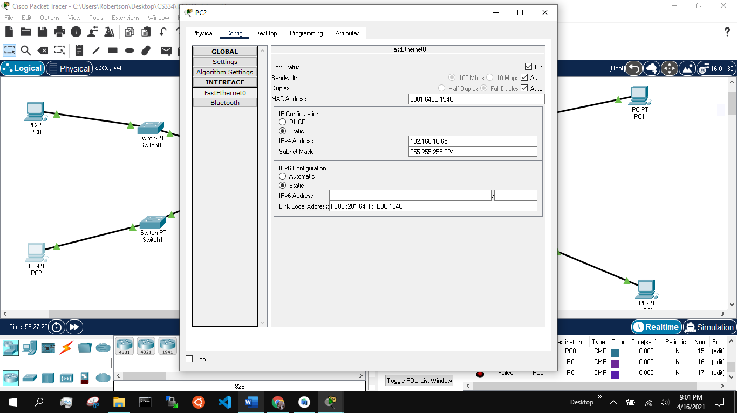

1. 