14:

We roll two fair 6-sided dice. Each one of the 36 possible outcomes is assumed to be equally likely.

1. Find the probability that doubles are rolled.

*There are 6 double combos.* ***6/36 = 1/6.***

1. Given that the roll results in a sum of 4 or less, find the conditional probability that doubles are rolled.

*A: (1, 1), (1, 2), (1, 3), (2, 1), (3, 1), (2, 2)*

*B ^ A: (1, 1), (2, 2)*

*P(B|A) = P(B ^ A)/P(A) = (2/36)/(1/6) = 12/36 =* ***1/3***

1. Find the probability that at least one die roll is a 6.

*A: (1, 6), (2, 6), (3, 6), (4, 6), (5, 6), (6, 6), (6, 1), (6, 2), (6, 3), (6, 4), (6, 5)*

***11/36****.*

1. Given that the two dice land on different numbers, find the conditional probability that at least one die roll is a 6.

*A: (1, 2), (1, 3), (1, 4), (1, 5), (1, 6), (2, 1), (2, 3), (2, 4), (2, 5), (2, 6), (3, 1), (3, 2), (3, 4), (3, 5), (3, 6), (4, 1), (4, 2), (4, 3), (4, 5), (4, 6), (5, 1), (5, 2), (5, 3), (5, 4), (5, 6), (6, 1), (6, 2), (6, 3), (6, 4), (6, 5)*

*B ^ A: set from (c) - (6, 6)*

*P(A) = 30/36 = 5/6*

*P(B|A) = P(A ^ B)/P(A) = (10/36)/(5/6) = 60/180 =* ***1/3***

16:

We are given three coins: one has heads in both faces, the second has tails in both faces, and the third has a head in one face and a tail in the other. We choose a coin at random, toss it, and the result is head. What is the probability that the opposite face is tails?

*B = "Opposite face is tails"*

*A = "The result is head" (P(A) guaranteed to be 1 because it has already happened)*

*P(B|A) = P(A ^ B) / P(A) = P(A) * P(B) / P(A) = 1 * 0.5 / 1 =* ***0.5***

22:

Each of the k jars contain m white and n black balls. A ball is randomly chosen from jar 1 and transferred to jar 2, then a ball is randomly chosen from jar 2 and transferred to jar 3, etc. Finally, a ball is randomly chosen from jar k. Show that the probability that the last ball is white is the same as the probability that the first ball is white, i.e., it is m/(m+n).

*Next page*

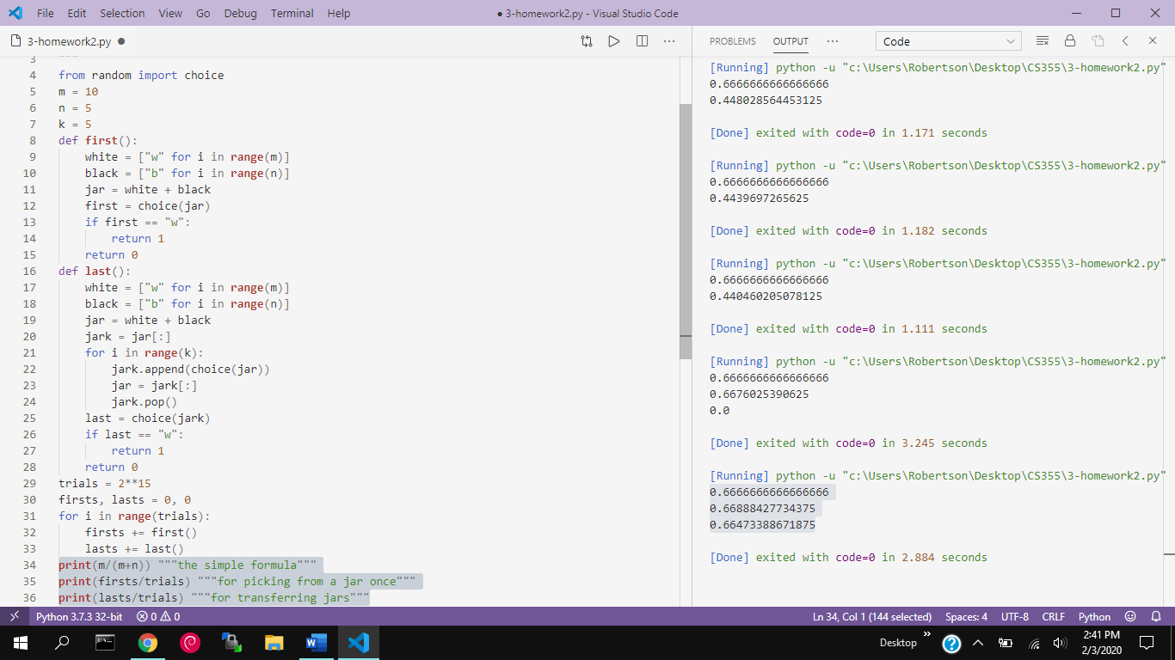

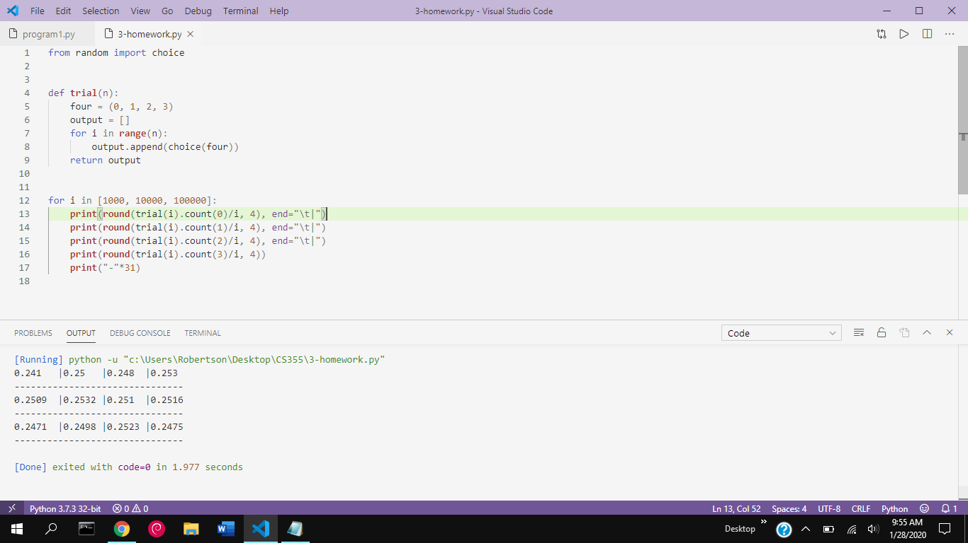4

Write a program to toss a fair coin three times and count the number of heads generated per toss. Run this program 1000 times, then 10,000 times, then 100,000 times, and create a table of the number of times three heads resulted, two heads, one head, and no heads. What value would you expect? Explain any difference?

*I expected it to be 1/4th every way because there are four equally likely possibilities to choose from.*