John Robertson

CS 433

Homework 2

Part A:

From the four functions I implemented, I draw the conclusion that implementing a shell is similar to implementing a programming language. The space case is like stringing subsequent commands together, and redirection and pipes are similar to directing *function* input and output to variable assignment or other functions.

Part B: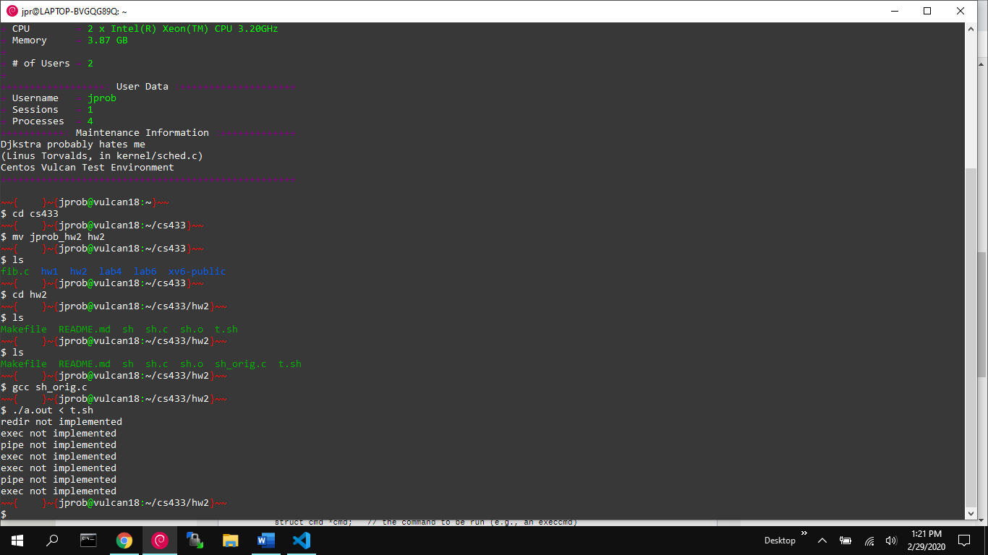

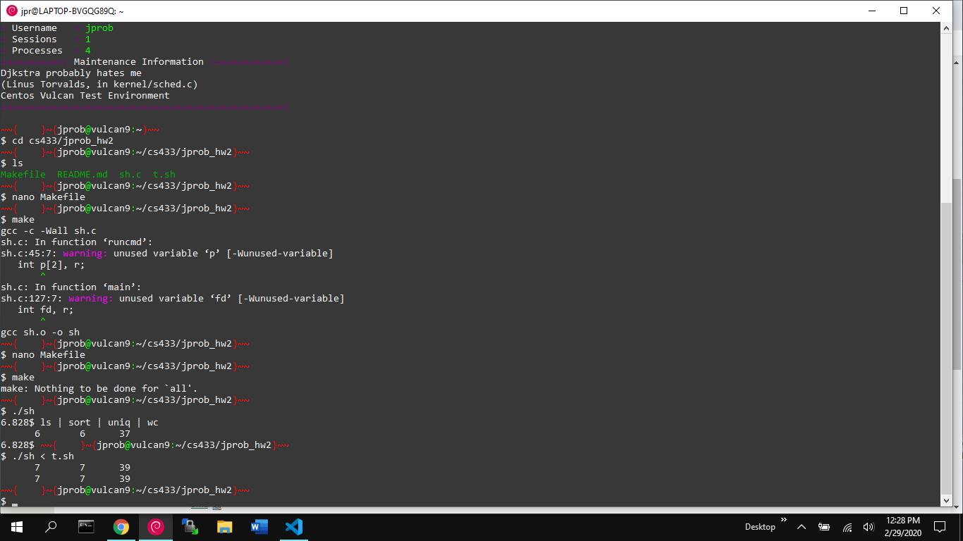

Part C:

I do not understand process creation any better after having done this. Redirection is more intuitive to me now that I know how it can be implemented. Use of exec() is also clearer; in the previous homework, I did not understand how to use exec(). Both of these shell homeworks have shown me more about how to create text-user-interfaces.