An attempt to do the following algorithm using mermaid

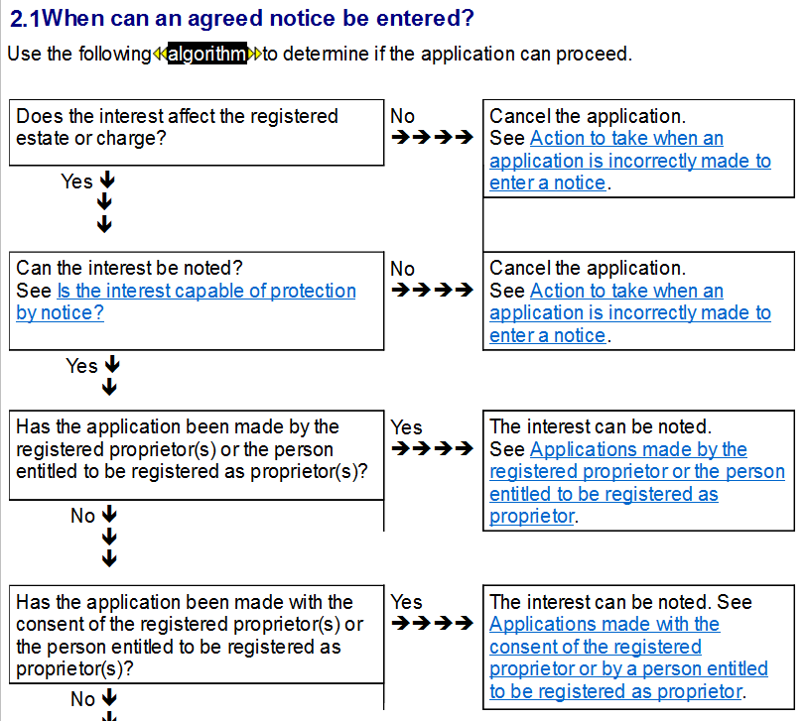

{article:{s,enteruniqueid}}{"id":"enteruniqueid","title":"","type":"article","purpose":"article","scope":"","lastupdate":"2016-10-27T10:48:07.000Z","popularity":"3","cluster":["nofile"],"clusters":[{"cluster":"nofile","priority":9999}],"author":"","owner":"","expert":"Pickerill, John","sensitivity":"normal","master":{"where":"Word","filename":"Document1"},"items":[],"keywords":[],"facets":[],"kmlinks":[],"extlinks":[],"content":"","markup":"","class":"","sdlt":"","fees":""}<--

This is an example of what could be done using the language approach

We could embed diagrams like this in items or snippets or could surface these in articles or as associated tabs or potentially in some other way e.g. slide out panels.

I think we could also display these as thumbnails and click to expand

With a bit of work we could do the hover overs and the screen reader stuff based on the metadata associated with the link

-<:<{{drop!_enteruniqueid_:>:>-

I've styled clickable boxes in pink

Note: tooltips are appearing at the bottom left - this needs some css styling to put them in a more obvious place. Also styling of circles appears to not be working.

-<+<drop!_enteruniqueid_}}>:>-

-<+<[[@cre:bx900]]>:>-

{{graph:

%% there are several ways of constructing the chart. I've chosen to split the definition into three sections the first defining the nodes, the second describing the arcs and the thirs defining the links.

%%Nodes

Query00(Does the interest <br> affect the registered <br> estate or charge)

Query01(Can the interest be noted ? <br> Click here)

Query02("Has the application been made by the <br> registered proprietors or the person <br> entitled to be registered as proprietors(s)?")

Query03("Has the application been made <br> with the consent of the registered proprietor(s) or <br>the persones entitled to be registered as proprietors(s)")

Cancel_App[Cancel the <br> Application <br> Click Here]

Note_By[The interest <br> can be noted <br> Click Here]

Note_Consent[The interest <br> can be noted <br> Click Here]

%% Arcs

Query00--> |Yes| Query01

Query00 -->|No| Cancel_App

Query01-->|Yes| Query02

Query01 -->|No| Cancel_App

Query02-->|No| Query03

Query02 -->|Yes| Note_By

Query03 -->|Yes| Note_Consent

%% Links and callbacks

classDef clickable fill:#f9f

class Query01,Cancel_App,Note_By,Note_Consent clickable;

click Query01 "article/banks" "link to banks article"

click Cancel_App "article/co_osea_evidence" "link to evidence article"

click Note_By "article/co_osea_ident" "link to ident article"

click Note_Consent "article/co_protect" "link to protect article"

graph}}

{article:{f,enteruniqueid}}{"id":"enteruniqueid"}<--