-<*<{{*ghost=JuyJO:>:>-

-<~<ghost1>:>-

-<*<*ghost=JuyJO}}>:>-

{article:{s,article}}{"id":"article","title":"","type":"article","purpose":"Article","scope":"","lastupdate":"2017-09-25T10:37:42.000Z","popularity":"3","cluster":["ghostcleanup"],"clusters":[{"cluster":"ghostcleanup","priority":9999}],"author":"","owner":"","expert":"Pickerill, John","sensitivity":"normal","archive":"false","master":{"change":"reason for change unknown","significance":"low","where":"Word","filename":"ghostcleanup.docx"},"items":[],"keywords":[],"facets":[],"kmlinks":[],"extlinks":[],"content":"","markup":"","class":"","sdlt":"","fees":""}<--

article

-<+<[articletext](anarticle#articleanchor "link to guidance article")>:>- -<+<how are you>:>- -<+<[externaltext](http://externallink.com "externaldesc")>:>- -<+<[inttext](/intdox "intdesc")>:>- -<+<![intimage](/_static/images/alt_map_ji_lines/Load%20dialog.PNG "intdesc")>:>- hello

-<+<guide1>:>- -<-<ERROR>:>- -<+<guide2>:>-

-<+<image1>:>- 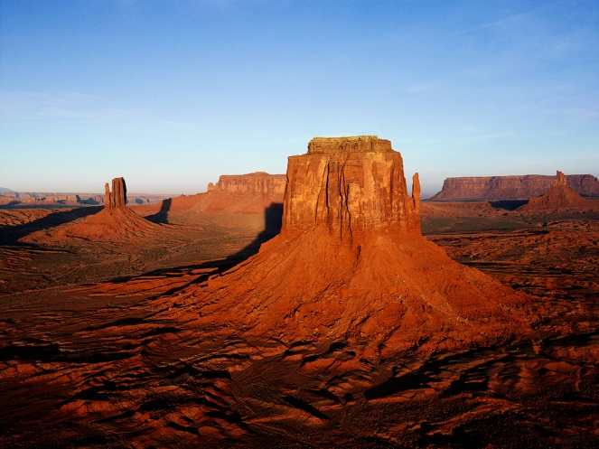-<+<image1>:>-

-<*<{{*ghost=i4YXZ:>:>-

-<~<ghost2>:>-

-<~<ghost2>:>-

-<*<*ghost=i4YXZ}}>:>-

-<&<apparition=JuyJO>:>-

-<&<apparition=i4YXZ>:>-

-<&<apparition=4dFM/>:>-

{article:{f,article}}{"id":"article"}<--

-<*<{{*ghost=4dFM/:>:>-

-<~<ghost3>:>-

-<~<ghost3>:>-

-<~<ghost3>:>-

-<*<*ghost=4dFM/}}>:>-