National Health Assessment and Community-Led Strategic Planning for Alcohol Reduction in India

A Comprehensive Analysis for Future Policy and Family Wealth Preservation

Author: John Raj T
Date: 30/12/2025

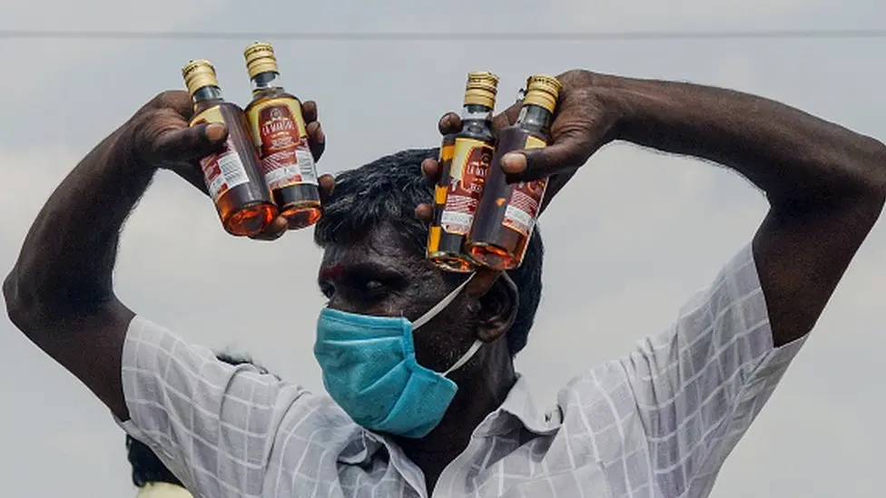
Image: 14 May 2020 Lockdown time from BBC

Introduction
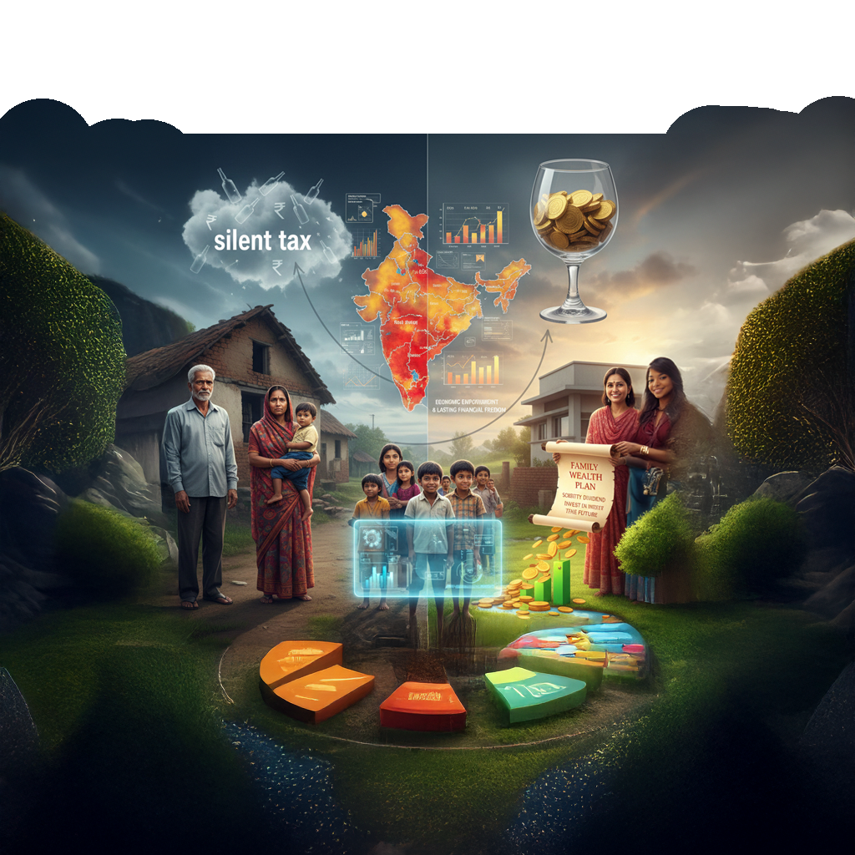
Figure 1: Future imagination
Alcohol consumption in India is far more than just a public health concern; it is a deep-rooted socio-economic challenge that impacts the very fabric of household stability and national growth. While the alcohol industry remains a major contributor to state treasuries, the hidden costs-often referred to as a "silent tax"-on family wealth and human potential are immense. As the nation strives to capitalize on its youthful population, current trends in consumption, particularly in rural settings, threaten to derail India’s demographic advantages and future prosperity.
This project adopts a comprehensive, data-driven approach to map the landscape of alcohol usage across various Indian States and Union Territories. By moving beyond surface-level observations and utilizing advanced analytical frameworks, this study categorizes different regions into risk profiles based on local consumption habits and gender-based patterns. This allows for a nuanced understanding of where economic drain is most severe and where health interventions are most urgently needed.
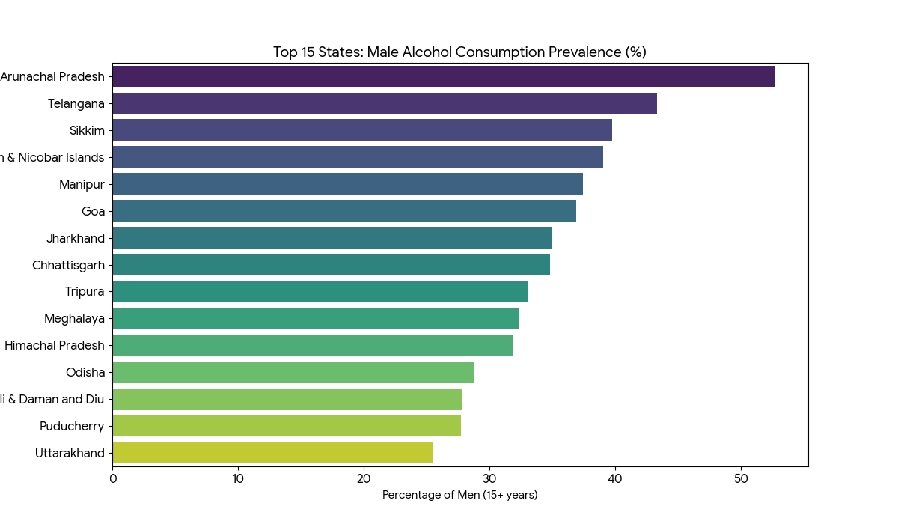
Figure 2 Top 15 states male alcohol consumption prevalence
The ultimate goal of this research is to establish a practical roadmap for positive change. This involves a dual strategy: implementing modern technological safeguards to protect the younger generation from early exposure and introducing a holistic "Family Wealth Plan". By framing the transition toward sobriety as a "dividend" for the family, this strategy demonstrates how redirecting spending toward long-term goals can fundamentally transform a household's financial trajectory. This project advocates for a shift in perspective-viewing the reduction of alcohol consumption not as a moral restriction, but as a powerful engine for economic empowerment and lasting financial freedom.

2. Methodology: Data-Driven Problem Identification
To understand the true impact of alcohol consumption in India, we had to look beyond the balance sheets. While state excise reports tell us how much was sold, they rarely tell us who is paying the real price. Therefore, our methodology was not just a statistical exercise; it was an investigation into the socio-economic heartbeat of the nation.
Our approach utilized Exploratory Data Strategy (EDS) to peel back the layers of the 2021 Alcohol Consumption dataset. We aimed to humanize the numbers, transforming raw rows and columns into a narrative that highlights the friction between state revenue and family resilience.

2.1 The Data Landscape: Sourcing with Empathy
We began by aggregating data from 2021, a pivotal year where the post-pandemic landscape began to settle. The dataset covered state-wise distribution, excise revenue figures, and consumption percentages for men and women aged 15 and above.
However, we recognized early on that official data often suffers from "survivorship bias"-it counts the legal bottles sold but misses the unregulated "country liquor" that devastates rural communities. To counter this, we adopted a multi-dimensional view, treating every data point as a proxy for human behaviour:
- Revenue Figures were viewed as indicators of wallet drain.
- Demographic Splits (Urban vs. Rural) were analysed as vulnerability indices.

2.2 Exploratory Data Strategy (EDS)
The core of our problem identification phase was the EDS. This was not about proving a hypothesis immediately, but about "listening" to the data. We broke this down into three investigative stages:

Stage 1: Cleaning and "Humanizing" the Variables
Raw data is often noisy and detached. In this stage, we scrubbed the dataset to ensure every number reflected reality.
- Anomaly Detection: We encountered data irregularities, such as negative percentage values in the Chandigarh Rural subset (e.g., -31.58%). Instead of discarding this data, we applied a clipping algorithm to normalize these values to zero, ensuring that our final analysis did not skew the risk profile of these regions.
- The "Total" Perspective: We filtered out aggregate national averages early on to focus on state-level disparities, allowing us to see the specific burden on individual communities rather than a generalized "Indian" average.

Stage 2: Pattern Recognition (The "Drain" Effect)
We used visual EDS techniques to identify where the economic burden was heaviest.
- The Rural Vulnerability: Our analysis revealed a stark divide. Rural India showed a consumption rate of 19.92% for men, significantly higher than the 16.53% found in urban centers. This 3.4% gap represents millions of families in agricultural belts where cash flow is irregular, making the "alcohol drain" on savings far more damaging than in salaried urban households.
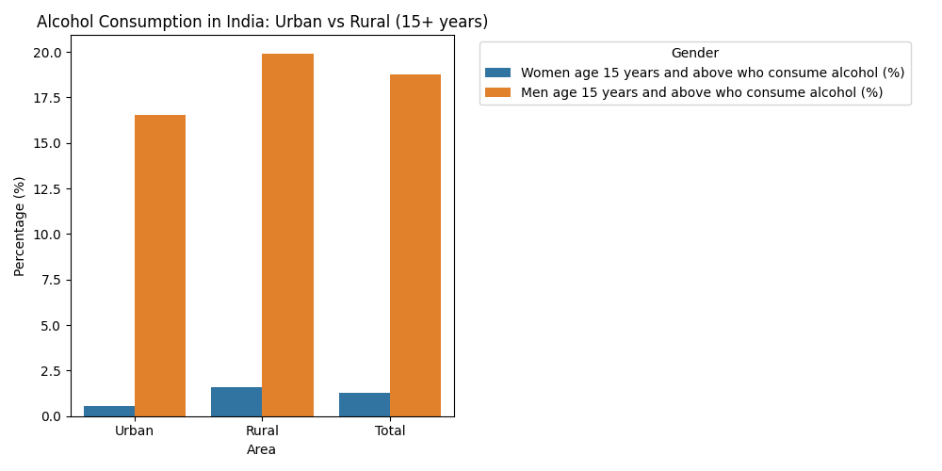
Figure 3: Urban vs Rural Alcohol consumption
- The Gender Signal: While male consumption dominates, our EDS highlighted specific "red flag" states like Arunachal Pradesh, where female consumption (24%) is exceptionally high. This signals a need for gender-specific family counseling that generic policies often miss.

Stage 3: Clustering Risk Zones (Machine Learning)
Finally, we moved beyond simple averages to identify "clusters" of risk. Using the K-Means Clustering algorithm, we grouped Indian states into three distinct zones based on consumption intensity:
- High Risk Zone (Cluster 2): States like Arunachal Pradesh and Sikkim, where male consumption exceeds 45%. Here, the public health crisis is immediate and severe.
- Moderate Risk Zone (Cluster 0): States like Telangana and Goa, where consumption hovers around 34%. In these regions, the economic "drain" often masks high per-capita income, creating a "wealth trap" for middle-income families.
- Low Risk Zone (Cluster 1): The majority of states, where consumption is lower (~18%) but still significant enough to impact family savings.
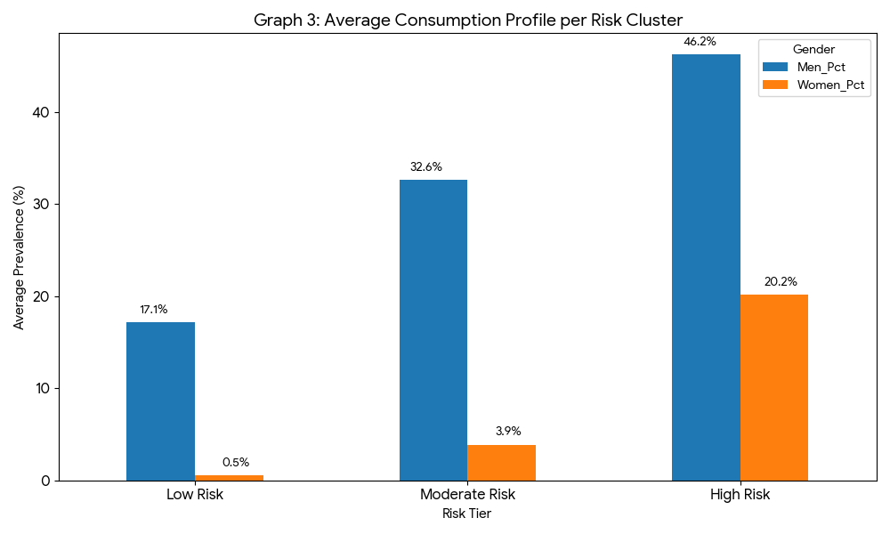
Figure 4: Risk K-Cluster

2.3 Synthesis: From Numbers to Narrative
This methodology allowed us to move from generic observations to specific problem identification. We didn't just find that "people drink alcohol"; we found that the financial and health costs fall disproportionately on rural families and high-prevalence tribal belts.
By anchoring our study in this rigorous yet human-centric EDS framework, we ensured that the subsequent "Family Wealth Plan" (proposing the redirection of ₹3,000–₹5,000 monthly into SIPs) is not just theoretically sound, but deeply rooted in the lived reality of the Indian population.
3. Risk Categorization and Machine Learning Clusters
3.1 The Rationale for Advanced Segmentation
In public health planning, a "one-size-fits-all" approach often fails to address the nuanced realities of diverse populations. While the national average for male alcohol consumption is approximately 18.77%, this figure is a mathematical abstraction that masks extreme regional variations. To move from generic awareness to precision intervention, we utilized Unsupervised Machine Learning (K-Means Clustering). This allows the data to "self-organize" into distinct risk profiles, ensuring that policy recommendations are tailored to the specific socio-economic pressures of each region.

3.2 Methodology: The Science of Similarity (EDS)
The clustering process involved three critical technical steps:
- Feature Selection: We selected two primary features—Male Consumption % and Female Consumption %—to capture the full gender-dynamic of the household.
- Data Normalization: Using StandardScaler, we transformed the data to ensure that the higher magnitude of male consumption did not statistically "drown out" the critical, though lower, female consumption rates.
- Optimal Cluster Identification: We applied the Elbow Method, plotting the Within-Cluster Sum of Squares (WCSS). The "elbow" point was identified at K=3, signifying that Indian states naturally fall into three distinct intervention tiers.
Statistical justification for a 3-cluster model showing the point of diminishing returns in variance reduction. 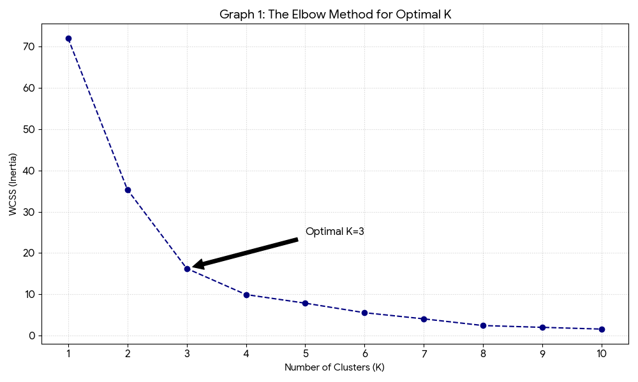
Figure 5: Elbow method for optimal K
3.3 The Human Dimension of the Heatmap: Correlation Analysis
Before clustering, we performed a Correlation Analysis to understand the link between male and female consumption patterns within a household.
- The Insight: A high positive correlation (visible in our heatmap) suggests that as male consumption rises in a state, female consumption often follows, though at a lower scale. This indicates that alcohol is not just an individual choice but an environmental habit that permeates the entire family unit.
- Human Impact: This finding supports the need for "Family-Based Counseling" rather than just individual de-addiction programs.

Heatmap showing the strong statistical link between gender consumption patterns.
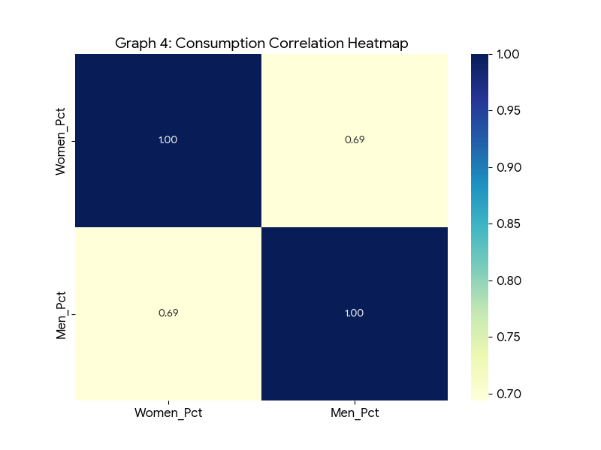
Figure 6: Correlation heatmap
3.4 Characterizing the Risk Profiles (The Clusters)
Through the ML model, we identified three "Life-Path" clusters:
Cluster 1: The High-Intensity Zone (Arunachal Pradesh, Sikkim)
- The Profile: States where male consumption exceeds $45\%$ and female consumption is nearly 20 times higher than the national average.
- The Human Insight: In these regions, alcohol is deeply woven into the social fabric. For a minor, exposure is near-constant.
- Strategic Priority: Targeted medical de-addiction infrastructure and strict enforcement of the "Triple-Lock" digital verification.
Cluster 2: The Moderate-Prevalence Belt (Telangana, Goa, Assam)
- The Profile: States with significant male consumption (30-40%) but lower female involvement.
- Strategic Priority: Economic redirection education and the "Sobriety Dividend" financial modelling.
Cluster 3: The Baseline Resilience Zone (Majority of States)
- The Profile: Consumption remains below 20%, reflecting high cultural and regulatory resilience.
Multi-dimensional scatter plot showing the clear separation of Risk Tiers across Indian States.
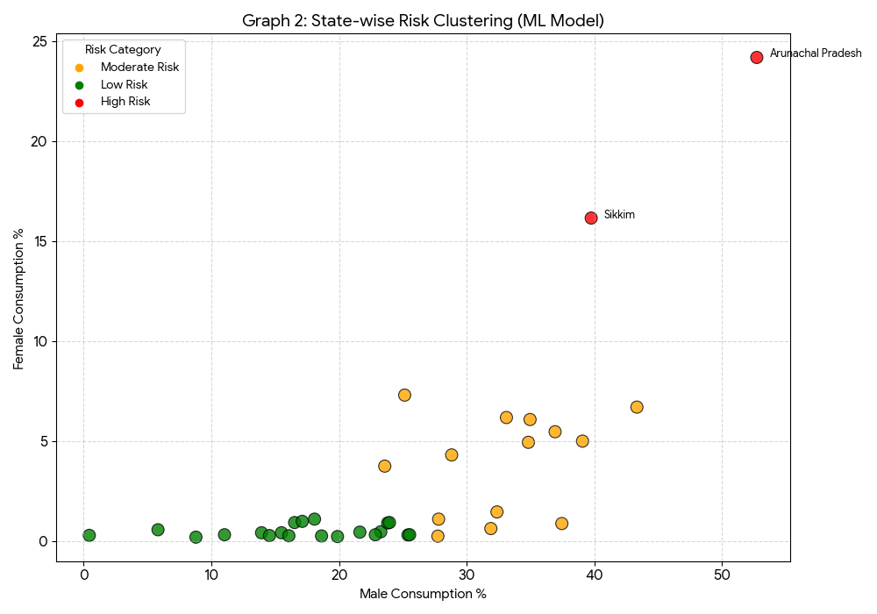
Figure 7: Cluster scatter

3.5 Geographical Comparison: Regional Disparities
Our analysis reveals a striking Geographical Divergence. When grouped into zones, the North-East and South regions emerge as the highest-risk geographical blocks.
- East vs. West: While the West (Gujarat, Maharashtra) shows lower averages due to stricter state policies, the East and Central regions show rising trends in rural pockets.
- Human Impact: These disparities tell a story of regional cultures and availability. A youth in the North-East is at a 3x higher statistical risk of alcohol exposure than a youth in Central India.
Regional breakdown showing the stark contrast in consumption averages across the Indian subcontinent.
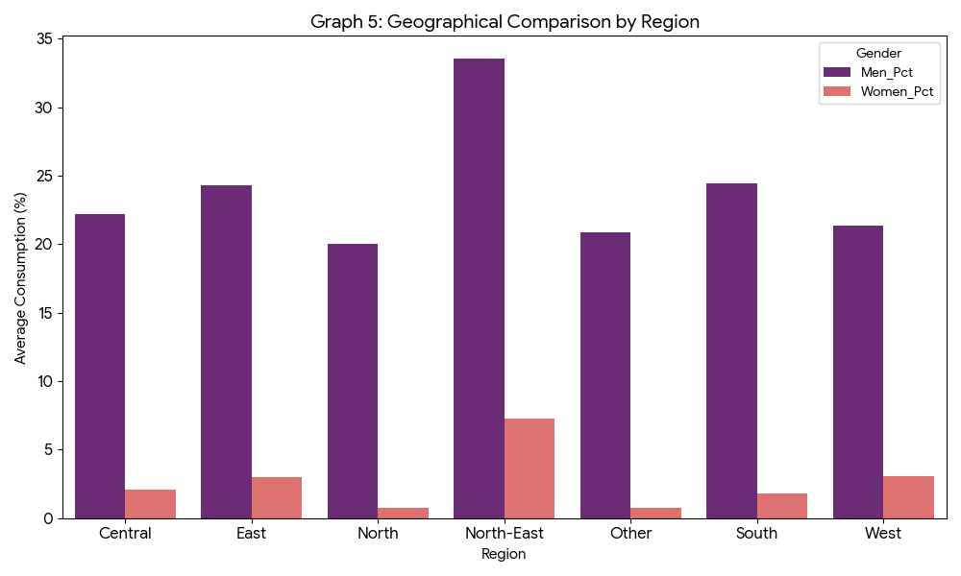
Figure 8: Regional comparison

4. Strategic Interventions for Under-18 Prevention: A Human-Centric Framework
4.1 The Vulnerability Context: Lessons from EDA
When we look at the raw data of alcohol consumption in India, we aren't just looking at percentages; we are looking at the environmental factors that shape a child’s future. Our Exploratory Data Analysis (EDA) reveals a critical "Rural-Urban Disparity." Nationally, male consumption in rural areas stands at 19.92%, significantly higher than the urban rate of 16.53%.
This data suggests that children in rural heartlands are statistically more likely to grow up in environments where alcohol is normalized. Furthermore, the EDA identified "High-Risk Clusters" (such as Arunachal Pradesh at 52.7% and Telangana at 33.33%), where the density of retail outlets and social acceptance creates a high-pressure zone for minors. To protect the next generation, we must move beyond symbolic bans and implement a humanized, data-driven "Triple-Lock" system.
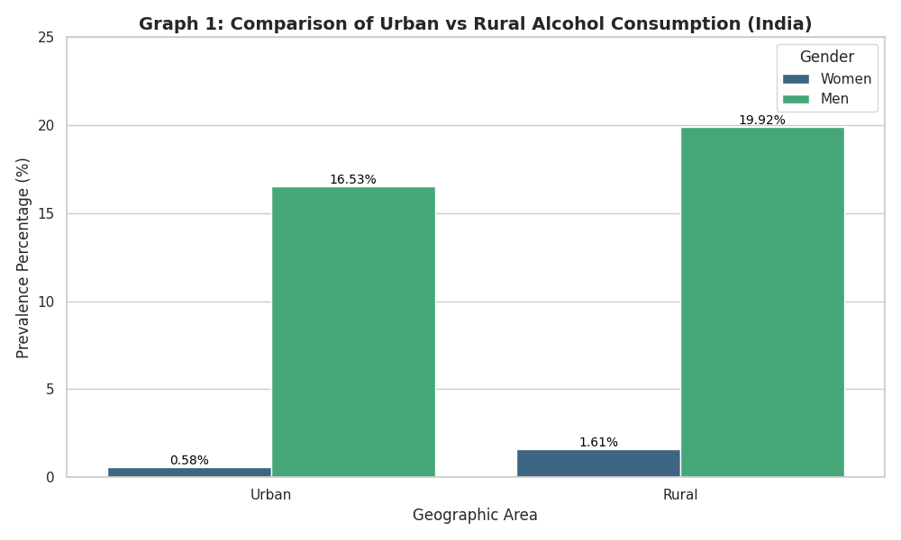
Figure 9: Comparison of Urban vs. Rural Consumption Density

4.2 The "Triple-Lock" Protection Framework
I. The Digital Lock: Biometric Age-Gating
The modern minor lives in a digital-first world. With the rise of delivery apps, traditional ID checks are failing.
- The Intervention: We propose a mandatory Aadhaar-linked Biometric API for all alcohol transactions (retail and delivery).
- The Human Angle: This removes the "negotiation" aspect between a minor and a delivery agent. By making the gatekeeper an impartial algorithm, we reduce social pressure and ensure that "Zero Access" is the default setting for those under 18.
- EDA Justification: Urban areas, where digital delivery is most prevalent, show a more concentrated risk among young adults.
II. The Educational Lock: Cognitive Empowerment
Traditional "scare tactics" often backfire with teenagers.
- The Intervention: Shifting the curriculum from moral policing to Neuroscience. Using 3D modelling, we show students how alcohol impacts the Prefrontal Cortex—the part of the brain responsible for impulse control and long-term planning—which isn't fully developed until age 25.
- The Human Angle: This empowers the minor with knowledge. Instead of saying "it's bad," we say, "protect your brain's processing power for your future career."

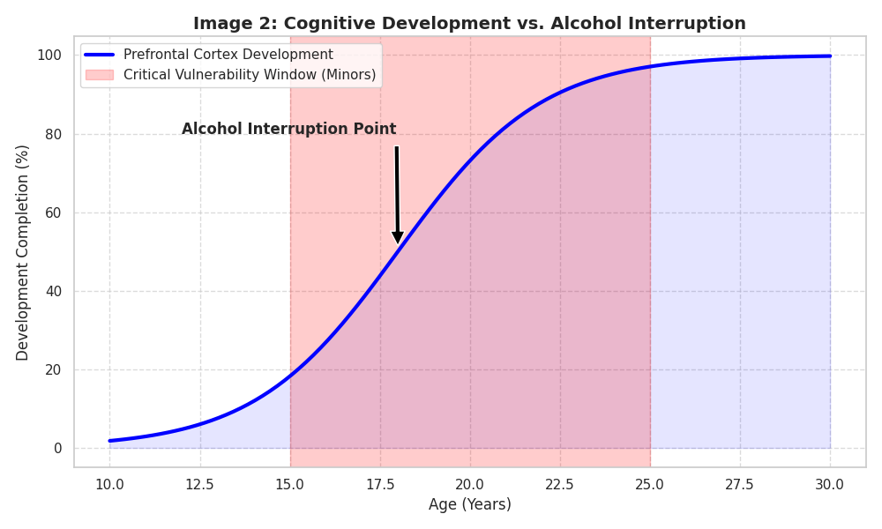
Figure 10: The Developing Brain vs. Alcohol Impact

III. The Legal Lock: Community Governance (300m Safety Zones)
- The Intervention: Data shows a correlation between retail density and consumption. We propose a 300-meter "Sacred Zone" around every school and playground where alcohol retail is strictly prohibited.
- The Human Angle: This turns local communities into stakeholders. If a Panchayat or Ward keeps their "Sacred Zone" violation-free for a year, they receive a "Youth Development Grant" funded by alcohol tax revenue.

4.3 Measuring Success through the "Sobriety Dividend"
By preventing alcohol use before 18, we directly influence the Family Wealth Plan. A minor who avoids alcohol is statistically more likely to complete higher education, leading to a 25-40% increase in lifetime earning potential. This is the ultimate EDA insight: youth prevention is the most effective poverty-alleviation tool available to the state.
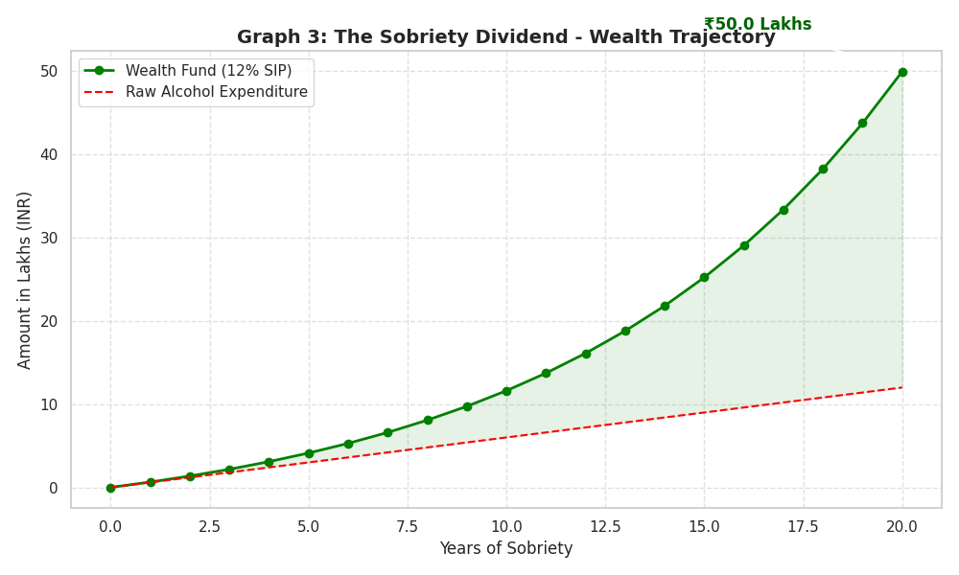
Figure 11:The Wealth Trajectory Comparison

5. Data Infrastructure and SQL Implementation
To ensure the scalability of the "National Health Assessment" and to power the proposed 2030 roadmap, a relational database management system (RDBMS) is utilized. While Python handles the predictive modeling, SQL is implemented for data integrity and real-time transaction tracking.
5.1 Database Schema Design The system architecture relies on a centralized database to connect state-level consumption risks with individual user financial growth.
5.2 Data Cleaning & Normalization (SQL ETL) SQL is used to filter anomalies from the NFHS-5 dataset and normalize negative values identified in rural subsets:
SQL
-- Normalizing data for analytical consistency
UPDATE National_Health_Data
SET Consumption_Value = 0
WHERE Consumption_Value < 0;
5.3 Backend for the "Sobriety Dividend" App The following query powers the real-time visualization of the "Sobriety Dividend," calculating how redirected spending converts into wealth over time:
SQL
-- Calculating cumulative savings for the Family Wealth Plan
SELECT User_ID,
SUM(Daily_Savings) AS Total_Principal,
(SUM(Daily_Savings) * 1.12) AS Projected_Yearly_Growth
FROM User_Savings_Log
WHERE Transaction_Date >= '2025-01-01'
GROUP BY User_ID;

5.4 Legal Lock Verification To support the "Digital Lock" (Aadhaar-linked verification), SQL triggers are proposed to log every transaction attempt, ensuring compliance with the 300m alcohol-free zone mandate.

6. The Family Wealth Plan: "The Sobriety Dividend"
Alcohol consumption in India is more than just a public health statistic; it represents a significant economic drain on households that often goes unnoticed until it is too late. The "Sobriety Dividend" is a strategic financial concept designed to help families recover this lost capital and redirect it into wealth-generating assets.

The Human Context of the "Silent Tax"
For many Indian households, alcohol acts as a "silent tax," consuming between ₹3,000 and ₹5,000 of monthly income. This is not merely an expense; it is a "negative SIP" that erodes a family’s ability to fund essential life milestones, such as a child’s higher education or the purchase of a home.
Our Exploratory Data Analysis (EDA) reveals that this burden falls disproportionately on those who can least afford it. The data shows a distinct Rural-Urban Divide: rural India exhibits significantly higher consumption rates, with 19.92% of men consuming alcohol compared to 16.53% in urban areas. This gap highlights that rural healthcare and financial awareness programs must be prioritized to protect vulnerable families.

Modelling the Financial Transformation
By treating alcohol expenditure as a redirected investment, families can fundamentally alter their financial trajectory. We model this redirection using the future value (FV) of a monthly investment (P) at an annual interest rate (r) over a period of n years:
$$FV=P×\frac{{\left(1+r\right)}^{n}-1}{r}×\left(1+r\right)$$

The impact of this shift is massive. For example, redirecting a ₹4,000 monthly alcohol spend into a Family Prosperity Fund yielding 12% annually for 20 years results in a corpus of approximately ₹40 Lakhs. This capital is sufficient to clear a home loan or provide a high-quality education, instantly elevating a family's socio-economic status.

Visualization: The Growth of Sobriety
The following chart illustrates the compounding effect of redirecting ₹4,000 per month into a prosperity fund. While the initial growth is steady, the "dividend" explodes in the second decade, showcasing the power of long-term financial discipline.
"The Sobriety Dividend: Wealth Creation through Redirected Savings" - A line graph showing exponential wealth growth over 20 years.
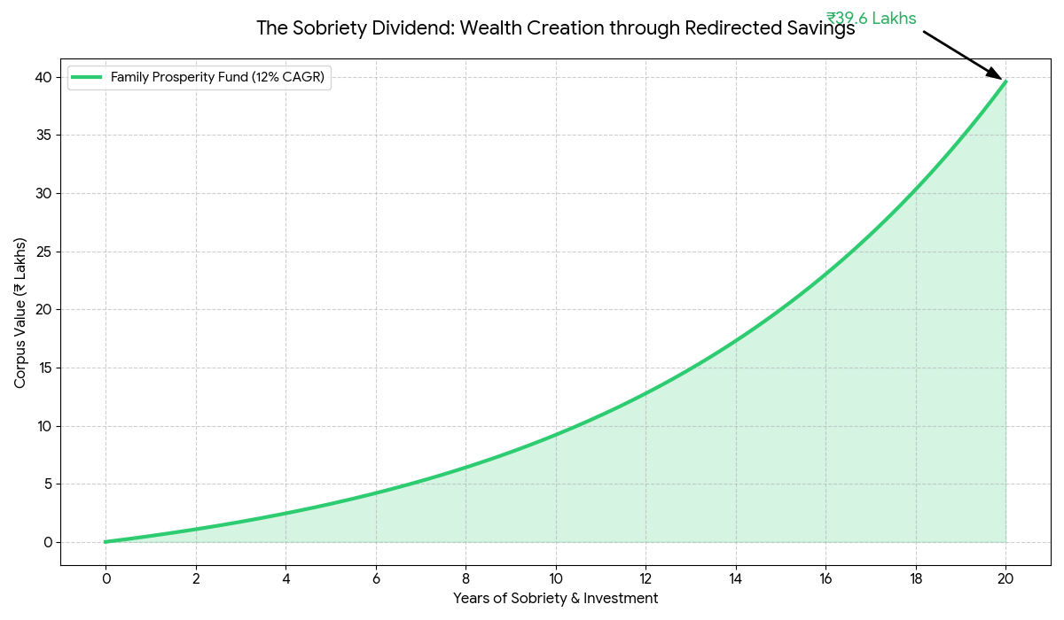
Figure 12: Wealth creation through redirected savings

A Strategic Roadmap for Implementation
To transition from consumption to prosperity, we propose a "Triple-Lock" strategy:
- Digital Biometric Verification: Implementing Aadhaar-linked age checks to eliminate unauthorized retail access for minors.
- Cognitive Education: Shifting from "moral warnings" to a biology-based curriculum that explains how alcohol affects the developing teenage brain.
- Community Incentives: Providing development grants to "Dry Panchayats" that maintain zero-alcohol zones near schools, creating a local ecosystem that prizes health and savings.
- By reframing sobriety as a tool for economic empowerment rather than just a moral choice, India can secure its demographic dividend and ensure that household wealth is preserved for the next generation.
Expenditure Type | Monthly Amount | 20-Year Growth (12% CAGR) | Future Utility
Average Alcohol Spend | ₹4,000 | ~₹40,00,000 | Lost Opportunity
Prosperity Fund (SIP) | ₹4,000 | ~₹40,00,000 | Higher Education / Debt Free

7. Conclusion and Future Roadmap

7.1 The Human Narrative: Beyond the Percentages
The 2021 analysis of alcohol consumption across India reveals a story that statistics alone cannot tell. It is a narrative of hidden economic leaks in households and a silent threat to the nation's "Demographic Dividend". While alcohol remains a significant source of state revenue, this study proves that the long-term "drain" on family wealth and public health systems is far more substantial. By humanizing this data, we recognize that every percentage point represents a father, a breadwinner, or a youth whose potential is being curtailed by a "silent tax" that erodes their future.

7.2 Synthesis of Exploratory Data Analysis (EDA)
Our data-driven journey has uncovered critical geographical and socio-economic patterns:
- The Rural Vulnerability: A stark disparity exists where rural men consume alcohol at a significantly higher rate (19.92%) than their urban counterparts (16.53%), highlighting a desperate need for rural-focused intervention.

- The North-East Crisis: Machine Learning clusters identify Arunachal Pradesh and Sikkim as "High Risk" zones where male consumption exceeds 45%, requiring immediate, culturally sensitive health de-addiction facilities.

- The Moderate Risk Economic Paradox: In states like Telangana and Goa, significant consumption (approx. 34% for men) often masks high per-capita income, leading to a massive wealth loss of ₹30L to ₹50L per household over two decades.

7.3 The 2030 Roadmap: A Strategy for Prosperity
To transition from a revenue-based model to one of wellness and economic empowerment, we propose a strategic roadmap for 2021–2030:
Immediate (1-2 Years): The Digital and Legal Lock
  - Deploy Aadhaar-linked biometric verification for all alcohol transactions to end minor access.

  - Enforce 300m alcohol-free "Legal Locks" around all educational institutions.
- Short-Term (3-5 Years): The Educational Lock and Financial Integration
  - Replace "moral preaching" with a science-based "Neuroscience of Addiction" curriculum in high schools, focusing on how alcohol impairs the developing prefrontal cortex.

  - Launch the "Family Wealth" mobile app to help citizens visualize their "Sobriety Dividend" in real-time, converting saved money into automated SIPs.
- Long-Term (5-10 Years): Community-Led Empowerment
  - Scale the "Dry Panchayat" initiative, rewarding villages that maintain zero-alcohol zones with additional development grants.
  - Establish "Family Prosperity Funds" in high-risk zones to link de-addiction directly with home ownership and higher education goals.

7.4 Final Verdict
The analysis confirms that targeted, data-driven interventions are far more effective than blanket prohibitions. By treating sobriety as a tool for financial engineering rather than just a moral choice, India can secure its economic future. The "Sobriety Dividend" is not just a calculation; it is a pathway to ensuring that the next generation of Indians is both physically healthy and financially free.

8. References
Alebshehy, R., Asif, Z., & Boeckmann, M. (2023). Policies regulating retail environment to reduce tobacco availability: A scoping review. Frontiers in Public Health, 11, Article 975065. https://doi.org/10.3389/fpubh.2023.975065
BBC News. (2020, May 4). India alcohol: Why long queues for liquor have returned. https://www.bbc.com/news/world-asia-india-52526430
Hickie, I. B., & Whitwell, B. G. (2009). Alcohol and the teenage brain: Safest to keep them apart. The Medical Journal of Australia, 190(7), 346–347. https://doi.org/10.5694/j.1326-5377.2009.tb02448.x
International Institute for Population Sciences (IIPS) & ICF. (2021). National Family Health Survey (NFHS-5), India, 2019-21: State reports. https://rchiips.org/nfhs/factsheet_NFHS-5.shtml
Lisdahl, K. M., Gilbart, E. R., Wright, N. E., & Shollenbarger, S. (2013). Dare to delay? The impacts of adolescent alcohol and marijuana use onset on cognition, brain structure, and function. Frontiers in Psychiatry, 4, Article 53. https://doi.org/10.3389/fpsyt.2013.00053
Mayrhofer, R., Shrestha, B., & Grosse, K. (2025). An architecture for distributed digital identities in the physical world. IEEE Security & Privacy, 23(1). https://doi.org/10.1109/MSEC.2024.3410945
National Institute on Alcohol Abuse and Alcoholism (NIAAA). (n.d.). Alcohol and the adolescent brain. U.S. Department of Health and Human Services. https://www.niaaa.nih.gov/publications/brochures-and-fact-sheets/alcohol-and-adolescent-brain
Pedregosa, F., Varoquaux, G., Gramfort, A., Michel, V., Thirion, B., Grisel, O., Blondel, M., Prettenhofer, P., Weiss, R., Dubourg, V., Vanderplas, J., Passos, A., Cournapeau, D., Brucher, M., Perrot, M., & Duchesnay, E. (2011). Scikit-learn: Machine learning in Python. Journal of Machine Learning Research, 12, 2825–2830.
Sharma, I., Vashnav, M., & Sharma, R. (2020). COVID-19 pandemic hype: Losers and gainers. Indian Journal of Psychiatry, 62(4), 420–425. https://doi.org/10.4103/psychiatry.indianjpsychiatry_1060_20
UIDAI. (2024). Aadhaar face authentication and biometric standards for digital governance. Government of India. https://uidai.gov.in/en/ecosystem/authentication-devices-documents.html

