**Where to get the source code, technologies used, where to get data, etc**

**Technology:**

The program is written in java. It is a java applet. A large reason for it being an applet is because the genetic algorithm requires a lot of processing power and memory.

**Formats:**

It can read file formats in geojson, ESRI shapefile, or comma separated values.

**Code source:**

The source code is available at <https://github.com/happyjack27/autoredistrict> or you can just google “autoredistrict”. Included with the source code are screenshots, samples, and this document.

**Data source:**

The best – and usually only – place to find geographic election data is the “HARVARD ELECTION DATA archive” at <http://projects.iq.harvard.edu/eda/home>

**THE PROGRAM**

1. if you do not have java, install it. (you can find it by googling java jre)
2. run the launch script (e.g. run.bat)
3. load the atoms - from the file menu, select open geojson file if the file is in geojson, or open shapefile if it’s an esri shapefile.
4. Import additional data (merge data button)
5. Select the layers for population and demographics (remember to check the checkboxes)
6. Set the number of desired districts
7. Hit play. “|>”
8. Wait until the map is no longer changing.
9. Hit pause “||”
10. Export results - From the file menu, select export results.

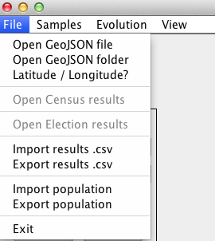

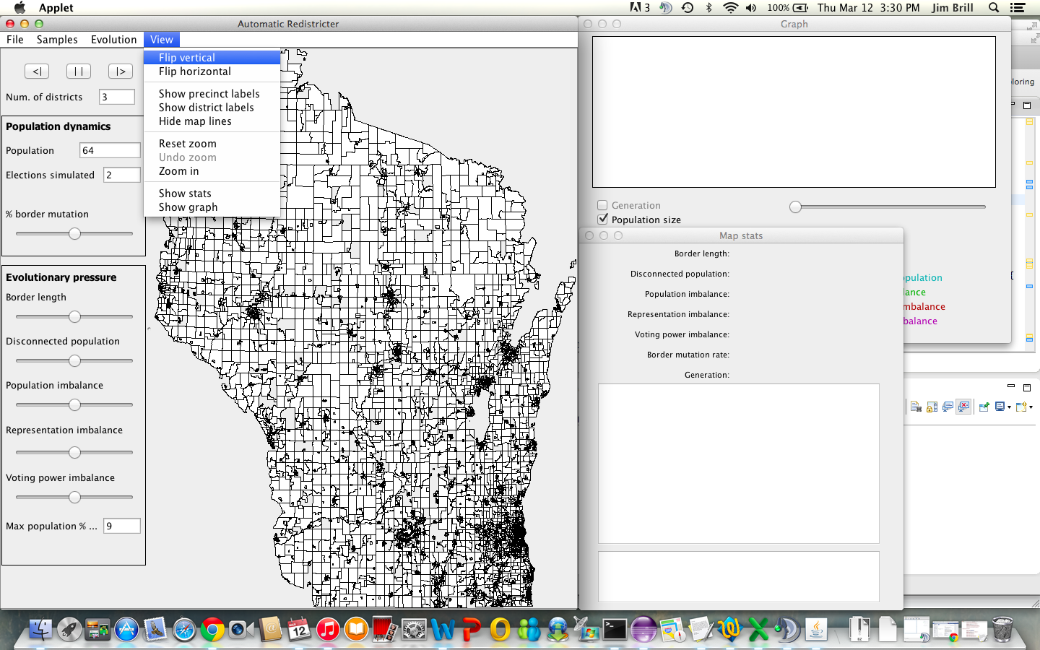

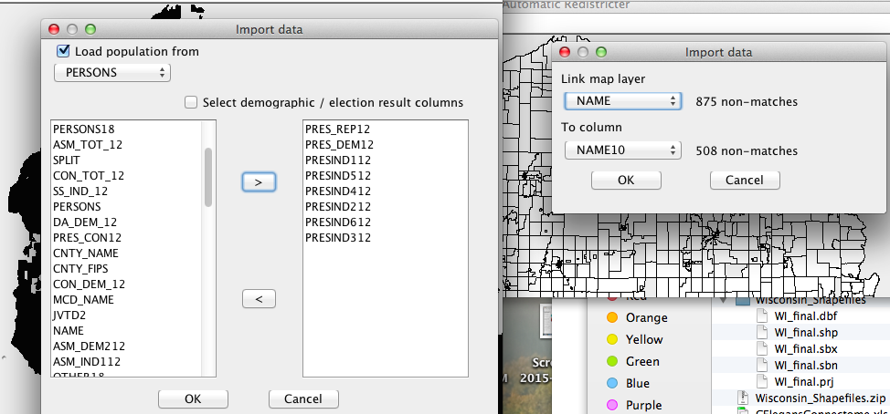

**Advantage 2020**

[**http://www.msnbc.com/msnbc/democrats-launch-new-super-pac-combat-gop-gerrymanders**](http://www.msnbc.com/msnbc/democrats-launch-new-super-pac-combat-gop-gerrymanders)

[**http://www.msnbc.com/msnbc/2016-democrats-already-have-plan-2020**](http://www.msnbc.com/msnbc/2016-democrats-already-have-plan-2020)

[**http://dlcc.org/news/dlcc-launches-advantage-2020-key-success-next-round-redistricting-70-million-plus-effort**](http://dlcc.org/news/dlcc-launches-advantage-2020-key-success-next-round-redistricting-70-million-plus-effort)

**TODO?: add section on how to deal with communities of interest? (basically either lock them into one unit in the shapefile, and/or include as part of the demographics for power equality / proportionality – or maybe better to put that in the in_practice doc?)**