**SAMPLES**

**Older revision - Sample Results – Wisconsin 2010 - Federal Congress**

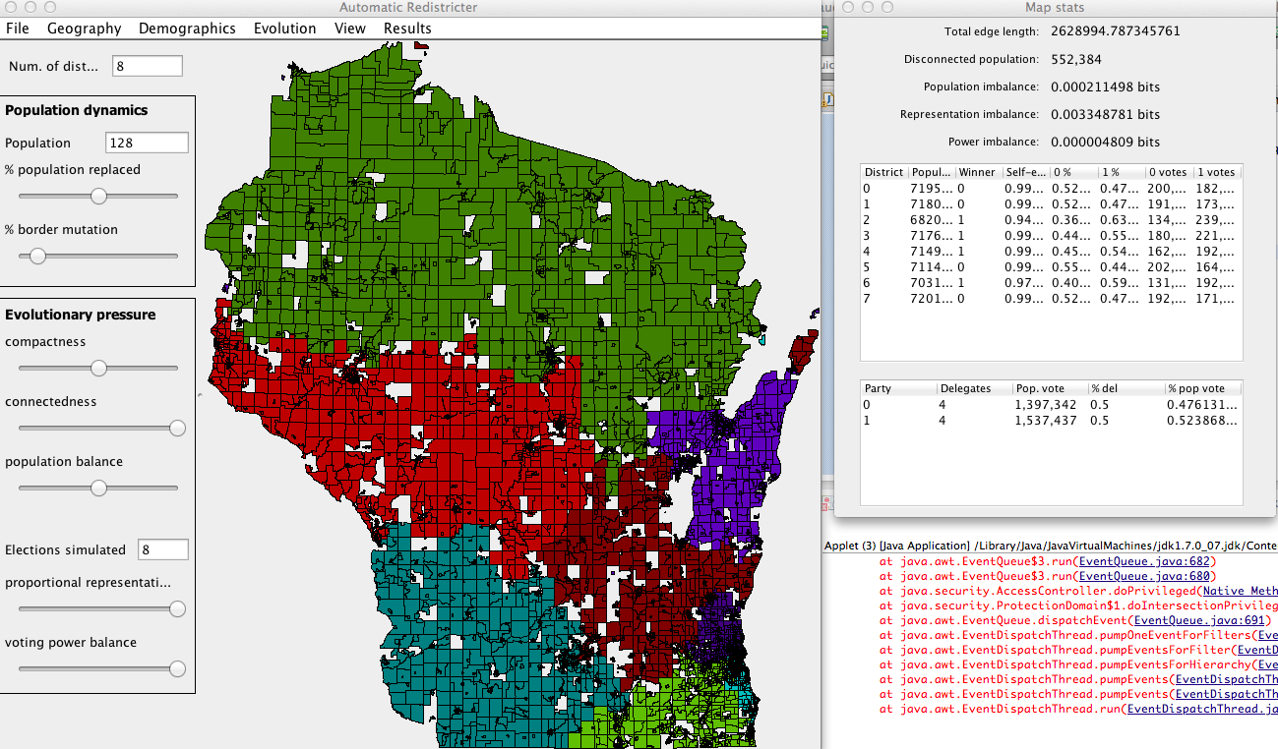

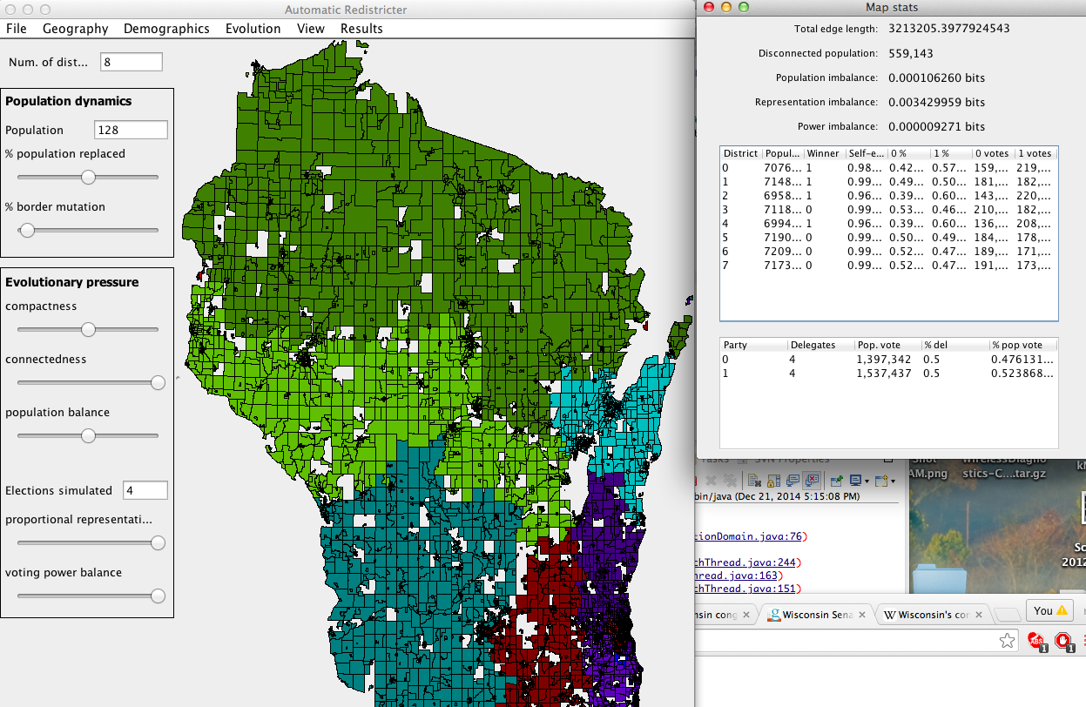

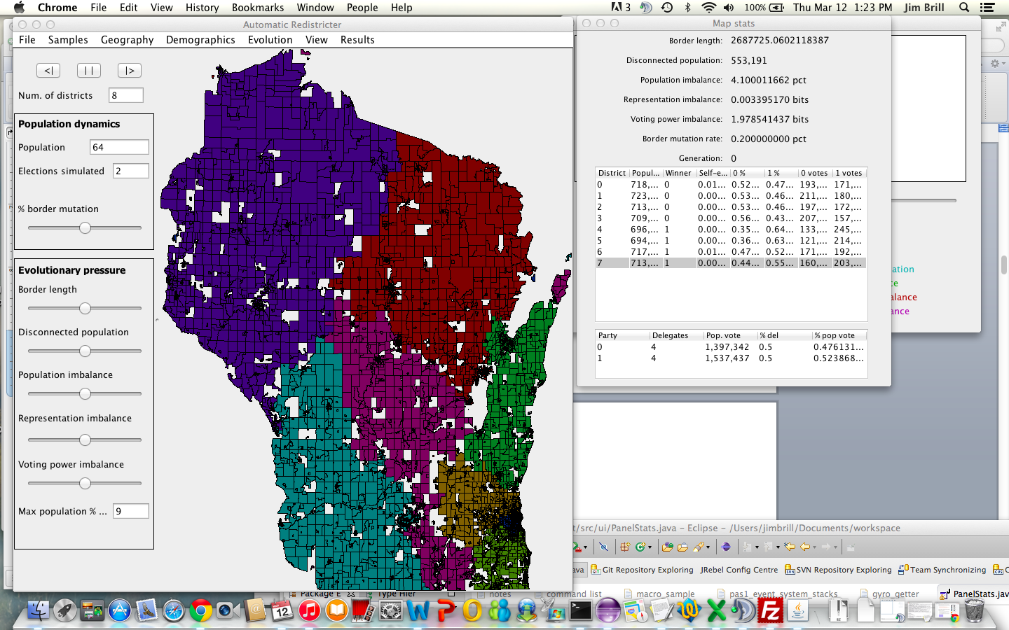

**Older revision - Sample Results – Wisconsin 2010 - State Assembly**

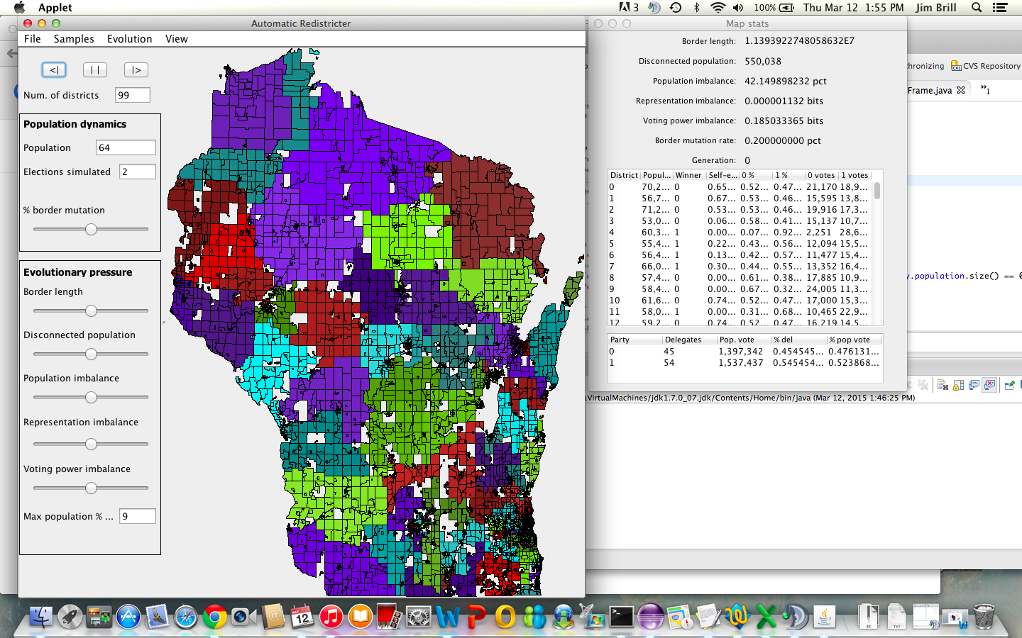

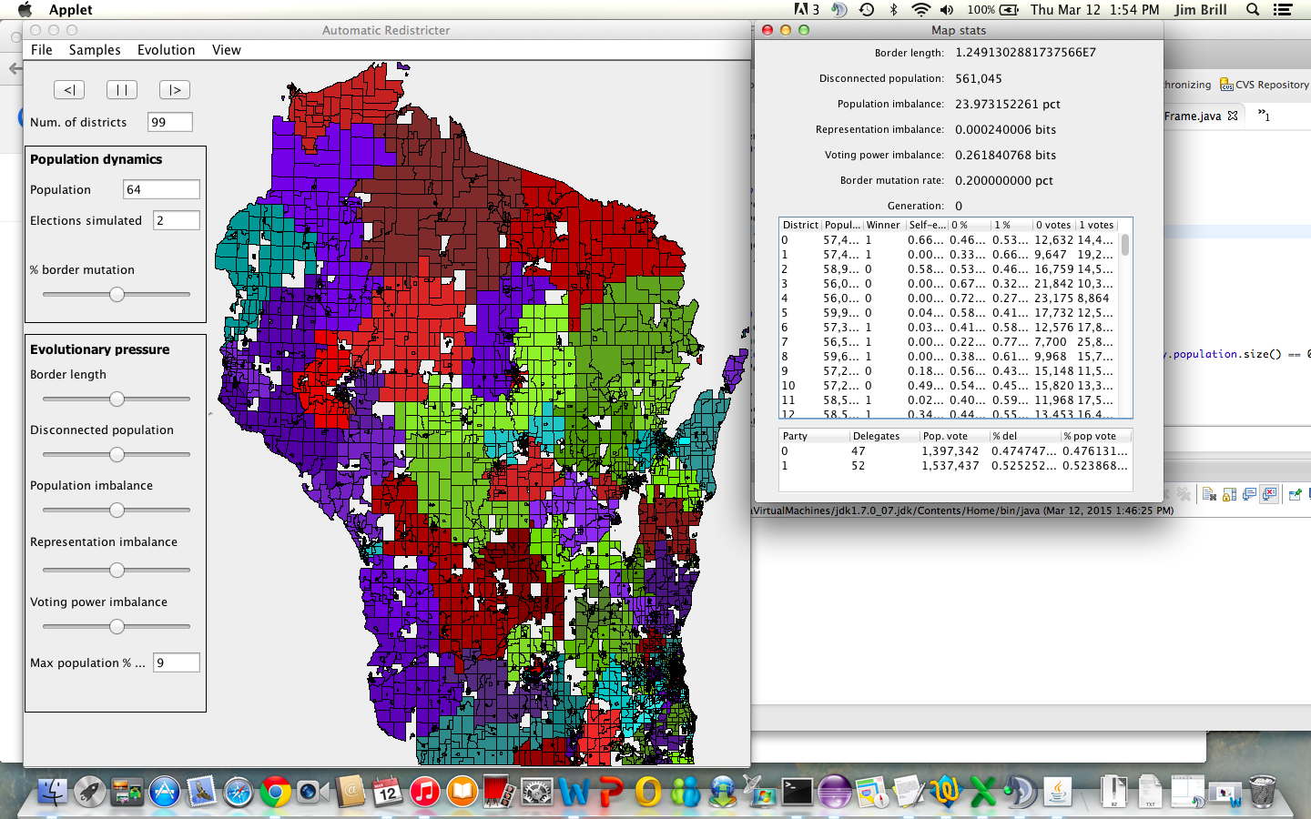

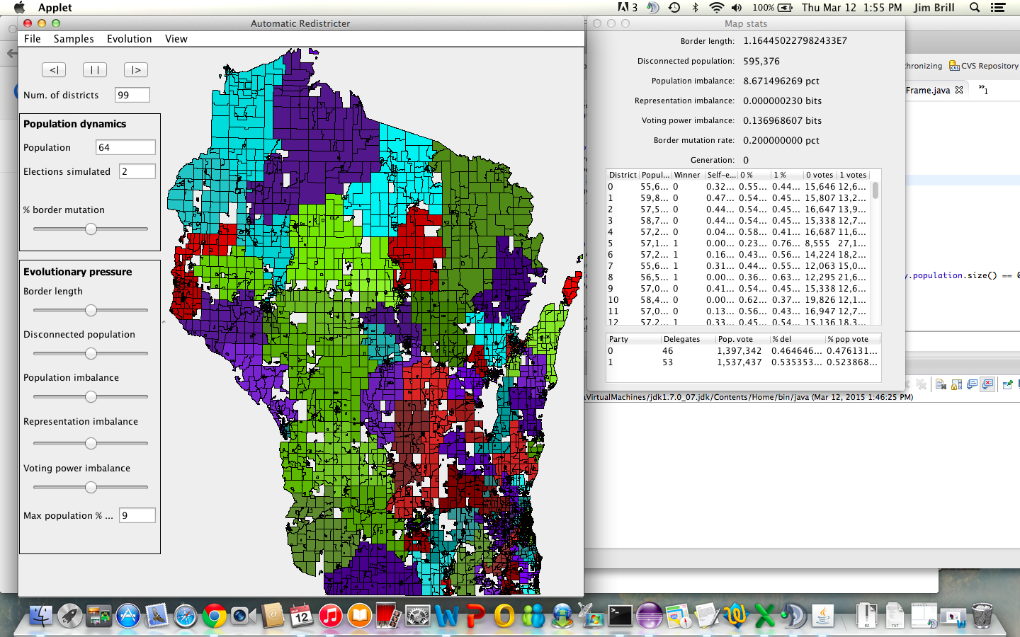

**Sample results – Wisconsin 2010 - State Assembly**

**Sample results – Wisconsin 2010 - State Assembly – MMPD - 3 members per district**

**Sample results – Wisconsin 2010 – State Senate**

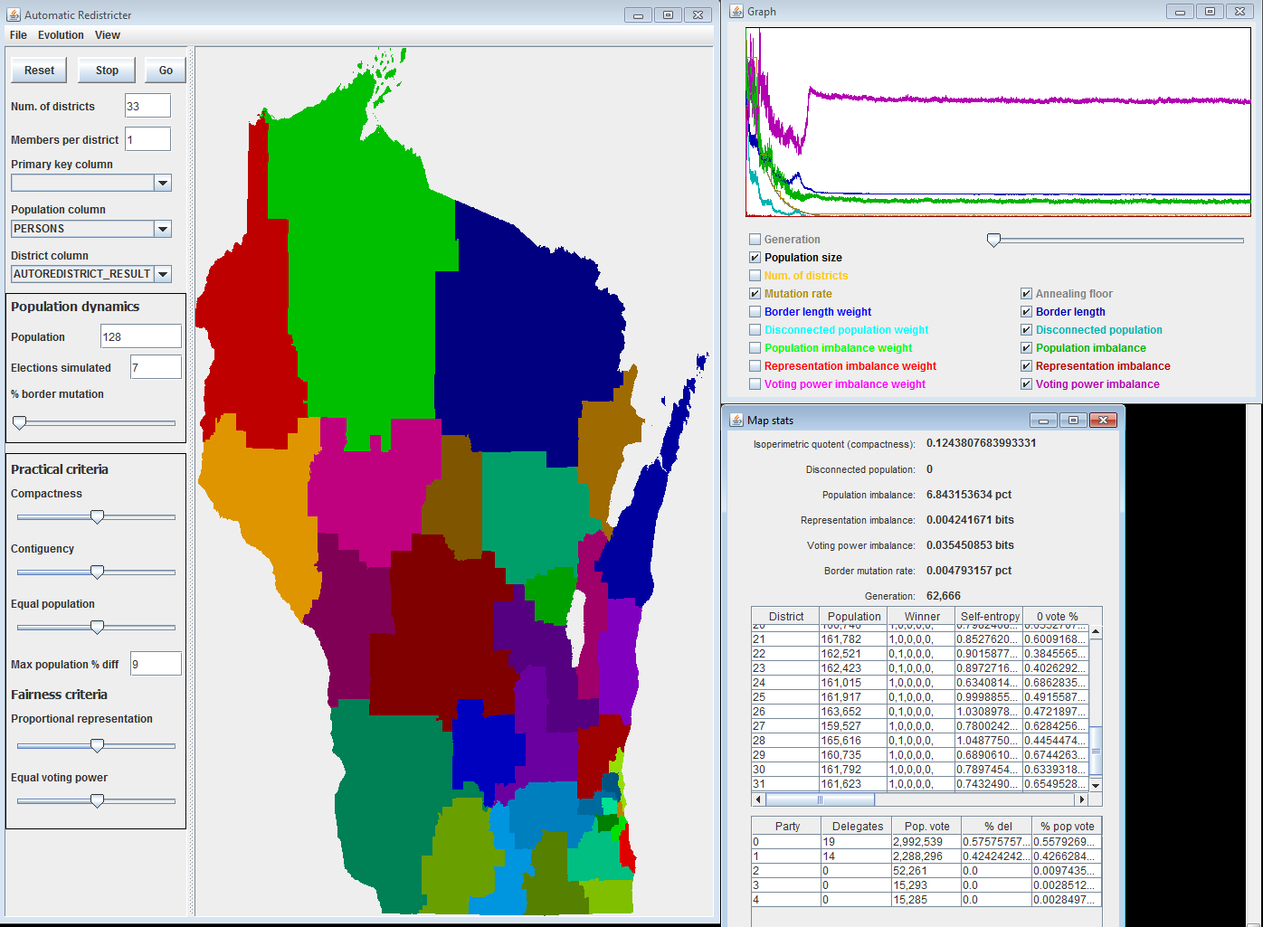

**Sample result – Wisconsin 2010 – Federal Congress**

