REGISTRAR DOCUMENT REQUEST SYSTEM
Technology: VB. NET and MySQL

Submitted by:
Borromeo, Ronalyn M.
Cantor, Rhayniel Allen D.
Quimson, Allen Dwayn T.
Reosa, Patricia I.
Rivel, John Cristian I.

BSIT-31E3

Submitted to:
Ms. Alyssa Broncano

October 2026
Table of Contents
1.1 Background of the Study 1
1.2 Statement of the Problem 1
1.3 Objectives of the Project 1
SYSTEM DESCRIPTION 2
2.1 About the Proposed System 2
2.2 Who Will Use the System 2
3.1 Hardware Needed 3
3.2 Software Needed 3
3.3 What the System Can Do 3
3.4 Other Important Qualities 3
SYSTEM ANALYSIS AND DESIGN 4
4.1 How the System Works 4
4.2 How a Request is Processed 4
4.3 Use Case Diagram 4
DATABASE DESIGN 6
5.1 Database Overview 6
5.2 Database Tables 6
5.3 Entity Relationship Diagram 8
5.4 How Tables Connect 8
SYSTEM MODULES 9
6.1 Login Page 9
6.2 Main Menu 9
6.3 Student Management 10
6.4 Document Management 11
6.5 Making a New Request 11
6.6 Payment Recording 12
6.7 Updating Request Status 13
6.8 Viewing All Requests 14
6.9 Reports 15
7.1 How the System Was Built 17
7.2 Connecting VB.NET to MySQL 17
7.3 Adding, Editing, and Deleting Records 17
7.4 Handling Transactions 18
8.1 Checking Inputs 19
8.2 Keeping Data Safe 19
8.3 Test Cases 19
8.4 Test Results 19
USER GUIDE 20
9.1 Logging In 20
9.2 Using the Main Menu 20
9.3 Managing Student Records 20
9.4 Creating a Request 20
9.5 Recording a Payment 20
9.6 Changing Request Status 21
9.7 Generating Reports 21
CONCLUSION AND RECOMMENDATIONS 22
10.1 Conclusion 22
10.2 Recommendations 22
10.3 What the System Cannot Do Yet 22

INTRODUCTION

Background of the Study
The Registrar Document Request System was built to solve these problems. It’s a straightforward system that lets staff manage and track all requests in one organized place. Students can still visit the office if they want to, but the whole process is now faster, neater, and much easier to follow. Every request is stored in a database, so important documents and details won’t get lost.
Right now, things work very differently. When students need documents like transcripts, diplomas, or certificates, they have to go to the Registrar’s Office, fill out forms by hand, wait in long queues, and come back over and over just to check if their papers are ready. It wastes a lot of time, for students and for the staff too. Files can go missing, paperwork piles up everywhere, and sometimes information gets written down incorrectly.

1.2 Statement of the Problem
Right now, getting school documents takes so much time. When students need
transcripts, diplomas, or certificates, they go to the Registrar’s Office, fill out form
by hand, wait in long lines, and come back again and again just to check if their papers
are ready. To fix all these issues. It’s a simple program that lets staff manage and track
every request in one organized place. Students can still visit the office if they want to, but
the whole process is now faster, neater, and much easier to follow. Everything is saved
securely in a database, so nothing gets lost.

1.3 Objectives of the Project
Main Goal
To build a simple and working computer system using VB.NET and MySQL that makes requesting and releasing school documents faster and easier.
Specific Goals
- To let staff add, edit, and find student records quickly.
- To make requesting documents simple and clear.
- To show the status of each request so anyone can see where it stands.
- To record payments and connect them to the right request.
- To create reports that show how many requests were made and how much money was collected.
- To keep the system safe so only allowed people can use it.

SYSTEM DESCRIPTION

2.1 About the Proposed System
The Registrar Document Request System is a desktop program that runs on a computer at the Registrar's office. It was built with VB.NET for the interface and MySQL to store all the information.
Here's what it does:
- Staff log in with their own username and password.
- They can add new students and update student information.
- They can see a list of documents available and how much each one costs.
- When a student asks for a document, staff enter the request into the system, and it automatically calculates the total cost.
- Every request has a status: Pending → Processing → Ready for Pickup → Released.
- Payments are recorded and linked to the request.
- Reports can be printed or viewed on screen.

2.2 Who Will Use the System
- eAdministrator – Full control add or remove staff, change settings, see everything
- Registrar Staff - Add students, create requests, update status, record payments, make reports
- Student – Will not log in directly, staff will enter requests on their behalf

SYSTEM REQUIREMENTS

3.1 Hardware Needed
Item | Needed
Computer | Intel Core i3/ AMD Ryzen 3 or similar
Memory (RAM) | 4 GB or more
Storage | 500 GB hard drive
Screen | 1024 × 768 resolution
Printer | To print forms and reports

3.2 Software Needed
Item | Details
Operating System | Windows 10 or Windows 11
Programming Tool | Visual Studio (VB.NET)
Database | MySQL
Extra Tool | MySQL Connector — connects the program to the database

3.3 What the System Can Do
- Let users log in and log out
- Add, edit, find, and delete student records
- Keep a list of documents and their prices
- Create new requests and calculate costs automatically
- Record payments
- Change and show request status
- Search and view all requests
- Make reports that can be printed

3.4 Other Important Qualities
- Safe — Only people with the right password can get in
- Fast — Records should load in just a few seconds
- Reliable — Information stays saved even if the computer is turned off
- Easy to use — Buttons and menus are simple and clearly labelled
- Backed up — Database can be copied and saved to prevent losing data

SYSTEM ANALYSIS AND DESIGN

4.1 How the System Works
- Staff opens the program and logs in
- The main menu appears
- Staff chooses what to do: add a student, make a request, record payment, view reports, etc.
- Information is saved to the database
- Results or messages appear on screen
- When finished, staff logs out

4.2 How a Request is Processed
- Staff looks up the student by ID or name
- Staff selects what document is needed and how many copies
- System shows the total amount
- Request is saved - status is Pending
- Staff reviews it - status becomes Processing
- Student pays - status becomes Ready for Pickup
- Student gets the document - status becomes Released

4.3 Use Case Diagram
People involved: Administrator, Registrar Staff
What they do:
- Administrator: Manage users, manage everything
- Registrar Staff: Manage students, create requests, update status, record payments, make reports
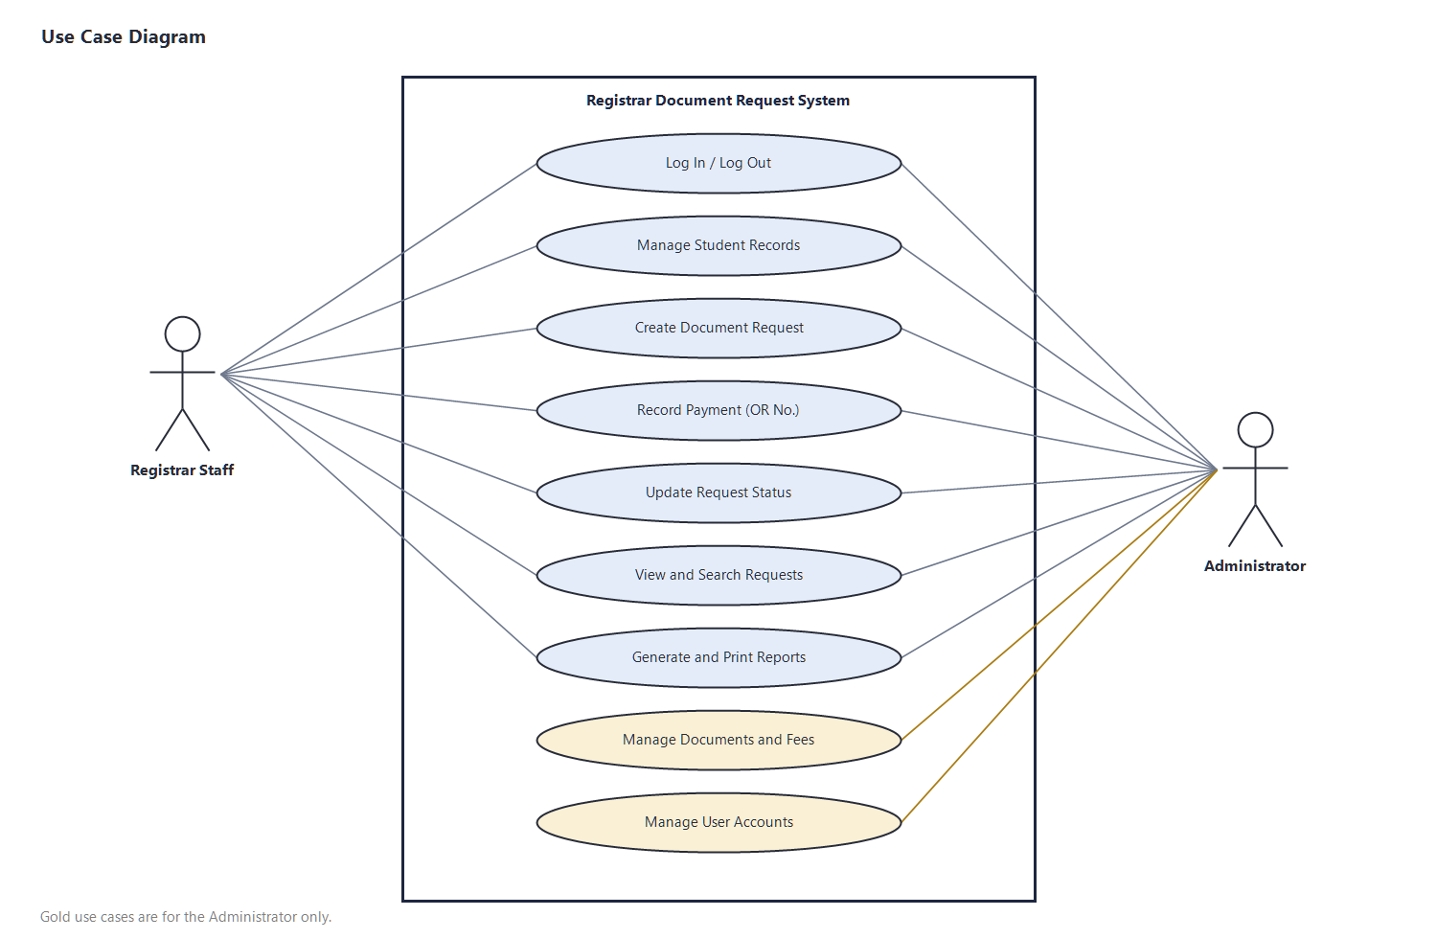
Figure 4.1 - Use case diagram of the Registrar Document Request System

DATABASE DESIGN

5.1 Database Overview
The database is called registrar_db. It stores all the information in separate tables so everything stays organised.
Table | What It Stores
users | Usernames, passwords, and roles of staff
students | Student names, IDs, course, contact details
documents | Names of documents and their fees
requests | The main request information — who, when, status, total cost
Request details | Which documents were requested and how many copies
payments | Payment records — amount, date, who received it

5.2 Database Tables
Users Table
Field | Type | About
User id | Number | Unique ID for each staff
username | Text | Login name
password | Text | Password
Full name | Text | Staff member's name
role | Text | Administrator or Staff
Students Table
Field | Type | About
Student id | Text | School ID number
Full name | Text | Student's name
course | Text | What they are studying
Year level | Number | 1st year, 2nd year, etc.
Contact no | Text | Phone number
email | Text | Email address

Document Table
Field | Type | About
Doc id | Number | Document code
Doc name | Text | Name of the document
fee | Decimal | Cost per copy
Requests Table
Field | Type | About
Request id | Number | Request reference number
Student id | Text | Who asked for it
Request date | Date | When it was entered
status | Text | Pending / Processing / Ready / Released
Total amount | Decimal | Total cost
Request Details Table
Field | Type | About
Detail id | Number | Line item ID
Request id | Number | Which request it belongs to
Doc id | Number | Which document
quantity | Number | How many copies
subtotal | Decimal | Cost for this item
Payments Table
Field | Type | About
Payment id | Number | Payment reference
Request id | Number | Which request was paid
Amount paid | Decimal | How much was paid
Payment date | Date | When payment was made

5.3 Entity Relationship Diagram
- One student can have many requests
- One request can have many documents
- One request can have one or more payments
- All information is linked together so nothing gets mixed up
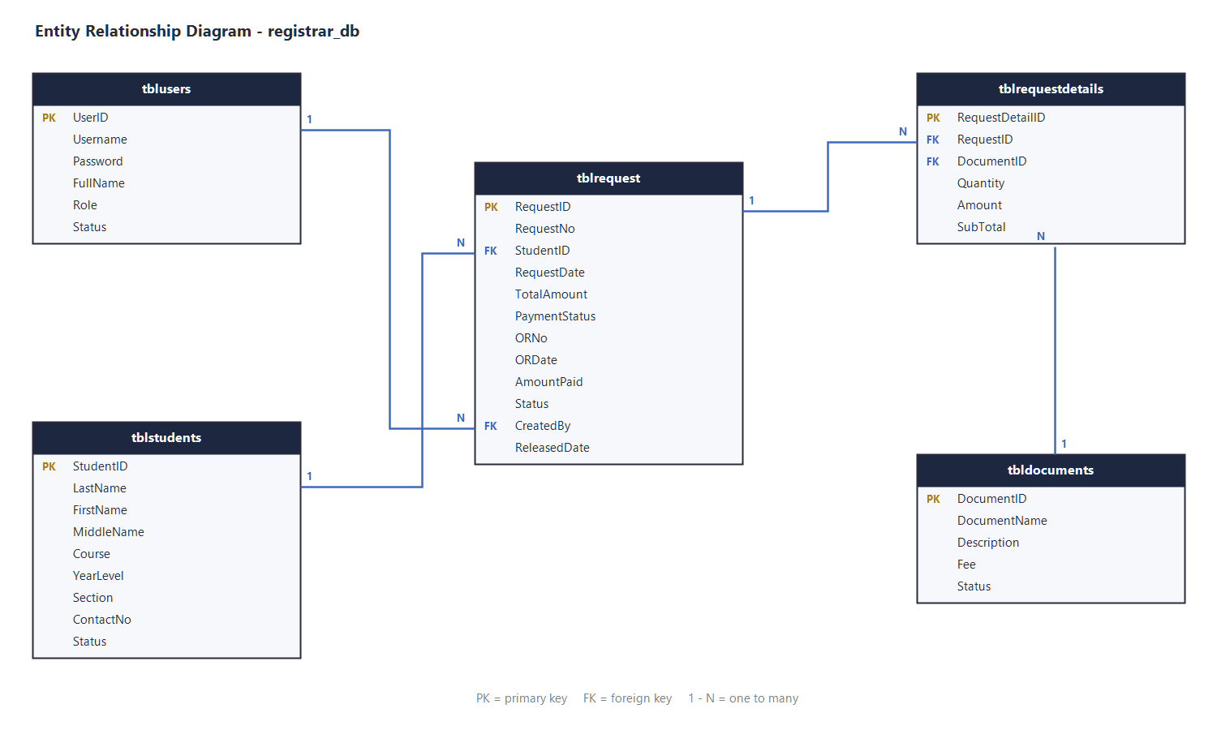
Figure 5.1 - Entity relationship diagram of registrar_db

5.4 How Tables Connect
- When a request is made, the student ID is taken from the students table
- The cost is taken from the documents table
- Payments are linked to the request by the request ID
- If a student is removed, their old requests are kept for records

SYSTEM MODULES

6.1 Login Page
- Enter username and password
- If correct, main menu opens
- If wrong, message says 'Login failed'
- Different users may see different menu options
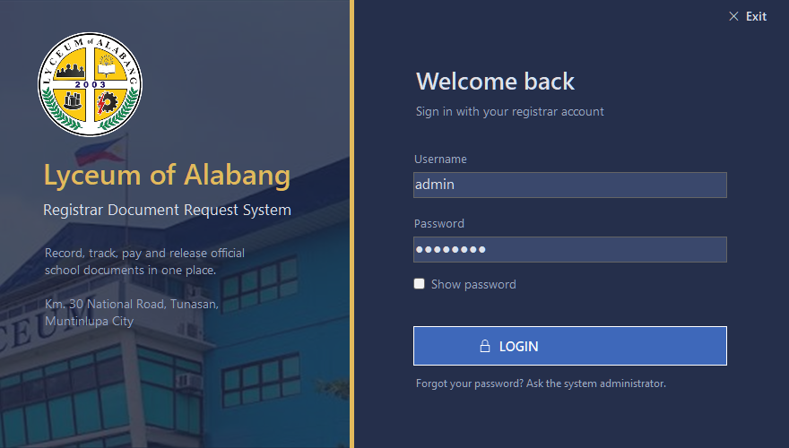
Figure 6.1 - Login page

6.2 Main Menu
- Central page with buttons for everything: Students, Documents, New Request, Requests List, Payments, Reports, Logout
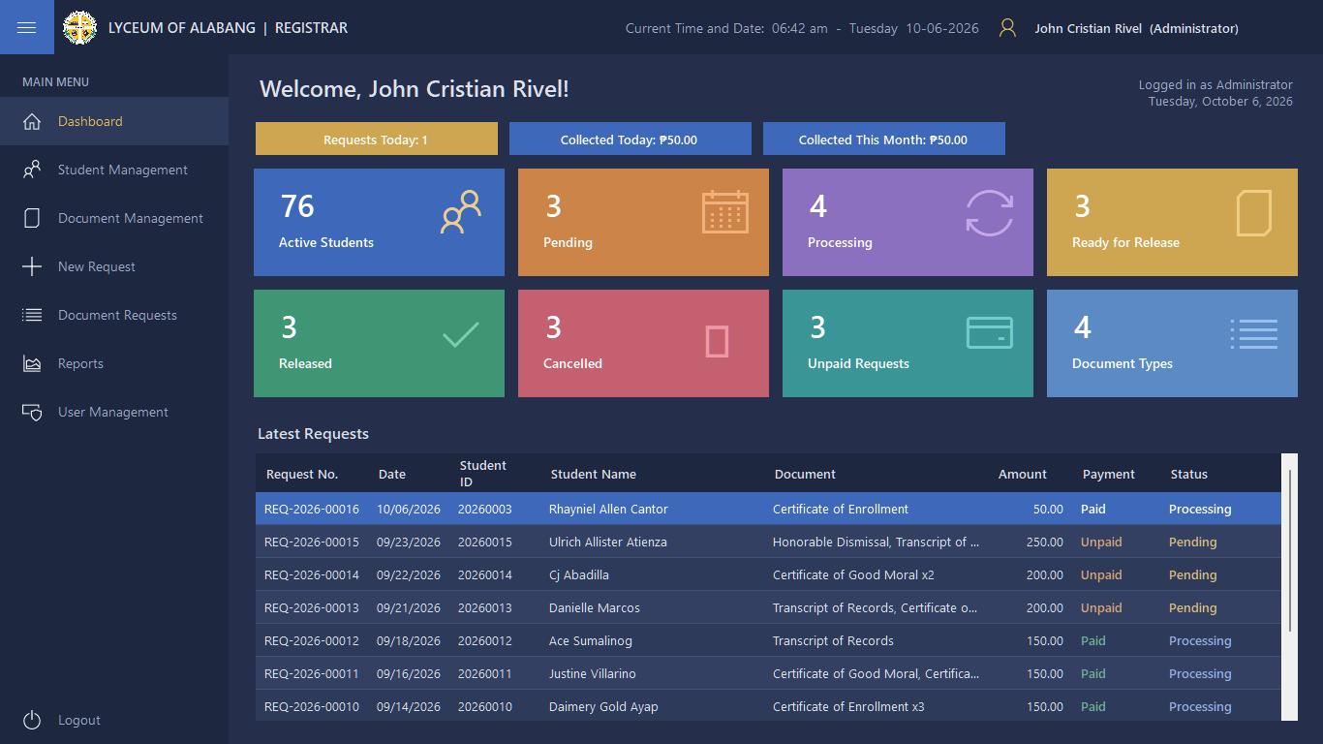
Figure 6.2 - Main menu and dashboard

6.3 Student Management
- Add new students
- Edit student information
- Search for a student by ID or name
- Remove students who have graduated or left
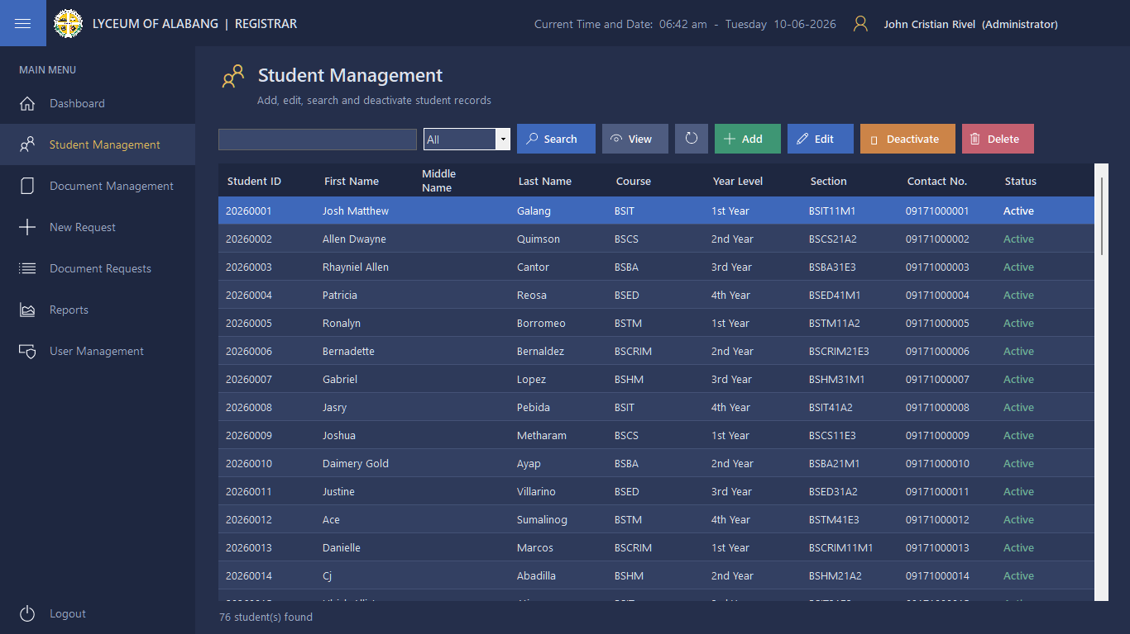
Figure 6.3 - Student Management
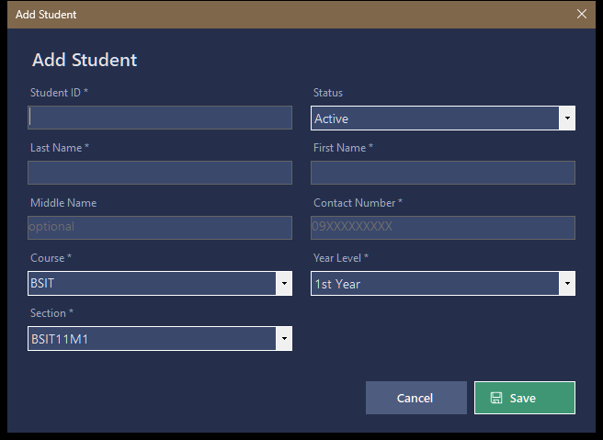
Figure 6.4 - Add Student form

6.4 Document Management
- Add new types of documents
- Change prices
- Remove documents that are no longer offered
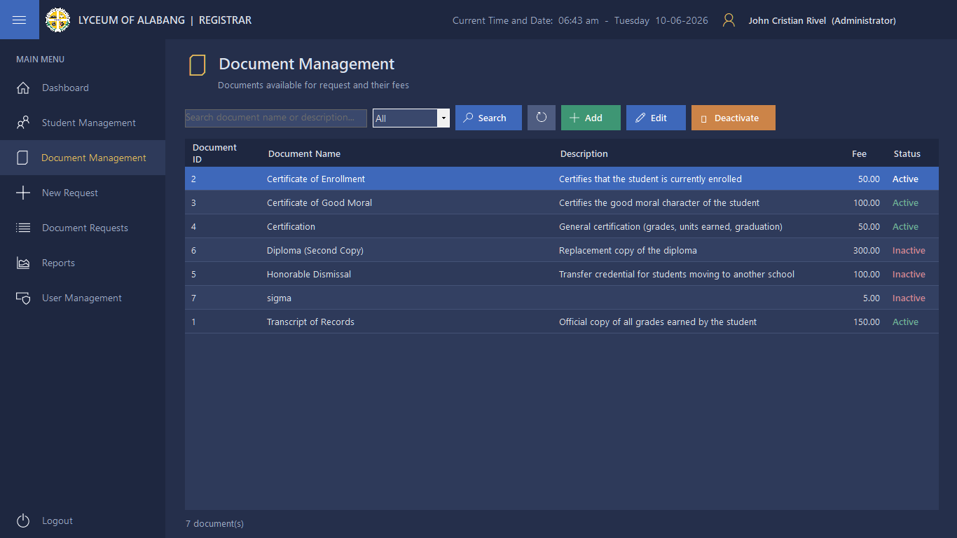
Figure 6.5 - Document Management

6.5 Making a New Request
- Find the student
- Pick the document and type the number of copies
- System shows the price and total
- Click Save — a request number appears
- Status is set to Pending
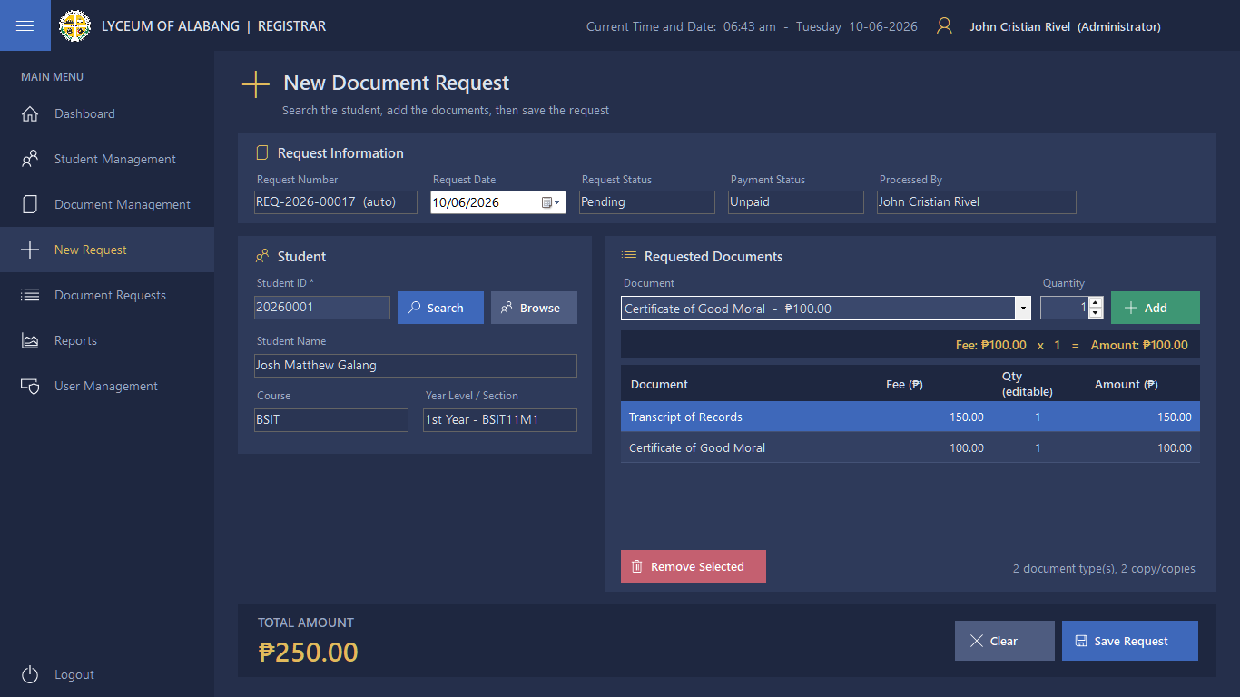
Figure 6.6 - New Document Request showing the fee, amount and total

6.6 Payment Recording
- Enter the request number
- System shows how much is due
- Type the amount paid
- Save — status changes automatically
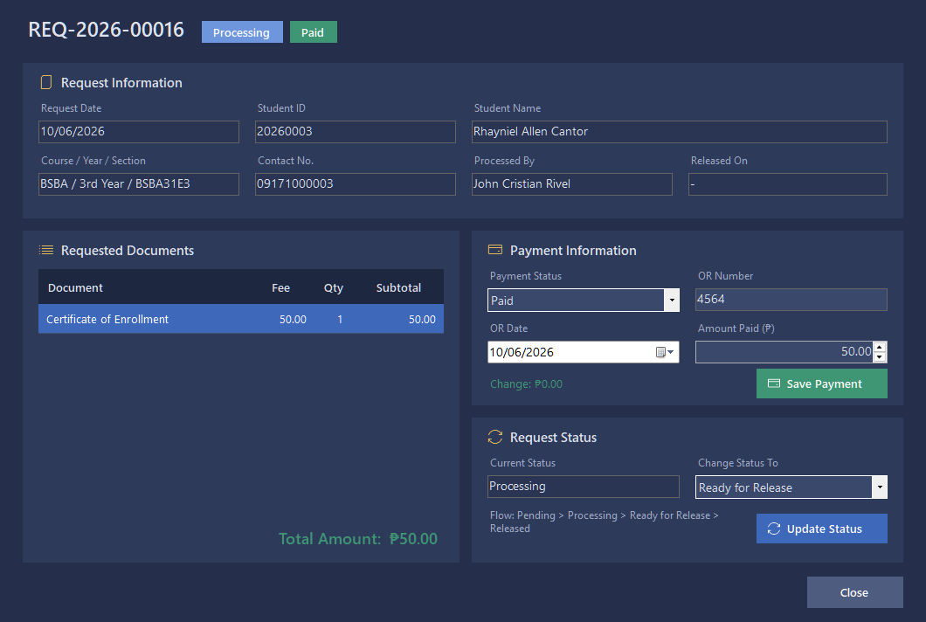
Figure 6.7 - Recording a payment in Request Details

6.7 Updating Request Status
- Open the request
- Change status to Processing, Ready, or Released
- Add notes if needed
- Save changes
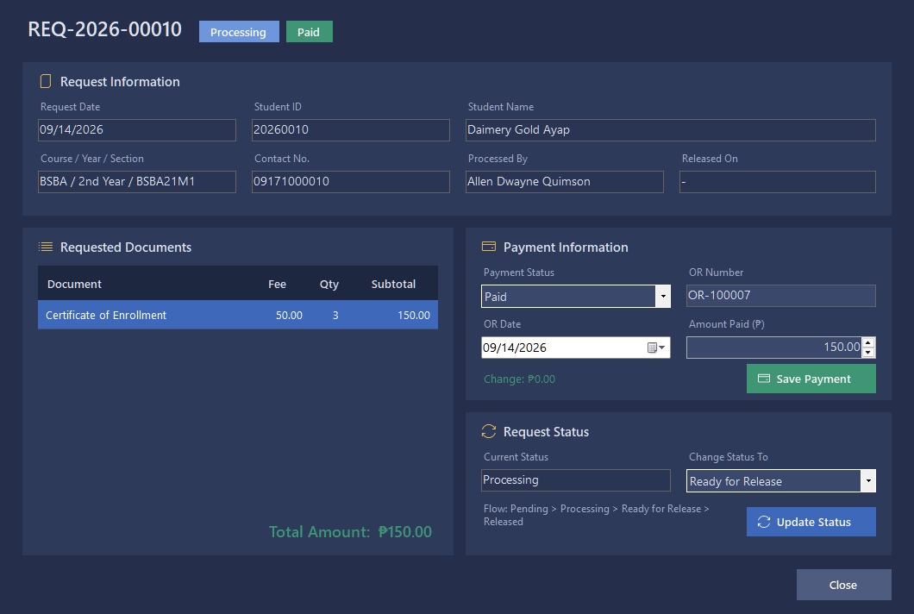
Figure 6.8 - Updating the status of a paid request

6.8 Viewing All Requests
- See every request in a list
- Search by date, student name, or status
- Click to see full details
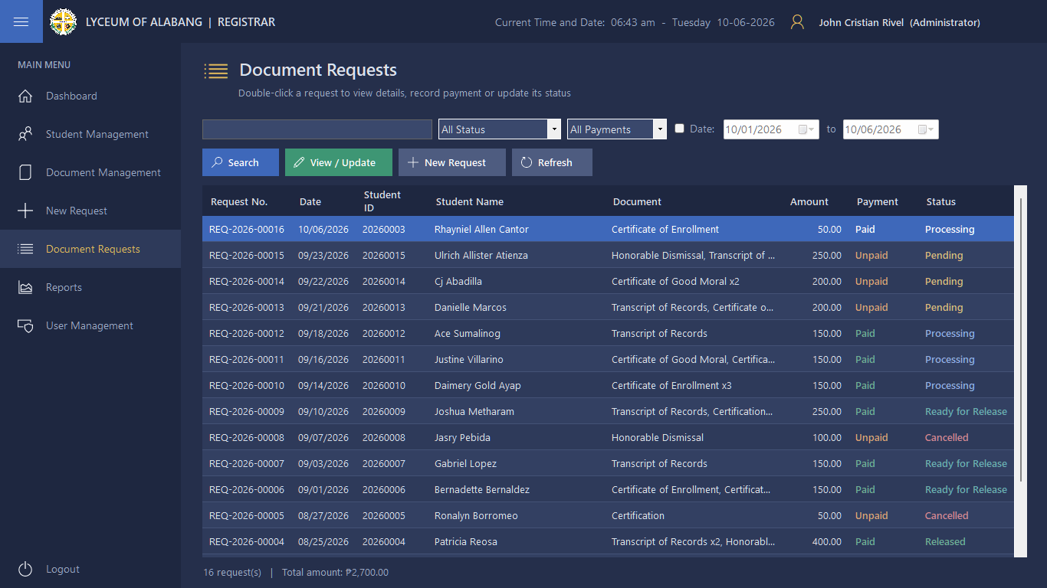
Figure 6.9 - Document Requests list

6.9 Reports
- Show requests from a certain date range
- Show total payments collected
- Show which documents were released
- Print or save the report
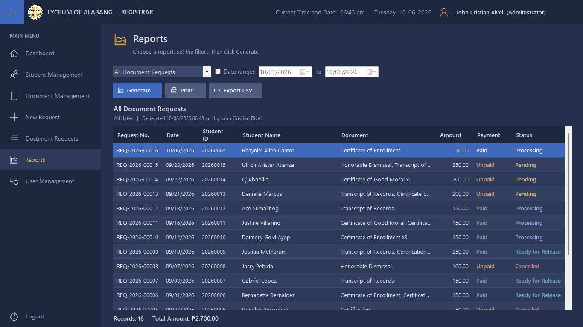
Figure 6.10 - Reports
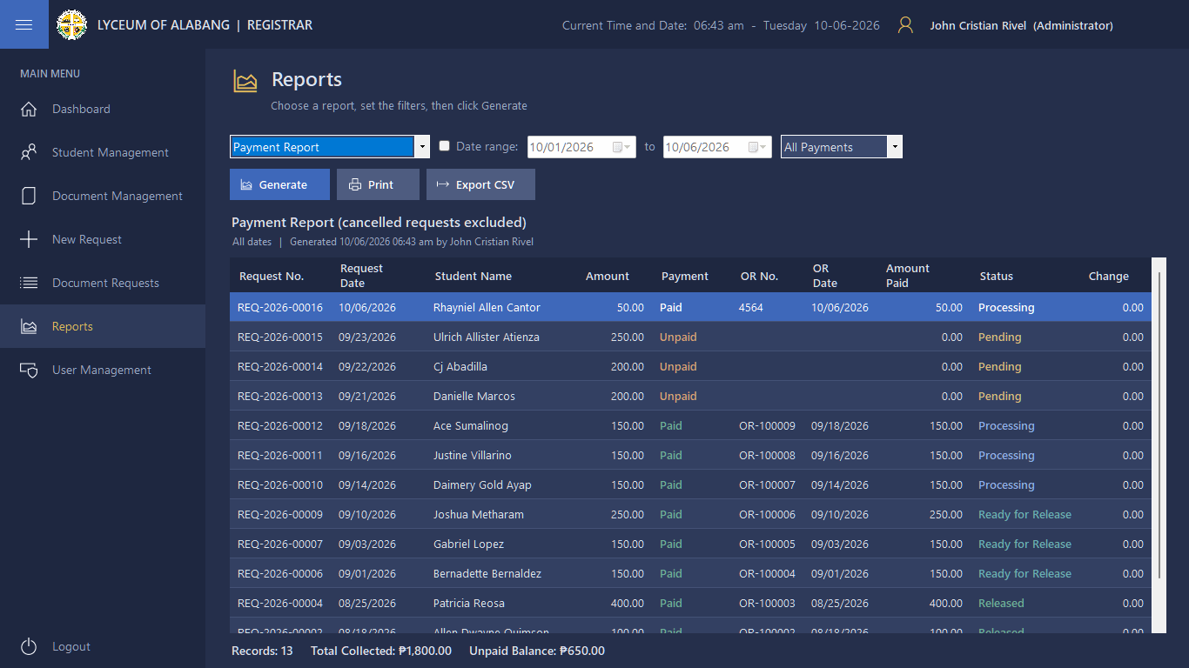
Figure 6.11 - Payment Report
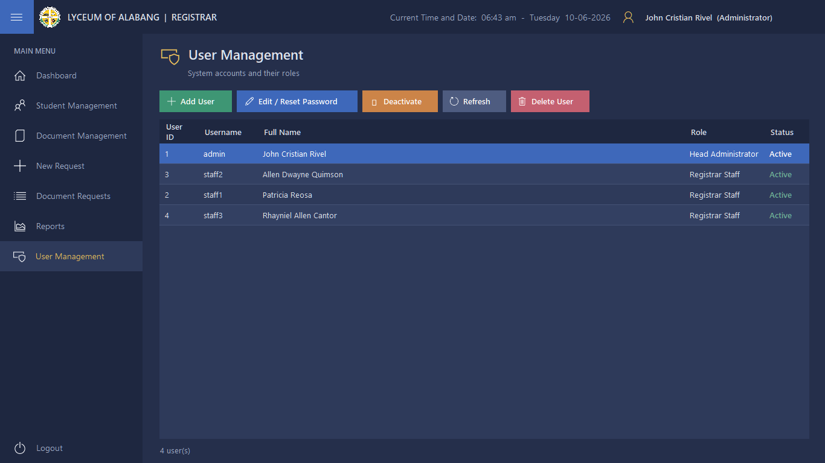
Figure 6.12 - User Management (Administrator only)
SYSTEM IMPLEMENTATION

7.1 How the System Was Built
We followed these steps:
1. Found out what the Registrar's office actually needs
2. Planned how the screens and database should look
3. Built the forms and buttons in Visual Studio using VB.NET
4. Created the database in MySQL
5. Connected the program to the database
6. Tested it and fixed problems

7.2 Connecting VB.NET to MySQL
Here's how the program connects to the database:
' Core\Db.vb
Imports MySql.Data.MySqlClient
Public Module Db
Public ConnectionString As String =
"Server=localhost;Port=3306;Database=registrar_db;Uid=root;Pwd=;" &
"SslMode=Disabled;AllowPublicKeyRetrieval=True;Convert Zero Datetime=True;"
Public Function OpenConnection() As MySqlConnection
Dim cn As New MySqlConnection(ConnectionString)
cn.Open()
Return cn
End Function
End Module

7.3 Adding, Editing, and Deleting Records
Adding a student:
' Forms\StudentEditorDialog.vb
Db.Execute("INSERT INTO tblstudents (StudentID, LastName, FirstName, MiddleName, Course, " &
"YearLevel, Section, ContactNo, Status) " &
"VALUES (@id, @ln, @fn, @mn, @course, @yr, @sec, @contact, @st)", ps)
Reading and showing records:
' Forms\StudentsForm.vb
Dim dt = Db.GetTable(
"SELECT StudentID AS `Student ID`, FirstName AS `First Name`, LastName AS `Last Name`, " &
" Course, YearLevel AS `Year Level`, Section, ContactNo AS `Contact No.`, Status " &
" FROM tblstudents " &
" WHERE (StudentID LIKE @q OR LastName LIKE @q OR FirstName LIKE @q OR Course LIKE @q) " &
" AND (@st = 'All' OR Status = @st) ORDER BY StudentID",
Db.P("@q", "%" & txtSearch.Text.Trim() & "%"), Db.P("@st", cboStatus.Text))
BindGrid(grid, dt)
Updating:
' Forms\StudentEditorDialog.vb
Db.Execute("UPDATE tblstudents SET LastName = @ln, FirstName = @fn, MiddleName = @mn, " &
"Course = @course, YearLevel = @yr, Section = @sec, ContactNo = @contact, " &
"Status = @st WHERE StudentID = @id", ps)
Deleting:
' Forms\StudentsForm.vb
Try
Db.Execute("DELETE FROM tblstudents WHERE StudentID = @id", Db.P("@id", id))
LoadData()
Catch ex As MySqlException When ex.Number = Db.ErrRowReferenced
Warn("This student already has document requests, so the record cannot be deleted." &
vbCrLf & "Use Deactivate instead.")
End Try

7.4 Handling Transactions
When saving a request and payment together, we make sure both are saved or neither is — so no partial data:
' Forms\NewRequestForm.vb
Using cn = Db.OpenConnection()
Using tx = cn.BeginTransaction()
requestNo = NextRequestNo(cn, tx, dtpDate.Value.Year)
Using cmd As New MySqlCommand(
"INSERT INTO tblrequest (RequestNo, StudentID, RequestDate, TotalAmount, " &
"PaymentStatus, Status, CreatedBy) VALUES (@no, @sid, @dt, @total, @pay, @st, @by)", cn, tx)
' ... parameters ...
cmd.ExecuteNonQuery()
requestId = CInt(cmd.LastInsertedId)
End Using
For Each row As DataGridViewRow In gridItems.Rows
Using cmd As New MySqlCommand(
"INSERT INTO tblrequestdetails (RequestID, DocumentID, Quantity, Amount, SubTotal) " &
"VALUES (@rid, @did, @qty, @amt, @sub)", cn, tx)
' ... parameters ...
cmd.ExecuteNonQuery()
End Using
Next
tx.Commit() ' nothing is saved unless every insert succeeded
End Using
End Using

VALIDATION AND TESTING

8.1 Checking Inputs
- Important fields cannot be left empty
- Numbers only where numbers belong
- Student ID cannot be repeated
- Amounts must be positive numbers

8.2 Keeping Data Safe
- Passwords are hidden
- Only people with accounts can enter
- No one can delete a request that already has a payment without a warning

8.3 Test Cases
Test | What We did | What Should Happen | Result
Login | Enter correct username & password | Main menu opens | Works ✔
Wrong Login | Enter wrong password | Error message appears | Works ✔
Add Student | Enter new student details | Student appears in list | Works ✔
Duplicate ID | Use existing student ID | Error prevents saving | Works ✔
Make Request | Select student and document | Request saved with number | Works ✔
Record Payment | Enter amount paid | Status changes to Ready | Works ✔
Release Doc | Set status to Released | List shows Released | Works ✔
Report | Generate daily summary | Numbers match manual count | Works ✔

8.4 Test Results
All main features work as planned. The system saves information correctly, calculates prices right, and shows reports accurately. The people who tested it said it was easy to understand and use.

USER GUIDE

9.1 Logging In
1. Open the program
2. Type your username
3. Type your password
4. Click Login
5. If you can't get in, check with your Administrator
6. When finished, click Logout

9.2 Using the Main Menu
- Click buttons on the left to move between pages
- The page you are on will be highlighted
- To go back, click another menu item or close the current page

9.3 Managing Student Records
- Add — Click Add, fill all boxes, click Save
- Edit — Find the student, click Edit, change details, click Save
- Search — Type in the search box to filter the list
- Refresh — Click Refresh to see the full list again

9.4 Creating a Request
1. Click New Request
2. Type the student ID or name to find them
3. Select the document from the list
4. Type how many copies
5. The system shows the cost
6. If adding more documents, repeat
7. Check the total
8. Click Submit
9. Write down the Request Number

9.5 Recording a Payment
1. Go to Payments
2. Type the Request Number
3. The system shows the amount due
4. Type the amount received
5. Click Save Payment
6. The status will change automatically

9.6 Changing Request Status
1. Go to Requests List
2. Find and click the request
3. Click Update Status
4. Pick the new status from the list
5. Type any notes if needed
6. Click Save

9.7 Generating Reports
1. Click Reports
2. Pick what kind of report you want
3. Choose the date range
4. Click Generate
5. Check the numbers on screen
6. Click Print if you need a paper copy

CONCLUSION AND RECOMMENDATIONS

10.1 Conclusion
The Registrar Document Request System has been built and tested successfully. It replaces the old manual method with a computerized system that’s faster, neater, and much more dependable. It keeps student records safe, makes requesting documents easy, shows exactly where every request stands, keeps track of payments, and can generate reports too. The system does everything we planned for it, and it’s ready to use at the Registrar’s Office.

10.2 Recommendations
- Switch fully to the system so everyone works faster
- Train staff and students to use it properly
- Add Online payments, status checks, and ready alerts later
- Keep daily backups on to protect all data
- Ask users for feedback and improve as you go
- Update security regularly to keep student info safe

10.3 What the System Cannot Do Yet
- Right now it works only on office computers - students can't use it directly
- Payments must be recorded by staff - no online payment yet
- No automatic notifications - students must come or call to check
- It's designed for one school - not for multiple branches or campuses

References:

Appendices:

