**Project One Stepping Stone**

John Rizkallah

Southern New Hampshire University

CYB-310: Network Defense

Professor Salmon

July 19, 2025

**Network Deficiencies**

The default gateway for the office router is .254. After running **ipconfig /all**, we saw that our HR PC’s all had different default gateways, except for PC#1. Additionally, Each PC failed the ping test to the cloud except for PC#1. This led me to believe that one of the points of failure for connection to the cloud was misconfiguration of HR PC’s to the office router.

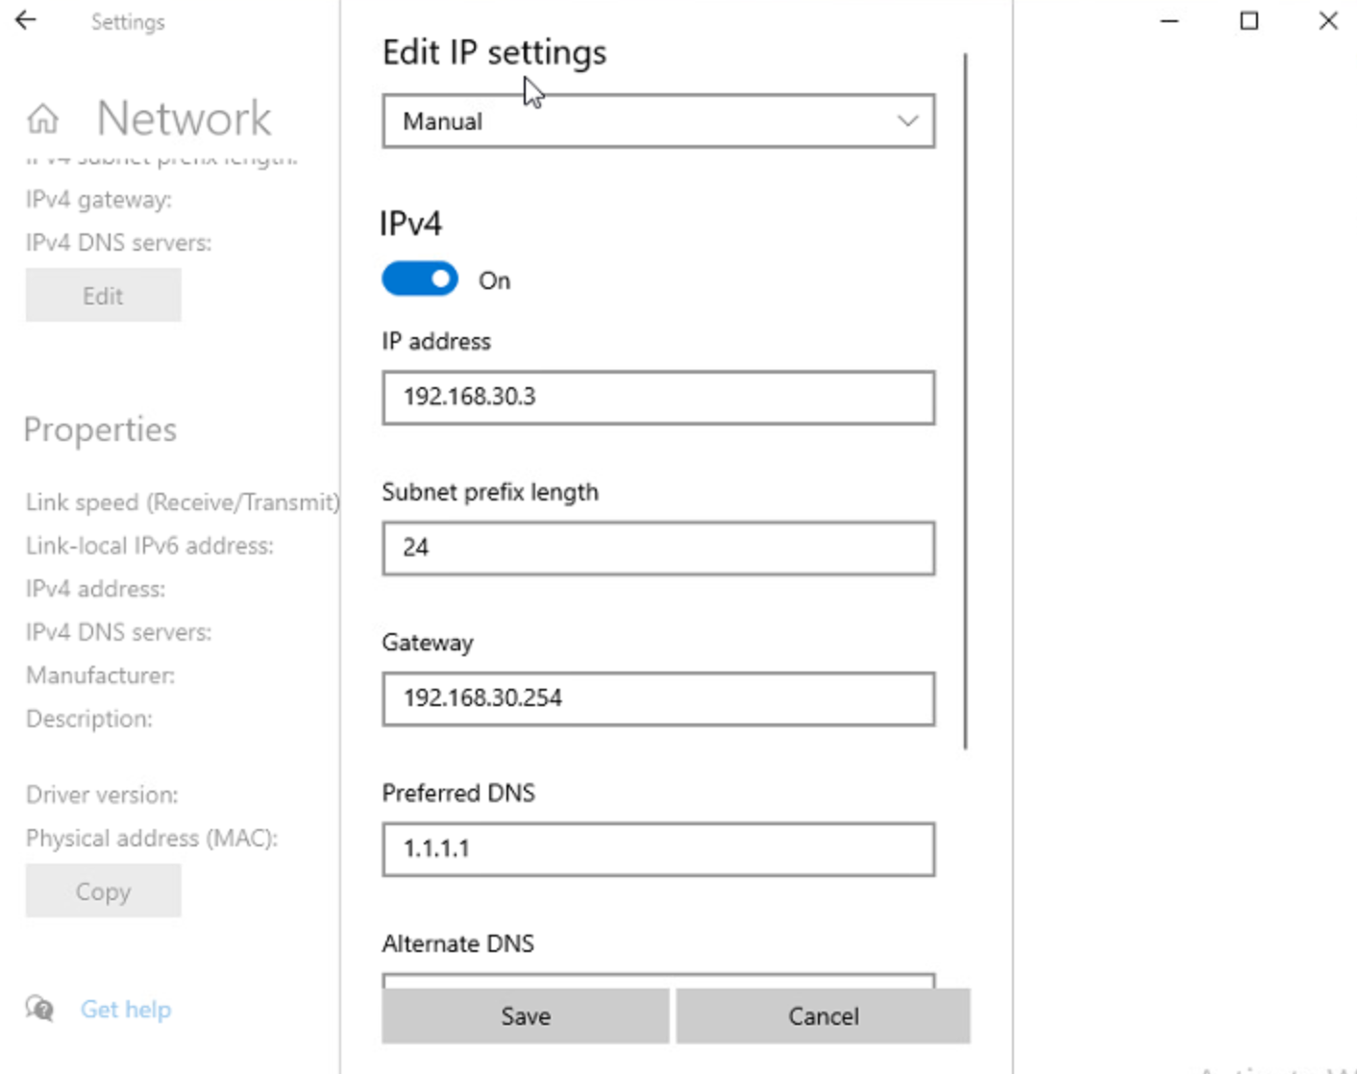

As seen above, we navigated to the network settings changed all the default gateways to .254. This fixed PC#3 and allowed it to connect to the cloud (IP 10.10.10.1).

Unfortunately, PC#2 & PC#4 still failed the ping tests to the cloud. Since all the subnets and default gateways were correct, we decided to look at the switch.

After looking at the switch, we noticed that ports 2 & 4 had VLANS that weren’t VLAN 30. After switching the VLANS to 30, we ran more ping tests.

As seen above, we passed our ping tests for all 4 PC’s after making the changes in the switch. It appears the issue of the ping failures to the cloud (10.10.10.1) were due to improper default gateway assignments to the office router for 3 out of the 4 HR PC’s, as well as a misconfigured switch.