**1508801**

**Project Title:** Creating a digital trading card game

**Student**: John Rugen **Supervisor:** Matthew Crossley

**Course Specific Learning Outcomes:**

* Be skilled and fluent in the use of structured computer programming.
* Techniques and demonstrate these skills though implementation of programmes.
* Acquire a knowledge and understanding of behavioural systems most commonly employed in games design and be able to apply these appropriately.
* Appreciate the characteristics and features of a variety of game genres and be able to relate games design to broader media, art and culture.
* Demonstrate effective communication, decision making and creative problem solving skills, and identify appropriate practices within a professional, legal and ethical framework.

**Project Background:**

A collectable card game (CCG) is a strategy card game that revolves around the players using cards they have collected to complete an objective. The first modern widespread CCG created was Magic: The Gathering in 1993. This then lead to an explosive market with other companies creating their own lines of CCGs. The 1995 Game Manufacturers Association (GAMA) trade show, which highlighted new games coming out throughout the year showed a third of all games announced to be CCGs. This was a lucrative era for CCGs and the sheer amount of companies releasing CCGs highlighted this. Two big names that are still relevant in today's culture are, the Pokémon Trading Card Game and Yu-Gi-Oh! Trading Card Game.

The demand for CCG fluctuated dramatically, up until recently. It has become much more lucrative throughout recent years. (Superdataresearch.com, 2018) This could be seen as a positive correlation with the ease of access to CCGs with popularity in using smartphones to play games. As stated by Superdataresearch, 71% of CCG players play on their smartphones.

*Hearthstone* (Blizzard, 2014) has become one of the largest digital CCGs on the market, for the first 3 months of 2018 it had a 50% market share (Superdataresearch,com, 2018). Hearthstones success could be derived from it’s rich lore and huge fanbase achieved from the success of *World of Warcraft* (Blizzard, 2004). Hearthstone features cross play on smartphone devices and PCs. Whilst being free, it offers players the ability to purchase ‘decks’ for money. Much like old-school CCG.

Mainstream CCGs have become digital and the majority of people have access to them; the cards do not take up physical space anymore and often do not cost money. This makes CCGs accessible to all types of gamers and allows for competitive play between casual and hard-core gamers.

**Project Aims:**

My main project aim will be to create a unique collectable card game experience for Android users, the game will focus mainly around the single player experience and really emphasise the ‘collectable’ part of a CCG. The game should consist of allowing the player to choose an opponents difficulty level and proceed throughout the game collecting a plethora of cards.

**Objectives:**

* Research a suitable game engine that meets the projects needs.
* Research existing CCG mechanics that users find enjoyable and balanced.
* Creating a persistent Player Inventory system throughout the game by using suitable programming techniques and technology.
* Ensuring the game is expandable through documentation and commenting sections of code.
* Allowing the game to be played on a variety of android devices with screen scaling.
* Constant testing, this can be done through compiling the game after each task has been completed and recording any bugs that appear.
* Analysing the game through the use of questionnaires once the polishing and bug squashing has been complete.

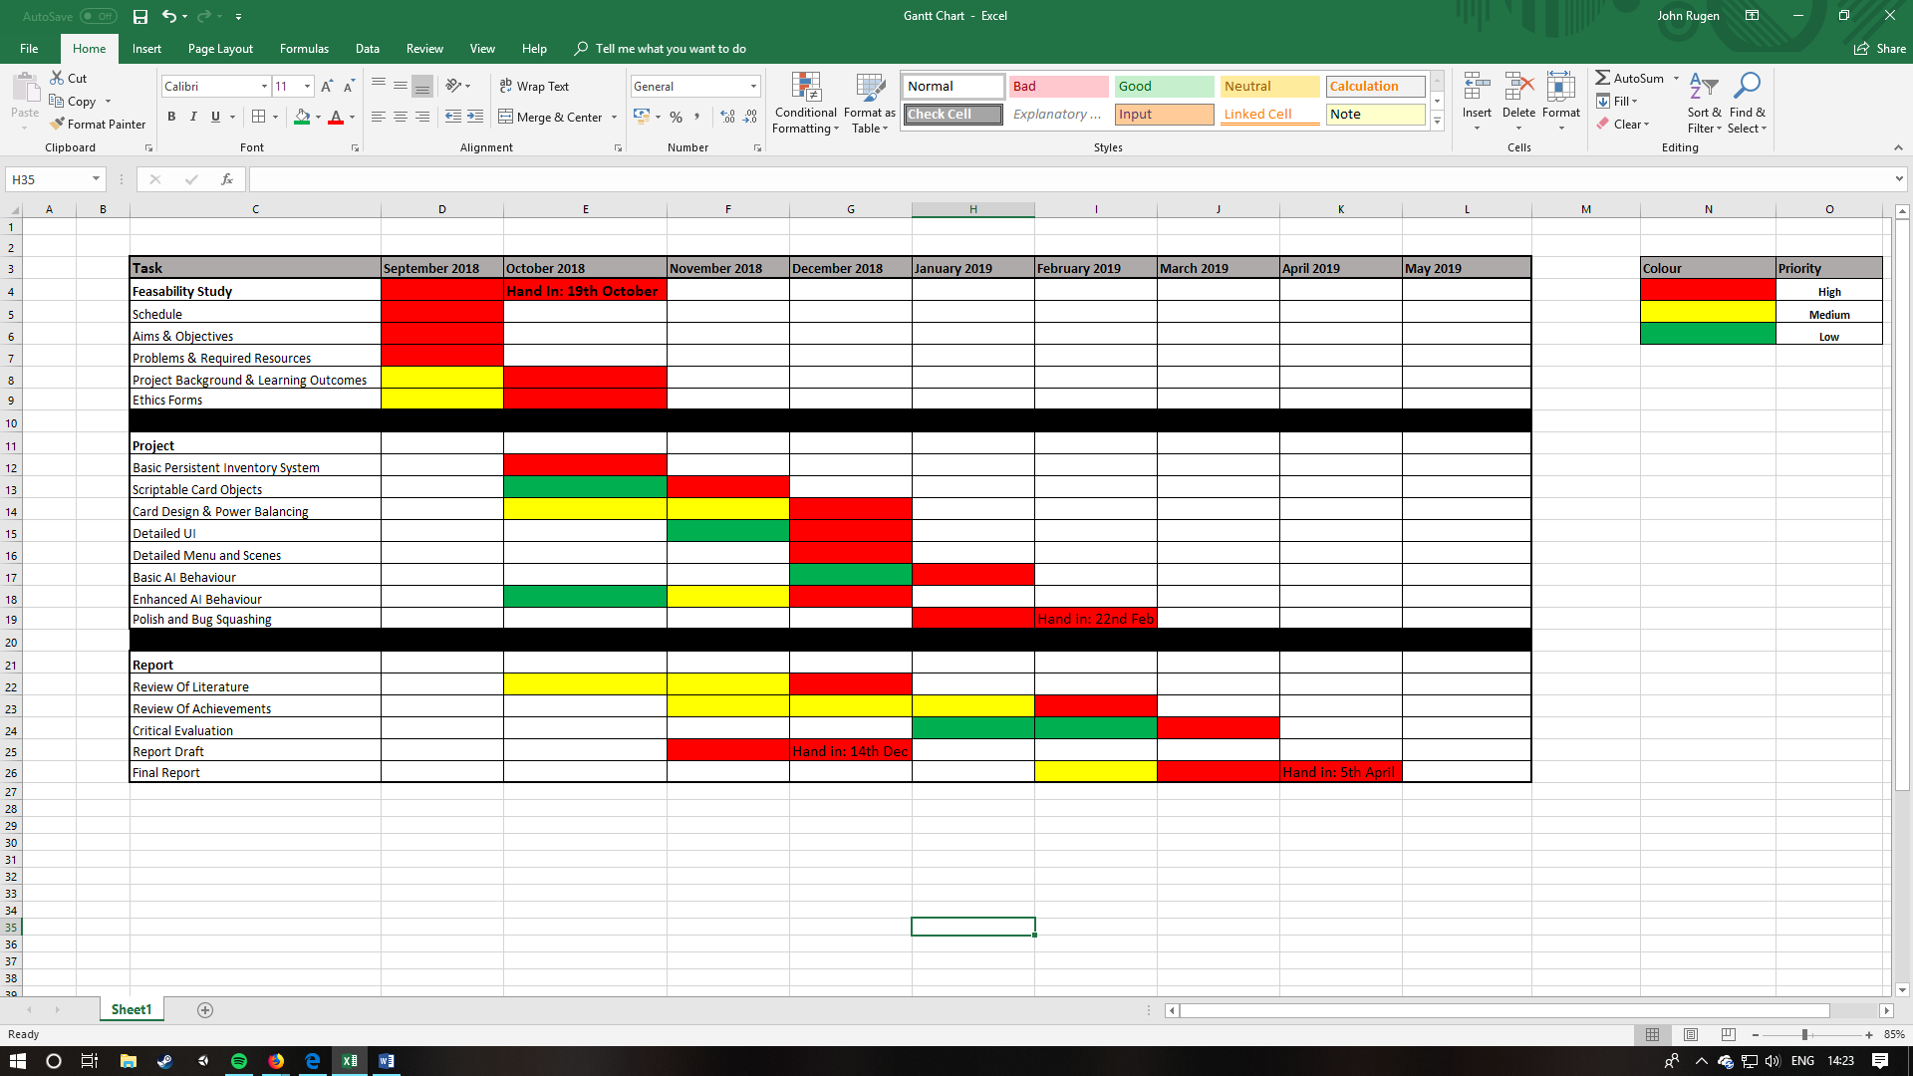**Timetable and Deliverables:**



**Required Resources:**

No extra resources will be required for me to complete my project. I will be using my personal computer; however, the product will be able to be put on the University’s computers as they share the same software and hardware capabilities.

**Ethics Forms:**