# Introduction

Under current standard practices, water resource planning relies on forecast, which is based on historical data. While these practices assume stationarity, more and more evidence suggest this assumption may not be a good one and that historical data alone may not be the best predictor of the future. Current decision-making by water planners is not working – potentially creating vulnerable systems. Therefore, some sort of paradigm shift is needed to create a water resource planning approach that incorporates this non-stationarity.

One common approach to addressing the uncertainty introduced by non-stationarity and climate change is to “downscale” global climate models to improve forecasting so that we can apply the familiar water resource planning approach. There are a number of problems with this approach:

* Unsuitability of downscaling methods for providing useful targeted climate data at the right space and time scales for decision-making. Requires assumptions about (1) which GCM is most representative of the location that we care about and (2) about future emission scenarios. The choice of assumption drives the result. But there is no consensus about which assumptions are the right ones – no clear method of producing your assumptions. There is no way to validate those assumptions other than waiting for the future. It does not produce a good representation of project vulnerability. Additionally, there is no clear link between the results from downscaling to decision-making – because of the level of confidence in the assumptions.
* Downscaling is outside of the typical technical and financial resources available to water planners and decision-makers. The resolution of global climate models is at the country-scale and the outputs are not easily usable at the water basin scale.

Given the challenges with incorporating climate change and its associated uncertainty into current methods, water planners are at an impasse – continuing to operate at status quo (using historical climate data), which could result in infrastructure vulnerable to climate events.

The current study uses a pilot case to present an alternative method in the absence of strong forecasting/downscaling: ‘Climate Risk-Informed Decision Analysis’ or CRIDA. This approach provides a framework that supports planning and decision-making in the face of all types of deep uncertainty (e.g., uncertainty in development, population growth, etc.). CRIDA is “bottom-up” decision-making framework that consists of five main steps:

1. Establish the decision context
2. Perform a bottom-up vulnerability assessment of defined system using stress test
3. Robust Plan Formulation based on stress test vulnerabilities
4. Evaluate and compare robust actions using an incremental cost analysis approach
5. Institutionalize the decision

CRIDA has a number of advantages compared to business as usual or attempts to forecast climate: (1) starting from system vulnerability avoids having to predict future climate states – CRIDA provides a resilience approach, (2) incremental cost of climate adaptation rather than conflating it with the baseline investment that would be required regardless of climate change, (3) decision-scaled approach that fits into the existing decision-making process, (4) exit strategies at different stages of the analysis, preventing the need to over-analyze pathways that would not impact the decision outcome, (5) the decision is informed by the level of confidence in the data quality and analysis, and (6) relatively simple and easy to implement

We apply the CRIDA methodology to a case study, the Iolanda Water Treatment Plant in Lusaka, Zambia, for illustrative purposes. Although a few facts and processes specific to the plant’s operations have been simplified to focus on the vulnerability assessment and adaptive planning process, the conclusions remain relevant. The Iolanda Water Treatment Plan plays and important role in determining public health outcomes in Zambia’s capital city where it aims to deliver about 90,000 m3/day of treated water, serving approximately one million residents (LWSC 2016; NWASCO 2016). Other sources of water in Lusaka include private boreholes and shallow wells, which are often untreated, account for about 80,000 m3/day of the daily water supply in Lusaka. Frequent performance failures at the Lusaka plant are driven by drought and the condition of nearby water resource infrastructure. Factors including poor data quality, institutional weakness, and system vulnerability to climate make decisions related to water resources investments incredibly challenging and risky. This paper uses the decision-centric CRIDA approach to examine potential investments in the plant’s existing and future performance. The current study demonstrates how a decision-centric method like CRIDA can be used to support a robust decision-making process even in the face of challenges common to water resources planning in the developing world.

This case study represents a collaboration between the Millennium Challenge Corporation and the US Army Corps of Engineers. Retrospectively applied CRIDA to an existing project – purpose was to demonstrate the usefulness of the CRIDA method to MCC portfolio investments. It ultimately did not influence the outcome of the project – some details are hypothetical. This work builds on a community of practice (add references).

* Research need that we meet: can a form of decision-scaling be useful in the development context?

# Materials and Methods

## Hydrologic, climatological and operational input data

Precipitation, temperature, and streamflow data were taken from separate gage sites (see . ), each with different data record periods. Both monthly rainfall and temperature data were obtained from the National Oceanic and Atmospheric Administration (NOAA) Climate Data Online (CDO) database. Streamflow data were obtained from the Global River Discharge Database (<http://nelson.wisc.edu/sage/data-and-models/riverdata/>). Streamflows into the Itezhi-Tezhi and Kafue Gorge reservoir systems were calibrated using the above precipitation data and four years of stream flow data (from 1980 to 1984) obtained from the Nduben stream gauge located 350 km upstream of Itezhi Tezhi Reservoir. Ideally streamflow data directly up and downstream of Itezhi Tezhi as well as streamflow data between Itezhi Tezhi and Kafue Gorge would have been used to calibrate the water balance model’s hydrology. However, this these data were either unavailable at the time of the study or simply do not exist. One purpose of this effort was to show that useful models can still be developed and applied to decision-making with limited data, time, and funding.

Simulated streamflows into the Itezhi-Tezhi and Kafue Gorge reservoir systems were estimated from the hydrologic data as per (Zhang 2008) using watershed areas of 95,000 km2 and 47,138 km2 respectively (Mwelwa-Mutekenya, 2004). The assumed values of other input parameter values for the Zheng water balance are given in Supporting Information. Limited historical data on Kafue Gorge reservoir levels and operational parameters were obtained from the Lusaka Water and Sewage Company (see Figure 4).

Thirty-year climate projections (2010-2039) were downloaded from <<the IPCC’s GCM runs for the 3rd?? 4th?? Assessment Report ???? {add link} >>. These projections are reported as percent deviations from the monthly historical averages for precipitation and temperature. The seven GCMs were CCSR/NIES, CSIRO, ECHAM4, HADCM3, NCAR PCM, CGCM2, and GFDL-R30, and the emissions scenarios included A1FI, A2, B1, and B2. Scenarios A1FI and B1 are not modeled under CGCM2 or GFDL-R30, so there were 24 future climate scenarios in total.

## Computational tools: Excel, Python

Describe construction of our system model using Excel + VBA macros, Python coding.

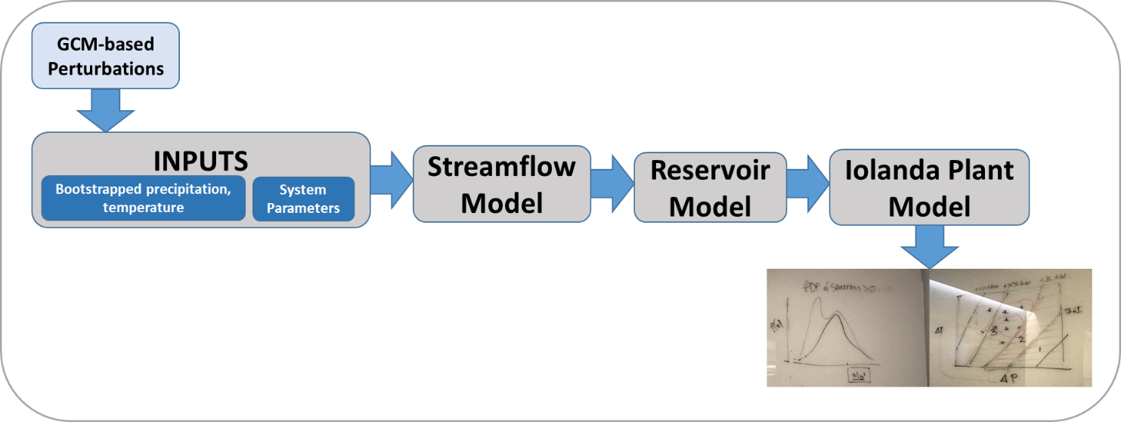

Figure . Schematic of inputs, outputs and model structure. The main model consisted of three main modules, the streamflow, the reservoir, and the Iolanda Plant models.

## Statistical methods: constrained bootstrap, Monte Carlo

A Monte Carlo approach was applied to assess the likely performance of the Kafue Gorge Water Treatment Plant under present climate conditions.

One thousand synthetic precipitation data series of 50-year duration at a monthly timestep were generated for historical/current climate conditions using constrained bootstrap sampling of the gage data. Intra-annual variability was constrained by the requirement that the annual mean across any given synthetic 50-year series had to fall within 2.5 standard deviations of the annual mean that was actually observed over the entire gage record. Inter-annual variability was constrained by the requirement that the standard deviation in annual precipitation should be 20% of the mean across the 50-year series, reflecting the fact that the coefficient of variability for historical annual precipitation is 0.2 in the 30-year observed Kaoma gage record. Series that did not meet these constraints were discarded and re-bootstrapped.

In generating series of monthly minimum (Tmin) and maximum (Tmax) temperatures consistent with the 1000 realizations of synthetic precipitation data, we sought to preserve intra-annual correlations between temperature and precipitation that were present in the observed gage data. Monthly gage temperatures (minimums and maximums) were binned by the corresponding gage precipitation observed during that month using a 10 mm bin size. This precipitation bin along with the synthetic record month are used as stratification criteria from which Tmin and Tmax are selected through bootstrapping. This allows for the full observed precipitation record (1960 - 1990) to be used, even though the temperature records must be selected from the shorter 10 year period (1980 - 1990) over which the precipitation and temperature records overlap.

A Monte Carlo approach was similarly applied to potential future climate conditions. As mentioned previously, future climate predictions are reported as percent deviation (delta) from the current monthly average. So the monthly precipitation, Tmin and Tmax from each of the 1000 realizations of 50 years of synthetic hydrologic data was multiplied by the delta predicted by each of the 24 future climate scenarios.

## CRIDA, plan formulation, and plan evaluation

The CRIDA approach was used to examine a number of different potential investment options for improving performance at the Iolanda Water Treatment Plant in Lusaka, Zambia. Due to the fact that the plant was already failing to consistently deliver clean water under current (climate and development/political), an additional analysis was needed to evaluate a baseline level of investment under current conditions to best characterize the decision context for the Iolanda system.

### Step 1: Establish Decision Context / Baseline Level of Investment

For most water resource infrastructure hydrologic variability is the driving force behind project performance. It is impossible to evaluate the cost or benefits of climate adaptation decisions without disentangling the natural variability associated with any given climate state from changes in the state of the climate. This is particularly true for the Iolanda Water Treatment Plant where existing performance failures justify investment even in the absence of climate change. Thus, the first step in the process outlined in this paper is the identification of this baseline level of investment, which is justifiable under the current climate state given MCC’s existing plan evaluation and selection rubric. This level of investment and the performance benefit it provides sets a baseline against which the cost and benefits of adaptation planning for future climate scenarios can be understood.

The decision context should be defined to support the desired decision to be made/problem to be solved, by capturing the level and type of information needed to make the desired decision, the spatial and temporal extent of the system of interest, all involved parties and stakeholders, any known constraints making decision-making challenging in the system, and critical thresholds to measure success. The decision context may vary greatly from one application to the next.

**Desired Decision/Problem to be solved:** To improve the reliability with which the Iolanda Water Treatment Plant delivers their goal of 90,000m3 of per day of treated water to Lusaka both under current and potential future climate, development (especially hydropower demands) and political conditions.

**Required Decision Metrics:** Measure of reliability (i.e., % of the time that Iolanda meets 90,000 m3/d goal) of water delivery, action (e.g., addition of diesel generators) costs.

**System Extent:** In order to accurately represent the relationship between climate and Iolanda plant water deliveries, a model is required that incorporates the entire contributing drainage area to the Kafue Gorge reservoir, from which the Iolanda plant pulls its water. Given that the challenges facing the plant’s current and future reliability are to manage for increased power demands and greater uncertainty in seasonal precipitation and in temperature changes, the appropriate scale for this water supply analysis is a monthly time step; this is a water resources system designed to regulate seasonal variability.

**Key Constraints:**The institutional, technical, and finanacial capacity of the water management and donor agency serve as practical constraints influencing the analysis and selection of investment plans. Low availability and poor temporal frequency of rainfall, temperaturue and streamflow data increase the analytical uncertainty in the analysis.

**Stakeholders.** The primary stakeholders for this project are the Iolanda Water Treatment Plant and the population that the Iolanda plant serves. It was assumed that operation of the Itezhi Tezhi, Kafue Gorge, and Kariba Reservoirs were outside of the scope of the project.

**Critical Thresholds.** The Iolanda treatment plant requires constant, uninterrupted stream of about 7.2 MW per day, 24-hours per day in order to provide its target of 90,000 m3 of treated water daily to Lusaka. The inability to deliver this amount of water will further deteriorate the customer base to unsustainable levels, reduce cost recuperation, and cause water-related diseases.

A number of potential plans were formulated to reduce the plant’s performance deficiencies under the existing climate, as modeled by 50,000 simulated data records (1,000 50 year periods), sampled by bootstrapping from the observed monthly precipitation and temperature data. As is consistent with the MCC’s internal plan evaluation and selection protocols, the benefits of each plan was measured in monetized decreases morbidity and increased productivity tied to lower incidents of illness and increased accessibility of potable water. These benefits were compared to the plans present cost and the plan generating the highest internal rate of return was selected as the baseline level of investment.

### Step 2: Perform Bottom-Up Vulnerability Assessment

The vulnerability of the Iolanda water treatment plant performance relative to changes in climate stressors (such as precipitation, temperature or more directly stream flow) were assessed. The goal of this analysis was to understand the domain of plausible scenarios under which the water treatment plant is vulnerable to unacceptably low levels of performance.

### Step 3: Plan Formulation

The vulnerability analysis findings drive the formation of climate adaptation strategies and actions. Even under the baseline scenario, extreme plant outages have a 0.04 probability of occurrence in any given year. A one percent decrease in the mean monthly precipitation (x millimeters of precipitation) and one percent (x degrees Celsius) is expected to lead to an xx percent increase in treated water shortfalls. Such an increase in treated water shortfalls is associated with a $xx loss in economic benefit.

#### Defining the Level of Concern

Evidence suggests drier conditions are likely and the consequences associated with a drier climate are severe. Thus the project’s climate risks are high. The poor quantity and quality of climate data, poor fit of the water balance model to observed stream flows, high degree of dispersion in the climate models (average distance between global circulation model estimates of xx aridity units), and lack of more geographically specific scenarios are all evidence of a high degree of analytical uncertainty (e.g. low confidence in a specific range of climate scenarios). As Figure 1 shows this plots the case study within quadrant four of the level of concern matrix.

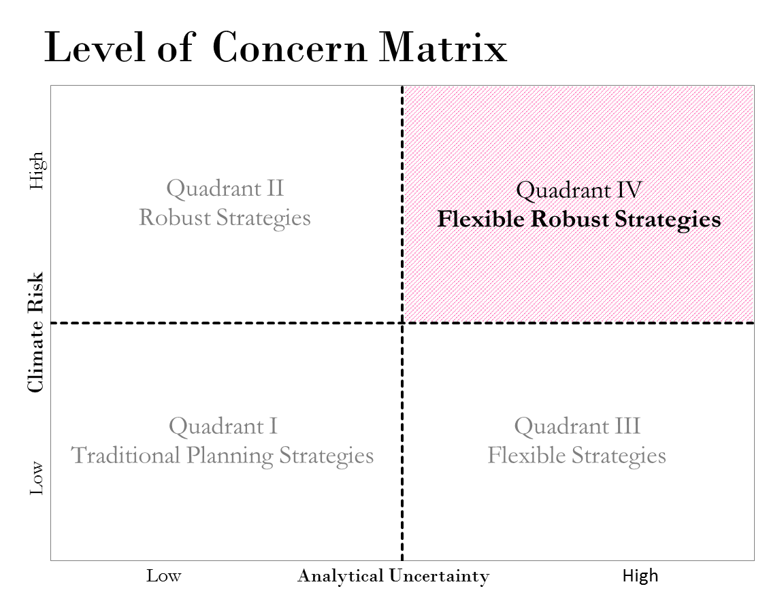

Figure 2. Level of Concern Matrix with Analytical Uncertainty on the x-axis and Climate Risk on the y-axis. Projects with the lowest climate and analytical risk are in quadrant I while the riskiest projects are in quadrant IV. The Iolanda Plant project is place in Quadrant IV given its high climate risk (high likelihood and consequences of drought conditions) and high analytical (poor/sparse data, modeling resources).

Robust strategies (as defined in Stedinger, Louckes, Hashimoto 1984) are favored as a result of the project’s high climate risks since they immediately mitigate against a range of likely and high consequence outcomes. As a result of the project’s high analytical uncertainty flexible solutions are favored. These strategies allow incremental investments in response to climate signals, reducing the threat of over-investment.

Three type of plans were considered for the Iolanda Water Treatment Plant; those that install new water storage capacity; those that increase the reliability of hydroelectric deliveries to the plant; and those the install power generation capacity at the plant. The first set of plans was determined to be neither robust of flexible enough. The demand for water storage capacity is theoretically unlimited as the size of power outages increases and it is difficult to build this capacity in increments, though it might be possible to combine this action with one of the other two. A new dedicated power circuit between the hydroelectric plant and the Iolanda water Treatment Plant was also considered. While this action would be robust to the entire range of climate scenarios (e.g. Iolanda consumes an insignificant amount of power relative to what is produced at the hydroelectric plant) it would be expensive to maintain and enforce; and because it cannot be implemented incrementally it is not a flexible option. Plans installing power generation capacity at the Iolanda Water Treatment Plant were the most flexible and could be scaled to produce a very robust plan.

### Step 4: Plan Evaluation and Selection

Discounted cash flow methods represent well established default infrastructure investment plan evaluation and selection methods. These methods rely on forecasts of future benefits and costs, as well as the use of discount rates that differ based on plans differential exposure to future risks. In the absence of a well-understood forecast future condition, cost and benefits are likely to be incorrectly estimated and discount rate will fail to accurately capture the differences in each projects risk profile. Ceterus paribus, decision making will generally be biased against marginally more expensive climate adaptation plans.

Under the CRIDA approach, plans that are robust to a specific set of climate scenarios are formulated. Plan benefits and costs are evaluated under the assumption that a particular climate scenario is realized. Discounted cash flow (DCF) methods can be used, to choose between competing plans within the context of a single assumed climate scenario. However the methods cannot be used to compare plans associated with different climate scenarios. For this reason adaptation plans designed to be robust against different sets of climate scenarios are compared on the basis of the incremental benefits and costs associated with a single set of climate scenarios.

### Step 5: Institutionalize the Decision

The institutionalization of options are limited for the Iolanda water treatment plant. Institutions are weak and require international donor assistance. The institutions have limited access to loans or other sustainable funding sources to monitor and implement pathways. A single plan was necessary to identify and implement immediately – the immediate option was the installation of power generators.

The decision is limited by the instructional capacities in Zambia and by the scope of assistance by the donor. A more robust plan of action would require more engagement with the international development community to include the strengthening of Zambia’s institutions so that they can monitor, adapt, etc. However, given the uncertainty of institutional stability, in this the case, the addition of diesel generators provided the most reliable solution that allows the Iolanda plant to successfully operate independent of outside, institutional shifts.

# Data

## Describe geographic and local context

The rainfall gage is located in Kaoma, Zambia (NOAA gage ZA000067641) which is just outside of the Kafue River basin, and lies about 400 km west of the Kafue Gorge reservoir, over the record period 1960-1991. Monthly temperature data were collected from a gage in Kawbe (200 km north of Kafue Gorge) for the record period 1973-2002 (NOAA gage ZAM00067663). From this 29 year record only nine years of usable data were obtained, due to the large number of missing values. Summary statistics describing temperature at the Kaoma gage between 1960 and 1991 were also obtained and used in the initial calibration of the hydrologic model. See Figure 2 for map showing gage and reservoir locations.

Streamflows into the Itezhi-Tezhi and Kafue Gorge reservoir systems were calibrated using the above precipitation data and four years of stream flow data (from 1980 to 1984) obtained from the Nduben stream gauge located 350 km upstream of Itezhi Tezhi Reservoir. Although the area between the Nduben gage and Itezhi Tezhi Reservior is relatively flat, the two sites are affected by different precipitation regimes, as is shown in Figure 3. Consequently, the calibration may be based on a different hydrologic regime than what exists in reality. Additionally, about 8 years (2007-2015) of reservoir level data at the Kafue Gorge dam were provided by the Lusaka Water and Sewage Company (LWSC) as shown in Figure 4.

The Kafue system has been under increasing water stress due to more extreme drought conditions in addition to increased hydropower demands due to structural issues with the nearby Kariba dam which has historically provided 40% of Zambia’s power. Recent erosion of the Kariba dam’s plunge pool required a drawdown of the reservoir pool, which is currently filled to roughly 12 percent of its capacity (Leslie 2016). The Kafue Gorge dam has had to fill some of the hydropower demand that the Kariba dam would normally meet. Figure 5 shows a simple diagram of the system model and its relationship with the Kariba dam.

This level of data availability and reliability is indicative of data situations in many places around the world. The point of this effort was to show that even with limited data, time, funding, and specialized computing tools, useful system models can be developed to support decision making. Data will never be perfect and models will almost never be correct, but they can both be useful and informative for decision-making. Decisions do not wait for perfect data.

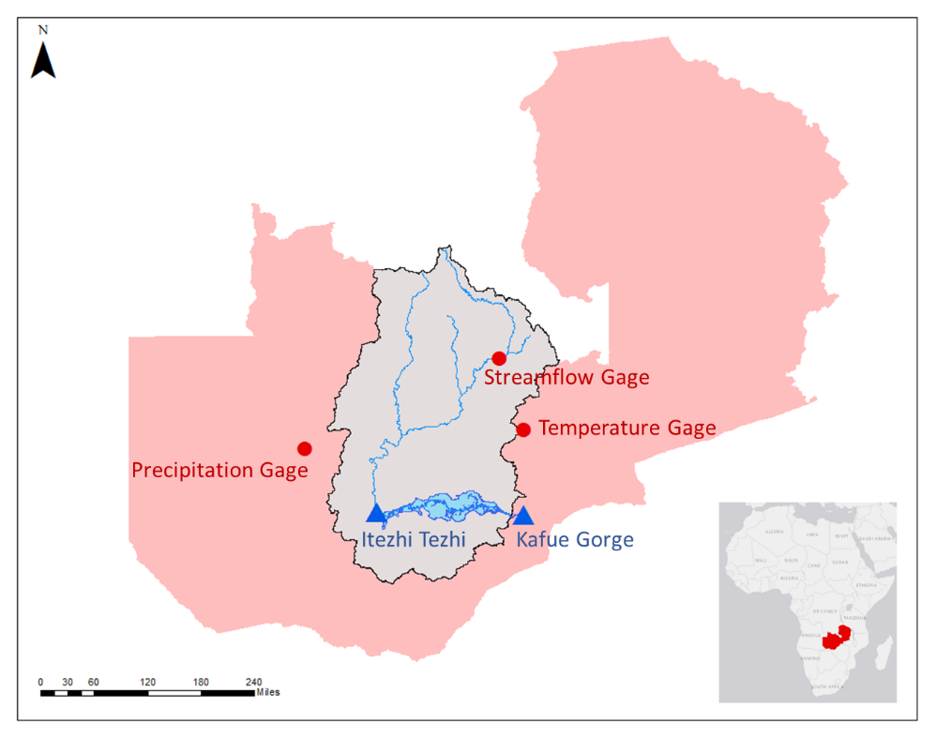

Figure 3. Map of study area with the Kafue River basin in tan, which is contained completely in Zambia. The Kafue River runs from north to south into the Itezhi Tezhi reservoir, then from west to each from the Itezhi Tezhi to the Kafue Gorge reservoir through the Kafue Flats wetlands.

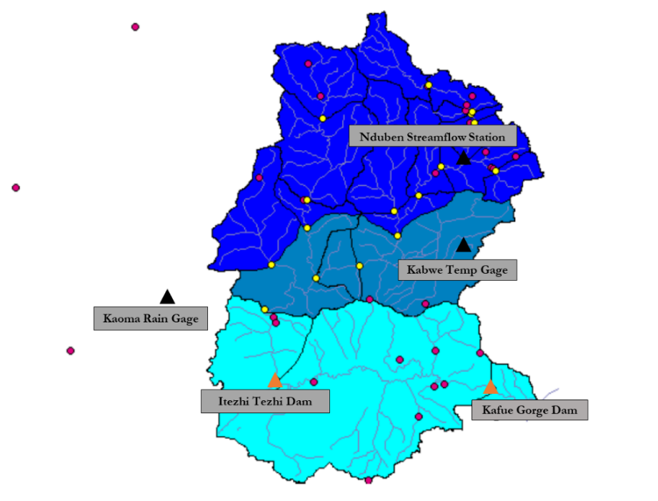

Figure 4. Map of case study system (Itezhi Tezhi and Kafue Gorge dams) and all gages used for model calibration and simulation. Circles represent rain gages in the area. Also shows three rainfall regions where the southern most, light blue region receives ≤ 800 mm/yr the middle region receives 800-1000 mm/yr; and the north most, darkest blue region receives 1000-1300 mm/yr (adapted from Mwelwa-Mutekenya 2004).

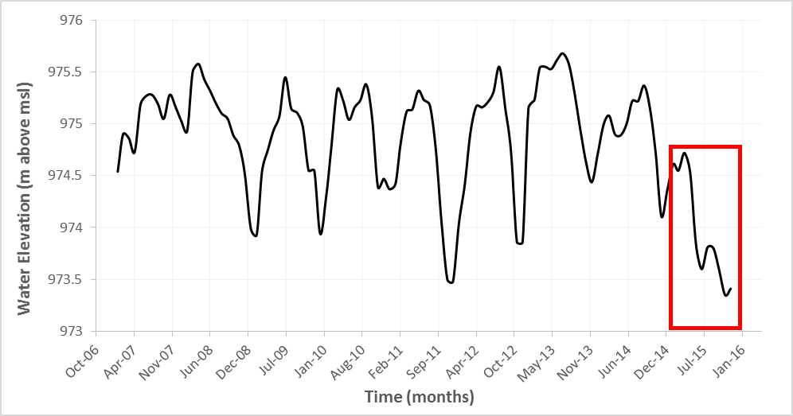

Figure 5. Time series of water elevation (in meters above mean sea level) in Kafue Gorge reservoir at the Iolanda Treatment Plant intake. Note how levels begin to decline dramatically around April 2015 (Lusaka Water and Sewage Company 2015).

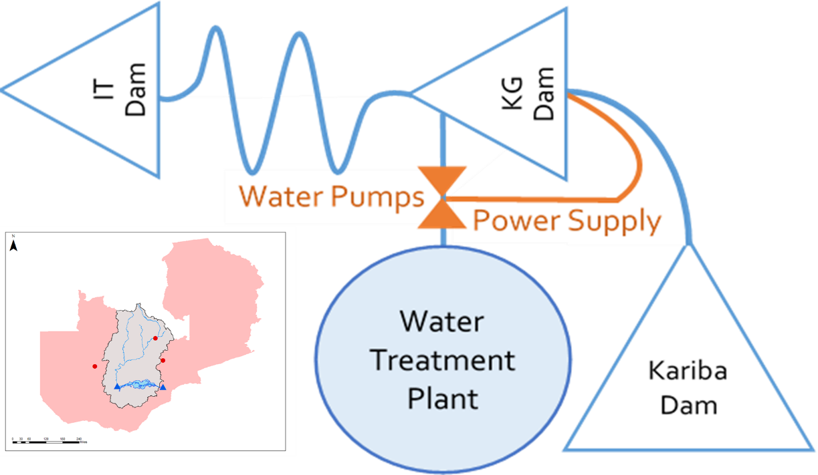

Figure 6. Simple diagram of system model with water flow from Itezhi Tezhi (IT) to Kafue Gorge (KG) to the Iolanda Water Treatment Plant. The Kariba dam, while not in the same natural water system as the plant, does place increased hydropower demands at Kafue Gorge, which in turn, reduces the amount of water available to the plant.

## Hydrologic data used for model input and calibration

Discuss data and the clean-up we had to do in order to perform constrained bootstrap.

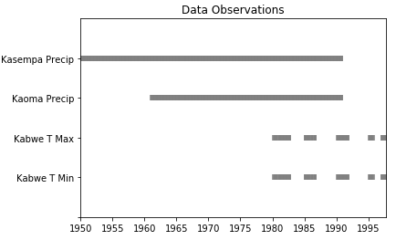

Figure 7. Time series of observed field data for precipitation, maximum and minimum temperature, streamflow, and reservoir levels.

## Reservoir and Lusaka Plant data

Reservoir data were collected from a number of sources identified during a quick literature review as well as through discussions with the MCC Zambia team. Parameters used in the model are summarized in Table 1. Data were also obtained from LWSC for the Iolanda water treatment plant receiving water from the Kafue Gorge reservoir (see).

Table 1. Summary table of Itezhi Tezhi and Kafue Gorge dam parameters and corresponding sources.

|  |  |  |  |  |
| --- | --- | --- | --- | --- |
| Parameter | Units | Itezhi Tezhi | Kafue Gorge | Source |
| Dam height | m | 62 | 400 | Pfister and Zurich, 2007 |
| Maximum depth (estimated average) | m | 57.5 | 398 | APFM, 2007 |
| Minimum operational pool depth | m | 33 | 392.6 | APFM, 2007 |
| Bottom Elevation | m | 973 | 580 | APFM, 2007 |
| Maximum volume | MCM | 6,000 | 900 | Pfister and Zurich, 2007; IFC 2001 |
| Maximum reservoir surface area | km2 | 392 | 805 | Pfister and Zurich, 2007 |
| Maximum power generation capacity | MW/month | 120 | 990 | Wikipedia |
| Watershed area | km2 | 95,000 | 47,138 | Mwelwa-Mutekenya, 2004 |

Table 2 Summary table of Iolanda water treatment plant data provided by LWCS.

| Parameter | Units | Value |
| --- | --- | --- |
| Daily Iolanda water delivery target | m3/d | 90,000 |
| Water treatment capacity | m3/d | 110,000 |
| Intake pumps energy demands | kWh/m3 | 0.77 |
| Water treatment plant energy demands | kWh/m3 | 0.38 |
| Hydropower energy cost | K/kwh | 0.31 |
| Storage capacity of treated water | m3 | 4,700 |

# Results & Discussion

## Baseline performance vs. no investment under (synthetic) current climate scenarios

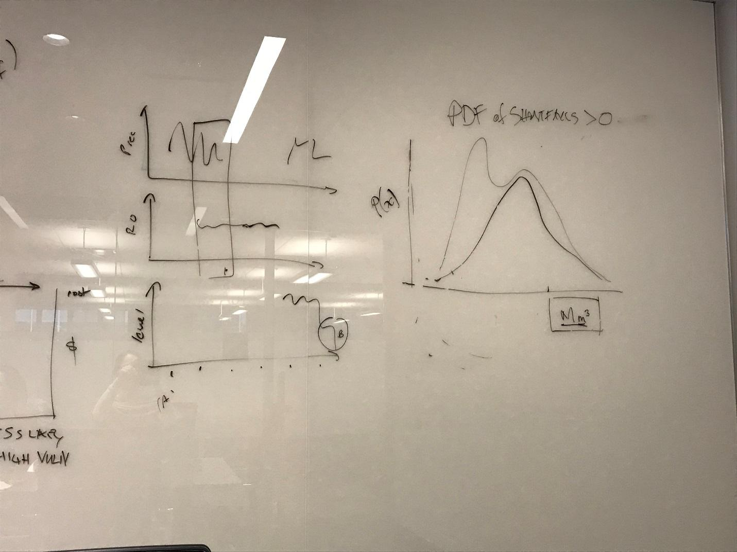

Figure: probability distribution fxn - probability of (monthly?) water delivery shortfalls on y vs. volume of shortfall on x.

## Vulnerability analysis: Baseline performance across a variety of possible (synthetic, changing) future climate scenarios

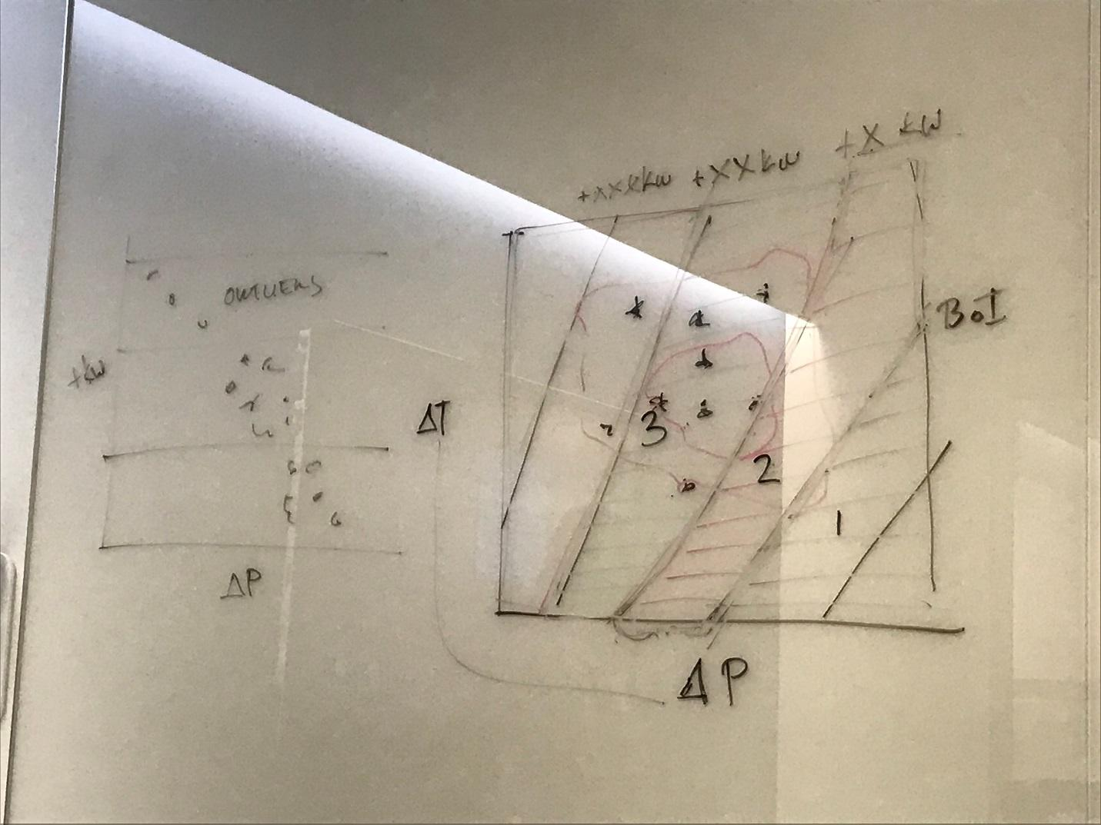

Figure: response surface showing how our baseline investment would perform in a changing climate. Superimpose color zones for binned robustness (e.g., in terms of water delivery shortfalls) on ΔT vs. ΔPcp space, with GCM predictions (points) marked on scatter plot for comparison.

## Plan formulation and evaluation under future climate

(Possible figure much like 4.1 showing PDF of performance for best (cost effective plan) for a given bin plus PDF of performance for best plan from next lower bin. Possibly side-by-side figures, maybe superimposed, not sure. We may eventually decide to omit this figure.)

?

Room to discuss plan options in more detail, as guided by Level of Concern matrix and available data.

Binning of scenarios discussed, if necessary.

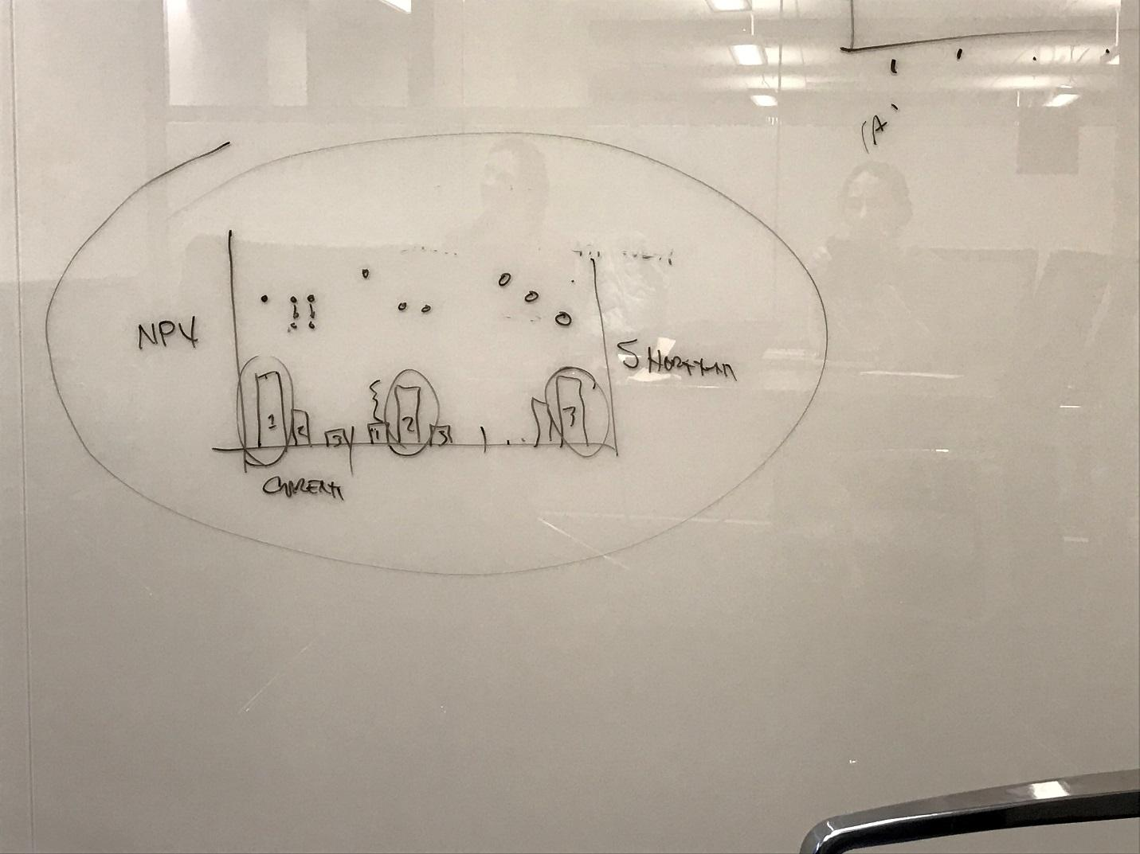

Figure: performance of 3 plans (bars 1-3) in current, and 2+ future climate scenarios (groupings on X). Cost effectiveness (maybe as $ per unit shortfall avoided) bars read from Y1 (left side) (but not NPV, as shown in sketch). Additional scatter points corresponding to each bar read from Y2 (on right) can show shortfalls of each alternative in the corresponding future climate bin.

## Compare Excel vs. R results?

If we decide to run the analysis in parallel in R (full version) and in Excel (computational shortcuts) then we can present the affected figure (which is probably just the one for evaluation of plan resilience under future climate?) in parallel: one version from R and a second version from Excel. Then in this section we can compare the two and discuss the impacts of taking shortcuts, and whether such shortcuts would be problematic for decision-making in the development context.

# Conclusions

Brief resume of findings and relevance. Mention of needs for future work, including forthcoming economic analysis.

# References

Associated Programme Flood Management (APFM) (2007) “Strategy for Flood Management for Kafue River Basin, Zambia”

Mwelwa-Mutekenya, E. (2004) “The application of the monthly time step Pitman rainfall-runoff model to the Kafue River basin of Zambia” Master’s Thesis, Rhodes University, Grahamstown, South Africa.

NWASCO 2016

Leslie J. (2016) “One of Africa’s Biggest Dams is Falling Apart” *The New Yorker*

LWSC 2016

Zhang et al (2008)

IRIN (2014) http://www.newzimbabwe.com/news-15220-Kariba+Dam+and+Zim+disaster+preparedness/news.aspx

# Supporting Information

Table of input constants to Zhang water balance for Itezhe-Tezhi & Kafue gorge, c.f. 2.1