IoT project for UES

Aleksandar Grahovac
E1 53/2021
Table of Contents
Components 3
Hardware circuit 3
Tools 3
Server setup 3
AWS 3
VS Code 5
Whitelisting 6
Node.js 6
Postman 7
React.js 9
Arduino 9
Simple 9
Plotter 9
Web client 9

Components
Heltec ESP32 WiFi LoRA V2
Light sensor MH Photoresistor
Moisture/Temp sensor DHT11

Hardware circuit
Light sensor AnalogOUT – PIN 36
Moisture/Temp sensor AnalogOUT – PIN 13

Tools
AWS
Node.js
React.js
Arduino IDE
VS Code

Server setup

AWS

EC2 Instance
Go to the main instance screen:
https://us-east-1.console.aws.amazon.com/ec2/v2/home?region=us-east-1#Instances:
There, select
Launch instance
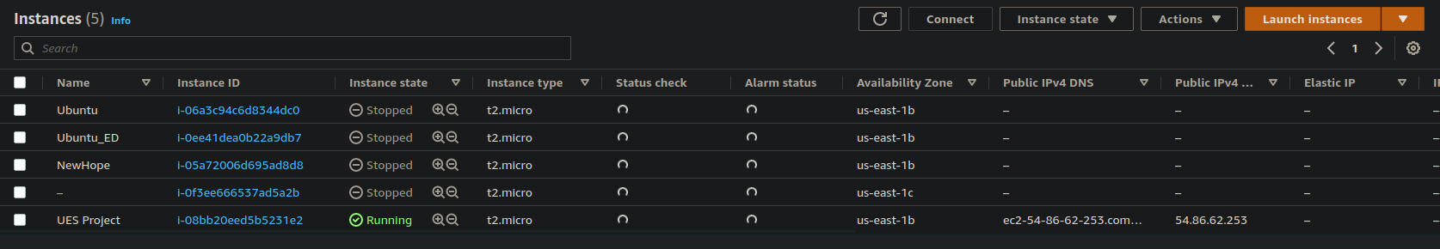
On the new screen, enter the name of your instance:
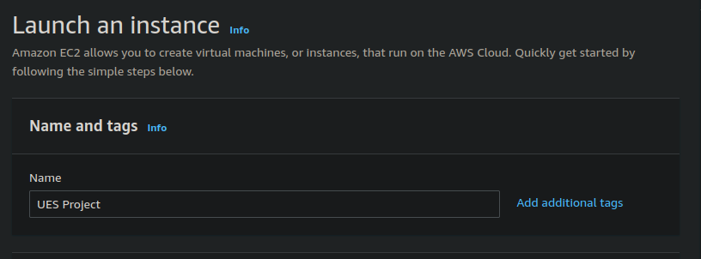

Then, select Ubuntu machine
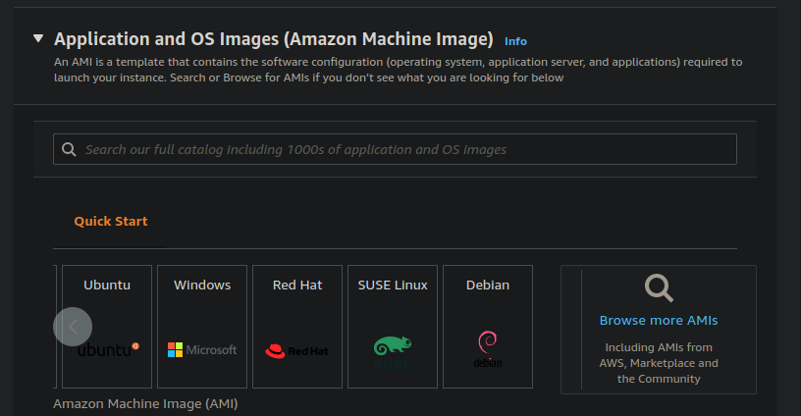
Leave default instance type.
Create new ssh key, or use existing one:
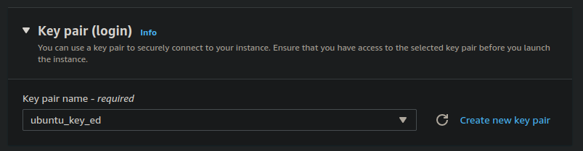

Leave default network settings and storage.
On the right side, press Launch Instance on the summary window. And go back to the main instance screen.
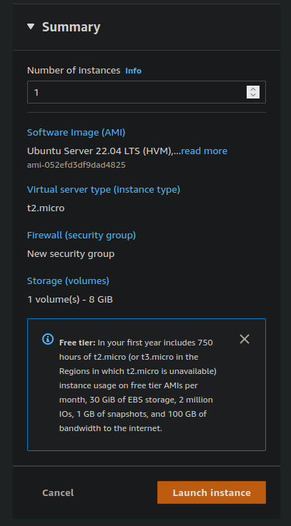

After some time, refresh the main instance page to see your newly created instance.
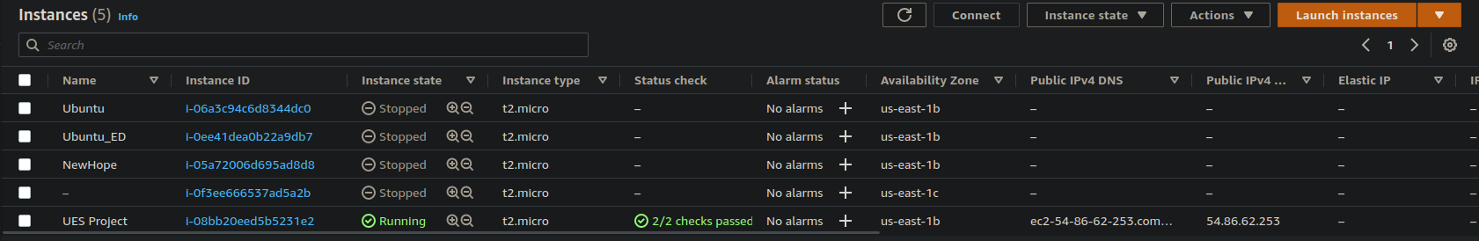
When your new instance is added to the list, click on it to find it’s Public address, which is in our case:
ec2-54-86-62-253.compute-1.amazonaws.com
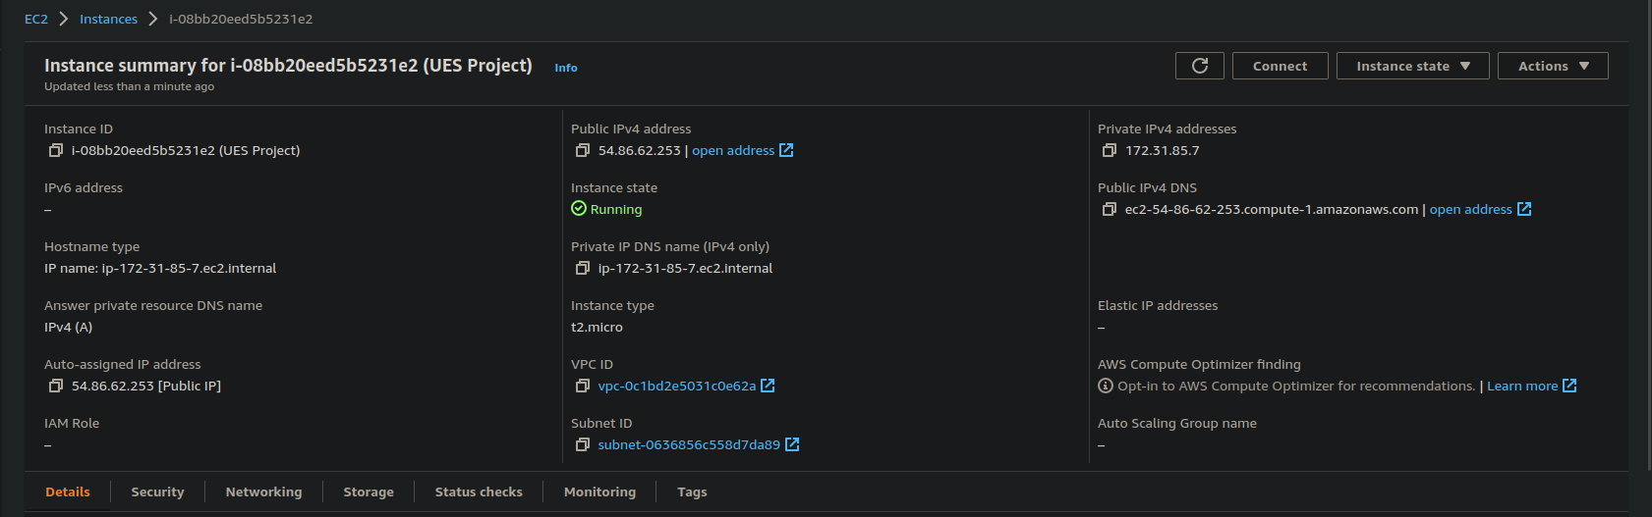

Elasitc IP
In order for your instance to have a fixed IP address each time you stop and start again your instance, you need to assign it AWS Elastic IP. It is a rather simple procedure that you can easily follow. First you need to allocate Elastic IP address:
https://docs.aws.amazon.com/AWSEC2/latest/UserGuide/elastic-ip-addresses-eip.html#using-instance-addressing-eips-allocating
And then you need to associate it with your instance:
https://docs.aws.amazon.com/AWSEC2/latest/UserGuide/elastic-ip-addresses-eip.html#using-instance-addressing-eips-associating
Now you have a fixed IP adress and you can open VS Code.

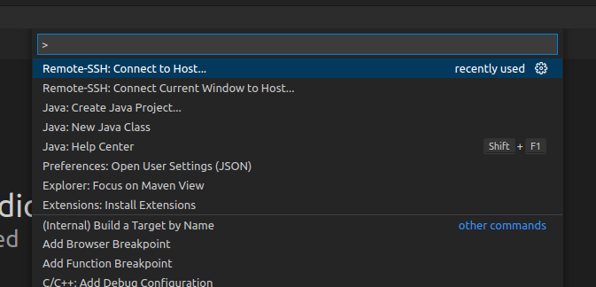
VS Code
Open the menu with:
Ctrl+Shift+P
In the drop down menu, select:
Remote-SSH: Connect to Host
Then, enter your web server address, which is in our case:
ec2-54-86-62-253.compute-1.amazonaws.com
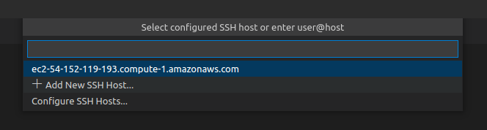

And then, select the location of your ssh configuration file:
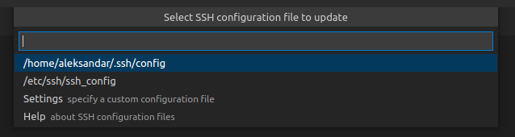

After this is completed, open your ssh configuration file, in our case:
/home/aleksandar/.ssh/config
And append to your host machine (tabulated):
IdentityFile ~/Documents/Work/AWS/ubuntu_key_ed.pem
User ubuntu
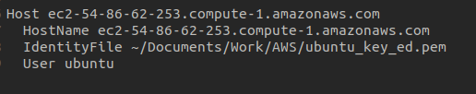
Then, run
Ctrl+Shift+P
Enter again your web server address:
ec2-54-86-62-253.compute-1.amazonaws.com
After everything is configured, open the terminal with:
Ctrl+Shift+`

Whitelisting
Go back to AWS and instance page. Select your instance and go to its Security tab:
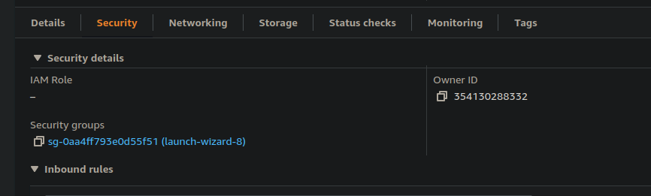

Now click on its security group (in blue) and click to edit inbound rules:
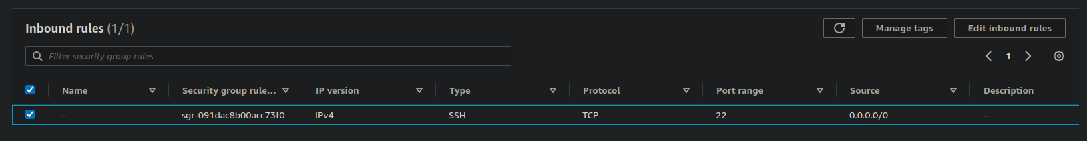
Here add new rule that whitelists HTTP port:
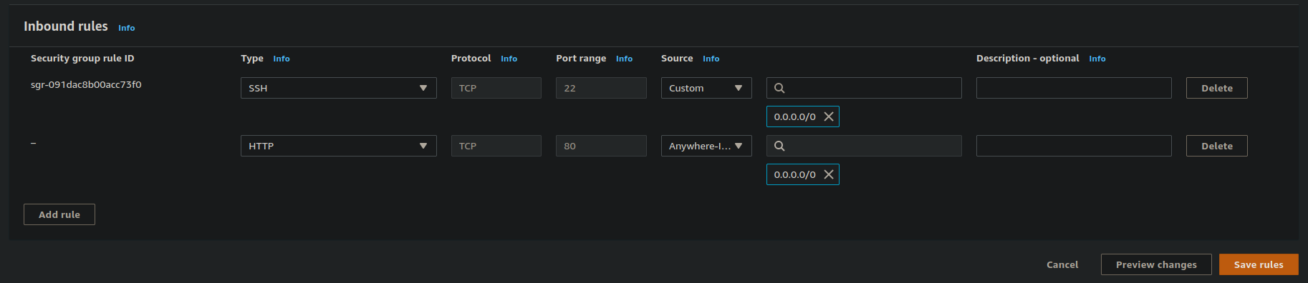

Node.js
In the terminal (on the server) insert the following commands:
sudo apt update
sudo apt install nodejs -y
sudo apt install npm -y
After this is installed, create your project folder:
mkdir node-server
cd node-server
Here run:
npm init
And fill the questionary how you please. This will create package.json file.
Open package.json and insert:
“type”: “module”
and in:
“scripts”:
insert:
“start”: “sudo nodemon index.js”
You can now copy the following to your folder:
/controllers
/models
/routes
.env
index.js
Now you need to install required packages:
npm i express
npm i mongoose
npm i cors
npm i dotenv
npm i -g nodemon
Finally, go to .env file and change USERNAME and PASSWORD to your MongoDB credentials.

Postman
In Postman, press new button:
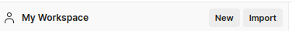

And select new collection:
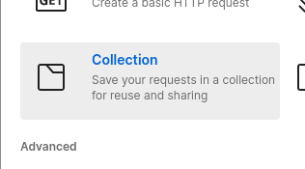

In the new collection, create a new HTTP request, by right clicking on the created collection and selecting Add request:
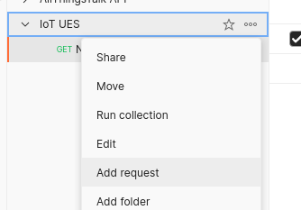

Similarly to the new collection, create the new environment:
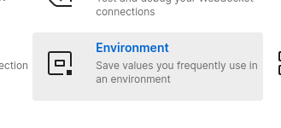

Select it to active by pressing the check mark:
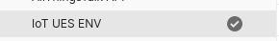
And insert HOST variable with your address as the value:
Now go back to your HTTP request and insert your endpoint:
{{HOST}}/sensors
Now create similar request, but this time make it a POST request:
Then, select Body tab, there select raw radio button, change Text to JSON, and finally write your test package:
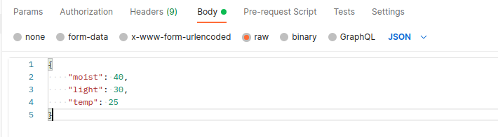
By sending GET and POST requests, you can easily test your endpoints.

React.js
We will need newer node version than the one that is provided by Ubuntu. On AWS this is not so trivial, so one should follow their official instrutions from:
https://docs.aws.amazon.com/sdk-for-javascript/v2/developer-guide/setting-up-node-on-ec2-instance.html
This is done with the following commands:
curl -o- https://raw.githubusercontent.com/nvm-sh/nvm/v0.34.0/install.sh | bash
. ~/.nvm/nvm.sh
nvm install --lts
Now, follow the official Facebook instructions for starting new React project from:
https://github.com/facebook/create-react-app
By doing the following:
npx create-react-app react-client
cd react-client
npm start
Install the following libraries:
npm i axios -y
npm i react-redux -y
npm i redux-thunk --force
npm i chart.js react-chartjs-2
In order to deploy on AWS follow this simple tutorial:
https://aws.amazon.com/getting-started/hands-on/build-react-app-amplify-graphql/module-one/?e=gs2020&p=build-a-react-app-intro
Note: It is possible to select a specific folder from the repository where your react app is.

Arduino

Setup
In order to start, we need first to install Arduino IDE. For that, follow the official Ubuntu website:
https://ubuntu.com/tutorials/install-the-arduino-ide#2-installing-via-a-tarball
When installed, open Arduino IDE and go to:
File → Preferences → Additional Boards Manager
And past the following link into the Additional Boards Manager URLs:
https://dl.espressif.com/dl/package_esp32_index.json
If you already have some links in the Additional Boards Manager URLs section, simply separate them with a comma.
Next, open:
Tools → Board → Boards Manager → ESP32
Search for and install:
esp32
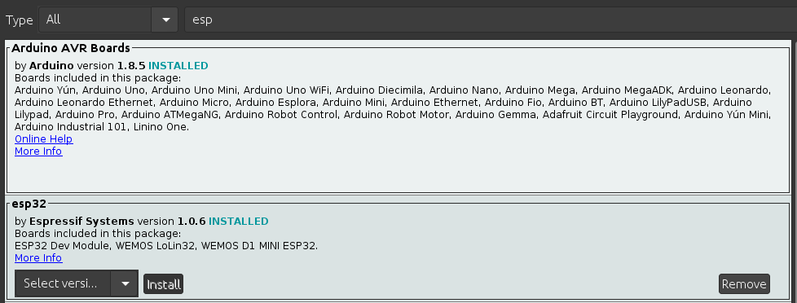
Finally, go to:
Sketch → Include Library → Manage Library
Search for and install:
Heltec ESP32 Dev-Boards
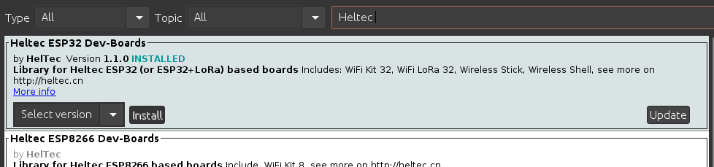
Only thing left is to add library for our temperature and moisture sensors. Zip file is located in the following location:
/Client/Library
Simply select:
Sketch → Include Library → Add .ZIP library
Navigate to your location and add your .zip file:
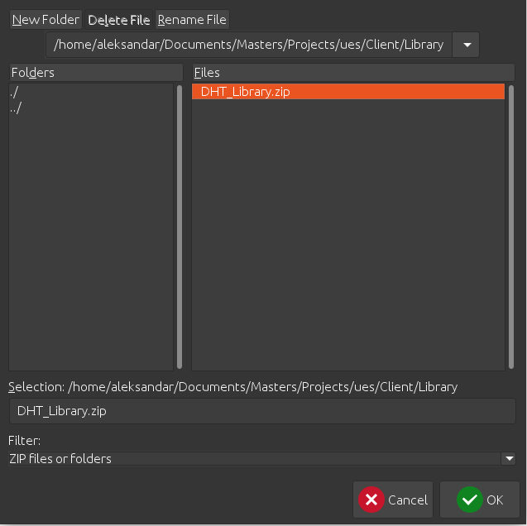

Simple
This code is just a test for the hardware and circuitry. We simply print on the serial monitor the current value of each sensor.

Plotter
This code is also just a test for the hardware and circuitry, but a more fun one. Here we log, without the delay, live values on the serial plotter.

Web client
This is the main application that is running on our client. It is a simple HTTP client that sends raw values of its sensors.
In order for the client to connect to the internet, you need to provide correct USERNAME and PASSWORD information in the HTTP_Client.ino file.

Running Existing Project
In order to run existing project, first you need to create your AWS machine as described previously. After that, you need to install Node.js and npm:
sudo apt update
curl -o- https://raw.githubusercontent.com/nvm-sh/nvm/v0.34.0/install.sh | bash
. ~/.nvm/nvm.sh
nvm install --lts
sudo apt install npm -y
Then clone our git repository:
git clone https://github.com/JohnRussell13/IoT-esp32.git
Install react project:
cd react-client
npm intall
Then set your mongo credentials in .env file, and run it:
npm start
In order to start react.js follow this simple tutorial on AWS Amplify:
https://aws.amazon.com/getting-started/hands-on/build-react-app-amplify-graphql/module-one/?e=gs2020&p=build-a-react-app-intro
Arduino part of the project is done as described previously.

