Library Management System
Java OOP Project Documentation
Course: Object-Oriented Programming
Language / GUI: Java 21, Swing
Submitted by: (your name / group members)
Date: October 2026

1. Project Title
Library Management System (Java Swing)

2. Project Description
The Library Management System is a desktop application that helps a small school or community library manage its collection, its members and the lending of items. Librarians can record books, magazines and DVDs, register students and faculty members, lend and receive items, and view reports on overdue loans and collected late fees.
The program is written in Java with a Swing graphical user interface. It is organised into model classes (the real-world objects), a service class (the business rules) and GUI classes (the screens), and it applies all four pillars of Object-Oriented Programming.

3. Problem Statement
Many small libraries still track borrowed items on paper or in spreadsheets. This leads to several problems:
- Staff cannot quickly tell whether an item is available or who has it.
- Due dates and late fees are calculated by hand, which causes mistakes and inconsistent rules.
- Different kinds of items (a book, a magazine, a DVD) and different kinds of borrowers (a student, a teacher) need different rules, which are hard to apply consistently.
- Invalid data (blank names, wrong dates, duplicate records) goes unnoticed.
This application addresses these problems by keeping all records in one system, applying the correct loan and fee rules automatically, and rejecting invalid input.

4. Objectives
- Develop a functional Java GUI application that models a real-world library.
- Design classes and objects with clear responsibilities and relationships.
- Apply encapsulation to protect and manage the data of every object.
- Apply inheritance to share common code between related classes (items and members).
- Apply polymorphism so that different item and member types behave differently through the same method calls.
- Apply abstraction through abstract classes and an interface that capture essential behaviour.
- Provide input validation and error handling so that invalid data and invalid transactions are never processed.
- Provide a clear, organised GUI for all major functions.

5. System Features
# | Feature | Description
1 | Add / view items | Add books, magazines and DVDs. Each type has its own extra field (ISBN, issue number, duration). IDs (B001, M001, D001) are generated automatically.
2 | Search items | Search by ID, title or author and filter by item type.
3 | Update / delete items | Select an item to edit its details or remove it. An item that is on loan cannot be deleted.
4 | Register / manage members | Register students and faculty members (IDs S001, F001…), search them, and delete members who have no borrowed items. Duplicate email addresses are rejected.
5 | Borrow items | Lend an available item to a member. The system calculates the due date from the item type and member type, and enforces borrowing limits and the no-overdue rule.
6 | Return items and calculate late fees | Return a loan; the system calculates the late fee using the item’s fee rule and the member’s discount.
7 | Overdue report | Lists all overdue loans for any chosen date, with the fee that would be charged.
8 | Statistics and loan history | Shows total items, available items, members, active loans, overdue loans, fees collected and the full loan history.

Business rules
Item type | Loan period | Late fee per day | Special rule
Book | 14 days | PHP 5 | none
Magazine | 7 days | PHP 3 | none
DVD | 3 days | PHP 20 | fee capped at PHP 500

Member type | Max items | Extra loan days | Late-fee discount
Student | 3 | 0 | 0%
Faculty | 10 | 7 | 50%
Due date = borrow date + item loan period + member extra days. A member with an overdue item cannot borrow until it is returned.

6. OOP Implementation

6.1 Class overview
Package | Class | Responsibility
library.model | Borrowable (interface) | Contract for anything that can be lent
 | LibraryItem (abstract) | Common data and behaviour of all items
 | Book, Magazine, DVD | Specific item types
 | Member (abstract) | Common data and rules of all members
 | Student, Faculty | Specific member types
 | Loan | One borrowing transaction
 | ItemType, MemberType | Enumerations of the types
library.service | LibraryService | All business rules and data storage
 | LibraryException | Business-rule errors
 | SampleData | Demo data
library.util | Validator, Money | Input validation and money formatting
library.ui | RefreshablePanel (abstract) | Shared base of all tabs
 | ItemsPanel, MembersPanel, CirculationPanel, ReportsPanel | The four screens
 | MainFrame | Main window
library | Main | Program entry point

6.2 Encapsulation
Where | How it is applied
LibraryItem | Fields id, title, creator, year, available are private. They are read with getters and changed only with setTitle, setCreator, setYear, checkOut and checkIn, which validate the new value first (blank title, year range, double check-out). The id has no setter, so it can never change.
Book, Magazine, DVD | isbn, issueNumber and durationMinutes are private and can only be set through setExtraValue, which validates the format (10/13-digit ISBN, issue 1-9999, duration 1-600).
Member | id, name and email are private. setName and setEmail validate letters-only names and email format.
Loan | All fields are private. The fee and return date can only be set through markReturned, so a loan cannot be given an arbitrary fee.
LibraryService | The collections items, members and loans are private. getAllLoans() returns an unmodifiable list so outside code cannot change the records directly.
GUI classes | All fields (text fields, tables, combo boxes) are private.
Test evidence: the automated test “every instance field in the model classes is private” checks this with reflection.

6.3 Inheritance
Parent class | Child classes | Relationship
LibraryItem | Book, Magazine, DVD | Each is a kind of library item. The children reuse the id, title, creator, year, availability, checkOut(), checkIn() and the default calculateLateFee() from the parent and add only what is different (ISBN / issue number / duration, loan period, fee rate).
Member | Student, Faculty | Each is a kind of member. The children reuse id, name, email, validation and applyDiscount() and add their own borrowing privileges.
RefreshablePanel (extends JPanel) | ItemsPanel, MembersPanel, CirculationPanel, ReportsPanel | Every tab reuses the shared error dialogs, table setup and attempt() helper.
Exception | LibraryException | Custom error type for business-rule violations.
Without inheritance, the code for id, title, year, availability and validation would be repeated in three item classes and two member classes.

6.4 Polymorphism
Where | Behaviour
getLoanPeriodDays() | The same call returns 14 for a Book, 7 for a Magazine and 3 for a DVD.
getLateFeePerDay() / calculateLateFee(days) | Each item type has its own rate. DVD overrides calculateLateFee() to cap the fee at PHP 500 (method overriding).
getMaxLoans(), getExtraLoanDays(), getFeeDiscount() | Student and Faculty return different values for the same calls.
Loan and LibraryService.borrowItem() / returnItem() | These methods work with the parent types LibraryItem and Member only. When they call item.getLoanPeriodDays() or item.calculateLateFee(...), Java runs the version belonging to the real object (dynamic binding). Adding a new item type needs no change in these methods.
LibraryService.addItem(...) | Returns a LibraryItem reference that is really a Book, Magazine or DVD.
refresh() in MainFrame | The tab-change listener calls refresh() on any RefreshablePanel; each tab reloads its own data in its own way.
setExtraValue() / getExtraValue() | The GUI uses one form field for every item type; each subclass validates and stores it differently (ISBN, issue number, duration).
Example from the program: returning a DVD 33 days late through loan.markReturned(date) produces a fee of PHP 500 (capped), while a book 33 days late would produce PHP 165, using exactly the same line of code.

6.5 Abstraction
Abstraction | Purpose
Borrowable (interface) | Defines what a lendable object can do (isAvailable, checkOut, checkIn, getLoanPeriodDays, calculateLateFee) without saying how. LibraryItem implements it.
LibraryItem (abstract class) | Represents the general idea of “a library item”. It cannot be instantiated. It declares abstract methods getType(), getLateFeePerDay(), getLoanPeriodDays(), getExtraValue() and setExtraValue() that each concrete item must define.
Member (abstract class) | Represents the general idea of “a member”. Abstract methods getType(), getMaxLoans(), getExtraLoanDays() and getFeeDiscount() force each member type to define its privileges.
RefreshablePanel (abstract class) | Represents “a screen that can reload its data”. Abstract method refresh() must be implemented by each tab.
LibraryService | Hides all storage and rule details from the GUI. The screens just call borrowItem(...) and do not know how loans are stored or validated.

7. UML Class Diagram
The class diagram is split into two figures for readability: Figure 1 shows the domain model and service layer; Figure 2 shows the GUI layer. Notation: + public, - private, # protected; italic = abstract; underlined = static; hollow triangle = inheritance; dashed hollow triangle = interface realization; filled diamond = composition; dashed open arrow = dependency.
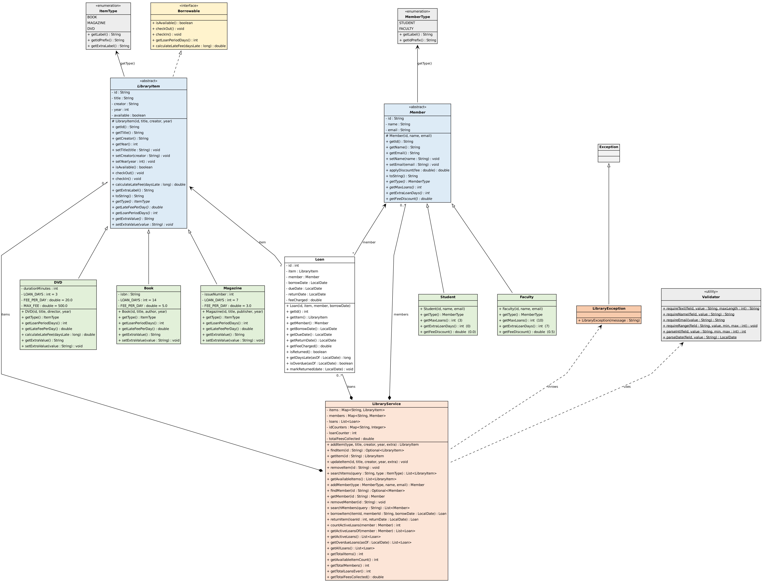
Figure 1 - Domain model and service layer
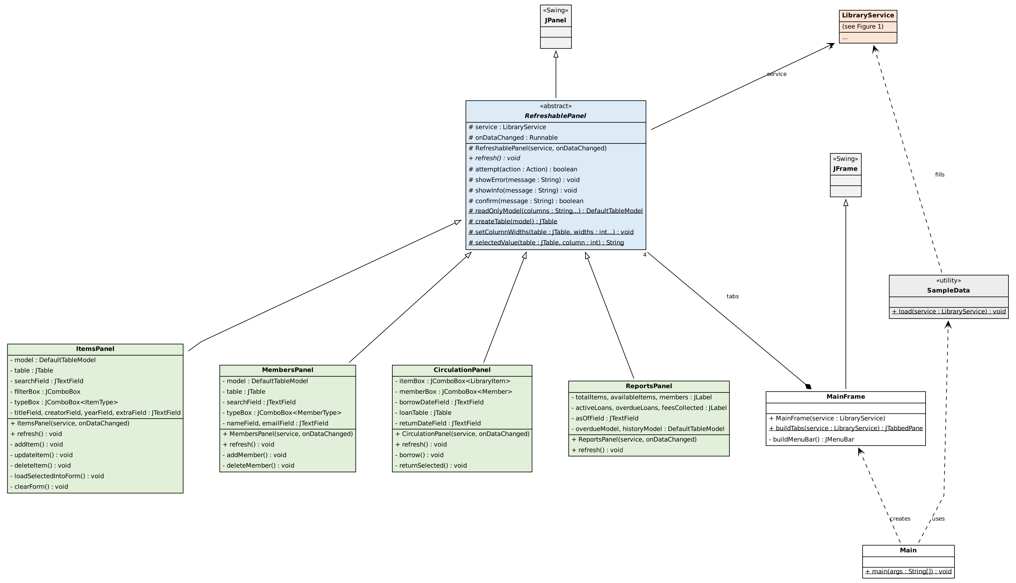
Figure 2 - GUI layer

8. GUI Screenshots
Items screen - list, search, add, update and delete items.
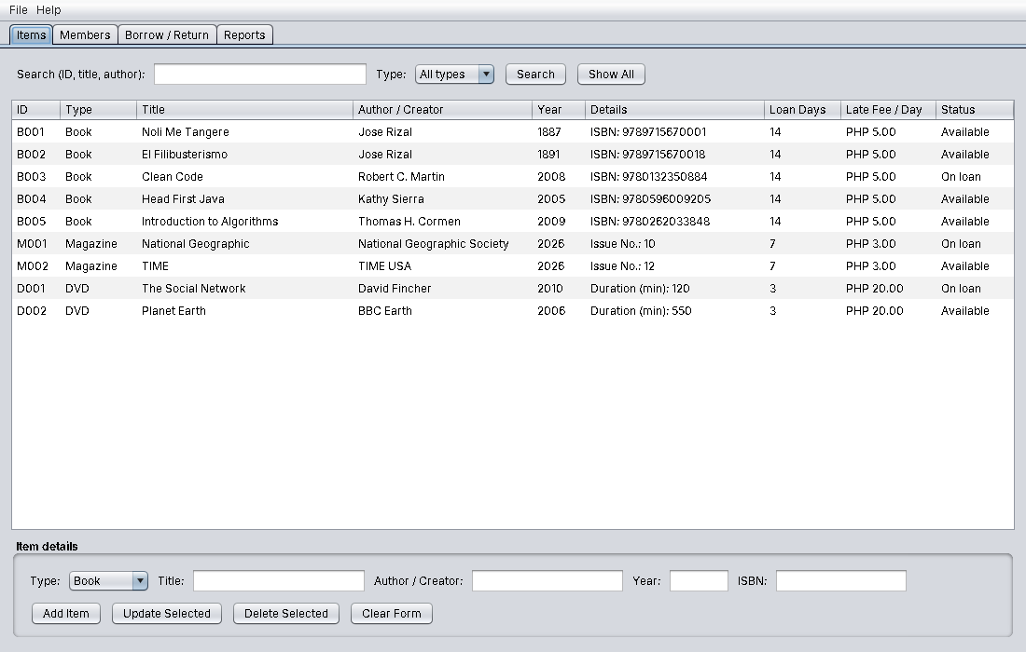
Items tab
Validation on the Items screen - a blank title is rejected.
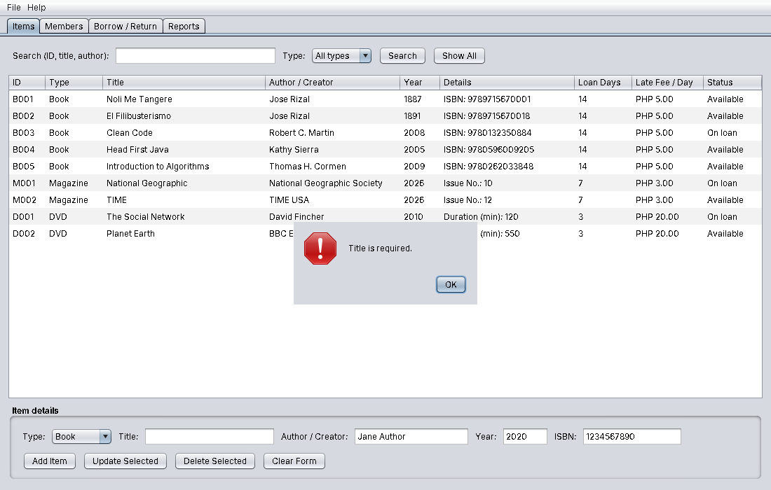
Item validation error
Adding an item - success message.
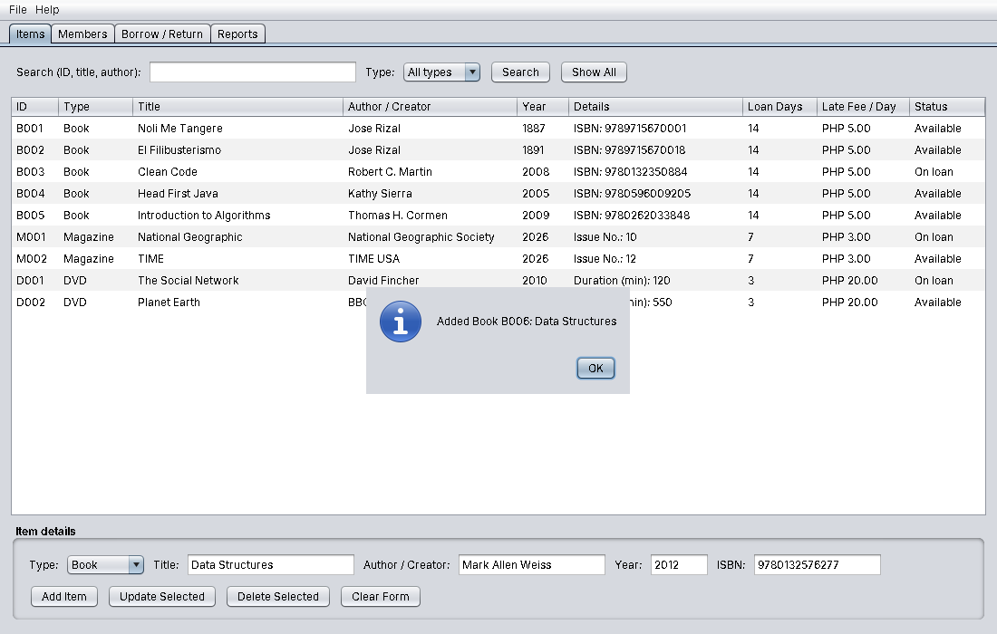
Item added
Searching items - results for “rizal”.
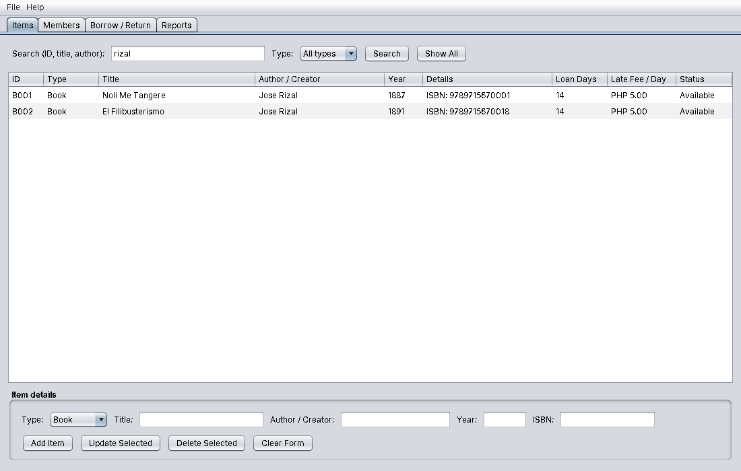
Item search
Members screen
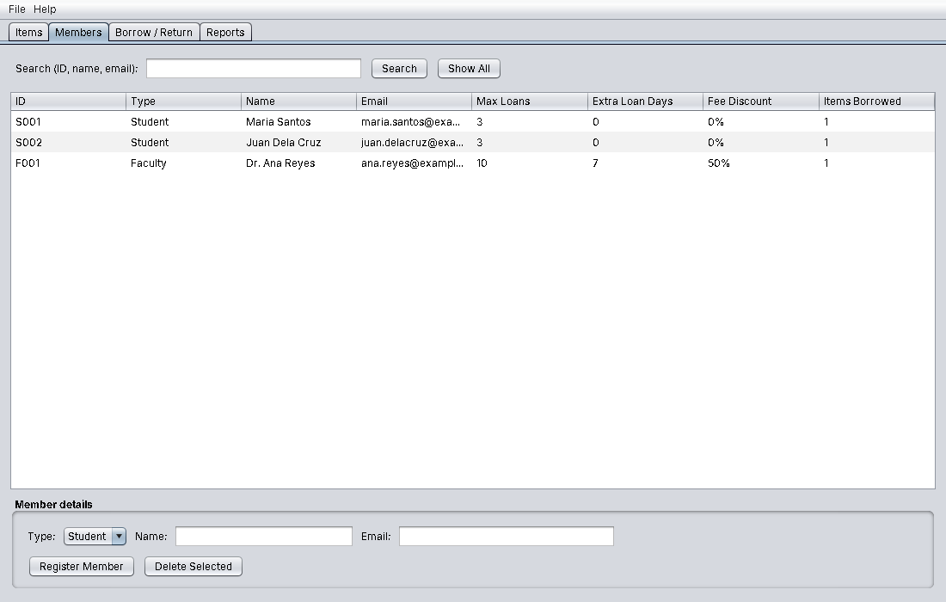
Members tab
Member validation - an invalid email address is rejected.
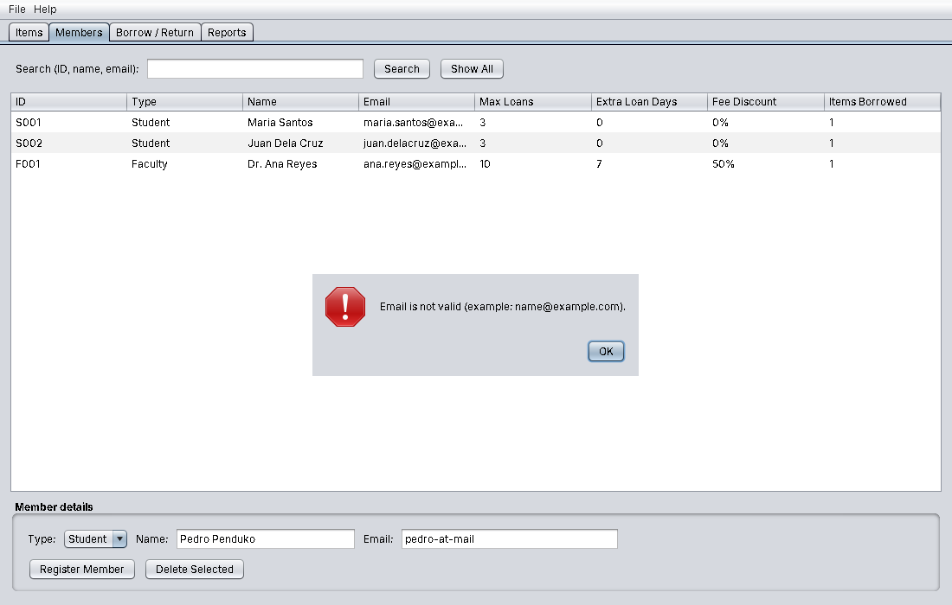
Member validation error
Registering a member
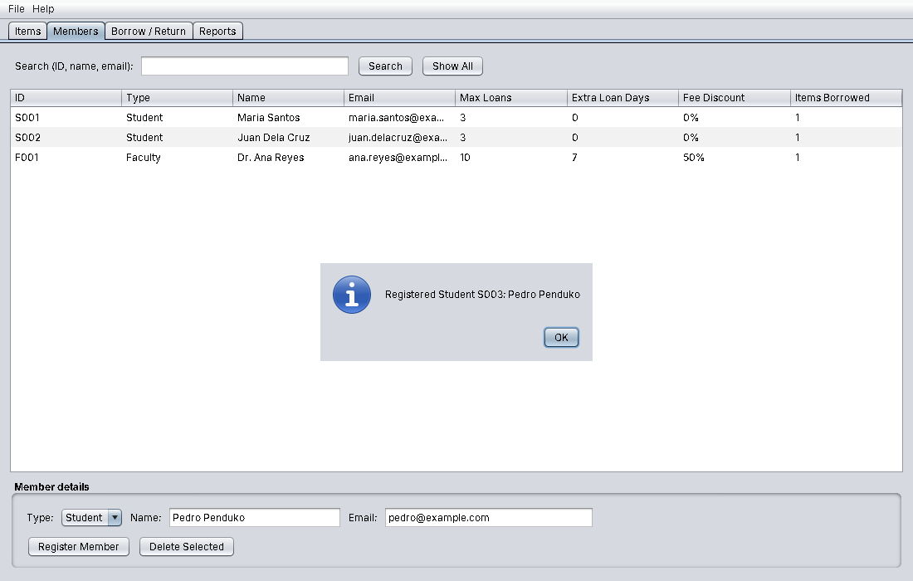
Member registered
Borrow / Return screen - available items, members, and the list of active loans with their status.
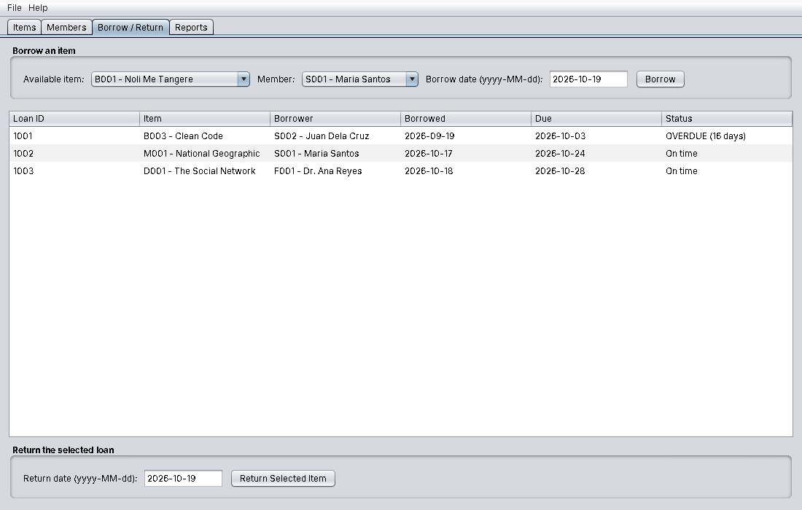
Borrow and return tab
Invalid transaction prevented - a member with an overdue item cannot borrow.
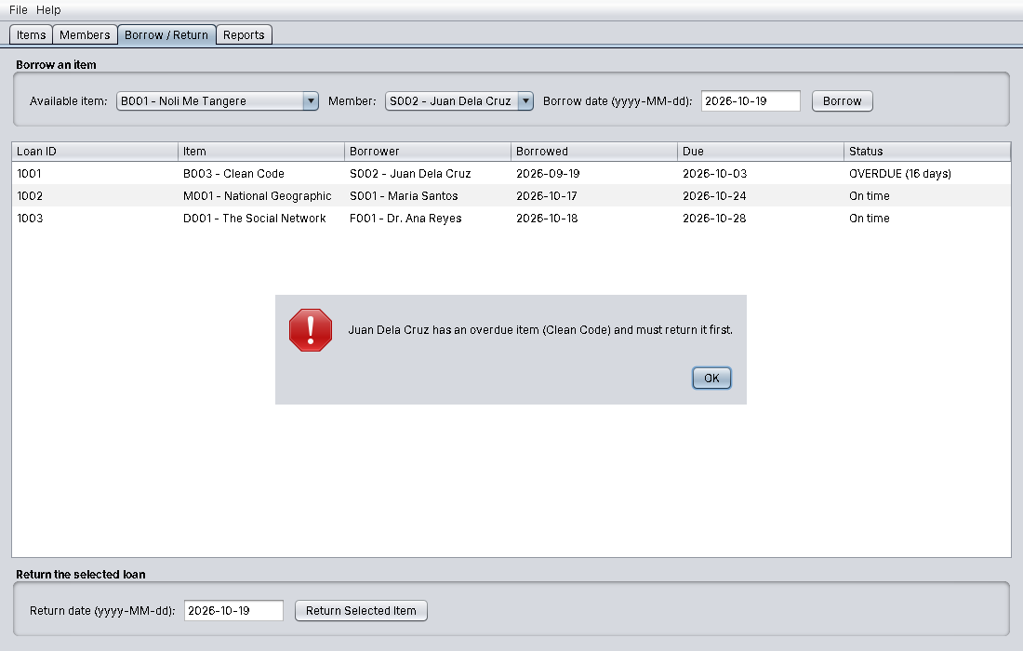
Borrow blocked
Borrowing an item - the due date is calculated automatically.
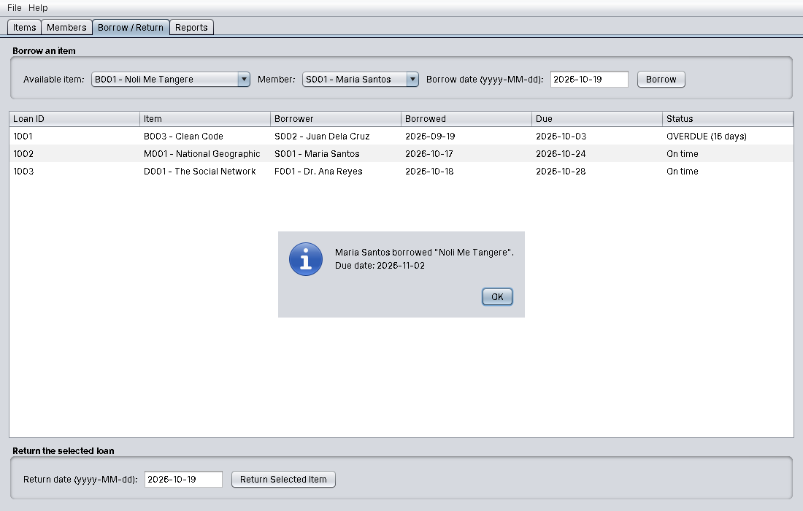
Borrow success
Returning a late item - 16 days late x PHP 5 = PHP 80.
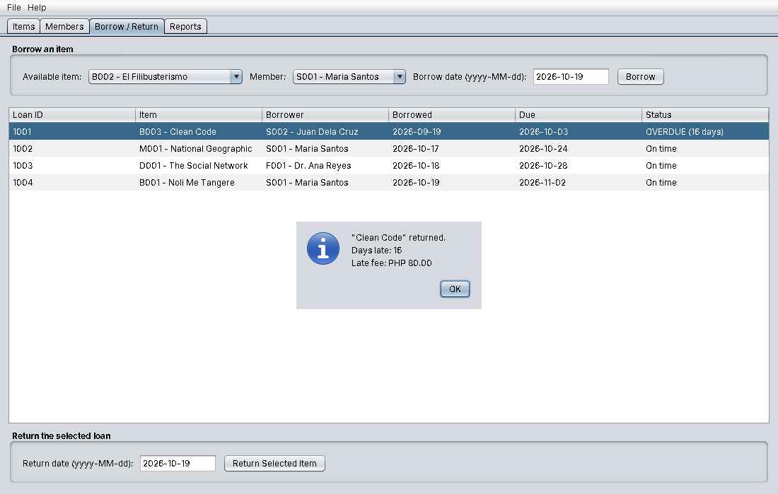
Return with late fee
Reports screen - statistics, overdue report and loan history.
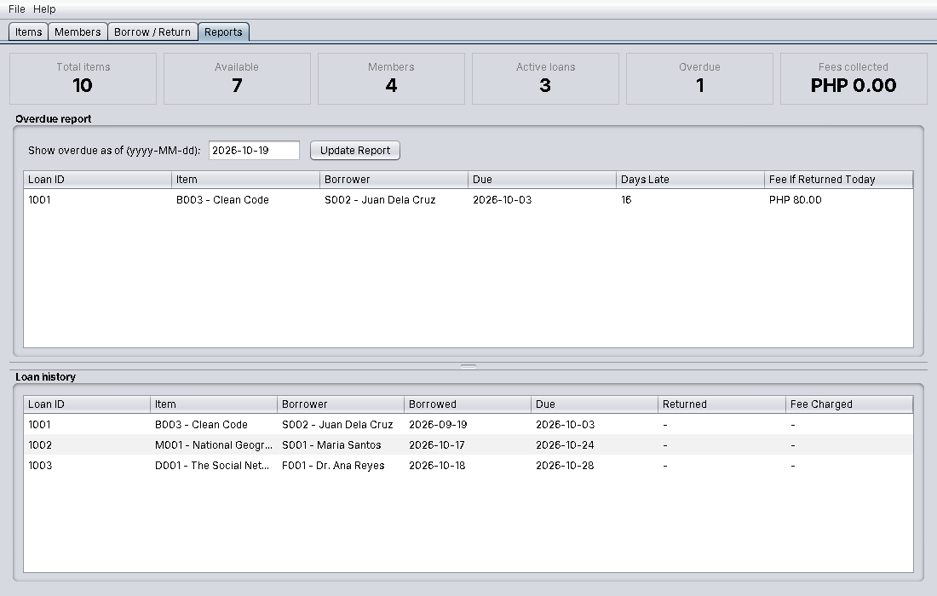
Reports tab with an overdue loan
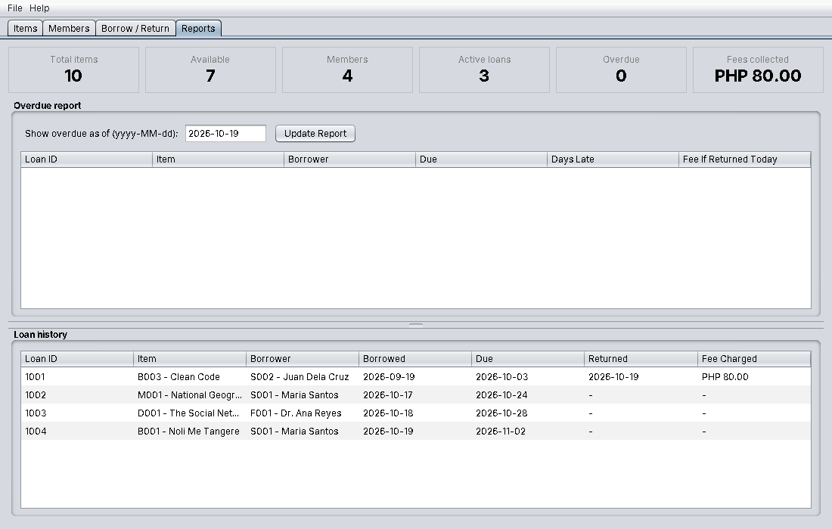
Reports tab after the return

9. Testing

9.1 Input validation and error handling
Input | Rule | Result shown
Blank title / author | Required fields | “Title is required.”
Year “abc”, 999 or 3000 | Whole number between 1000 and next year | “Year must be a whole number.” / “Year must be between …”
ISBN “12345” | 10 or 13 digits | “ISBN must contain 10 or 13 digits.”
Issue number 0, duration -5 or “abc” | Positive whole number in range | Error message
Member name “John123” | Letters, spaces, dots, apostrophes, hyphens only | Error message
Email “pedro-at-mail” | Valid email format | “Email is not valid.”
Duplicate email | Must be unique | “A member with the email … already exists.”
Date “19/10/2026” | Format yyyy-MM-dd | “… must use the format yyyy-MM-dd”
Borrow date in the future | Not allowed | Error message
Return date before borrow date or in the future | Not allowed | Error message
Borrow an item already on loan | Not allowed | “… is already borrowed.”
Student borrows a 4th item | Limit of 3 | “… has reached the limit of 3 items”
Member with overdue item borrows | Not allowed | “… has an overdue item … must return it first.”
Delete item or member that is in use | Not allowed | Error message
All errors are shown in dialog boxes and nothing is changed when an error occurs (for example, a failed item update is rolled back).

9.2 Automated test results
The test class LibraryServiceTest runs 31 checks against the service and model classes (run with java -cp out library.LibraryServiceTest).
Result: 31 passed, 0 failed.
Area | Tests (all passed)
Features | Add item with generated IDs; search by title / author / ID / type; update item; update rollback on invalid data; delete item; register and search members
Borrowing and returning | Due date for book/student (+14) and book/faculty (+21); item already on loan; student limit of 3 and faculty higher limit; borrowing blocked by overdue item; on-time return; item becomes available again
Late fees | Book/student 10 days = PHP 50; Book/faculty 10 days = PHP 25 (50% discount); Magazine 4 days = PHP 12; DVD 33 days capped at PHP 500; total fees tracked
Reports and rules | Overdue report; cannot delete item/member on loan
Validation | Blank fields; year range; ISBN / issue / duration; rejected item does not consume an ID; member name and email; duplicate email; invalid dates; unknown IDs
OOP pillars | Encapsulation (all fields private, checked by reflection); Inheritance (class hierarchy); Abstraction (abstract classes and interface); Polymorphism (same call, different results per subclass)

9.3 GUI testing
The screenshots in section 8 were produced by running the real application and operating its buttons and fields: adding an item (valid and invalid), registering a member (valid and invalid), borrowing (allowed and blocked), returning a late item with a fee, and opening the reports.

10. Conclusion
Developing the Library Management System showed how the four pillars of OOP work together in one application:
- Encapsulation kept every object’s data private and valid, so errors are caught at the place where the data is stored, not only in the GUI.
- Inheritance removed duplicated code: the shared parts of items, members and screens are written once in the parent class.
- Polymorphism let one piece of code (borrowItem, returnItem, markReturned) handle every item and member type, each following its own rules, so new types can be added with little change.
- Abstraction separated what the system does from how: the abstract classes and interface define the essential behaviour, and the service layer hides the details from the GUI.
Separating the program into model, service and GUI classes also made it easier to test (the service can be tested without opening any window) and to explain. Possible future improvements are saving data to a file or database, a login system for librarians, and reservation of borrowed items.

