Explanatory note for the team project.

**Program name**: MemoryBoost.

**Annotation.**

MemoryBoost’s main goal is to increase user’s study efficiency. It uses a special spaced repetition algorithm (SuperMemo-3) and has a flashcard format (a card has a question on one side and answer on another side). The first step to start memorizing things effectively one should create a deck, the next step is to create cards. By clicking the deck name in the list, a user starts a study session: the deck’s cards are shown to the user one after another, by evaluating card’s difficulty (hard, good or easy) user increases or decreases its interval (when the card will be shown again). The program allows its users to delete and change cards and decks, attach images to questions and answers, create several profiles with or without a password. After several weeks of studying users can find their visualized studying process by pressing the “Study statistics” hyperlink (how many cards they reviewed/studied this day, week, month and year).

**Central repository address**: https://github.com/JohnSWD/MemoBoost

**Members of the team**: Alaev Evgeniy.

**Classes.**

The program has four main entities: Card, Deck, User and Statisticks. Cards’s main properties are question and answer, numbers which are used in the SR (spaced repetition) algorithm. Decks are used to store cards. The User class has a password, a name, a list of decks and a list of statistics. The Statisticks class stores information about users’ studying processes (integer numbers of quantity reviewed/studied cards).

The other classes are ScheduleManager, MediaManager, StudySession and ColumnsChart. The first class is responsible for calculating cards’ intervals according to user’s performance. MediaManager has methods to storea and remove images. The StudySession class has information about the current user, filters cards to find the ones which need to be studied or reviewed, passes information about study process to the Statisticks class. The last class is used to visualize user’s study process.

**Program’s interface with an example.**

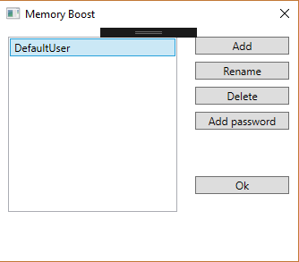

*Profile selection window.*

The window’s buttons are self-explanatory. A user can create/delete several profiles (password is optional and can be removed). If there is only one profile in the database and it has not a password, then the program’s starting window is the home page. When MemoryBoost’s database is created, the program already has a “DefaultUser” profile.

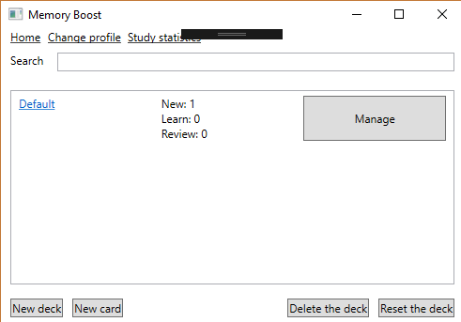

*Home page*

Home page is the main part of UI. It has a list of decks, hyperlinks and buttons. The “Reset the deck” button is used to reset deck’s cards numbers which are used in the SRS algorithm. To change deck’s name, edit its cards, attach images one should press the “Manage button”. The searcbox is used to find deck’s which contain a substring. Each deck’s name is a hyperlink which navigates a user to the study page on click, three textblocks show how many cards are available to study.

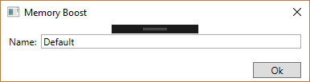

*Window used to add new decks*

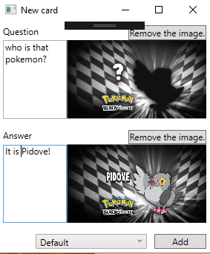

*Windows used to create new cards*

When a user creates a new card, it is possible to drop an image into a textbox with a question/answer. ComboBox is used to pick the deck which will store the created card.

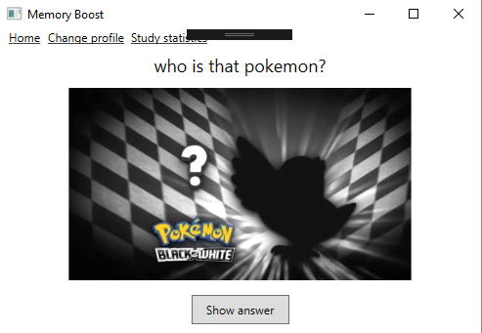

*Study page (question)*

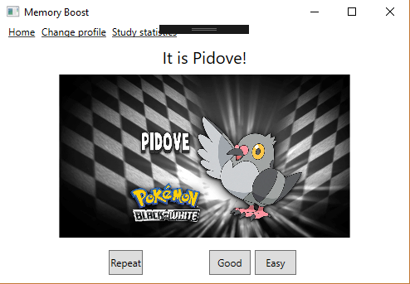

*Study page (answer)*

Because the card is new and currently has a leaning state, there are only two options: good or easy. Choosing the easy option changes card’s state to “review” and it will be shown in 4 days; if a user presses “Good”, the card will be shown again in 10m. Another “good” or “easy” answer will change card’s type to “review” (will be shown in 1d or 4d respectively). Repeat button makes card “new” again (if a user completely forgot the card).

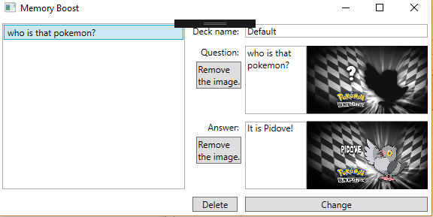

*Deck manager window*

Decks can have its name changed and cards edited or deleted.

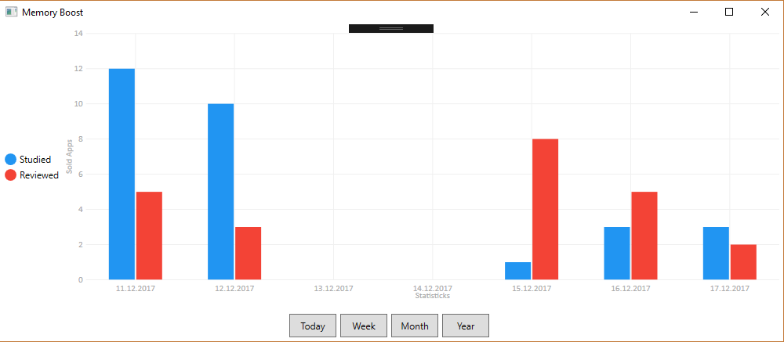

*Statistics window*

Statistics window shows the progress a particular user made. Pressing buttons changes the graph being shown (can show statistics of twelve prior months, seven prior days, three prior years).