**SERVIER’s aging model in porcine aortic endothelial cells (PAEC)**

Isolation of primary cells, P0 -> P1

* Anesthetization of pig (2-3 month old, 24 kg, check lungs!) with Zoletil®100 (5ml) and Rompun® (3 ml)
* Isolation of aorta (thoracic, approximately 10 cm)
* Put aorta in “conservation-buffer”
  + *Conservation-buffer (500 ml)*

*+ EBSS: 500 ml*

*+ FCS: 25 ml / 500 ml*

*+ penicillin/streptomycin: 5 ml / 500 ml*

* Cleaning of the aorta in “conservation-buffer” with sterilized devices
* Cut aorta in length
  + CAVE: cut at side of collaterals; avoid touching the endothelium!
* Aorta should be fixed (and a little bit stretched) with sterilized pins and washed (2x) with “conservation-buffer” (maintain aorta in conservation-buffer all the time)
* Area around aorta should be dry
* Just scrap one time before putting cells in full MEM!
* Wash scalpel (with endothelial cells) after scrapping in full MEM (ca. 40 ml)
  + *Full MEM (1 l)*

*+ MEM 1 l*

*+ penicillin/streptomycin/glutamine 10 ml / 1 l*

*+ gentamicin 10mg/ml 2.5 ml / 1 l*

*+ amphotericin-B 250 µg/ml 10 ml / 1 l*

*+ FCS 100 ml / 1 l*

* Sterile filtration (0.2 µm, PES)
  + - CAVE: Store full MEM no longer than 1 week at 4 °C, don’t heat in water bath (growth factors will get lost!!)
  + FCS: heat-inactivation
    - if frozen: water bath, 56 °C, 1 h (not more!!!)
    - if not frozen: water bath, 56 °C, 30 min (not more!!!)
    - aliquote FCS (50 ml) and refreeze it (- 20 °C)
* Centrifugation: 4 °C, 1000 rpm (200 g), 5 min
* Change full MEM-Medium (50 ml), suspend cells and put them in a 175 cm2-flask (Collagen I-coated)
* Check cells on the next day (are they adherent?)
* 2 days afterwards
  + Wash 2times with EBSS
  + Add 50 ml new full MEM
* 5 days afterwards: perhaps it’s necessary to change the media to “boost” them (if confluency is just around 50 %)
* For P0 -> P1: passaging 6 – 8 days after isolation (high confluency is no problem for this P0)

Passaging (P1 -> P4/P5)

* Wash cells with EBSS (> 3x)
* Trypsinizefor 2 min at 37 °C (2 ml trypsin for 175 cm2 falcon)
* Hit flask and look at trypsinized cells under the microscope
* Add 10 ml full MEM
* Wash flask with MEM to be sure that no cells are left in the flask
* Centrifugation: 4 °C, 1000 rpm (200 g), 5 min
* Count cells
  + 800 000 cells / 175 cm2 flask (50 ml full MEM)
  + 400 000 cells / 75 cm2 flask (25 ml full MEM)
* Z2 Coulter Particle Counter
  + 10 ml of isotonic solution + 50 µl of cell-suspension (cell-pellet/10ml full MEM)
  + Mix cells in cuvette before measurement!
  + Set-up: 100 µm C, Kd = 59.78  
    Select: Units: < µm >  
    Set upper size tu: 19.95 µm  
    Set lower size tl: 6.7 µm  
    Count mode: < above Tl >
  + For washing: Function – Start; For measurement: Setup – Start
  + Always check measurement of cells!
  + Calculation: [Count>6.7 µm]*4000 = cells / 10 ml
* Add calculated amount of cell-suspension to 50 ml of full MEM in flask
  + Labeling of flask: number of primary culture, passage, date of trypsinization
* Check cells at least every 2 days
* Changing of media: depends on the day of measurement/passaging, perhaps after 5 days
* Go to next passage after 6 – 8 days

Plating of cells

* Whole trypsinization-procedure
* Count cells (like described above)
  + 24 well - plate: 100 000 cells / well, 1 ml / well (maximal density!)
  + 6 well - plate: 500 000 cells / well, 5 ml / well (maximal density!)
* Measurement 24 h after trypsinization

Transfection-procedure

* Invitrogen-LifeScience: “CellLight protocol”
  + - MOI: multiplicity of infection; PPC: particles per cells
    - Transfection should be done in the morning (with plating!!), measurement on the next day or two days afterwards

1- Calculation of reagent to add:

**Volume of CellLight reagent (ml) = Cell X desired PPC/ 1 X 10^8 (particles /ml)**

Example: For 100000 cell / well :

Volume of reagent = 100000 x 30/1x10^8= 30µl

2- Mix cellLight reagent by inversion (no vortexing!)

3- Add cellLight in the full medium

4- Incubate overnight

5-Cells are ready for measurement

* Electroporation, System Neon, Invitrogen

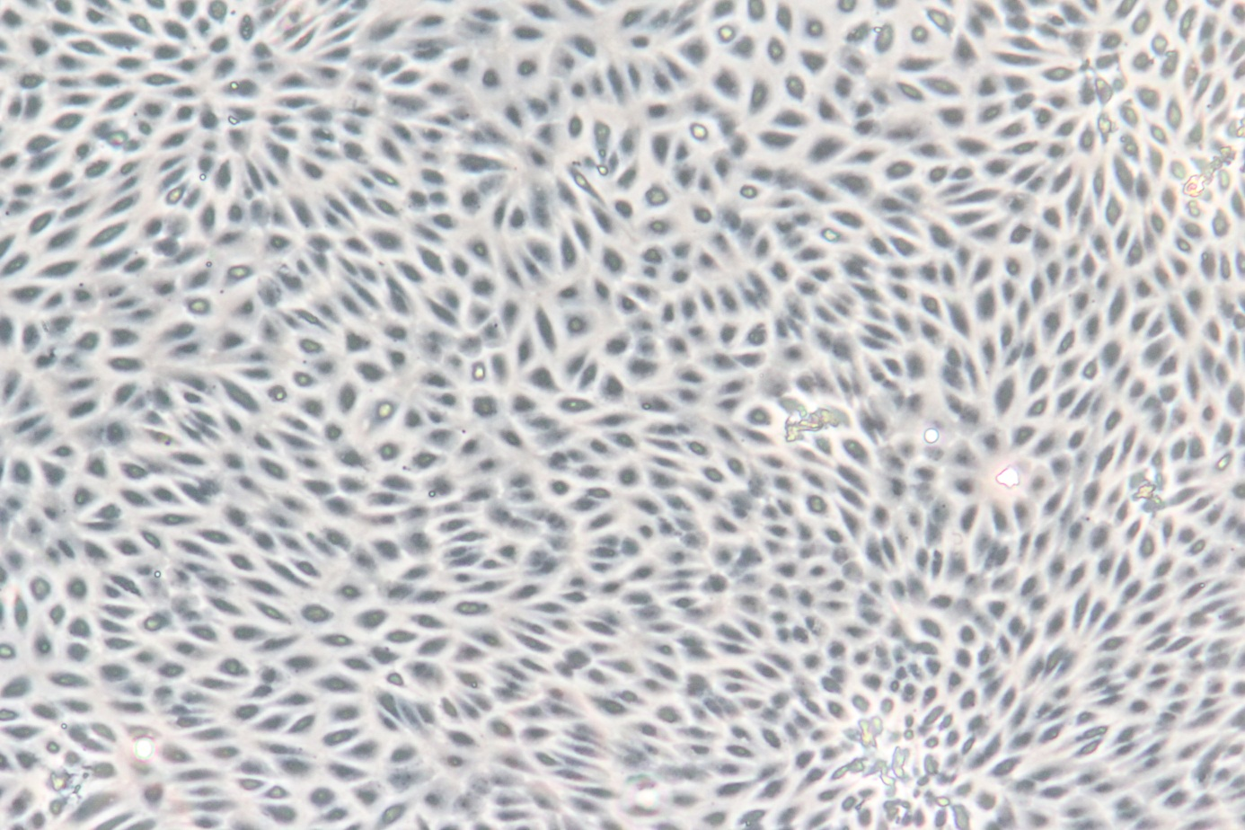**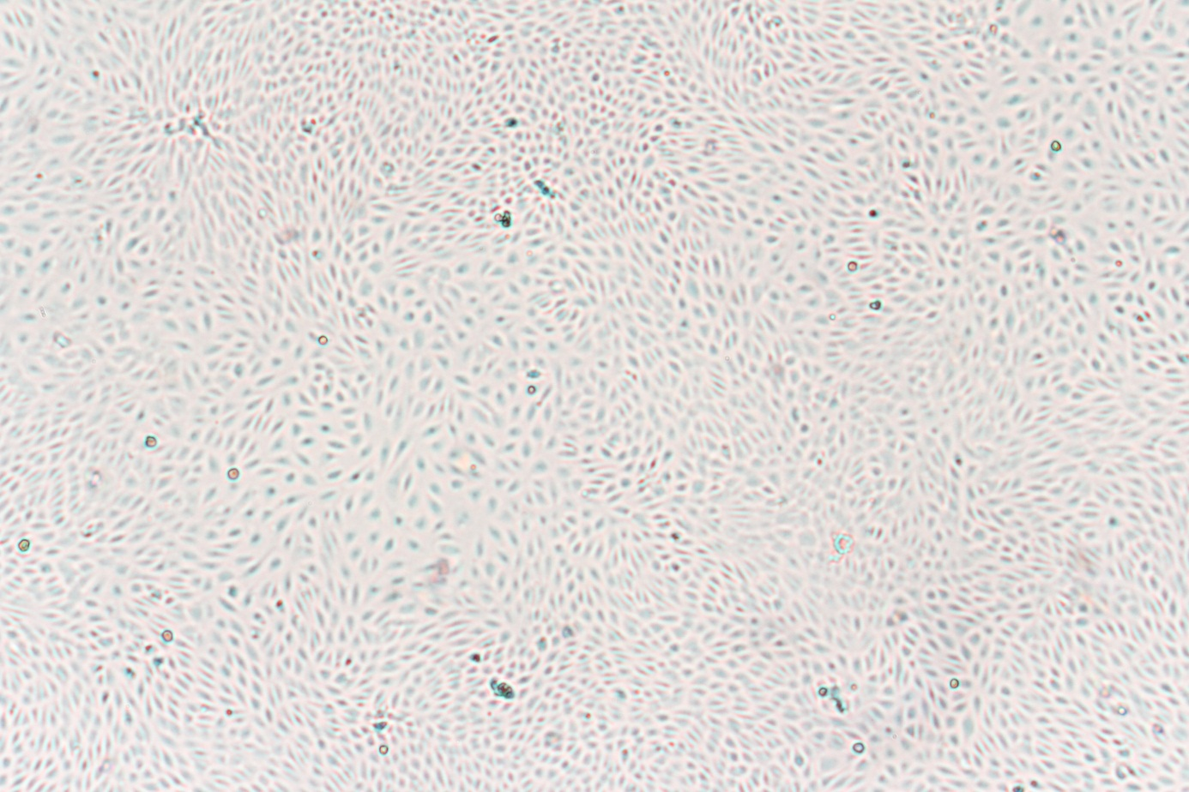P0 (1)**

**P1 (1)**

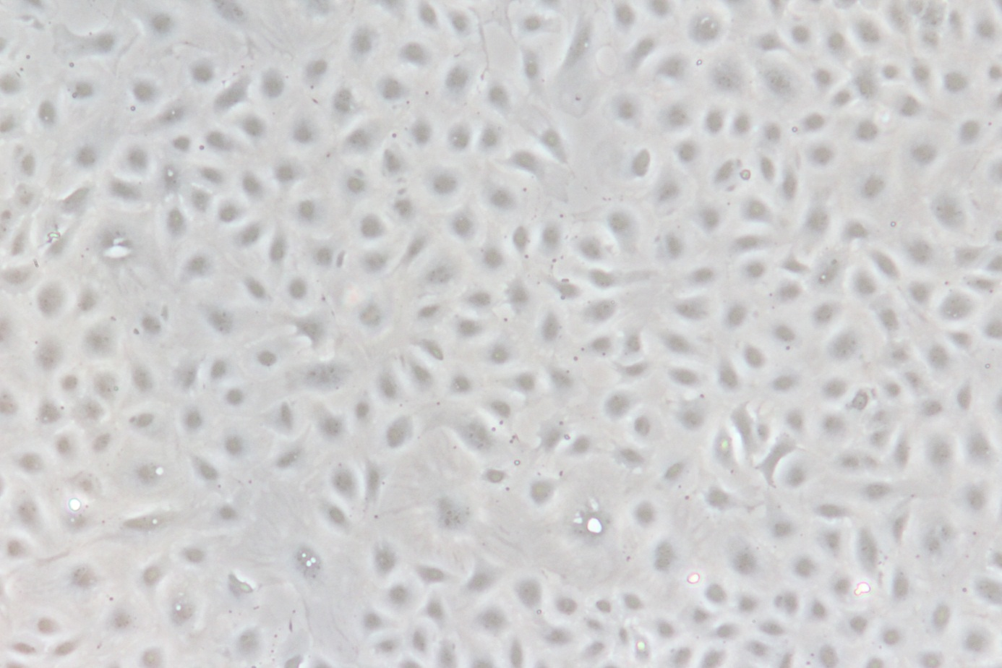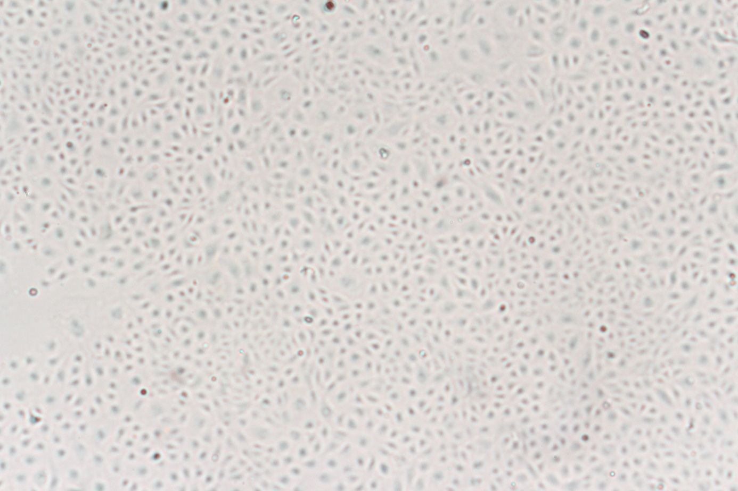

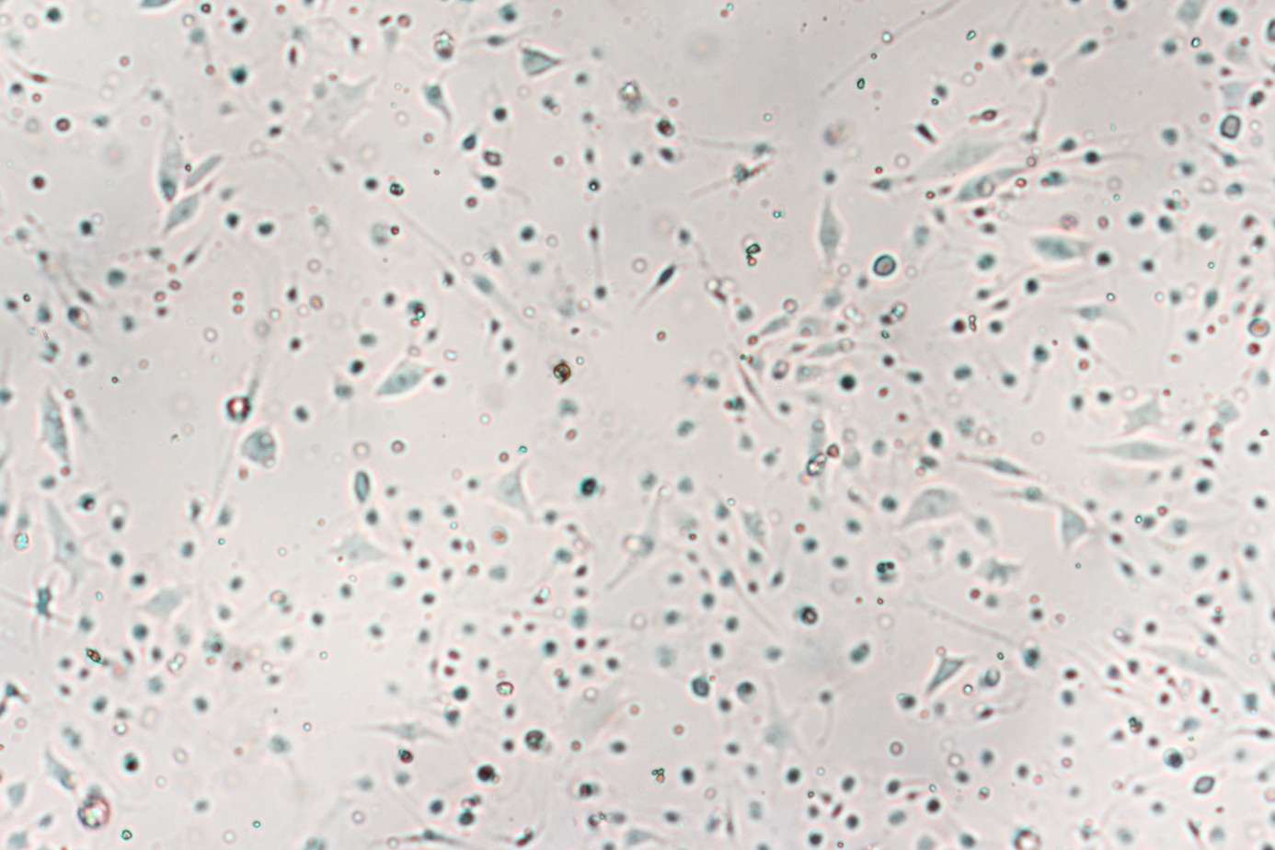**P2**

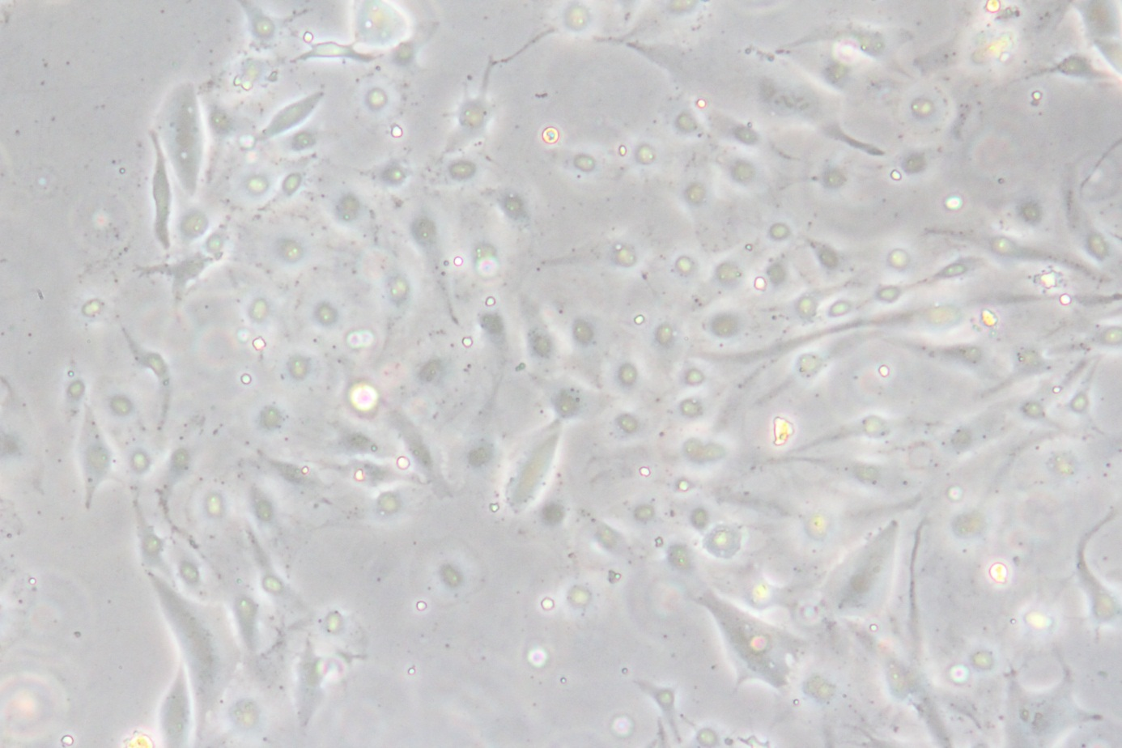

**P3**

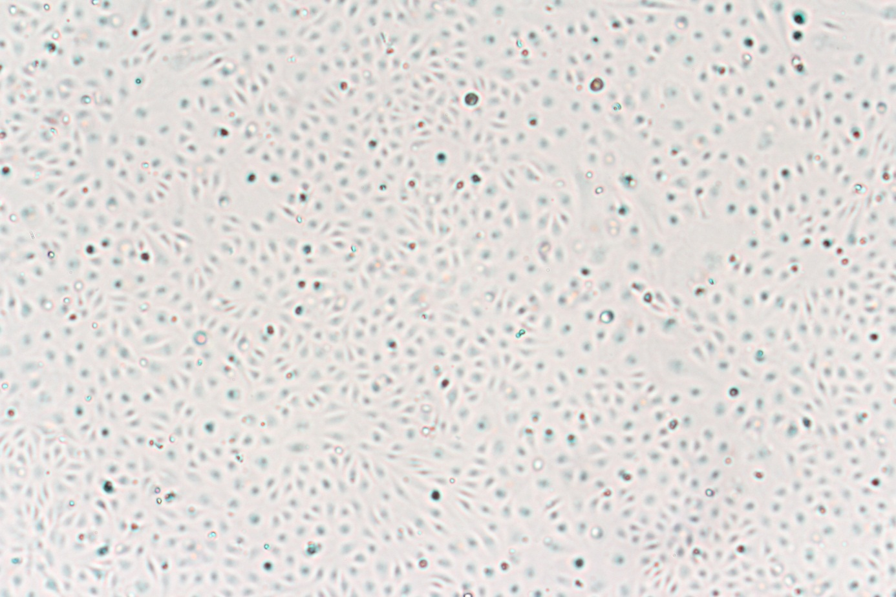

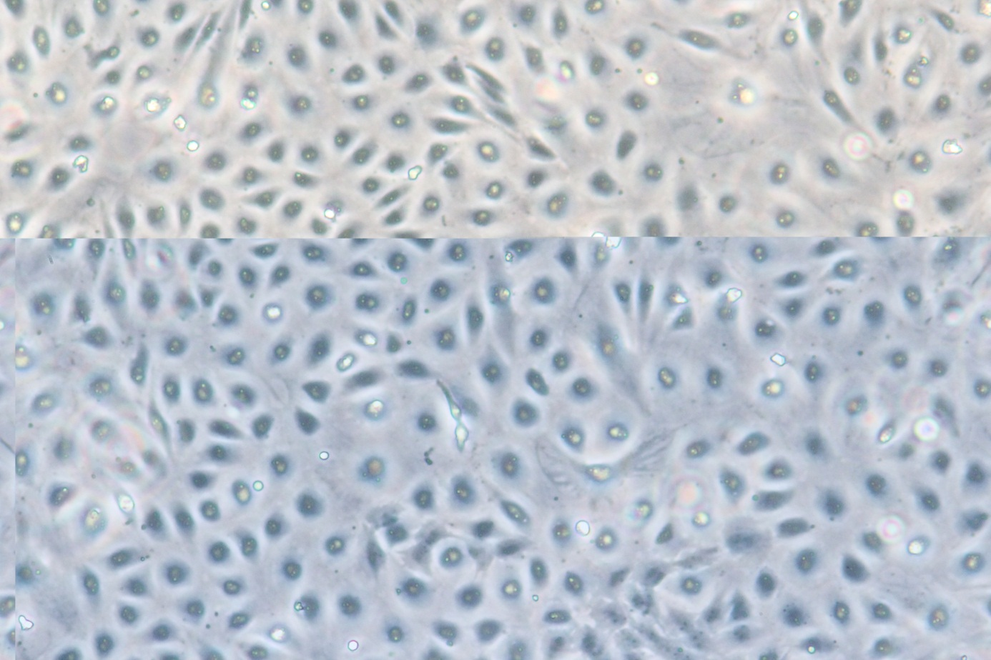

**P4**

