Matchmaker
August 20, 2022

Description
Among the first commercial uses of computers was for matchmaking, or “computer dating”. We propose a 21st century version of this application, using a human matchmaker.
There are two classes of users: seekers and matchmakers. They are distinguished when they sign up.

Seekers
After choosing to sign up, a seeker must fill out his profile in which he lists his vital statistics and his wish list, where he describes the person he would like to be matched with. He must also provide a credit card to be charged for his use of the service.
The seeker can see the matches that have been suggested for him by the matchmaker, rated from 1 to 10, and can choose one, after which he sees only the chosen match.

Matchmakers
When signing up as a matchmaker no profile or credit card is required. A matchmaker is presented with a list of possible matches that have not yet been rated. The matchmaker chooses a possible match and can see the profiles of both seekers, their wish lists, and their extended descriptions of themselves. Only matches in which the profiles match the wish lists are considered. The matchmaker rates the quality of the match from 0 to 10, where 0 means the match should not be considered.
These matches are presented to seekers when they log in. If a seeker chooses a match, both seekers are presented with the other’s contact information.

Personnel
Spencer Brown, John Sauter, Rachel Williams

Motivation for Development
This seems like a simple yet interesting application. It does not depend on external APIs, and so does not expose us to the risk that the API will not be available.

User Stories
As a lonely person,
I would like to be put in touch with a compatible person.

As a matchmaker,
I would like to facilitate the meeting of compatible people.

Technologies
- React with useContext in the front end
- GraphQL to communicate between the front and back ends: queries for pulling data from the back end and mutations for modifying such data
- Node.js and Express.js in the back end
- MongoDB and the Mongoose ODM for the database, hosted on Heroku using Atlas
- The UI in the clent will look professional and be mobile-friendly, but the CSS will be coded from scratch: no use of Bootstrap or Foundation.
- As described above, there will be extensive user interaction.
- Use JWT for authentication.
- Only the server knows how to access the Stripe payment processor for credit cards and the secrets needed to send e-mail.

Task Breakdown
- Design user flows: what pages will each type of user see, and what actions can be taken on each
- Design data structures to support the user actions
- Design the GraphQL queries and mutations for communicating between the client and server
- Code the client, which includes the CSS for each page.
- Code the server. Begin with the resolver, and stub out each function so the client can be debugged while each server function is coded.
- Test and debug. This may require some changes to the queries and mutations.
- Deploy to Heroku and MongoDB Atlas.
- Present the application to the class

Page Layout
Each page will include a navigation bar at the top which lists the permitted pages for this state of the user. If there is only one choice it is pre-selected. Once logged in, Logout is always available.
- Front page: possible choices are Login and Sign Up, default is Login
- Signup: The signup page will have space for name, email address and password. The name and email address must be unique, and the server will indicate if they are not. There will be a checkbox to choose between seeker and matchmaker. When signup is complete the seeker is taken to the profile page whereas the matchmaker is taken to the Matchmaker Matches page.
- Login: name and password. When login is complete the next page for a matchmaker is the matchmaker matches page. For a seeker the next page depends on his state. A seeker with no profile is taken to the profile page. A seeker with a profile but no wish list is taken to the with list page. A seeker who has provided a profile and wish list but not a credit card is taken to the credit card page. A seeker with all three is taken to the seeker matches page unless he has been matched, in which case he is taken to the match chosen page.
- Profile: gender (male, female, non-binary), age (entered as date of birth), height, weight, eye color (blue or brown) and hair color (dark, blonde, red). In addition there are two free-form text fields: one for his extended description of himself, his likes and dislikes, and the other for his contact information. The latter is presented only when there is a successful match. The next page is wish list.
- Wish List: Having filled out his profile the seeker fills out a wish list which describes what kind of person he is looking for: gender (male, female, don’t care), minimum age (18 to 118), maximum age (18 to 118), minimum height, maximum height, minimum weight, maximum weight, eye color (any or all of blue or brown), hair color (any or all of dark, blonde and red). The next page is credit card. The navigation bar lets you return to Profile.
- Credit card: supplied by Stripe. The next page, assuming the credit card is valid, is Seeker Matches.
- Seeker Matches: A list of seekers whose profiles fit the wish list and whose wish lists fit this seeker’s profile. They are listed by matchmaker rating, with the highest rated at the top. Seekers with a matchmaker rating of 0 are not shown, as are matches not yet rated by a matchmaker. Clicking on a list item navigates to Match. Navigation choices are Profile (to update profile) and Wish List (to update the wish list). Making a change to either deletes all matchmaker ratings for this seeker, rendering the seeker matches page empty.
- Match: All the information provided by the other seeker except contact information, and the matchmaker’s rating. The next screens are seeker matches (going back to the previous screen) or match chosen.
- Match Chosen: All of the information provided by the other seeker, including contact information. Making this choice sends email to both seekers and places them in the match chosen state, so when they login they are taken to this page. The only navigation choice is logout. All other matches for both seekers is deleted. If a seeker decides the match wasn’t good after all he can reject the match, at which point he needs to provide a credit card again.
- Matchmaker Matches: A list of pairs of seekers who match based on their profiles and wish lists, but who have not yet been rated by the matchmaker. The matchmaker chooses one to examine in the matchmaker possible match page.
- Matchmaker Possible Match: The complete profile and wish list of both seekers, except for contact information. The matchmaker can choose to rate this match from 0 to 10, or can use the navigation bar to return to the matchmaker matches page without rating this match.

Things to add if there is time:
- verify the password
- PWA
- upload photo
- seed data should include a Klingon

Wireframe Screen Shots:

Front Page:
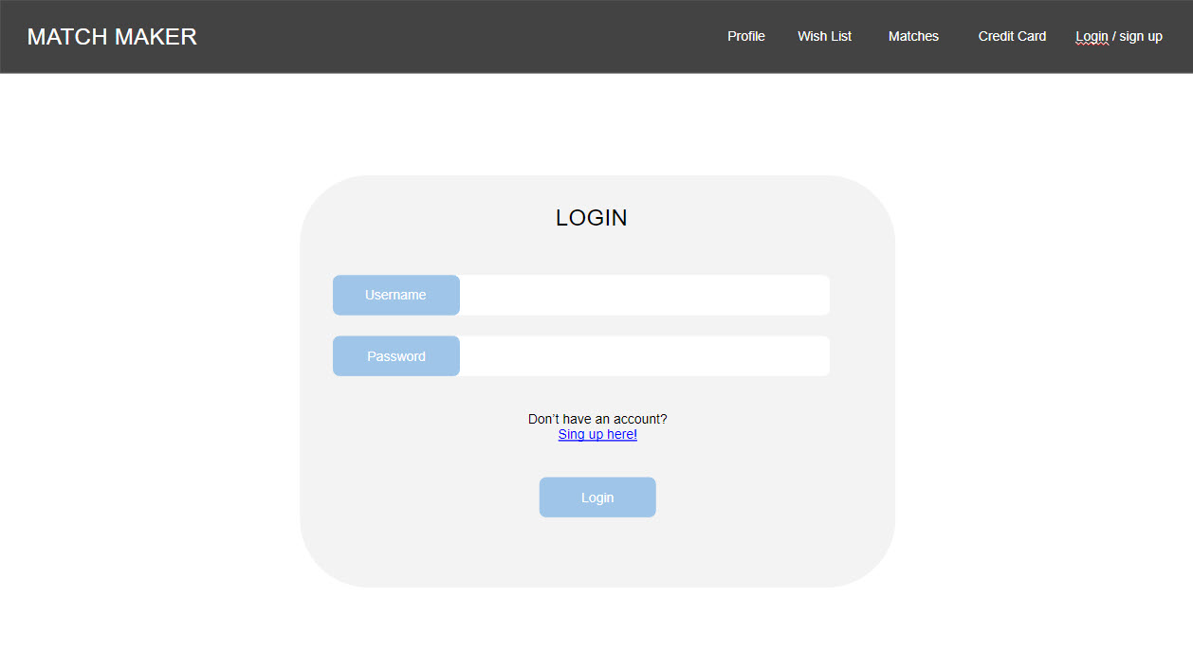

Sign Up:
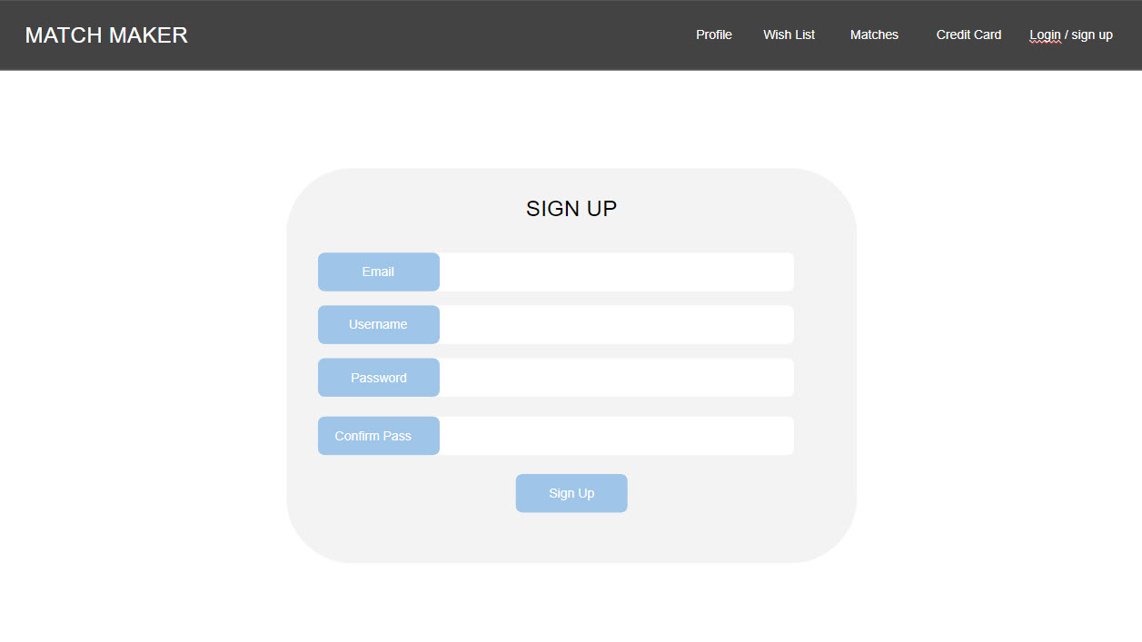
Profile:
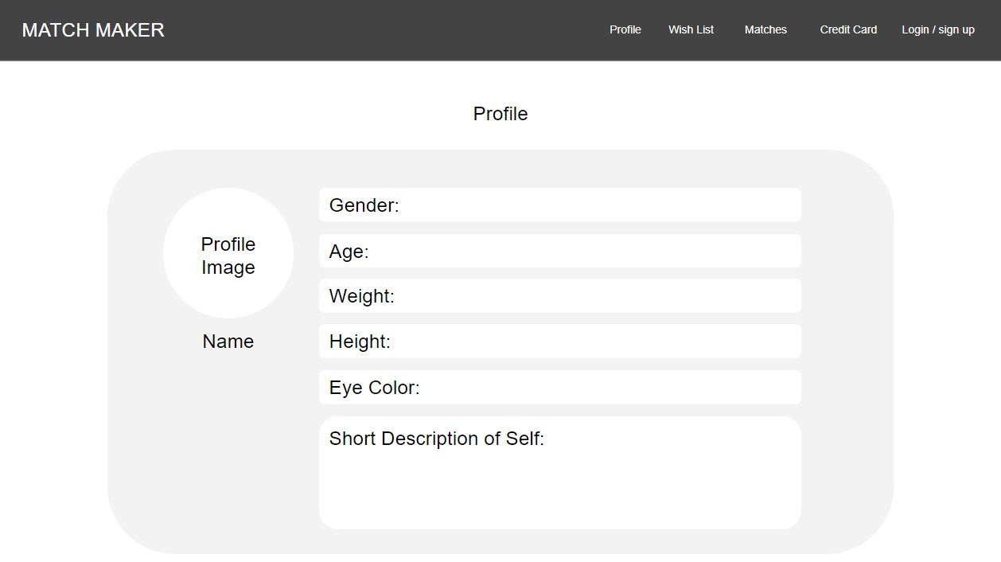

Wishlist:
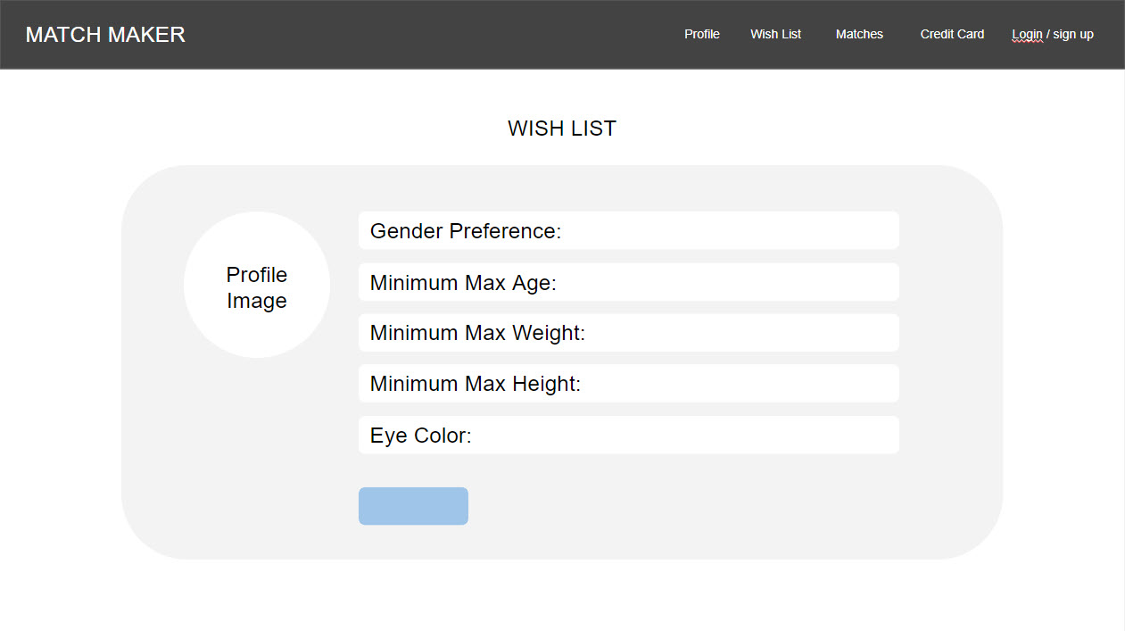
Matches: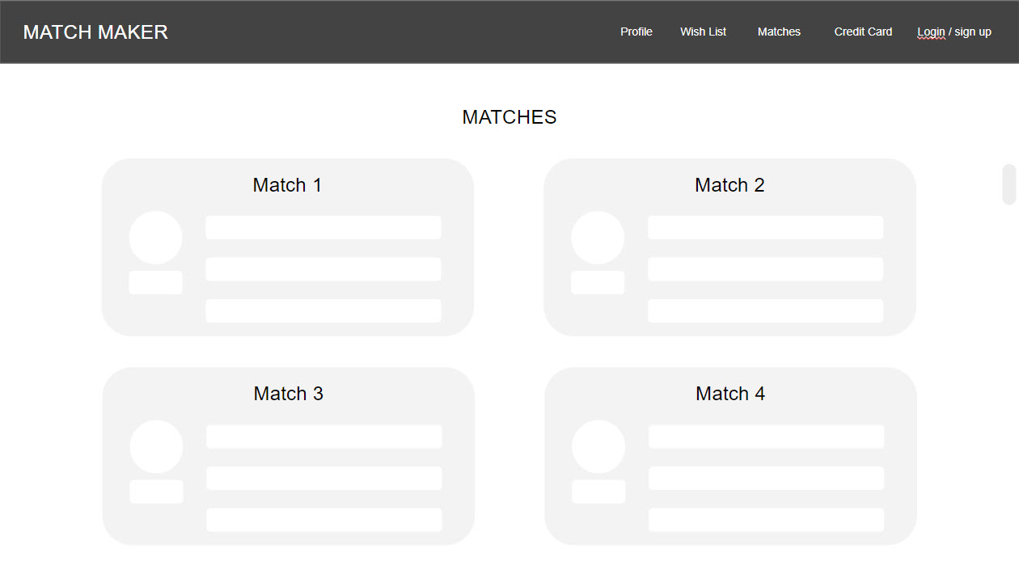

Credit Card Input:
