Kentucky

Education Cabinet

Unemployment Insurance Eligibility Review

Save Handler: Technical Siebel Integration

Any change requires re-testing of the OWD-Siebel Integration

Technical note: Setting this attribute "the eligibility review should be saved" (opa_finish_and_save_goal) to true will cause the save event plugin to save the session back to Siebel. Note that if the screen name changes "the screen 'Your Interview is almost complete' has been displayed" then this rule must be updated to reflect the new screen name.
Note: the order that the save event is activated and then de-activated is directly controlled by the sequence of these two screens in the Finish and Save Confirmation – screen flow.
Your Interview is almost complete should occur first.
Save Confirmation should occur last.
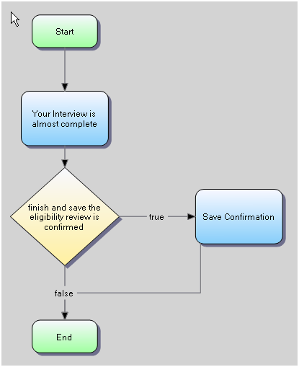

Java Source for the event handler is in SaveTxtDocument.java , a copy is in the Development/Documents/Design folder.

When TRUE the Save is Active, and the Save Handler event will fire, for each screen…

[b1] the eligibility review should be saved
[true] true | [b2] the screen 'Your Interview is almost complete' has been displayed and  [b3] finish and save the eligibility review is confirmed
[false] false | otherwise

Once TRUE, the save event handler is inactive again…

[b4] the eligibility review has been saved
[true] true | [b1] the eligibility review should be saved and  [b5] the screen 'Save Confirmation' has been displayed
[false] false | otherwise

