See OPM Help:
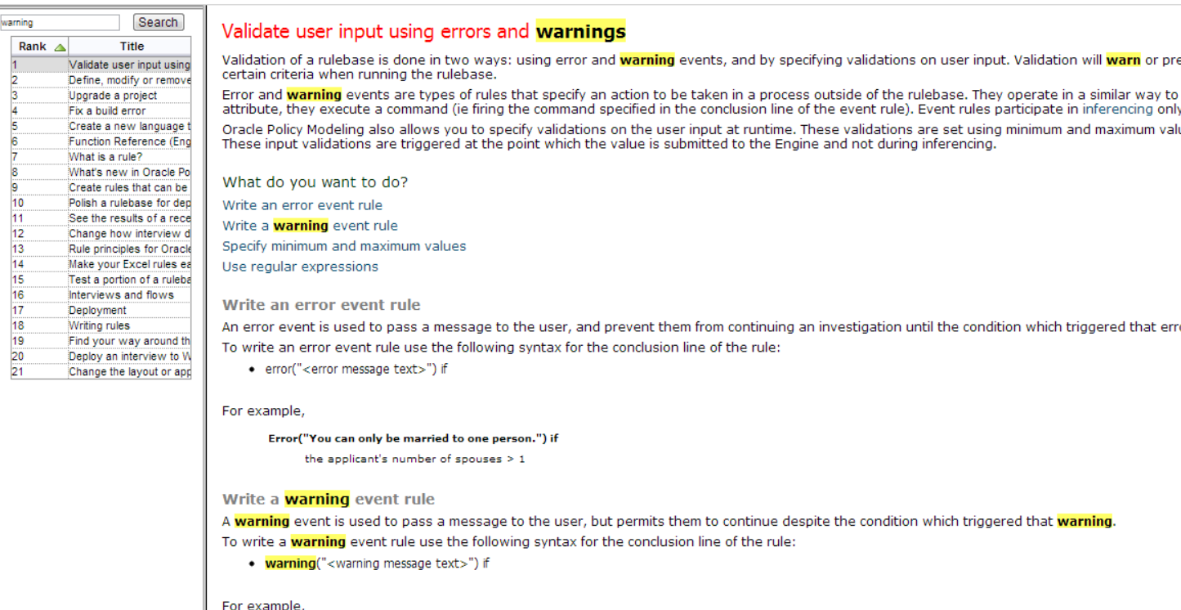

Worked Example

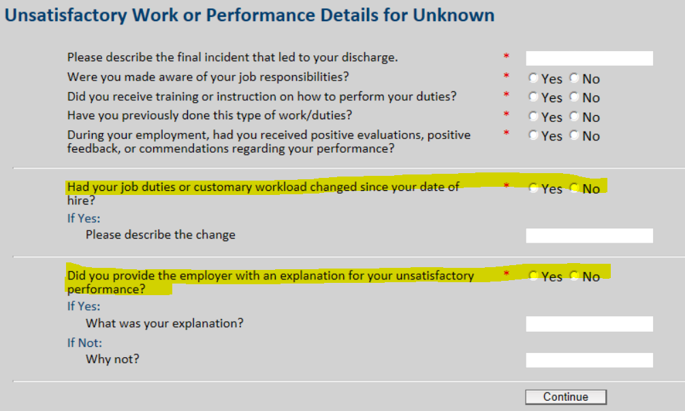

Screen Definitions: Note the bugs highlighted
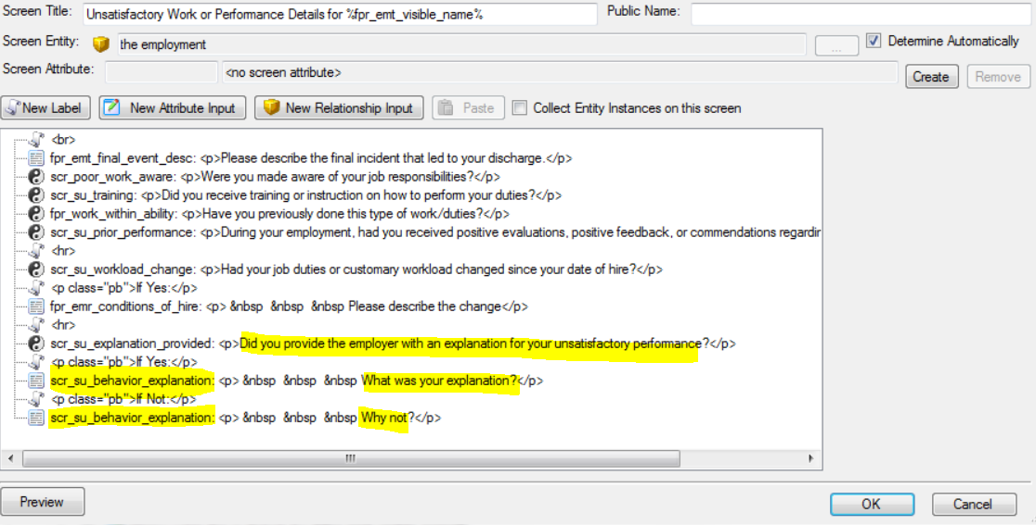

These two rules should work ok.

[raiseevent "warning(\"Please explain the change to your job duties or customary workload.\")"] warning("Please explain the change to your job duties or customary workload.")

[b1] the claimants job duties or customary workload has changed since their date of hire and

[Length(p1) <= 0] the length of the claimants explanation for their behavior or conduct <=0

[raiseevent "error(\"You have entered an explanation, but indicated that there was no change to your job duties or customary workload.\")"] error("You have entered an explanation, but indicated that there was no change to your job duties or customary workload.")

[not b1] the claimants job duties or customary workload has not changed since their date of hire and

[Length(p1) > 0] the length of the claimants explanation for their behavior or conduct >0

These rules are broken by the attribute re-use.
The same text attribute is being used on this screen for both possible explanations… This makes it impossible to check which has been completed, or not.

MetaRule: The same attribute must not be re-used, whenever it may appear, more than once, in the flow for any claim/employer/employment instance of an entity; if it does, the reules won't know te context in which the data was entered.
In these specific circumstances, wheredata entry validation is required, we will need to arrange for different input fields to check the different possibilities.

[raiseevent "warning(\"Please enter the explanation you provided to your employer.\")"] warning("Please enter the explanation you provided to your employer.")

[b2] the claimant provided the employer with an explanation for their unsatisfactory performance and

[Length(p1) <= 0] the length of the claimants explanation for their behavior or conduct <=0

[raiseevent "error(\"You have entered an explanation, but indicated that there was no explanation provided to the employer.\")"] error("You have entered an explanation, but indicated that there was no explanation provided to the employer.")

[not b2] the claimant did not provide the employer with an explanation for their unsatisfactory performance and

[Length(p1) > 0] the length of the claimants explanation for their behavior or conduct >0

Would normally check for the inverse (entered an explanation, but also chose the wrong radio button)
This rule may fail if the other field has data entered in error… So Toggled Out

warning("Please enter the reason you did not provide an explanation to your employer.")

the claimant did not provide the employer with an explanation for their unsatisfactory performance and

the length of the claimants explanation for their behavior or conduct <=0

[raiseevent "warning(\"You have selected ‘Other', please enter the reason your employer reduced your hours of work.\")"] warning("You have selected ‘Other’, please enter the reason your employer reduced your hours of work.")

[p2 = "ED03"] the reason the employment reduced the claimants work hours = "ED03" and

[Length(p3) <= 0] length (the claimants description of the final incident) <=0

[raiseevent "warning(\"Please describe prior warnings or disciplinary action.\")"] warning("Please describe prior warnings or disciplinary action.")

[b3] the claimant had been previously warned or disciplined during the employment and

[Length(p4) <= 0] length (the claimant's description of the previous disciplinary warnings they received) <= 0

[raiseevent "warning(\"The date that the final incident took place must be on or before your last day worked\")"] warning("The date that the final incident took place must be on or before your last day worked")

[not b4] the dispute in the workplace was not the final incident that caused the claimant to quit and

[not p8 <= p9] it is not true that the date the final incident occurred during the employment is on or earlier than the employment's effective separation date

[raiseevent "warning(\"You have selected ‘Other', please enter the reason that the employer gave you for the layoff.\")"] warning("You have selected ‘Other’, please enter the reason that the employer gave you for the layoff.")

[p10 = "LC07"] the employment's layoff category code= "LC07" and

[Length(p11) <= 0] length (the claimants description of the layoff reason final incident) <=0

