SECUREVAULT
Secure Password Management System
PRG800 – Systems Analysis and Design
Milestone 4 – System Design
Cloud Deployment Architecture & DevOps Strategy

Submitted to:
Professor Miles McDonald
Submitted by:
Secure Vault Group
Deployment & DevOps lead: Jean Luc Sita Mbuya
Name | Student # | Email
Felix Akuetteh Torto | 168365229 | fatorto@myseneca.ca
Akshay Nedumparambil Unnikrishnan | 190635235 | anedumparambil-unnik@myseneca.ca
Harmon Anthony Tuazon | 165229220 | hamtuazon@myseneca.ca
Jean Luc Sita Mbuya | 111827242 | sjlmbuya@myseneca.ca
Kulsum Timol | 112867247 | katimol@myseneca.ca
Anju Babu | 115640245 | ababu35@myseneca.ca
Seneca Polytechnic • PRG800NAA.06353.2264
June 25, 2026
github.com/JohnSite07/SPMS_Deployment

Table of Contents
1. Introduction & Executive Summary 2
2. Technology Stack 2
3. Deployment Architecture 3
3.1 Architecture Overview 3
3.2 Component Responsibilities 4
3.3 Runtime Request Flow 4
3.4 Network & Security Boundaries 5
4. Provisioned Resources (Terraform) 5
4.1 Resource Inventory 5
4.2 Terraform Project Structure 6
4.3 Remote State & Locking 7
4.4 Cost-Aware Sizing 7
5. CI/CD Pipeline (GitHub Actions) 7
5.1 Pipeline Overview 7
5.2 Pipeline Stages 8
5.3 Deployment Strategy 8
5.4 Keyless Authentication (Workload Identity Federation) 8
6. Cost Analysis & Budget Management 9
6.1 Estimated Monthly Cost 9
6.2 Cost Controls 9
7. Motivation & Rationale 10
8. Points of Consideration 10
8.1 Secrets Hosting 10
8.2 Security & Least Privilege 10
8.3 Cost & Teardown 11
8.4 Backups & Recovery 11
8.5 Region & Data Residency 11
8.6 Availability & Known Limits 11
8.7 Risks & Mitigations 11
9. Summary 11
References 12

1. Introduction & Executive Summary
This Milestone 4 report presents the system design for the deployment of SecureVault — the Secure Password Management System. Where earlier milestones defined the project plan (Milestone 2) and the requirements analysis (Milestone 3), this document specifies how the application is packaged, provisioned, deployed, operated, and torn down in a live cloud environment.
The deployment rests on three pillars: Google Cloud Platform (GCP) as the hosting environment, Terraform as the infrastructure-as-code (IaC) tool that provisions every resource, and GitHub Actions as the continuous integration and delivery (CI/CD) engine that builds, tests, and ships each change. All source and infrastructure code lives in the team repository, SPMS_Deployment.
The design is deliberately cost-aware. The full environment is sized to run comfortably within the $300 GCP free-trial credit across a two-month academic window, and the entire stack can be destroyed with a single command once grading is complete, returning spend to zero.
The sections that follow cover the technology stack, the deployment architecture and its diagrams, the Terraform-provisioned resources, the CI/CD pipeline and deployment strategy, an estimated cost breakdown, the rationale behind each major decision, and a set of operational considerations covering secrets, security, backups, and budget.
Scope. This milestone covers the deployment and DevOps view of SecureVault. The application-level design (class model, sequence flows, and UI/UX) is documented in the team's parallel design deliverable; this document treats the application as a containerised Node.js/Express service and focuses on how it is run.

2. Technology Stack
The deployment combines a small, well-supported set of tools. Each was chosen to minimise operational overhead and stay within free or low-cost tiers.
Layer | Technology | Role in SecureVault
Source control | GitHub (SPMS_Deployment) | Single source of truth for application and infrastructure code.
CI/CD | GitHub Actions | Automated build, test, and deploy on every push and pull request.
Infrastructure as Code | Terraform | Declarative provisioning, versioning, and one-command teardown of all GCP resources.
Cloud platform | Google Cloud Platform | Hosting environment; $300 free-trial credit available.
Containerisation | Docker | Packages the Node.js/Express app into a portable, immutable image.
Image registry | Artifact Registry | Stores built Docker images for deployment to Cloud Run.
Compute | Cloud Run | Serverless container runtime; scales to zero when idle.
Database | Cloud SQL for MySQL | Managed relational store for vault and user data.
Object storage | Cloud Storage | Encrypted document blobs and the Terraform remote state.
Secrets | Secret Manager | Stores DB credentials, JWT and encryption keys, and SMTP credentials.
Identity & access | Workload Identity Federation + IAM | Keyless, least-privilege access for the pipeline and runtime.
Observability | Cloud Logging & Monitoring | Application logs, metrics, uptime checks, and budget alerts.
The application stack itself is carried over from prior milestones: Node.js with Express, a MySQL database, AES-256 encryption at rest, TLS in transit, and two-factor authentication. The deployment layer is largely engine-agnostic but is tuned to this stack.

3. Deployment Architecture

3.1 Architecture Overview
The architecture is organised into three zones: GitHub, which holds the code and runs the CI/CD pipeline; the GCP project that hosts every runtime resource; and the external actors and services that interact with the system. Figure 3.1 shows the full topology, including both the build/deploy path (top) and the runtime data path (bottom).
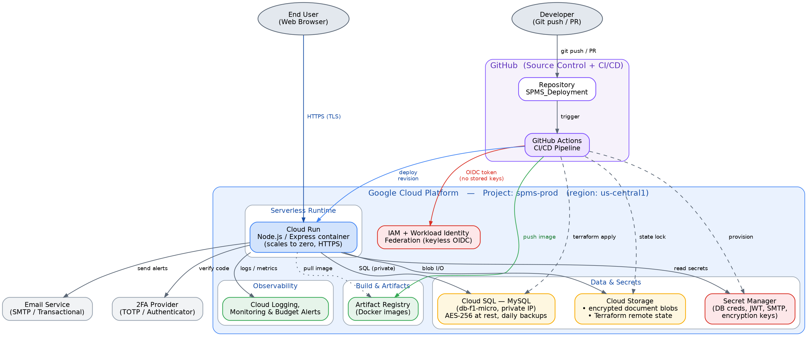
Figure 3.1: SecureVault GCP deployment architecture — resources, CI/CD path, and runtime connections.
On the deploy path, a developer pushes to GitHub, which triggers GitHub Actions. The pipeline authenticates to GCP without any stored keys using Workload Identity Federation, pushes the built image to Artifact Registry, runs Terraform to converge infrastructure, and deploys a new Cloud Run revision. On the runtime path, end users reach Cloud Run over HTTPS; the service reads secrets from Secret Manager, queries Cloud SQL over a private path, stores document blobs in Cloud Storage, and emits logs and metrics to Cloud Operations.

3.2 Component Responsibilities
Component | Responsibility | Key configuration
Cloud Run | Hosts the containerised Node.js/Express app; terminates HTTPS; auto-scales. | 1 vCPU / 512 MiB, min=0, max=2
Cloud SQL (MySQL) | Managed relational store for users, credentials, and audit data. | db-f1-micro, 10 GB SSD, private IP, MySQL 8.4
Cloud Storage | Encrypted document blobs and versioned Terraform state. | Two buckets, uniform access, versioning on state
Secret Manager | Central store for all runtime secrets, injected at start-up. | DB creds, JWT key, AES key, SMTP creds
Artifact Registry | Stores immutable Docker images tagged by git commit SHA. | Docker format, single regional repo
IAM + WIF | Identity for the pipeline and runtime; least-privilege roles. | Keyless OIDC federation, scoped SAs
VPC (Direct egress) | Private network path from Cloud Run to Cloud SQL. | Direct VPC egress (scales to zero)
Cloud Logging/Monitoring | Centralised logs, metrics, uptime checks, budget alerts. | Default sink + budget at $300

3.3 Runtime Request Flow
Figure 3.2 traces a single authenticated request end to end. The Google Front End terminates TLS and forwards the request to a Cloud Run instance, which fetches secrets on cold start, reads or writes the database, performs blob I/O when documents are involved, and calls external services for 2FA verification and alert e-mails before returning the response.
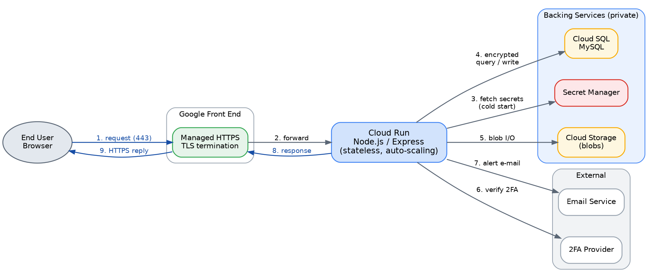
Figure 3.2: SecureVault runtime request flow — from browser through Cloud Run to backing and external services.

3.4 Network & Security Boundaries
- The database is never exposed publicly: Cloud SQL uses a private IP and is reached only over the VPC via Direct VPC egress.
- All client traffic is HTTPS only; the Google-managed certificate terminates at the Cloud Run front end.
- Secrets never live in source code or in the Docker image; they are read from Secret Manager at runtime under a dedicated service account.
- Pipeline and runtime each use their own least-privilege service account, so a compromise of one does not grant the other's access.
- The design preserves SecureVault's zero-knowledge posture: encryption is applied at the application layer and at rest, so the infrastructure never handles plaintext vault contents.

4. Provisioned Resources (Terraform)
Every resource below is declared in Terraform and created, updated, or destroyed through the pipeline. Nothing is clicked together by hand in the console, which keeps the environment reproducible and easy to tear down.

4.1 Resource Inventory
Resource | GCP service | Terraform resource | Tier / config
App service | Cloud Run | google_cloud_run_v2_service | 1 vCPU / 512 MiB, min 0 / max 2
MySQL instance | Cloud SQL | google_sql_database_instance | db-f1-micro, 10 GB SSD, private IP
Database & user | Cloud SQL | google_sql_database / _user | App schema and login
Image repository | Artifact Registry | google_artifact_registry_repository | Docker format, regional
State bucket | Cloud Storage | google_storage_bucket | Versioned, uniform access
Document bucket | Cloud Storage | google_storage_bucket | Standard, lifecycle rules
Secrets | Secret Manager | google_secret_manager_secret(_version) | ~6 secrets
Runtime identity | IAM | google_service_account | Least-privilege Cloud Run SA
Deployer + WIF | IAM | google_iam_workload_identity_pool(_provider) | Keyless CI/CD identity
Role bindings | IAM | google_project_iam_member | Scoped roles only
Private network | VPC | google_compute_network / _subnetwork | Direct VPC egress to Cloud SQL
Budget alert | Billing | google_billing_budget | $300 cap; 50/90/100% alerts

4.2 Terraform Project Structure
The Terraform code is split into small, single-purpose modules so that resources can be reasoned about and changed independently. A thin root configuration wires the modules together and selects the remote state backend.
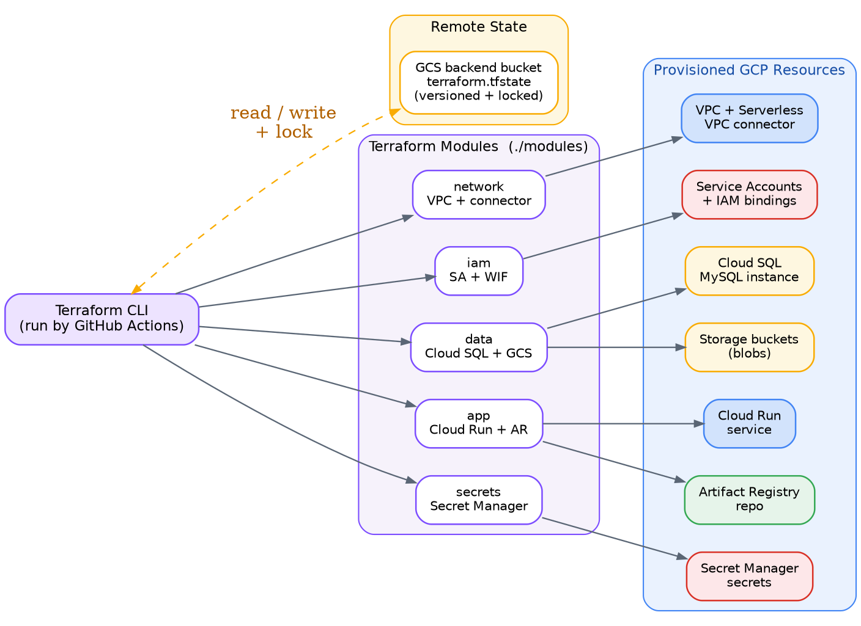
Figure 4.1: Terraform provisioning model — CLI, remote state, modules, and the GCP resources they create.
Repository layout:
SPMS_Deployment/
├── .github/workflows/
│ ├── ci.yml # lint, test, terraform plan on PRs
│ └── cd.yml # build, push, apply, deploy on main
├── app/ # Node.js / Express source + Dockerfile
├── terraform/
│ ├── main.tf # wires modules together
│ ├── variables.tf
│ ├── outputs.tf
│ ├── backend.tf # GCS remote state backend
│ └── modules/
│ ├── network/ # VPC + Direct VPC egress
│ ├── iam/ # service accounts + WIF
│ ├── data/ # Cloud SQL + Cloud Storage
│ ├── app/ # Cloud Run + Artifact Registry
│ └── secrets/ # Secret Manager
└── README.md

4.3 Remote State & Locking
Terraform state is stored in a dedicated, versioned Cloud Storage bucket rather than on a developer's laptop. The GCS backend provides built-in state locking, which prevents two pipeline runs from corrupting state by writing at the same time. Versioning on the bucket means any bad apply can be rolled back to a previous state file.

4.4 Cost-Aware Sizing
Several choices keep the environment small. Cloud Run runs with min-instances of zero so it costs nothing while idle; Direct VPC egress is used instead of a Serverless VPC connector so there is no always-on connector instance to pay for; Cloud SQL uses the shared-core db-f1-micro machine; and all resources sit in a single Tier-1 region so that data transfer between them is free.

5. CI/CD Pipeline (GitHub Actions)

5.1 Pipeline Overview
Two workflows drive delivery. A CI workflow runs on every pull request and must pass before code can merge; a CD workflow runs after a merge to main and carries the change through to a live Cloud Run revision. Figure 5.1 shows both lanes and the rollback path.
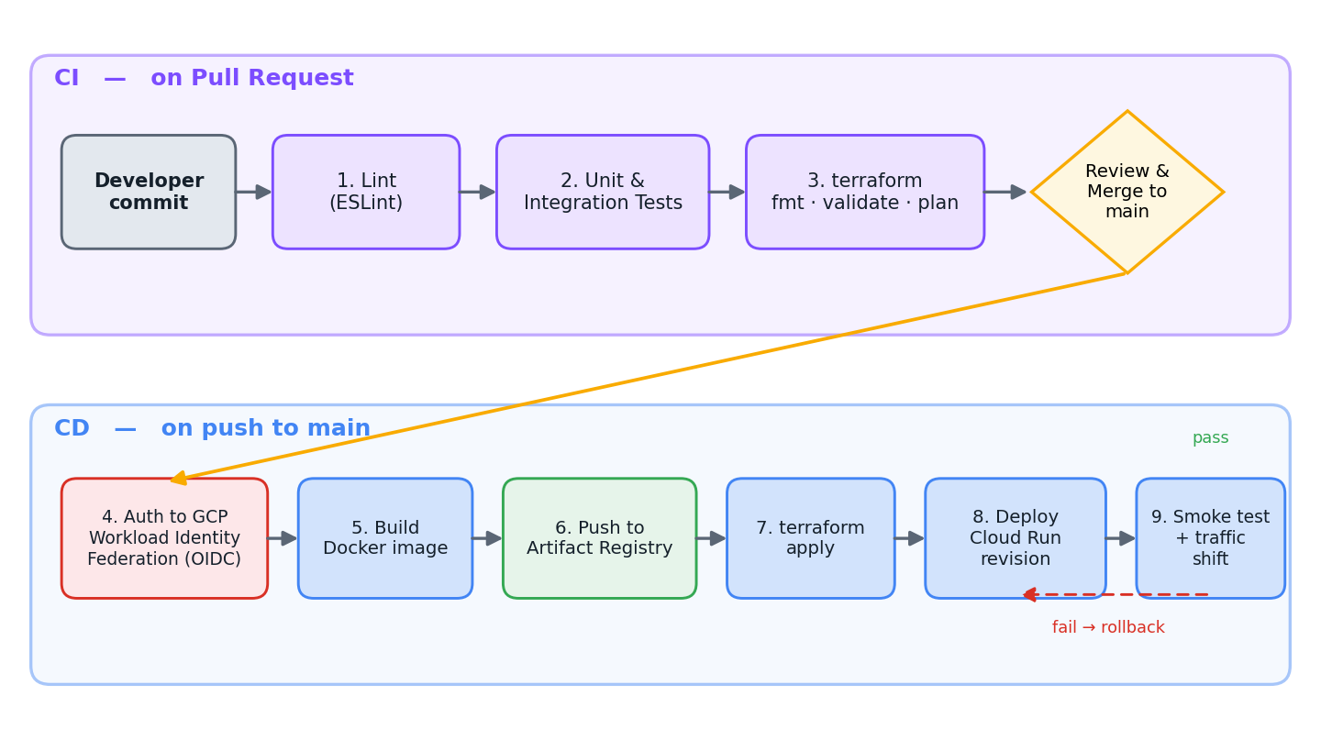
Figure 5.1: GitHub Actions CI/CD pipeline — validation on pull request, delivery on merge to main.

5.2 Pipeline Stages
Stage | Trigger | Action | Tooling
Lint | Pull request | Static analysis of application code. | ESLint
Test | Pull request | Run unit and integration tests. | Jest / npm test
Plan | Pull request | Format, validate, and preview infra changes. | terraform plan
Authenticate | Push to main | Exchange GitHub OIDC token for GCP access. | Workload Identity Fed.
Build | Push to main | Build Docker image tagged with commit SHA. | Docker buildx
Push | Push to main | Upload image to Artifact Registry. | gcloud / docker push
Apply | Push to main | Converge infrastructure to desired state. | terraform apply
Deploy | Push to main | Roll out a new Cloud Run revision. | gcloud run deploy
Verify | Push to main | Smoke-test the new revision, then shift traffic. | curl / gcloud

5.3 Deployment Strategy
Cloud Run is revision-based: each deploy creates a new immutable revision while the previous one remains intact. The pipeline deploys the new revision with no traffic, runs a smoke test against its direct URL, and only then shifts 100% of traffic to it. If the smoke test fails, traffic stays on the last good revision and the deploy is effectively a no-op — an instant, built-in rollback. Because images are tagged with the git commit SHA, every revision is traceable to an exact commit, and a rollback is simply re-pointing traffic at an earlier revision.
For the academic scope a single production environment is used. The same Terraform and workflows can stand up a separate staging project by changing one variable, should the team want a pre-production target later.

5.4 Keyless Authentication (Workload Identity Federation)
The pipeline never stores a service-account key. Instead, GitHub issues a short-lived OIDC token for each run; GCP's Workload Identity Federation trusts that token and lets the run impersonate a dedicated deployer service account for a few minutes. This removes the single most common CI/CD credential risk — a long-lived JSON key leaking from repository secrets. Only non-sensitive identifiers (project ID, the WIF provider resource name, and the deployer SA e-mail) are stored as GitHub Actions variables.
Illustrative authentication step in the CD workflow:
- name: Authenticate to Google Cloud (keyless)
uses: google-github-actions/auth@v2
with:
project_id: ${{ vars.GCP_PROJECT_ID }}
workload_identity_provider: ${{ vars.WIF_PROVIDER }}
service_account: ${{ vars.DEPLOYER_SA }}

- name: Deploy to Cloud Run
run: |
gcloud run deploy spms \
--image=$REGION-docker.pkg.dev/$PROJECT/spms/app:$GITHUB_SHA \
--region=$REGION --no-traffic --tag=candidate

6. Cost Analysis & Budget Management

6.1 Estimated Monthly Cost
The table below estimates steady-state monthly cost for low, demo-level traffic in the us-central1 (Tier-1) region. Figures are planning estimates, not quotes; actual spend depends on usage and should be confirmed with the GCP Pricing Calculator.
Resource | Configuration | Est. / month | Notes
Cloud Run | 1 vCPU/512 MiB, min=0, low traffic | $0 – 3 | Mostly inside free tier (2M req, 180k vCPU-s)
Cloud SQL (MySQL) | db-f1-micro, 10 GB SSD | $9 – 10 | Largest line item; shared-core, no SLA
Cloud Storage | < 5 GB standard + state | ~ $0.20 | Negligible at this scale
Artifact Registry | < 2 GB of images | ~ $0.10 | Near the free storage allotment
Secret Manager | ~6 secrets, low access | < $1 | $0.06 / active version + access
Networking egress | minimal; same-region free | $0 – 1 | 1 GiB North-America egress free
Logging & Monitoring | within free allotment | ~ $0 | First 50 GiB of logs free
Estimated total | — | ≈ $11 – 15 | ≈ $22 – 30 over two months
Headroom. At roughly $11–15 per month, two months of operation costs about $22–30 — under 10% of the $300 credit. The dominant cost is Cloud SQL, which can be stopped between work sessions to push spend lower still.

6.2 Cost Controls
- Scale to zero: Cloud Run min-instances=0 means no charge while the app is idle.
- No idle connector: Direct VPC egress avoids the always-on cost of a Serverless VPC connector.
- Stop Cloud SQL between sessions and start it only when developing or demoing.
- A Terraform-managed budget alerts the team at 50%, 90%, and 100% of the $300 credit.
- Single Tier-1 region keeps inter-service data transfer free and compute rates at their lowest.
- Bucket lifecycle rules expire old objects; one terraform destroy returns all spend to zero after grading.

7. Motivation & Rationale
Each major decision favoured the option that delivered the most managed capability for the least operational and financial overhead, given an academic timeline and a fixed credit.
Decision | Chosen option | Why (and what was set aside)
Cloud platform | Google Cloud Platform | Free-trial credit is available to the team; strong managed services and first-class Terraform support. AWS/Azure offered no credit here.
Compute | Cloud Run | Scales to zero, no cluster to operate, cheapest for bursty low traffic, and it runs our container directly. GKE was overkill and costly; a plain VM means manual ops and always-on cost.
Database | Cloud SQL for MySQL | Managed backups, patching, and encryption on a cheap shared-core tier. Self-managing MySQL on a VM adds an ops burden with no benefit at this scale.
Infra as Code | Terraform | Declarative, reproducible, and trivially destroyable; mature GCP provider and broad team familiarity. Hand-run gcloud scripts are not reproducible.
CI/CD | GitHub Actions | Code already lives on GitHub; tight pull-request integration and ample free minutes for this scope, with native OIDC support. Cloud Build would split tooling across platforms.
Pipeline auth | Workload Identity Federation | Eliminates long-lived service-account keys — the highest-risk CI/CD secret — in favour of short-lived OIDC tokens.

8. Points of Consideration

8.1 Secrets Hosting
All secrets live in Secret Manager and are referenced by the Cloud Run service at start-up under its own service account; they never appear in the repository, the Docker image, or environment files committed to git. The pipeline itself holds no secret key — it authenticates through Workload Identity Federation. Secrets can be rotated by adding a new secret version without redeploying code.

8.2 Security & Least Privilege
The database has no public IP and is reachable only through the VPC. The pipeline and the runtime use separate service accounts, each granted only the roles it needs. Public access to Cloud Run is restricted to the application's own endpoints over HTTPS. These boundaries reinforce SecureVault's zero-knowledge design, in which the platform stores only encrypted data.

8.3 Cost & Teardown
The budget alert and scale-to-zero defaults guard against runaway spend, and the whole environment is disposable: terraform destroy removes every resource in minutes, which is the safest way to protect the remaining credit once the project is graded.

8.4 Backups & Recovery
Cloud SQL is configured with automated daily backups and point-in-time recovery, so the database can be restored after an accidental change. The Terraform state bucket is versioned, allowing infrastructure state to be rolled back as well.

8.5 Region & Data Residency
us-central1 is chosen for its Tier-1 pricing and free-tier eligibility. If Canadian data residency becomes a requirement, the same Terraform can target northamerica-northeast1 (Montreal) by changing one variable, at a modestly higher rate.

8.6 Availability & Known Limits
The shared-core db-f1-micro instance is not covered by the Cloud SQL SLA, which is acceptable for an academic demo but would be upgraded for production. Cloud Run cold starts can add a brief delay on the first request after idle; setting min-instances to 1 during a live demonstration removes this at a small cost.

8.7 Risks & Mitigations
Risk | Mitigation
Free credit exhausted before term ends | Budget alerts at 50/90/100%; stop Cloud SQL when idle; teardown after grading.
Cold-start latency during a demo | Temporarily set Cloud Run min-instances=1 for the demo window.
Secret or key leakage | Secret Manager + Workload Identity Federation; no keys in repo or image.
Terraform state corruption | Versioned, locked GCS remote state; restore a previous version.
Configuration drift / bad change | terraform plan gate on every pull request before merge.
Accidental data loss | Automated Cloud SQL backups with point-in-time recovery.

9. Summary
This milestone defined a complete, cost-aware deployment design for SecureVault on Google Cloud Platform. The application is containerised and run on Cloud Run, backed by Cloud SQL for MySQL, Cloud Storage, and Secret Manager, with every resource declared in Terraform and shipped through a GitHub Actions pipeline that authenticates to GCP without stored keys.
The design keeps estimated spend near $22–30 over the two-month window — well inside the $300 credit — while preserving the security boundaries SecureVault requires: a private database, least-privilege identities, centralised secrets, and a fully reproducible, disposable environment. Together with the project plan and requirements analysis from earlier milestones, it provides a clear, defensible path from source commit to a running, secure system.

References
- Google Cloud. (2026). Cloud Run pricing. https://cloud.google.com/run/pricing
- Google Cloud. (2026). Cloud SQL pricing. https://cloud.google.com/sql/pricing
- Google Cloud. (2026). About instance settings — Cloud SQL for MySQL. https://cloud.google.com/sql/docs/mysql/instance-settings
- Google Cloud. (2026). Best practices for cost-optimized Cloud Run services. https://cloud.google.com/run/docs/tips/services-cost-optimization
- Google Cloud. (2026). Secret Manager documentation. https://cloud.google.com/secret-manager/docs
- Google Cloud. (2026). Workload Identity Federation. https://cloud.google.com/iam/docs/workload-identity-federation
- HashiCorp. (2026). Terraform — Google Cloud provider documentation. https://registry.terraform.io/providers/hashicorp/google/latest/docs
- GitHub. (2026). GitHub Actions documentation. https://docs.github.com/actions
- google-github-actions. (2026). auth — Authenticate to Google Cloud from GitHub Actions. https://github.com/google-github-actions/auth
- National Institute of Standards and Technology. (2020). SP 800-63B: Digital identity guidelines. https://pages.nist.gov/800-63-3/sp800-63b.html
- OWASP Foundation. (2025). Password storage cheat sheet. https://owasp.org

