Batter Up App Project 2B

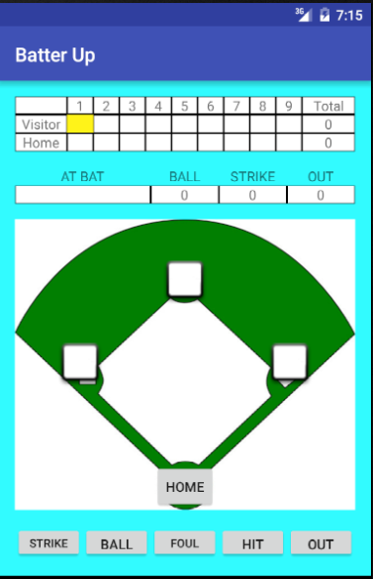

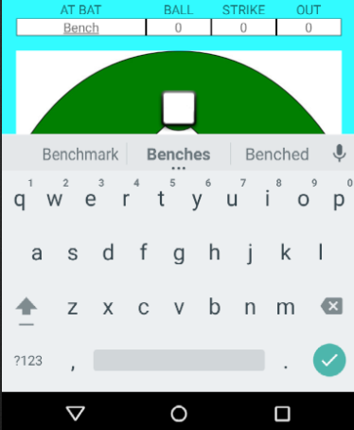

Batter Up is a baseball game tracking app. The top view is a table which tracks score and inning.

As each half is completed by reaching three outs the next half is highlighted yellow. Normally Home is up on top but I changed this to have Visitor first as the top of each inning is the visitors turn as they are up first.

The next view below is the ability to type in the players name or jersey number. If you tap the AT BAT text box it will bring up a keyboard to type in the number or name. Then hitting the back button will get rid of the keyboard

Next Column is the BALL count. This will track the times a ball is thrown. If this hits 4 the player walks and the counts are zeroed except OUTS. Strike count gets updated when the STRIKE button on the bottom is clicked. At three BALL and STRIKE are zeroed and OUT is updated by one. If OUT hits three all except AT BAT is zeroed and inning is moved by one. I should have zeroed the AT BAT. I thought it would be nice to have a list of batters that can be read from and update later as I learn more.

FOUL Ball button increases strike count if STRIKES are less than 2. If more then nothing is done.

HIT clears BALL, STRIKE and OUT but does not move runners as the application would not know the distance of the hit.

Bases one, two and three are check boxes that the user can select or deselect based on position of runners. HOME is a button that increases the inning score and adds to the Total for that team.