# **Task 1**

# The HTML page has an unordered list with id = "list", which consists of 5 elements. It is necessary to consistently display the content:

# 1) the first element of the list

# 2) the last item in the list

# 3) second element of the list

# 4) the fourth element of the list

# 5) the third element of the list

# Do the task in **2 different ways**.

# Example:

# • User1

# • User2

# • User3

# • User4

# • User5

# Output result: User1, User5, User2, User4, User3

# **Task 2**

For the page:

<body>

<h1>I'am a big header!!!</h1>

<div id="myDiv">

<p>First paragraph</p>

<p>Second paragraph</p>

<p>Third paragraph</p>

<p>Fourth paragraph</p>

</div>

<ul id="myList">

<li>Make</li>

<li>me</li>

<li>horizontal!</li>

</ul>

<span>Make me invisible, please!</span>

</body>

Write a script that uses DOM to style the page as shown below:

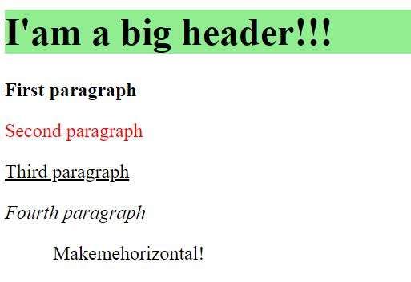

**Task 3**

Implement a program that displays

- the message "I was pressed!" when you click the button,

- displays the message "Mouse on me!" when you hover the button,

- displays the message "Mouse is not on me!" when you move the mouse cursor.

Example of work:

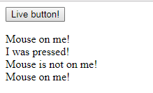

# **Task 4**

1. To complete the task, use the website developed in the 1st HTML/CSS topic of the course.

2. On the “Fans” page, add a function that will be called when adding a fan appeal.

3. When adding a fan appeal, the function must validate the entered data (fields must not be empty), add the date of publication and publish the appeal in the list of appeals on the current page. After successful publication - clear input fields without reloading the page.