**Analysis of my project**

**Problem identification**

For my project I will be making a turn-based RPG in python. It will have world traversal and a separate battle system, with dialogue being presented in the python shell as plain text and the user will input data using the keyboard. It will have a save system that will save the state of all of the variables into a separate database that will be called to when the program is next run, so all the positions of objects, state of characters etc are saved.

**Why should it be computerised?**

This is a problem that should be computerised as I believe it will offer a more engaging experience than if I were to make a card game, for example. It is easier to make a more engaging story and will entertain the user with a battle system to get them fully invested and always thinking ahead of their next move in order to obtain the best outcome possible. It will also be easier if it is computerised as I will need to make algorithms to calculate the amount of damage taken from each attack, which will be much quicker when it is computerised. My main features will be the battle system, which can be broken down into the individual commands for the party characters and enemies, and traversal of the world, which can be broken down into movement and scripted events. This will mean I am able to implement abstraction to break down the problem into smaller, more manageable parts. Some of these parts, such as the movement or the commands, can be separated into different procedures to make my code easier to debug as I can find exactly where the program goes wrong in my code.

Users can easily get frustrated with the overall system, causing them to potentially quit the game if the UI is difficult to navigate. My project will include a UI that is easy to navigate and is very self-explanatory, lessening any frustration that could occur from the user. Users will also need to be able to restart from the exact point they last saved after the code is rerun, so they don’t need to slog through the same areas to get back to where they were. The state of variables will be saved to a database to be retrieved when the program is re-run and you will have an option to delete this data to start the game again from the beginning. The game will run on 1 window, switching between traversal and battles when necessary. There will be no need for a budget to make this, as all of the resources that I require are already available to me.

**Stakeholders**

My main stakeholders are Sam Davis and Alex Morrison, as they are very interested in games, are a similar age to me and my target audience so what they and I would like for the game should be similar to that of the target audience, and they know what goes into an engaging RPG. The primary way they will make use of my solution is entertainment, and a good engaging story to get invested into. They are looking for a new RPG experience to get invested into, with some replayability in order for them to get the most out of this game as possible. They also want the game to challenge them mentally requiring them to come up with a good strategy to overcome the harder challenges. They require a game that has 2 main parts: traversal and battle. The battle system will be turn-based, suiting their needs, with a party of characters either being controlled by the player, or given a role by the player, allowing the character to control themselves with their own AI. They want the traversal to be top-down with a fixed camera. My game will provide them with sufficient challenge to make them always think about their next move, but not so hard that they need to grind levels for a long time to be able to win. The battle system will have a party of 4 characters, each coming into the team at different parts of the story, and the player will have the option of controlling each of them themselves or allowing the AI to take control of the characters that aren’t the main character. The story will also invest them with sidequests to flesh out the world to make it feel more alive, and that there are other things going on in the world than just what happens in the main story.

**Research**

My research methods are a questionnaire for my stakeholder and researching online into 3 existing turn-based RPGs: Final Fantasy VII, Pokemon Platinum and Persona 5. I am also interviewing my main stakeholder to see what they want in some of the more detailed features of the game.

I believe these are the best methods of research for making a game, as since there are already many turn-based RPGs on the market, I can look in-depth into some of them and try to extrapolate the best features out of them and try to improve upon them to make an overall better experience. For example, in Final Fantasy VII, traversal can be cumbersome and awkward, so I want to make it easier to see where it is you can go to make a more enjoyable experience for the player. A questionnaire is also a good research technique as it can give me a good idea for the sort of game that my stakeholder and my audience want, so I can tailor the game to their desires. These methods are better than something like observation as I can ask what the stakeholders really want for the game, instead of watching someone play a game and decide myself what I think should be implemented, as what I think should go into it may be different to what my stakeholders want. An interview is much better as I can see what the stakeholders want in the more detailed aspects like how random encounters are handled, or specifics in the battle system to make it more entertaining for them.

**Research into existing products**

Product 1- Final Fantasy VII

**Developer- SquareSoft**

**Publisher- JP: SquareSoft, WW: Sony Computer Entertainment**

**Platforms- Playstation, Windows, iOS, Playstation 4, Android, Nintendo Switch, Xbox One**

**Initial release date- 31 January 1997**

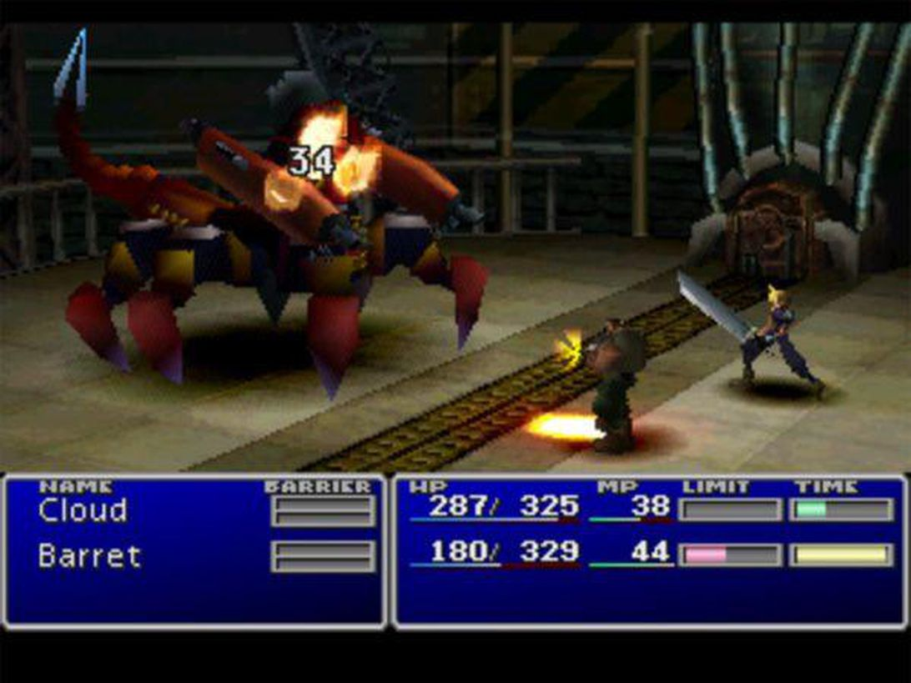

This picture shows part of the battle system in Final Fantasy VII. There is a bar that shows how much time each character has to wait to be able to attack again and, if the bar is full for more than one character, the player can choose which character will be the first to attack. The MP gauge is used up each time a magic attack is used, which can be equipped onto the characters’ weapons. If you don’t have enough MP for the next magic attack, the game will not allow the character to attack with magic. The ‘Limit’ gauge fills up a certain amount when the character attacks or is attacked. The amount it fills by depends on how much damage is taken. When the gauge is full, the character’s normal attack is replaced by a ‘limit break’, which is a much more powerful attack. You are able to run away from these battles, but it is advised that you defeat all the enemies, as doing so will gain you experience points so that you can level up and grow stronger. This battle system is a lot more engaging than many turn-based RPGs that allow you to take as much time as you want before each attack, since the enemies attack on a timer, you are forced to think on your feet and to stay engaged at all times in the battle. Otherwise the enemies will attack you before you are able to attack them or use any items. Certain enemies are weaker to certain magic attacks, so it is encouraged to try different attacks on different enemies to see what works. It is good to have certain enemies weak to certain types of attacks, to reward the player for experimenting with attacks in battle. I will make enemies that are weak to some attacks and that resist others, but I will also make enemies that have no weaknesses to offer a higher level of challenge to the player.

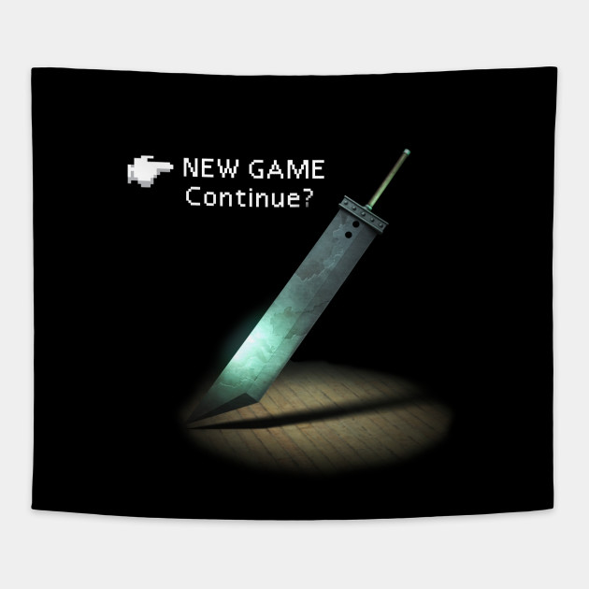

This picture is of the game’s main menu. It is very simple, only offering 2 options: New game, which allows the player to play the game for the very start, or continue, which allows the player to load a save file from the PS1 memory card. My main menu will also be very simple, as there won’t be any options for the player to change for the game, like difficulty.

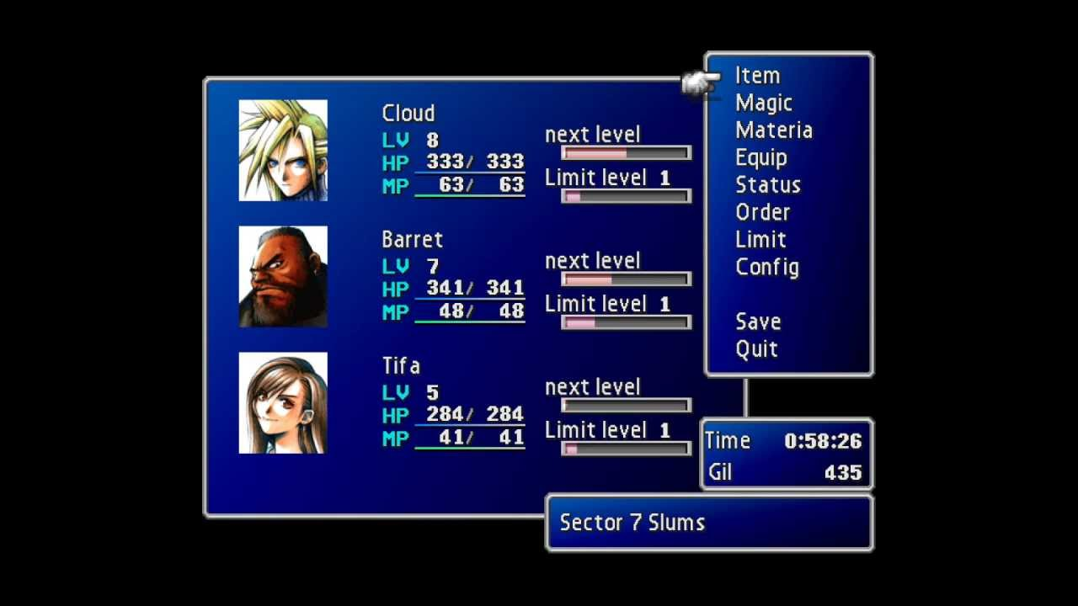

This picture is of the pause menu. The ‘item’ option allows you to use items such as potions the replenish the health of your party. The ‘magic’ option allows you to choose which type of magic attacks each character in your party can use. The ‘materia’ option allows you to equip stones (called materia) to each characters’ weapons to allow them to use magic attacks such as ice and fire. The ‘equip’ option allows you to equip weapons and armour for each character. The ‘order’ option allows you to change the order of your party and, as the maximum party size is 3, if there are more than 3 characters with you, you can switch characters in and out of your party. This pause menu also allows you to save your game onto a save file, and you can quit to the main menu. Gil is the currency in Final Fantasy VII, which you use to buy weapons, armour, items and materia. This menu, I believe, is quite useful as each option is relatively self-explanatory, making it very easy to quickly do what you need to and easily get back to the game.

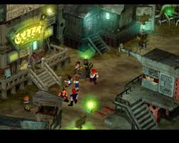

This picture shows how the player traverses the main towns. This picture shows one of the slums in the main city of Midgar. The world mainly consists of static backgrounds with the character models over the top. This method of traversal can be quite confusing in more cramped areas of the game as it can be hard to tell which parts are interactable and which are just walls. Random encounters with enemies will occur in most of these sections with enemies that will allow you to gain experience. I won’t be using this method of traversal in my game as I think it is too awkward to find your way, and I would need to draw every background as a static image which, with the time constraints, I will not be able to do.

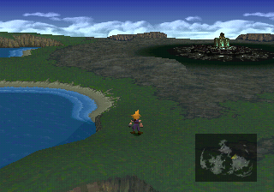

This picture shows the other method of traversal in Final Fantasy VII when you aren’t in any major towns and you are just traversing the world map. In this section, the player has control over the camera and can move all throughout the world. The map on the bottom right of the picture shows the character’s current position and any towns they are able to visit. Random encounters can occur in this area as well with different enemies to those in the major cities. This a much easier method of traversal than in the towns as you can easily see the places that you are allowed to go to, and you have full control over the camera, allowing you to easily go in all directions.

Product 2- Pokemon Platinum

**Developer- Game Freak**

**Publisher- Pokemon Company, Nintendo**

**Platforms- Nintendo DS**

**Initial release date- 13 September 2008**

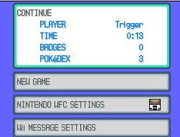

This picture shows the main menu of Pokemon Platinum, with options to continue playing the current save file from the last point you saved, a new game option to start the game from the beginning, and WiFi settings so that you could do things online such as receive ‘Mystery Gifts’ and battle/trade with others online. This menu is very concise and does exactly what it needs to, allowing the player to jump quickly into the game.

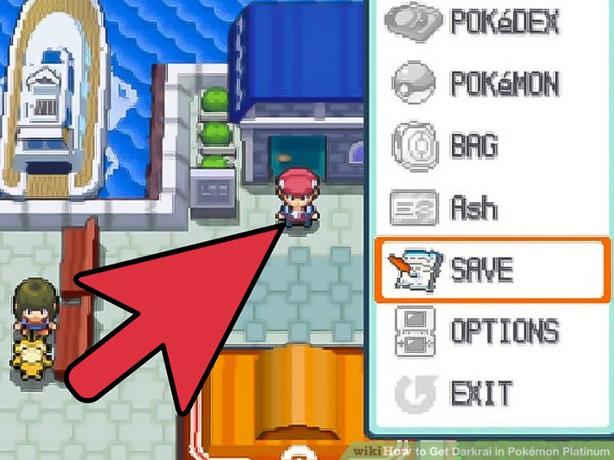

This picture shows the start menu that is activated in the main world when pressing the X button. This allows you to do things like checking the pokemon in your current party and switch who will come out first in the next battle in the ‘Pokemon’ option. You can also go into your ‘bag’ and use items that have different effects on the world or your pokemon like potions to heal your pokemon and repels to lure away wild pokemon. You can also view your ‘Pokedex’ to see how many species of pokemon that you have seen or caught. The ‘save’ option allows you to save your current progress to your save file. You can view your trainer card with the amount of money you currently have and your gym badges in the option labelled with your character’s name (in this case: Ash). The ‘Options’ menu allows you to change the game settings such as text speed. This menu is useful in the way that it is obvious which option leads to which menu, but it can be quite clunky and can take a while to do what you need to at times. For example, if all of your pokemon need healing, you cannot use a potion on each of them at once, you need to heal one, then select the potion again to heal the next and so on.

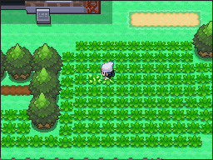

This picture shows a portion of the world traversal. At the moment the character is in tall grass, meaning that on each step of a new tile, there is a chance that a wild pokemon will attack and the player will be forced into a battle. The chance of encountering a pokemon depends on the area and time of day you are currently in. The entire game world is split up into separate tiles and one step from the player moves them one tile in the direction that is pressed. Sometimes the path is blocked by an obstacle such as a rock or a tree that will require an HM move to be taught to a pokemon in your party so they can remove it for you to proceed. This method of traversal is much easier than Final Fantasy VII as you can always see where you can go and where you can’t as it is blocked by a wall or an immovable object.

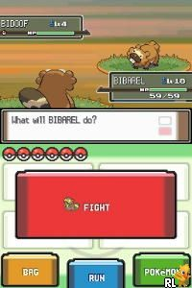

This picture shows the battle system for Pokemon Platinum, which utilizes both screens of the DS effectively. The top screen shows the health and level of the player’s and opponent’s pokemon, allowing the player to devise a strategy depending on the current state of each pokemon. The bottom screen shows all of the options the player can choose during the battle. The ‘fight’ option will bring you to a menu of a maximum of 4 moves that the pokemon can use to either attack the other pokemon or heal/buff themselves. The ‘run’ option can only be used in wild pokemon battles and will allow you to escape the battle but will give you no experience points. This cannot be used in trainer battles and will bring up a message saying that you cannot escape a trainer battle. The ‘bag’ option allows you to go into your bag and use any items that you have available, for example, to heal one of your pokemon. Pokeballs can be used to catch wild pokemon but cannot be used to steal pokemon from other trainers. The ‘Pokemon’ option allows the player to view the state of all pokemon in their party, all of their moves and a general summary of the pokemon. It allows the player to switch out the current pokemon they have in battle for another one in their party, for example, to gain the type advantage over the opponent. The touch screen is used very well in this game, as it is much quicker than in other pokemon games to select the options you want.

Each pokemon and move that a pokemon can learn has a certain type (a pokemon can have a maximum of 2 types) and, most of the time, is ‘super effective’ against other types, meaning it will do 2x damage against that type. If a move is super effective against both of a pokemon’s types (e.g. a fire type move being used against a pokemon that is bug and steel type) it will do 4x damage. This, in my opinion, is a very good battle system as it rewards the player for learning the type combinations and for having a well-balanced team with many different types. Unlike in Final Fantasy VII, you have as much time as you want to decide what you want to do in the next turn, meaning you can think of a good strategy without any time pressure so you don’t always need to be thinking on your feet. However, if you are not over-levelled, the game can still be very challenging in places, causing you to need to think very carefully about what you need to do next in order to win the battle.

Product 3- Persona 5

**Developer- P-Studio**

**Publishers- JP: Atlus, NA: Atlus USA, PAL: Deep Silver**

**Platform- Playstation 4, Playstation 3**

**Initial release date- 15 September 2016**

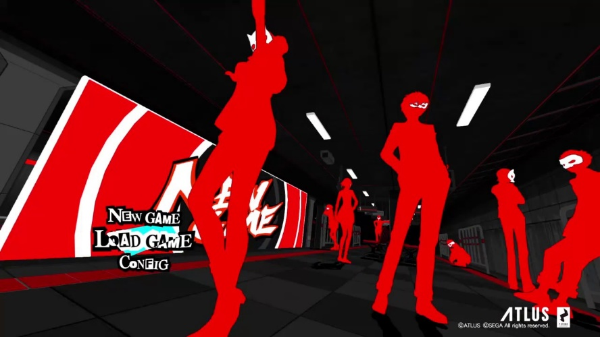

This picture shows the main menu for Persona 5. If you choose ‘New Game’, the game will begin from the start but all save files you already own will stay. If you choose ‘Load Game’, you can choose one of a maximum of 16 save files, and start the game from where you last saved to that file. The ‘Config’ option allows you to change the game’s settings, such as the difficulty of the game and the language.

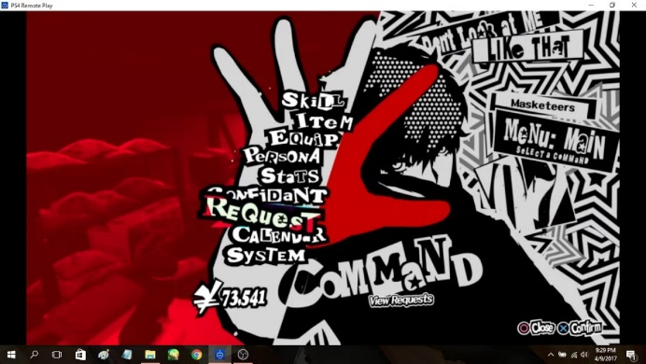

This picture shows the pause menu in Persona 5. The ‘Skill’ option is only available inside the Metaverse (see later picture) and allows you to use healing spells with a Persona from one of your party members if they have a healing spell. The spell will cost a certain amount of SP, depending on how powerful the spell is. You can also use items to heal your party’s HP or SP. You can also use items in battle to buff your party or de-buff your enemies. The main character can hold multiple personas at once, and the ‘Persona’ option allows you to view these personas and choose which one will be equipped at the start of the next battle. The ‘Stats’ option allows you to view the levels and general stats of your party members, along with their personas. The ‘Confidant’ option allows you to view the ‘contracts’ you have made with characters throughout the story and see how far along their storyline you are. (see later picture). You can view the requests you have received from the general public to reform people by going into Mementos and defeating their ‘shadow’. The game takes place over the course of around a year and you can view the calandar to plan your days ahead of time, as most things in the game have a deadline.

This menu is very stylised but it is easy to navigate so it works very well.

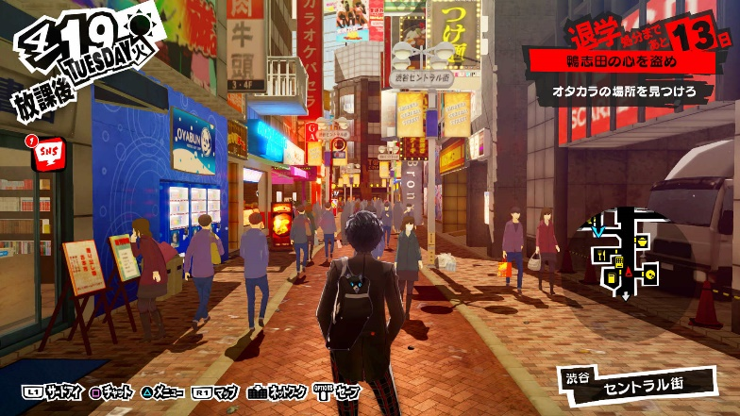

This picture shows one of the main cities in Persona 5: Shibuya. In these cities, you can sometimes meet with your confidants to progress through their storyline. If you choose to meet with a confidant, time will pass, and it will be the evening after you have met with them. You usually only have 2 timeslots per day if no story cutscenes happen in that day. This is why you need to plan your day ahead, as you cannot go back and redo any days. In these cities, there are also many shops where you can spend money on items for the Metaverse or buy things to increase your social stats.

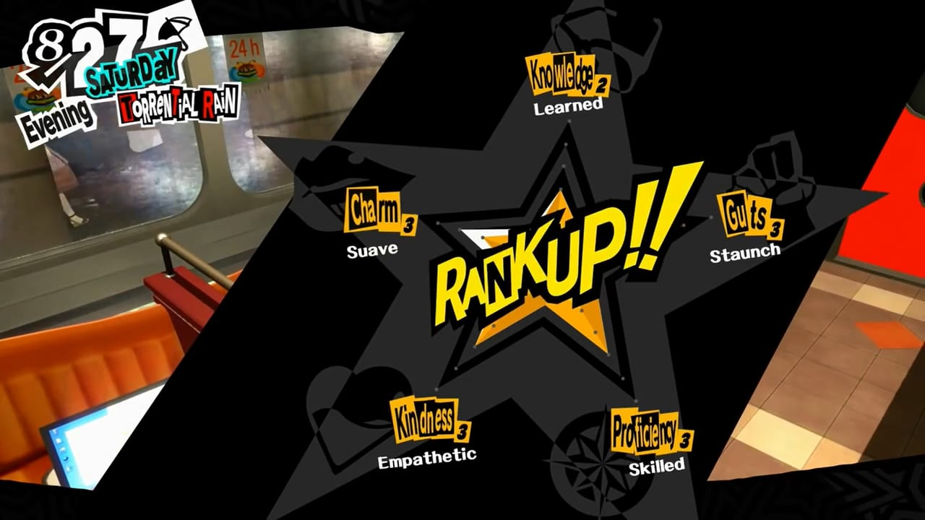

This picture shows the social stats that you can upgrade during your playthrough. At some point, during most of your confidant storylines, you need to have a certain social stat at a high enough level in order to trigger something to progress with your confidant. For example, to progress past level 6 confidant ranking with Makoto Niijima, you need charm level 5. This mechanic forces the player to balance ranking up confidants and ranking up social stats, to get the most out of the playthrough. You need a certain amount of points to rank up one of your stats. Each stat needs a different amount of points to rank up, knowledge needing the most as it is the easiest to get points for.

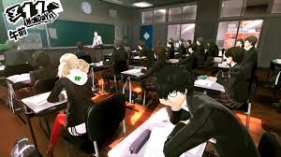

This picture shows the school segments in Persona 5. These segments happen most days (other than Sundays and holidays) and, some of the time, you get asked multiple choice questions by your teacher. If you get this question right, you get a point in your knowledge stat. Most of the time, though, you get text messages from your friends about the current situation in the main story during these segments.

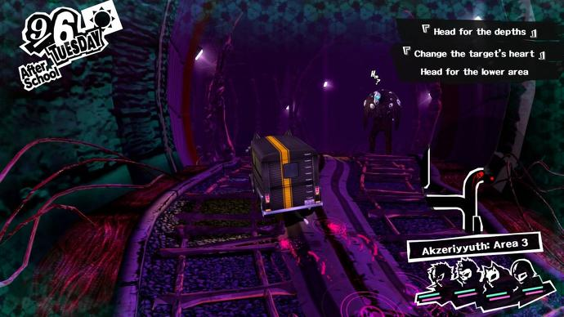

This picture shows the group traversing through Mementos, dubbed as ‘the public’s palace’ throughout the game. This area has many floors, all of which are procedurally generated and the enemies, named shadows, get harder the lower down through Mementos you go. This is a place that is often used for levelling up your party, and you go here to cause a change of heart in the general public if you get a request from someone on your ‘Phan-site’, run by a character called Mishima. You can go to this place any time, after a certain point in the story, but once you leave, it will be the evening and you won’t be able to do anything in that time slot, as you will be too tired.

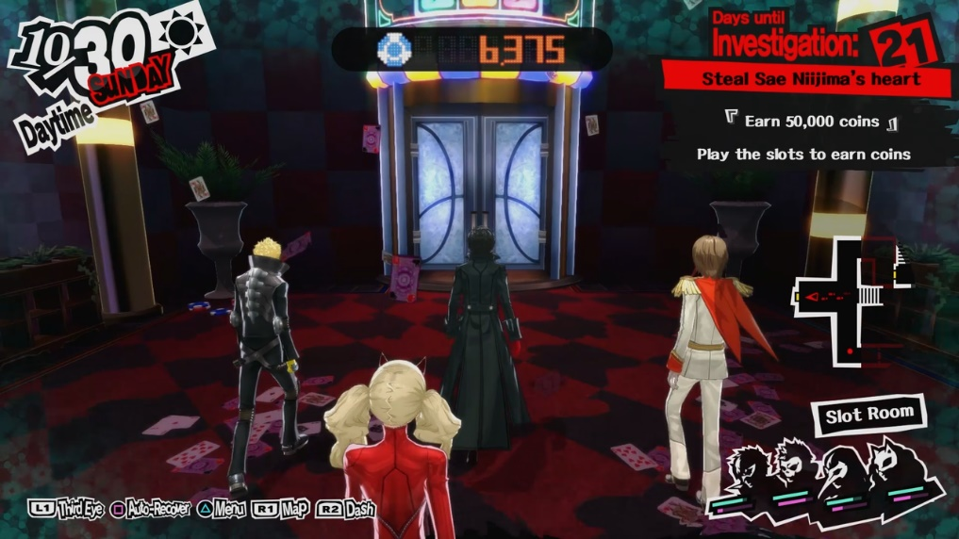

This picture shows one of the main dungeons in the game, dubbed ‘Palaces’. These palaces, unlike Mementos, are not procedurally generated. The shadows will always be around the same places, but the enemies that will show up in the battle are random to a certain degree. Like when you go to Mementos, once you leave the palace, it will be the evening and you will be unable to do anything in that timeslot. Each palace has a certain deadline to finish it by and, if you don’t finish it by the deadline, you will get a game over and have to restart a week back from the deadline. Each palace has a different theme, the one in the picture is a casino and all of the palaces are based on the ruler’s cognition of how they think of the place in the real world. For example, the first palace is based off one of the teacher’s cognition of the school, and he views it as a castle and views himself as the king of the castle.

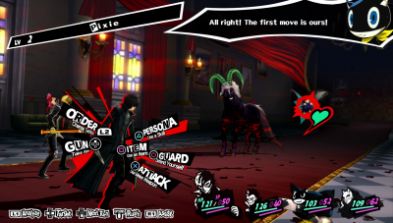

This picture shows one of the battles you encounter in the game. If you sneak up on the enemy and start the battle without them seeing you, you will get an ‘ambush’ and all of you party will be able to attack before any of the opponents. The picture shows all of the different attacks each person in your party can use, and the button that corresponds to each attack. When you use your persona skills, the enemy may be weak to that type of attack, and they will be knocked down. If you knock down an enemy, you will get a ‘1 more’ meaning you can attack again with the same character. If all of the opponents are knocked down in one turn, you can hold them up to either negotiate with them, or perform an ‘all out attack’ which does large amounts of damage to all of the enemies. If you negotiate with them, you can ask for money or items, or you can have a conversation with one of them to try and convince them to join you as a persona. This battle system is the most fluid of the 3 games I have researched as you can instantly use one of the attacks at your disposal instead of having to scroll through a menu to find the command you want to use.

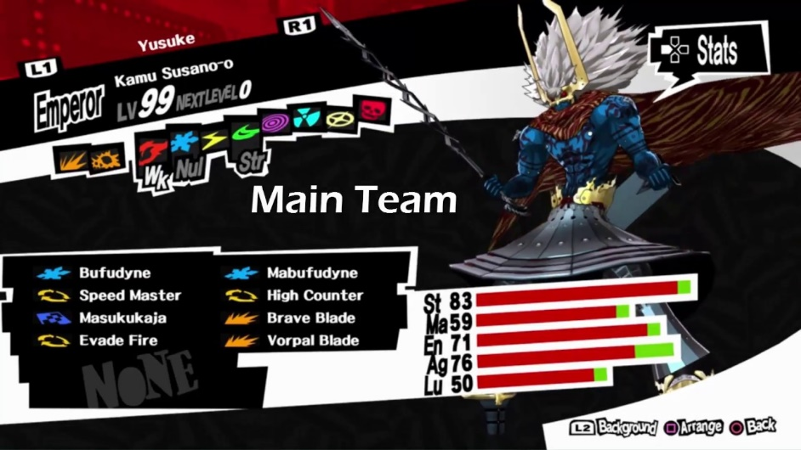

This picture shows the stats and attacks of one of the personas. In this case, the types of attack at the top show that this persona is weak to fire, resistant to wind and immune to ice. Other effects can be ‘drain’, meaning the attack will heal them instead of attack them, and ‘repel’ reflects the attack back at the user. Each persona can have a maximum of 8 attacks and gain more as they level up. If it tries to learn an attack after already having 8, it will ask you to delete one or not learn this attack. Every persona will learn different attacks, have different stats and will receive different effects when attacked with certain skills.

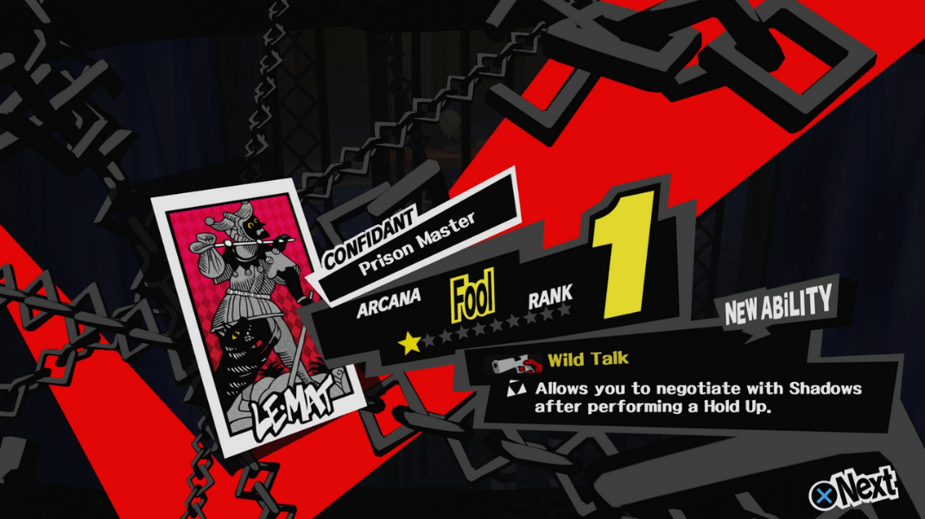

This picture shows one of the confidant progression lines, each represented by one of the tarot cards. As each confidant levels up, if you fuse a persona in the Velvet Room, the resulting persona will gain extra experience points depending on the level of the corresponding confidant, as each persona is also represented by a tarot card. Most of the time when a confidant levels up, you will also get some sort of upgrade that will help you when you infiltrate palaces. For example, as you level up your confidant with Mishima, your party will gain more experience in battle, allowing them to level up quicker. Levelling up your confidants is crucial to having a chance in battle in later areas in the game, so you need to plan who you need to spend time with to get the most desired effects.

**Essential features**

I feel that one of the most essential features of my game will be the save system. I want the player to be able to save at any time outside of battle and dialogue, like in Pokemon Platinum and Persona 5 when out of the metaverse. This is an issue in Final Fantasy VII as there are designated save points and you can only save the game at those points, and they can be quite spread out, which can lead to a lot of frustration, especially if the game crashes.

Another essential feature for my game and most RPGs is sidequests. These often give more depth to the overall story and characters in the game, giving the player an overall better experience. For example, in Persona 5, you can spend time with many different characters, each with their own story, enriching the experience for the player. Without the sidequests, the game will be a very bare-bones experience and it will be much harder to flesh out the world.

The most essential features are story and the battle system. An engaging story is crucial to keeping the player interested in the world to carry on playing. The battle system is also crucial as that is what you will be doing for most of the game, so you need to be able to enjoy it to be able to carry on playing. It will need to have a party system, with the player being able to choose whether or not they control the rest of the party along with their own character, or if they will pick commands automatically. This adds extra depth to the game as the player will need to think about more than just their own character, so they need to think hard about their strategy in harder fights to keep all of their party members healthy. Different enemies will need to have different weaknesses and resistances, as well as the different characters in your party. The player and party characters will need to gain EXP from winning battles, or choose to run away but will not gain any EXP. Also, if they win the battle, there is a chance for them to get money and items as a reward as well as EXP. The EXP will cause them to level up over time, and they will gain more EXP from boss fights than anything else. Pokemon Platinum has a relatively basic story when compared to other RPGs, as it is mainly geared towards children, but Persona 5 and Final Fantasy VII have a constantly engaging story and, in Persona 5, there are plot twists around every corner to keep the player guessing, and wanting to carry on to see how the story progresses. Without a good story, the player may get bored with the game, as the story is normally one of the main appeals of an RPG, and they may stop playing without finishing it.

**Questionnaire**

1. Should there be separate difficulties to make the game more accessible to new players?
2. Should there be references to other media? If so, what sort of references should they be?
3. Should there be optional content such as bosses to reward extra exploration?
4. Should the battle system be based on a party of characters, or just one with multiple abilities?
5. What is more important, the battle system or ease of exploration?
6. Should there be random encounters or enemies that you can try and avoid or attack?
7. Should the game be sprite-based or hand-drawn?
8. Should there be multiple endings with a different final boss, or just one ending?
9. What could there be to make the game more replayable?
10. Should there be a main ‘hub world’ to go back to?

**Stakeholder answers (Sam Davis)**

1. No
2. Yes: Hidden references
3. Yes
4. Party
5. Battle system
6. Enemies that you can choose to avoid or attack
7. Sprite-based
8. Multiple endings
9. NG+ with new bosses/enemies
10. There should be a hub world

**Stakeholder answers (Alex Morrison)**

1. No
2. Hidden references
3. Yes
4. Party
5. Exploration
6. Random encounters
7. Sprite-based
8. One ending
9. NG+ with more sidequests
10. There should be a hub world

**Interview**

Q: What sort of save system do you require?

A: You should be able to save through the menu at any time in the game. You should be able to restart the game from the exact position that you saved at before.

Q: How should the battle system work?

A: The fastest character should go first but can choose whether or not the rest of your party is controlled by the player, or if it will be automatic. Each type of character should have different weaknesses and resistances, and if a character uses an attack of the same type as them, they get an attack bonus (like STAB in Pokemon). Characters will be able to learn new moves by level up, or by finding items in the world, if that move is compatible with the character. There should be items to increase basic stats like defence or attack or can find items that give you a benefit in battle, but with a drawback as well, like increasing speed but decreasing defence. Some moves should also inflict status effects, such as stun making them unable to attack for the next turn. These can be moves or items.

Q: What optional content should I add to the game?

A: Extra items to find off the beaten path, and if you find enough, you can open up a new area, should be more difficult than main game areas.

**Summary of research**

My project is a turn-based RPG made in Python using Pygame, inspired by the likes of Final Fantasy VII, Pokemon Platinum and Persona 5. I researched into these 3 games as part of my research into existing products. Final Fantasy VII and Persona 5 showed a battle system with a party of characters, each with different specialist abilities. Pokemon Platinum differed with this as it showed a battle system that only utilizes 1 character at a time, making it an easier system to understand for younger consumers, as they don’t need to worry about the state of more than 1 party member at a time. A Pokemon style battle system will be easier to code but I feel a party battle system will be more complex and fun to code, as well as being more entertaining to play for a more experienced player.

The 3 games that I researched also presented differing traversal systems. Final Fantasy VII shows the models traversing a static background which can be very awkward to traverse, as it can be hard to tell which surfaces are interactable and which are just walls. The traversal system is much better in Pokemon Platinum as it is tile-based, and it is much easier to see what is interactable, making it less of a pain to get where you need to go. Persona 5 differs greatly to both of these as it has free traversal, so it is not tile-based, and you have a map to show where you can go.

My questionnaire with my stakeholders, for the most part, gave similar results to each other. They both believe there should be one fixed difficulty, as is the case for the vast majority of turn-based RPGs, as you can make the game a lot easier if you put in the time to grind levels and become ‘over-levelled’. They both believe there should be optional content to reward the player’s curiosity and exploration. They both believe that a party battle system is the better way to go as it is more complex and deepens the battle system. They offered differing opinions in how the player will encounter enemies: Sam said the enemies should be preset and you can choose to attack or avoid them, and Alex said that random encounters are better. I have decided on using random encounters, so I don’t need to make individual enemies as separate objects in the world, making it simpler to code. They both believe it should be sprite-based, which I agree with as it will look much better than if it was hand-drawn. They offer differing opinions on whether or not there should be multiple endings: Sam said there should, Alex said there shouldn’t. I am going to try and make multiple endings with different final bosses for each depending on how well you have done throughout the game. They both believe there should be a New Game + (NG+) to offer more replayability to the game, with new bosses/enemies and new sidequests. Finally, they both believe there should be a main ‘hub world’ to go back to for some reprieve and to be able to buy items, for example.

I feel this should be computerised as it will create a more engaging experience than something like a board game or card game. I will also need to create algorithms for damage taken and given for certain enemies and levels of characters and they will be much easier to incorporate in a program as the calculations are done in an instant.

**Limitations of my Product**

Given the time constraints of this project, and the limitations of Pygame, I will not be able to make a game that looks as good as the games I have researched and will not be able to implement any 3D elements, but as it is going to be sprite-based, like Pokemon Platinum but fully 2D, I think I will still be able to make it aesthetically pleasing to the user. I will not be able to implement something to do when you aren’t travelling on a quest, like in Persona 5 when, outside of the metaverse, you have a sort of life simulator. There will be the main story, sidequests and interactions with characters within and outside your party, but nothing on quite the scale of Persona 5 when living as a student. There also will not be time constraints within the game, you will be able to do sidequests while something is going on in the main story, if you come across them. I will not be able to implement this game on anything other than a computer as that would require a development kit and license to develop for a console, which would be very costly and, since I have no budget, I cannot buy extra tools and equipment. Also, I will only be using a keyboard to control the game, as there will be limited commands for the player to input so they won’t need a controller to be able to control it effectively, and it will be simpler to code for the keyboard on my laptop. I will only be able to output dialogue on the Python shell as having to output text on the game window along with other animations will be a lot harder and will make the program less efficient. The game will only be able to run on my laptop as all of the sprites for the game will be saved on it, so the program needs to call from my laptop’s files to use them, and the program needs a Python interpreter and the Pygame library downloaded in order to run.

**Proposed Solution**

The game should be displayed in 1 window, switching between battles and traversal when necessary. This is because displaying 2 windows is very difficult in Pygame and requires a lot of hassle, so it will be much easier to just switch between the 2 main parts of the game using the same window. The Python shell will be used for displaying dialogue, so animations can be displayed fully on the game window without covering anything up, and there is then a designated place specifically for dialogue. The player will have a party of characters for battles, but only the main character will be displayed when traversing the world to avoid cluttering the screen with too many sprites. During battles, each character will take a turn with the person or enemy with the highest speed stat going first and so on. The player will be able to control the actions of each of the party members, giving them full control over each battle so they can plan their attack more efficiently, or they can leave the AI to choose the other characters’ attacks, making the player have to improvise after each turn as they won’t know what each character will do. If the player wins the battle, they will be rewarded with EXP which will lead to levelling up, and they have a chance of getting items and money after each battle. They can also run away from the battle, but they will gain no EXP from it if no enemies are beaten.

The game will have random encounters with enemies and there will be 5 bosses to fight through the story, with 2 being optional to reward exploration. Once you have entered a boss fight, it becomes a scripted event, so you will not be able to run away from the battle.

The method of input will be the keyboard, with the arrow keys being used to move throughout the world, and certain keys being used for each character and attack during battles, being explained in a separate text file.

The text file will explain the controls and mechanics of the game, allowing the player to jump right into the game after reading, eliminating the need for a tutorial section.

There will be a GUI menu that the player can navigate using the arrow keys and the enter key, to choose whether they want to start a new game or continue from a previous save. Once the game is completed for one save file, that file will then have access to NG+, with harder enemies, new sidequests and a new boss, adding to the replayability of the game. The player will also be able to keep all of the equipment and money that they finished the game with before starting NG+. You can enter into NG+ by just hitting continue on the main menu with a finished save file.

The game will be sprite-based, with all of the sprites being created in Piskel online, because it is easy to make sprites and animations with, and it is free since I have no budget. I will make all of the character sprites, NPCs, enemies/bosses and backgrounds/terrain in Piskel.

My game will only be able to work on this laptop, unless all of the sprites are copied to a separate computer that it needs to run on and can be accessed properly by the program. The computer will also need to have the Python interpreter and to have Pygame installed onto it to be able to run the game.

**Success Criteria**

1. Create all character and background sprites to be implemented into the game for the character to traverse the world while always being able to see where they can go. Each sprite for characters will be unique, and each area will be unique.
2. Create a battle system to be used on the same window with random encounters.
   * There will be a random number between 1 and 3 of enemies in each battle and the types of enemies will depend on the area the player is currently in.
   * Enemies will be weak to certain attacks and resistant to others, but some enemies will not be weak to any attacks.
   * There will be 4 people in your party that the player can control. The characters will be able to have their own spells to either attack enemies, buff allies or de-buff enemies.
   * There will also be consumable items that have similar effects but will not use SP.
3. There will be optional content to reward the player for exploring well, like an optional area based on Bloodborne with a boss fight and good opportunities to gain experience and items.
4. Create multiple endings based on whether or not the player gained the necessary items throughout their playthrough to encounter the true final boss.
5. Create 2 sidequests in each area for the player to get invested into, if they want a break from the main story to do new things with interesting characters, fleshing out the world more and making each area have more life to it.
6. Create a NG+ feature to add to the replayability of the game, making enemy and boss encounters harder, but the player keeps the equipment that they built up over the course of the previous playthrough. It will also have new bosses to encounter and 2 extra sidequests to incentivise the player to do another playthrough, keeping the player interested in the game for longer.
7. Create a save system that stores the state of all variables into a separate text file to be called to when the program is re-run to save the state of those variables back into the program, so the player can start exactly back from when they saved, unless they choose to start a new game, in which case, the values called will be the default values for each variable.
8. There will be 4 different areas for the player to explore throughout the story, 1 being optional, with 2 exclusive enemies for each area, and some that appear in multiple areas.
9. The game will have a balanced difficulty, so it won’t be too easy to plough through, but it won’t be so hard that it is impossible to get through without grinding levels for hours.
10. The program needs to be efficient, taking up as little space as possible, with no load times as the world will be fully interconnected to keep the player as immersed as possible.
11. My project will be finished by the 14th February 2020.