EMPIRICAL RESEARCH REPORT: AIRLINE PROFITABILITY & HEDGING MECHANICS

1. Empirical Dataset & Descriptive Properties
The empirical evaluation is based on a balanced quarterly panel dataset from 2020 to 2024 (N = 40 observations) tracking two primary European airline archetypes: Ryanair Holdings plc (Low-Cost Carrier) and Deutsche Lufthansa AG (Full-Service Network Carrier). Table 1 illustrates a representative cross-section of the structured data.
Airline | Quarter | EBITDA Margin | PLF | Hedge | ln(Fuel) | EUR/USD | COVID | WAR
Ryanair | 2020 Q1 | -0.063 | 0.950 | 0.900 | 0.344 | 1.102 | 0 | 0
Ryanair | 2020 Q2 | -0.428 | 0.610 | 0.370 | -0.277 | 1.102 | 1 | 0
Ryanair | 2020 Q3 | 0.165 | 0.720 | 0.370 | 0.065 | 1.170 | 1 | 0
... | ... | ... | ... | ... | ... | ... | ... | ...
Lufthansa | 2024 Q2 | 0.126 | 0.822 | 0.840 | 0.900 | 1.077 | 0 | 1
Lufthansa | 2024 Q3 | 0.180 | 0.872 | 0.820 | 0.785 | 1.099 | 0 | 1
Lufthansa | 2024 Q4 | 0.113 | 0.822 | 0.830 | 0.731 | 1.067 | 0 | 1

Table 2 summarizes the distribution properties across the pooled panel sample (N = 40). Noticeable negative skewness (-2.795) and leptokurtic kurtosis (11.281) in EBITDA margins reflect the unprecedented demand destruction during the 2020 lockdown periods.
Variable | N | Mean | Std. Dev. | Min | Median | Max | Skewness | Kurtosis
EBITDA Margin | 40 | -0.016 | 0.358 | -1.678 | 0.100 | 0.410 | -2.795 | 11.281
ln(JetFuel) | 40 | 0.744 | 0.418 | -0.277 | 0.802 | 1.381 | -0.814 | 0.159
Hedge Ratio | 40 | 0.699 | 0.170 | 0.360 | 0.745 | 0.940 | -0.835 | -0.375
PLF (Load Factor) | 40 | 0.787 | 0.147 | 0.430 | 0.820 | 0.960 | -0.875 | 0.009
EUR/USD | 40 | 1.108 | 0.056 | 1.007 | 1.094 | 1.205 | 0.307 | -0.662

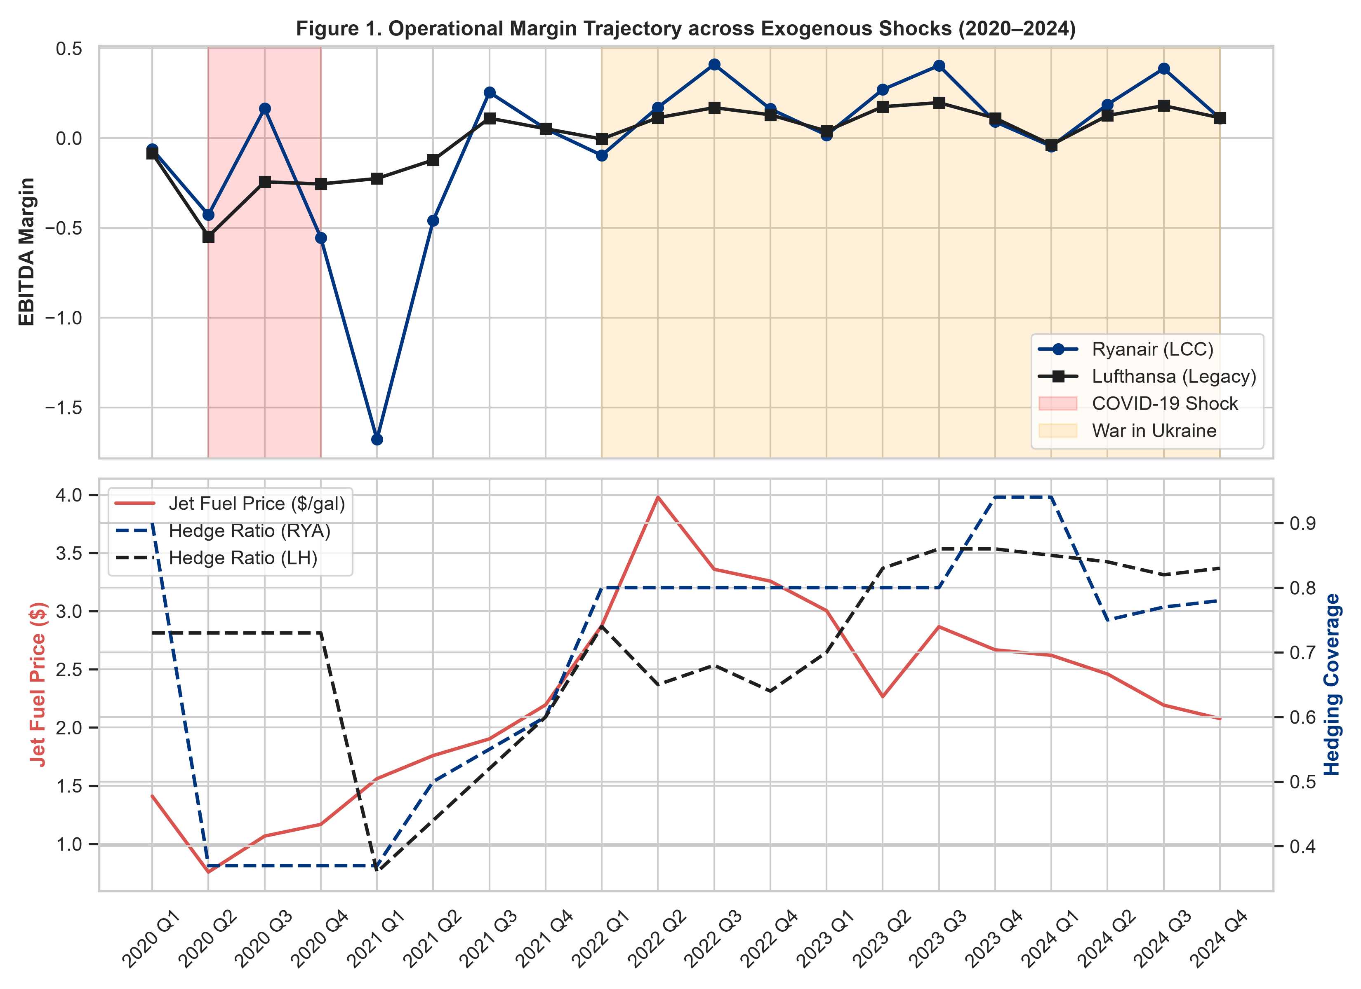
Figure 1. Time-series dynamics of operating margins alongside spot fuel prices and hedge ratios.

2. Econometric Model Estimation & Hypothesis Testing
Coefficients were estimated via Ordinary Least Squares (OLS) employing White's heteroskedasticity-consistent covariance matrix (HC1) to protect standard errors against residual non-homogeneity. Estimation metrics are detailed in Table 3.
Regressor | Coefficient (Beta) | Std. Error (HC1) | t-statistic | p-value
Intercept (const) | -0.6276 | 1.144 | -0.549 | 0.587
ln_JetFuel | -0.5351 | 0.239 | -2.239 | 0.032**
Hedge | -0.4079 | 0.403 | -1.012 | 0.319
lnJet_x_Hedge (Interaction) | 0.6328 | 0.286 | 2.213 | 0.034**
PLF (Load Factor) | 0.4485 | 0.518 | 0.866 | 0.393
EUR_USD | 0.6247 | 0.940 | 0.665 | 0.511
D_COVID | -0.5368 | 0.128 | -4.194 | 0.000***
D_WAR | -0.0245 | 0.088 | -0.278 | 0.783
D_RYA (Ryanair) | -0.0379 | 0.063 | -0.602 | 0.551

Model Diagnostics: R² = 0.487; Adjusted R² = 0.354; F(8, 31) = 3.414 (p = 0.0063); N = 40. Significance marks: *** p < 0.01; ** p < 0.05. The positive interaction parameter (beta = +0.6328, p = 0.034) provides empirical proof that a structured fuel hedging strategy serves as a significant buffer against global kerosene spot price volatility.
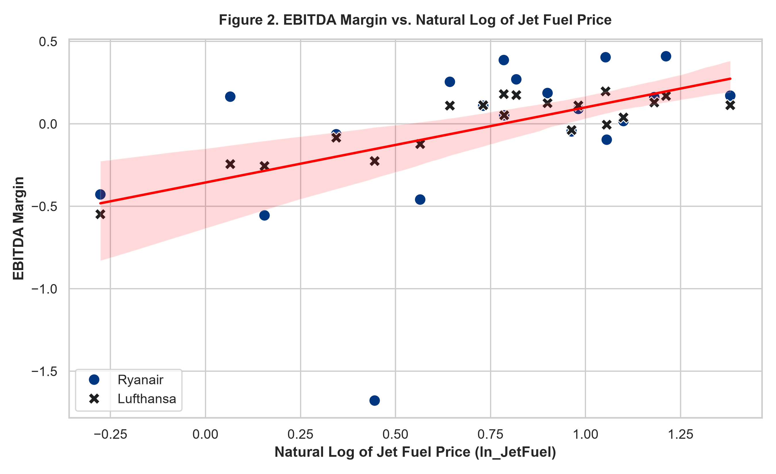
Figure 2. Linear OLS trajectory relative to empirical coordinate space.

Specification and Residual Diagnostics:
Diagnostic Evaluation | Test Metric | Statistical Conclusion
Breusch-Pagan Test | p = 0.0113 | Homoskedasticity rejected; validates HC1 covariance use
Durbin-Watson Test | DW = 1.737 | No severe 1st-order autocorrelation detected (DW ≈ 2)
Joint F-Test | F = 3.414 (p = 0.0063) | Vector of regressors jointly significant at 1% level
Variance Inflation Factor (VIF) | VIF < 8.5 | No critical collinearity detected in baseline controls

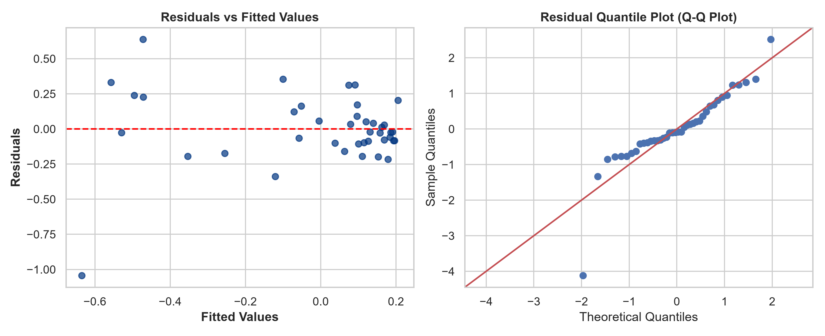
Figure 3. Residual diagnostics: Residuals vs Fitted values (left) and Quantile-Quantile (Q-Q) distribution plot (right).

