AI AGENTS FOR EVERYONE
AI Agents for Everyone
A Plain-English Guide to Artificial Intelligence, Digital Agents, Business Uses, Benefits, Risks, and Responsible Adoption
Purpose of this paper
This guide is written for business leaders, professionals, students and interested members of the public. It explains the technology without assuming programming expertise and separates practical capability from promotional claims.

John Straumann
jstraumann@hotmail.com
October 1, 2026

Executive Summary
Artificial intelligence is becoming a general-purpose layer in modern software. Generative AI can produce text, images, code and other content. AI agents extend that capability by combining a model with instructions, information, memory and tools so the software can pursue a goal rather than merely answer a question.
Technology companies propose that people will use agents as personal research assistants, workplace copilots, customer-service representatives, software-development partners and operators of business processes. The promise is significant: faster work, broader access to expertise, continuous service and automation of tasks that previously required people to move manually among applications.
The same features that make agents useful also create risk. An agent can misunderstand a request, invent facts, expose data, follow malicious instructions, misuse a tool, act with excessive authority or consume unexpected resources. Unlike an ordinary chatbot error, an agent error may change a record, send a message, place an order or affect another system.
Central conclusion
AI agents should be treated as powerful but fallible software workers. They can create substantial value when assigned a narrow job, given trustworthy information, constrained permissions, measurable tests and clear human accountability.

Seven ideas to remember
- AI is an umbrella term covering many different techniques and products.
- A language model predicts useful output; it does not possess human understanding or judgment.
- An agent adds goals, tools, context, memory and a decision loop to a model.
- Not every task needs an agent; fixed workflows are often cheaper and more reliable.
- Vendor demonstrations show possibility, not guaranteed performance in every organization.
- More autonomy means more security, governance and operational responsibility.
- The best adoption path begins with assistance and earns authority through evidence.

Contents
Executive Summary 2
Seven ideas to remember 2
Contents 3
1. What Artificial Intelligence Is 4
Machine learning 4
Generative AI 4
What a language model actually does 4
2. What an AI Agent Is 5
The basic ingredients 5
Agent versus chatbot 5
3. Not Everything Is—or Should Be—an Agent 7
4. How Companies Propose People Will Use Agents 8
Personal productivity 8
Workplace productivity 8
Customer and employee service 8
Business-process automation 8
Software development and IT 9
5. The Agent Marketplace 10
6. Potential Benefits 11
Less coordination work 11
Faster access to expertise 11
Continuous availability 11
Handling variability 11
Personalization at scale 11
Better process visibility 11
7. Limitations and Misconceptions 12
Fluency is not certainty 12
Reasoning is uneven 12
The agent does not understand the organization automatically 12
Autonomy does not eliminate operations 12
A demonstration is not production evidence 12
8. Risks of AI Agents 13
9. Responsible Adoption 14
Begin with the business problem 14
Choose the lowest sufficient autonomy 14
Separate recommendation from execution 14
Test complete tasks, not just answers 14
Operate the agent as a production system 14
10. A Practical Evaluation Checklist 16
11. Examples for Individuals 17
12. Examples for Organizations 18
13. The Future of Human-Agent Work 19
Skills that become more important 19
Questions society must continue to address 19
Conclusion 20
References 21

In Microsoft Word, right-click the table and select Update Field to refresh page numbers.

1. What Artificial Intelligence Is
Artificial intelligence, or AI, is a broad term for computer systems designed to perform tasks associated with human abilities such as recognizing patterns, understanding language, making predictions, solving problems or selecting actions. AI does not describe one machine, one algorithm or one level of capability.
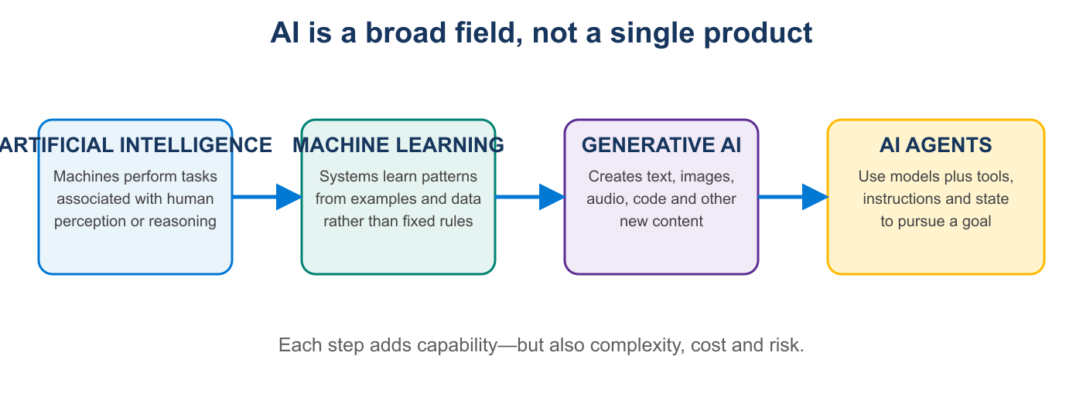

Machine learning
Traditional software follows rules explicitly written by people. Machine-learning systems instead infer statistical patterns from examples. A fraud model may learn patterns associated with suspicious transactions; a vision model may learn to identify objects in images.

Generative AI
Generative AI produces new content—such as prose, images, music, video or software code—based on patterns learned from large amounts of data. Large language models, or LLMs, are generative models optimized for language and related reasoning tasks.

What a language model actually does
At its core, a language model estimates which pieces of language are likely to follow the text and context it has received. Modern models can perform surprisingly sophisticated work because they have learned rich patterns involving language, knowledge, structure and problem solving. Nevertheless, fluent output is not proof that the output is true.
A useful mental model
Think of a language model as an extremely capable pattern-and-language engine—not a human mind, an infallible database or an independent moral decision-maker.

2. What an AI Agent Is
Microsoft describes agents as dynamic, goal-oriented systems that can reason, plan and act on behalf of users, with a model, instructions and tools as core components.[1] Anthropic distinguishes predefined workflows from agents that dynamically direct their own processes and tool usage.[2]
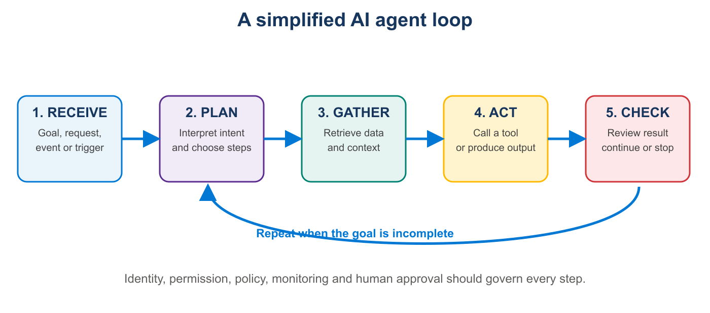

The basic ingredients
Ingredient | Purpose | Everyday analogy
Model | Interprets information and proposes steps or output | The worker's general reasoning and communication ability
Instructions | Define the job, limits, tone and success criteria | A job description and operating procedure
Knowledge | Provides trusted facts and organizational context | Files, policies, records and reference materials
Tools | Allow retrieval, calculations and actions in other systems | Email, calendar, browser, CRM, database or calculator
Memory / state | Carries relevant information across steps or sessions | Notes about the current case and prior work
Trigger | Starts the work | A question, schedule, new email, alert or business event
Controls | Constrain access and require approval | Permissions, policies, supervision and audit

Agent versus chatbot
Chatbot | AI agent
Usually responds to one request | May pursue a goal through multiple steps
Primarily produces conversation or content | Can retrieve information and invoke tools
The person normally directs each step | The system may decide which step or tool comes next
Errors generally remain in the response | Errors may propagate into external actions
Often stateless or session-based | May maintain task state or longer-lived memory

3. Not Everything Is—or Should Be—an Agent
The word “agent” is used loosely in the market. Some products are chatbots with better tools; some are workflows that include AI at selected steps; others give a model meaningful discretion over planning and tool use. These are all useful patterns, but they are not identical.
Pattern | Use when | Example
Traditional software | Rules and calculations are known | Calculate payroll tax from established formulas
Automation workflow | The sequence is fixed and predictable | Copy approved form data into three systems
AI assistant | A person remains the primary operator | Summarize documents and draft a response
AI agent | The path varies and requires tool selection or investigation | Research an account, identify issues and propose next actions
Multi-agent system | Distinct specialties must coordinate | Research, financial analysis and proposal-writing agents collaborate
Anthropic recommends using the simplest approach that works because agentic systems commonly trade additional latency and cost for flexibility and task performance.[2]
Decision rule
If the steps are known, use ordinary automation. If the work requires interpreting changing information and choosing among possible actions, an agent may be appropriate.

4. How Companies Propose People Will Use Agents
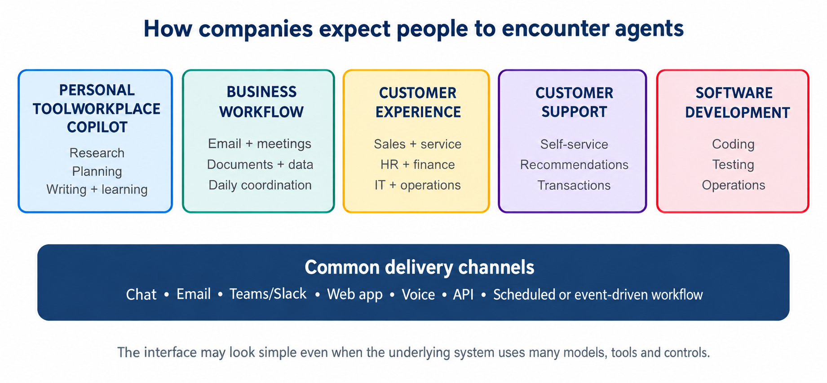

Personal productivity
- Research topics, compare options and assemble sourced reports.
- Plan trips, projects, learning programs or personal goals.
- Organize information, summarize communications and prepare daily priorities.
- Draft content and iterate based on criteria or feedback.

Workplace productivity
- Prepare for meetings by gathering email, calendar, CRM and document context.
- Review an inbox, identify required action and prepare drafts.
- Analyze documents, spreadsheets and business data.
- Coordinate tasks across productivity applications.

Customer and employee service
Salesforce promotes Agentforce for resolving cases, recommending products, engaging customers continuously and handing work to people when needed.[3] ServiceNow and other workflow vendors similarly position agents around service, IT and employee processes.

Business-process automation
Amazon Bedrock Agents is positioned to combine models, APIs and data, break down requests and complete tasks; AWS also promotes memory, guardrails and collaboration among specialized agents.[4]
- Classify and route incoming requests.
- Gather missing information and follow up with customers.
- Reconcile documents or investigate anomalies.
- Update systems after review or approval.

Software development and IT
- Explain code, implement changes and run tests.
- Investigate incidents and summarize evidence.
- Generate infrastructure or operational recommendations.
- Monitor systems and propose remediation.
What companies are really selling
The broad vision is software that moves from answering questions to participating in work. The practical offerings range from ready-made copilots to low-code builders and developer platforms for custom agents.

5. The Agent Marketplace
Major technology providers approach agents from different starting points. Some begin with productivity software, some with customer data and workflows, and others with cloud infrastructure or foundation models.
Provider / offering | How it is positioned | Typical use
Microsoft Copilot, Copilot Studio and Azure AI | Ready-made, low-code and custom agents connected to productivity and business systems | Microsoft 365 work, internal knowledge, business processes and custom applications
OpenAI agent tools and APIs | Models and developer tools for building agents that use web, files, computers and custom functions | Research, customer experiences, software and bespoke automation
Google Gemini Enterprise Agent Platform | Design and operate agents using Gemini models and Google Cloud capabilities | Search, data, workspace and enterprise applications
Salesforce Agentforce | Agents grounded in CRM and customer data | Sales, service, commerce and customer engagement
Amazon Bedrock Agents / AgentCore | Cloud services for agents using models, APIs, data, memory and guardrails | Custom enterprise and AWS-centered workflows
Anthropic Claude and agent tooling | Models and composable patterns for workflows, tools and more autonomous systems | Research, coding, document-intensive and custom applications
ServiceNow AI Agents | Agents embedded in enterprise service workflows | IT, HR, customer service and operational case management
Vendor names, packaging and product capabilities change rapidly. The important question is not which company uses the word “agent,” but whether the product fits the organization's data, identity, integration, governance, support and cost requirements.

6. Potential Benefits

Less coordination work
Many knowledge workers spend substantial time searching for information, moving data between applications, checking status and composing routine communications. Agents can reduce this coordination burden by gathering context and preparing the next step.

Faster access to expertise
A well-grounded agent can make policies, product information, procedures and institutional knowledge easier to use. This does not replace experts, but it can help more people find and apply relevant knowledge.

Continuous availability
Software can monitor events and provide first-line service outside normal working hours. Continuous availability is especially useful for intake, triage, notification and preparation.

Handling variability
Traditional automation works best when inputs are structured and rules are stable. Agents can interpret emails, documents and conversational requests, making automation possible in processes that previously resisted rigid rules.

Personalization at scale
Agents can adapt explanations, recommendations or workflows to a user's role, history and stated needs—provided the personalization is lawful, transparent and based on appropriate data.

Better process visibility
When implemented correctly, an agent platform can produce structured traces showing requests, sources, tool calls, approvals, costs, results and exceptions. That visibility can expose process problems that were previously hidden in email and individual habits.
Benefit | Useful measure
Time saved | Handling time before and after deployment
Faster response | Median and worst-case time to first useful action
Higher throughput | Cases completed per person or team
Quality | Accuracy, correction rate and customer outcome
Consistency | Variation across users, locations and time
Availability | Cases handled outside staffed hours
Knowledge access | Successful answers grounded in approved sources
Economic value | Benefit minus model, integration, support and change-management costs

7. Limitations and Misconceptions

Fluency is not certainty
Models often express uncertain or incorrect conclusions in confident language. Retrieval and citations help, but they do not guarantee that the agent selected the right evidence or interpreted it correctly.

Reasoning is uneven
An agent may perform impressively on one example and fail on a slightly different case. Performance depends on instructions, context, tool design, model behavior and the difficulty of the environment.

The agent does not understand the organization automatically
Useful deployment requires curated knowledge, clear terminology, correct permissions, system integrations and examples of acceptable behavior. Buying a model does not supply organizational context.

Autonomy does not eliminate operations
Agents require monitoring, incident handling, testing, access reviews, cost management and maintenance as systems and policies change. In many cases, operational work increases before it decreases.

A demonstration is not production evidence
A polished demonstration usually shows a selected path under favorable conditions. Production systems must handle missing data, ambiguous requests, malicious content, outages, duplicate actions and thousands of edge cases.
Avoid the employee metaphor when it obscures responsibility
Calling an agent a “digital employee” can be intuitive, but the organization still owns the design, permissions, decisions, monitoring and consequences. The software does not hold legal or moral accountability.

8. Risks of AI Agents
NIST's AI Risk Management Framework is intended to help organizations incorporate trustworthiness into the design, development, use and evaluation of AI systems.[5] OWASP identifies agent-specific risks including prompt injection, tool abuse, data exfiltration, memory poisoning, excessive autonomy, cascading failures and denial of wallet.[6]
Risk | What can happen | Illustrative control
Incorrect output | The agent invents or misinterprets information | Grounding, citations, confidence thresholds and human review
Prompt injection | Malicious text in a message, website or file changes agent behavior | Treat external content as untrusted; isolate instructions; validate actions
Excessive authority | The agent performs an action beyond the user's intent | Least privilege, approval gates and risk-based tool policies
Data exposure | Sensitive data appears in prompts, outputs, logs or external calls | Data minimization, isolation, redaction and egress controls
Tool misuse | A valid tool is called with unsafe or manipulated parameters | Schema validation, allowlists and independent execution checks
Identity abuse | Agent credentials are stolen or broader than required | Managed identity, short-lived credentials and access review
Memory poisoning | False or malicious information persists into future work | Validated memory, expiration, user isolation and provenance
Bias or unfairness | Outputs disadvantage people or groups | Representative testing, policy review and appeal paths
Cascading failure | One agent's bad output influences other agents or systems | Trust boundaries, validation and circuit breakers
Unexpected cost | Loops or abuse create excessive model and API usage | Budgets, rate limits, run ceilings and alerts
Accountability gap | No one can explain or own an outcome | Named owner, audit trail, decision rights and incident process
Workforce harm | Poorly planned automation displaces work or degrades skills | Change management, role redesign, training and worker participation

9. Responsible Adoption
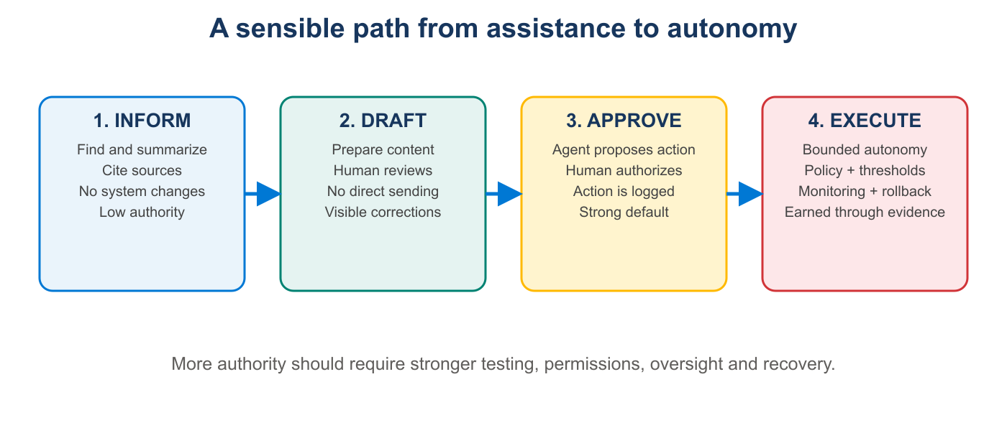

Begin with the business problem
Start with an expensive, slow or inconsistent job—not with a desire to deploy an agent. Describe the current process, users, systems, risks, exceptions and measurable outcome.

Choose the lowest sufficient autonomy
If summarization solves the problem, do not add write access. If a draft is valuable, do not send automatically. Authority should expand only when measured performance and operational controls justify it.

Separate recommendation from execution
OWASP recommends independent validation for destructive, financial, administrative or externally visible actions. The agent may propose an action, but deterministic software should verify identity, policy, exact parameters and approval before execution.[6]

Test complete tasks, not just answers
- Normal cases, unusual cases and deliberately ambiguous requests.
- Incorrect, missing or conflicting source information.
- Malicious instructions embedded in emails, documents and websites.
- Tool failures, timeouts and partial completion.
- Attempts to exceed permissions or disclose another user's information.
- Cost, latency and repeated-loop behavior.

Operate the agent as a production system
- Assign a business owner and a technical owner.
- Log decisions, sources, tool calls, approvals and outcomes.
- Monitor quality, security, latency, user corrections and spend.
- Provide a visible escalation path and a reliable stop mechanism.
- Review access, knowledge and evaluations whenever the process changes.

10. A Practical Evaluation Checklist
Question | Evidence to request
What exact job will the agent perform? | Written scope, users, trigger, output and stopping condition
Why is an agent better than a workflow? | Examples where the path varies and model judgment adds measurable value
What data can it access? | Data inventory, ownership, classification and retention
What can it change? | Tool list, permission scopes and approval rules
How is identity handled? | User and service identities, authentication and authorization design
How is quality measured? | Evaluation set, pass thresholds, correction rate and ongoing monitoring
How are unsafe actions prevented? | Policy enforcement outside the model, input/output validation and fail-closed behavior
What happens when it fails? | Escalation, rollback, duplicate prevention and incident response
What will it cost? | Expected and worst-case model, tool, storage, support and integration costs
Who is accountable? | Named owner, review cadence and authority to pause the system
How are workers affected? | Role changes, training, workload, consultation and transition plan
How can the customer leave? | Data export, deletion, portability and vendor lock-in considerations

11. Examples for Individuals
Agent idea | Useful behavior | Important caution
Research agent | Gather sources, compare claims and create a report | Verify sources and distinguish fact from inference
Meeting-preparation agent | Combine calendar, prior notes and approved account information | Protect confidential communications and customer data
Learning coach | Create lessons, quizzes and adaptive practice | Do not treat generated material as authoritative without review
Travel planner | Research options and build a schedule | Require confirmation before purchases or reservations
Career assistant | Find roles and prepare application material | Avoid misrepresentation and monitor sensitive personal data
Personal finance assistant | Categorize spending and explain patterns | Use strong security; do not delegate regulated financial decisions blindly
Home-management agent | Track warranties, maintenance and reminders | Limit access to household and identity information
For personal use, the safest agents usually begin as research, organization and drafting tools. Financial, health, legal and identity-related actions warrant professional advice and explicit human confirmation.

12. Examples for Organizations
Use case |  | Agent contribution | Human responsibility
Customer-service triage |  | Classify intent, retrieve guidance and draft a response | Handle exceptions, complaints and policy-sensitive decisions
Sales preparation |  | Assemble account context, recent activity and suggested questions | Validate strategy and customer-facing claims
Employee policy support |  | Answer questions from approved policies with citations | Maintain policy content and resolve ambiguous cases
Document follow-up |  | Identify missing items, draft reminders and track status | Approve communications and resolve disputed requirements
IT service desk |  | Diagnose common issues and propose or execute bounded fixes | Own access, production changes and incident response
Finance operations |  | Reconcile data and flag anomalies | Approve postings, exceptions and regulated decisions
Software engineering |  | Explain, write, test and review code | Own architecture, security, correctness and release decisions
Procurement research |  | Compare vendors, contracts and performance | Own negotiation, legal review and purchasing authority
Strong first use cases
Look for frequent work that involves several information sources, meaningful but reversible recommendations, clear success measures and an existing human review step.

13. The Future of Human-Agent Work
The likely near-term future is not a clean replacement of people by autonomous software. It is a redesign of work in which people set goals, define policy, handle relationships and exceptions, while agents prepare, coordinate and execute bounded portions of a process.

Skills that become more important
- Defining a problem and a measurable outcome.
- Judging evidence, uncertainty and source quality.
- Designing processes, controls and escalation paths.
- Understanding data ownership, privacy and permissions.
- Testing systems against normal, unusual and adversarial cases.
- Communicating decisions and maintaining accountability.

Questions society must continue to address
- When should people be told they are interacting with an agent?
- Which decisions must remain meaningfully human?
- How should responsibility be divided among vendors, deployers and users?
- How can benefits be shared without concentrating harm on particular workers or communities?
- What evidence should be required before agents operate in high-impact settings?
These are not questions that technology alone can answer. They require governance, law, organizational policy, professional judgment and public participation.

Conclusion
AI agents represent an important shift from software that waits for explicit commands toward software that can interpret goals, coordinate tools and participate in work. That shift can reduce administrative effort, broaden access to knowledge and create more responsive services.
It also moves AI closer to real-world consequences. The central challenge is therefore not merely making agents more capable; it is making their authority proportionate, their behavior observable, their information trustworthy and their owners accountable.
A balanced position
Be optimistic about the value agents can create, skeptical of unsupported claims, disciplined about risk, and deliberate about where human judgment must remain in control.

References
1. Microsoft Learn. Introduction to AI Agents. https://learn.microsoft.com/en-us/startups/build/ai/agents/intro-agents
2. Anthropic. Building Effective Agents. https://www.anthropic.com/engineering/building-effective-agents
3. Salesforce. Agentforce. https://www.salesforce.com/agentforce/
4. Amazon Web Services. Amazon Bedrock Agents. https://aws.amazon.com/bedrock/agents/
5. National Institute of Standards and Technology. Artificial Intelligence Risk Management Framework. https://www.nist.gov/itl/ai-risk-management-framework
6. OWASP. AI Agent Security Cheat Sheet. https://cheatsheetseries.owasp.org/cheatsheets/AI_Agent_Security_Cheat_Sheet.html
7. Google Cloud. Gemini Enterprise Agent Platform. https://cloud.google.com/products/gemini-enterprise-agent-platform
8. World Economic Forum. A Playbook for Trusted Adoption, Authorization and Scaling. https://reports.weforum.org/docs/WEF_AI_Agents_in_Action_A_Playbook_for_Trusted_Adoption_Authorization_and_Scaling_2026.pdf
9. Microsoft Learn. Agents Hub. https://learn.microsoft.com/en-us/agents/
10. NIST. Generative Artificial Intelligence Profile (NIST AI 600-1). https://doi.org/10.6028/NIST.AI.600-1
Sources were accessed in October 2026. Product names and capabilities evolve rapidly; readers should consult current vendor documentation before making purchasing or deployment decisions.

