
Master SGB
Duration : 6h

Hybridization of light rail systems

We consider the displacement of a light rail system (Alstom – CITADIS) along a test line 1.5 km long. The electric vehicle power (Pelec) at the overhead contact line is simulated thanks to a global simulator of mechanical and electrical parts.
The data profile at a sampling period equal to 1s is described in donnees.mat file. Calculations can be performed in the Matlab © environment.
1) Characterization of the load profile
From the power supply profile, you have to determine the Potential of Hybridization in Power (PHP) and the Potential of Hybridization in Energy (PHE).
Conclude about the interest of hybridizing the engine with an auxiliary source (storage device) and the choice of technology.
In the following, you will take the following convention on signs:
- Pelec is positive for traction mode (corresponding to a phase of discharge of storage);
- Pelec is negative for braking mode (corresponding to a phase of charging storage);
2) Choosing Storage Technology
Using spectre.m function, determine the frequency spectrum of the load profile. Conclude about the (in) technology (s) holding storage (s).
Subsequently, we assume that the average power profile will be provided by the french energy distributor. The remaining power demand will be provided by the storage device.

Answer:

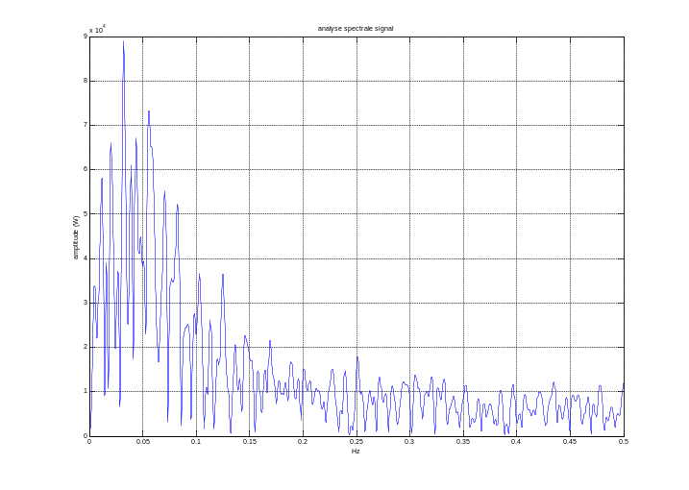
The peak frequency is at 0.03 Hz. So the flywheel seems to be the best option.
3) Storage by Supercapacitors
a) Calculate:
- The power of energy storage delivered at each sampling time;
- The actual power provided by the storage device, taking overall conversion efficiency (converters and losses of the storage facility) equal to 95% for supercapacitors;
- Energy actually stored in the device for supercapacitors.

b) Deduce (without any loss compensation of the capacitive pack):
- The useful energy needed for the mission;
- The total capacitance of the package (we will take an average DoD of 75%);
- The maximum supercapacitor pack for charging and discharging modes;
- From technological elements shown in Table 1, design the size of supercapacitors pack (number of elements, voltage and current, volume and weight).

series resistance element (ESR) | 350 μΩ
Capacitor | 5000 F
Voltage | 2.5 V
Table 1 Characteristics of EPCOS (B49410B2506Q000) data element

4) To study the sensitivity of the design obtained depending on the power output of the electrical network. This may be done changing the power rate of ± 50% in 10%.

The next subject will focus on robust control command of energy storage device.

