ELEC 490/498 Blueprint
Deep Learning Calorie Counter


  - Submitted By: Group 59
  - Group Members: Andy Craig, Nathan Goodman, Brock Tureski, John Turnbull
  - Faculty Supervisor: Il-Min Kim
Contents
Executive summary 2
Section 1: Introduction 2
1.1 Purpose 3
1.2 Intended Audience 3
1.3 Organization 3
Section 2: Work breakdown structure 3
2.1 Dataset Acquisition and Labelling 5
2.2 Model Training and Storage 5
2.3 Exercise Prediction 6
2.4 Caloric Estimation 6
2.5 Mobile App 6
Section 3: Progress to date 7
3.1 Milestones/Divisions of Labor 7
Section 4: Budget 8
Section 5: Potential Technical problems and mitigation strategies 9
Section 6: Strategies to address the wider impact of the projectTop of Form 10
Section 7: Conclusion 11
Bibliography 11
Appendix 11

Table of Figures
Figure 1: Project Architecture Diagram showing the interconnection of the 4 component deliverables. 2
Figure 2: Work Breakdown Structure displaying the 5 component deliverables and sub-components.. 3
Table of Tables
Table 1: Milestone breakdown 5
Table 2: Fixed-Cost Bill of Materials 7
Table 3: Usage-based Cost breakdown 7
Table 4: Problems with Dataset Acquisition component deliverable. 9
Table 5: Potential problems with Model Training and Storage component. 10
Table 6: Potential problems with caloric estimation and exercise prediction components. 10
Table 7: Potential problems with Mobile App development. 11

Executive summary
The Calorie Counter project aims to develop a workout tracker that predicts caloric output from user-uploaded workout videos. This blueprint serves as a roadmap for the project, encompassing development scheduling, cost estimation, challenge mitigation, and broader impact strategies. The project is structured into five distinct components: dataset acquisition and preprocessing, model training and storage, exercise prediction, caloric estimation, and mobile application integration. Each of the aforementioned components has distinct sub-components, ensuring a systematic approach within project development. Progress to date has focused on planning, data acquisition, and preprocessing. The team recorded personal workouts, collected third-party exercise images, and conducted research on computer vision models. Front-end development progress includes UI prototypes designed with Figma, and research into iOS application development. The project has a budget of $600 CAD, covering Google Colab Pro for GPU server usage, Google Cloud for backend hosting, and potentially an Apple Developer Program subscription to allow for internal distribution of the application. The budget is well-managed, with sufficient budgetary slack remaining to cover unforeseen expenses. Potential technical problems include obtaining enough image data, performance issues due to a lack of video angles, poor responsiveness, and the model's ability to accurately estimate caloric output. Strategies to address broader impacts involve mitigating health risks associated with strength training exercises, ensuring privacy through encrypted image networks, implementing cybersecurity measures, and limiting legal liability through clear terms of service outlining the app’s intentions and users’ responsibilities. The team anticipates successful project development that will push the boundaries of the fitness market in alignment with academic goals and ethical considerations.

Section 1: Introduction
This blueprint document outlines the groups proposed project – Calorie Counter. The project involves creating a workout tracker for users that can predict caloric expenditure during an exercise given a video uploaded to a mobile app. The purpose of this document is to guide us through the completion of the project.

1.1 Purpose
This blueprint document serves as a roadmap for successful project completion by giving detailed development scheduling, cost estimation, challenge mitigation and broader impact strategies. Secondly, the team aims to give the audience a clear image of the project approach, ensuring that the team is on right path to successful completion.

1.2 Intended Audience
Targeted at course instructors, our faculty supervisor, and ECE Faculty members to keep them informed and engaged in the project.

1.3 Organization
The organization of the blueprint document is as follows:
- Work Breakdown Structure (WBS): Visual representation of project tasks and their hierarchy.
- Progress to Date: Snapshot of achievements, milestones, and encountered challenges.
- Budget: Overview of estimated costs, ensuring financial transparency.
- Potential Technical Problems and Mitigation Strategies: Identifies and addresses potential challenges proactively.
- Strategies to Address the Wider Impact: Explores ethical, social, and environmental considerations.
This blueprint document ensures clarity for the course project, aligning with academic goals and expectations. The team anticipates a successful development of our Calorie Counter project.

Section 2: Work breakdown structure
The project has been broken down into 5 component deliverables for the purpose of simplifying development. A system architecture diagram has been created to outline the interconnection of these components and how they mesh to form a functional end-to-end system. Note that this architecture diagram includes 4 out of the 5 components, since the Dataset Acquisition and Labelling component cannot be represented diagrammatically.

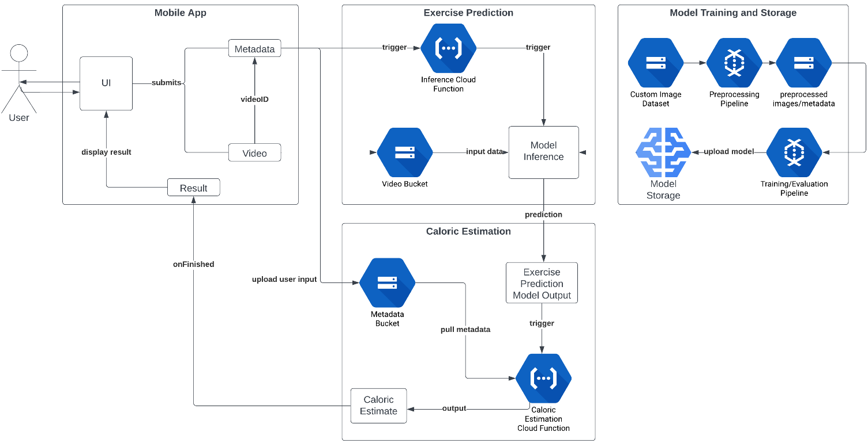
Figure 1: Project Architecture Diagram showing the interconnection of the 4 component deliverables.
The above system architecture can be translated into a Work Breakdown Structure for more clarity. Below, the 5 distinct sub-components have been highlighted, with each showing the necessary deliverables required for completion. These are our proposed sub-components: Dataset Acquisition, Model Training and Storage, Exercise Prediction, Caloric Estimation, and the Mobile App.
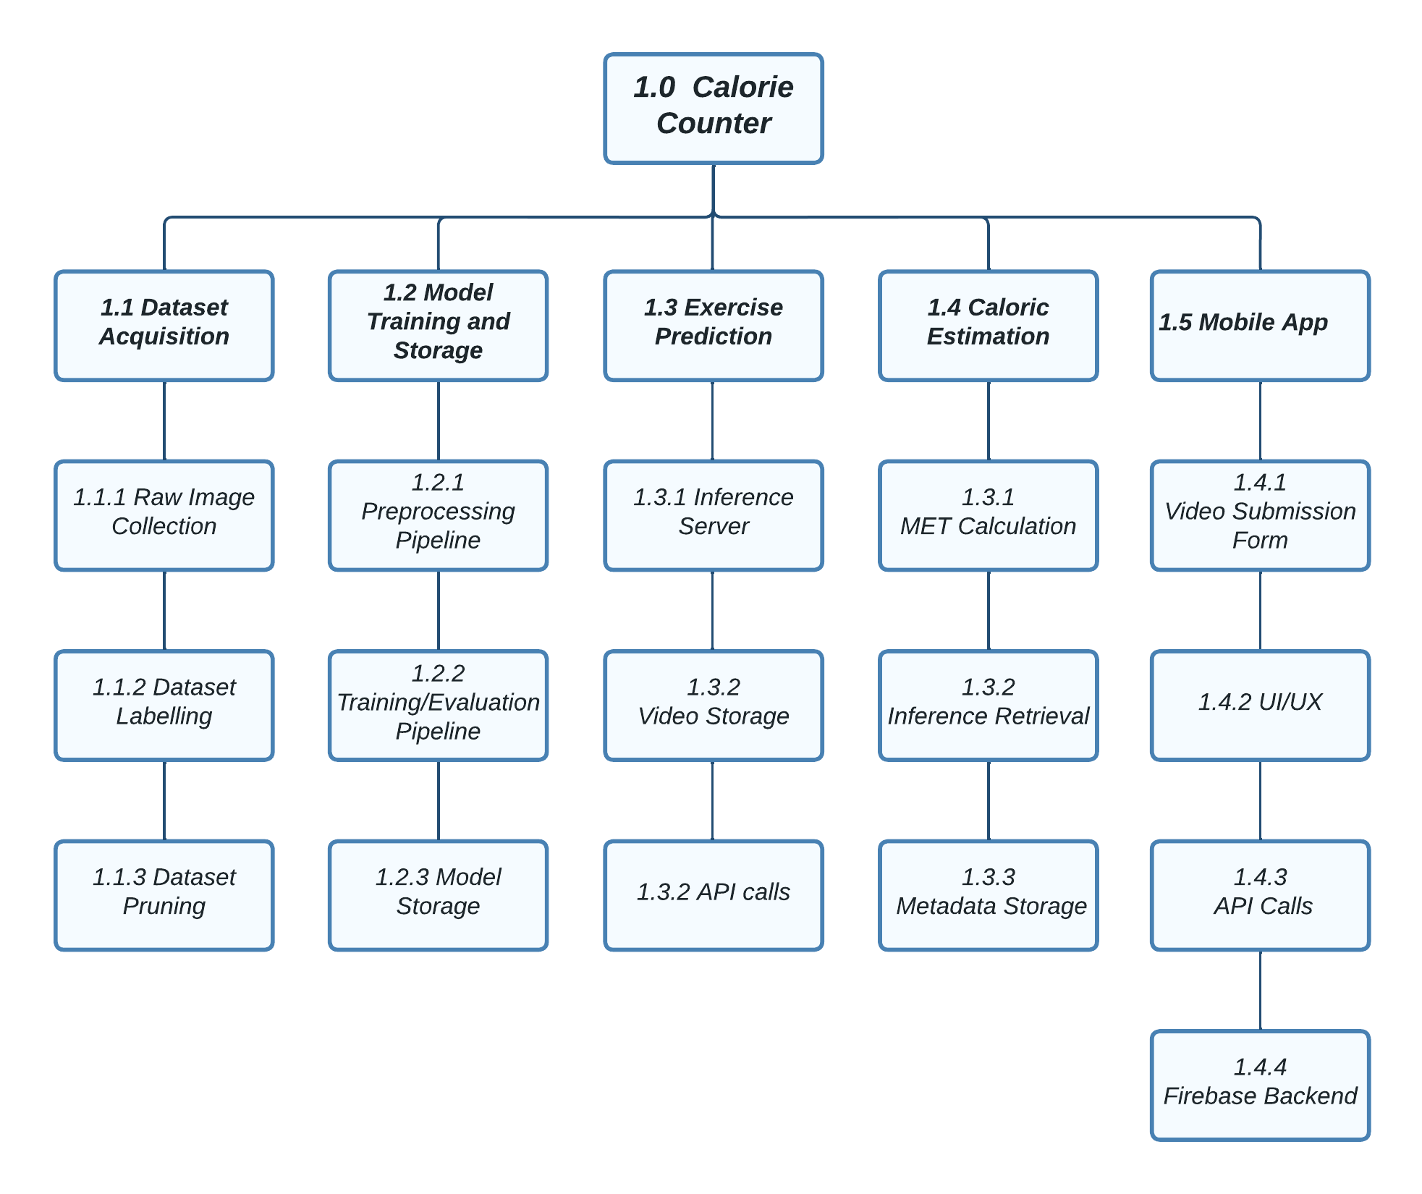
Figure 2: Work Breakdown Structure displaying the 5 component deliverables and sub-components.

2.1 Dataset Acquisition and Labelling
Prior to developing the Model Training and Storage components, our dataset must be finalized. The team must place emphasis on this component deliverable as the accuracy of our solution is highly dependent on the quantity and quality of exercise data we can gather. To build a dataset of this caliber, the following sub-components must be created:
- Raw image dataset: Gather a diverse dataset of exercise images, ensuring it represents various activities and demographics. Minimum of 500 images for each class [1].
- Dataset labels: Manually or automatically label the collected dataset with corresponding exercise classes.
- Dataset pruning [2]: Implement a process to remove low-quality or irrelevant images from the dataset.

2.2 Model Training and Storage
The model training and storage component deliverable is the only component that will be run asynchronously to the user’s requests. This means that it can be developed and tested independently from the rest of the system, the only dependence it has is on the Dataset Acquisition component. The team can build the preprocessing pipeline, train/evaluate models and tune our hyperparameters before the development of the inference server, mobile app, and caloric estimation. For the model training and storage deliverable, the following functionality is required:
- Preprocessing Pipeline: Develop a preprocessing pipeline to clean and preprocess raw exercise video data.
- Training/Evaluation Pipeline: Develop a pipeline for training and evaluating exercise prediction models. Additionally, fine-tune model hyperparameters for optimal performance.
- Model Storage: Establish a system for storing trained models securely.

2.3 Exercise Prediction
The exercise prediction component deliverable is the interface between our mobile app, and our pre-trained exercise prediction model. It will handle all the API calls to our inference server and trigger the caloric estimation component once the inference is complete. The exercise prediction component must achieve the following functionality:
- Model Inference: Inference server that pulls our pretrained model from our model storage system, run’s inference on the users exercise video, then returns the predicted exercise class.
- Video Storage: Google Cloud storage bucket that temporarily stores user’s videos as they await inference. [3]
- API Calls: Once the inference is complete, an API call must be made to the caloric prediction component, containing the predicted exercise. This will trigger the caloric prediction logic and then return the result to the user.

2.4 Caloric Estimation
The Caloric Estimation component involves the logic for caloric estimation using the MET of the given exercise. Once the inference has been complete, an API call will be made to our Caloric Estimation cloud function, which begin computing the estimated caloric expenditure of the user during their exercise. Once this value has been calculated, it will be returned to the mobile app. The following sub-components are necessary for this deliverable:
- MET Calculation Logic [4]: Develop an algorithm to calculate Metabolic Equivalent of Task (MET) values based on the predicted exercise class.
- Inference Retrieval: Retrieve inferences from the Exercise Prediction component.
- Metadata Storage: Store metadata related to caloric estimation, including user details and exercise information.

2.5 Mobile App
The mobile app component deliverable is our only user facing component of the project. It serves as an interface between the caloric estimation logic and the user. The mobile app must achieve the following functionality:
- Video Submission Form: Allow the user to upload and submit an exercise video, along with video context such as users age, weight, height, exercise load, repetitions.
- User Interface: Allow the user to navigate the app, authenticate user login, store user data safely and securely as well as allowing the user to view past workouts.
- API Calls: When the user submits a video, make the appropriate API calls that trigger the inference and calorie prediction cloud functions.
- Firebase: Firebase integration for user auth, storing user data, keeping track of past workouts.

Section 3: Progress to date
Most of the progress on the project has been oriented toward planning and strategizing. Due to the project's nature, the progress will occur in distinct steps, with the initial focus on data acquisition and preprocessing. Subsequently, the emphasis will shift to model development and front-end development during the later stages of the project.
As a result, most of the physical progress within the project has been in the data acquisition and preprocessing portion. The team has been recording personal workouts as training data and collecting third-party photographs and videos of relevant exercises. This training data is then labeled and stored via file-sharing software for use in model training.
For the model development phase of the project, much of the work involves researching computer vision models, specifically focusing on the YOLOv5 model. In terms of front-end development progress, UI prototypes have been designed with Figma as shown in figure 3. Additionally, there has been research into iOS app development, primarily focusing on SwiftUI and its respective frameworks, as well as the process of distributing iOS apps.

3.1 Milestones/Divisions of Labor
Table 1: Milestone breakdown
No. | Milestone | Due date | Responsible member(s)
1 | Preliminary UI design completed | Week 9 | Brock
2 | Data training set fully collected and preprocessed | Week 13 | John, Andy
3 | Exercise identification model fully trained | Week 15 | Nathan, John
4 | Caloric output estimation model completed | Week 17 | Andy, Brock
5 | Exercise identification model and caloric output model integrated into one cohesive unit | Week 18 | Andy, Brock
6 | Backend completed and cloud hosted with endpoints fully functioning | Week 19 | All members
7 | Frontend completed | Week 20 | Brock, Nathan
8 | Project fully tested and completed | Week 21 | All members
9 | Open House | Week 22 | All members
10 | Final deliverable | Week 23 | All members
11 | Final project report | Week 24 | All members

Section 4: Budget
The project has a budget of $600 CAD. The main costs associated with this project include Google Colab Pro, Google Cloud, and possibly an Apple Developer Program subscription. Google Colab Pro will serve as the GPU server for the neural network. The subscription model for Google Colab runs monthly, costing $13.99 CAD. This subscription will be required from December 2023 to April 2023, resulting in a total cost of $69.95 CAD [5].
Google Cloud will host the backend of the system, and its cost depends on monthly usage, varying according to the computing power utilized each month. Google offers a $300 free credit for new customers, which the team will leverage, potentially covering the entire cost for the project duration [6].
While the ideal scenario involves publishing the application on the iOS App Store, this subjects our application to Apple's scrutinous guidelines. If the application cannot be published due to these guidelines, the purchase of an Apple Developer Program subscription becomes necessary. This subscription, costing $99 USD ($136 CAD), is available only as a full-year subscription [7].
Although there might be unforeseeable needs for resources, there is significant room left in the budget. Therefore, this project should comfortably stay within the $600 CAD budget.
Table 2: Fixed-Cost Bill of Materials
Fixed-Cost Bill of Materials
Item | Quantity | Unit | Unit Cost | Cost
Google Colab Pro | 5 | Month | $13.99 CAD | $69.95 CAD
Apple Developer Program | 1 | Year | $99 USD ($136 CAD) | $136 CAD
Subtotal | $205.95 CAD

Table 3: Usage-based Cost breakdown
Usage-Based Costs
Item | Unit | Unit Cost
Google Cloud Predefined vCPU | VCPU month | $24.80 USD ($34 CAD)
Google Cloud Predefined Memory | GB month | $3.33 USD ($4.56 CAD)

Section 5: Potential Technical problems and mitigation strategies
The "Potential Problems" section is divided into segments based on the design phases outlined in Section 2: Dataset Acquisition, Model Training and Storage, Caloric Estimation & Exercise Prediction, and Mobile App. Tables containing the: potential problems, their descriptions, and solutions/mitigation strategies; for each of the segments can be found in the Appendix.
For the Data Acquisition component, the group focused on problems pertaining to the creation of the required custom dataset—since there is no publicly available dataset containing images for each of the group’s desired exercises. Mainly: how will the group acquire enough data, and how the group’s custom dataset will be created. Refer to Table 4 for full problem descriptions.
For the Model Training and Storage component, the team focused on performance issues with the AI Model that could be fixed by tweaking/changing the model. Including: how to improve accuracy of the model and how to improve the performance (speed and memory wise) of the model. Refer to Table 5 for full problem descriptions.
For the Exercise Prediction and Caloric Estimation components, the team focused on the issues that may arise during both the Caloric Estimation and Exercise Prediction deliverables. Such as: how to know if a given caloric estimate is accurate and how could features of a given exercise affect the model exercise prediction. Refer to Table 6 for full problem descriptions.
For the Mobile App component, the team focused on concerns that surround any potential technical problems with the development or testing of the mobile interface. Since the development of a Mobile App is fairly straightforward, the main concern was with the distribution of the application. Refer to Table 7 for full problem descriptions.

Section 6: Strategies to address the wider impact of the projectTop of Form
In terms of health risks, the calorie counter itself poses no harm to the user. However, as the app is directly correlated with strength training exercises, there is a risk of injury on the user end. It's important to note that the calorie counter app holds no responsibility for these exercise-related issues. The most significant safety concern lies in privacy, the app captures user pictures for upload to a neural network. To mitigate this risk, it is imperative for the project to ensure stringent measures are in place to prevent third-party exploitation or data leaks. Prioritizing robust privacy safeguards will enhance user confidence in the app's data handling practices.
To prevent data leaks of users’ personal images, implementing an encrypted image network appears to be a crucial strategy. This method enhances security by safeguarding the images, even in the event of unauthorized access to the internal network of the calorie counter app. Another strategy is to incorporate cybersecurity measures directly into the app to defend against external breaches. Recognizing that this task may exceed the current capabilities of the team, it may be essential to enlist the expertise of a dedicated cybersecurity company to provide this service. By taking these measures, the project can significantly boost the security framework, instilling confidence in users regarding the protection of their sensitive data.
While there are no grounds for someone to sue the company in the event of an injury during a strength training exercise, it remains crucial to establish and incorporate comprehensive terms of service that users must accept before utilizing the application. These terms should explicitly state that the company is not liable for any injuries related to the use of the application. Additionally, it is imperative to outline in the terms of service that the company requires access to users images [8]. To ensure legal clarity and mitigate potential issues, it is essential to articulate intentions clearly and create a well-defined legal document for users to acknowledge and accept.

Section 7: Conclusion
In conclusion, since the writing of the proposal, Group 59 has conducted research and held meetings to organize and construct the blueprint for completing the Calorie Counter project. The group identified five key deliverables needed for project completion: Dataset Acquisition, Model Training and Storage, Exercise Prediction, Caloric Estimation, and Mobile App development; as well as the sub-components needed for the completion of each of these deliverables. These deliverables and respective tasks have been distributed among group members and mapped to form a timeline for the project across the school year’s remaining weeks. Additionally, expected payments were documented and totaled showing the expected costs falling well below the capstone 600$ budget. And all foreseeable problems discovered during research were compiled, with potential solutions and mitigation strategies being assessed. Finally, an analysis of the project’s potential wider impact was conducted, where the team acknowledged the importance of good data security practices and the importance of notifying users of potential safety risks while using the application.

Bibliography

[1] | P. M. G. F. Saleh Shahinfar, “How many images do I need?” Understanding how sample size per class affects deep learning model performance metrics for balanced designs in autonomous wildlife monitoring,, vol. 57, Science Direct, 2020.
[2] | S. G. G. K. D. Mansheej Paul, "Deep Learning on a Data Diet: Finding Important Examples Early in Training," Stanford University, Berkely, CA, 2021.
[3] | Google, "Product Overview of Google Cloud Storage," Google.
[4] | T. Y. Y. T. Y. M. K. H. Haramura M, "Cardiorespiratory and metabolic responses to body mass-based squat exercise in young men.," J Physiol Anthropol., 2017.
[5] | Google, "Colab subscription pricing," Google.
[6] | Google, "Google Cloud Pricing," Google.
[7] | Apple, "Apple Developer Package," Apple.
[8] | G. o. Canada, "Justice Laws Website," 13 04 2000. [Online]. Available: https://laws-lois.justice.gc.ca/eng/acts/P-8.6/FullText.html.

Appendix
Table 4: Problems with Dataset Acquisition component deliverable.
Potential Problem | Description | Mitigation Strategy
Annotating Images | As YOLO v5 is an object detection framework, training and testing samples (images) need not only to be labelled as a given exercise, but bounding boxes will need to be drawn around objects (person and weights) within these exercise images—need annotations. It will be difficult to do this manually. | A third-party tool will likely need to be used to create annotation files—files defining where the bounding boxes for objects are in each image.  Note: YOLO v5 is compatible with a variety of annotation formats: .xml, .csv, etc. So, there is plenty of options.
Obtaining Enough Data | Touched on in Group 59’s Project Proposal document, data acquisition will be one of the more difficult parts of this project.  Group 59’s goal is to have 1000 images for each of the three exercises we want the model to predict, taken from different angles and various lighting conditions. | Group members will capture a variety of data on their own, recording videos of themselves performing the respective exercises.  Additionally, the group will look online for datasets or use a variety of publicly available fitness content (Youtube, Instagram) to train the model.

Table 5: Potential problems with Model Training and Storage component.
Potential Problem | Description | Mitigation Strategy
Overfitting | All AI models are prone to the problem of overfitting—the model is “overtrained” and starts to associate small artifacts in the training samples with the output classes, potentially harming overall performance of the model on images not from the training set. | To attempt to reduce the likelihood of this problem, the team will ensure training samples will include images captured at a variety of different angles and various lighting conditions.  Strategies can be implemented such as injecting noise, trimming nodes, and considering node weights’ momentum, to avoid this issue outright.  The group will also play around with the various training parameters (batch size, number of epochs, learning rate, etc.) to find optimal performance.
Poor Responsiveness and Storage Size | Since the model is to be integrated into a mobile application, the size and speed of the model will need to be within reason. Ex. It should not take 5+ minutes to generate a prediction. | YOLO v5 is a family of object detection models varying in size and speed, with the smaller models (less input parameters) having faster speeds but lower accuracy.  The group can play around with the various versions of YOLO v5 to find the one with optimal size and speed for our use case.

Table 6: Potential problems with caloric estimation and exercise prediction components.
Potential Problem | Description | Mitigation Strategy
Evaluating Caloric Estimation Accuracy | It is impossible to know the exact amount of calories burned (units of energy consumed) in a given exercise. However, there exist various methods for estimating this number using a variety of different parameters (Ex. heartrate, weight, exercise duration, etc.).  As a result, the group will need some way of verifying the accuracy of the app’s caloric estimates to ensure good results. | To check the results of our caloric estimator, the group will compare the estimates generated by the app with the estimates generated by an Apple Watch for a given exercise and given exercise duration.
Performance Problems Stemming from Video Angle | In an ideal scenario, the model should be able to generate exercise predictions for images taken from a series of different angles.  However, some of the selected exercises look drastically different depending on the angle the image is taken.  This could lower the model’s prediction confidence for each of the exercises. | For better performance, it may be necessary to create different classes (labels) depending on the image angle. Ex. for the deadlift exercise, creating two classes: deadliftSide, and deadliftFront

Table 7: Potential problems with Mobile App development.
Potential Problem | Description | Mitigation Strategy
Distributing App Across Group Members’ Devices | To test the application, it is important group members are able to get the app onto their mobile phones.  Since the app will be created on a desktop, finding a way to access it on your mobile device is essential. | The application distribution will be done via the general IOS app store. Apple does have stringent guidelines for apps so if the application is unable to be approved it will be distributed through an apple developer program license which allows developers to distribute applications to their teams.

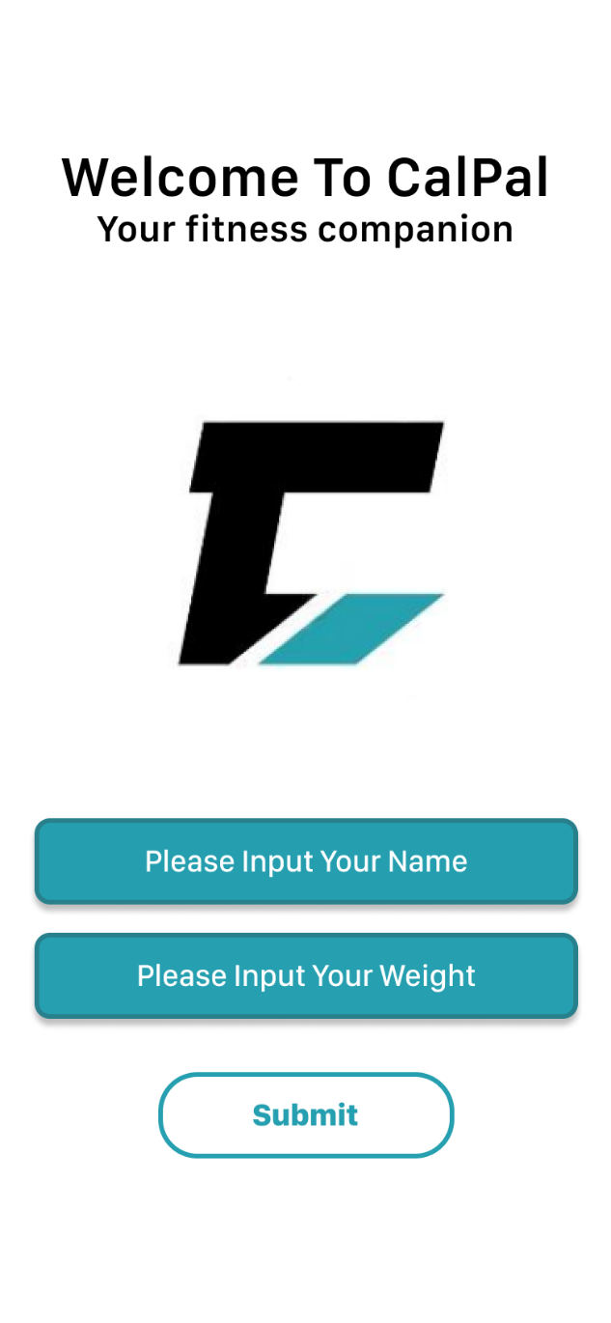
Figure 3: UI prototype for signup page- page will appear when initially loading app to take in user information.


Figure 4: UI prototype for landing page allowing for users to either create a new workout which will prompt video upload or view saved workouts which will take users to the page shown in Figure 6.
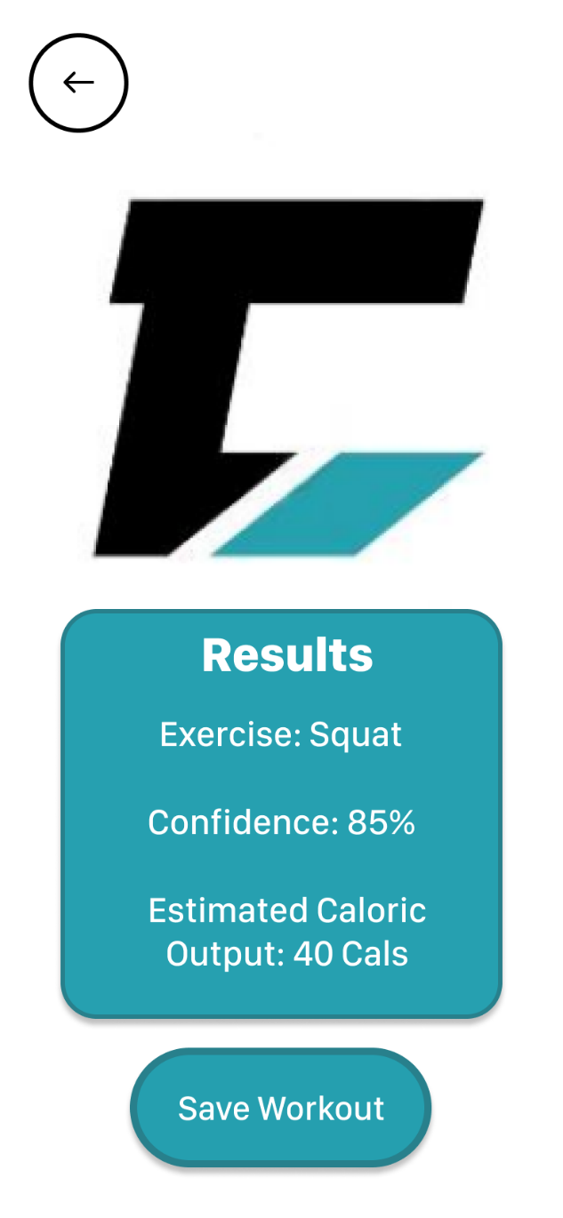
Figure 5: UI prototype for results page. This is the page shown after a video is uploaded then processed by the backend.

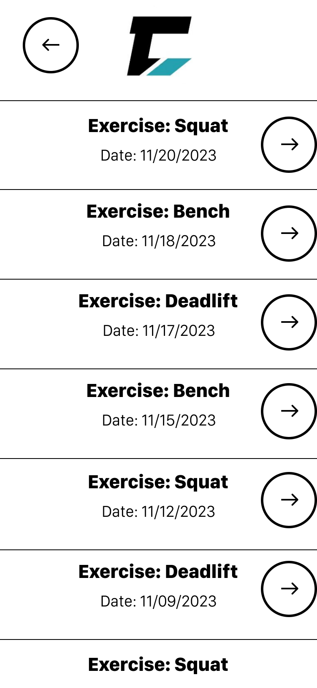
Figure 6: UI prototype for saved workout page. This page allows users to view previously saved workouts, clicking the arrow next to the exercise column will bring users to the results page for that exercise like in Figure 5.

