Quick Start User Guide
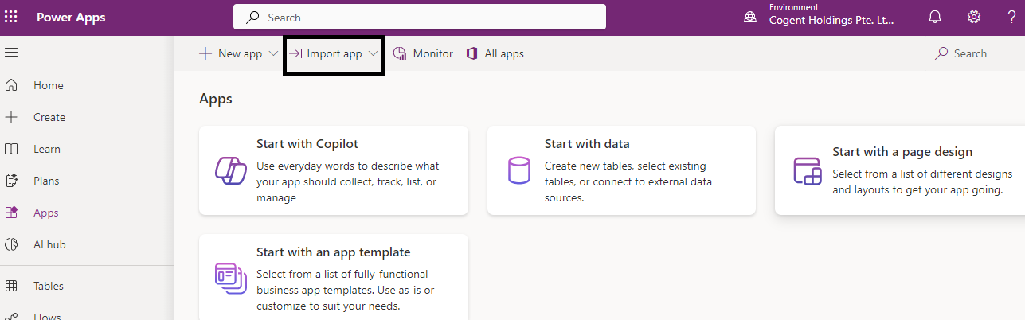
Select Import App

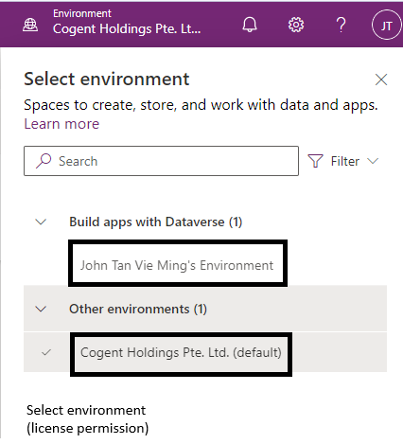
Select either environment. Import (Save) App to environment.
Click ‘Play’ button to launch App. Follow on-screen instructions.

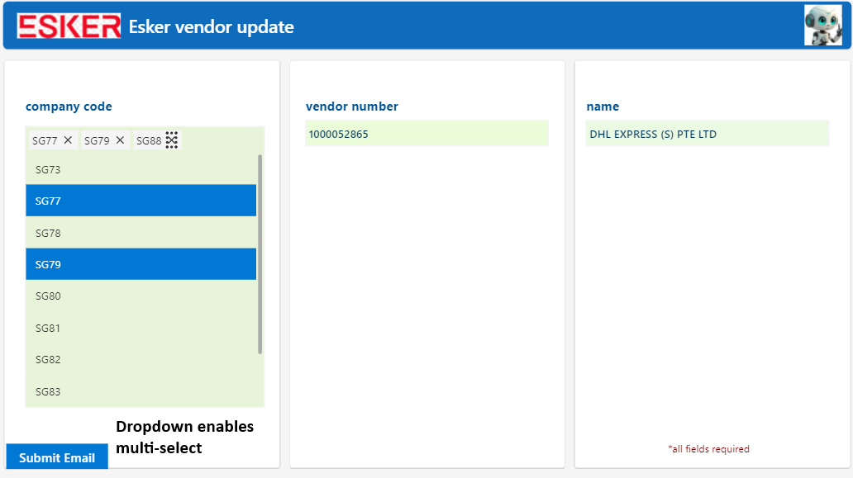
Dropdown enables users to select multiple company codes with the same vendor number.

Refer to documentation for more details.
Esker Vendor Data Update
Suggested time to run automation script: 0930am – 1730pm (Monday – Friday)

