

*Demonstration Video*

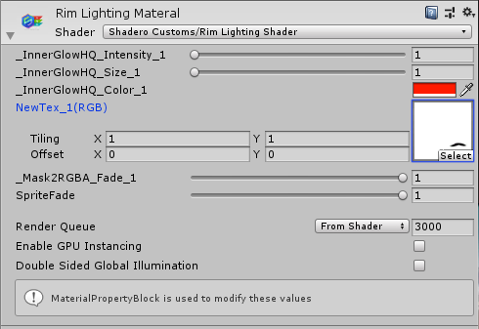

Elder Iron Rim Lighting Shader Docmentation.

This shader allows you to add a rim light effect onto a sprite using a mask. The shader was built using the provided asset, Shadero.

**How to use:   
InnerGlowHQ_Intensity_1** – This will control the strength of the effect around the rim of the object.

**InnerGlowHQ_Size_1** – This will control the size of the effect from the edge to the centre, obeying the masks shapes.

**InnerGlowHQ_Color_1** – Will let you control the colour of the inner glow effect.

**NewTex_1(RGB)** – This is where you place your mask for the material, allowing you to control the location of the effect on the sprite. If no mask is placed the effect will not show. Black is where the effect will show, and white will be ignored.

**Mask2GBRA_Fade_1** – Will let you control how the mask affects the sprite, 1 will place the effect in the black parts of your mask, 0 will place it in the white areas of the mask. .5 will give you a blend between giving you a rim around the whole sprite.

**SpriteFade** – Will control the opacity of the sprite. (This can be ignored.)