**Course One**

# Foundations of Data Science



# Instructions

This is a strategy document using the PACE workflow to organize and classify project tasks. Futhermore, to record decisions and reflections as one works through this project. This document responds the following questions:

* what steps could one take to get 'up to speed' with this project? Who would one like to meet with?
* How would one plan an analytics project?
* What steps would one take to translate a business question to an analytical solution?
* Why is actively managing data an important part of a data analytics team's responsibilities?
* What are some considerations one might need to be mindful of when reporting results?

**Reference Guide**

This project has three tasks; the following visual identifies how the stages of PACE are incorporated across those tasks.

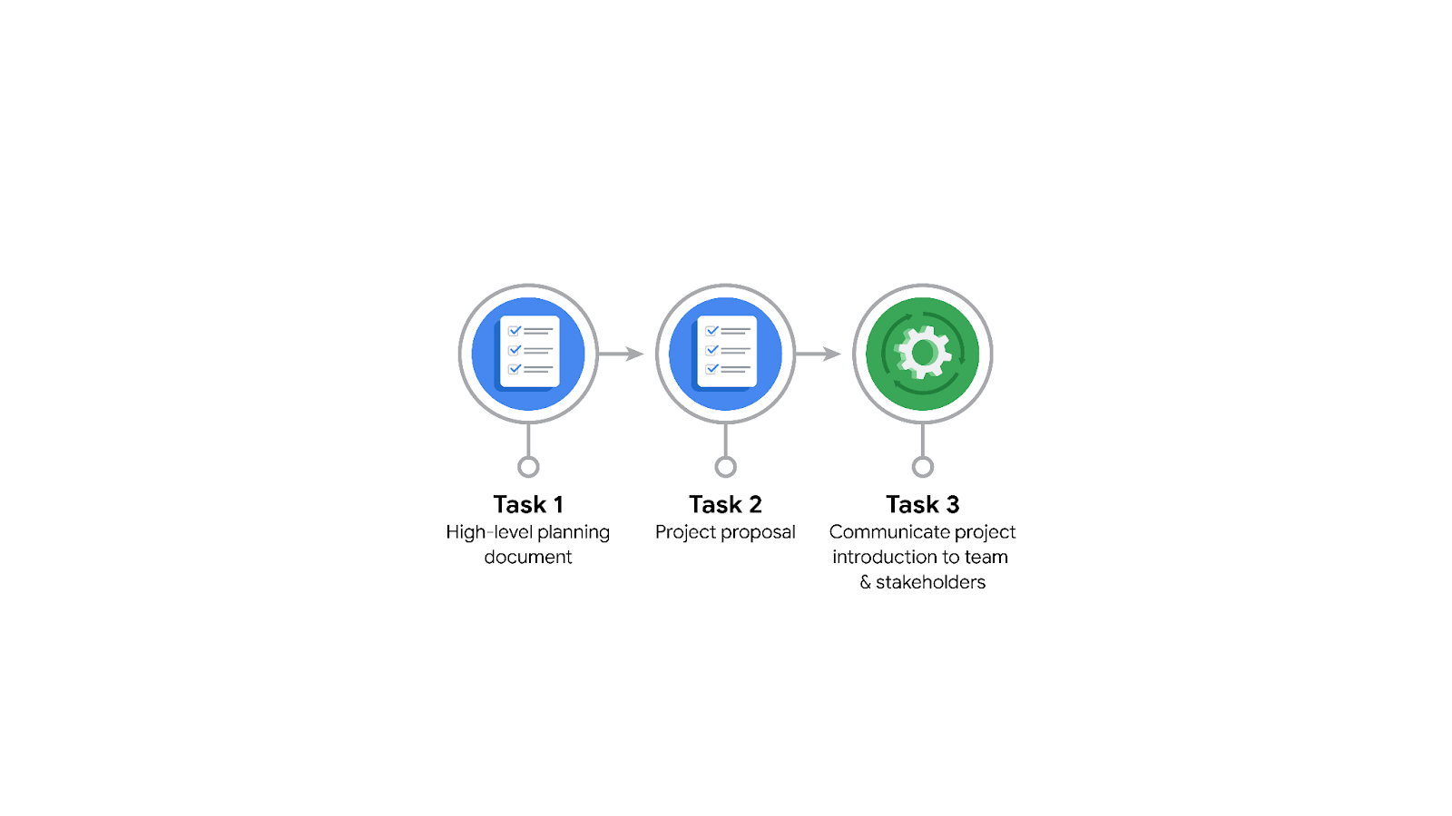

**Data Project Questions & Considerations**

**PACE: Plan Stage**

* Who is your audience for this project?

the Waze data team and cross-functional team members.

* What are you trying to solve or accomplish? And, what do you anticipate the impact of this work will be on the larger needs of the client?

working to develop a machine learning model to predict user churn.

* What questions need to be asked or answered?

What is the condition of the provided dataset? What variables will be the most useful? Are there trends within the data that can provide insight? What steps can I take to reduce the impact of bias?

Who are the users most likely to churn? Why do users churn? When do users churn?

* What resources are required to complete this project?

The project dataset, Python notebook, and input from stakeholders.

* What are the deliverables that will need to be created over the course of this project?

***The*** deliverables include*a*dataset scrubbed for exploratory data analysis, visualizations, statistical model, regression analysis and/or machine learning model.

## 

## **THE PACE WORKFLOW**

**[Alt-text: The PACE Workflow with the four stages in a circle: plan, analyze, construct, and execute.]**

### **Project tasks**

Organized group of tasks that need to be completed within this project.

1. **Evaluating the model: Execute**

Why did you select this stage for this task?

After the model has been constructed, data is run through to evaluate whether it meets the project’s expectations and goals.

1. **Conduct hypothesis testing: Analyze** **and** **Construct**

Why did you select these stages for this task?

During the analyzing stage, it is determined that a statistical test will be used. During the construction phase, the test is carried out.

1. **Begin exploring the data: Analyze**

Why did you select this stage for this task?

During the analysis phase, you will gain a deeper understanding of the dataset and the information within it.

1. **Data exploration and cleaning: Plan** **and Analyze**

Why did you select these stages for this task?

Planning takes place when you first make choices about the methods needed. The cleaning process then takes place in the analyzing stage.

1. **Establish structure for project workflow (PACE): Plan**

Why did you select this stage for this task?

Planning stage. Creating an initial project PACE document outlines the workflow and helps to plan how to best approach a project.

1. **Communicate final insights with stakeholders: Execute**

Why did you select this stage for this task?

Communication is necessary at various points throughout a project. Final insights are shared with stakeholders in the execute phase of the data project workflow.

1. **Compute descriptive statistics: Analyze**

Why did you select this stage for this task?

Investigating the statistics within data takes place during analysis.

1. **Visualization building: Analyze and Construct**

Why did you select these stages for this task?

Visualization begins with data assessment and is created during the construction stage.

1. **Write a project proposal: Plan**

Why did you select this stage for this task?

Planning stage. A project proposal is the initial document used to define a project.

1. **Build a regression model: Analyze and Construct**

Why did you select this stage for this task?

During the analyzing stage, the model is examined in detail to be sure it will meet the needs of the task. The building of the regression model will take place in the construction phase.

1. **Compile summary information about the data: Analyze**

Why did you select this stage for this task?

Inspecting a dataset to compile information would take place in the analysis phase.

1. **Build machine learning model: Construct**

Why did you select this stage for this task?

The building of a data model would take place in the construct stage.