|  |  |
| --- | --- |
| The SPN Catalogue  How to use the Supplementary App | Abstract  This app allows you to visualize data from the Shape & Symmetry Lab with respect to the visually evoked event-related component, the Sustained Posterior Negativity (SPN).  Alexis Makin, John Tyson-Carr, Giulia Rampone, Yiovanna Derpsch, Damien Wright & Marco Bertamini  V1.0 |

# 1. Introduction

The database comprises data from 6674 individual SPN components from 2215 subjects spanning across 40 separate projects recorded since 2012. In an attempt to facilitate open-science procedures, we present here an easy-to-use tool for visualizing and exporting data from any project of interest.

This tool allows users to flexibly visualize and export data for further analysis in an attempt to remove barriers to open-science.

# 2. Downloading App & Data

1. This tool was developed using MATLAB. However, we have compiled this tool into a standalone executable file that only requires MATLAB Runtime to run. MATLAB Runtime does not require MATLAB to be installed. MATLAB Runtime is also royalty-free, and thus, it does not require a MATLAB license to be utilized.

This app only requires that you download and install the appropriate MATLAB Runtime (if not installed already). To facilitate this, we have compiled the app using multiple MATLAB Runtime versions to maximize compatibility. Simply download the executable file compiled using the version of MATLAB already installed on your computer. If your version of MATLAB is not available in the list, or if you do not have MATLAB installed on your computer, please download the tool compiled with the latest version of MATLAB listed:

<https://github.com/JohnTyCa/The-SPN-Catalogue>

Next, head to the following website to download the corresponding version of MATLAB Runtime:

<https://uk.mathworks.com/products/compiler/matlab-runtime.html>

1. After installing MATLAB Runtime, the data is available to be downloaded on Open Science Framework at:

<https://osf.io/2sncj/>

Note that the database comprises data from 40 projects requiring 2GB+ of memory, but you are free to only download the required projects - the tool will still work with a subset of the projects.

# 3. Folder Layout

In order to run, the data needs to be organized in a certain manner. Below is an example of the folder downloaded from GitHub for MATALAB 2020b:

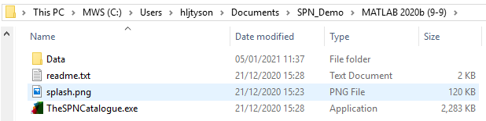

The contents of this folder include:

1. *Data* – This is the folder where the data will be located (obtained from OSF).
2. *readme.txt* –This is the readme file from GitHub.
3. *Splash.png* – The splash image for the app.
4. *TheSPNCatalogue.exe* – Executable app file.

As mentioned above, the “Data” folder will contain the data downloaded from OSF. Each folder within “Data” will correspond to data from a single project with the naming convention of “Project 1”, “Project 2”, “Project N”. See below for an example:

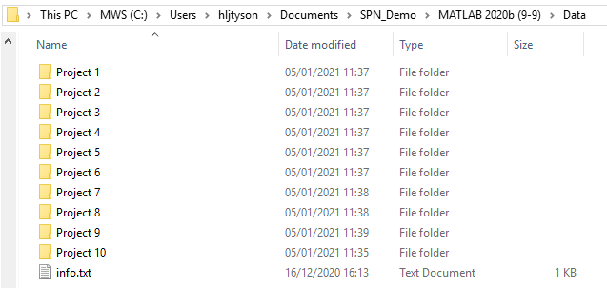

Note that above, only a subset of the 40 project folders are included since not all projects are required for the app to run. Therefore, you are free to download a subset of project folders.

If the folders are organized like described above, the app should work fine.

# 4. Running the App

As long as the prior instructions have been followed, run the executable app file “TheSPNCatalogue.exe” in the root folder. If the “Data” folder is found in the same directory as the executable file, no further pathing is required. If the “Data” folder is located elsewhere on your device, you will be given the opportunity to select the location of the folder when the app initiates.

An example of what the window should look like when it opens is below:

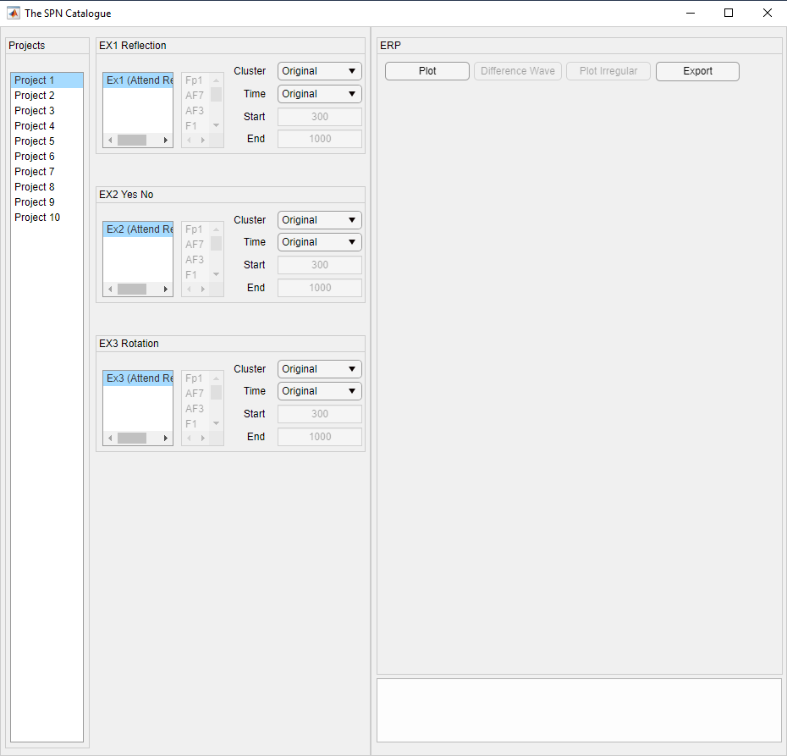

# 5. Visualizing Data

Once the app is open, you will see multiple projects listed on the left (corresponding to the project folders in the “Data” folder). Next to this list, you will see between 1 and 5 boxes corresponding to the individual experiments for the selected project. If the selected project is changed, the corresponding experiments will also refresh. For each experiment, you can see the conditions listed for that experiment.

## 5.1. Plot

The “Plot” button allows for the plotting of data for all selected conditions. When “Plot” is clicked,



When “Plot” is clicked, the waveforms for the selected conditions will be displayed. You are free to select multiple conditions from the same experiment by holding down the “Ctrl” button on your keyboard and clicking the required conditions. On the right, you will also see the mean amplitude for the selected electrodes in the time interval selected for each experiment and condition. Below this bar graph, the summary statistics are shown in a table.

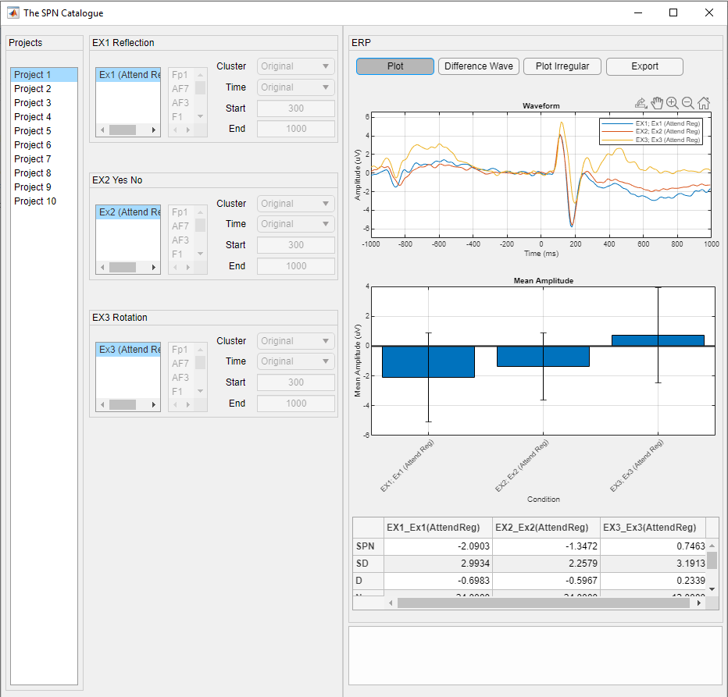

## 5.2. Difference Wave

The “Difference Wave” button allows for the visualization of the SPN wave, i.e. each condition has its corresponding “irregular” condition subtracted from it to produce regularity specific activity.

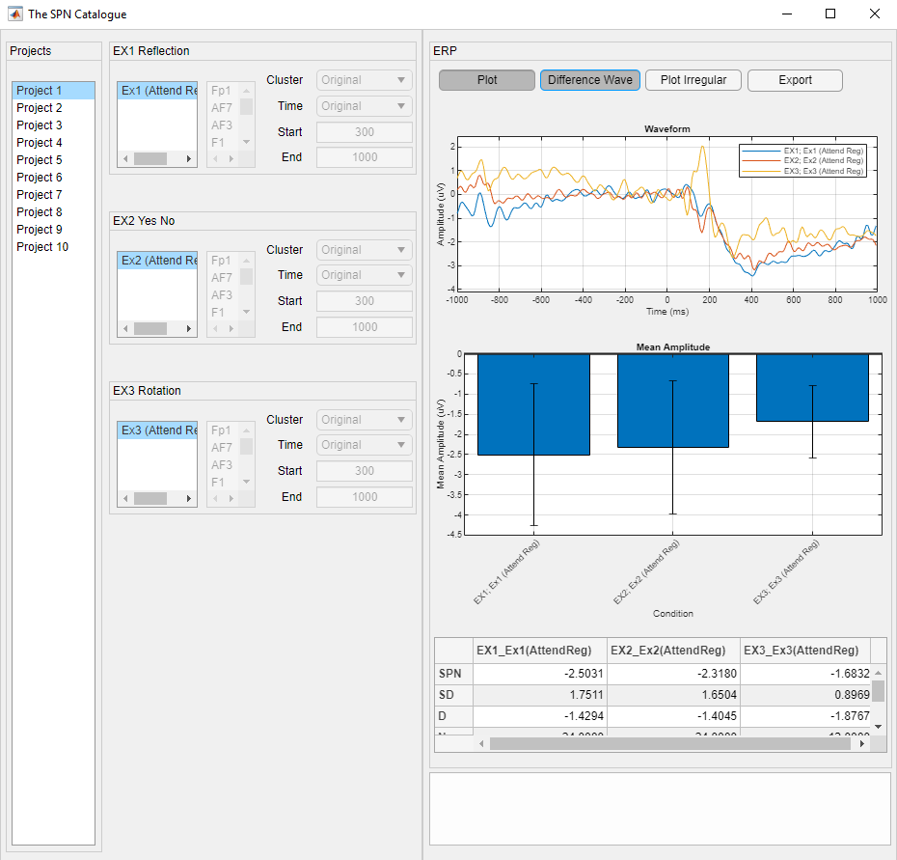

When “Difference Wave” is clicked, the waveforms, the mean values in the bar plot and the summary statistics in the table are all updated to represent the new values.



## 5.3. Plot Irregular

The “Plot Irregular” button allows for the plotting of the irregularity conditions for each experiment. Note that since the irregularity conditions are used to produce the difference waves, they will not be plotted whilst “Difference Wave” is also selected.

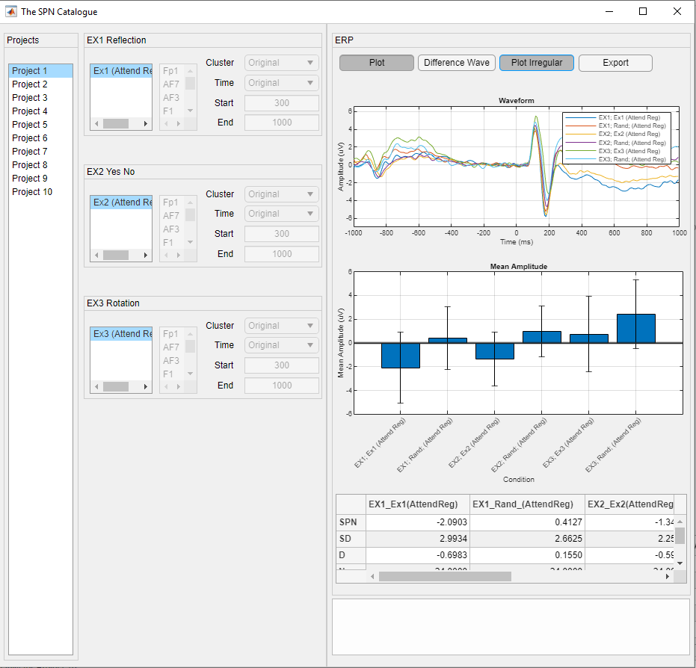

The waveform plot, the mean values bar graph and the table now include the irregularity conditions.



## 5.4. Cluster Selection

For each experiment, a cluster of electrodes were selected for the original analysis and reported within the corresponding manuscript. This app allows us to visualize the waveforms and mean values when different electrode clusters are selected.

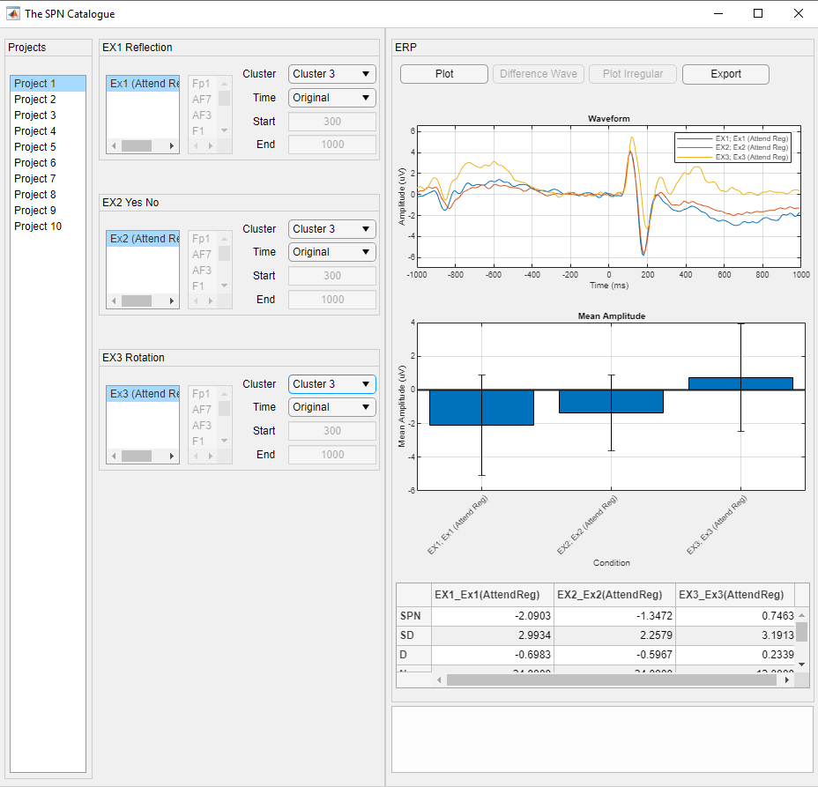

For each experiment, there is a dropdown box corresponding to the “Cluster” of electrodes. In addition to the “Original” cluster, other default selections are available under “Cluster 1”, “Cluster 2” and “Cluster 3”. Furthermore, you can select “Custom” in order to manually select a subset of electrodes from the list of electrodes. To select multiple electrodes, hold down “Ctrl” on your keyboard and click on the desired electrodes.

Please note that the selected electrode cluster is specific to the currently selected condition and the electrode cluster will need to be selected for each condition for each experiment. **Electrode clusters can only be changed when “Plot” is not selected. When the desired electrode clusters are selected, click “Plot” to update the values in the figures and table.**

## 5.5. Time Selection

Similar to the cluster selection process, the time window can be selected for which to extract mean amplitude. Using the “Time” dropdown box, the “Original” time window is selected by default corresponding to the time window originally analyzed. To present alternative analysis windows, a second option of “Dogma” is available. This corresponds to an alternative time window that was not originally analyzed. Using the “Custom” option, a custom time window can be selected.

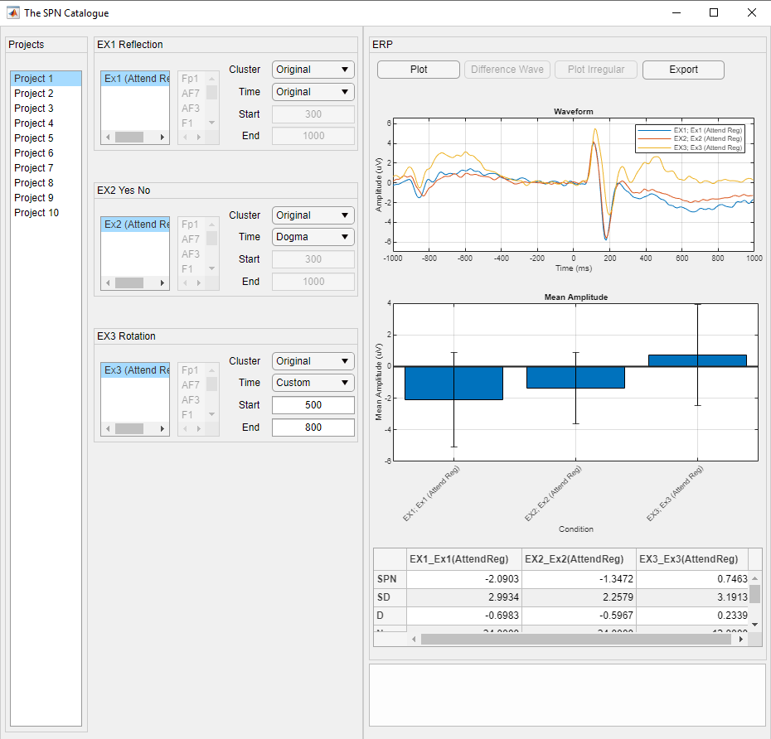

Please note that the selected time window is specific to the currently selected condition and the time window will need to be selected for each condition for each experiment. Time windows **can only be changed when “Plot” is not selected. When the desired time window is selected, click “Plot” to update the values in the figures and table.**

# 6. Exporting Data

In order to allow users to carry out further statistical analysis on the data, we have included an export function that will export the data to .csv format. Simply select the desired project in the project list and click “Export”.

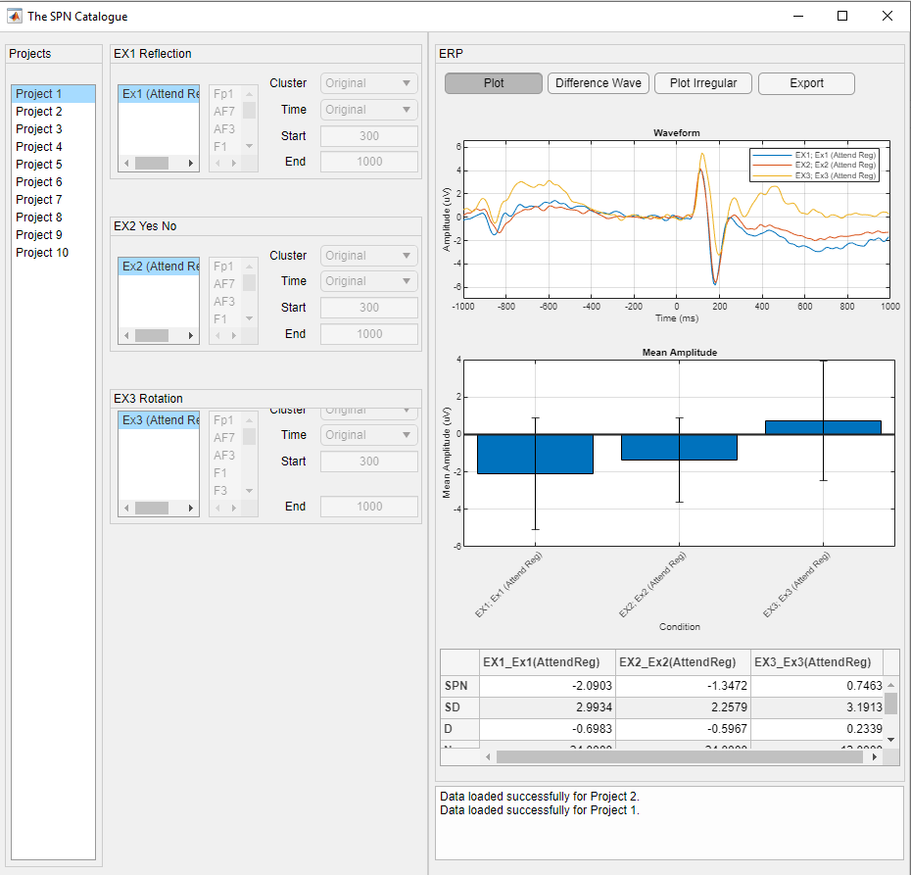

Below is the export window:

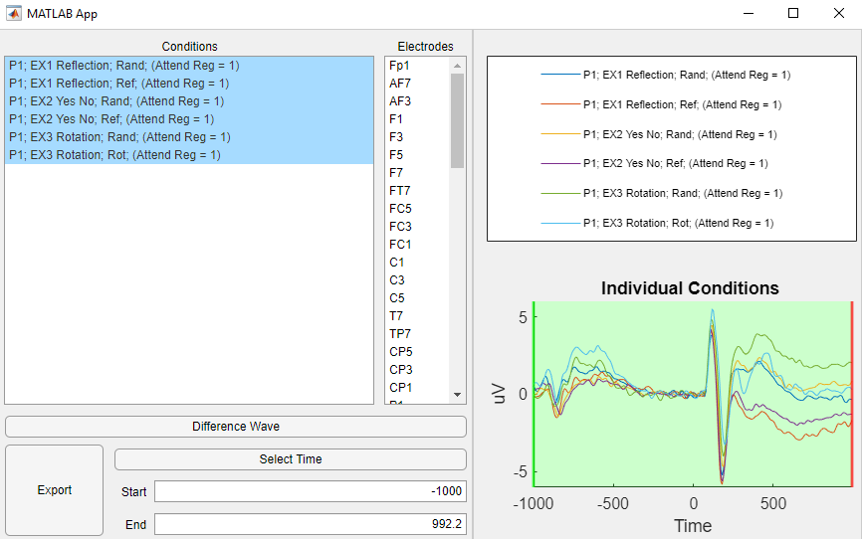

The conditions for the currently selected project will be listed on the right. The conditions for which we want to export data for can be selected. To select multiple conditions, hold “Ctrl” on your keyboard and click them.

## 6.1. Difference Wave

Similar to the main visualization window, you can export mean amplitudes obtained from either the original waveform or the difference waveform.

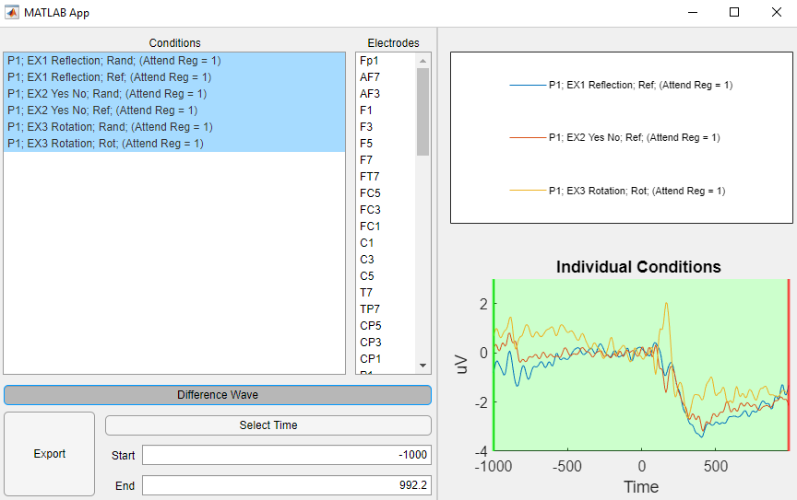

Once selected, the waveforms on the right will update to represent the difference from the corresponding irregularity condition.



## 6.2. Cluster Selection

The “Electrodes” list allows us to select the electrodes for which we wish to extract mean values for. To select multiple electrodes, hold “Ctrl” on your keyboard and click the desired electrodes. The data across these electrodes will be averaged.



## 6.3. Time Selection

The time window we wish to average across can also be changed. The default selection will be the originally analyzed time window. To edit these values, either type in the desired “Start” and “End” time, or click “Select Time”. Clicking “Select Time” allows you to click on the waveform on the right to manually select the “Start” and “End” times.



## 6.4. Export

When the desired conditions, electrodes and time windows have been selected, clicking “Export” will allow you to select a folder to save the data to.



Once the desired folder has been selected, multiple files will be generated depending on the conditions selected:

1. A single “Long” format .csv file will be generated that will contain the mean amplitude for each subject and condition. The data from all experiments for that project will be contained within this file.
2. Multiple “Wide” format .csv files will be generated, one for each experiment in the project.

If the selected save folder already contains save data for the desired project, save names will be appended to avoid overwriting.