CS 008 Section A

John Urbani & Alex Silence

Assignment: Final Project

The Beatles Tribute Website

Version <1.0>

Table Of Contents

Time Log 3

Introduction 5

Purpose 5

Definitions, acronyms, and abbreviations 5

Overall Description 5

Story Board 6

Specific requirements 7

|  |  |  |  |
| --- | --- | --- | --- |
| Time Log | | | |
| Estimated time to complete assignment => | | | 35 Hours |
| Date | Time Spent  (in hours) | Description | Author |
| 11/1 | 3 | Basic site outline and CSS | John Urbani |
| 11/2 | 1 | Met with client to discuss project | Alex Silence |
| 11/9 | 1 | Work on About the Band section | John Urbani |
| 11/10 | .75 | Updated nav to be static | Alex Silence |
| 11/10 | 2 | Worked on videos and CSS for other pages | John & Alex |
| 11/20 | 2 | Worked on feed back system and contact page | John Urbani |
| 11/23 | 1 | Tested website for errors and talked more with client | Alex Silence |
| 11/30 | 1 | Remade the home page, added news sections | John Urbani |
| 12/1 | 1.5 | Tested website for errors and talked more with client | Alex Silence |
| 12/5 | 3 | Added band member bios, found new images, sourced new images, fixed CSS to be consistent across the site, validated HTML and CSS | John Urbani |
| 12/6 | 4 | Added photos section, fixed videos section to contain information about the songs, fixed contact page to be relevant to the band site, added more news articles, finished the About page, fixed CSS issues, and added a footer with info about the image sources | John Urbani |
|  |  |  |  |
|  |  |  |  |
|  |  |  |  |
|  |  |  |  |
|  |  |  |  |
|  |  |  |  |
|  |  |  |  |
|  |  |  |  |
|  |  |  |  |
|  |  |  |  |
|  | 19.25 | <=Total Time Spent |  |
|  |  |  |  |

# Introduction

### Purpose

The purpose of this document is to describe the requirement specification for the web site “A Tribute to the Beatles”.

The intended audience for this document is Fans of The Beatles band

*First it is the contract between you and the client. Second it is for the developer of the site. Two primary goals are:*

1. *Client gets a very good understanding of what you will be delivering.*
2. *Developer has a very good understanding of what they are going to create.*

### Definitions, acronyms, and abbreviations

*Sample for the client:*

ER Diagram – a diagram to represent the data you want to save with your system

W3 Validation – refers to both Html and CSS validation tool provided by the W3c.org. the html validator is located at:

<http://validator.w3.org/>

with the CSS validator located at:

<http://jigsaw.w3.org/css-validator/>

# Overall Description

A short paragraph describing the site

# Story Board

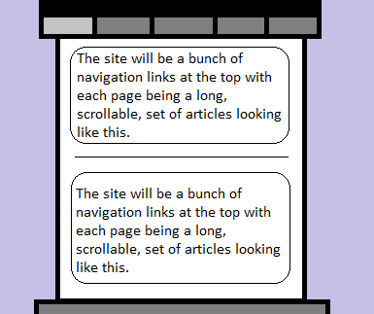

# Specific requirements

1. *You fill out* – This is where you would put the exact detail of what you want for the project. For example:
2. *Title for main page*: *A Tribute to The Beatles.*
3. *Meta Description*: *Home page with recent Beatles news.*
4. *Meta Character set*: UTF - 8
5. *Logo*: *Picture of a band member.*
6. *Main page photo*: *News articles*