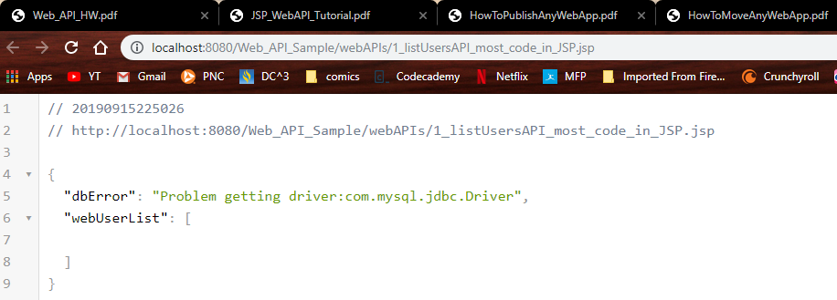

To achieve this I disincluded the MySQL connector library

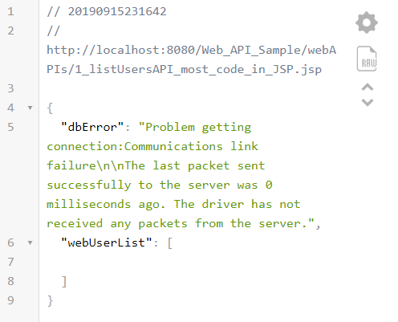

To achieve this I failed to tunnel into cis-linux2 before running the JSP

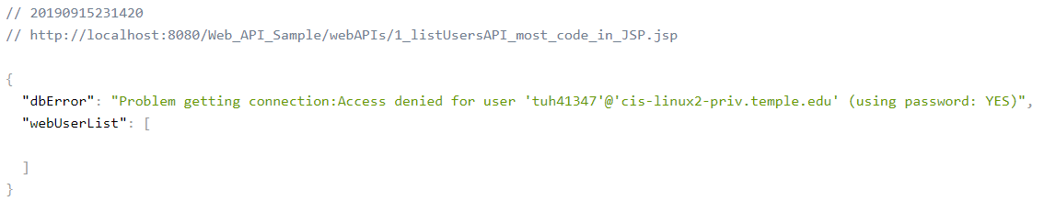

To achieve this I intentionally misspelled my database password, but accidentally misspelling it would’ve worked just as well to achieve this result, I presume.

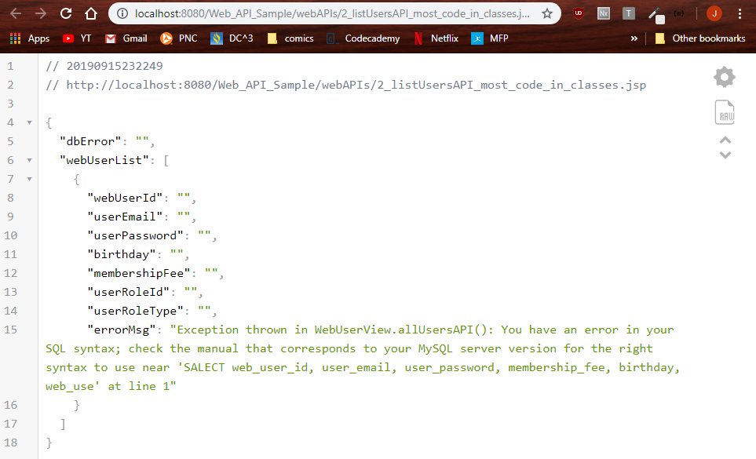

Now, this is my best work yet, you see in, an absolutely revolutionary stroke of brilliance, I’ve replaced the word SELECT in the WebUserView class with the word SALECT, which SQL simply lacks the chutzpah to work with, yielding the syntax error you see before you.

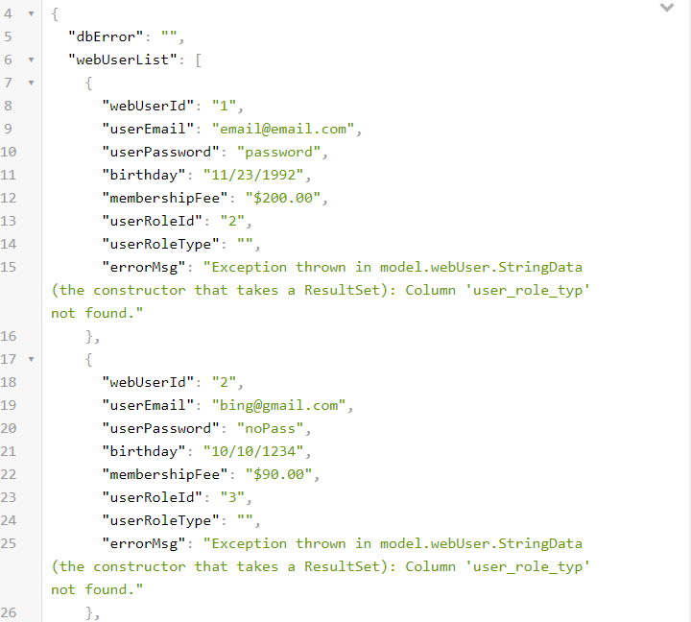

The given error message repeats much the same for the rest.  
To achieve this result, I left off the tailing ‘e’ of ‘user_role_type’ in the StringData class wherein the FormatUtils is called for each desired column.

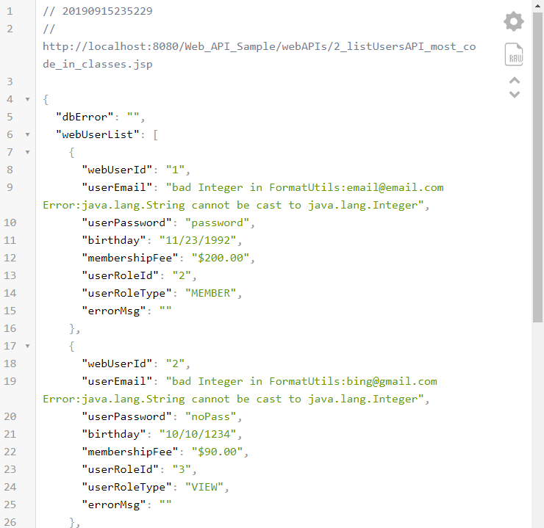

Trying to prove the compiler wrong, I spent 4 days attempting to count from 1 to an e-mail address, but in the end I had to concede defeat. It may have been a better use of my time to instead go back into StringData.java and make a .formatString call rather than a .formatInteger call on the user_email column.