



**SAKET GYANPEETH’S**

**SAKET COLLEGE OF ARTS, SCIENCE AND COMMERCE**

**(Permanently Affiliated to University of Mumbai)**

**NAAC Accredited B Grade**

Saket Vidyanagari Marg, Chinchpada Road, Katemanivali, Kalyan (East) – 421306, Dist. Thane (MAH)

Department of Information Technology

**CERTIFICATE**

**This is to certify that**

**SEJAL JAIPRAKASH SINGH** of **MSc Information Technology Part-II** Class has satisfactory carried out the required practical in the subject.

**MACHINE LEARNING**

For the Academic year 2023 – 2024

**Practical In-Charge Head of Department External Examiner**

**INDEX:**

|  |  |  |
| --- | --- | --- |
| **Sr. No.** | **Content** | **Page No.** |
| **1** | 1A. Design a simple machine learning model to train the training instances and test the same.  1B. Implement and demonstrate the FIND-S algorithm for finding the most specific hypothesis based on a given set of training data samples. Read the training data from a .CSV file. | 4-8 |
| **2** | 2A. Perform Data Loading, Feature selection (Principal Component Analysis) and Feature Scoring and Ranking  2B. For a given set of training data example stored in a .CSV file, implement and demonstrate the Candidate-Elimination algorithm to output a description of the set of all hypotheses consistent with the training examples. | 9-13 |
| **3** | 3A. Write a program to implement the Naïve Bayesian classifier for a sample training data set stored as a .CSV file. Compute the accuracy of the classifier, considering few test data sets.  3B. Write a program to implement Decision Tree and Random Forest with Prediction, Test Score and Confusion Matrix. | 14-17 |
| **4** | 4A. For a given set of training data example stored in a .CSV file implement Least Square Regression Algorithm.  4B. For a given set of training data examples stored in a .CSV file implement Logistic Regression Algorithm. | 18-23 |
| **5** | Write a program to demonstrate the working of the decision tree based ID3 algorithm. Use an appropriate data set for building the decision tree and apply this knowledge to classify a new sample. | 24-27 |
| **6** | Implement the classification model using clustering for the following techniques with K means clustering with prediction, Test Score and Confusion Matrix. | 28-34 |
| **7** | Implement the Rule Based method and test the same. | 35-39 |
| **8** | 8A. Write a program to construct a Bayesian Network considering medical data. Use this model to demonstrate the diagnosis of heart patient using standard Heart Disease Data Set. | 40-43 |

**PRACTICAL:1**

**1A. Design a simple machine learning model to train the training instances and test the same.**

import numpy

import matplotlib.pyplot as plt

numpy.random.seed(2)

x = numpy.random.normal(3, 1, 100)

y = numpy.random.normal(150, 40, 100) / x

plt.scatter(x, y)

plt.show()

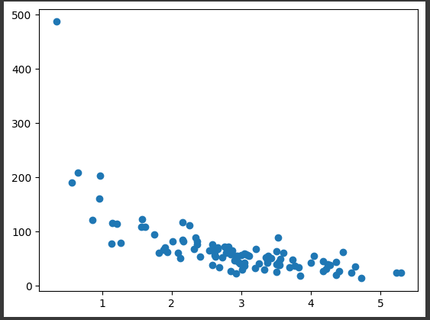

train_x = x[:80]

train_y = y[:80]

test_x = x[80:]

test_y = y[80:]

plt.scatter(train_x, train_y)

plt.show()

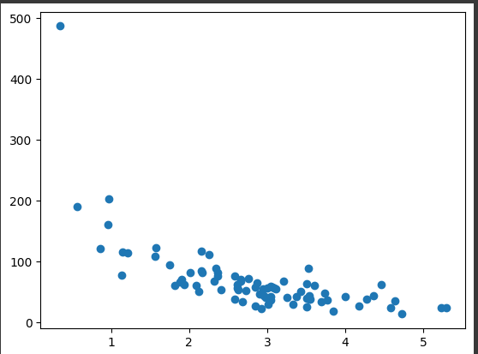

plt.scatter(test_x, test_y)

plt.show()

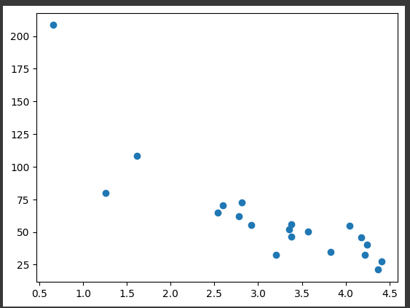

import numpy

import matplotlib.pyplot as plt

numpy.random.seed(2)

x = numpy.random.normal(3, 1, 100)

y = numpy.random.normal(150, 40, 100) / x

train_x = x[:80]

train_y = y[:80]

test_x = x[80:]

test_y = y[80:]

mymodel = numpy.poly1d(numpy.polyfit(train_x, train_y, 4))

myline = numpy.linspace(0, 6, 100)

plt.scatter(train_x, train_y)

plt.plot(myline, mymodel(myline))

plt.show()

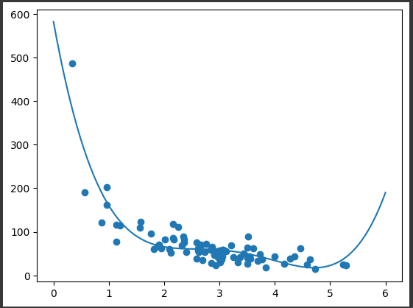

#USING R2

import numpy

from sklearn.metrics import r2_score

numpy.random.seed(2)

x = numpy.random.normal(3, 1, 100)

y = numpy.random.normal(150, 40, 100) / x

train_x = x[:80]

train_y = y[:80]

test_x = x[80:]

test_y = y[80:]

mymodel = numpy.poly1d(numpy.polyfit(train_x, train_y, 4))

r2 = r2_score(train_y, mymodel(train_x))

print(r2)

**OUTPUT**: 0.79886455446298

import numpy

from sklearn.metrics import r2_score

numpy.random.seed(2)

x = numpy.random.normal(3, 1, 100)

y = numpy.random.normal(150, 40, 100) / x

train_x = x[:80]

train_y = y[:80]

test_x = x[80:]

test_y = y[80:]

mymodel = numpy.poly1d(numpy.polyfit(train_x, train_y, 4))

r2 = r2_score(test_y, mymodel(test_x))

print(r2)

**OUTPUT**: 0.8086921460343566

**1B. Implement and demonstrate the FIND-S algorithm for finding the most specific hypothesis based on a given set of training data samples. Read the training data from**

**a .CSV file**

import csv

hypo = ['%','%','%','%','%','%'];

with open('/trainingdata.csv') as csv_file:

    readcsv = csv.reader(csv_file, delimiter=',')

    print(readcsv)

    data = []

    print("\nThe given training examples are:")

    for row in readcsv:

        print(row)

        if row[len(row)-1].upper() == "YES":

            data.append(row)

**OUTPUT:**

<_csv.reader object at 0x796a0f73b060>The given training examples are:

['sky','airTemp', 'humidity', 'wind', 'water', 'forecast', 'enjoySport']

['Sunny', 'Warm', 'Normal', 'Strong', 'Warm', 'Same', 'Yes']

['Sunny', 'Warm', 'High', 'Strong', 'Warm', 'Same', 'Yes']

['Rainy', 'Cold', 'High', 'Strong', 'Warm', 'Change', 'No']

['Sunny', 'Warm', 'High', 'Strong', 'Cool', 'Change', 'Yes']

print("\nThe positive examples are:");

for x in data:

    print(x);

print("\n");

**OUTPUT:**

The positive examples are:

['Sunny', 'Warm', 'Normal', 'Strong', 'Warm', 'Same', 'Yes']

['Sunny', 'Warm', 'High', 'Strong', 'Warm', 'Same', 'Yes']

['Sunny', 'Warm', 'High', 'Strong', 'Cool', 'Change', 'Yes']

TotalExamples = len(data);

i=0;

j=0;

k=0;

print("The steps of the Find-s algorithm are :\n",hypo);

list = [];

p=0;

d=len(data[p])-1;

for j in range(d):

    list.append(data[i][j]);

hypo=list;

i=1;

for i in range(TotalExamples):

    for k in range(d):

        if hypo[k]!=data[i][k]:

            hypo[k]='?';

            k=k+1;

        else:

            hypo[k];

    print(hypo);

i=i+1;

**OUTPUT:**

The steps of the Find-s algorithm are :

['%', '%', '%', '%', '%', '%']

['Sunny', 'Warm', 'Normal', 'Strong', 'Warm', 'Same']

['Sunny', 'Warm', '?', 'Strong', 'Warm', 'Same']

['Sunny', 'Warm', '?', 'Strong', '?', '?']

print("\nThe maximally specific Find-s hypothesis for the given training examples is :");

list=[];

for i in range(d):

    list.append(hypo[i]);

print(list);

**OUTPUT:**

The maximally specific Find-s hypothesis for the given training examples is :

['Sunny', 'Warm', '?', 'Strong', '?', '?']

**PRACTICAL 2**

**2A. Perform Data Loading, Feature selection (Principal Component analysis) and Feature Scoring and Ranking.**

import numpy as np

import pandas as pd

url = "https://archive.ics.uci.edu/ml/machine-learning-databases/iris/iris.data"

names = ['sepal-length', 'sepal-width', 'petal-length', 'petal-width', 'Class']

dataset = pd.read_csv(url, names=names)

dataset.head()

**OUTPUT:**

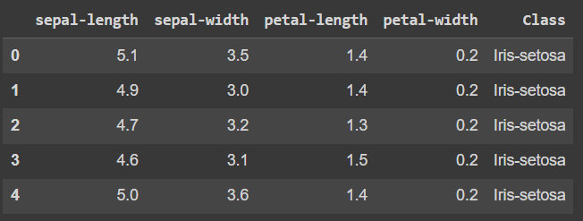

X = dataset.drop('Class', 1)

y = dataset['Class']

**OUTPUT:**



from sklearn.model_selection import train_test_split

X_train, X_test, y_train, y_test = train_test_split(X, y,test_size=0.2, random_state=0)

from sklearn.preprocessing import StandardScaler

sc = StandardScaler()

X_train = sc.fit_transform(X_train)

X_test = sc.transform(X_test)

from sklearn.decomposition import PCA

pca = PCA()

X_train = pca.fit_transform(X_train)

X_test = pca.transform(X_test)

explained_variance = pca.explained_variance_ratio

from sklearn.decomposition import PCA

pca = PCA(n_components=1)

X_train = pca.fit_transform(X_train)

X_test = pca.transform(X_test)

from sklearn.ensemble import RandomForestClassifier

classifier = RandomForestClassifier(max_depth=2, random_state=0)

classifier.fit(X_train, y_train)

# Predicting the Test set results

y_pred = classifier.predict(X_test)

from sklearn.metrics import confusion_matrix

from sklearn.metrics import accuracy_score

cm = confusion_matrix(y_test, y_pred)

print(cm)

print( accuracy_score(y_test, y_pred))

**OUTPUT:**

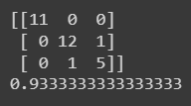

from sklearn.decomposition import PCA

pca = PCA(n_components=1)

X_train = pca.fit_transform(X_train)

X_test = pca.transform(X_test)

print()

**OUTPUT:**

<class 'sklearn.decomposition._pca.PCA'>

**2B. For a given set of training data examples stored in a .CSV file, implement and demonstrate the Candidate-Elimination algorithm to output a description of the set of all hypotheses consistent with the training examples.**

import numpy as np

import pandas as pd

# Loading Data from a CSV File

data = pd.DataFrame(data=pd.read_csv('/content/train (1).csv'))

print(data)

**OUTPUT:**

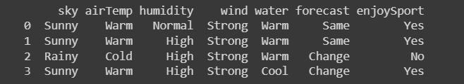

# Separating concept features from Target

concepts = np.array(data.iloc[:,0:-1])

print(concepts)

**OUTPUT:**

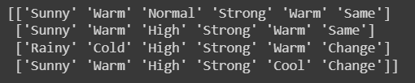

# Isolating target into a separate DataFrame

# copying last column to target array

target = np.array(data.iloc[:,-1])

print(target)

**OUTPUT:**



def learn(concepts, target):

    # Initialise S0 with the first instance from concepts

    # .copy() makes sure a new list is created instead of just pointing to the same memory location

    specific_h = concepts[0].copy()

    print("\nInitialization of specific_h and general_h")

    print(specific_h)

    #h=["#" for i in range(0,5)]

    #print(h)

    general_h = [["?" for i in range(len(specific_h))] for i in range(len(specific_h))]

    print(general_h)

    # The learning iterations

    for i, h in enumerate(concepts):

        # Checking if the hypothesis has a positive target

        if target[i] == "Yes":

            for x in range(len(specific_h)):

                # Change values in S & G only if values change

                if h[x] != specific_h[x]:

                    specific_h[x] = '?'

                    general_h[x][x] = '?'

        # Checking if the hypothesis has a positive target

        if target[i] == "No":

            for x in range(len(specific_h)):

                # For negative hyposthesis change values only  in G

                if h[x] != specific_h[x]:

                    general_h[x][x] = specific_h[x]

                else:

                    general_h[x][x] = '?'

        print("\nSteps of Candidate Elimination Algorithm",i+1)

        print(specific_h)

        print(general_h)

    # find indices where we have empty rows, meaning those that are unchanged

    indices = [i for i, val in enumerate(general_h) if val == ['?', '?', '?', '?', '?', '?']]

    for i in indices:

        # remove those rows from general_h

        general_h.remove(['?', '?', '?', '?', '?', '?'])

    # Return final values

    return specific_h, general_h

s_final, g_final = learn(concepts, target)

print("\nFinal Specific_h:", s_final, sep="\n")

print("\nFinal General_h:", g_final, sep="\n")

**OUTPUT:**

Initialization of specific_h and general_h

['Sunny' 'Warm' 'Normal' 'Strong' 'Warm' 'Same']

[['?', '?', '?', '?', '?', '?'], ['?', '?', '?', '?', '?', '?'], ['?', '?', '?', '?', '?', '?'], ['?', '?', '?', '?', '?', '?'], ['?', '?', '?', '?', '?', '?'], ['?', '?', '?', '?', '?', '?']]

Steps of Candidate Elimination Algorithm 1

['Sunny' 'Warm' 'Normal' 'Strong' 'Warm' 'Same']

[['?', '?', '?', '?', '?', '?'], ['?', '?', '?', '?', '?', '?'], ['?', '?', '?', '?', '?', '?'], ['?', '?', '?', '?', '?', '?'], ['?', '?', '?', '?', '?', '?'], ['?', '?', '?', '?', '?', '?']]

Steps of Candidate Elimination Algorithm 2

['Sunny' 'Warm' '?' 'Strong' 'Warm' 'Same']

[['?', '?', '?', '?', '?', '?'], ['?', '?', '?', '?', '?', '?'], ['?', '?', '?', '?', '?', '?'], ['?', '?', '?', '?', '?', '?'], ['?', '?', '?', '?', '?', '?'], ['?', '?', '?', '?', '?', '?']]

Steps of Candidate Elimination Algorithm 3

['Sunny' 'Warm' '?' 'Strong' 'Warm' 'Same']

[['Sunny', '?', '?', '?', '?', '?'], ['?', 'Warm', '?', '?', '?', '?'], ['?', '?', '?', '?', '?', '?'], ['?', '?', '?', '?', '?', '?'], ['?', '?', '?', '?', '?', '?'], ['?', '?', '?', '?', '?', 'Same']]

Steps of Candidate Elimination Algorithm 4

['Sunny' 'Warm' '?' 'Strong' '?' '?']

[['Sunny', '?', '?', '?', '?', '?'], ['?', 'Warm', '?', '?', '?', '?'], ['?', '?', '?', '?', '?', '?'], ['?', '?', '?', '?', '?', '?'], ['?', '?', '?', '?', '?', '?'], ['?', '?', '?', '?', '?', '?']]

Final Specific_h:

['Sunny' 'Warm' '?' 'Strong' '?' '?']

Final General_h:

[['Sunny', '?', '?', '?', '?', '?'], ['?', 'Warm', '?', '?', '?', '?']]

**PRACTICAL 3**

**3A. Write a program to implement the naïve Bayesian classifier for a sample training data set stored as a .CSV file. Compute the accuracy of the classifier, considering few test data sets.**

import numpy as np

import matplotlib.pyplot as plt

from sklearn import svm, datasets

iris = datasets.load_iris()

X = iris.data[:, :2]

y = iris.target

C = 1.0 # SVM regularization parameter

svc = svm.SVC(kernel='linear', C=1,gamma=0).fit(X, y)

x_min, x_max = X[:, 0].min() - 1, X[:, 0].max() + 1

y_min, y_max = X[:, 1].min() - 1, X[:, 1].max() + 1

h = (x_max / x_min)/100

xx, yy = np.meshgrid(np.arange(x_min, x_max, h),

 np.arange(y_min, y_max, h))

plt.subplot(1, 1, 1)

Z = svc.predict(np.c_[xx.ravel(), yy.ravel()])

Z = Z.reshape(xx.shape)

plt.contourf(xx, yy, Z, cmap=plt.cm.Paired, alpha=0.8)

plt.scatter(X[:, 0], X[:, 1], c=y, cmap=plt.cm.Paired)

plt.xlabel('Sepal length')

plt.ylabel('Sepal width')

plt.xlim(xx.min(), xx.max())

plt.title('SVC with linear kernel')

plt.show(

**OUTPUT:**

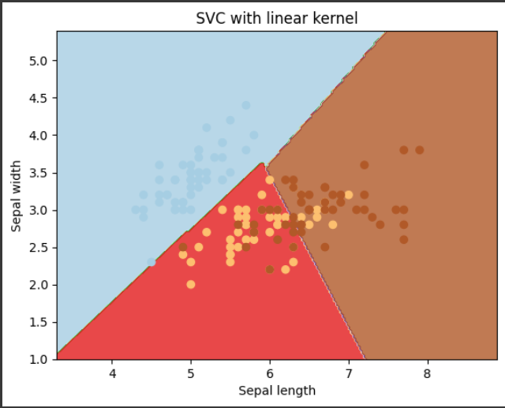

**3B. Write a program to implement Decision Tree and Random forest with Prediction, Test Score and Confusion Matrix**

import numpy as np

import math

import csv

def read_data(filename):

    with open(filename, 'r') as csvfile:

        datareader = csv.reader(csvfile, delimiter=',')

        headers = next(datareader)

        metadata = []

        traindata = []

        for name in headers:

            metadata.append(name)

        for row in datareader:

            traindata.append(row)

    return (metadata, traindata)

class Node:

    def __init__(self, attribute):

        self.attribute = attribute

        self.children = []

        self.answer = ""

    def __str__(self):

        return self.attribute

def subtables(data, col, delete):

    dict = {}

    items = np.unique(data[:, col])

    count = np.zeros((items.shape[0], 1), dtype=np.int32)

    for x in range(items.shape[0]):

        for y in range(data.shape[0]):

            if data[y, col] == items[x]:

                count[x] += 1

    for x in range(items.shape[0]):

        dict[items[x]] = np.empty((int(count[x]), data.shape[1]), dtype="|S32")

        pos = 0

        for y in range(data.shape[0]):

            if data[y, col] == items[x]:

                dict[items[x]][pos] = data[y]

                pos += 1

        if delete:

            dict[items[x]] = np.delete(dict[items[x]], col, 1)

    return items, dict

def entropy(S):

    items = np.unique(S)

    if items.size == 1:

        return 0

    counts = np.zeros((items.shape[0], 1))

    sums = 0

    for x in range(items.shape[0]):

        counts[x] = sum(S == items[x]) / (S.size * 1.0)

    for count in counts:

        sums += -1 * count * math.log(count, 2)

    return sums

def gain_ratio(data, col):

    items, dict = subtables(data, col, delete=False)

    total_size = data.shape[0]

    entropies = np.zeros((items.shape[0], 1))

    intrinsic = np.zeros((items.shape[0], 1))

    for x in range(items.shape[0]):

        ratio = dict[items[x]].shape[0]/(total_size * 1.0)

        entropies[x] = ratio * entropy(dict[items[x]][:, -1])

        intrinsic[x] = ratio * math.log(ratio, 2)

    total_entropy = entropy(data[:, -1])

    iv = -1 * sum(intrinsic)

    for x in range(entropies.shape[0]):

        total_entropy -= entropies[x]

    return total_entropy / iv

def create_node(data, metadata):

    if (np.unique(data[:, -1])).shape[0] == 1:

        node = Node("")

        node.answer = np.unique(data[:, -1])[0]

        return node

    gains = np.zeros((data.shape[1] - 1, 1))

    for col in range(data.shape[1] - 1):

        gains[col] = gain_ratio(data, col)

    split = np.argmax(gains)

    node = Node(metadata[split])

    metadata = np.delete(metadata, split, 0)

    items, dict = subtables(data, split, delete=True)

    for x in range(items.shape[0]):

        child = create_node(dict[items[x]], metadata)

        node.children.append((items[x], child))

    return node

def empty(size):

    s = ""

    for x in range(size):

        s += "   "

    return s

def print_tree(node, level):

    if node.answer != "":

        print(empty(level), node.answer)

        return

    print(empty(level), node.attribute)

    for value, n in node.children:

        print(empty(level + 1), value)

        print_tree(n, level + 2)

metadata, traindata = read_data("/content/tennisdata.csv")

data = np.array(traindata)

node = create_node(data, metadata)

print_tree(node, 0)

**OUTPUT:**

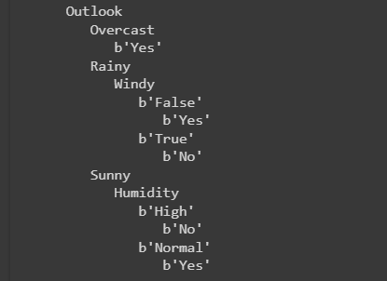

**PRACTICAL 4**

**4A. For a given set of training data examples stored in a .CSV file implement Least Square Regression algorithm.**

import datetime

import numpy as np

import pandas as pd

import matplotlib.pyplot as plt

import seaborn as sns

%matplotlib inline

from sklearn.model_selection import train_test_split

from sklearn.linear_model import LinearRegression

from sklearn.ensemble import RandomForestRegressor

from sklearn.preprocessing import StandardScaler

from sklearn.metrics import r2_score

dataset = pd.read_csv("/content/dataset.csv")

dataset.head(5)

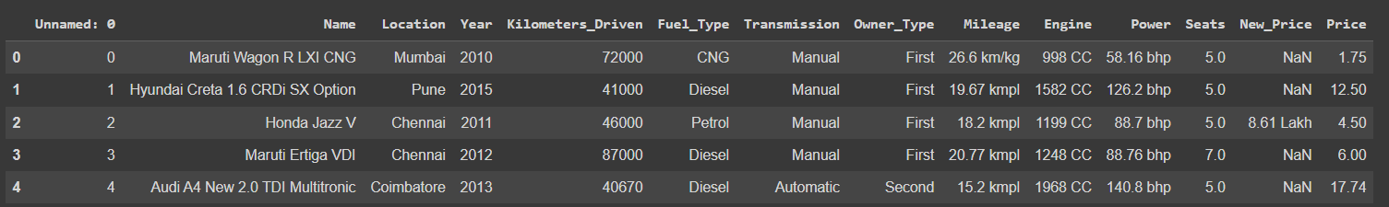

X_train, X_test, y_train, y_test = train_test_split(dataset.iloc[:, :-1],dataset.iloc[:, -1],test_size = 0.3,random_state = 42)

X_train.info()

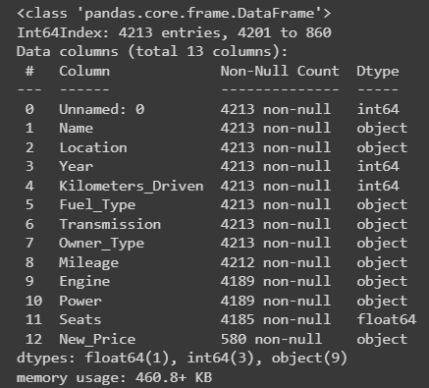

X_train = X_train.iloc[:, 1:]

X_test = X_test.iloc[:, 1:]

X_train["Name"].value_counts()

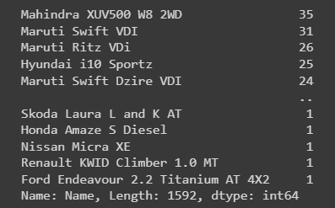

make_train = X_train["Name"].str.split(" ", expand = True)

make_test = X_test["Name"].str.split(" ", expand = True)

X_train["Manufacturer"] = make_train[0]

X_test["Manufacturer"] = make_test[0]

plt.figure(figsize = (12, 8))

plot = sns.countplot(x = 'Manufacturer', data = X_train)

plt.xticks(rotation = 90)

for p in plot.patches:

    plot.annotate(p.get_height(),

                        (p.get_x() + p.get_width() / 2.0,

                         p.get_height()),

                        ha = 'center',

                        va = 'center',

                        xytext = (0, 5),

                        textcoords = 'offset points')

plt.title("Count of cars based on manufacturers")

plt.xlabel("Manufacturer")

plt.ylabel("Count of cars")

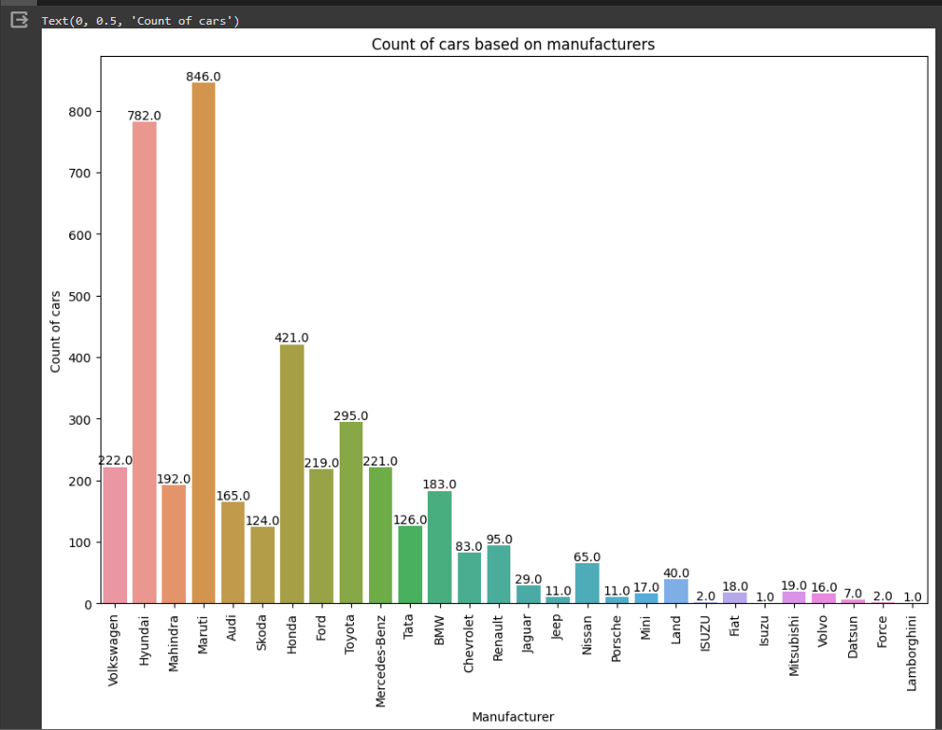

X_train.drop("Name", axis = 1, inplace = True)

X_test.drop("Name", axis = 1, inplace = True)

X_train.drop("Location", axis = 1, inplace = True)

X_test.drop("Location", axis = 1, inplace = True)

curr_time = datetime.datetime.now()

X_train['Year'] = X_train['Year'].apply(lambda x : curr_time.year - x)

X_test['Year'] = X_test['Year'].apply(lambda x : curr_time.year - x)

X_train["Kilometers_Driven"]

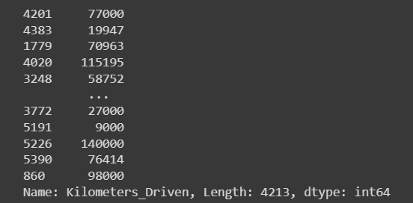

mileage_train = X_train["Mileage"].str.split(" ", expand = True)

mileage_test = X_test["Mileage"].str.split(" ", expand = True)

X_train["Mileage"] = pd.to_numeric(mileage_train[0], errors = 'coerce')

X_test["Mileage"] = pd.to_numeric(mileage_test[0], errors = 'coerce')

print(sum(X_train["Mileage"].isnull()))

print(sum(X_test["Mileage"].isnull()))



X_train["Mileage"].fillna(X_train["Mileage"].astype("float64").mean(), inplace = True)

X_test["Mileage"].fillna(X_train["Mileage"].astype("float64").mean(), inplace = True)

cc_train = X_train["Engine"].str.split(" ", expand = True)

cc_test = X_test["Engine"].str.split(" ", expand = True)

X_train["Engine"] = pd.to_numeric(cc_train[0], errors = 'coerce')

X_test["Engine"] = pd.to_numeric(cc_test[0], errors = 'coerce')

bhp_train = X_train["Power"].str.split(" ", expand = True)

bhp_test = X_test["Power"].str.split(" ", expand = True)

X_train["Power"] = pd.to_numeric(bhp_train[0], errors = 'coerce')

X_test["Power"] = pd.to_numeric(bhp_test[0], errors = 'coerce')

X_train["Engine"].fillna(X_train["Engine"].astype("float64").mean(), inplace = True)

X_test["Engine"].fillna(X_train["Engine"].astype("float64").mean(), inplace = True)

X_train["Power"].fillna(X_train["Power"].astype("float64").mean(), inplace = True)

X_test["Power"].fillna(X_train["Power"].astype("float64").mean(), inplace = True)

X_train["Seats"].fillna(X_train["Seats"].astype("float64").mean(), inplace = True)

X_test["Seats"].fillna(X_train["Seats"].astype("float64").mean(), inplace = True)

X_train.drop(["New_Price"], axis = 1, inplace = True)

X_test.drop(["New_Price"], axis = 1, inplace = True)

X_train = pd.get_dummies(X_train,columns = ["Manufacturer", "Fuel_Type", "Transmission", "Owner_Type"],drop_first = True)

X_test = pd.get_dummies(X_test, columns = ["Manufacturer", "Fuel_Type", "Transmission", "Owner_Type"],drop_first = True)

missing_cols = set(X_train.columns) - set(X_test.columns)

for col in missing_cols:

    X_test[col] = 0

X_test = X_test[X_train.columns]

standardScaler = StandardScaler()

standardScaler.fit(X_train)

X_train = standardScaler.transform(X_train)

X_test = standardScaler.transform(X_test)

linearRegression = LinearRegression()

linearRegression.fit(X_train, y_train)

y_pred = linearRegression.predict(X_test)

r2_score(y_test, y_pred)



rf = RandomForestRegressor(n_estimators = 100)

rf.fit(X_train, y_train)

y_pred = rf.predict(X_test)

r2_score(y_test, y_pred)



**4B. For a given set of training data examples stored in a .CSV file implement Logistic Regression Algorithm.**

import numpy as np

import matplotlib.pyplot as plt

import pandas as pd

# Importing the datasets

datasets = pd.read_csv('/content/Social_Network_Ads.csv')

X = datasets.iloc[:, [2,3]].values

Y = datasets.iloc[:, 4].values

# Splitting the dataset into the Training set and Test set

from sklearn.model_selection import train_test_split

X_Train, X_Test, Y_Train, Y_Test = train_test_split(X, Y, test_size = 0.25, random_state = 0)

# Feature Scaling

from sklearn.preprocessing import StandardScaler

sc_X = StandardScaler()

X_Train = sc_X.fit_transform(X_Train)

X_Test = sc_X.transform(X_Test)

# Fitting the Logistic Regression into the Training set

from sklearn.linear_model import LogisticRegression

classifier = LogisticRegression(random_state = 0)

classifier.fit(X_Train, Y_Train)

# Predicting the test set results

Y_Pred = classifier.predict(X_Test)

# Making the Confusion Matrix

from sklearn.metrics import confusion_matrix

cm = confusion_matrix(Y_Test, Y_Pred)

# Visualising the Training set results

from matplotlib.colors import ListedColormap

X_Set, Y_Set = X_Train, Y_Train

X1, X2 = np.meshgrid(np.arange(start = X_Set[:,0].min() -1, stop = X_Set[:, 0].max() +1, step = 0.01),

                     np.arange(start = X_Set[:,1].min() -1, stop = X_Set[:, 1].max() +1, step = 0.01))

plt.contourf(X1,X2, classifier.predict(np.array([X1.ravel(), X2.ravel()]).T).reshape(X1.shape),

             alpha = 0.75, cmap = ListedColormap(('red', 'green')))

plt.xlim(X1.min(), X2.max())

plt.ylim(X2.min(), X2.max())

for i, j in enumerate(np.unique(Y_Set)):

    plt.scatter(X_Set[Y_Set == j, 0], X_Set[Y_Set == j,1],

                c = ListedColormap(('red', 'green'))(i), label = j)

plt.title('Logistic Regression ( Training set)')

plt.xlabel('Age')

plt.ylabel('Estimated Salary')

plt.legend()

plt.show()

<ipython-input-1-3fd06d73ad23>:51: UserWarning: *c* argument looks like a single numeric RGB or RGBA sequence, which should be avoided as value-mapping will have precedence in case its length matches with *x* & *y*. Please use the *color* keyword-argument or provide a 2D array with a single row if you intend to specify the same RGB or RGBA value for all points.

plt.scatter(X_Set[Y_Set == j, 0], X_Set[Y_Set == j,1]

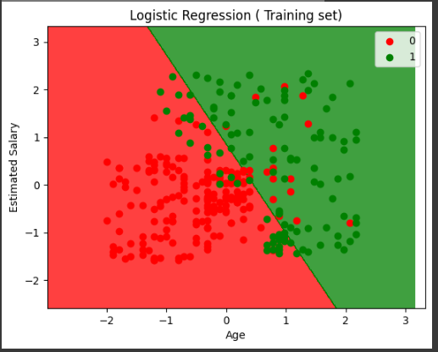

**PRACTICAL:5**

**Write a program to demonstrate the working of the decision tree based ID3 algorithm. Use an appropriate data set for building the decision tree and apply this knowledge to classify a new sample.**

import pandas as pd

import numpy as np

train_data_m = pd.read_csv("PlayTennis.csv")

test_data_m = pd.read_csv("PlayTennis.csv")

train_data_m.head()

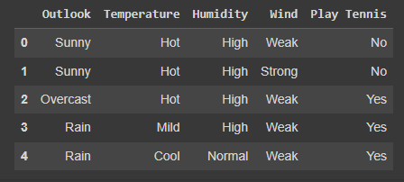

def calc_total_entropy(train_data, label, class_list):

    total_row = train_data.shape[0]

    total_entr = 0

    for c in class_list:

        total_class_count = train_data[train_data[label] == c].shape[0]

        total_class_entr = - (total_class_count/total_row)*np.log2(total_class_count/total_row)

        total_entr += total_class_entr

    return total_entr

def calc_entropy(feature_value_data, label, class_list):

    class_count = feature_value_data.shape[0]

    entropy = 0

    for c in class_list:

        label_class_count = feature_value_data[feature_value_data[label] == c].shape[0]

        entropy_class = 0

        if label_class_count != 0:

            probability_class = label_class_count/class_count

            entropy_class = - probability_class * np.log2(probability_class)

        entropy += entropy_class

    return entropy

def calc_info_gain(feature_name, train_data, label, class_list):

    feature_value_list = train_data[feature_name].unique()

    total_row = train_data.shape[0]

    feature_info = 0.0

    for feature_value in feature_value_list:

        feature_value_data = train_data[train_data[feature_name] == feature_value]

        feature_value_count = feature_value_data.shape[0]

        feature_value_entropy = calc_entropy(feature_value_data, label, class_list)

        feature_value_probability = feature_value_count/total_row

        feature_info += feature_value_probability * feature_value_entropy

    return calc_total_entropy(train_data, label, class_list) - feature_info

def find_most_informative_feature(train_data, label, class_list):

    feature_list = train_data.columns.drop(label)

    max_info_gain = -1

    max_info_feature = None

    for feature in feature_list:

        feature_info_gain = calc_info_gain(feature, train_data, label, class_list)

        if max_info_gain < feature_info_gain:

            max_info_gain = feature_info_gain

            max_info_feature = feature

    return max_info_feature

def generate_sub_tree(feature_name, train_data, label, class_list):

    feature_value_count_dict = train_data[feature_name].value_counts(sort=False)

    tree = {}

    for feature_value, count in feature_value_count_dict.iteritems():

        feature_value_data = train_data[train_data[feature_name] == feature_value]

        assigned_to_node = False

        for c in class_list:

            class_count = feature_value_data[feature_value_data[label] == c].shape[0]

            if class_count == count:

                tree[feature_value] = c

                train_data = train_data[train_data[feature_name] != feature_value]

                assigned_to_node = True

        if not assigned_to_node:

            tree[feature_value] = "?"

    return tree, train_data

def make_tree(root, prev_feature_value, train_data, label, class_list):

    if train_data.shape[0] != 0:

        max_info_feature = find_most_informative_feature(train_data, label, class_list)

        tree, train_data = generate_sub_tree(max_info_feature, train_data, label, class_list)

        next_root = None

        if prev_feature_value != None:

            root[prev_feature_value] = dict()

            root[prev_feature_value][max_info_feature] = tree

            next_root = root[prev_feature_value][max_info_feature]

        else:

            root[max_info_feature] = tree

            next_root = root[max_info_feature]

        for node, branch in list(next_root.items()):

            if branch == "?":

                feature_value_data = train_data[train_data[max_info_feature] == node]

                make_tree(next_root, node, feature_value_data, label, class_list)

def id3(train_data_m, label):

    train_data = train_data_m.copy()

    tree = {}

    class_list = train_data[label].unique()

    make_tree(tree, None, train_data, label, class_list)

    return tree

def predict(tree, instance):

    if not isinstance(tree, dict):

        return tree

    else:

        root_node = next(iter(tree))

        feature_value = instance[root_node]

        if feature_value in tree[root_node]:

            return predict(tree[root_node][feature_value], instance)

        else:

            return None

def evaluate(tree, test_data_m, label):

    correct_preditct = 0

    wrong_preditct = 0

    for index, row in test_data_m.iterrows():

        result = predict(tree, test_data_m.iloc[index])

        if result == test_data_m[label].iloc[index]:

            correct_preditct += 1

        else:

            wrong_preditct += 1

    accuracy = correct_preditct / (correct_preditct + wrong_preditct)

    return accuracy

tree = id3(train_data_m, 'Play Tennis')

tree

<ipython-input-17-87bd3102be49>:5: FutureWarning: iteritems is deprecated and will be removed in a future version. Use .items instead.

for feature_value, count in feature_value_count_dict.iteritems():

<ipython-input-17-87bd3102be49>:5: FutureWarning: iteritems is deprecated and will be removed in a future version. Use .items instead.

for feature_value, count in feature_value_count_dict.iteritems():

<ipython-input-17-87bd3102be49>:5: FutureWarning: iteritems is deprecated and will be removed in a future version. Use .items instead.

for feature_value, count in feature_value_count_dict.iteritems():

{'Outlook': {'Sunny': {'Humidity': {'High': 'No', 'Normal': 'Yes'}},

'Overcast': 'Yes',

'Rain': {'Wind': {'Weak': 'Yes', 'Strong': 'No'}}}}

accuracy = evaluate(tree, test_data_m, 'Play Tennis')

print("accuracy:", accuracy)

accuracy: 1.0

**PRACTICAL :6**

**Implement the classification model using clustering for the following techniques with K means clustering with prediction, Test Score and Confusion Matrix.**

import numpy as np

import pandas as pd

import matplotlib.pyplot as plt

from matplotlib.colors import ListedColormap

%matplotlib inline

blobs = pd.read_csv('kmeans_blobs.csv')

colnames = list(blobs.columns[1:-1])

blobs.head()

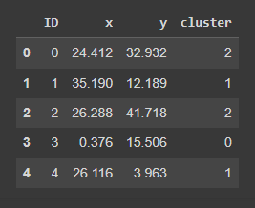

customcmap = ListedColormap(["crimson", "mediumblue", "darkmagenta"])

fig, ax = plt.subplots(figsize=(8, 6))

plt.scatter(x=blobs['x'], y=blobs['y'], s=150,

            c=blobs['cluster'].astype('category'),

            cmap = customcmap)

ax.set_xlabel(r'x', fontsize=14)

ax.set_ylabel(r'y', fontsize=14)

plt.xticks(fontsize=12)

plt.yticks(fontsize=12)

plt.show()

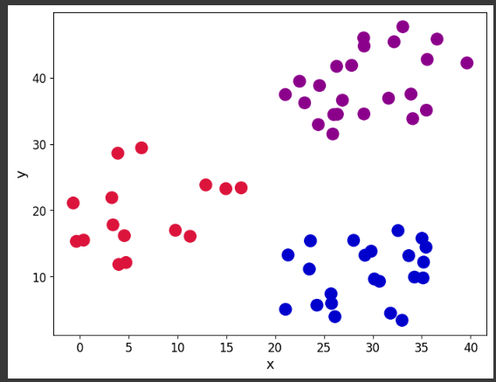

def initiate_centroids(k, dset):

    '''

    Select k data points as centroids

    k: number of centroids

    dset: pandas dataframe

    '''

    centroids = dset.sample(k)

    return centroids

np.random.seed(42)

k=3

df = blobs[['x','y']]

centroids = initiate_centroids(k, df)

centroids

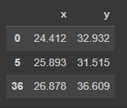

def rsserr(a,b):

    '''

    Calculate the root of sum of squared errors.

    a and b are numpy arrays

    '''

    return np.square(np.sum((a-b)**2))

for i, centroid in enumerate(range(centroids.shape[0])):

    err = rsserr(centroids.iloc[centroid,:], df.iloc[36,:])

    print('Error for centroid {0}: {1:.2f}'.format(i, err))

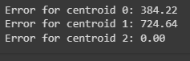

def centroid_assignation(dset, centroids):

    '''

    Given a dataframe `dset` and a set of `centroids`, we assign each

    data point in `dset` to a centroid.

    - dset - pandas dataframe with observations

    - centroids - pa das dataframe with centroids

    '''

    k = centroids.shape[0]

    n = dset.shape[0]

    assignation = []

    assign_errors = []

    for obs in range(n):

        # Estimate error

        all_errors = np.array([])

        for centroid in range(k):

            err = rsserr(centroids.iloc[centroid, :], dset.iloc[obs,:])

            all_errors = np.append(all_errors, err)

        # Get the nearest centroid and the error

        nearest_centroid =  np.where(all_errors==np.amin(all_errors))[0].tolist()[0]

        nearest_centroid_error = np.amin(all_errors)

        # Add values to corresponding lists

        assignation.append(nearest_centroid)

        assign_errors.append(nearest_centroid_error)

    return assignation, assign_errors

df['centroid'], df['error'] = centroid_assignation(df, centroids)

df.head()

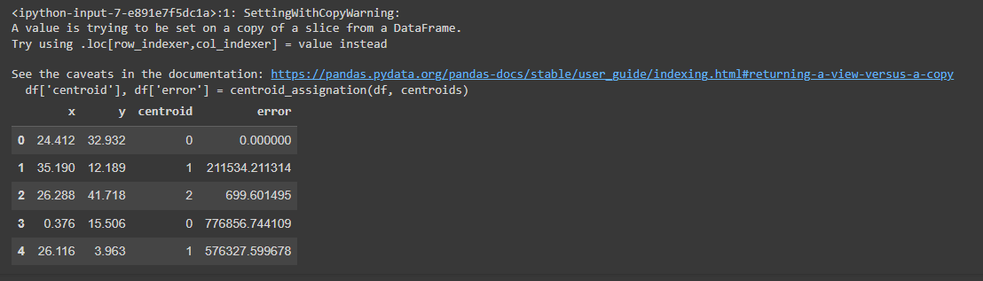

fig, ax = plt.subplots(figsize=(8, 6))

plt.scatter(df.iloc[:,0], df.iloc[:,1],  marker = 'o',

            c=df['centroid'].astype('category'),

            cmap = customcmap, s=80, alpha=0.5)

plt.scatter(centroids.iloc[:,0], centroids.iloc[:,1],

            marker = 's', s=200, c=[0, 1, 2],

            cmap = customcmap)

ax.set_xlabel(r'x', fontsize=14)

ax.set_ylabel(r'y', fontsize=14)

plt.xticks(fontsize=12)

plt.yticks(fontsize=12)

plt.show()

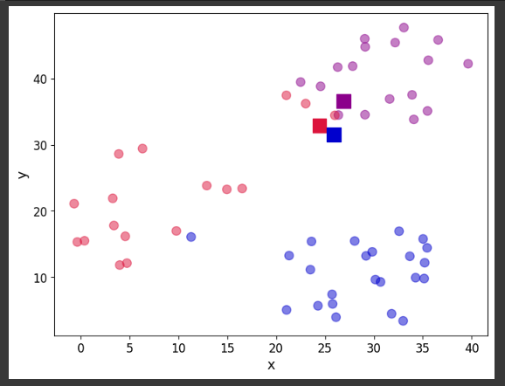

print("The total error is {0:.2f}".format(df['error'].sum()))

The total error is 11927659.01

centroids = df.groupby('centroid').agg('mean').loc[:, colnames].reset_index(drop = True)

centroids

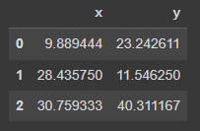

fig, ax = plt.subplots(figsize=(8, 6))

plt.scatter(df.iloc[:,0], df.iloc[:,1],  marker = 'o',

            c=df['centroid'].astype('category'),

            cmap = customcmap, s=80, alpha=0.5)

plt.scatter(centroids.iloc[:,0], centroids.iloc[:,1],

            marker = 's', s=200,

            c=[0, 1, 2], cmap = customcmap)

ax.set_xlabel(r'x', fontsize=14)

ax.set_ylabel(r'y', fontsize=14)

plt.xticks(fontsize=12)

plt.yticks(fontsize=12)

plt.show()

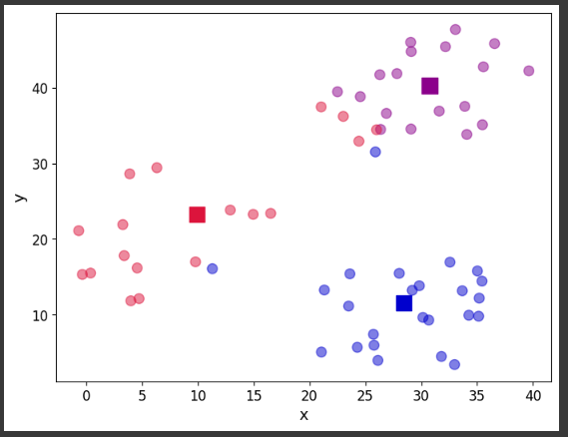

def kmeans(dset, k=2, tol=1e-4):

    '''

    K-means implementationd for a

    `dset`:  DataFrame with observations

    `k`: number of clusters, default k=2

    `tol`: tolerance=1E-4

    '''

    # Let us work in a copy, so we don't mess the original

    working_dset = dset.copy()

    # We define some variables to hold the error, the

    # stopping signal and a counter for the iterations

    err = []

    goahead = True

    j = 0

    # Step 2: Initiate clusters by defining centroids

    centroids = initiate_centroids(k, dset)

    while(goahead):

        # Step 3 and 4 - Assign centroids and calculate error

        working_dset['centroid'], j_err = centroid_assignation(working_dset, centroids)

        err.append(sum(j_err))

        # Step 5 - Update centroid position

        centroids = working_dset.groupby('centroid').agg('mean').reset_index(drop = True)

        # Step 6 - Restart the iteration

        if j>0:

            # Is the error less than a tolerance (1E-4)

            if err[j-1]-err[j]<=tol:

                goahead = False

        j+=1

    working_dset['centroid'], j_err = centroid_assignation(working_dset, centroids)

    centroids = working_dset.groupby('centroid').agg('mean').reset_index(drop = True)

    return working_dset['centroid'], j_err, centroids

np.random.seed(42)

df['centroid'], df['error'], centroids =  kmeans(df[['x','y']], 3)

df.head()

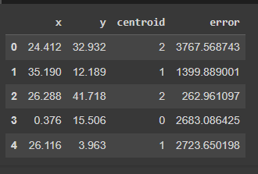

fig, ax = plt.subplots(figsize=(8, 6))

plt.scatter(df.iloc[:,0], df.iloc[:,1],  marker = 'o',

            c=df['centroid'].astype('category'),

            cmap = customcmap, s=80, alpha=0.5)

plt.scatter(centroids.iloc[:,0], centroids.iloc[:,1],

            marker = 's', s=200, c=[0, 1, 2],

            cmap = customcmap)

ax.set_xlabel(r'x', fontsize=14)

ax.set_ylabel(r'y', fontsize=14)

plt.xticks(fontsize=12)

plt.yticks(fontsize=12)

plt.show()

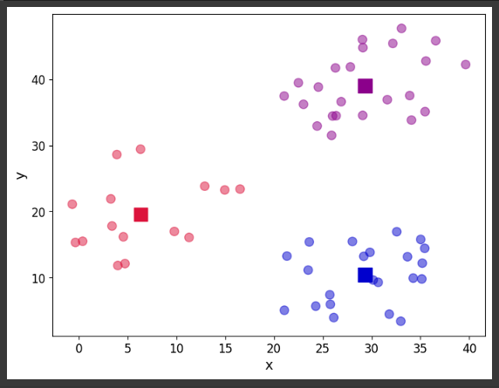

err_total = []

n = 10

df_elbow = blobs[['x','y']]

for i in range(n):

    _, my_errs, _ = kmeans(df_elbow, i+1)

    err_total.append(sum(my_errs))

fig, ax = plt.subplots(figsize=(8, 6))

plt.plot(range(1,n+1), err_total, linewidth=3, marker='o')

ax.set_xlabel(r'Number of clusters', fontsize=14)

ax.set_ylabel(r'Total error', fontsize=14)

plt.xticks(fontsize=12)

plt.yticks(fontsize=12)

plt.show()

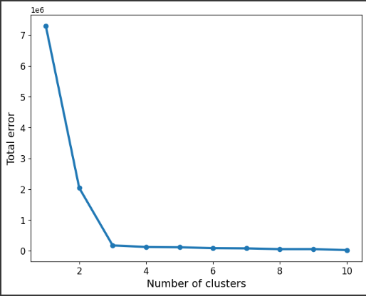

**PRACTICAL 7**

**Implement the Rule Based method and test the same.**

import pandas as pd

df = pd.read_csv("persona.csv")

df.head()

df.shape

df.describe().T

df.isnull().values.any()

df.isnull().sum()

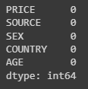

df.head()

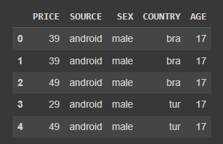

df.describe().T

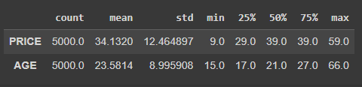

df["SOURCE"].nunique()

df["SOURCE"].value_counts()

df["COUNTRY"].value_counts()

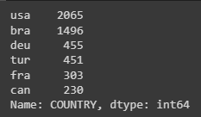

df.groupby("COUNTRY")["PRICE"].agg({"mean"})

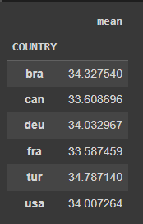

df.groupby(["COUNTRY", 'SOURCE'])["PRICE"].mean()

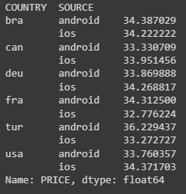

agg_df = df.groupby(["COUNTRY", 'SOURCE', "SEX", "AGE"])["PRICE"].mean().sort_values(ascending=False)

agg_df.head()

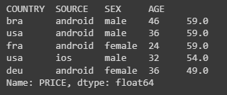

agg_df = agg_df.reset_index()

agg_df.head()

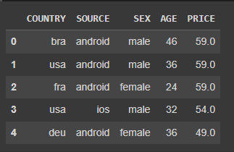

my_labels = ['0_18', '19_23', '24_30', '31_40', '41_70']

agg_df["AGE_CUT"] = pd.cut(x=agg_df["AGE"], bins=[0, 18, 23, 30, 40, 70], labels=my_labels)

agg_df.tail(10) # Just checking data

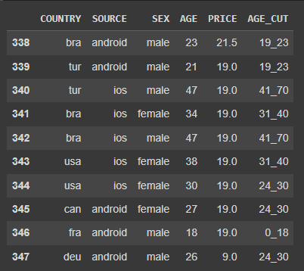

agg_df["customers_level_based"] = [f"{i[0]}_{i[1]}_{i[2]}_{i[-1]}" for i in agg_df.values]

agg_df = agg_df.loc[:, ["customers_level_based", "PRICE"]].groupby("customers_level_based").agg({"PRICE": "mean"}).sort_values(by="PRICE", ascending=False).reset_index()

agg_df["customers_level_based"].head() # Just checking data again

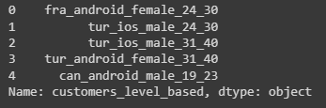

agg_df["SEGMENT"] = pd.qcut(agg_df["PRICE"], 4, labels=["D", "C", "B", "A"])

agg_df.head()

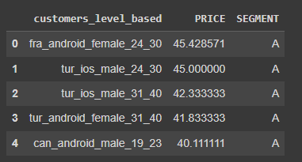

agg_df.groupby(["SEGMENT"]).agg({"PRICE": ["mean", "max", "sum"]})

agg_df[agg_df["SEGMENT"] == "C"].describe()

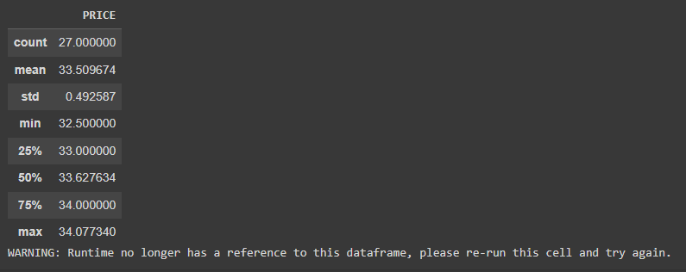

agg_df.groupby(["SEGMENT"]).agg({"PRICE": ["mean", "max", "sum"]})

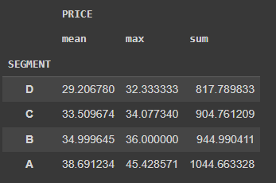

new_user = "fra_android_male_24_30"

print(agg_df[agg_df["customers_level_based"] == new_user])



**PRACTICAL 8.**

**Write a program to construct a Bayesian network considering medical data. Use this model to demonstrate the diagnosis of heart patient using standard Heart Disease Data Set.**

import numpy as np # linear algebra

import pandas as pd # data processing, CSV file I/O (e.g. pd.read_csv)

# visualization tools

import matplotlib.pyplot as plt

import seaborn as sns

from plotly.offline import init_notebook_mode, iplot

init_notebook_mode(connected=True)

import os

for dirname, _, filenames in os.walk('heart.csv'):

    for filename in filenames:

        print(os.path.join(dirname, filename))

df = pd.read_csv("heart.csv")

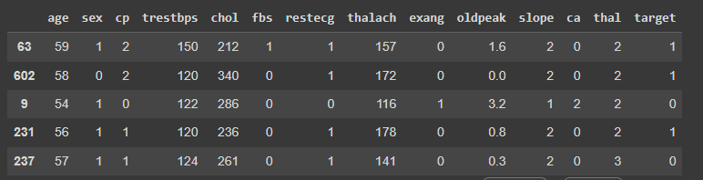

df.info()

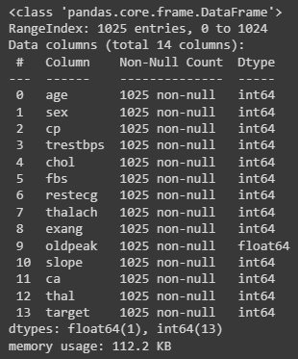

import missingno as msno

msno.matrix(df)

plt.show()

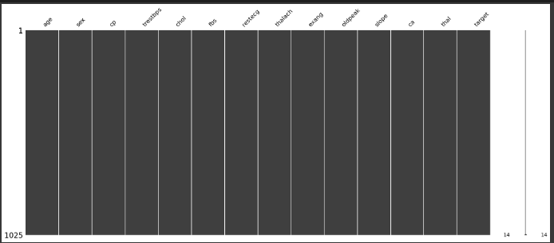

f,ax = plt.subplots(figsize=(25, 15))

sns.heatmap(df.corr(), annot=True, linewidths=0.5,linecolor="red", fmt= '.1f',ax=ax)

plt.show()

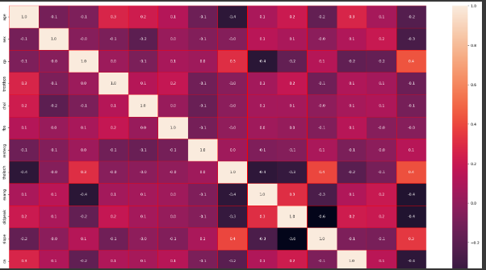

X=df.iloc[:, 0:13]

X.head()

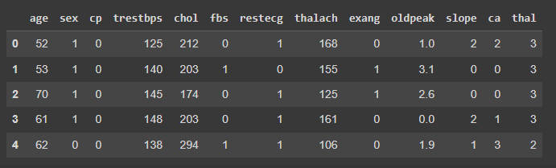

y=df.iloc[:,1]

y.head()

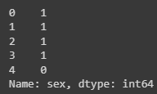

from sklearn.preprocessing import StandardScaler

scaler = StandardScaler()

scaler.fit(X)

X = scaler.transform(X)

from sklearn.model_selection import train_test_split

X_train, X_test, y_train, y_test = train_test_split(X, y, test_size=0.2, random_state=42)

from sklearn.naive_bayes import GaussianNB

from sklearn import metrics

classifier = GaussianNB()

classifier.fit(X_train, y_train)

y_pred = classifier.predict(X_test)

print('Accuracy Score:')

print(metrics.accuracy_score(y_test,y_pred))

**Accuracy Score: 1.0**

from sklearn.metrics import confusion_matrix

cm = confusion_matrix(y_test, y_pred)

f,ax = plt.subplots(figsize=(10, 10))

sns.heatmap(cm, annot=True, linewidths=0.5,linecolor="red", fmt= '.0f',ax=ax)

plt.show()

plt.savefig('ConfusionMatrix.png')

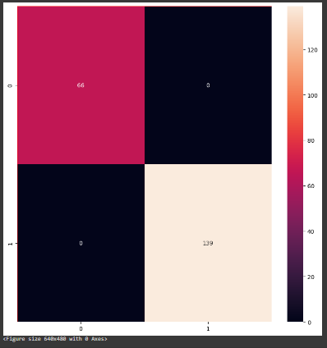

from sklearn.metrics import  f1_score

f1_score = f1_score(y_test, y_pred)

print("F1 Score:")

print(f1_score)

F1 Score:1.0