1. (20 points) [Data Attributes] [Angela Zhang] Classify the following attributes 1) as nominal, ordinal, interval, or ratio and 2) as binary, discrete, or continuous. Some cases may have more than one interpretation, so briefly justify your answer if you think there may be some ambiguity.

(a) (1 point) Temperature measured in Kelvin.

(b) (1 point) City/town (Raleigh, Durham, Cary, etc.).

(c) (1 point) Annual income (US currency).

(d) (1 point) Eye color (Blue, Green, Brown, etc.).

(e) (1 point) Temperature measured in Celsius.

(f) (1 point) The amount of Calories found on a nutrition label.

(g) (1 point) Binary numbers (0, 1, 10, 11, 100, 101, ...).

(h) (1 point) Blood type (O+, O-, A+, A-, B+, B-, AB+, AB-).

(i) (1 point) Letter grade assigned to coursework (A+, A, A-, B+, ..., F).

(j) (1 point) The distance traveled by a jogger measured in kilometers.

(k) (1 point) Unix time (also known as Epoch time, POSIX time, UNIX Epoch time, etc.).

(l) (1 point) True or false.

(m) (1 point) CPU processing speed (actual or base) measured in Gigahertz.

(n) (1 point) A person’s height measured in meters.

(o) (1 point) The pH of water that has been measured using the pH scale.

(p) (1 point) Day of the week (Sunday, Monday, Tuesday, ...).

(q) (1 point) Calendar dates.

(r) (1 point) An angle measured in radians between 0 and 2π.

(s) (1 point) Active Duty Enlisted Basic Military pay grade scale e.g. E-1, E-2, ..., E-9 (for simplicity of the exercise, do not factor in years of service in your answer).

(t) (1 point) The mileage on a vehicle’s odometer.

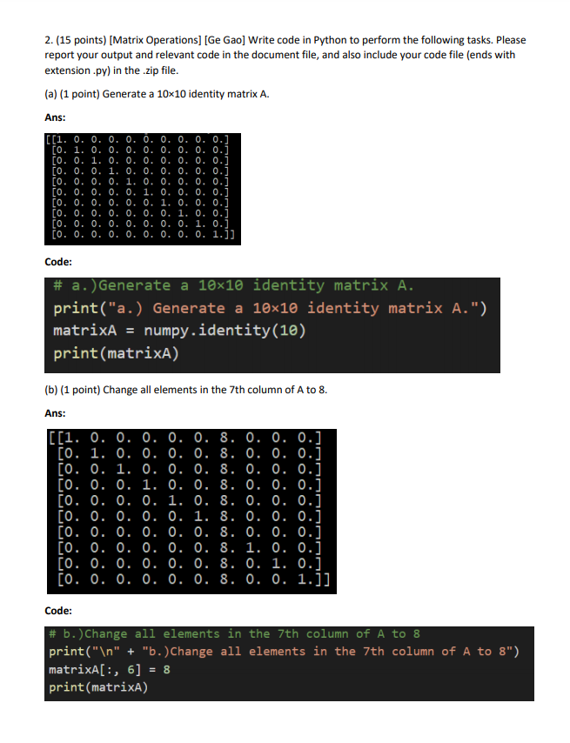

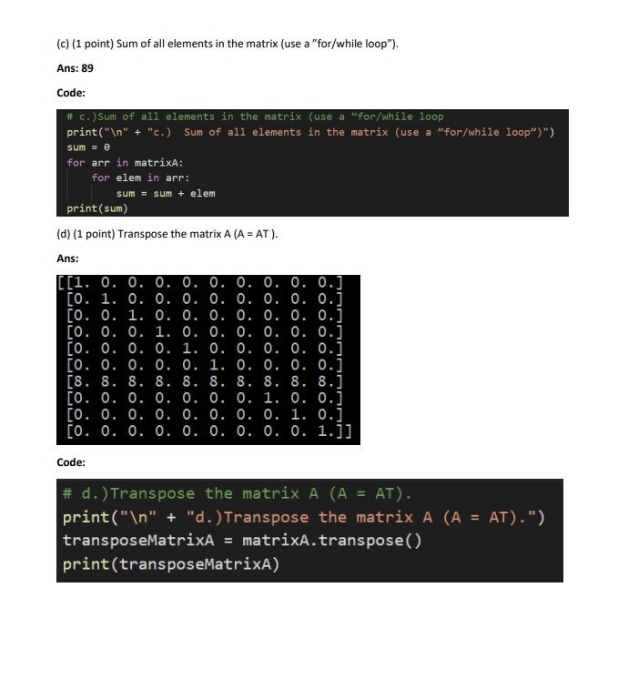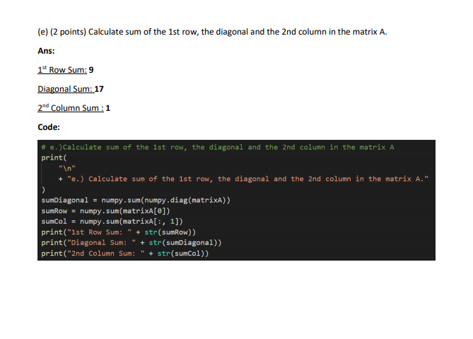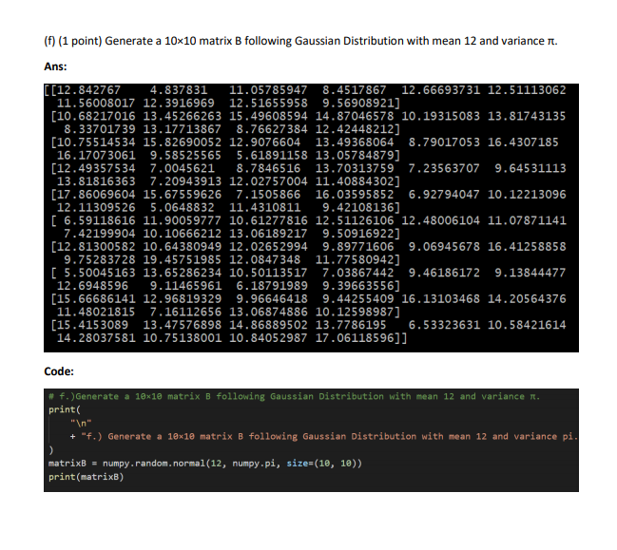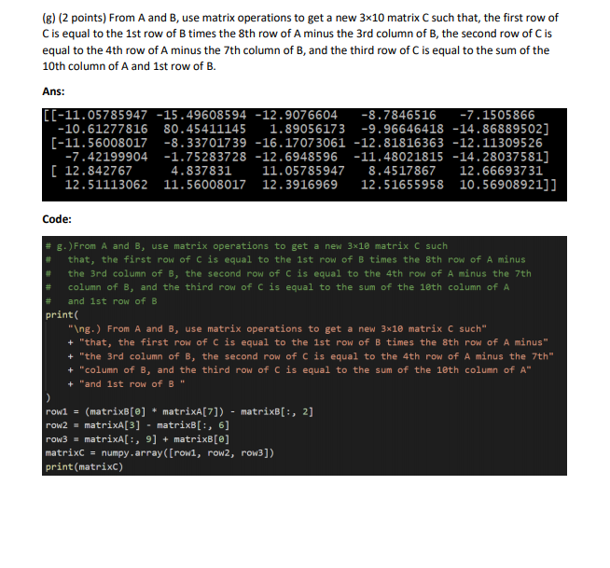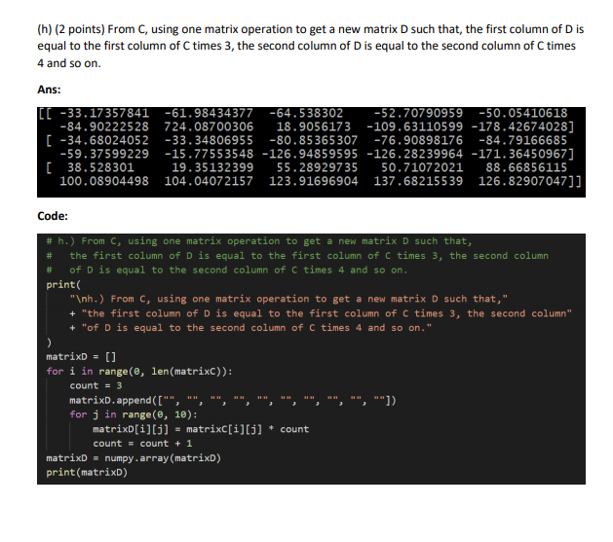

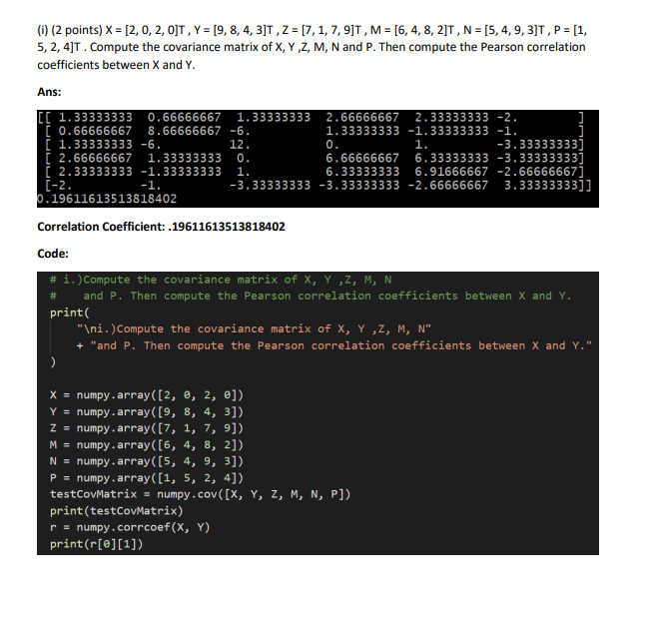

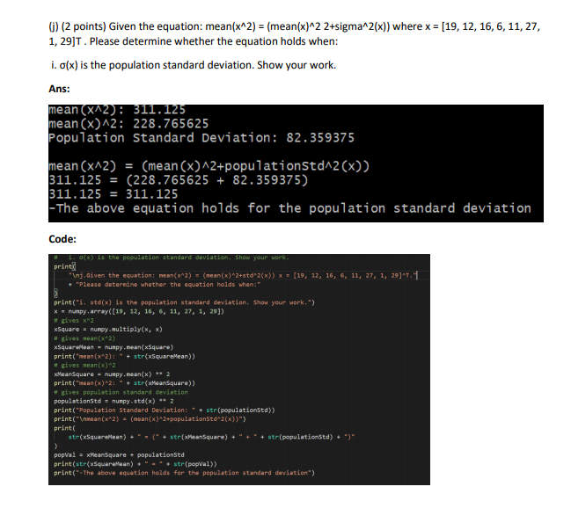

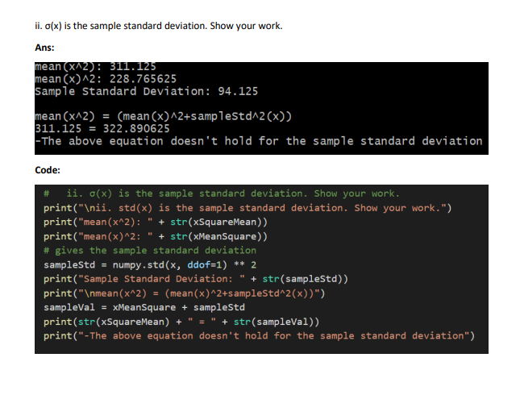

3. (24 points) [Data Visualization] [John Wesley Hostetter] In this question, please summarize and explore data in the provided file “data\iris.csv”. This data is the “Iris Data Set” and is a famous database created by R.A. Fisher in 1936. It was later donated by Michael Marshall to the UCI Machine Learning Repository (https://archive.ics. uci.edu/ml/datasets/Iris). In this data file, each row represents an instance and has 5 attributes:

1. sepal length in centimeters

2. sepal width in centimeters

3. petal length in centimeters

4. petal width in centimeters

5. class (Iris Setosa, Iris Versicolour, Iris Virginica)

Write code in Python to perform the following tasks. Please report your output and relevant code in the document file, and also include your code file (ends with extension .py) in the .zip file.

(a) (3 points) Compute the mean, median, standard deviation, range, 25th percentiles, 50th percentiles, 75th percentiles for each feature (except the class attribute).

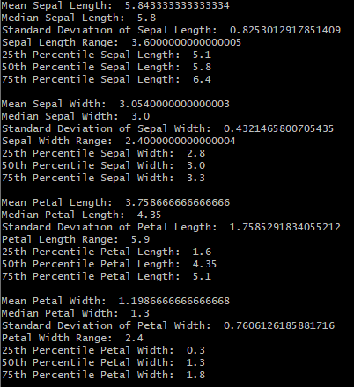

(b) (3 points) Make a box-and-whisker plot for each feature (except the class attribute). Be sure to include a title for each plot of what feature is being described.

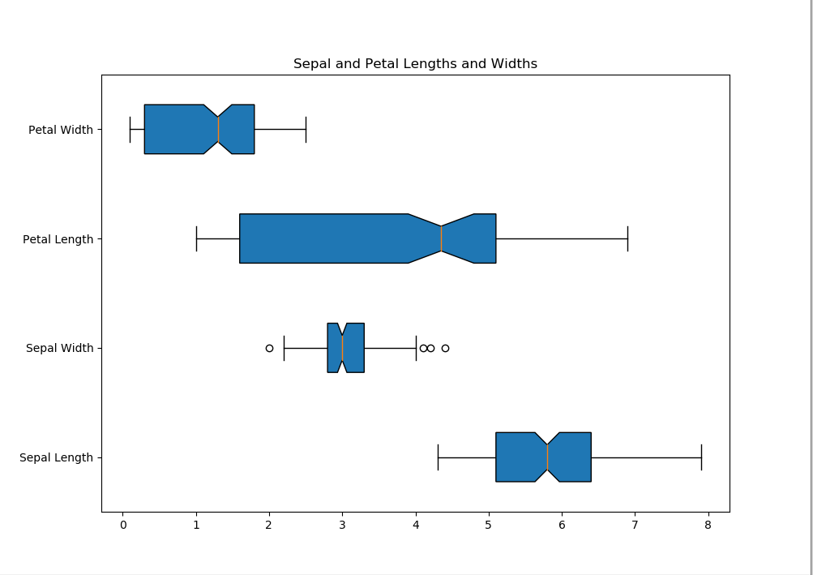

(c) (4 points) Create histogram plot using 8 bins for the two features sepal width and petal length, respectively.

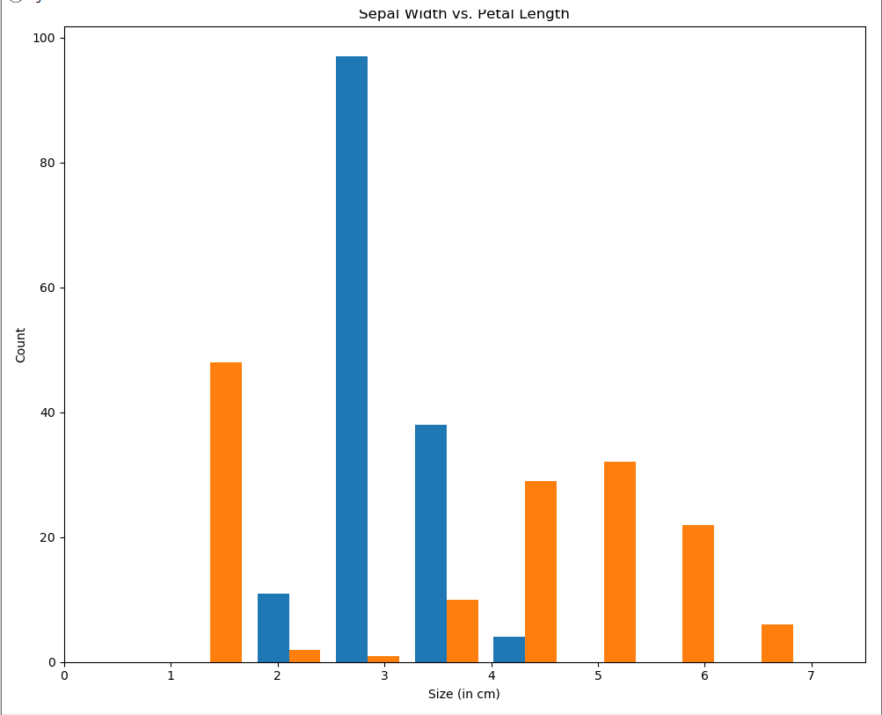

(d) (4 points) Create a scatter matrix of the data. Include all features, but use the class attribute to change the color of the data points (for convenience, you may use a library for this). For the diagonal of the scatter matrix, plot the kernel density estimation (KDE).

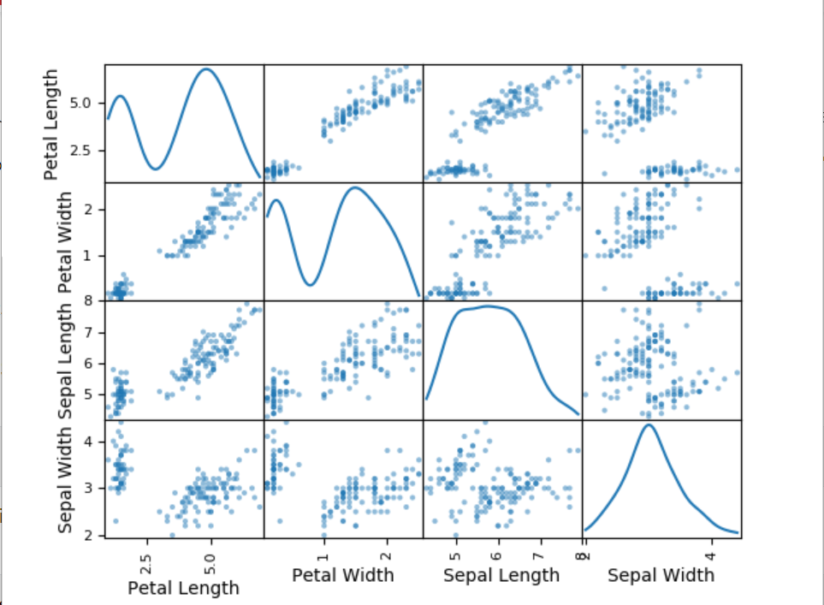

(e) (5 points) Now, write code to produce a three-dimensional scatter plot using the sepal length, sepal width and petal width as dimensions, and color the data points according to the class attribute.

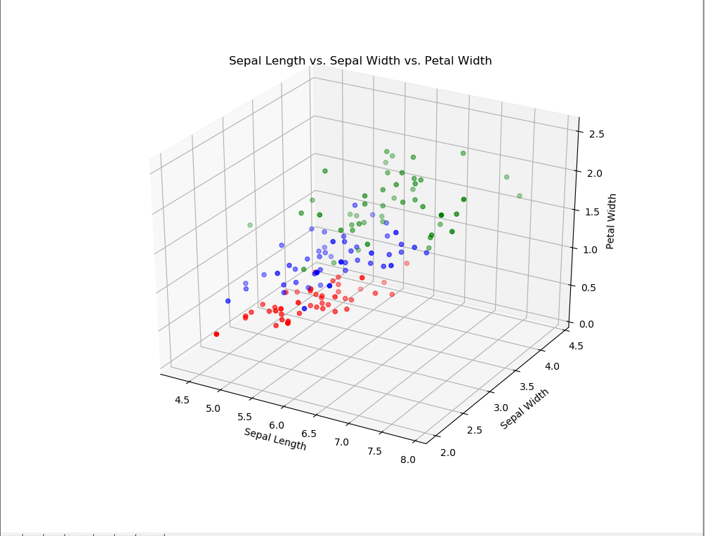

(f) (5 points) The quantile-quantile plot can be used for comparing the distribution of data against the normal distribution. Create a quantile-quantile plot for the two features sepal length and petal length, respectively. Give a brief analysis for the two plots.

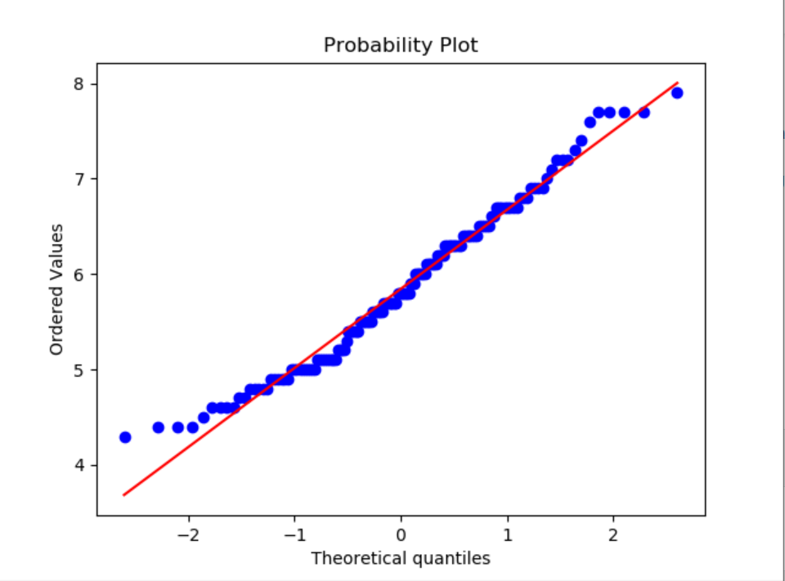

Figure : Sepal Length

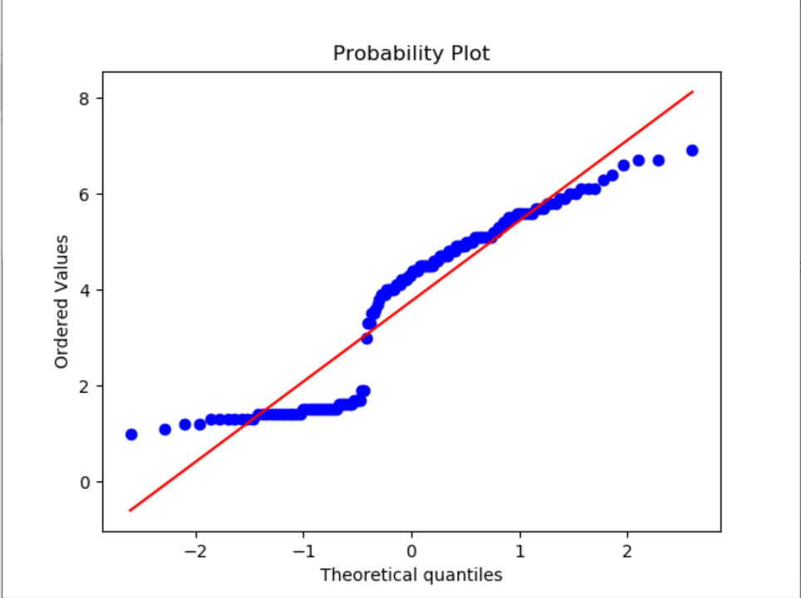

Figure : Petal Length

**- As seen the Sepal Length is fairly linear indicating that it follows a symmetric normal distribution.**

**-In the Petal Length QQ plot it is seen that the values displayed have a gap indicating the petal length distribution is bimodal**

4. (16 points) [Short Answer Questions] [Angela Zhang] Please read Chapters 2.2 and 2.3 in Tan et. al, textbook and answer the following questions:

(a) (8 points) Data quality.

1. (1 point) How is precision often measured?

**-Precision is often measured by the standard deviation of a set of values.**

1. (2 points) When can we reliably determine if there truly exists a bias?

**-Bias can only be truly determined when a measured quantity is made known by a means which is external from the current situation. If you were to use internal measures, they would have the bias applied and would not determine anything**

1. (2 points) Explain how accuracy and precision are different from one another.

**-I think of accuracy and precision as different if you imagine a target with a bullseye. Precise shots are repeatedly hitting very close to each other but not necessarily on the bullseye. Accurate shots are close to the bullseye but not necessarily close to each other.**

1. (3 points) List and explain at least 3 ways on how to handle missing values.

**-The first way you can handle missing data is simply by eliminating either the object with the missing data or the entire attribute with missing data from all objects. With this technique you lose information, information which may be vital to the analysis of the data making your analysis unreliable. This happens often when there is much data missing.**

(b) (8 points) Data preprocessing.

1. (2 points) Compare the advantages and disadvantages of data aggregation.

-**Advantages for data aggregation include smaller data sets which reduces memory consumption and processing time. This advantage can be very helpful when needing to use an expensive data mining algorithm. Other advantages are that you can get a higher scoped view of the data and that the data is typically more stable than non-aggregated data.**

1. (1 point) What is the key principle for effective sampling?

**-If the sample has about the same properties as the original set of data then the sample will work almost as well as the original data set.**

1. (2 points) When trying to do effective sampling, how do we determine the proper sampling size? (specifically, name a technique and explain it)

**-Adaptive/progressive sampling is a technique to effectively sample. These techniques start with a small sample size and then incrementally increase the sample size until the sample is sufficient.**

1. (2 points) In your own words, explain the curse of dimensionality.

**-The curse of dimensionality is when the more attributes/dimensions that the data to be analyzed contains the more difficult it is to pull meaningful data out of the set. For example, if your data set is a glass of water and in that glass of water you dissolve some sugar, when you add more water to the glass the more difficult it will be to tell that the water has sugar in it.**

1. (1 point) What is often required for effective feature extraction?

**-Having knowledge of the domain for which you are developing and extracting features as they are typically highly domain specific.**

5. (11 points) [Sampling] [John Wesley Hostetter] Answer the following questions:

(a) (5 points) A chess dataset contains records for 10,000 unique games, where 5,000 games result in a win for player white and 5,000 games result in a win for player black. Among the 10,000 unique games, 3% witness an en passant move and 11% have a castling move occur at least once on either the King’s side or Queen’s side. For simplicity, assume that the two events - en passant or castling - are mutually exclusive. Suppose we are developing a classifier in hopes of predicting the outcome of a chess game as it is being played. However, we are unable to use the entire data set due to computational limitations, and thus can only use a sample of the entire data set. Which sampling method would be appropriate and why? If we are sampling 2,000 games from the provided dataset, how many games should be selected from each group using your choice of sampling methods. Briefly justify your answer.

(b) (6 points) Consider the following scenario: The data set originally had 10,127 games, but the 127 games that were omitted from consideration in the previous section did not result in a win for either player, but rather, a draw instead. Are the games that resulted in a draw, noise or outliers? Briefly justify your answer and describe the differences between noise and outliers.

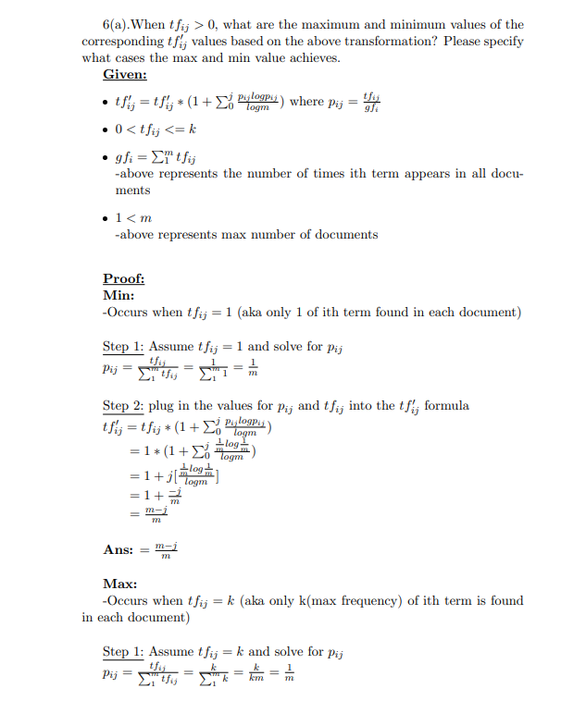

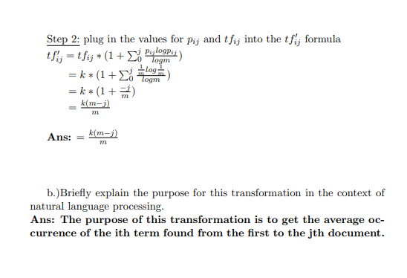

7. (30 points) [Distance] [John Wesley Hostetter] For this exercise, use the provided file “data\parkinsons.csv” (https://archive.ics.uci.edu/ml/datasets/Parkinsons), which contains a list of 195 data instances. Each of these instances represents a recording. There are 23 attributes; please refer to the included link for documentation. For this exercise, we will only be concerned with a select few - namely, the HNR and NHR attributes. Write code in Python to perform the following tasks, please report your output and relevant code in the document file, and also include your code file (ends with .py) in the .zip file.

(a) (4 points) Load the file and read all the columns. Make a plot between the HNR and the NHR of the observations. Label the axes (NHR should be y-axis and HNR should be x-axis). Call this plot ”HNR and NHR data”. What general interpretation can you make from this plot?

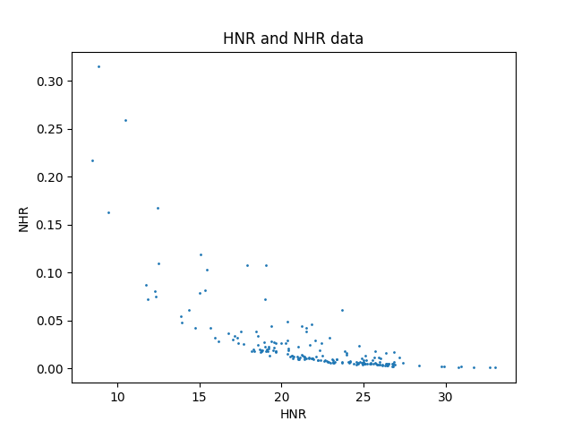

**-From the HNR and NHR data plot you can see that the relationship between these two attributes is logarithmic. As HNR increases, NHR decreases logarithmically coming to a lower limit of zero and vice versa. Also, the typical subject seems to have an HNR of around 17-27 and a NHR of around 0 to 0.05.**

(b) (2 points) Compute the mean of the attributes HNR and NHR. Define a data point called P such that P = (mean(HNR), mean(NHR)).

**-Data point P = (21.885974358974366, 0.024847076923076923)**

(c) (10 points) Compute the distance between P and the 195 data points using the following distance measures: 1) Euclidean distance, 2) Manhattan block metric, 3) Minkowski metric (for power=6), 4) Chebyshev distance, and 5) Cosine distance. List the closest 5 points for each distance. (d) For each distance measure, identify the 10 points from the dataset that are the closest to the point P from

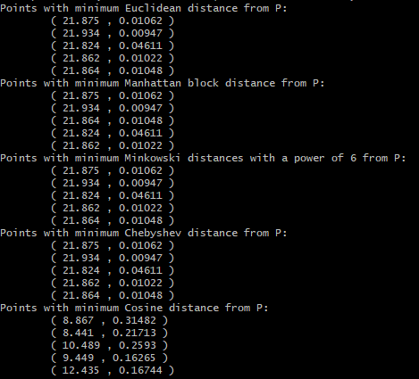

(d). (You are allowed to use any package functions to calculate the distances.)

1. (10 points) Create plots, one for each distance measure. Place P on the plot and mark the 10 closest points. To mark them, you could use different colors or shapes. Make sure the points can be uniquely identified.

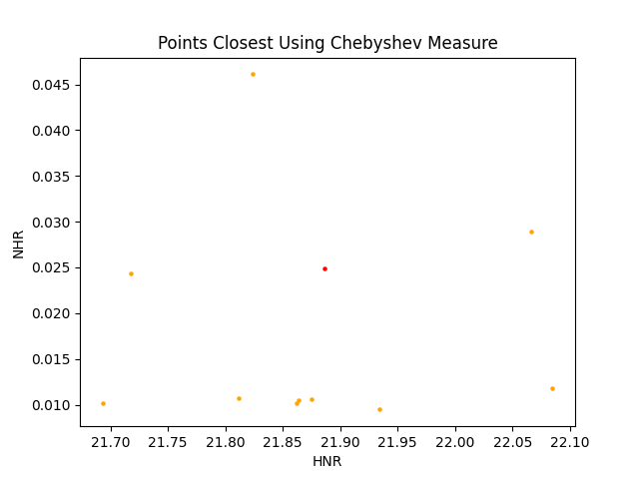

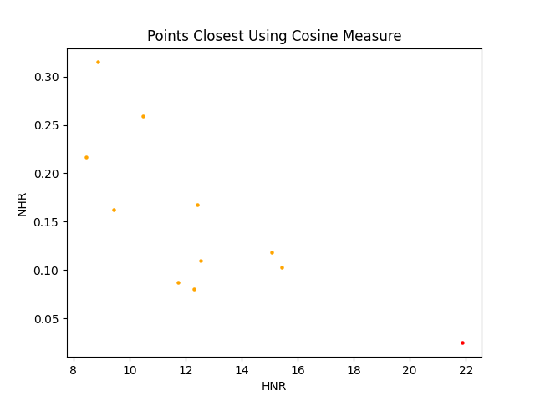

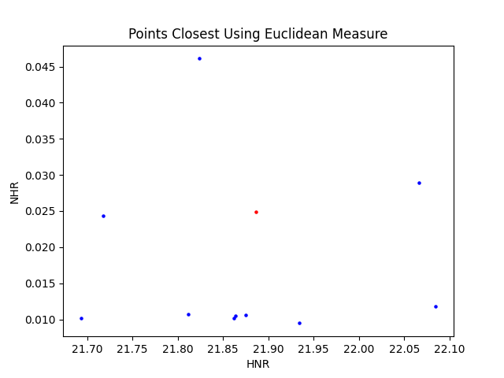

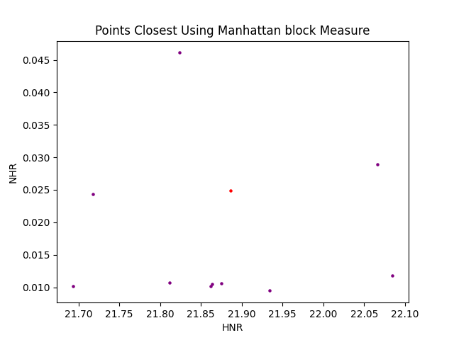

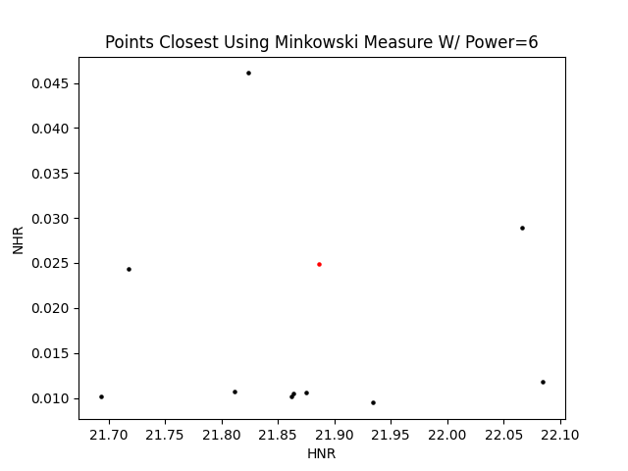

1. (4 points) Verify if the set of points is the same across all the distance measures. If there is any big difference, briefly explain why it is.

**-All sets of points are the same across distance measures with the exception of the cosine distance scatterplot. This plot is wildly different from the pattern. I believe that this is due to the cosine distance being based on angular distance while the others don't take this into account as greatly.**